BORROW BOX

WEB TECHNOLOGY PROJECT REPORT, V SEM. BTech (Program Name)
FLEXICORE-3131

SUBMITTED TO
SCHOOL OF COMPUTER ENGINEERING, M.I.T., MANIPAL


By
[Student 1 name] (Reg. No: [number])
[Student 2 name] (Reg. No: [number])

Under the guidance of: [Faculty name]
October 2026


Team Details and Work Split
Draft work allocation for the report; confirm each student’s actual contribution before submission.

Sl. | Name | Reg. No. | Modules / Pages designed (2 per student) | Signature
1 | [Student 1 name] | [Reg. No.] | 1. Explore and search  2. Item detail and request | [Signature]
2 | [Student 2 name] | [Reg. No.] | 1. List an item  2. Dashboard and loan status | [Signature]

1. Project Overview
Borrow Box is a campus item-sharing website. A student lists a useful object, another student requests to borrow it, and the owner approves and later marks it returned. The returned item becomes available again. The site was built as a small full-stack project using the course technologies: HTML, CSS, JavaScript, PHP and MySQL [1]. Its distinctive feature is this repeatable reuse cycle rather than a one-time listing.
1.1 Purpose of the Website
Students often need a calculator, book or lab item only briefly. Borrow Box helps them find available items shared by other students, ask for a short loan, and see when the item is available again. The owner controls approval and return status. This reduces unnecessary purchases and makes existing resources more useful.
1.2 Objectives
Create an account and log in; publish and remove available items; search by keyword and category; view item details; send and cancel requests; approve or decline requests; mark borrowed items returned; track owned items and requests in a dashboard.
1.3 Target Users
The target users are students sharing or borrowing items on campus. The responsive layout supports phone screens. Semantic landmarks, descriptive labels, a skip link, visible keyboard focus, and text-based status/error messages support keyboard and screen-reader users. These choices follow the accessibility criteria supplied with the assignment [2]; a formal WCAG audit has not been performed.
1.4 Site Map
Explore (Student 1) → Item detail and request (Student 1). Account access is shared. After login, List an item (Student 2) and My dashboard (Student 2) are available from the common navigation. The dashboard links back to item details. All pages use the same header and footer.

1.5 Tools and Technologies
Item | Details
HTML version | HTML5
CSS framework and version | None; custom CSS in assets/style.css
JavaScript (if any) | Plain JavaScript for DOM events, character count, and client-side form validation
Data source (static / JSON / API) | MySQL database; PHP renders HTML from database records
IDE and Environment used | Codex editor; PHP 8.5.12 local server; MySQL 5.7.24 test database
Accessibility Guidelines for Users with Disabilities. | WCAG 2.1 AA principles: labels, semantic landmarks, keyboard focus, text contrast
Testing tools (Lighthouse, WAVE etc.) | PHP syntax checks, Python HTTP smoke test, browser visual inspection

1.6 Common Design Followed by the Team
Every page uses the same header, navigation, footer, green and cream color scheme, system font, buttons, form fields and spacing rules from one CSS file. HTML5 elements such as header, nav, main, section, article and footer give the pages a clear structure. CSS Grid and media queries adapt the layout to narrower screens.
2. Student 1: [Student 1 name] (Reg. No: [number])
Modules / Pages: Explore and search; Item detail and request
2.1 Module Description
Explore displays available items as cards and provides a keyword field and category selector. Item detail shows the description, pickup location, owner and status. A logged-in student can send a request with a short message. The modules use a shared navbar, cards, labels, forms and responsive grids.
Input: GET search terms and category, or a POST request message. Processing: PHP validates values and reads or inserts records in MySQL. Output: a filtered HTML page, an item detail page, or a dashboard message showing the request result.
2.2 Design of the module
Search uses HTTP GET so the filter remains visible in the URL. PHP builds a prepared SELECT query and renders matching item cards. The request form sends form data by HTTP POST to action.php with a CSRF token. JavaScript checks required fields in the browser; PHP repeats validation, checks ownership and item availability, then inserts the request. The browser receives a redirect and a text status message.
2.3 Development of the module
Relevant excerpt from index.php:
$stmt = db()->prepare($sql);
if ($values) $stmt->bind_param($types, ...$values);
$stmt->execute(); $items = $stmt->get_result();
Relevant excerpt from action.php:
$itemId=(int)($_POST['item_id']??0); $message=trim((string)($_POST['message']??''));
$s->bind_param('isiiii',$uid,$message,$itemId,$uid,$itemId,$uid);
$s->execute();

2.4 Results
Figure 1 shows a real filtered result from the local running site. Figure 2 shows the request form on the item detail page.
Figure 1. Search and category filter with one matching item.
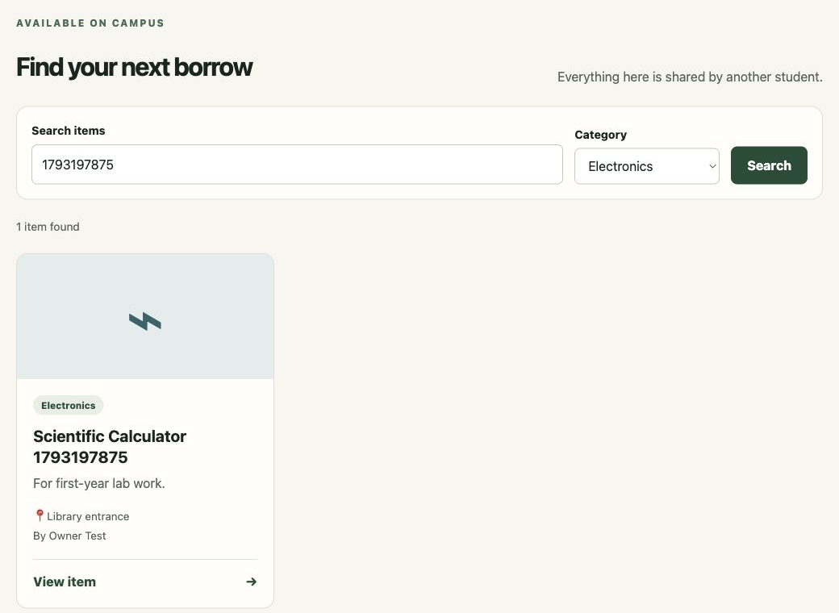
Figure 2. Item detail and request form viewed as the borrower.
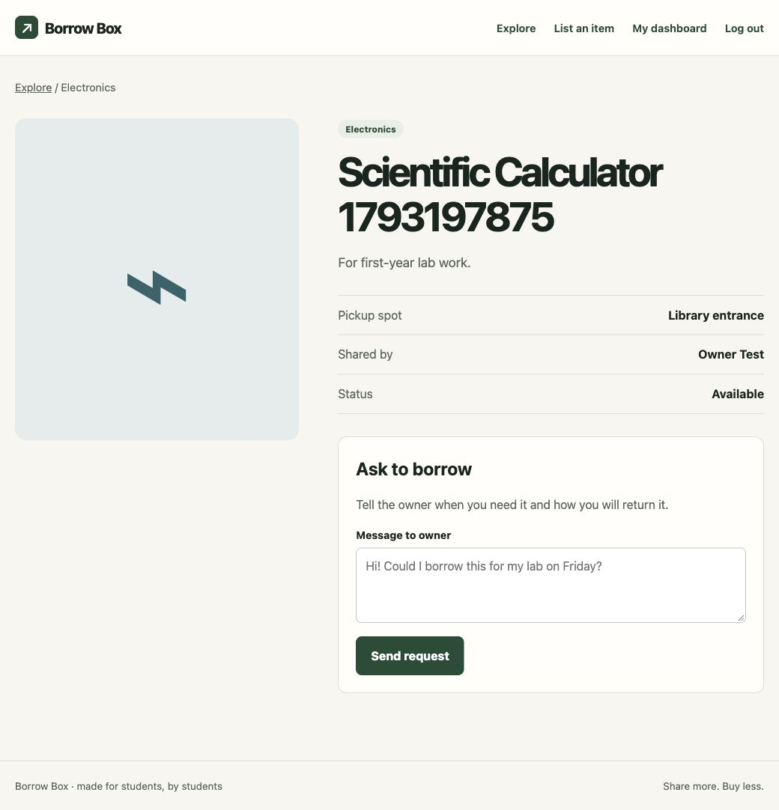
3. Student 2: [Student 2 name] (Reg. No: [number])
Modules / Pages: List an item; Dashboard and loan status
3.1 Module Description
List an item lets an owner enter a title, category, description and pickup location. The dashboard groups owned items, incoming requests and outgoing requests. Owners can approve, decline, mark returned, or remove available listings. Borrowers can cancel pending requests. Shared forms, status labels and card-like rows keep the pages consistent.
Input: listing fields or an action button on a request. Processing: PHP validates the input and updates MySQL; approval and return changes run inside transactions. Output: a new detail page or dashboard with the current state and a text confirmation.
3.2 Design of the module
The listing form uses POST to action.php, which checks a CSRF token, validates field lengths and categories, and inserts the item using a prepared statement. Dashboard buttons also use POST. The server checks the logged-in user owns the item before approval, decline or return. Approval marks the item lent and closes other pending requests; return marks it available. Client-side required fields and character counting help before submission; server-side checks remain authoritative.
3.3 Development of the module
Relevant excerpt from action.php:
$s->bind_param('issss',$uid,$title,$category,$description,$location); $s->execute();
Approval and return update both requests and items inside a database transaction.

3.4 Results
Figure 3 shows the real listing form. Figure 4 shows the owner dashboard with owned items and incoming requests. The two-account HTTP smoke test passed registration, login, listing, search, filtering, requesting, cancellation, repeated requests, duplicate prevention, decline, approval, return, reuse and removal.
Figure 3. Item listing form.
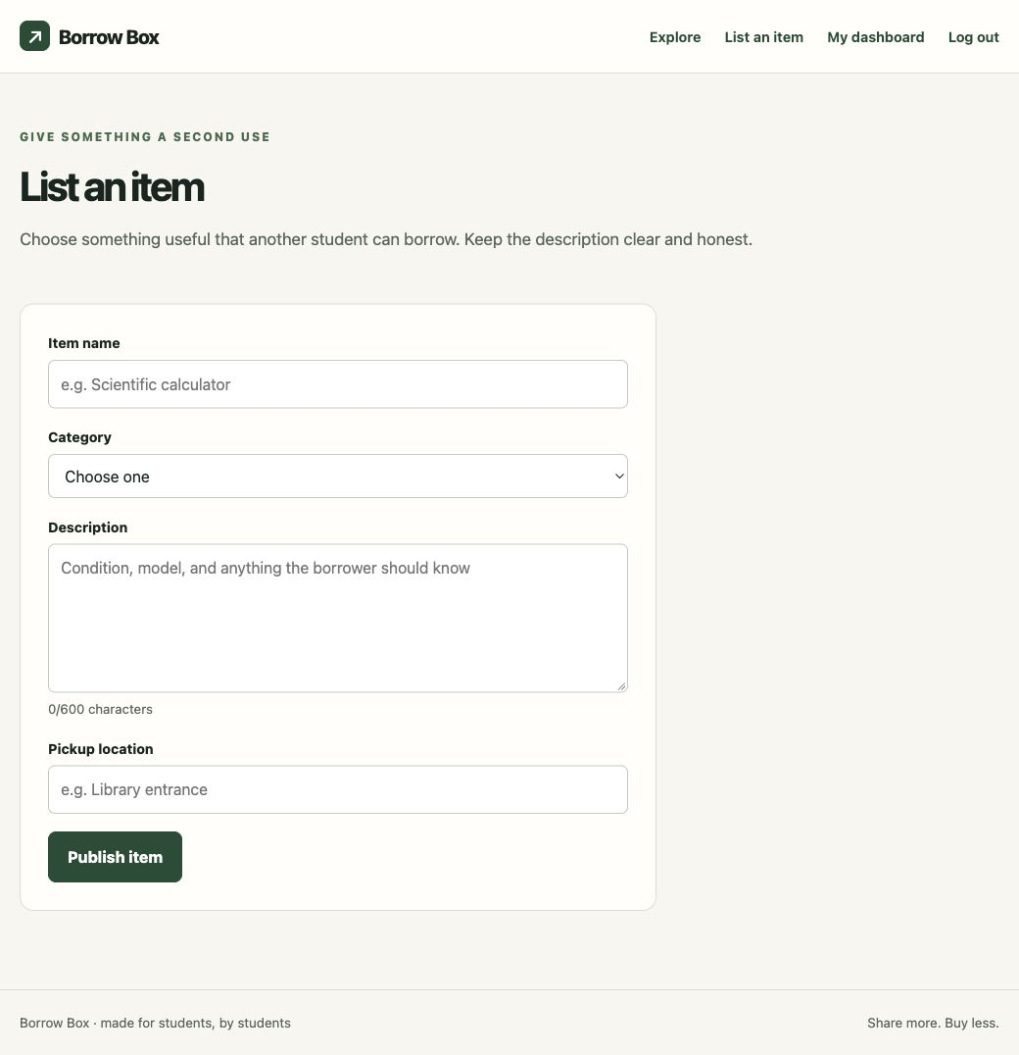
Figure 4. Owner dashboard and request controls.
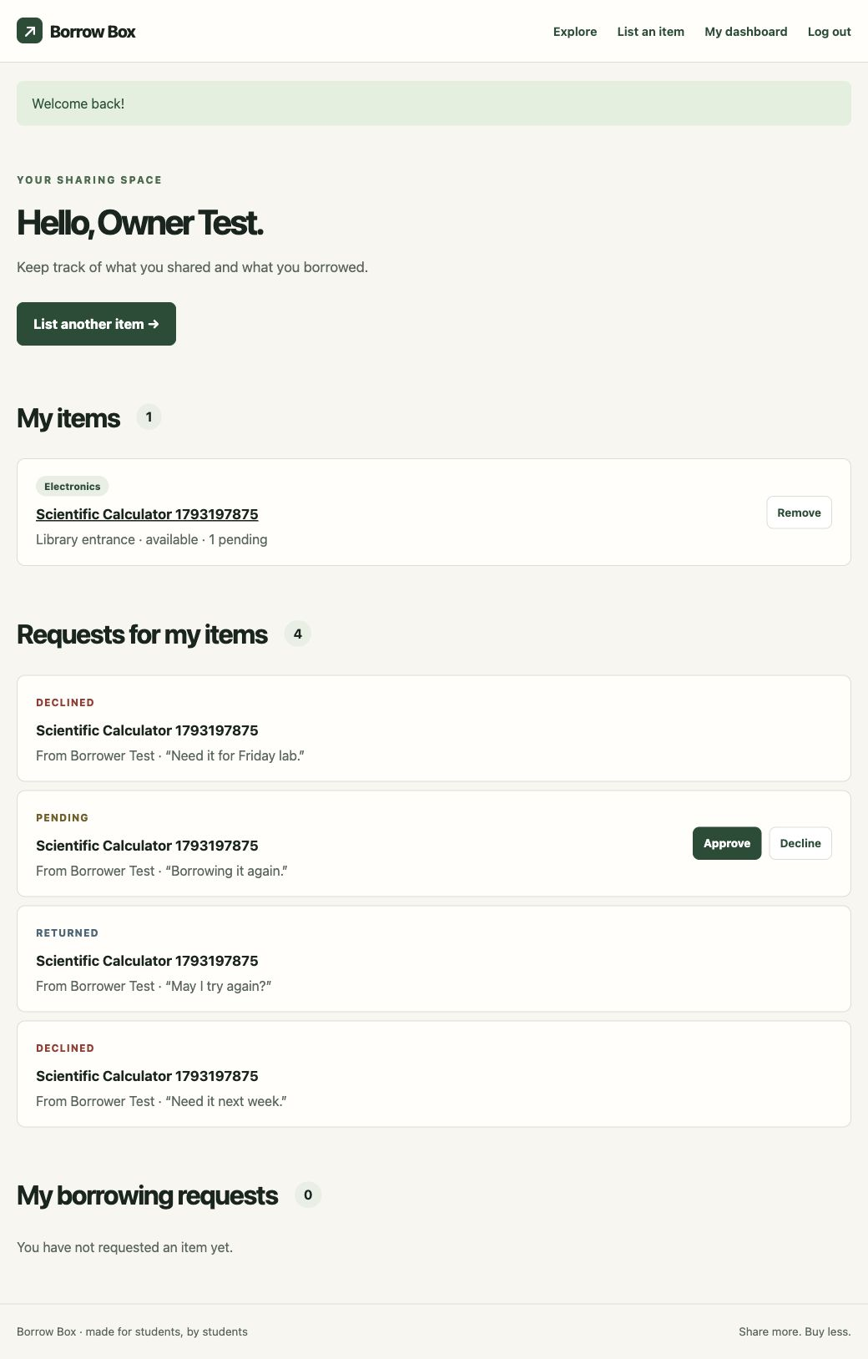

4. Conclusion and Future Scope
Borrow Box demonstrates how HTML, CSS, JavaScript, PHP and MySQL work together in a small campus application. The team used forms, sessions, prepared SQL statements, validation and responsive layouts. The tested reuse cycle returns an item to the available list after a loan ends. Future work could add campus email verification, pickup scheduling, and notifications. Those additions are outside the current implementation.

5. Reference
[1] ICT3131 Web Technology lecture PDFs supplied for this course: HTML_L6_L11.pdf; CSS_L12_L15.pdf; L18_22.pdf; L 24-25.pdf; PHP L29-L35.pdf; db_connect.pdf; insert_frontend.pdf; update_dept.pdf.
[2] Assignment evaluation criteria supplied as screenshots: semantic HTML, readable text, labels, error messages and keyboard access.
[3] Project source: [add real GitHub URL after uploading the repository].

Course concepts are mapped to source files in the project README. Actual student names, registration numbers, faculty name, signatures and GitHub URL must be completed before submission.

