**Startup**: Electronics, Apparels and Automobiles

Scraping (allowed, legal), Spamming Issues; DATA SEGREGATION

Scraping publicly available data is legal, but you need to be careful not to extract content that is protected by copyright or contains personal information. So, after scraping Instagram, double-check your output for data that would go against GDPR, CCPA, or could be considered intellectual property.

**1. Figure out what problem is being solved:** all successful companies, products, or services enhance the lives of their customers by eliminating a problem.

**2. Find your market:** Picture who your ideal user is - this is the first step to actually figuring out where your idea fits into a sea of consumers. They all have different habits and needs to fulfil, yet are facing the same problem. Figure out where your solution will fit into the market and in the lives of people.

One of the biggest mistakes startups make is the failure to get people to understand and want the product or service. If it turns out that your idea isn’t being “sold” to your audience, don’t blame the market. Instead, figure out what they find compelling, or what it will take to get them to want something different than what they already have

You have a solution, but it needs to be in front of the right people to be seen as such.

**3. Find your support: business partners, talk with seasoned entrepreneurs.**

**4. Create a financial model and plan the first phase:** Since you have your market research done, now you must figure out if it’s financially viable. Create a “bottom-up” financial model that focuses on how your product or service is created, marketed, and sold to an individual user. Doing this will give you more insight on how your business will function. Then, to verify your projections, create another financial model that is “top-down,” which examines the size of your market and what goals you need to reach to turn a profit.

**5. Figure out your source of capital: for now, Sharmila Ma’am.**

Depending on the amount you need, a more helpful source can be angel investors and venture capitalists looking to back your mission for a slice of the profits and room for decision-making.

Whatever source(s) you choose to obtain or to aim for, consider that each one has their own rewards and risks.

**6. Build the MVP:** The MVP, or minimal viable product, provides you with the feedback you need before putting your idea on the market. After all, it’s of no use to anyone if you build product customers don’t want.

*The point is not to build a minimal product, but a product that is already great (viable), yet has room to improve (minimal). It’s how early adopters actually jump on board to use the product and, if they like it, will provide you the feedback to make it better for them.*

**7. Find the pivot:** The information gathered from your early adopters helps you figure out what works and what garnered the most response from your audience. You might find that their feedback is entirely different than what you expected and planned for.

This can lead you to “pivot” your business model, or change a fundamental part of it. Changing direction doesn’t mean you failed entirely; it actually helps to prevent failures you may have encountered. Pivoting doesn’t necessarily mean abandoning everything you learned - it’s about taking what you learned and using it for your new direction. You took one route to a destination and got lost; pivoting is just recalculating a different route to get there.

**8. Stay positive**

[**www.ibef.org**](http://www.ibef.org)(Industry)

[**https://www.statista.com/markets/**](https://www.statista.com/markets/)

Free apps make money in a variety of ways, including the following:

* Advertising: Many free apps display ads to users. Advertisers pay the app developers for displaying their ads to a targeted audience.
* In-app purchases: Some free apps offer in-app purchases, allowing users to buy virtual goods or premium features within the app.
* Subscriptions: Some apps offer a monthly or annual subscription model, where users pay for access to premium content or services.
* Affiliate marketing: Some free apps earn money by promoting and selling other companies' products or services and earning a commission on each sale.
* Sponsorships: Some app developers partner with companies to offer branded content or experiences within the app in exchange for payment.
* Data monetization: Some free apps collect user data, such as location or usage patterns, and sell this data to third-party companies for various purposes, such as targeted advertising.
* Physical goods and services: Some free apps serve as a platform for selling physical goods or services, such as a food delivery app that earns money by taking a commission on each transaction.

**List of Industries we are going to work upon**

1. **Automobiles**

<https://www.ibef.org/industry/india-automobiles>

* Revenue - US$100 billion Contributing **8%** of the country's total export and accounts for **2.3%** of India's GDP
* CAGR of 8.1% over the forecast period (2022-2027) EV market in India is likely to increase at a CAGR of 36% until 2026

1. **E-Commerce**

* Revenue - US$70 billion
* Expected annual growth rate (CAGR 2023-2027) of 13.97%, resulting in a projected market volume of US$120.30bn by 2027.
* In the eCommerce market, the number of users is expected to amount to 1,090.1m users by 2027.

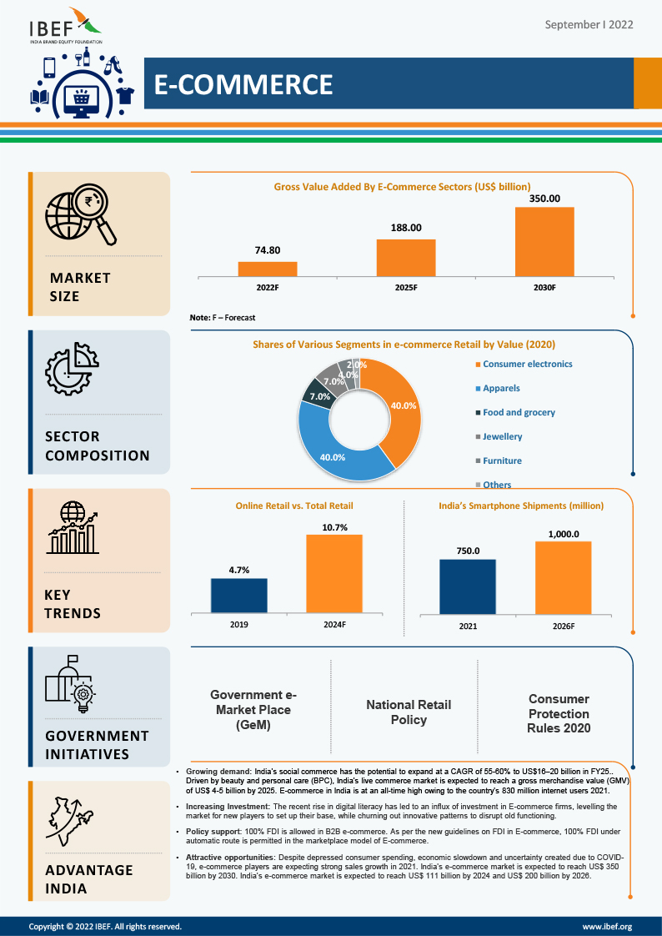

1. **Retail**

* Revenue -US$ 779 billion in 2019 to US$ 1,407 billion by 2026 and US$ 1.8 trillion by 2030.
* 10% of the country’s gross domestic product (GDP) and around 8% of the employment
* The retail sector in India is expected to reach a whopping US$ 2 trillion in value by 2032,

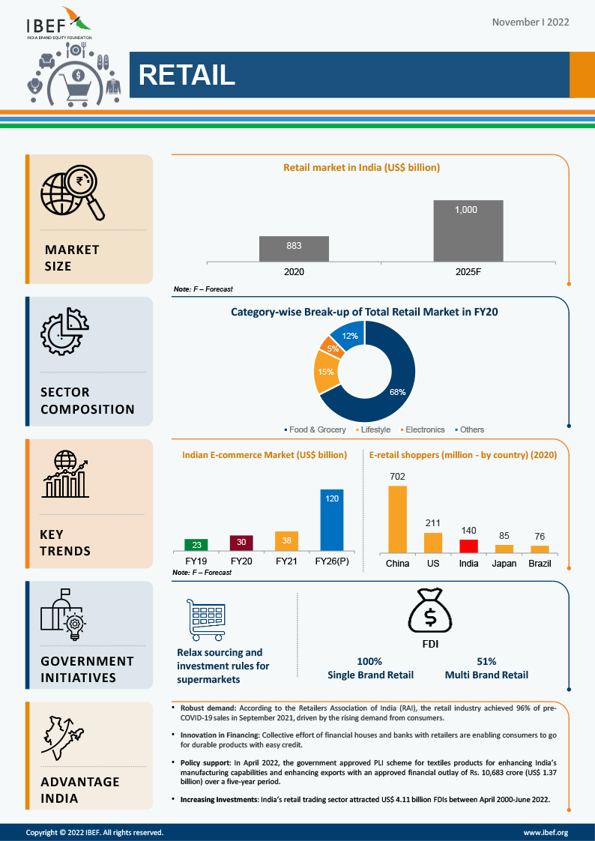

1. **Textiles**

* Revenue - $152 bn in 2021
* CAGR - growing at a CAGR of 12% to reach $225 bn by 2025

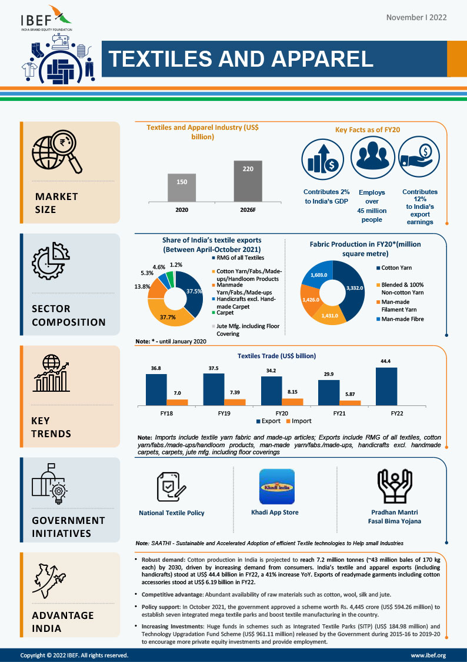

MODULES:

1. Price
2. NLP - Reviews System (fake reviews and fake brand info)
3. Filtering products based on Price, Top Sites, Quality, etc.

FUNCTIONALITIES:

1. Filtering Top websites - TRUSTED for B2C, B2B or C2C, etc. (keep only them in the site)

Work to Be Done:

1. Your mission statements.
2. A description of your business.
3. A list of your products or services.
4. An analysis of the current market and opportunity. [Existing Comp]

* Price
* Dataset
* Filtering out sites. [True n Fake reviews]
* NLP System
* Budget of individual modules.
* Our Target Audience
* Top Sites from where we can extract data, apis, etc.

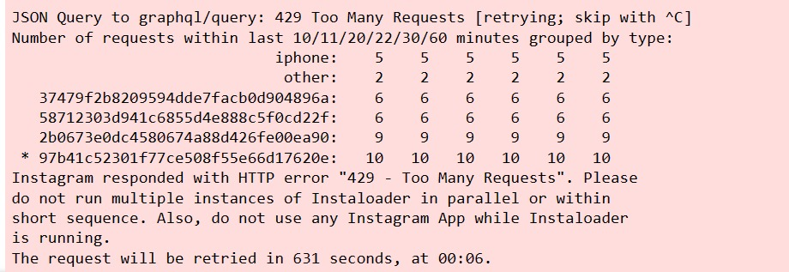

**NLP – SENTIMENT ANALYSIS**

The 3 sentiment analysis algorithm models

Once your Sentiment Library is ready, the next step is deciding on the algorithm model to determine the sentiment behind the text. This is normally a choice from 3 major sentiment analysis algorithms models. The model you select will depend on the amount of data you expect to process and the accuracy you need for your business.

1. Rule or Lexicon based approach

This approach relies on manually crafted rules for data classification to determine sentiment. This approach use dictionaries of words with positive or negative values to denote their polarity and sentiment strength to calculate a score. Additional functionality can also be added by including expressions. Rule based sentiment analysis algorithms can be customized based on context by developing even smarter rules. How it works: It counts the number of positive and negative words in the given text. If the number of positives is more than the negatives, it will return a positive sentiment. If both are equal, it will return a neutral sentiment.

Disadvantages:

The downside of this approach is that it does not take into account how the words are combined in a sentence, it only looks at occurrences.

It is quick to implement but the model involves a long-term cost outlay as it requires regular maintenance so that you get consistent and improved results.

2. Automated or Machine Learning approach

Instead of clearly defined rules, this sentiment analysis model uses machine learning to figure out the essence of the statement. This ensures that the exactitude of the analysis improves and information can be processed on many criteria without it being too complicated. This approach involves the use of machine learning algorithms under supervision. An algorithm is trained with many sample passages until it can predict with accuracy the sentiment of the text. Then large pieces of text are fed into the classifier and it predicts the sentiment as negative, neutral or positive.

Machine learning models can be of two kinds:

a. Traditional Models – This method requires the gathering of a dataset with examples for positive, negative, and neutral classes, then processing this data, and finally training the algorithm based on the examples. These methods are mainly used for determining the polarity of text.

Traditional machine learning methods such as Naïve Bayes, Logistic Regression and Support Vector Machines (SVM) are widely used for large-scale sentiment analysis because they are capable of scalability.

b. Deep Learning Models – This provides more precise results than traditional models and includes neural network models such as CNN (Convoluted Neural Network), RNN (Recurrent Neural Network), and DNN (Deep Neural Network).

The main models used for sentiment analysis classification algorithms are Naïve Bayes and Deep Learning.:

**Naive Bayes sentiment analysis**

It is called ‘Naïve’ because it uses the assumption that the occurrence of one feature is independent of other features. For instance, it identifies the orange fruit based on color, shape and taste with each feature independently being assessed to arrive at the conclusion. The ‘Bayes’ is because it is based on the principle of the Bayes theorem.

The Bayes theorem relies on the concept of conditional probability or the probability that event A occurs when event B occurs. The theorem in effect states that the probability of A if B is true = the probability of B if A is true, multiplied by the times the probability of A being true and the whole divided by the probability of B being true:

Naïve Bayes sentiment analysis formula:-

In Naïve Bayes sentiment analysis, the Bayesian classifier classifies documents, text or products as positive or negative.

For example, in the sentence ‘I like this product very much’, you get a clear sense of the positive sentiment. The classifier calculates each probability value and the class is selected as positive because the positive value outweighs it.

**Deep** **Learning**:- Sentiment analysis using NLP deep learning are able to learn patterns through multiple layers from unstructured and unlabeled data to perform sentiment analysis. Two techniques of neural networks are common – CNN or Convolutional Neural Networks for processing of images and RNN or Recurrent Neural Networks for NLP tasks.

3. Hybrid approach

Hybrid sentiment analysis models are the most modern, efficient, and widely-used approach for sentiment analysis. Provided you have well-designed hybrid systems, you can actually get the benefits of both automatic and rule-based systems. Hybrid models can offer the power of machine learning coupled with the flexibility of customization.

The approach that works for your business

A lexicon-based method may work for you provided you have a good lexicon to rely on. However, in many cases, especially for analytics related to social media, dictionaries may not adequately serve the purpose. They may not be tailored to the language features of evolving language as seen in social media platforms like Twitter and Instagram. Opting for a hybrid approach with a combination of both lexicon or rule-based approach and machine learning approach could work best for you.

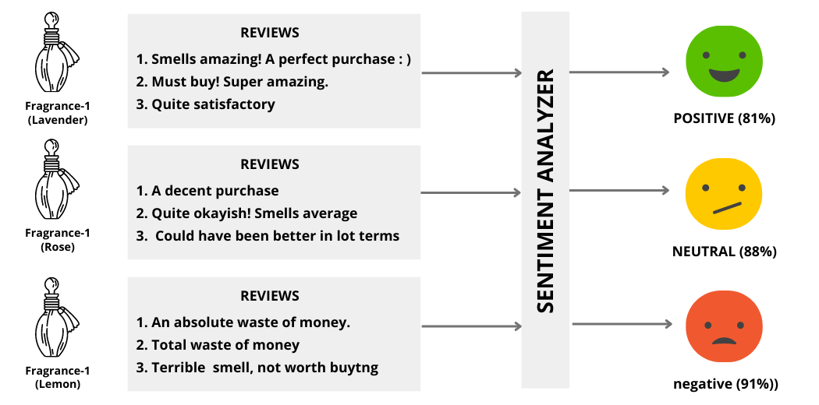From these results, we can clearly see that:

**Fragrance-1 (Lavender)** has highly **positive**reviews by the customers which indicates your company can **escalate its prices** given its popularity.

**Fragrance-2 (Rose)**happens to have a **neutral**outlook amongst the customer which means your company**should not change its pricing**.

**Fragrance-3 (Lemon)**has an overall **negative**sentiment associated with it — thus, your company should **consider offering a discount** on it to balance the scales.

This was just a simple example of how sentiment analysis can help you gain insights into your products/services and help your organization make decisions.