BUSINESS STRATEGY & INVESTMENT REPORT
PrepMate AI
AI-Powered Mock Interview Coach for Engineering Students
Prepared by: AI Co-Founder & Growth Strategy Desk
Market: India | Source: Day 23 Customer & MVP Blueprint | June 2026
VERDICT: VALIDATE

Table of Contents
- Startup Summary
- Executive Summary
- 1. Business Reality Check
- 2. Business Strategy Report
- 3. Investment Scorecard
- 4. Visual Dashboard
- 5. Founder Action Sheet
- Sustainability Verdict

Startup Summary
Source of truth: the Day 23 Customer & MVP Blueprint (PrepMate AI). Summary and assumptions below are extracted directly from that document.

Startup in 8 Bullets
- PrepMate AI is an AI-powered mock interview coach for engineering students preparing for campus placements in India.
- It simulates real technical + HR/behavioral interview rounds and gives instant, structured feedback.
- Target customer: final-year/pre-final B.Tech/B.E. (CSE/IT/ECE) students at Tier-2/Tier-3 colleges, mobile-first, price-sensitive.
- Core problem solved: students get plenty of DSA/coding practice (LeetCode, GFG) but almost no realistic, honest interview-performance practice.
- MVP scope: one AI-led technical round + one HR round, feedback report, and a basic progress tracker, delivered as mobile-web.
- Monetization: Free trial → Placement Pass (Rs. 299/month) → Drive Sprint (Rs. 499/30 days), timed to placement season urgency.
- GTM motion: campus seeding → free trial → deadline-driven upsell → peer referral via WhatsApp.
- Current status: no direct customer validation yet — concept and persona are well-defined, but unproven with real users or payments.

Extracted Assumptions
Dimension | Assumption Extracted from Blueprint
Customer | Final-year/pre-final engineering students, Tier-2/3 colleges, India, mobile-first, low discretionary budget
MVP | 1 technical round + 1 HR round + feedback report + progress tracker; mobile-web, no native app
Value Proposition | Realistic, judgment-free, repeatable interview practice with instant structured feedback — fills the gap between DSA prep and the real interview
Pricing | Freemium: free trial, then Rs. 299/month or Rs. 499/30-day "Drive Sprint"
Revenue Model | Subscription/season-pass hybrid, expected to spike around placement drive windows
GTM | Campus-first distribution via placement cells/coding clubs, social content, and peer referral

Executive Summary
PrepMate AI targets a real and specific pain point — engineering students have abundant coding practice tools but almost no realistic rehearsal for the live interview itself. The persona, journey, and MVP scope are sharply defined, which is a genuine strength most early-stage ideas lack. However, the business has not yet cleared the most important bar: real customers paying real money. Revenue depends on converting free-trial users into a Rs. 299–499 paid tier during a narrow, seasonal window, and the venture's distribution plan currently leans on a single channel family (campus + WhatsApp referral) that is unproven at scale. The moat is thin: nothing here is structurally hard for a well-funded competitor (or the student's own college placement cell) to replicate once the rubric and content exist. The recommended next move is not to keep building — it is to run a tightly scoped 100-user pilot, charge real money during it, and use that evidence to decide whether to scale, pivot the pricing/channel, or stop.

1. Business Reality Check

Who Pays?
The student themselves, in most cases — this is a B2C, self-funded purchase by a 20–21 year-old with thin discretionary income. There is a secondary, unvalidated possibility: college training & placement (T&P) cells or ed-tech partners paying on behalf of a cohort, which would be a materially different (and potentially more durable) revenue path.

Why Do They Pay?
Not for content (DSA questions are free everywhere) — they pay to reduce a specific fear: freezing up or under-performing in a live interview after months of solo prep. The willingness to pay is concentrated in a short pre-placement window, driven by urgency rather than steady-state desire.

How Will They Discover the Product?
Primarily through campus-level seeding (coding clubs, T&P cells), then peer-to-peer spread inside WhatsApp/Telegram batch groups, supplemented by placement-prep content on Instagram/LinkedIn. There is no evidence yet that any of these channels convert at a meaningful, repeatable rate.

Biggest Growth Risks
- Single-channel dependency: campus + WhatsApp referral is unproven and hard to control or scale predictably
- Demand is seasonal and bursty — most of the year there is little organic reason to use or discuss the product
- No flywheel yet: referral is assumed, not engineered or incentivized beyond a vague "1 free week"

Biggest Monetization Risks
- Price point (Rs. 299–499) is a guess, not validated against actual willingness to pay
- Free alternatives (YouTube mocks, college T&P sessions) directly compete for the same need at zero cost
- Revenue is concentrated in a short seasonal window, creating lumpy, hard-to-forecast cash flow

Weakest Assumptions to Validate First
Assumption | Why It's Risky | How to Validate
Students will pay Rs. 299–499 for this | No pricing test has been run; budgets are thin | Charge real money in the pilot, not a survey
AI feedback will be trusted over free human alternatives | Trust is the core value prop and is unproven | Compare completion + satisfaction vs. a peer-mock control group
WhatsApp referral will drive meaningful growth | Assumed, not engineered or incentivized concretely | Track actual referral rate during the pilot, not intent

2. Business Strategy Report

Business Model Canvas
Block | Detail
Customer Segments | Final-year/pre-final B.Tech/B.E. students at Tier-2/3 colleges in India
Value Proposition | Realistic, repeatable, judgment-free AI mock interviews with instant structured feedback
Channels | Campus seeding, T&P cells, Instagram/LinkedIn placement content, WhatsApp referral
Customer Relationships | Self-serve app + automated feedback; no human touch in MVP
Revenue Streams | Freemium → Rs. 299/month Placement Pass; Rs. 499/30-day Drive Sprint
Key Resources | AI interview/feedback engine, question + rubric library, campus relationships
Key Activities | Model/rubric refinement, content updates, campus partnerships, retention nudges
Key Partners | Campus coding clubs, T&P officers, possibly LLM/API provider
Cost Structure | LLM/API inference costs, campus acquisition cost, founder/dev time

Revenue & Pricing Strategy
Tier | Price | Strategic Role
Free Trial | Rs. 0 | Acquisition hook; must convert to paid within 14 days or it is pure cost
Placement Pass | Rs. 299/month | Core recurring revenue for students with 2-3+ months of runway before drives
Drive Sprint | Rs. 499/30 days | Deadline-driven upsell capturing urgency-based spend
Risk: both paid tiers assume the same thin student budget that the free alternatives are also competing for. A T&P-cell or institutional B2B2C pricing model (one license covering a batch) should be tested in parallel as a hedge against weak individual willingness to pay.

Go-To-Market Strategy
- Phase 1 (Weeks 1-2): Seed 2 pilot colleges directly through coding clubs and T&P cells
- Phase 2 (Week 3): Expand inside existing batch WhatsApp/Telegram groups via free trial posts
- Phase 3 (Week 4+): Convert via deadline-driven Drive Sprint offers tied to an actual announced placement date
- Ongoing: structured referral mechanic (not just goodwill) to compound acquisition without paid ads

Customer Acquisition Strategy
Channel | Role | Risk Level
Campus partnerships (T&P/clubs) | Primary seeding channel; high trust, low cost | Medium — relationship-dependent, not scalable fast
WhatsApp/Telegram peer referral | Organic spread inside existing student networks | High — currently unengineered, just assumed
Instagram/LinkedIn content | Top-of-funnel awareness, placement-prep content | Medium — crowded space, hard to stand out

First 100 Users Plan
Phase | Target | Action
Week 1-2 | 0 → 30 users | Direct outreach to 2 college coding clubs + T&P cell, manual onboarding
Week 3 | 30 → 70 users | Free trial posts seeded into student WhatsApp/Telegram groups
Week 4 | 70 → 100+ users | Referral incentive (1 free week per successful invite) + Drive Sprint launch

Competitive Position & Moat
Competitor Type | Their Edge | PrepMate's Position
LeetCode / GeeksforGeeks | Massive free question banks, brand trust | Owns the adjacent "performance practice" layer they don't address
Human coaching (InterviewBit, Pesto) | Real human nuance and credibility | Cheaper, 24/7 available, judgment-free — but lacks human depth
College T&P cells (free) | Zero cost, institutional trust | More repeatable and available, but must out-trust a free incumbent
Honest assessment: the current moat is weak. The only defensible assets are an accumulating feedback rubric (data advantage) and exclusive campus relationships — neither is hard to replicate quickly by a funded competitor.

Reverse SWOT Analysis
Quadrant | Reframed Insight
Strength → Hidden Weakness | Sharp, narrow persona focus is a strength now, but caps total addressable market and makes the business fully seasonal
Weakness → Hidden Strength | No human mentors (seen as a gap) keeps costs near-zero and lets the product scale to thousands of students per founder-hour
Opportunity → Hidden Threat | Placement-season urgency drives conversion, but the same urgency means most colleges already have a free, "good enough" T&P response
Threat → Hidden Opportunity | Free competitors (YouTube, T&P) lack structured tracking — a credible progress/score history could become the real differentiator over time

Investor One-Liner
"PrepMate AI gives every engineering student the realistic, judgment-free interview practice that only the top-ranked students currently get from seniors and coaching — on demand, for the price of a pizza."

30-Second Founder Pitch
"Every year, millions of Indian engineering students study hard for placements but still freeze up in the actual interview — because there's nowhere realistic to practice it. PrepMate AI is an AI interviewer that runs students through real technical and HR rounds and gives instant, specific feedback, so they walk into the real interview having already done it ten times. We're starting with two college pilots this month, charging a small placement-season fee, and using that data to prove students will pay for practice, not just content."

3. Investment Scorecard
Dimension | Score /100 | Reasoning
Business Viability | 58 | Clear problem and persona, but unit economics and pricing are still unproven assumptions
Revenue Potential | 52 | Real willingness-to-pay signal is untested; revenue is concentrated in a short seasonal window
GTM Strength | 62 | Campus-first motion is logical and low-cost, but depends on relationships and an unengineered referral loop
Competitive Strength | 45 | Differentiated positioning vs. DSA tools, but thin moat against funded competitors or free T&P alternatives
Investor Readiness | 38 | No customer or revenue evidence yet — too early for outside capital; pilot data is the missing prerequisite
Overall average: 51/100 — a fundable idea once it has pilot evidence, not before.

4. Visual Dashboard
The infographic below consolidates the business model, revenue streams, GTM flow, first-100-users plan, competitive moat, key risks, scorecards, and final verdict in a single view.
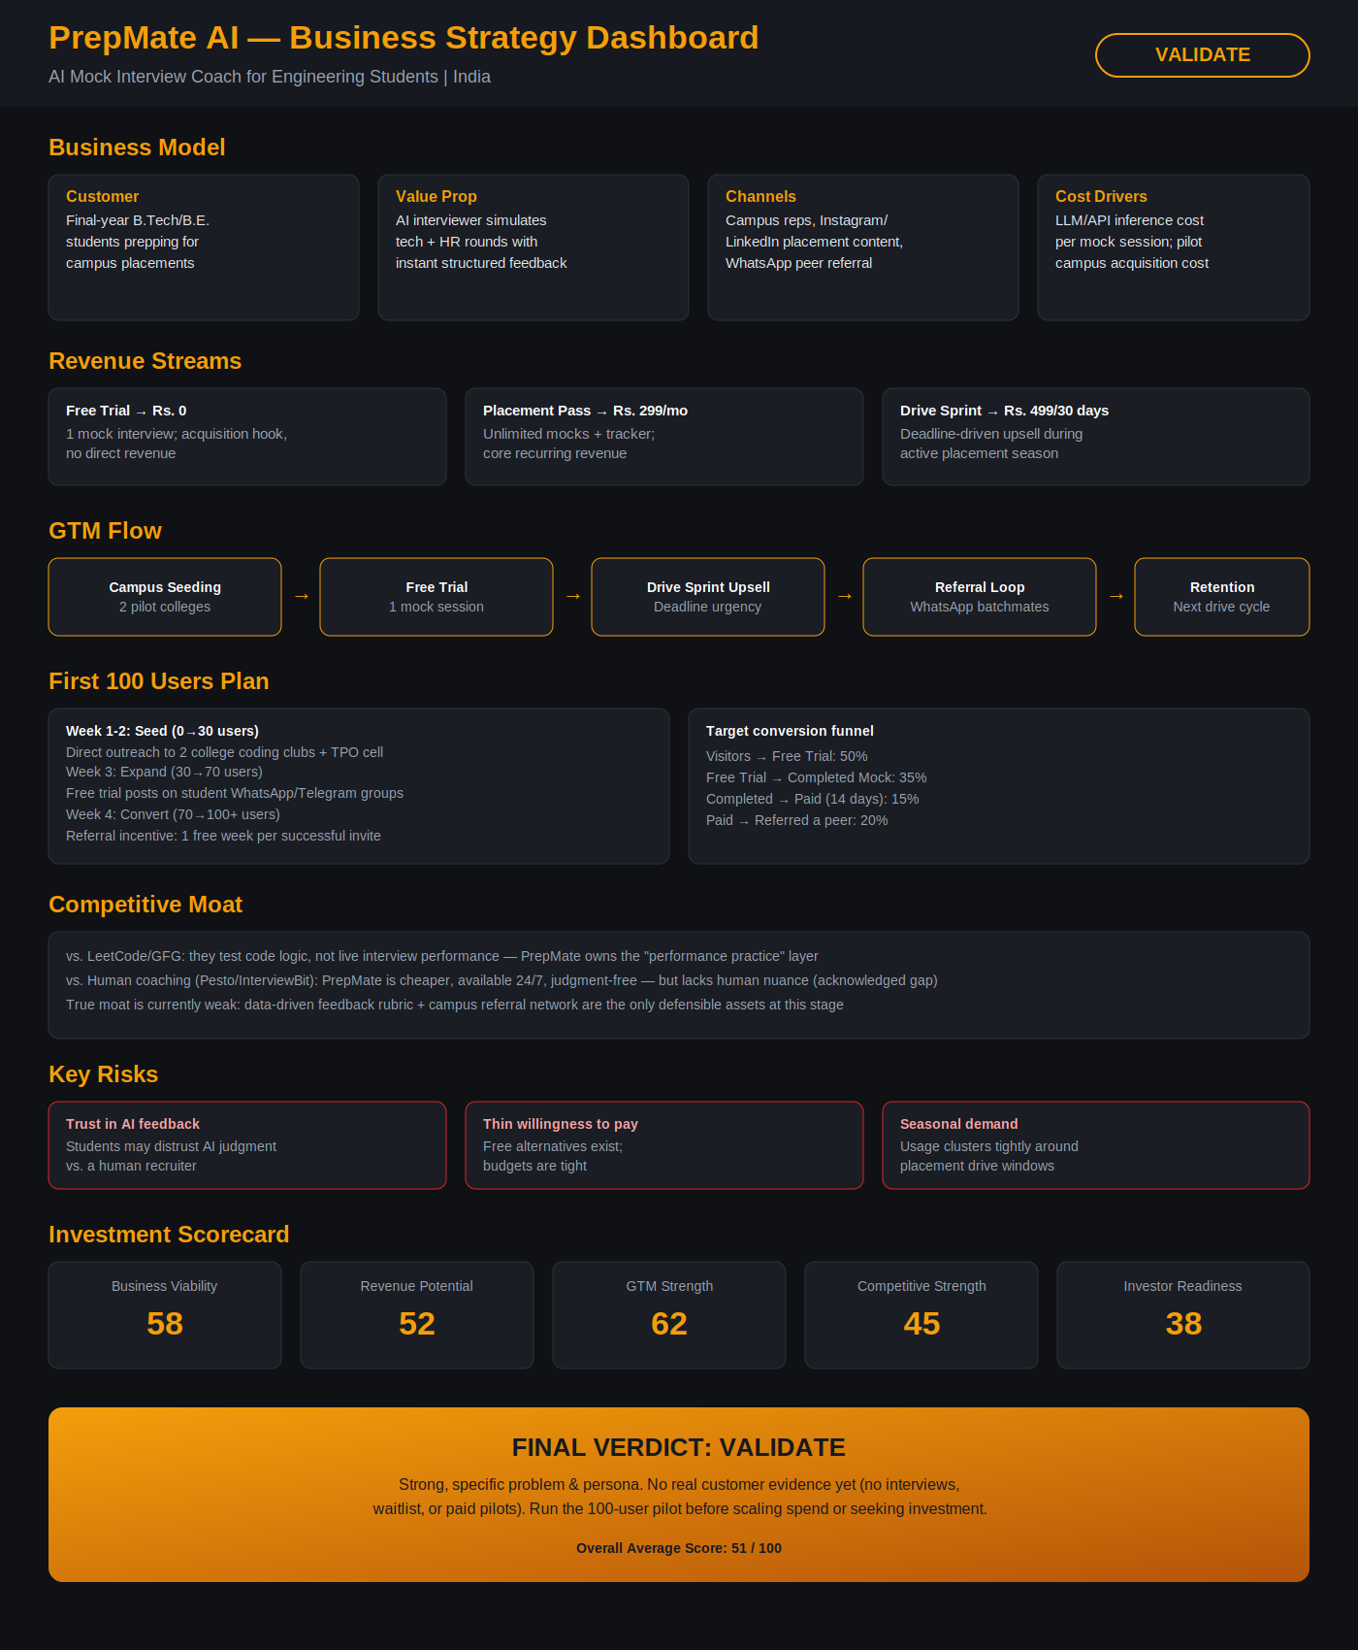

5. Founder Action Sheet — Top 10 Actions
- Run the 2-college pilot and charge real money (even a token Rs. 99) — do not give it away free
- Track hard numbers: trial completion rate, paid conversion rate, and referral rate — not satisfaction surveys alone
- Test a B2B2C / institutional pricing angle (per-batch T&P license) in parallel with the individual price
- Engineer the referral mechanic explicitly (in-app prompt + tracked incentive) instead of relying on organic sharing
- Validate AI feedback trust by benchmarking it against 2-3 real recruiters' judgments on the same answers
- Map a second acquisition channel beyond campus + WhatsApp before assuming GTM is solved
- Define a concrete plan for off-season retention/revenue, since demand is currently fully seasonal
- Write and publish a clear data-privacy policy covering recorded voice/answers before wider rollout
- Set a hard go/no-go threshold (e.g., 15% paid conversion) before investing in any paid acquisition
- Only after pilot evidence exists, build the investor narrative around real numbers, not projected ones

Sustainability Verdict
🟡 VALIDATE
PrepMate AI addresses a real, specific problem with a clear MVP and persona, but it is not yet a proven business — it has no direct evidence that students will pay, refer others, or use it beyond a single seasonal window. The path forward is a tightly measured, money-collecting pilot with two colleges, not further feature-building or outside fundraising. If that pilot shows real conversion and referral, the venture is worth scaling; if it doesn't, the pricing or channel — not the core idea — should pivot first.

