**User Manual**



**Introduction**

The Aquaselect is designed to help the internal and external sales teams configure and select the appropriate pump package based on customer requirements. This tool facilitates the preparation and modification of pump package costing and allows for quick report generation. Additionally, it enables users to retrieve any saved project costing along with its versions. This manual provides step-by-step instructions for navigating the platform and utilizing its features efficiently. Aquaselect is integrated with the FJ portal, with access restricted to Aquaflo division colleagues.

**Table of Contents**

1. Logging In
2. Navigating the Dashboard
3. Creating a New Pump Package
4. Selecting Pump Specifications
5. Customizing the Package
6. Adding a project revision
7. Generating and Exporting Reports

**1. Logging In**

* Open your web browser and **Login** to FJ Portal
* Navigate to Aquaflo page.

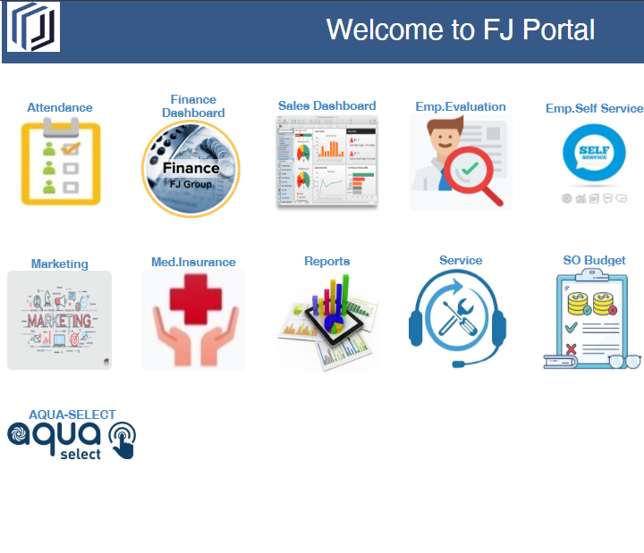

**2. Navigating the Dashboard**

* 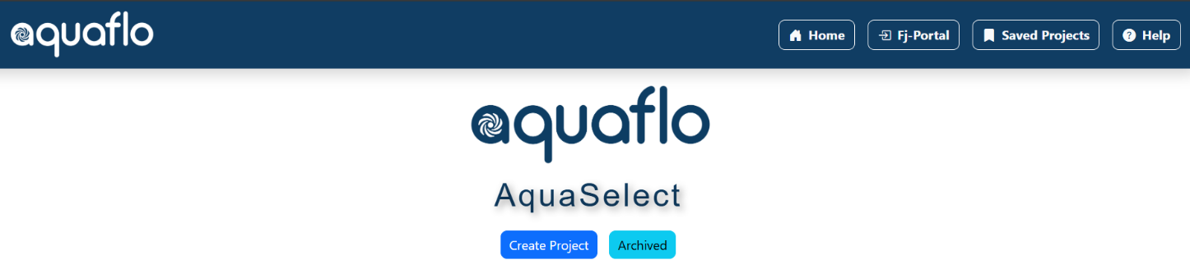The homepage displays available pump selection options.
* Use the navigation menu to access different modules:
  + **New Project**: Start a new project.
  + **Saved Projects /Archived**: View previously saved configurations.
  + **FJ portal**: return to fj portal.
  + **Help:** Help how to Use Aqua-Flow Application

**3. Creating a New Project**

* 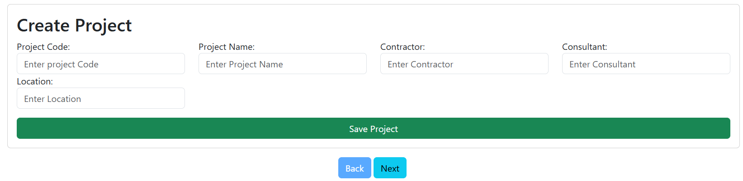Click **Create Project** on the dashboard.
* Enter customer details (e.g., name, project, location).
* Search for the project code or project name and select the right one. Other details will be automatically fetched from Orion database.
* Save Project before proceeding further. Make sure that you received a popup message as follows:

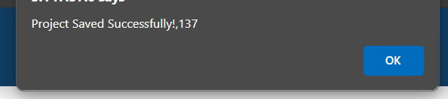

* A code with revision number will be generated corresponding to the saved project.

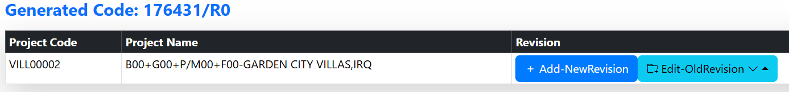

* 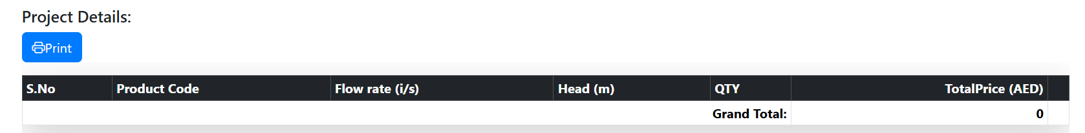A summary of selection will be available as a table:
* Navigate to package selection page by clicking on Next button.

**4. Selecting Pump Packages**

* Enter flow rate and head for reference.
* Choose pump series, size and model.
* 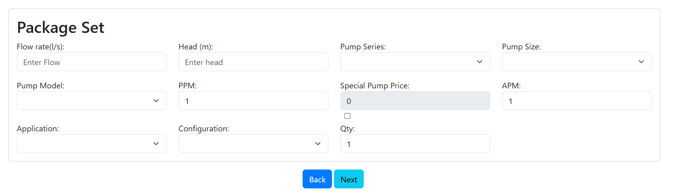PPM: Pump price multiplier provided by Xylem.
* If have a special discounted price form Xylem, Enter that price in the Special Pump Price field. This can be enabled by clicking on the check button.

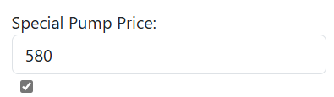

* APP: Assembly price multiplier provided by Aquaflo engineering team.
* Select the application, configuration and required quantity for the current selection.
* Navigate to add-on selection page by clicking on Next button.

**5. Customizing the Package**

* Configure optional mechanical add-ons based on customer needs.

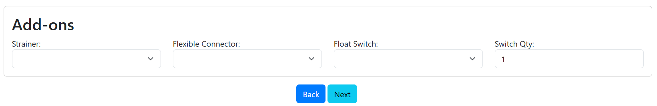

* Navigate to pressure vessel selection by clicking next

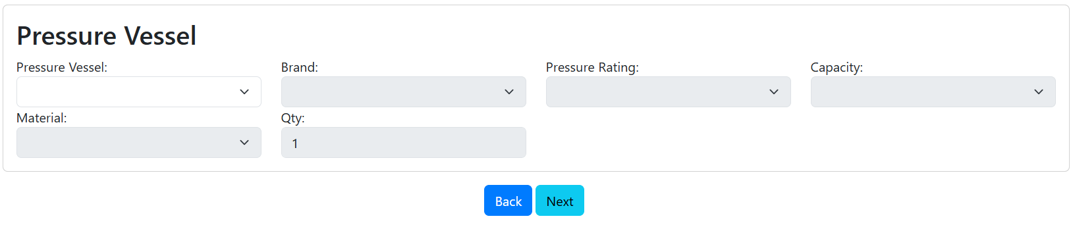If pressure vessel is required, select Yes. Then select the details and click next. If not required, select No and procced to Next

* 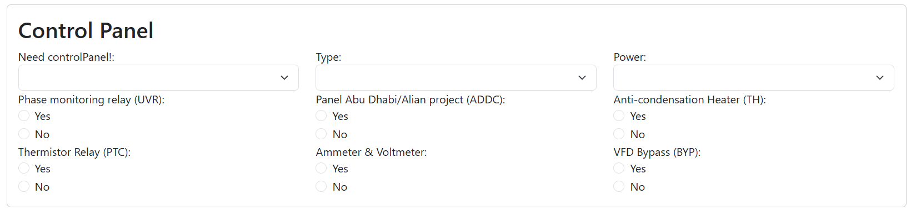Select Yes if control panel is required and select the required adders.
* Then click add to project. Now the configured package set will be added to the project and will be listed in the table.

**6. Adding a project revision**

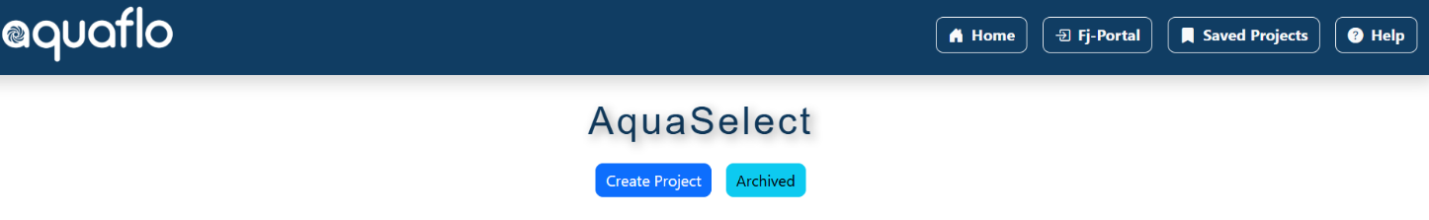

* Click Archived or Saved projects.
* 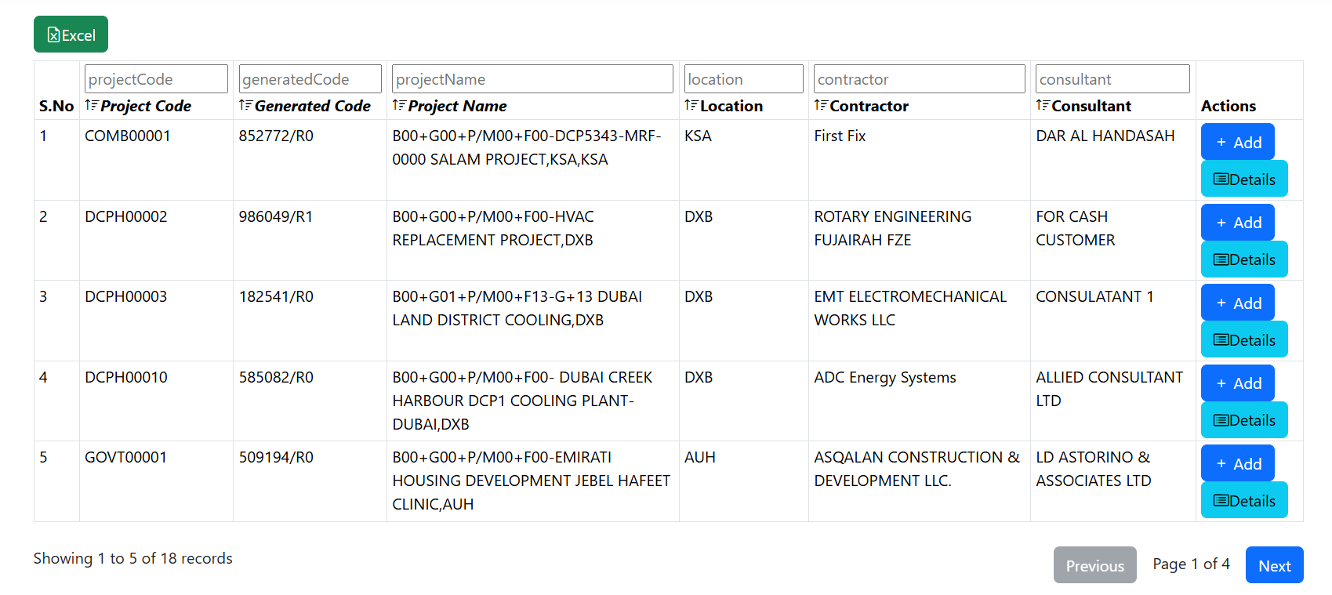Select the project and click add button.
* 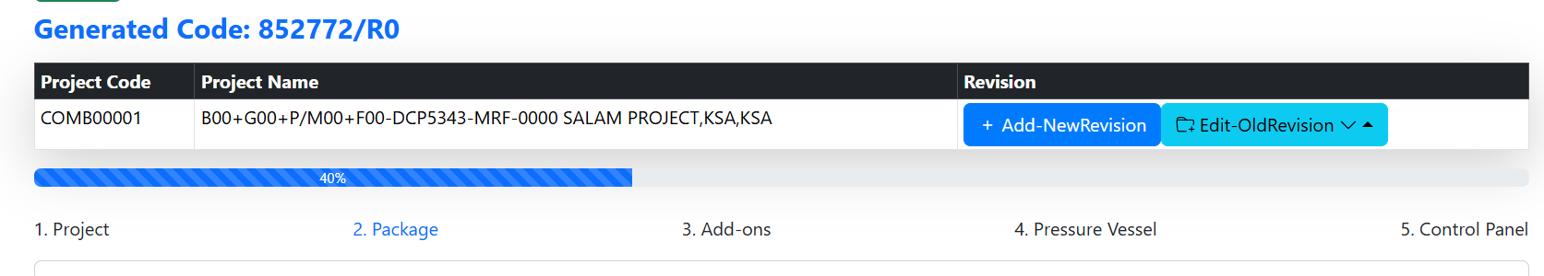Click Add New Revision. This will duplicate the complete project with a new revision code (######/R#). Add or update the selections and save it.
* Also, old revisions can be opened by clicking Edit-Old Revisions

**7. Generating and Exporting Reports**

* Click on **Excel** to generate a summary of the selected package.
* Click Print button to save the file as PDF or to print.