HVOC

LAB FILE

BACHELOR OF TECHNOLOGY

(Computer Science and Engineering)

SEMESTER-6



Department of Computer Science & Engineering

AMITY SCHOOL OF ENGINEERING AND TECHNOLOGY AMITY UNIVERSITY UTTAR PRADESH  
NOIDA, (U.P.), INDIA

SUBMITTED TO-   
Ankit shukla

SUBMITTED BY-

aryan123

(A12405218064)

CONTENT

|  |  |  |  |  |  |  |
| --- | --- | --- | --- | --- | --- | --- |
| Program No. | Name of Programs | Date of allotment of exp. | Date of evaluation | Max. Marks | Marks obtained | Signature of Faculty |
| 1 | Insertion sort | 2021-01-21 |  | 1 |  |  |
| 2 | Bubble sort | 2021-01-21 |  | 1 |  |  |
| 3 | Selection sort | 2021-01-21 |  | 1 |  |  |
| 4 | Binary search tree and display | 2021-01-21 |  | 1 |  |  |
| 5 | Stack | 2021-01-21 |  | 1 |  |  |
| 6 | Queue | 2021-01-21 |  | 1 |  |  |
| 7 | Linklist(left to right ) | 2021-01-21 |  | 1 |  |  |
| 8 | Linklist using stack (right to left ) | 2021-01-21 |  | 1 |  |  |
| 9 | Linklist using queue( L->R) | 2021-01-21 |  | 1 |  |  |
| 10 | count the number of times an items in a linked list | 2021-01-21 |  | 1 |  |  |
| 11 | doubly Linklist | 2021-01-21 |  | 1 |  |  |
| 12 | binary search | 2021-01-21 |  | 1 |  |  |

**Experiment -1**

Aim: Insertion sort

Code: #include<iostream.h>
  
#include<conio.h>
  
#include<stdio.h>
  
void main()
  
{
  
 int temp,n,a[10];
  
 clrscr();
  
 printf("enter the size of array ");
  
 scanf("%d",&n);
  
 printf("start\t");
  
 for(int i=0;i<n;i++)
  
 { scanf("%d",&a[i]); }
  
 for(i=1;i<n;i++)
  
 { temp=a[i];
  
 for(int j=i-1;j>=0 && temp<a[j] ; j--)
  
 { a[j+1]=a[j];
  
 a[j]=temp; }
  
 }
  
 printf("array is\n ");
  
 for(i=0;i<n;i++)
  
 { printf("%d",a[i]);
  
 printf("\n"); }
  
 getch();
  
}

Output:

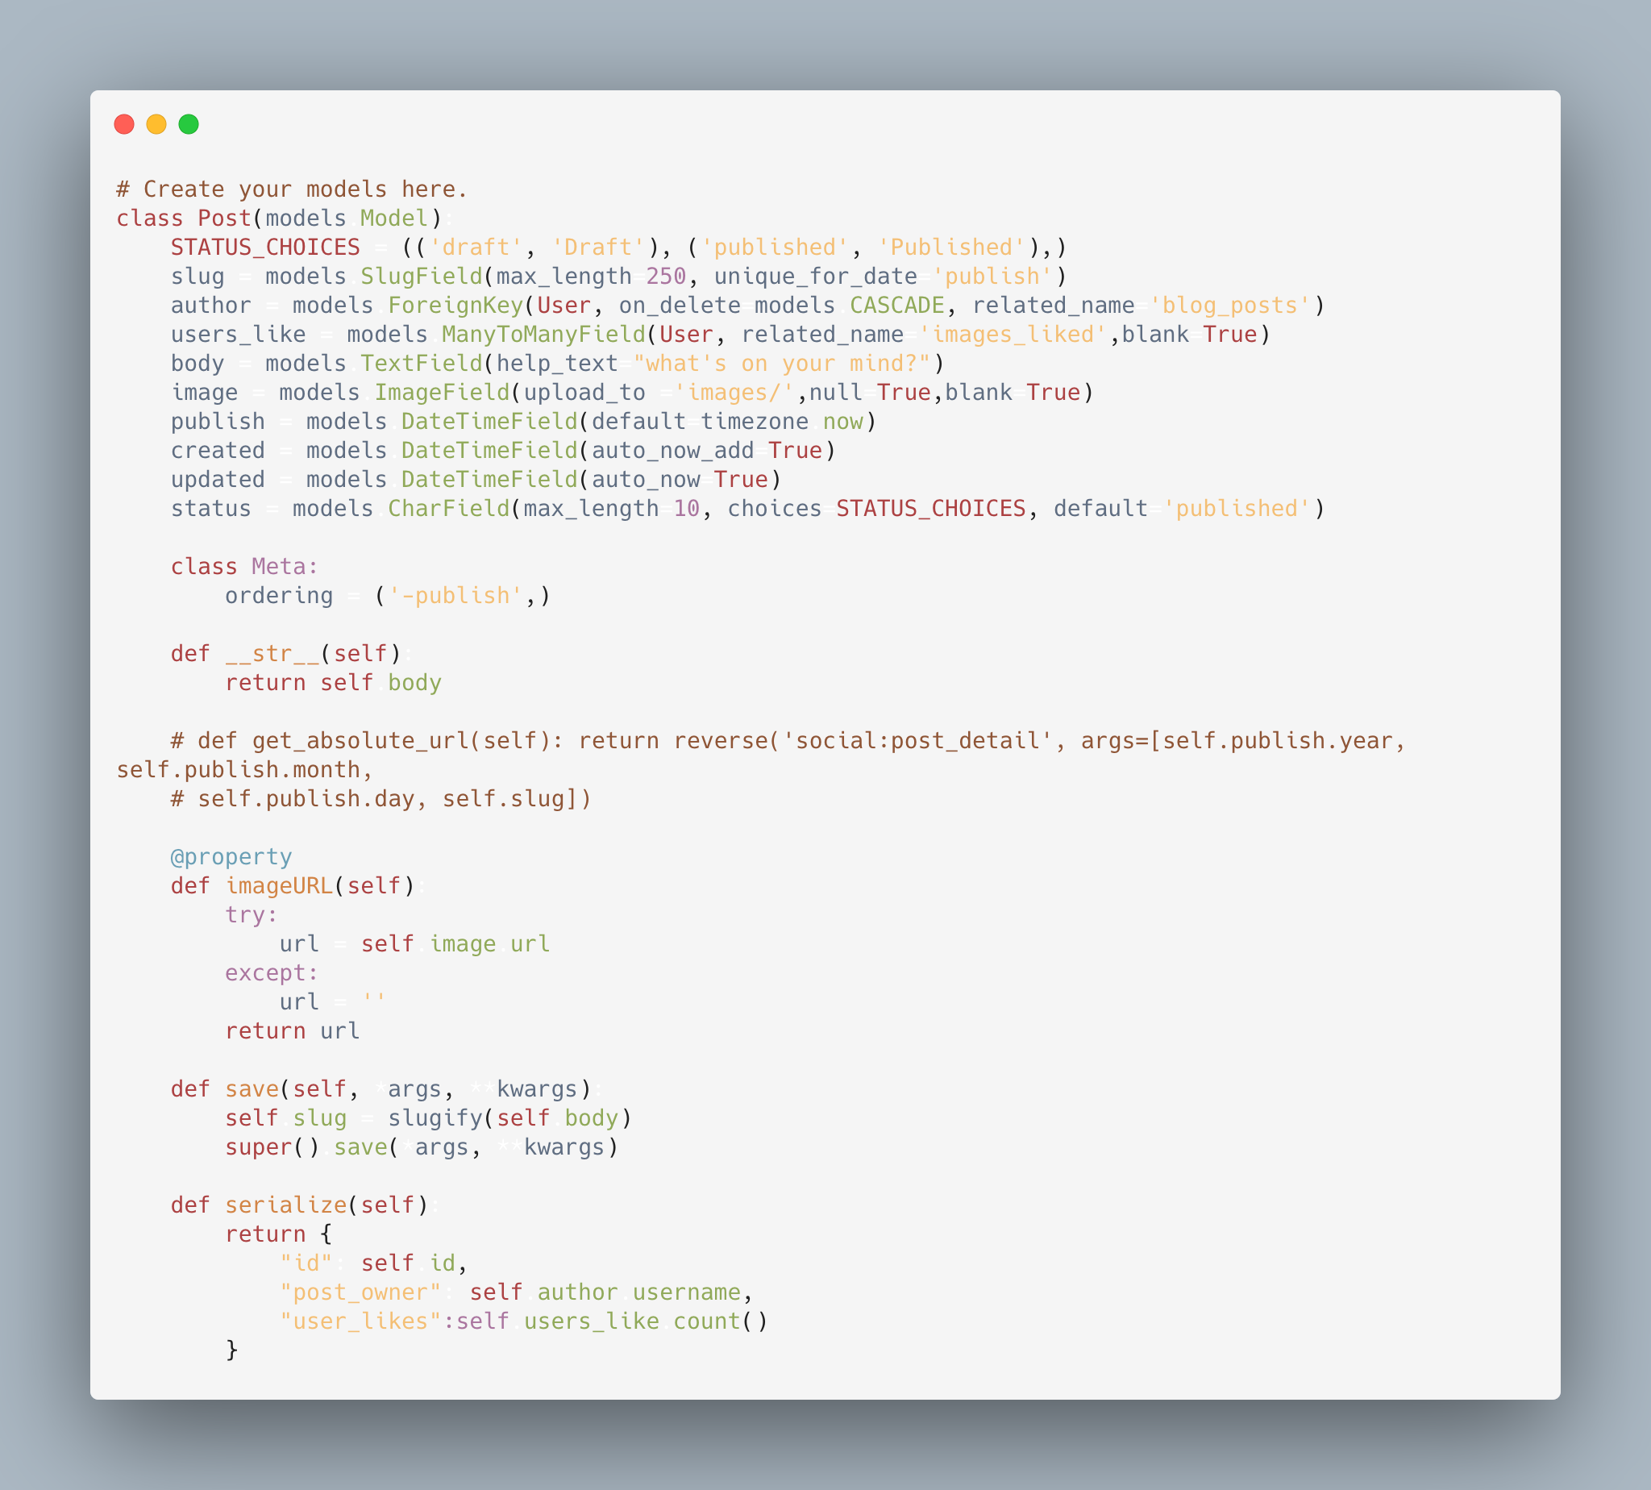

|  |  |  |  |
| --- | --- | --- | --- |
| **Internal Assessment (Mandatory Experiment) Sheet for Lab Experiment Department of Computer Science & Engineering Amity University, Noida (UP)** | | | |
| Programme | B.Tech-CSE | Course Name | HVOC lab |
| Course Code | CSE304 | Semester | 6 th |
| Student Name | aryan123 | Enrolment No. | A12405218064 |
| **Marking Criteria** | | | |
| **Criteria** | **Total Marks** | **Marks Obtained** | **Comments** |
| Concept (A) | 2 |  |  |
| Implementation (B) | 2 |  |  |
| Performance (C) | 2 |  |  |
| Total | 6 |  |  |

**Experiment -2**

Aim: Bubble sort

Code: #include<iostream>
  
using namespace std;
  
  
void display(int *A,int a)
  
{
  
 for(int i=0;i<a;i++)
  
 {
  
 cout<<*(A+i)<<" ";
  
 }
  
}
  
  
int main()
  
{
  
 int A[7]={13,24,5,19,2,17,4};
  
 int temp;
  
 for(int i=0;i<6;i++)
  
 {
  
 for(int j=0;j<6-i;j++)
  
 {
  
 if(A[j]>A[j+1])
  
 {
  
 temp=A[j];
  
 A[j]=A[j+1];
  
 A[j+1]=temp;
  
 }
  
 cout<<j<<" "<<"\n";
  
 }
  
 cout<<"\n";
  
 cout<<"Iteration "<<i<<" ";
  
 display(A,7);
  
 }
  
 return 0;
  
}

Output:

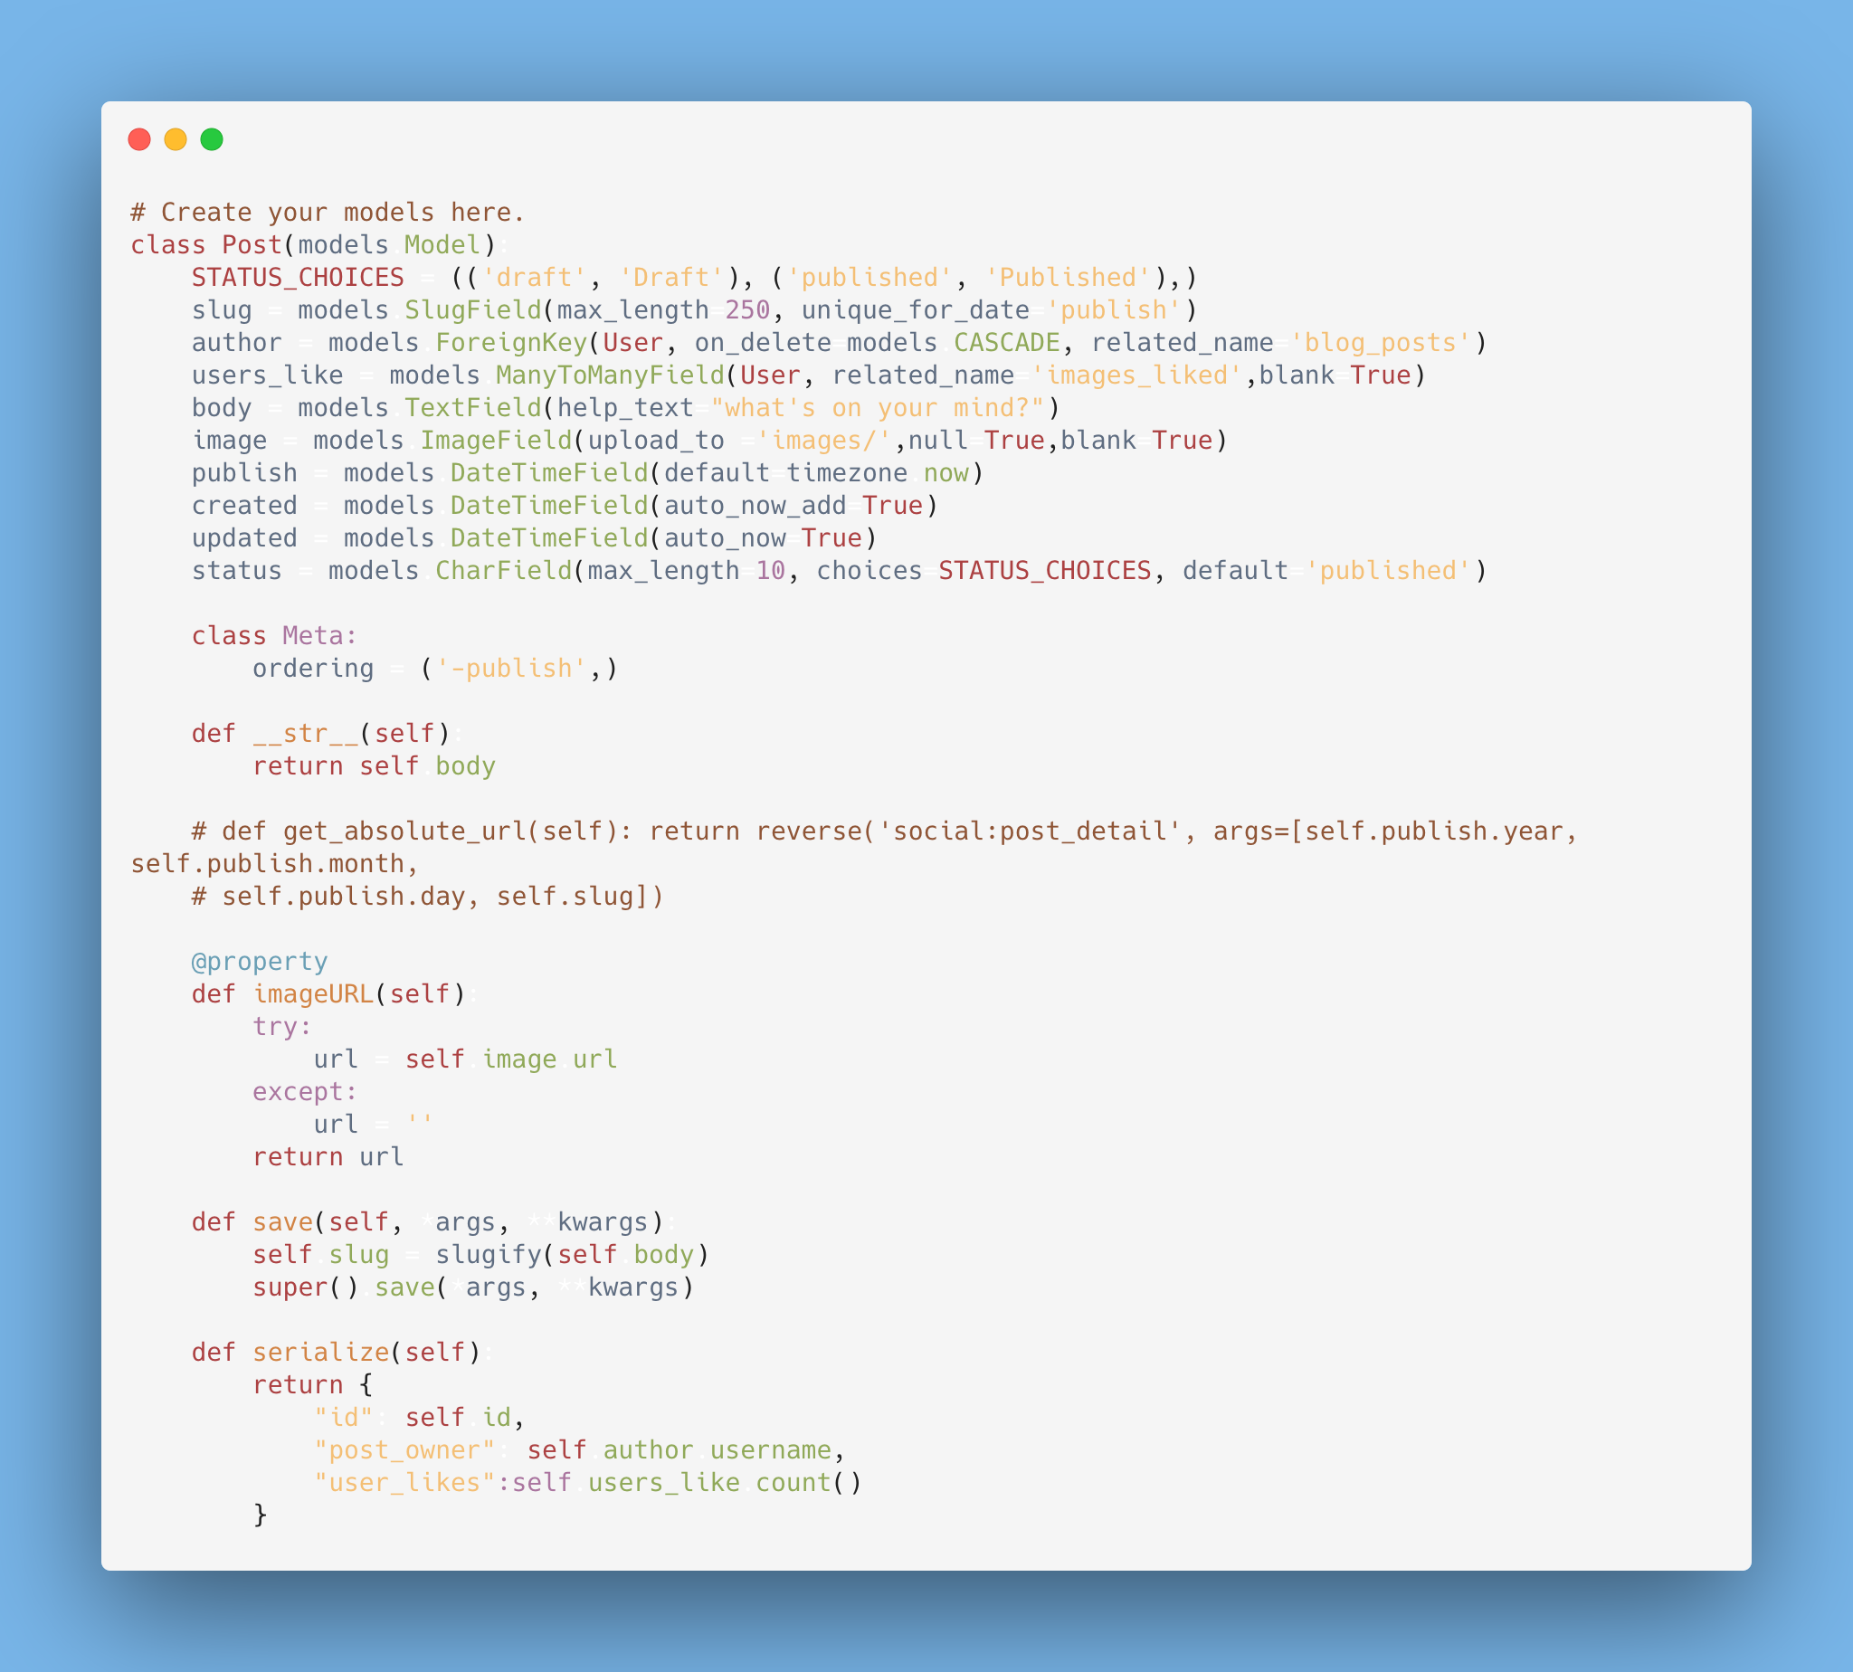

|  |  |  |  |
| --- | --- | --- | --- |
| **Internal Assessment (Mandatory Experiment) Sheet for Lab Experiment Department of Computer Science & Engineering Amity University, Noida (UP)** | | | |
| Programme | B.Tech-CSE | Course Name | HVOC lab |
| Course Code | CSE304 | Semester | 6 th |
| Student Name | aryan123 | Enrolment No. | A12405218064 |
| **Marking Criteria** | | | |
| **Criteria** | **Total Marks** | **Marks Obtained** | **Comments** |
| Concept (A) | 2 |  |  |
| Implementation (B) | 2 |  |  |
| Performance (C) | 2 |  |  |
| Total | 6 |  |  |

**Experiment -3**

Aim: Selection sort

Code: #include<conio.h>
  
#include<stdio.h>
  
void main()
  
{
  
 int temp,n,a[10],pos;
  
 clrscr();
  
 printf("enter the size of array ");
  
 scanf("%d",&n);
  
 printf("start\t");
  
 for(int i=0;i<n;i++)
  
 { scanf("%d",&a[i]); }
  
 for(i=0;i<n-1;i++)
  
 {
  
 int small;
  
 small=a[i];
  
 for(int j=i;j<n-1;j++)
  
 {
  
 if(small>a[j+1])
  
 { small=a[j+1];
  
 pos=j+1; }
  
 }
  
 if(small<a[i])
  
 {
  
 temp=a[i];
  
 a[i]=a[pos];
  
 a[pos]=temp;
  
 } }
  
 printf("array is\n ");
  
 for(i=0;i<n;i++)
  
 { printf("%d",a[i]);
  
 printf("\n"); }
  
 getch();
  
}

Output:

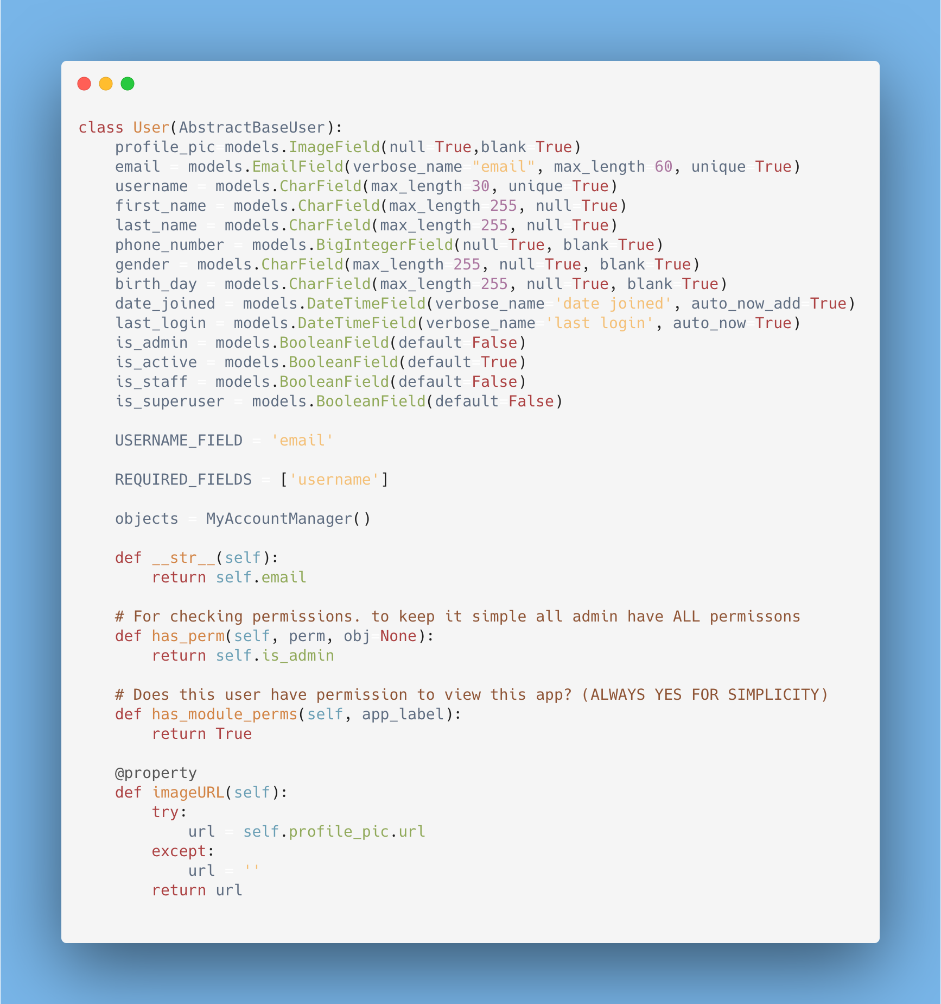

|  |  |  |  |
| --- | --- | --- | --- |
| **Internal Assessment (Mandatory Experiment) Sheet for Lab Experiment Department of Computer Science & Engineering Amity University, Noida (UP)** | | | |
| Programme | B.Tech-CSE | Course Name | HVOC lab |
| Course Code | CSE304 | Semester | 6 th |
| Student Name | aryan123 | Enrolment No. | A12405218064 |
| **Marking Criteria** | | | |
| **Criteria** | **Total Marks** | **Marks Obtained** | **Comments** |
| Concept (A) | 2 |  |  |
| Implementation (B) | 2 |  |  |
| Performance (C) | 2 |  |  |
| Total | 6 |  |  |

**Experiment -4**

Aim: Binary search tree and display

Code: #include<stdio.h>
  
#include<conio.h>
  
#include<stdlib.h>
  
struct node
  
{
  
 int info;
  
 node *left;
  
 node *right;
  
}*root=NULL,*newnode,*temp,*ptr;
  
void insert(int n)
  
{
  
 newnode=(node*)malloc(sizeof(node));
  
 newnode->info=n;
  
 newnode->left=NULL;
  
 newnode->right=NULL;
  
 if(root==NULL)
  
 {
  
  
 root=newnode;
  
 temp=newnode;
  
 }
  
 else
  
 {
  
 temp=root;
  
 node *q;
  
 while(temp!=NULL)
  
 {
  
 q=temp;
  
 if(temp->info>n)
  
 temp=temp->left;
  
 else
  
 temp=temp->right;
  
 if(temp==NULL)
  
 {
  
 if(q->info>n)
  
 q->left=newnode;
  
 else
  
 q->right=newnode;
  
 }
  
 }
  
 }
  
}
  
  
void inorder(node *r)
  
{
  
 if(r)
  
 {
  
 inorder(r->left);
  
 printf("%d ",r->info);
  
 inorder(r->right);
  
 }
  
 }
  
 void preorder(node *r)
  
 {
  
 if(r)
  
 {
  
 printf("%d ",r->info);
  
 preorder(r->left);
  
 preorder(r->right);
  
 }
  
 }
  
 void postorder(node *r)
  
 {
  
 if(r)
  
 {
  
 postorder(r->left);
  
 postorder(r->right);
  
 printf("%d ",r->info);
  
 }
  
 }
  
void main()
  
{
  
 clrscr();
  
 insert(15);
  
 insert(10);
  
 insert(50);
  
 insert(5);
  
 insert(20);
  
 insert(55);
  
 printf("inorder\n");
  
 inorder(root);
  
 printf("\npreorder\n");
  
 preorder(root);
  
 printf("\npostorder\n");
  
 postorder(root);
  
 getch();
  
}

Output:

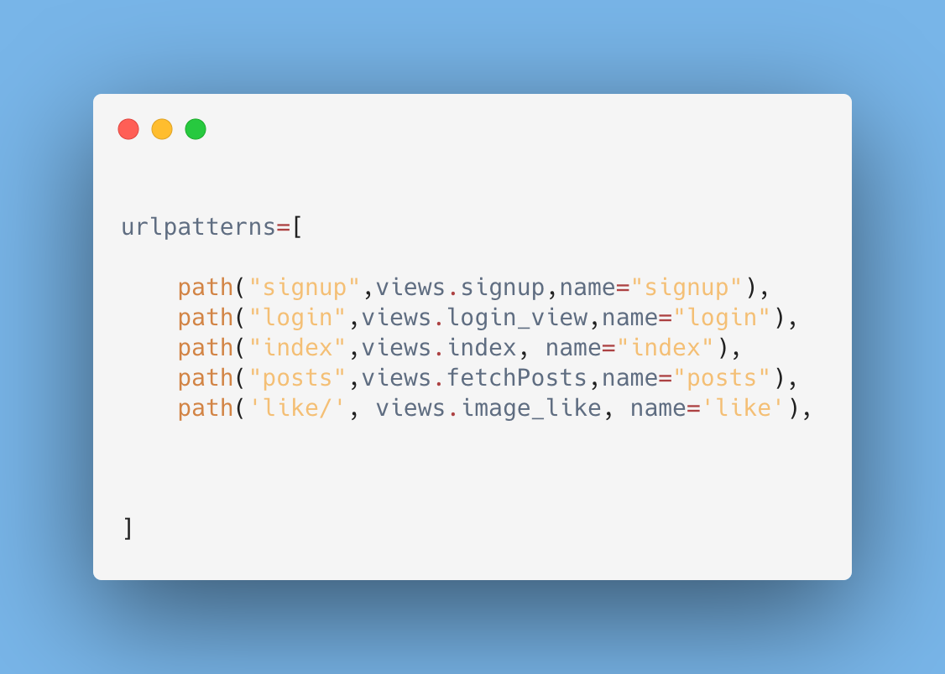

|  |  |  |  |
| --- | --- | --- | --- |
| **Internal Assessment (Mandatory Experiment) Sheet for Lab Experiment Department of Computer Science & Engineering Amity University, Noida (UP)** | | | |
| Programme | B.Tech-CSE | Course Name | HVOC lab |
| Course Code | CSE304 | Semester | 6 th |
| Student Name | aryan123 | Enrolment No. | A12405218064 |
| **Marking Criteria** | | | |
| **Criteria** | **Total Marks** | **Marks Obtained** | **Comments** |
| Concept (A) | 2 |  |  |
| Implementation (B) | 2 |  |  |
| Performance (C) | 2 |  |  |
| Total | 6 |  |  |

**Experiment -5**

Aim: Stack

Code: #include<stdio.h>
  
#include<conio.h>
  
const int MAX=2;
  
int a[MAX],top=-1;
  
void push(int n)
  
{
  
 if(top==MAX-1)
  
 printf("\noverflow\n");
  
 else
  
 a[++top]=n;
  
}
  
void pop()
  
{
  
 if(top==-1)
  
 printf("\nunderflow\n");
  
 else
  
 top--;
  
}
  
void display()
  
{
  
 int x;
  
 x=top;
  
 for(int i=0;i<x+1;i++)
  
 { printf("\n%d",a[i]);
  
 }
  
}
  
void main()
  
{
  
 push(34);
  
 push(56);
  
 pop();
  
 display();
  
 getch();
  
}

Output:

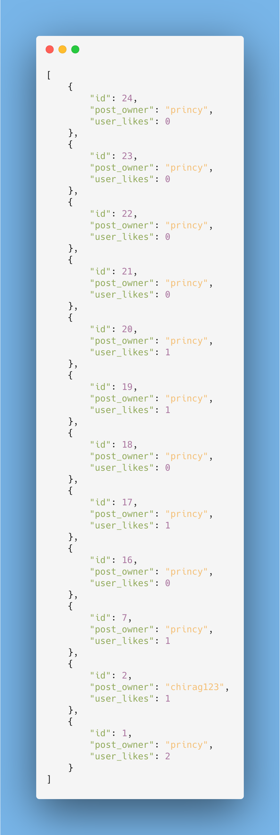

|  |  |  |  |
| --- | --- | --- | --- |
| **Internal Assessment (Mandatory Experiment) Sheet for Lab Experiment Department of Computer Science & Engineering Amity University, Noida (UP)** | | | |
| Programme | B.Tech-CSE | Course Name | HVOC lab |
| Course Code | CSE304 | Semester | 6 th |
| Student Name | aryan123 | Enrolment No. | A12405218064 |
| **Marking Criteria** | | | |
| **Criteria** | **Total Marks** | **Marks Obtained** | **Comments** |
| Concept (A) | 2 |  |  |
| Implementation (B) | 2 |  |  |
| Performance (C) | 2 |  |  |
| Total | 6 |  |  |

**Experiment -6**

Aim: Queue

Code: #include<stdio.h>
  
#include<conio.h>
  
#include<stdlib.h>
  
const int MAX=5;
  
int rear=-1,front=-1;
  
int a[MAX];
  
void push(int n)
  
{
  
 if(rear==MAX-1)
  
 { printf("\noverflow\n");
  
 }
  
 else if(front==-1)
  
 { front++; }
  
 a[++rear]=n;
  
}
  
void pop()
  
{
  
 if(front==-1)
  
 printf("\nunderflow\n");
  
 else if(front>rear)
  
 printf("\nCan't");
  
 else
  
 front++;
  
}
  
void display()
  
{
  
 for(int i=front;i<=rear;i++)
  
 { printf("%d ",a[i]); }
  
}
  
void main()
  
{
  
clrscr();
  
 push(10);
  
 push(15);
  
 push(45);
  
 display();
  
 pop();
  
 push(22);
  
 push(45);
  
 display();
  
 push(68);
  
 getch();
  
}

Output:

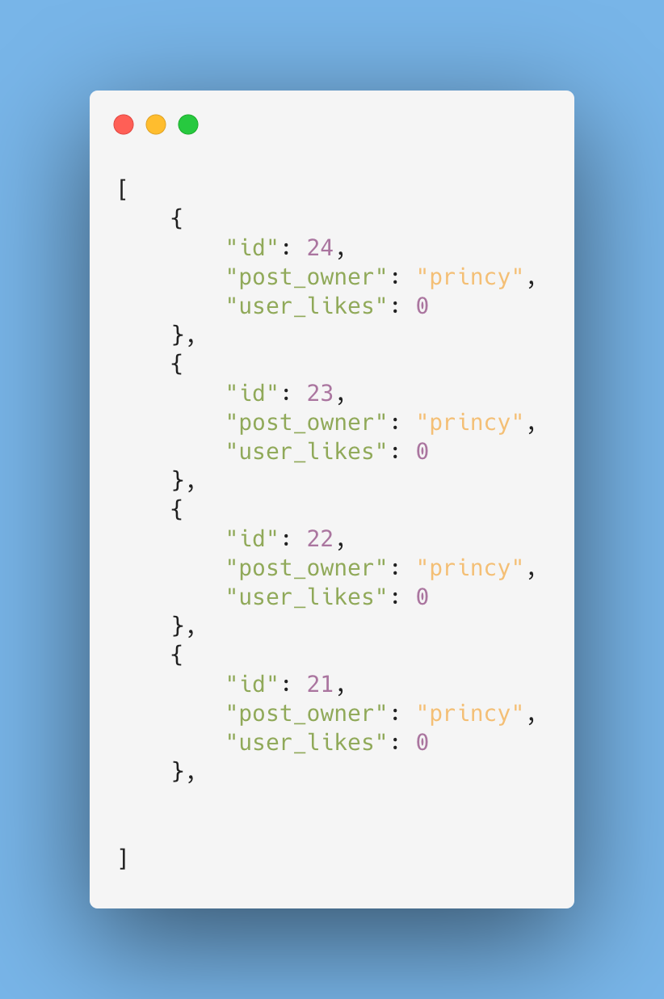

|  |  |  |  |
| --- | --- | --- | --- |
| **Internal Assessment (Mandatory Experiment) Sheet for Lab Experiment Department of Computer Science & Engineering Amity University, Noida (UP)** | | | |
| Programme | B.Tech-CSE | Course Name | HVOC lab |
| Course Code | CSE304 | Semester | 6 th |
| Student Name | aryan123 | Enrolment No. | A12405218064 |
| **Marking Criteria** | | | |
| **Criteria** | **Total Marks** | **Marks Obtained** | **Comments** |
| Concept (A) | 2 |  |  |
| Implementation (B) | 2 |  |  |
| Performance (C) | 2 |  |  |
| Total | 6 |  |  |

**Experiment -7**

Aim: Linklist(left to right )

Code: #include<stdio.h>
  
#include<conio.h>
  
#include<stdlib.h>
  
struct node
  
{
  
 int info;
  
 node *next;
  
}*start=NULL,*newnode,*temp;
  
void insert()
  
{
  
 for(int i=0;i<5;i++)
  
 {
  
 newnode=(node*)malloc(sizeof(node));
  
 printf("\nenter the element ");
  
 scanf("%d",&newnode->info);
  
 newnode->next=NULL;
  
 if(start==NULL)
  
 {
  
 start=newnode;
  
 temp=newnode;
  
 }
  
 else
  
 {
  
 temp->next=newnode;
  
 temp=newnode;
  
 }
  
 }
  
}
  
void display()
  
{
  
 node *root=start;
  
 while(root!=NULL)
  
 {
  
 printf("%d->",root->info);
  
 root=root->next;
  
 }
  
}
  
void del()
  
{
  
 int n;
  
 printf("\nenter the element you want to delete");
  
 scanf("%d",&n);
  
 if(start==NULL)
  
 {
  
 printf("\nempty");
  
 }
  
 else
  
 {
  
 if(n==start->info)
  
 {
  
 start=start->next;
  
 }
  
 else
  
 {
  
 node *ptr=start;
  
 node *p;
  
 while(ptr!=NULL)
  
 {
  
 p=ptr;
  
 ptr=ptr->next;
  
 if(ptr->info==n)
  
 {
  
 p->next=ptr->next;
  
 free(ptr);
  
 break;
  
 }
  
 }
  
 }

Output:

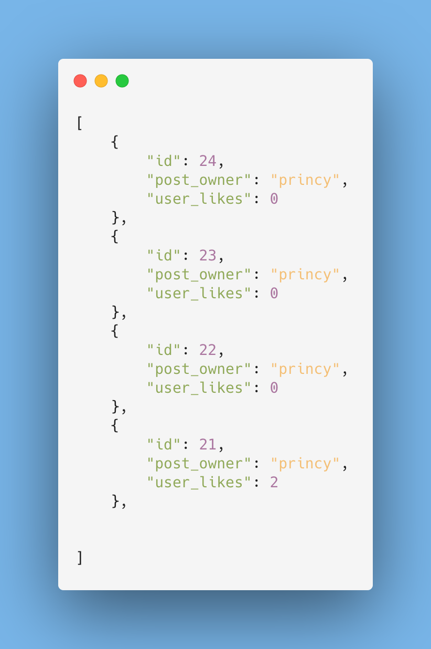

|  |  |  |  |
| --- | --- | --- | --- |
| **Internal Assessment (Mandatory Experiment) Sheet for Lab Experiment Department of Computer Science & Engineering Amity University, Noida (UP)** | | | |
| Programme | B.Tech-CSE | Course Name | HVOC lab |
| Course Code | CSE304 | Semester | 6 th |
| Student Name | aryan123 | Enrolment No. | A12405218064 |
| **Marking Criteria** | | | |
| **Criteria** | **Total Marks** | **Marks Obtained** | **Comments** |
| Concept (A) | 2 |  |  |
| Implementation (B) | 2 |  |  |
| Performance (C) | 2 |  |  |
| Total | 6 |  |  |

**Experiment -8**

Aim: Linklist using stack (right to left )

Code: #include<stdio.h>
  
#include<conio.h>
  
#include<stdlib.h>
  
struct node{
  
 int data;
  
 node *next;
  
 }*newnode,*top=NULL;
  
void push()
  
{
  
 newnode=(node*)malloc(sizeof(node));
  
 printf("\n enter the element");
  
 scanf("%d",&newnode->data);
  
 newnode->next=top;
  
 top=newnode;
  
}
  
void pop()
  
{
  
If(top==NULL)
  
Printf(“underflow”);
  
 node *a;
  
 a=top;
  
 top=top->next;
  
 free(a);
  
}
  
void display()
  
{
  
node *a;
  
a=top;
  
 while(a!=NULL)
  
 {
  
 printf("%d -->",a->data);
  
 a=a->next;
  
 }
  
}
  
void main()
  
{
  
 push();
  
 push();
  
 push();
  
 push();
  
 display();
  
 pop();
  
 display();
  
 getch();
  
}

Output:

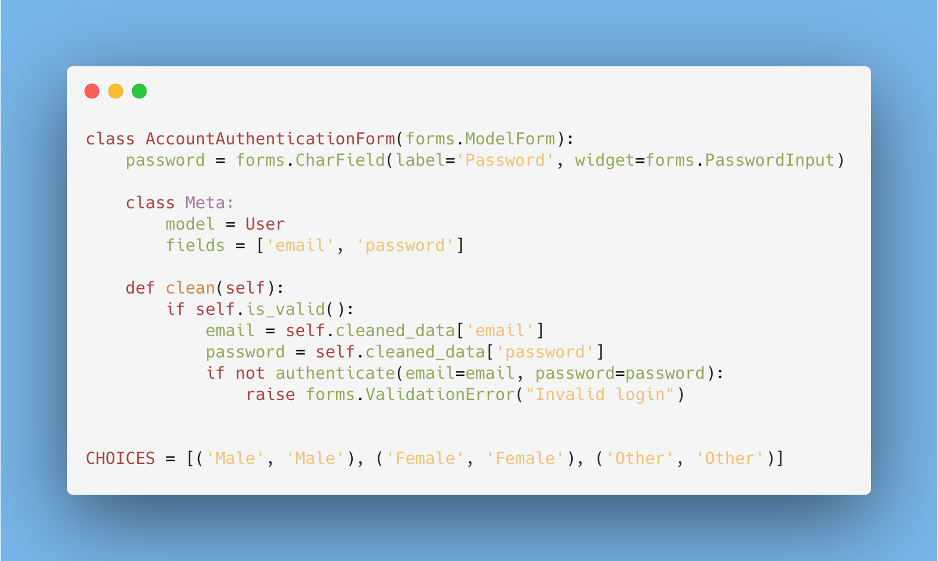

|  |  |  |  |
| --- | --- | --- | --- |
| **Internal Assessment (Mandatory Experiment) Sheet for Lab Experiment Department of Computer Science & Engineering Amity University, Noida (UP)** | | | |
| Programme | B.Tech-CSE | Course Name | HVOC lab |
| Course Code | CSE304 | Semester | 6 th |
| Student Name | aryan123 | Enrolment No. | A12405218064 |
| **Marking Criteria** | | | |
| **Criteria** | **Total Marks** | **Marks Obtained** | **Comments** |
| Concept (A) | 2 |  |  |
| Implementation (B) | 2 |  |  |
| Performance (C) | 2 |  |  |
| Total | 6 |  |  |

**Experiment -9**

Aim: Linklist using queue( L->R)

Code: #include<stdio.h>
  
#include<conio.h>
  
#include<stdlib.h>
  
struct node
  
{
  
 int info;
  
 node *next;
  
}*rear=NULL,*newnode,*front=NULL;
  
void push()
  
{
  
 newnode=(node*)malloc(sizeof(node));
  
 printf("\nenter thee element ");
  
 scanf("%d",&newnode->info);
  
 newnode->next=NULL;
  
 if(front==NULL)
  
 {
  
 front=newnode;
  
 rear=newnode;
  
 }
  
 else
  
 {
  
 rear->next=newnode;
  
 rear=newnode;
  
 }
  
}
  
void display()
  
{
  
 node *a=front;
  
 printf("\n");
  
 while(a!=NULL)
  
 {
  
 printf("%d-->",a->info);
  
 a=a->next;
  
 }
  
}
  
void pop()
  
{
  
 if(front==rear)
  
 { rear=NULL;
  
 front=NULL;
  
 }
  
 if(front==NULL)
  
 { printf("underflow"); }
  
 node *q=front;
  
 front=front->next;
  
 free(q);
  
 }
  
void main()
  
{
  
 clrscr();
  
 push();
  
 push();
  
 push();
  
 push();
  
 display();
  
 pop();
  
 display();
  
 pop();
  
 pop();
  
 pop();
  
 display();
  
 getch();

Output:

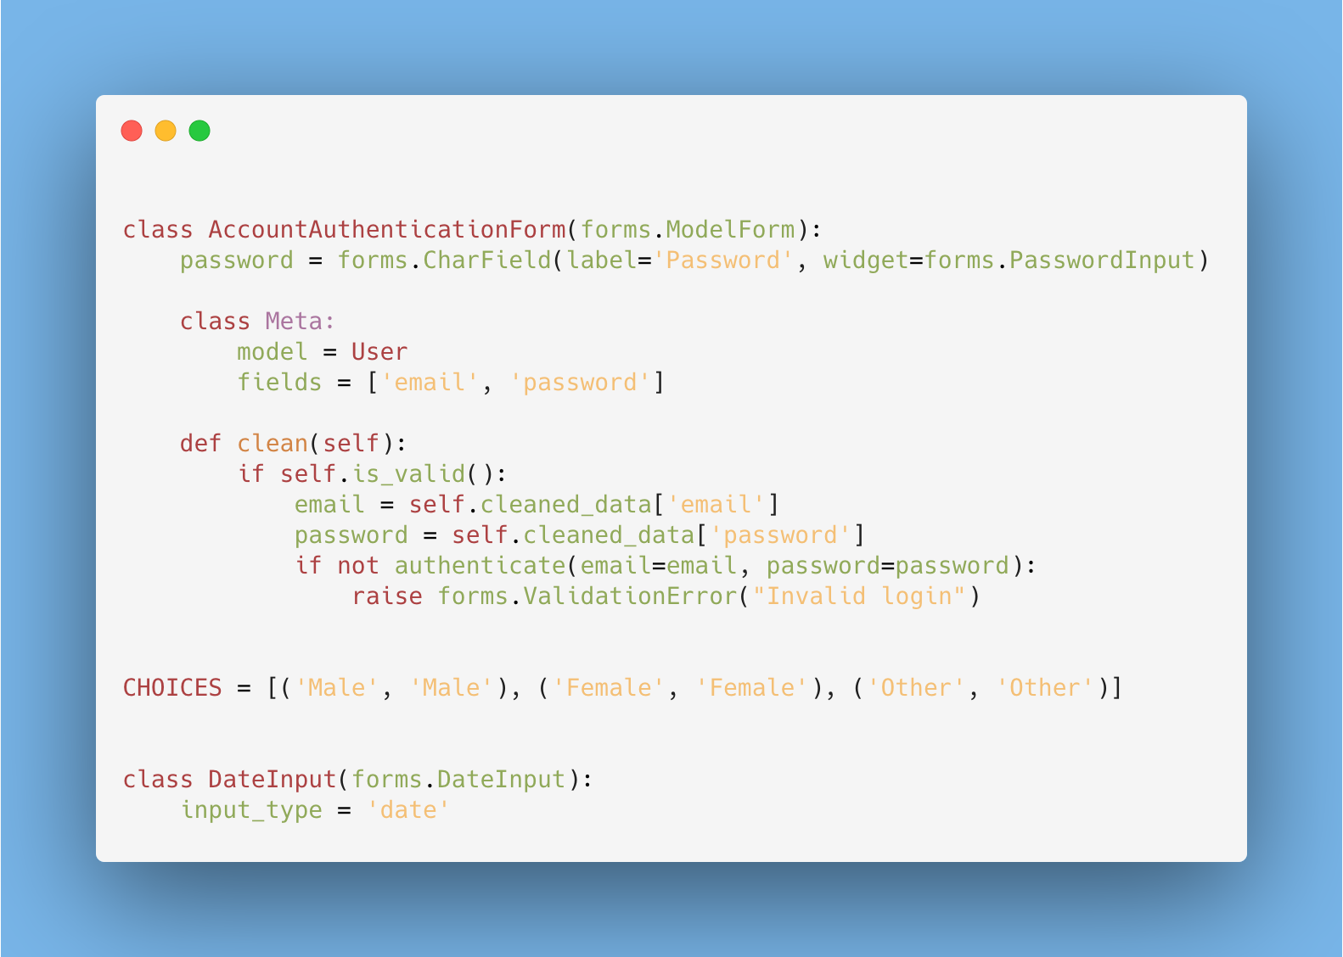

|  |  |  |  |
| --- | --- | --- | --- |
| **Internal Assessment (Mandatory Experiment) Sheet for Lab Experiment Department of Computer Science & Engineering Amity University, Noida (UP)** | | | |
| Programme | B.Tech-CSE | Course Name | HVOC lab |
| Course Code | CSE304 | Semester | 6 th |
| Student Name | aryan123 | Enrolment No. | A12405218064 |
| **Marking Criteria** | | | |
| **Criteria** | **Total Marks** | **Marks Obtained** | **Comments** |
| Concept (A) | 2 |  |  |
| Implementation (B) | 2 |  |  |
| Performance (C) | 2 |  |  |
| Total | 6 |  |  |

**Experiment -10**

Aim: count the number of times an items in a linked list

Code: #include<stdio.h>
  
#include<conio.h>
  
#include<stdlib.h>
  
struct node
  
{
  
 int info;
  
 node *next;
  
}*start=NULL,*newnode,*temp;
  
void insert()
  
{
  
 for(int i=0;i<5;i++)
  
 {
  
 newnode=(node*)malloc(sizeof(node));
  
 printf("\nenter the element ");
  
 scanf("%d",&newnode->info);
  
 newnode->next=NULL;
  
 if(start==NULL)
  
 {
  
 start=newnode;
  
 temp=newnode;
  
 }
  
 else
  
 {
  
 temp->next=newnode;
  
 temp=newnode;
  
 }
  
 }
  
}
  
void count()
  
{
  
 int a;
  
 node *root=start;
  
 a=root->info;
  
 int flag=0;
  
 while(root!=NULL)
  
 {
  
 if(root->info==a)
  
 flag++;
  
 root=root->next;
  
 }
  
 printf("%d count = %d",a,flag);
  
 }
  
void main()
  
{
  
 clrscr();
  
 insert();
  
 count();
  
 getch();
  
}

Output:

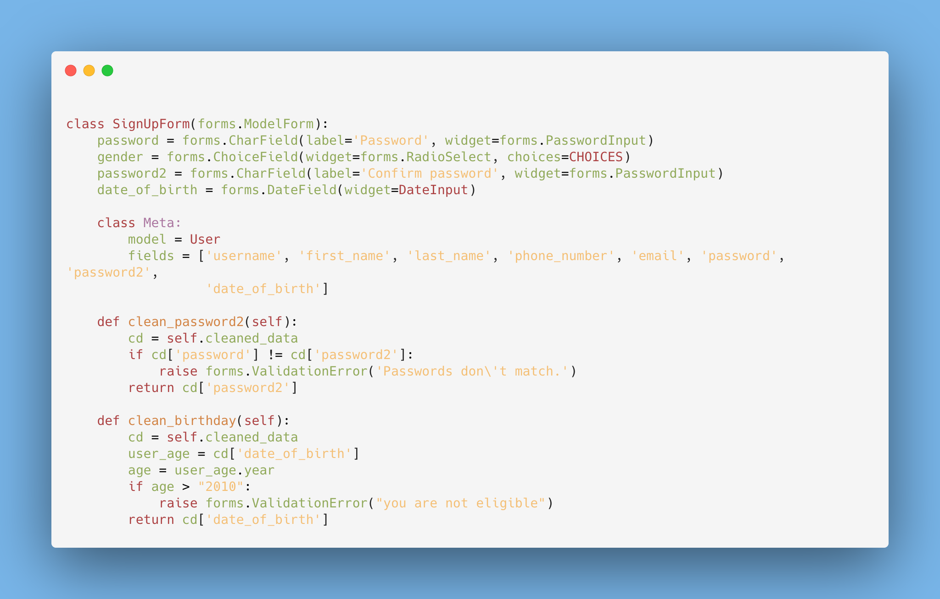

|  |  |  |  |
| --- | --- | --- | --- |
| **Internal Assessment (Mandatory Experiment) Sheet for Lab Experiment Department of Computer Science & Engineering Amity University, Noida (UP)** | | | |
| Programme | B.Tech-CSE | Course Name | HVOC lab |
| Course Code | CSE304 | Semester | 6 th |
| Student Name | aryan123 | Enrolment No. | A12405218064 |
| **Marking Criteria** | | | |
| **Criteria** | **Total Marks** | **Marks Obtained** | **Comments** |
| Concept (A) | 2 |  |  |
| Implementation (B) | 2 |  |  |
| Performance (C) | 2 |  |  |
| Total | 6 |  |  |

**Experiment -11**

Aim: doubly Linklist

Code: #include<stdio.h>
  
#include<stdlib.h>
  
struct node
  
{
  
 int data;
  
 node *lft;
  
 node *rgt;
  
}*temp,*newnode,*start=NULL;
  
void insert(int n)
  
{
  
 newnode=(node*)malloc(sizeof(node));
  
 newnode->lft=NULL;
  
 newnode->rgt=NULL;
  
 newnode->data=n;
  
 if(start==NULL)
  
 {
  
 start=newnode;
  
 temp=newnode;
  
 }
  
 else
  
 {
  
 temp->rgt=newnode;
  
 newnode->lft=temp;
  
 temp=newnode;
  
 }
  
  
}
  
void del()
  
{
  
 node *q=start;
  
 int n;
  
 printf("\nenter the number ");
  
 scanf("%d",&n);
  
 while(q!=NULL)
  
 {
  
 if( (q->data==n)&&(q->lft==NULL) )
  
 {
  
 start=q->rgt;
  
 q=NULL;
  
 }
  
 else if( (q->data==n)&&(q->rgt==NULL) )
  
 {
  
 q->lft->rgt=NULL;
  
 q=NULL;
  
 }
  
 else if(q->data==n)
  
 {
  
 q->lft->rgt=q->rgt;
  
 q->rgt->lft=q->lft;
  
 }
  
  
 q=q->rgt;
  
 }
  
  
}
  
void display()
  
{
  
 node *q=start;
  
 while(q!=NULL)
  
 {
  
 printf("%d->",q->data);
  
 q=q->rgt;
  
 }
  
}
  
main()
  
{
  
 insert(10);
  
 insert(20);
  
 insert(30);
  
 insert(40);
  
 display();
  
 del();
  
 display();
  
}

Output:

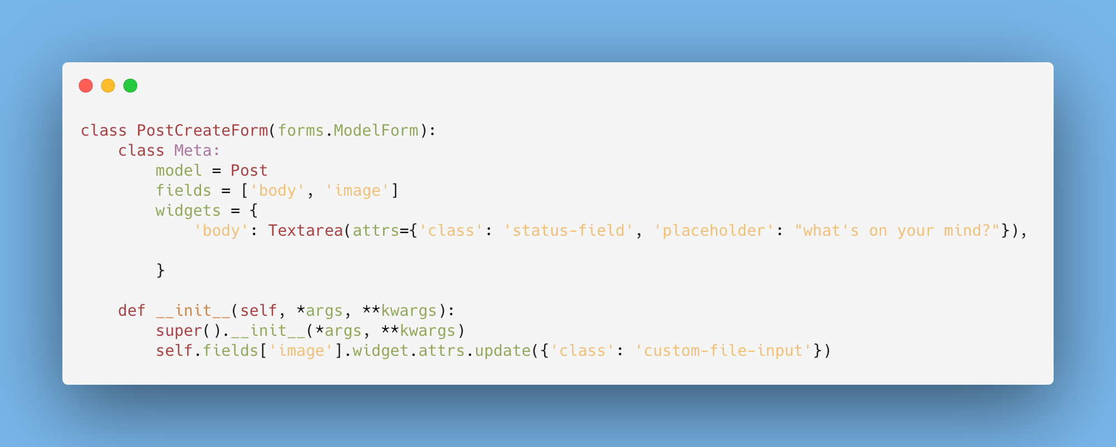

|  |  |  |  |
| --- | --- | --- | --- |
| **Internal Assessment (Mandatory Experiment) Sheet for Lab Experiment Department of Computer Science & Engineering Amity University, Noida (UP)** | | | |
| Programme | B.Tech-CSE | Course Name | HVOC lab |
| Course Code | CSE304 | Semester | 6 th |
| Student Name | aryan123 | Enrolment No. | A12405218064 |
| **Marking Criteria** | | | |
| **Criteria** | **Total Marks** | **Marks Obtained** | **Comments** |
| Concept (A) | 2 |  |  |
| Implementation (B) | 2 |  |  |
| Performance (C) | 2 |  |  |
| Total | 6 |  |  |

**Experiment -12**

Aim: binary search

Code: #include<stdio.h>
  
#include<conio.h>
  
int Bsearch(int [],int,int);
  
int main()
  
{
  
 int a[]={10,20,30,40,50,60,70};
  
 int n;
  
 printf("\n enter the element ");
  
 scanf("%d",&n);
  
 int b;
  
 b=Bsearch(a,7,n);
  
 if(b==-1)
  
 printf("\n number not found");
  
 else
  
 printf("no is found at %d",b);
  
 return 0;
  
}
  
  
  
int Bsearch(int a[],int size,int ele)
  
{
  
 int beg,lst,mid;
  
 beg=0;
  
 lst=size-1;
  
 while(beg<=lst)
  
 {
  
 mid=(beg+lst)/2;
  
 if(ele==a[mid])
  
 {
  
 printf("\n ele is found");
  
 return mid;
  
 }
  
 else if(ele>a[mid])
  
 beg=mid+1;
  
 else
  
 lst=mid-1;
  
 }
  
 return -1;
  
}

Output:

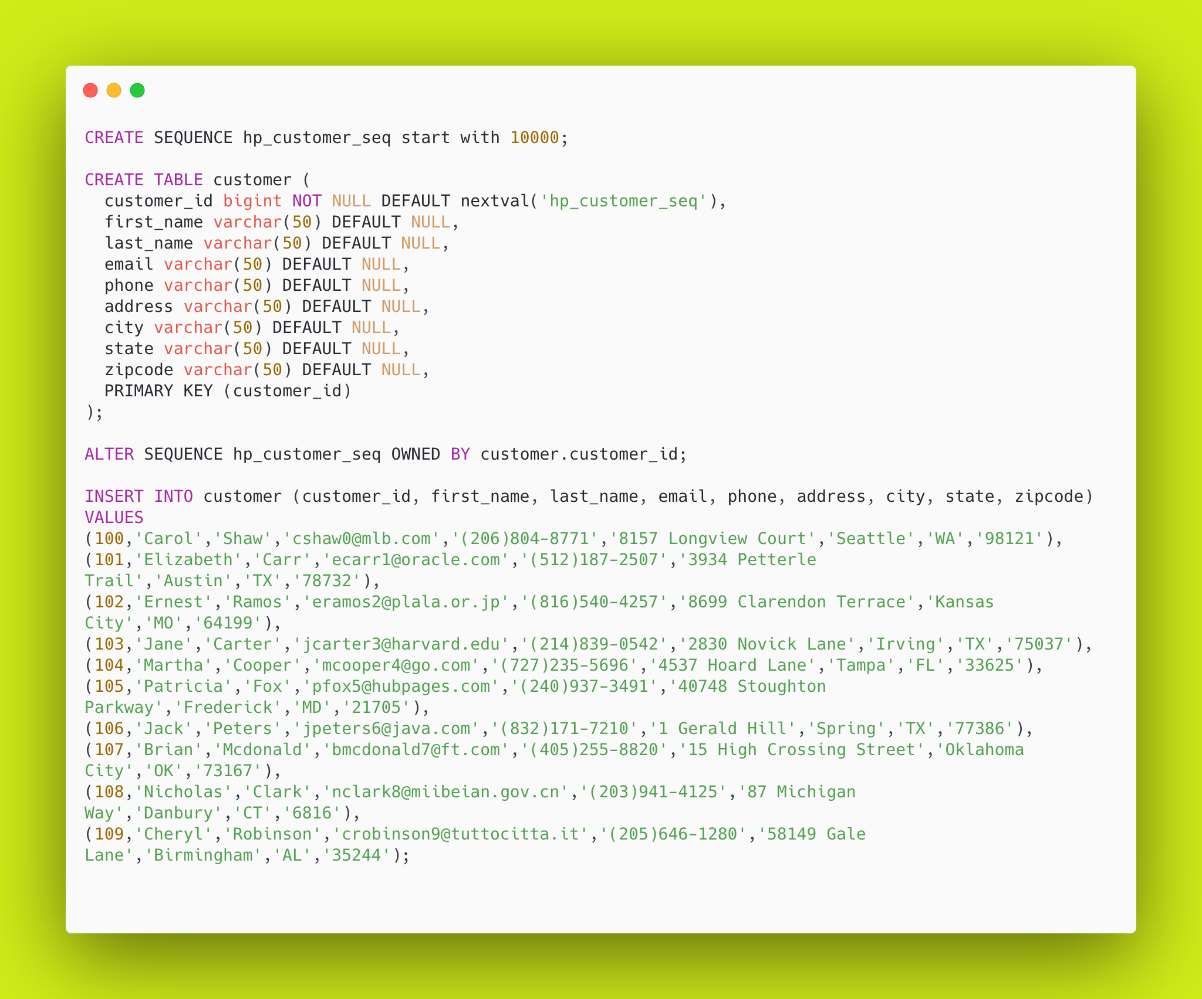

|  |  |  |  |
| --- | --- | --- | --- |
| **Internal Assessment (Mandatory Experiment) Sheet for Lab Experiment Department of Computer Science & Engineering Amity University, Noida (UP)** | | | |
| Programme | B.Tech-CSE | Course Name | HVOC lab |
| Course Code | CSE304 | Semester | 6 th |
| Student Name | aryan123 | Enrolment No. | A12405218064 |
| **Marking Criteria** | | | |
| **Criteria** | **Total Marks** | **Marks Obtained** | **Comments** |
| Concept (A) | 2 |  |  |
| Implementation (B) | 2 |  |  |
| Performance (C) | 2 |  |  |
| Total | 6 |  |  |