**Project Report**

**On**

**HOTEL Management**

**For**

**Class 12th Examination**

**[As a part of the Informatics Practices Course**

**(265)]**

**SUBMITTED BY-**

Kartik Gupta

{Roll No. }

***CERTIFICATE***

This is to certify that Kartik Gupta has successfully completed his IP project in academic year 2019-2020 on the topic “Hotel Management “ as per the rule of CBSE…

***…………………***

***Internal Teacher’s Sign***

***External Teacher’s Sign***

***Acknowledgement***

In the accomplished of this project successfully many people have best owned upon me their blessings and the heart pledged support.This time I am utilizing to thank all the people who have been concerned with project.

Primarily I would thank god for being able to complete this project with success. Then I would like to thank my IP teacher Mrs. Manmeet Kaur, whose valuable guidance has been the one that help me patch this project and make it full proof success her suggestion and instructions has served as the major contribution towards the completion of the project.

Last but not the least I would like to thank my parents and friends who have helped me with their valuable suggestions and guidance has been helpful in various phases of the project.

**KARTIK GUPTA**

**12th**

**CONTENTS**

* The Hardware used
* The Software Used
* Database Design
* Table Design
* JFrame Design And Event coding

**The Hardware Used:**

While developing the system, The used Hardware are;

Samsung PC with Intel Core 2 Duo Processor or sometimes, PC with (2.20GHz) Processor having 3 GB RAM, other required devices.

**The Software used:**

* Microsoft Window@7 as Operating System.
* Java NetBeans 6.9 as Front-End Developing Environment.
* My SQL as Back-End Server with Database For Testing.
* MS Word 2007 for Documentation.

**Database Design:**

An important aspects of system design of data storage structure.To begin with a logical model of data structure is developed first. A database is a container object witch contains tables, queries, reports and data validation policies enforcement rules etc. A logical data often represented as a records are kept in different tables after reducing anomalies and redundancies. The goodness of data base design lies in the table structure and its relationship.This softare project maintains a database named **kartik** which contains the following tables.

**Table structure:**

|  |  |  |  |  |
| --- | --- | --- | --- | --- |
| Column Name | Type | Size | Null | Key |
| Bo | Int | 9 | NO | Primary Key |
| Name | Varchar | 110 | YES |  |
| Po | Int | 10 | YES |  |
| Ro | Int | 4 | YES |  |
| Nd | Int | 2 | YES |  |
| Charges | Int | 8 | YES |  |
| Total | Int | 9 | YES |  |
| rt | varchar | 79 | YES |  |

**Bo:** Booking Number

**Po:** Phone Number

**Ro:** room Number

**Nd:** No. Of Days

**Rt:** Room Type

**My Sql Command:**

Create database kartik;

Use kartik;

Create table project(bo int(9),Name varchar(110),Po int(10), Ro int(4), nd int(2),Charges int(8),Total int(9),rt varchar(79));

Desc project;

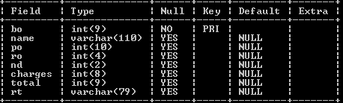

**JFrame Design And Event coding**

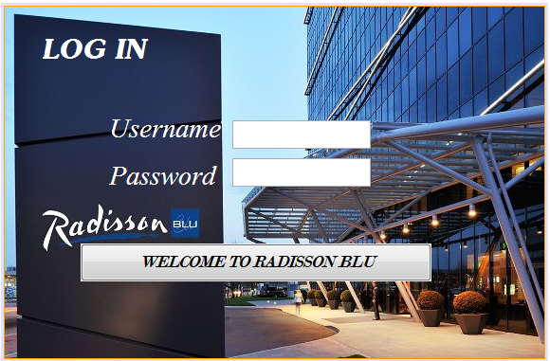

***Coding For:***

***WELCOME TO RADISSON BLU;***

*String u=jPasswordField1.getText();*

*String p=jPasswordField2.getText();*

*if (p.equals("2002") && u.equals("kartik"))*

*{*

*JOptionPane.showMessageDialog(null, "You Are Successfully LogIn");*

*//create object*

*welcome welcome = new welcome();*

*new welcome().setVisible(true);*

*}*

*else*

*{*

*JOptionPane.showMessageDialog(null, "Incorrect UserName and Password");*

*}*

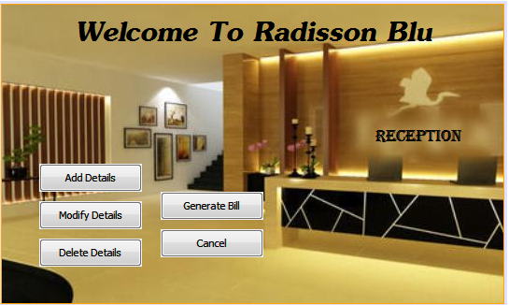

***import javax.swing.JOptionPane;***

***import java.sql.*;***

***Coding For:***

***Addition:***

*//create object*

*addition addition=new addition();*

*new addition().setVisible(true);*

*}*

***Modify;***

*//create object*

*modify modify=new modify();*

*new modify().setVisible(true);*

*}*

***Delete;***

*//create object*

*delete delete=new delete();*

*new delete().setVisible(true);*

*}*

***Cancel;***

*int a=JOptionPane.showConfirmDialog(this,"Are you sure you want to Exit");*

*if (a==0)*

*System.exit(0);*

*}*

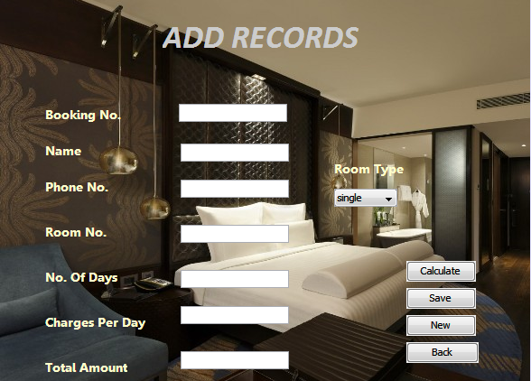

***Coding For:***

***Calculate;***

*int total,charges = 0;*

*String rt = jComboBox1.getSelectedItem().toString();*

*if (rt.equals("single"))*

*{*

*charges = 2000;*

*}*

*else if(rt.equals("double"))*

*{*

*charges = 2500;*

*}*

*else if(rt.equals("delux"))*

*{*

*charges = 3000;*

*}*

*jTextField6.setText(""+charges);*

*int nd;*

*nd=Integer.parseInt(jTextField5.getText());*

*total=charges*nd;*

*jTextField7.setText(""+total);*

*}*

***Save;***

*String name,rt;*

*int bo,po,ro,nd;*

*name=jTextField2.getText();*

*rt=jComboBox1.getSelectedItem().toString();*

*bo=Integer.parseInt(jTextField1.getText());*

*po=Integer.parseInt(jTextField3.getText());*

*ro=Integer.parseInt(jTextField4.getText());*

*nd=Integer.parseInt(jTextField5.getText());*

*try*

*{*

*Class.forName("java.sql.DriverManager");*

*Connection*

*con=DriverManager.getConnection("jdbc:mysql://localhost:3306/kartik","root","admin");*

*Statement stmt=(Statement)con.createStatement();*

*int total,charges = 0;*

*if (rt.equals("single"))*

*{*

*charges = 2000;*

*}*

*if (rt.equals("double"))*

*{*

*charges = 2500;*

*}*

*if (rt.equals("delux"))*

*{*

*charges = 4000;*

*}*

*jTextField6.setText(""+charges);*

*total=charges*nd;*

*jTextField7.setText(""+total);*

*String query="insert into project values('"+bo+"','"+name+"','"+po+"','"+ro+"','"+nd+"','"+charges+"','"+total+"','"+rt+"');";*

*int i=stmt.executeUpdate(query);*

*JOptionPane.showMessageDialog(null,"Saved Successfully");*

*stmt.close();*

*con.close();*

*}*

*catch(Exception e)*

*{*

*JOptionPane.showMessageDialog(this,e.getMessage());*

*}*

***New;***

*jTextField1.setText("");*

*jTextField2.setText("");*

*jTextField3.setText("");*

*jTextField4.setText("");*

*jTextField5.setText("");*

*jTextField6.setText("");*

*jTextField7.setText("");*

***Back;***

*new welcome().setVisible(true);*

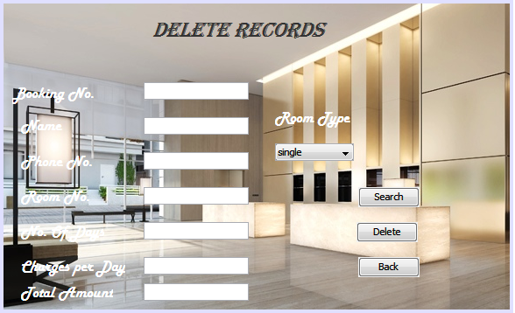

***Coding For:***

***Search;***

*int bo;*

*bo=Integer.parseInt(jTextField1.getText());*

*try*

*{*

*Class.forName("java.sql.DriverManager");*

*Connection*

*con=(Connection)DriverManager.getConnection("jdbc:mysql://localhost:3306/kartik","root","admin");*

*Statement stmt=(Statement)con.createStatement();*

*String query="select * from project where bo="+bo+";";*

*ResultSet rs=stmt.executeQuery(query);*

*int found=0;*

*if(rs.next())*

*{*

*String name,rt;*

*name=rs.getString("name");*

*rt=rs.getString("rt");*

*jTextField2.setText(name);*

*jComboBox1.setSelectedItem(rt);*

*int po,ro,nd,charges,total;*

*bo=rs.getInt("bo");*

*po=rs.getInt("po");*

*ro=rs.getInt("ro");*

*nd=rs.getInt("nd");*

*charges=rs.getInt("charges");*

*total=rs.getInt("total");*

*jTextField3.setText(""+po);*

*jTextField4.setText(""+ro);*

*jTextField5.setText(""+nd);*

*jTextField6.setText(""+charges);*

*jTextField7.setText(""+total);*

*found++;*

*JOptionPane.showMessageDialog(this,"Click OK to go to next Rcord");*

*}*

*Else*

*{*

*jTextField1.setText("");*

*jTextField2.setText("");*

*jTextField3.setText("");*

*jTextField4.setText("");*

*jTextField5.setText("");*

*jTextField6.setText("");*

*jTextField7.setText("");*

*JOptionPane.showMessageDialog(this,"No such record found");*

*}*

*}*

*catch(Exception e)*

*{*

*JOptionPane.showMessageDialog(this, e.getMessage());*

*}*

***Delete;***

*int bo;*

*bo=Integer.parseInt(jTextField1.getText());*

*try*

*{*

*Class.forName("java.sql.DriverManager");*

*Connection*

*con=DriverManager.getConnection("jdbc:mysql://localhost:3306/kartik","root","admin");*

*Statement stmt=con.createStatement();*

*{*

*String query="Delete from project where bo="+bo+";";*

*stmt.executeUpdate(query);*

*JOptionPane.showMessageDialog(null,"Record Successfully Deleted");*

*jTextField1.setText("");*

*jTextField2.setText("");*

*jTextField3.setText("");*

*jTextField4.setText("");*

*jTextField5.setText("");*

*jTextField6.setText("");*

*jTextField7.setText("");*

*}*

*}*

*//end of try*

*catch(Exception e)*

*{*

*JOptionPane.showMessageDialog(null, e);*

*}*

*}*

***Back;***

*new welcome().setVisible(true);*

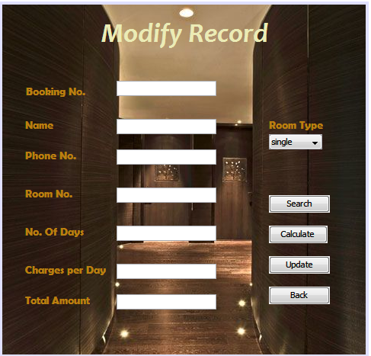

***Coding For:***

***Search;***

*int bo;*

*bo=Integer.parseInt(jTextField1.getText());*

*try*

*{*

*Class.forName("java.sql.DriverManager");*

*Connection*

*con=(Connection)DriverManager.getConnection("jdbc:mysql://localhost:3306/kartik","root","admin");*

*Statement stmt=(Statement)con.createStatement();*

*String query="select * from project where bo="+bo+";";*

*ResultSet rs=stmt.executeQuery(query);*

*int found=0;*

*if(rs.next())*

*{*

*String name,rt;*

*name=rs.getString("name");*

*rt=rs.getString("rt");*

*jTextField2.setText(name);*

*jComboBox1.setSelectedItem(rt);*

*int po,ro,nd,charges,total;*

*bo=rs.getInt("bo");*

*po=rs.getInt("po");*

*ro=rs.getInt("ro");*

*nd=rs.getInt("nd");*

*charges=rs.getInt("charges");*

*total=rs.getInt("total");*

*jTextField3.setText(""+po);*

*jTextField4.setText(""+ro);*

*jTextField5.setText(""+nd);*

*jTextField6.setText(""+charges);*

*jTextField7.setText(""+total);*

*found++;JOptionPane.showMessageDialog(this,"Click Ok to go to next Record");*

*}*

*else*

*{*

*jTextField1.setText("");*

*jTextField2.setText("");*

*jTextField3.setText("");*

*jTextField4.setText("");*

*jTextField5.setText("");*

*jTextField6.setText("");*

*jTextField7.setText("");*

*JOptionPane.showMessageDialog(this,"No such record found");*

*}*

*}*

*catch(Exception e)*

*{*

*JOptionPane.showMessageDialog(this, e.getMessage());*

*}*

***Update;***

*try*

*{*

*Class.forName("java.sql.DriverManager");*

*Connection*

*con=(Connection) DriverManager.getConnection("jdbc:mysql://localhost:3306/kartik","root","admin");*

*Statement stmt=(Statement)con.createStatement();*

*String name,rt;*

*int bo,po,ro,nd;*

*name=jTextField2.getText();*

*rt=jComboBox1.getSelectedItem().toString();*

*bo=Integer.parseInt(jTextField1.getText());*

*po=Integer.parseInt(jTextField3.getText());*

*ro=Integer.parseInt(jTextField4.getText());*

*nd=Integer.parseInt(jTextField5.getText());*

*int total,charges = 0;*

*if (rt.equals("single"))*

*{*

*charges = 2000;*

*}*

*else if (rt.equals("double"))*

*{*

*charges = 2500;*

*}*

*else if (rt.equals("delux"))*

*{*

*charges = 4000;*

*}*

*jTextField6.setText(""+charges);*

*total=charges*nd;*

*jTextField7.setText(""+total);*

*{*

*String query="update project set bo="+bo+",name='"+name+"',po="+po+",ro="+ro+",nd="+nd+",charges="+charges+",total="+total+",rt='"+rt+"'where bo="+bo+";";*

*int i=stmt.executeUpdate(query);*

*JOptionPane.showMessageDialog(null,i+"Successfully Updated");*

*}*

*}*

*catch(Exception e)*

*{*

*JOptionPane.showMessageDialog(this,e.getMessage());*

*}*

***Back;***

*new welcome().setVisible(true);*

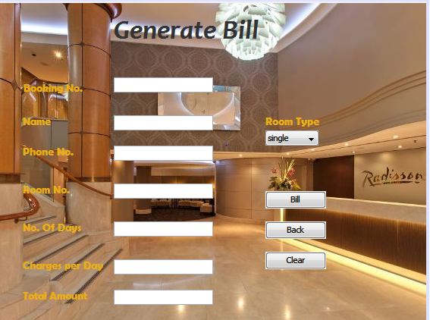

***import javax.swing.JOptionPane;***

***import java.sql.*;***

***Coding For:***

***Bill;***

*int bo;*

*bo=Integer.parseInt(jTextField1.getText());*

*try*

*{*

*Class.forName("java.sql.DriverManager");*

*Connection*

*con=(Connection)DriverManager.getConnection("jdbc:mysql://localhost:3306/kartik","root","admin");*

*Statement stmt=(Statement)con.createStatement();*

*String query="select * from project where bo="+bo+";";*

*ResultSet rs=stmt.executeQuery(query);*

*int found=0;*

*if(rs.next())*

*{*

*String name,rt;*

*name=rs.getString("name");*

*rt=rs.getString("rt");*

*jTextField2.setText(name);*

*jComboBox1.setSelectedItem(rt);*

*int po,ro,nd,charges,total;*

*bo=rs.getInt("bo");*

*po=rs.getInt("po");*

*ro=rs.getInt("ro");*

*nd=rs.getInt("nd");*

*charges=rs.getInt("charges");*

*total=rs.getInt("total");*

*jTextField3.setText(""+po);*

*jTextField4.setText(""+ro);*

*jTextField5.setText(""+nd);*

*jTextField6.setText(""+charges);*

*jTextField7.setText(""+total);*

*found++;JOptionPane.showMessageDialog(this,"Click Ok to go to next Record");*

*}*

*else*

*{*

*jTextField1.setText("");*

*jTextField2.setText("");*

*jTextField3.setText("");*

*jTextField4.setText("");*

*jTextField5.setText("");*

*jTextField6.setText("");*

*jTextField7.setText("");*

*JOptionPane.showMessageDialog(this,"No such record found");*

*}*

*}*

*catch(Exception e)*

*{*

*JOptionPane.showMessageDialog(this, e.getMessage());*

*}*

***Back;***

*new welcome().setVisible(true);*

***Clear;***

*jTextField1.setText("");*

*jTextField2.setText("");*

*jTextField3.setText("");*

*jTextField4.setText("");*

*jTextField5.setText("");*

*jTextField6.setText("");*

*jTextField7.setText("");*

***Report:***



