**Informatics**

**Practices**

**Program File**

**Submitted By-**

**Name-** Kartik Gupta

**Class-**XII

**Roll No -**

***CERTIFICATE***

*This is to certify that Kartik Gupta has successfully completed her IP project in academic year 2019-2020 on the topic “My SQL & Java “ as per the rule of CBSE…*

***Teacher’s Sign***

***Acknowledgement***

In the accomplished of this project successfully many people have best owned upon me their blessings and the heart pledged support.This time I am utilizing to thank all the people who have been concerned with project.

Primarily I would thank god for being able to complete this project with success. Then I would like to thank my IP teacher Mrs. Manmeet Kaur, whose valuable guidance has been the one that help me patch this project and make it full proof success her suggestion and instructions has served as the major contribution towards the completion of the project.

Last but not the least I would like to thank my parents and friends who have helped me with their valuable suggestions and guidance has been helpful in various phases of the project.

***KARTIK GUPTA***

**INDEX**

|  |  |  |
| --- | --- | --- |
| **S.NO.** | **NAME OF THE TOPIC** | **REMARKS** |
| 1. | Introduction to Java IDE |  |
| 2. | Java Programs |  |
| 3. | Introduction To My SQL |  |
| 4. | MySQL programs |  |
| 5. | Introduction To HTML |  |
| 6. | HTML Programs |  |



**JAVA**

Java is both a programming language and a platform. Like other programming languages, Java is used to create various types of computer applications. Java is also a platform for application development. The word platform is used to refer to some combination of hardware and system software. It is designed to deliver and run highly interactive, dynamic and secure application on network computer system.

**Byte code**

Window program will not be able to run on a computer that only runs dos (disco operating system). For the java application, applications are platform independent. Java solves the problem of platform independence by using byte code. The program or code written by a programmer is called course code. This course code needs to be converted into machine language. The process of converting a course code into machine code is called complication. The converted machine code depends a lot on the platform.

**Java complication**

Java compiler does not produce native executive code for a particular machine. Instead it produces a special format called byte code. The java byte code is a machine instruction for a java processor chip called java virtual machine. The byte code is independent of the computer system it has to run upon.

**Java virtual machine ( JVM )**

Programs written in java are compiled into java by code which is then interpreted by a special java intercepter for a special java interpreter is known as the java virtual machine (JVM). The machine language for the JVM is called java byte code.

**TEXT INTERACTION IN GUI**

In a GUI you need to use basically 3 types of methods:

1. **getText( )**: Method returns the text currently stored in a text based in GUI component. This method includes TextField, TextArea, Checkbox, button, label, and radiobutton.

ii) **setText ( )**: It stores or changes text in a text based GUI components. It includes textfield, textarea, button, label, and radiobutton.

iii) **Parse Method**: This method obtains number from GUI components. There are many methods that help you parse string into different numeric types.

**Selection statment**

* **If statement**: An if statement test a particular condition; if the condition evaluates to true, a course-of –action is followed i.e., a statement or set-of—statement is executed. Otherwise (if the condition evaluates to false), the course-of –action is ignored.

Syntax:

If (expression)

Statement;

* **If….else statement**: There is another form of if that allows for this kind of either-or condition by providing an else clause.

Syntax:

If (expression)

Statement 1;

Else

Statement 2;

* **The switch statement**: Java provides a multiple-branch selection statement known as switch. This selection statement successively tests the value of an expression against a list of integer or character constants.

Syntax:

Switch (expression)

{Case constant 1: statement 1;

Break;

Case constant 2: statement 2;

Break;

Default: statement n;

}

**Iteration statement**

The iteration statements allow a set of instructions to be performed repeatedly until a certain condition is fulfilled. The iteration statements are also called loops or looping statements. Java provides three kinds of loops: for loop, while loop, and do-while loop.

**Elements that control a loop**

**(part of a loop)**

1. Initialization Expression
2. Test Expression
3. Update Expression
4. The body- of-the-loop

* **The for loop**: The for loop is the easiest to understand of the java loop. All its loop-control elements are gathered in one place, while in the other loop construction of java, they are scattered about the program.

Syntax:

For (initialization expression; test-expression; updates expression)

Body-of-the-loop;

* **The while loop**: The second loop available in java us the while loop. The while loop is an entry-controlled loop.

Syntax:

While (expression)

Loop-body

* **The do-while loop**: Unlike the for& while loops, the do-while is an exit-controlled loop i.e., it evaluates its test-expression at the bottom of the loop after executionists loop-body statements.

Syntax: Do {statement;

} while (test-expression);

**JAVA PROGRAMS**

**1.Design a java program to display an Area of following Shapes.**

1. *Circle*
2. *Square*
3. *Rectangle*

***Design:***

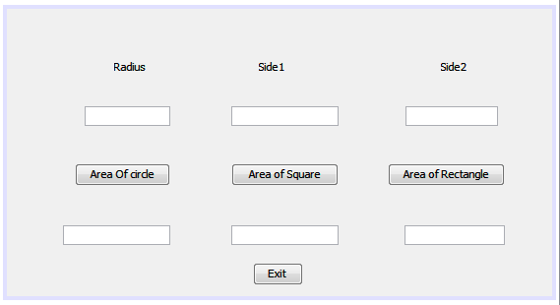

*import.javax.swing.JOptionPane;*

**Coding For:**

* **Circle:**

Double a,r;

r=Double.parseDouble(jTextField1.getText());

a=(Double) (3.14*r*r);

jTextField4.setText(Double.toString(a));

* **Square:**

Double i,a;

i=Double.parseDouble(jTextField2.getText());

a=(Double) (i*i);

jTextField5.setText(Double.toString(a));

* **Rectangle:**

Float i,j,a;

i=Float.parseFloat(jTextField2.getText());

j=Float.parseFloat(jTextField3.getText());

a=(Float) (i*j);

jTextField6.setText(Float.toString(a));

* **Exit:**

int a=JOptionPane.showConfirmDialog(this,"Are you sure you want to Exit");

if (a==0)

System.exit(0);

***Output:***

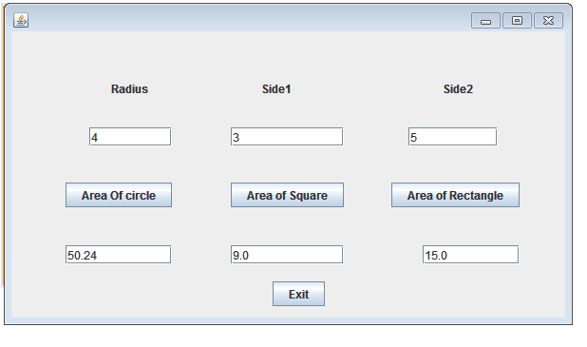**2.Design a program to display Discount and Payable Amount according to given condition;**

|  |  |
| --- | --- |
| ***Card Type*** | ***Discount*** |
| *HDFC* | *12%* |
| *VISA* | *15%* |
| *ICICI* | *10%* |
| *Master Card* | *14%* |
| *City Bank* | *18%* |

***Design:***

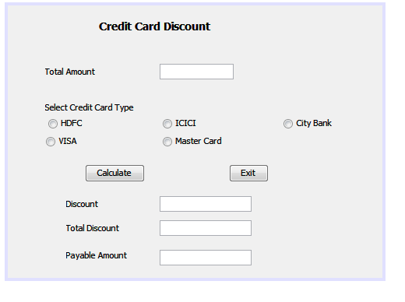*import .javax.swing.JOptionPane;*

**Coding For:**

* **Exit:**

int a=JOptionPane.showConfirmDialog(this,"Are you sure you want to Exit");

if (a==0)

System.exit(0);

* **Calculate:**

Double a,d = null,t;

a= Double.parseDouble(jTextField1.getText());

if (jRadioButton1.isSelected())

{

d=(Double) (a*0.12);

jTextField2.setText("12%");

}

else if (jRadioButton2.isSelected())

{

d=(Double) (a*0.15);

jTextField2.setText("15%");

}

else if (jRadioButton3.isSelected())

{

d=(Double) (a*0.10);

jTextField2.setText("10%");

}

else if (jRadioButton4.isSelected())

{

d=(Double) (a*0.14);

jTextField2.setText("14%");

}

else if (jRadioButton5.isSelected())

{

d=(Double) (a*0.18);

jTextField2.setText("18%");

}

jTextField3.setText("Rs."+d);

t= (Double) (a-d);

jTextField4.setText("Rs."+t);

}

***Output:***

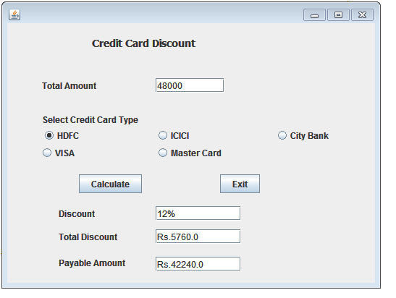

**3.ABCShipment Corporation imposes charges to customers for different product .The shipment company costs for an order in two forms: Wholesalers and Retailers . The cost is calculated on unit basis as follows:**

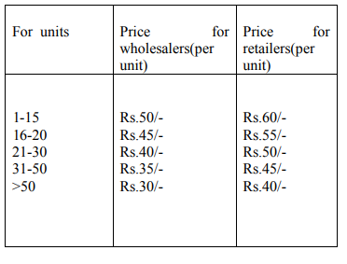

***Design:***

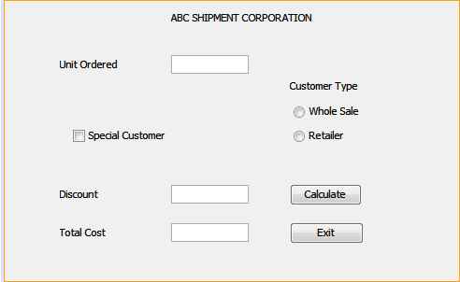

**Coding For:**

* **Exit:**

System.exit(0);

* **Calculate:**

inti;

i=Integer.parseInt(jTextField1.getText());

int t=0;

double d=0;

if (jRadioButton1.isSelected())

{

if(i>1 &&i<15)

t=i*50;

else if (i>=16 &&i<=20)

t=45*i;

else if (i>=21 &&i<=30)

t=40*i;

else if (i>=31 &&i<=50)

t=35*i;

else if (i>50)

t=30*i;

}

else if (jRadioButton2.isSelected())

{

if (i>=1 &&i<=15)

t=60*i;

else if (i>=16 &&i<=20)

t=55*i;

else if (i>=21 &&i<=30)

t=50*i;

else if (i>=31 &&i<=50)

t=45*i;

else if (i>50)

t=40*i;

}

jTextField3.setText(Integer.toString(t));

if (jCheckBox1.isSelected())

{

jTextField2.setText("10%");

d=t-(t*0.10);

jTextField3.setText(Double.toString(d));

}

***Output:***

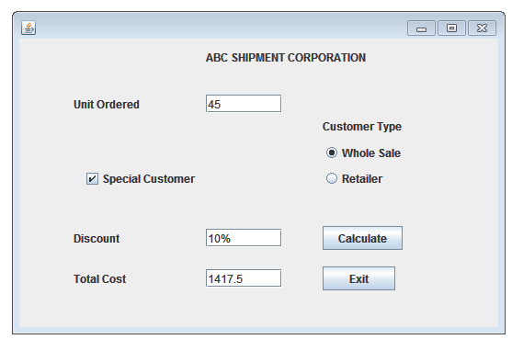

**4. Design a java program to accept a String and perform following functions :-**

1. *find length of the string*
2. *find no of words in it*
3. *find string is palindrome or not*
4. *find number of vowels in it.*

***Design:***

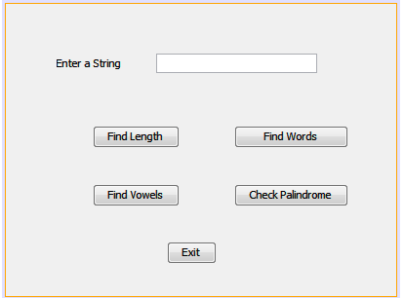

**Coding For:**

* **Exit:**

int a=JOptionPane.showConfirmDialog(this,"Are you sure you want to Exit");

if (a==0)

System.exit(0);

* **Length:**

String st=jTextField1.getText();

JOptionPane.showMessageDialog(null,"length="+ st.length());

* **Words:**

String st=jTextField1.getText();

int s=1;

for(inti=0;i<st.length();i++)

{

if (st.charAt(i)=='')

s++;

}

JOptionPane.showMessageDialog(null,"No. of words="+s);

}

* **Vowels:**

String st=jTextField1.getText();

inti,v;

v=0;

for (i=0;i<st.length();i++)

{

switch(st.charAt(i))

{

case'A':case'E':case'I':case'O':case'U':

case'a': case'e':case'i':case'o':case'u':

v++;

}

} JOptionPane.showMessageDialog(this,"no. of Vowels="+v);

}

**Palindrome:**

String st=jTextField1.getText();

inti=0;

int j=st.length()-1;

int flag=0;

while(i<st.length()/2)

{

if(st.charAt(i)!=st.charAt(j))

{

flag=1;

break;

}

else

{

i++;

j--;

}

}

if(flag == 1)

JOptionPane.showMessageDialog(null,"It is not a palindrome");

else

JOptionPane.showMessageDialog(null,"It is a palindrome");

}

***Output:***

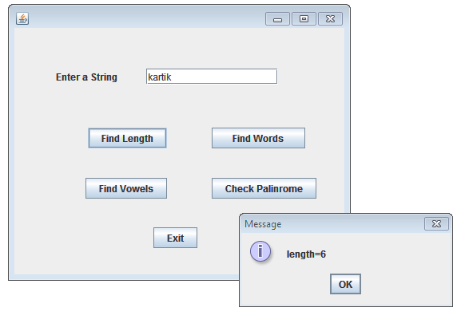

**5.Develop an application to compute the Factorial..**

***Design:***

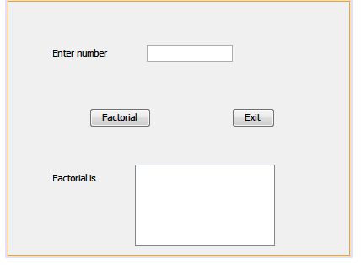

**Coding For:**

* **Exit:**

System.exit(0);

* **Factorial:**

inti,n,fac;

fac=1;

n=Integer.parseInt(jTextField1.getText());

for(i=1;i<=n;i++)

fac=fac*i;

jTextArea1.setText(Integer.toString(fac));

***Output:***

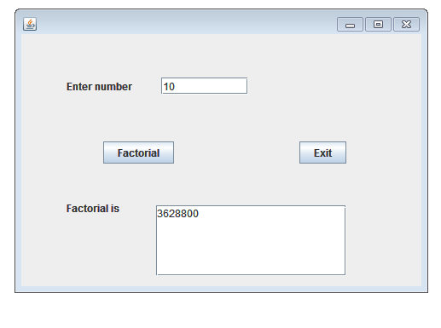

**6.Design a Java program to design the n Number of natural Number.**

***Design:***

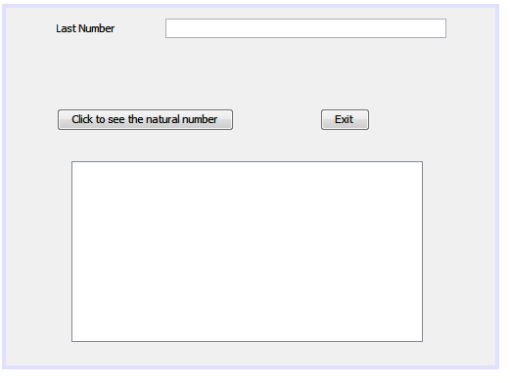

**Coding For:**

* **Exit:**

System.exit(0);

* **Click to see the natural no.:**

int n;

n=Integer.parseInt(jTextField1.getText());

for (inti=1;i<n;i++)

jTextArea1.setText(jTextArea1.getText()+""+Integer.toString(i));

***Output:***

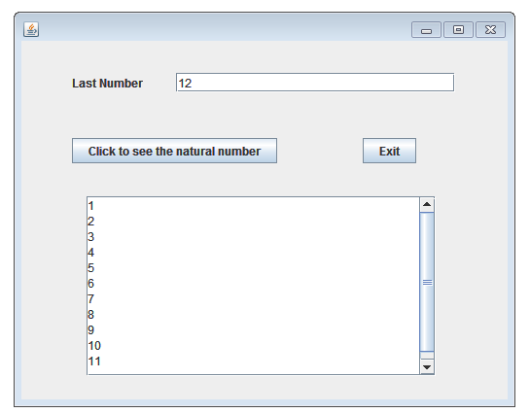

**7.** Design a program to calculate the simple Interest..

***Design:***

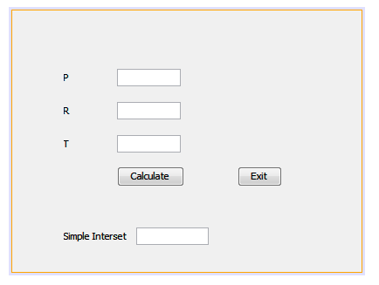

**Coding For:**

* **Exit:**

System.exit(0);

* **Calculate:**

Float a,b,c,r;

a=Float.parseFloat(jTextField1.getText());

b=Float.parseFloat(jTextField2.getText());

c=Float.parseFloat(jTextField3.getText());

r= (a*b*c)/100;

jTextField4.setText(Float.toString(r));

***Output:***

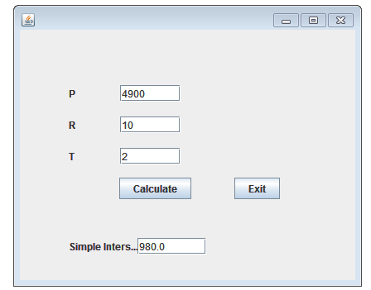

**8.Develop a program to know a person is eligible for vote or not**

***Design:***

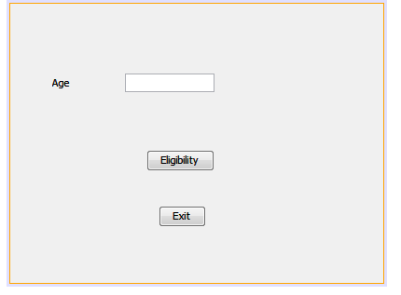

*Importjavax.Swing.JOptionPane;*

**Coding For:**

* **Exit:**

System.exit(0);

* **Eligibility:**

int a;

a=Integer.parseInt(jTextField1.getText());

if(a>=18)

JOptionPane.showMessageDialog(null, "You are Eligible for vote");

else if(a<18)

JOptionPane.showMessageDialog(null, "You are not Eligible for vote");

***Output:***

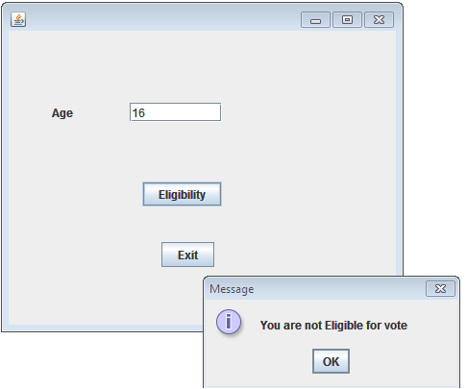

**9.The Entertainment Paradise- A theater wants to develop a computerized Booking System. The proposed Interface is given below. The theater offers different types of seats. The Ticket rates areStalls- Rs. 625/-, Circle- Rs.750/-, Upper Class- Rs.850/- and Box- Rs.1000/-. A discount is given 10% of total amount if tickets are purchased on Cash. In case of credit card holders 5% discount is given*.***

***Design:***

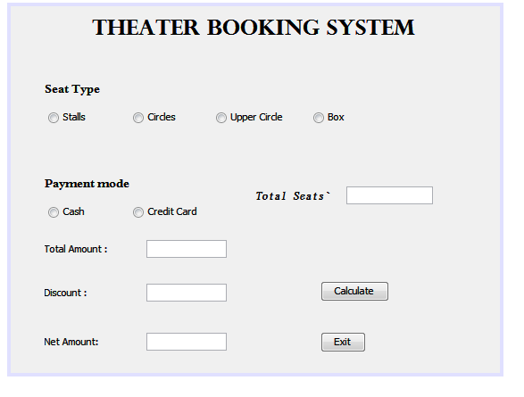

**Coding For:**

* **Calculate:**

double t = 0,a = 0,r = 0,d,h = 0;

int s;

s=Integer.parseInt(jTextField1.getText());

if (jRadioButton1.isSelected())

{

r=625;

}

else if (jRadioButton2.isSelected())

{

r=750;

}

else if (jRadioButton3.isSelected())

{

r=850;

}

else if (jRadioButton4.isSelected())

{

r=1000;

}

if (jRadioButton5.isSelected())

{

d=0.1;

a= (int) (double) (s*r);

t= (int) (double) (s*r*0.1);

h=(double) (a-t);

}

else if (jRadioButton6.isSelected())

{

d=0.05;

a= (int) (double) (s*r);

t=(int) (double) (s*r*0.05);

h=(double) (a-t);

}

jTextField2.setText("Rs."+a);

jTextField3.setText("Rs."+t);

jTextField4.setText("Rs."+h);

}

* **Exit:**

int a=JOptionPane.showConfirmDialog(this,"Are you sure you want to Exit");

if (a==0)

System.exit(0);

***Output:***

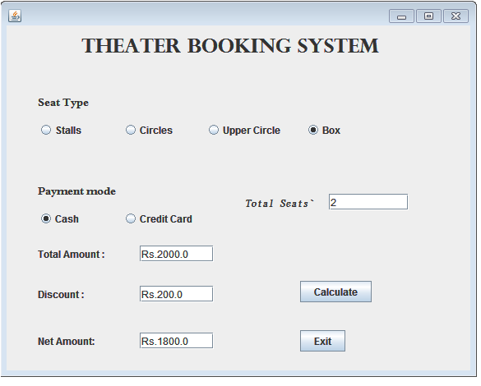

**10.Design a program to calculate the average of the Numbers**

***Design:***

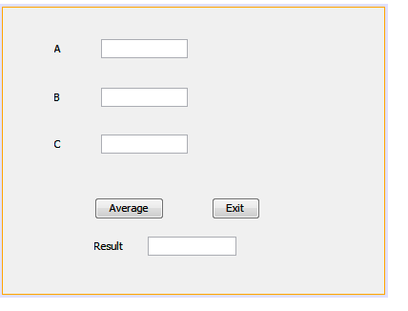

**Coding For:**

* **Exit:**

System.exit(0);

* **Average:**

Float a,b,c,r;

a = Float.parseFloat(jTextField1.getText());

b = Float.parseFloat(jTextField2.getText());

c = Float.parseFloat(jTextField3.getText());

r = (a+b+c)/3;

jTextField4.setText(Float.toString(r));

***Output:***

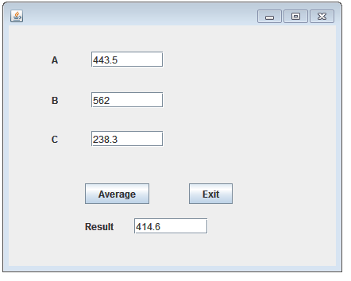

**11.Design a Program to display a Number according to the Button Selected.**

***Design:***

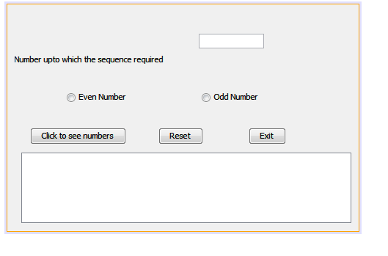

**Coding For:**

* **Click to see Numbers:**

intn,i;

n=Integer.parseInt(jTextField1.getText());

if(jRadioButton1.isSelected())

{

for(i=2;i<n;i+=2)

jTextArea1.setText(jTextArea1.getText()+""+Integer.toString(i));

}

else if(jRadioButton2.isSelected())

{

for(i=1;i<n;i+=2)

jTextArea1.setText(jTextArea1.getText()+""+Integer.toString(i));

}

else

JOptionPane.showMessageDialog(this,"Click to see EVEN or ODD Option");

}

* **Reset:**

jTextField1.setText("");

jRadioButton1.setSelected(false);

jRadioButton2.setSelected(false);

jTextArea1.setText("");

}

* **Exit:**

System.exit(0);

***Output:***

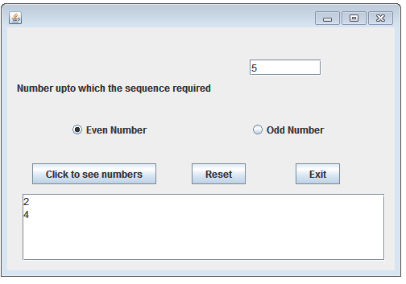

**12.Design a program to check whether the given user id and password is correct or not.**

***Design:***

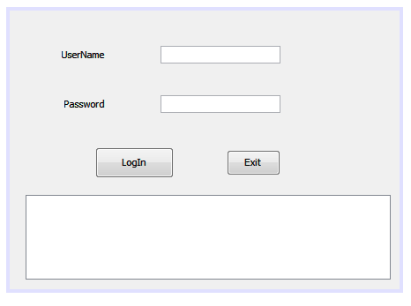

**Coding For:**

* **LogIn:**

String u;

String p;

u=jTextField1.getText();

p=jPasswordField1.getText();

if (p.equals("2002") &&u.equals("kartik"))

{

jTextArea1.setText("User name And Password Valid");

}

else

{

jTextArea1.setText("User name And Password InValid");

}

}

* **Exit:**

int a=JOptionPane.showConfirmDialog(null,"Are You sure you want to exit?");

if(a==0)

System.exit(0);

***Output:***

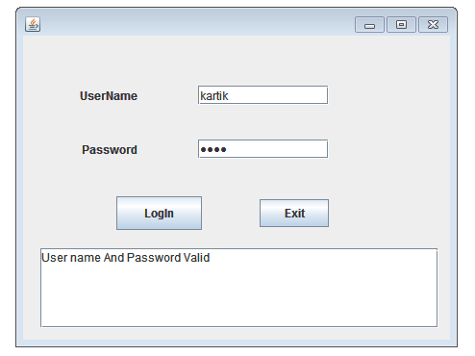

**13. Design a program to get a largest and Smallest number.**

***Design:***

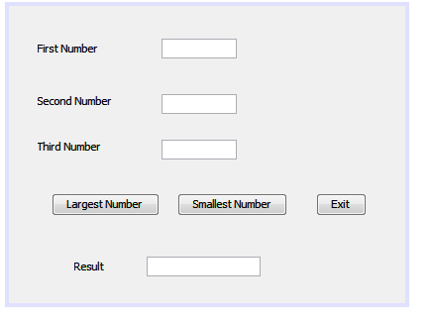

**Coding For:**

* **Largest Number:**

Double a,b,c;

a=Double.parseDouble(jTextField1.getText());

b=Double.parseDouble(jTextField2.getText());

c=Double.parseDouble(jTextField3.getText());

if (a>b && a>c)

{

jTextField4.setText(Double.toString(a));

}

else if (b>a && b>c)

{

jTextField4.setText(Double.toString(b));

}

else if (c>a && c>b)

{

jTextField4.setText(Double.toString(c));

}

else

{

jTextField4.setText("The numbers are not distinct.");

}

}

* **Smallest Number:**

Double a,b,c;

a=Double.parseDouble(jTextField1.getText());

b=Double.parseDouble(jTextField2.getText());

c=Double.parseDouble(jTextField3.getText());

if (a<b && a<c)

{

jTextField4.setText(Double.toString(a));

}

else if (b<a && b<c)

{

jTextField4.setText(Double.toString(b));

}

else if (c<a && c<b)

{

jTextField4.setText(Double.toString(c));

}

else

{

jTextField4.setText("The numbers are not distinct.");

}

}

* **Exit:**

System.exit(0);

***Output:***

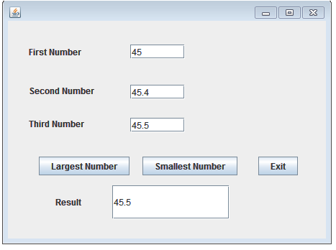

**14. Design a java program to display a menu of Pizza Hut..**

***Design:***

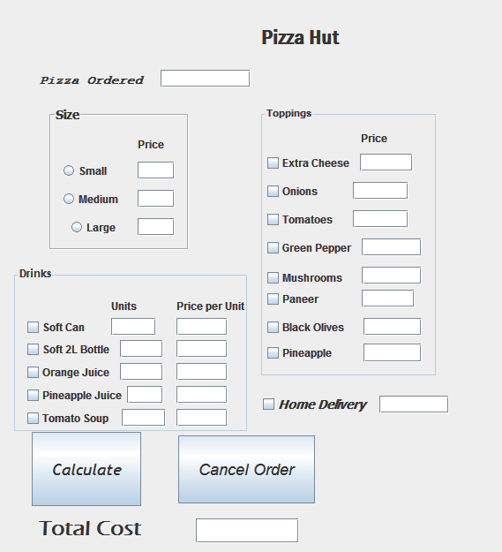

*import javax.swing.JOptionPane;*

**Coding For:**

* **Calculate:**

Double a,d = null;

a= Double.parseDouble(jTextField14.getText());

if (jRadioButton1.isSelected())

{

jTextField1.setText("Rs.30.0");

d=a*30;

}

else if (jRadioButton2.isSelected())

{

jTextField2.setText("Rs.40.0");

d=a*40;

}

else if (jRadioButton3.isSelected())

{

jTextField3.setText("Rs.50.0");

d=a*50;

}

if (jCheckBox1.isSelected())

{

jTextField4.setText("Rs.15.0");

d= d+ 15.0;

}

if (jCheckBox2.isSelected())

{

jTextField5.setText("Rs.09.0");

d = d+ 9;

}

if (jCheckBox3.isSelected())

{

jTextField6.setText("Rs.04.0");

d = d+ 4;

}

if (jCheckBox4.isSelected())

{

jTextField7.setText("Rs.05.5");

d = d+ 5.5;

}

if (jCheckBox5.isSelected())

{

jTextField8.setText("Rs.25.5");

d = d+ 25.5;

}

if (jCheckBox6.isSelected())

{

jTextField9.setText("Rs.35.5");

d = d+ 35.5;

}

if (jCheckBox7.isSelected())

{

jTextField10.setText("Rs.10.0");

d = d+10;

}

if (jCheckBox8.isSelected())

{

jTextField11.setText("Rs.25.5");

d = d+ 25.5;

}

if (jCheckBox12.isSelected())

{

jTextField22.setText("Rs.45");

double b1= Double.parseDouble(jTextField17.getText());

d=d+(b1*45);

}

if (jCheckBox13.isSelected())

{

jTextField23.setText("Rs.75");

double b2= Double.parseDouble(jTextField18.getText());

d=d+(b2*75);

}

if (jCheckBox14.isSelected())

{

jTextField24.setText("Rs.20");

double b3= Double.parseDouble(jTextField19.getText());

d=d+(b3*20);

}

if (jCheckBox15.isSelected())

{

jTextField25.setText("Rs.40");

Double b4= Double.parseDouble(jTextField20.getText());

d=d+(b4*40);

}

if (jCheckBox16.isSelected())

{

jTextField26.setText("Rs.30");

double b5= Double.parseDouble(jTextField21.getText());

d=d+(b5*30);

}

if(jCheckBox11.isSelected())

{

jTextField15.setText("Rs.50");

d=d+50;

}

jTextField16.setText("Rs."+Double.toString(d));

}

* **Cancel Order:**

int a=JOptionPane.showConfirmDialog(this,"Are you sure you want to exit");

if(a==0)

System.exit(0)

***Output:***

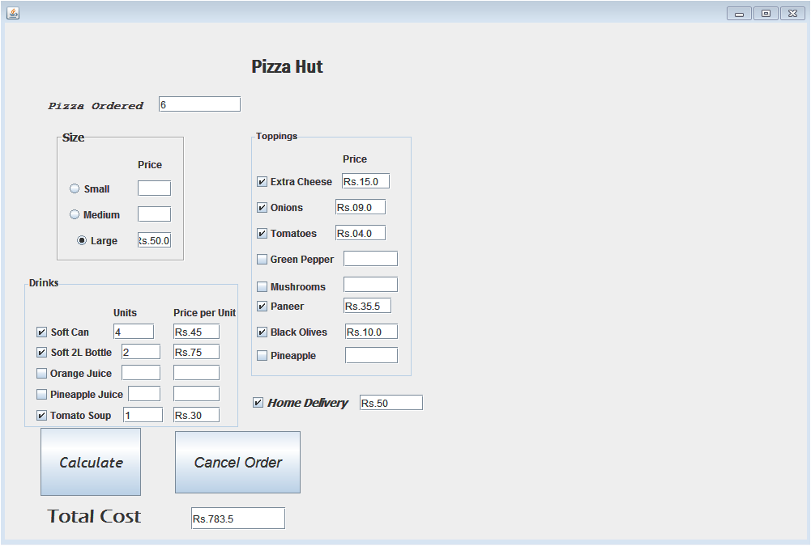

**15.Design a program To make a calculator..**

***Design:***

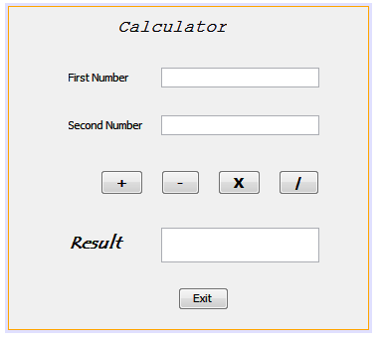

**Coding For:**

* **(+):**

Double a,b,r;

a= Double.parseDouble(jTextField1.getText());

b= Double.parseDouble(jTextField2.getText());

r = (Double) (a+b);

jTextField3.setText(Double.toString(r));

* **(-):**:

Double a,b,r;

a= Double.parseDouble(jTextField1.getText());

b= Double.parseDouble(jTextField2.getText());

r = (Double) (a-b);

jTextField3.setText(Double.toString(r));

* **(*):**

Double a,b,r;

a= Double.parseDouble(jTextField1.getText());

b= Double.parseDouble(jTextField2.getText());

r = (Double) (a*b);

jTextField3.setText(Double.toString(r));

* **(/):**

Double a,b,r;

a= Double.parseDouble(jTextField1.getText());

b= Double.parseDouble(jTextField2.getText());

r = (Double) (a/b);

jTextField3.setText(Double.toString(r));

* **Exit:**

System.exit(0);

***Output:***

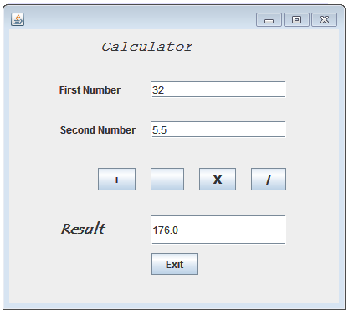

**16. Design a program for city highlights.**

***Design:***

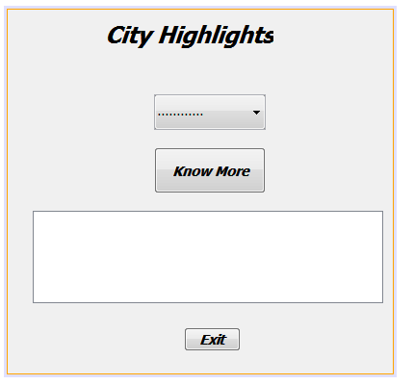

**Coding For:**

* **Know More:**

if (jComboBox1.getSelectedIndex() == 1)

jTextArea1.setText("Known as Silicon Vally of India");

else if (jComboBox1.getSelectedIndex() == 2)

jTextArea1.setText("Known as Capital City of India");

else if (jComboBox1.getSelectedIndex() == 3)

jTextArea1.setText("Known for broad Industrial Base");

else if (jComboBox1.getSelectedIndex() == 4)

jTextArea1.setText("Known for literacy, artistic and revolutionary heritage");

else if (jComboBox1.getSelectedIndex() == 5)

jTextArea1.setText("Known for hub of Bollywood");

* **Exit:**

System.exit(0);

***Output:***

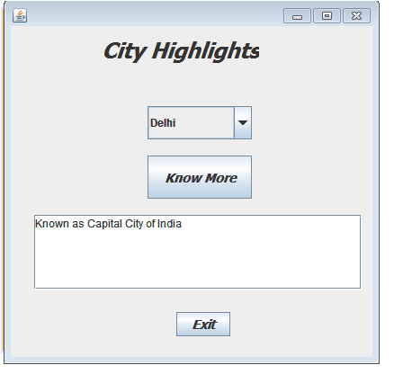

**17.Choice**

***Design:***

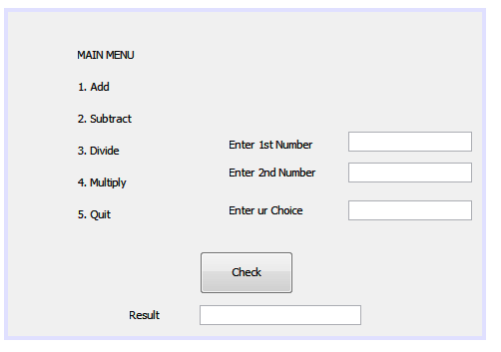

**Coding For:**

* **Check:**

Double r = null,a,b;

intch;

a=Double.parseDouble(jTextField1.getText());

b = Double.parseDouble(jTextField2.getText());

ch= Integer.parseInt(jTextField3.getText());

switch (ch)

{

case 1 : r = (Double) (a+b);

break;

case 2 : r = (Double) (a-b);

break;

case 3 : r =(Double) (a/b);

break;

case 4 : r= (Double) (a*b);

break;

case 5 : System.exit(0);

break;

default : jTextField4.setText("Wrong Choice");

}

jTextField4.setText(Double.toString(r));

}

***Output:***

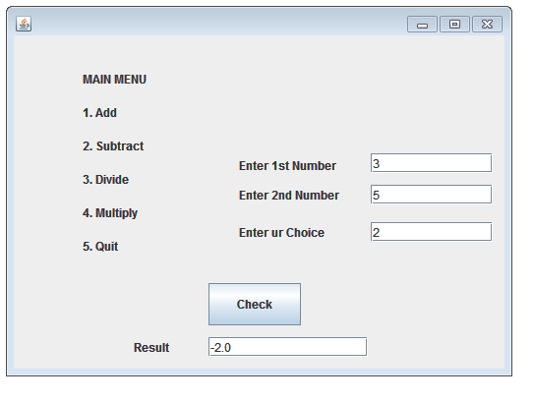

18.Design a program to make a full name.

***Design:***

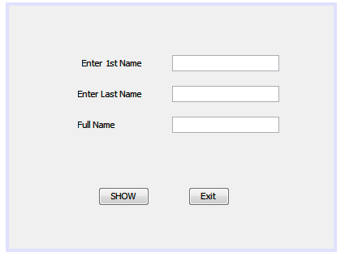

**Coding For:**

* **Show:**

jTextField3.setText(jTextField1.getText()+""+jTextField2.getText());

* **Exit:**

System.exit(0);

***Output:***

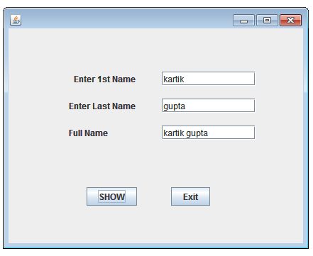

**19.Develop a Billing application for Happy Shoping. The happy Shopping offers discount to its members holding Platinum, Gold and Silver card.**

|  |  |
| --- | --- |
| **CARD** | **DISCOUNT** |
| Platinum | 10% |
| Gold | 8% |
| Silver | 5% |

***Design:***

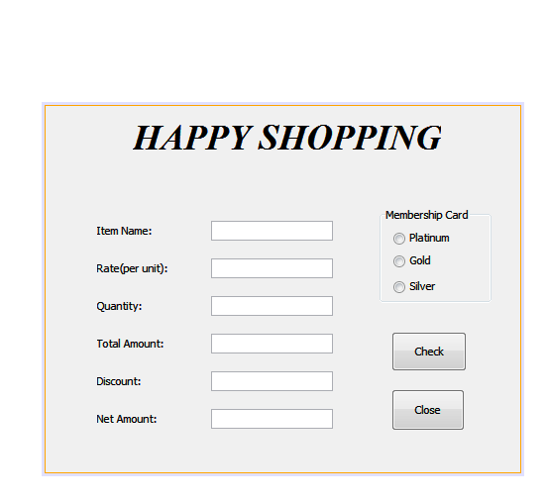

**Coding For:**

* **Check:**

Float r,q,a,d,n;

r=Float.parseFloat(jTextField2.getText());

q=Float.parseFloat(jTextField3.getText());

a=r*q;

if(jRadioButton1.isSelected()==true)

d=(Float)(a*0.1);

else if(jRadioButton2.isSelected() == true)

d=(Float)(a*0.08);

else

d= (Float)(a*0.05);

n=a-d;

jTextField4.setText("Rs."+a);

jTextField5.setText("Rs."+d);

jTextField6.setText("Rs."+n);

* **Close:**

System.exit(0);

***Output:***

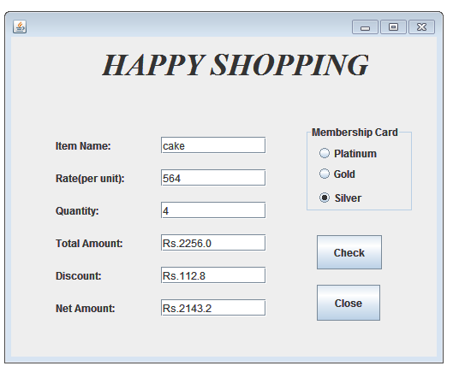

**20.Design a Program for a cost of Loan**

***Design:***

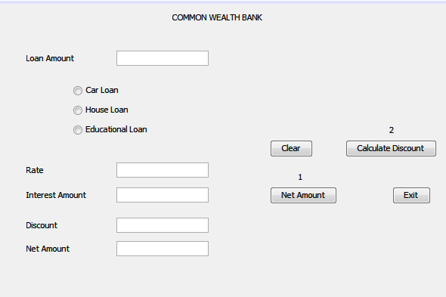

**Coding For:**

* **Clear:**

jTextField1.setText("");

jTextField2.setText("");

jTextField3.setText("");

jTextField4.setText("");

jTextField5.setText("");

jRadioButton1.setSelected(true);

* **Exit:**

System.exit(0);

* **Net Amount:**

double r=0;

if(jRadioButton1.isSelected()){

r=10;

}

else if(jRadioButton2.isSelected())

{

r=8.5;

}

else if(jRadioButton3.isSelected())

{

r=5;

}

doubleamt,iamt;

amt=Double.parseDouble(jTextField1.getText());

iamt=amt*r/100;

jTextField2.setText(""+r);

jTextField3.setText(""+iamt);

* **Calculate Discount:**

doubleamt,tamt,disc,netamt;

amt=Double.parseDouble(jTextField1.getText());

if(amt<=1000000)

{

disc=0.20*amt/100;

}

else{

disc=0.25*amt/100;

}

tamt=Double.parseDouble(jTextField3.getText());

tamt=tamt-disc;

netamt=amt+tamt;

jTextField3.setText(""+tamt);

jTextField4.setText(""+disc);

jTextField5.setText(""+netamt);

***Output:***

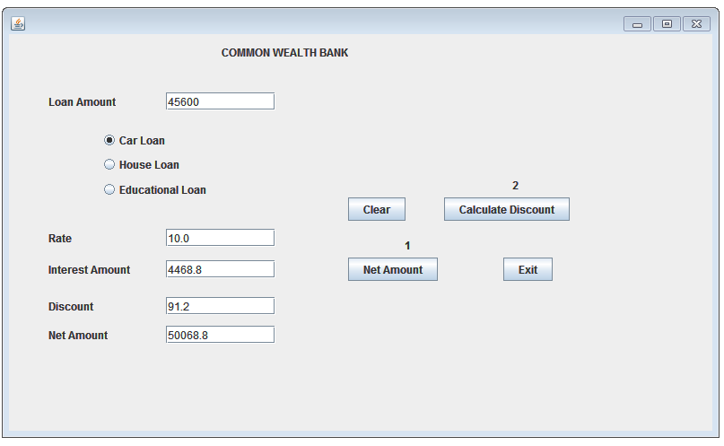

Connectivity

**1.Add:**

***Design:***

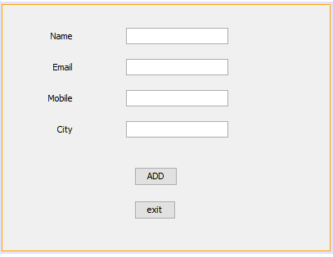

Import.javax.swing.JOptionPane;

Import.java.sql.Connection;

Import.java.sql.Statement;

Import.java.sql.DriverManager;

Import.java.sql.ResultSet;

Import.javax.swing.*;

**Coding For:**

* **Add:**

String name=jTextField1.getText();

String email=jTextField2.getText();

String mobile=jTextField3.getText();

String city=jTextField4.getText();

try

{

Class.forName("java.sql.Driver");

String path="jdbc:mysql://localhost/k";

String user="root";

String pass="123";

Connection con=DriverManager.getConnection(path,user,pass);

Statement stmt=con.createStatement();

String query="insert into student(name,email,mobile,city)values('"+name+"','"+email+"','"+mobile+"','"+city+"');";

stmt.executeUpdate(query);

JOptionPane.showMessageDialog(null,"Successfully inserted");

}

catch(Exception ex)

{

JOptionPane.showMessageDialog(null,"ErrorFound"+ex);

}

}

* **Exit:**

System.exit(0);

***Output:***

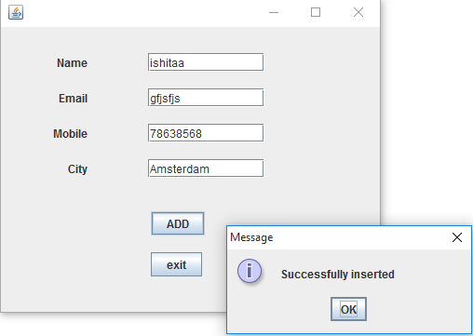

**2.Delete,Search,Display:**

***Design:***

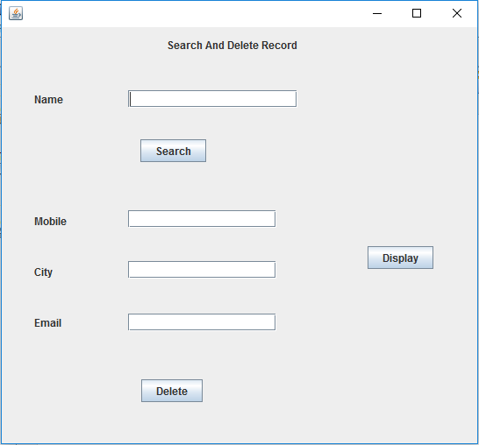

importcom.mysql.jdbc.Connection;

importcom.mysql.jdbc.Statement;

importjava.sql.DriverManager;

importjava.sql.ResultSet;

importjavax.swing.JOptionPane;

importjavax.swing.table.DefaultTableModel;

**Coding For:**

* **Search:**

String name=jTextField1.getText();

try

{

Class.forName("java.sql.DriverManager");

Connection

con=(Connection)DriverManager.getConnection("jdbc:mysql://localhost:3306/k","root","123");

Statement stmt=(Statement)con.createStatement();

String query="select*from student where name='"+name+"';";

ResultSetrs=stmt.executeQuery(query);

int found=0;

while(rs.next())

{

String mobile=rs.getString("mobile");

String city=rs.getString("city");

String email=rs.getString("email");

jTextField2.setText(email);

jTextField3.setText(mobile);

jTextField4.setText(city);

found++;

JOptionPane.showMessageDialog(this,"click OK to go to next record");

JOptionPane.showMessageDialog(this,"total no of matching records="+found);

}

}

catch(Exception e)

{

JOptionPane.showMessageDialog(this,e.getMessage());

}

* **Delete:**

String name,mobile,city,email;

name=jTextField1.getText();

try

{

Class.forName("java.sql.DriverManager");

Connection con=(Connection)DriverManager.getConnection("jdbc:mysql://localhost:3306/k","root","123");

Statement stmt=(Statement)con.createStatement();

String query="delete from student where name='"+name+"'";

int i=stmt.executeUpdate(query);

JOptionPane.showMessageDialog(null,i+"Record Deleted");

}

catch(Exception e)

{

JOptionPane.showMessageDialog(this,e.getMessage());

}

* **Display:**

try

{

Class.forName("java.sql.DriverManager");

Connection con=(Connection)DriverManager.getConnection("jdbc:mysql://localhost:3306/k","root","123");

Statement stmt=(Statement)con.createStatement();

String query="select * from student";

ResultSetrs=stmt.executeQuery(query);

DefaultTableModel model=(DefaultTableModel)jTable1.getModel();

int rows=model.getRowCount();

for(int i=0;i<rows;i++)

{

model.removeRow(0);

}

while(rs.next())

{

String name=rs.getString("name");

String email=rs.getString("email");

String mobile=rs.getString("mobile");

String city=rs.getString("city");

model.addRow(new Object[]{name,email,mobile,city});

}

}

catch(Exception e)

{

JOptionPane.showMessageDialog(this,e.getMessage());

}

***Output:***

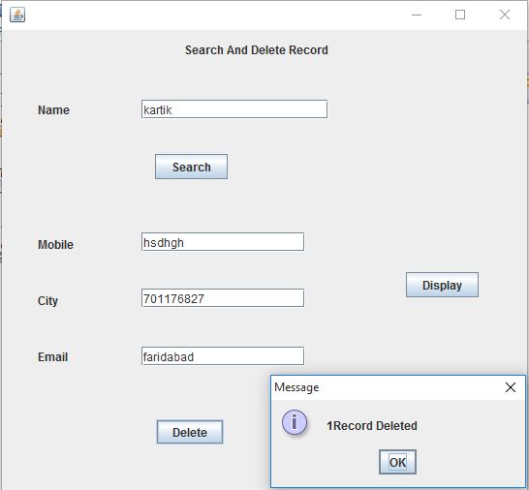



MySQL is an open source Relational Database Management System. MySQL is very fast reliable and flexible Database Management System. It provides a very high performance and it is multi-threaded and multi user Relational Database management system*.*

***DBMS (DATABASE MANAGEMENT SYSTEM)***

*To create and maintain a database on a computer we need a database program called DATABASE MANAGEMENT SYSTEM or DBMS. Database Management System is software that enables users to create and maintain database. Examples of some important database management system are MySQL, PostgreSQL, Microsoft Access, Oracle, Microsoft SQL Server, DB2 and Sybase.*

***RDBMS (RELATIONAL DATABASE MANAGEMENT SYSTEM)***

RDBMS stands for Relational Database Management System. RDBMS is the basis for SQL, and for all modern database systems like MS SQL Server, IBM DB2, Oracle, MySQL, and Microsoft Access. The data in RDBMS is stored in database objects called tables. A table is a collection of related data entries and it consists of columns and rows.

***Classification of SQL statements***

SQL provides many different types of commands used for different purposes. SQL can be divided into following parts:

***DML commands:***A DML is a language that enables users to access on manipulates data as organized by the appropriate data model. The query and update commands form the DML part of SQL:

* **SELECT -***extracts data from a database*
* **UPDATE -***updates data in a database*
* **DELETE -***deletes data from a database*
* **INSERT INTO -***inserts new data into a database*

***DDL commands:***

The DDL commands, as the name suggests, allow you to perform tasks related to data definition. The DDL part of SQL permits database tables to be created or deleted. The most important DDL statements in SQL are:

* **CREATE DATABASE -***creates a new database*
* **ALTER DATABASE -***modifies a database*
* **CREATE TABLE -***creates a new table*
* **ALTER TABLE -***modifies a table*
* **DROP TABLE -***deletes a table*

***TCL commands:***The TCL commands used to manage and control the transactions of data in database. The most important TCL commands are:

* **COMMIT –***it make all the changes made by statement issued.*
* **ROLLBACK –***it undoes all changes since the beginning of the transaction or since save point.*
* **SAVEPOINT –***it marks**a point upto successfully completed transaction.*
* **SET TRANSACTION** –*it establish properties for the current transaction.*

***Advantages of MySQL:-***1.)MySQL is very reliable and high performance relational database management system. It can used to store many GB's of data into database.  
2.) MySQL source code is available that's why now you can recompile the source code.  
3.)MySQL supports more than twenty different platform including the major Linux distribution .Mac OS X, UNIX and Microsoft windows.

***SQL Functions***

SQL has many built-in functions for performing calculations on data.

***SQL Aggregate Functions***

SQL aggregate functions return a single value, calculated from values in a column.  
Useful aggregate functions:

* **AVG() -**Returns the average value
* **COUNT() -**Returns the number of rows
* **FIRST() -**Returns the first value
* **LAST() -**Returns the last value
* **MAX() -**Returns the largest value
* **MIN() -**Returns the smallest value
* **SUM() -**Returns the sum

***SQL Scalar functions***

SQL scalar functions return a single value, based on the input value.  
Useful scalar functions:

* **UCASE() -**Converts a field to upper case
* **LCASE() -**Converts a field to lower case
* **MID() -**Extract characters from a text field
* **LEN() -**Returns the length of a text field
* **ROUND() -**Rounds a numeric field to the number of decimals specified
* **NOW() -**Returns the current system date and time
* **FORMAT() -**Formats how a field is to be displayed

**MySQL Programs**

**1) Consider the following table STREAM and answer the following questions:**

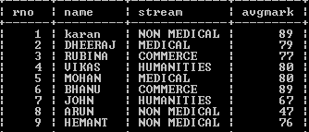

**a)Write the query to display the names of the students scoring more than 75.**

**b)Write the query to find the different streams.**

**c)Write the query to display the details of students whose name starts with B.**

**d)Write the output of SELECT SUM(AVGMARK) FROM STREAM WHERE STREAM=”NON MEDICAL”;**

* **Solution**

*a)SELECT NAME FROM STREAM WHERE MARKS>75;*

*b)SELECT DISTINCT STREAM FROM STREAM;*

*c)SELECT * FROM STREAM WHERE NAME LIKE ”B%”;*

*d) 212*

**2) Consider the following table JOB and answer the following questions:**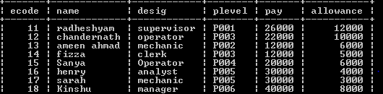

**a)Write the query to display name, ecode of the employees whose plevel=P003.**

**b)Write the query to display the designation of employees whose allowance is more than 6000.**

**c)Write the output of SELECT * FROM JOB WHERE PAY>20000 AND DESIG=”MECHANIC”;**

**d)Write the output of SELECT DISTINCT PLEVEL FROM JOB;**

* **Solution**

*a)SELECT NAME,ECODE FROM JOB WHERE PLEVEL=”P003”;*

*b)SELECT DESIG FROM JOB WHERE ALLOWANCE>6000;*

*c)17,sarah,mechanic,P005,30000,3000*

*d)6*

**3) Consider the table COACH and answer the following questions:**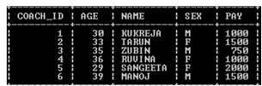

**a)Write the query to display the age of females.**

**b)Write the query to display the amount to be paid by males.**

**c) Write the query to display the COACH_ID,NAME,PAY,SEX WHERE AGE MORE THAN 30.**

* **Solution**

*a)SELECT AGE FROM COACH WHERE SEX=’F’;*

*b)SELECT SUM(PAY) FROM COACH WHERE SEX=’M’;*

*c) SELECT COACH_ID,NAME,PAY,SEX FROM COACH WHERE AGE >30;*

**Q4 Consider the table EMPLOYEE and answer the given questions:**

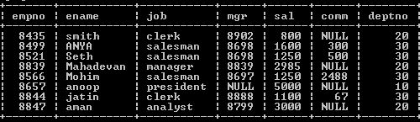

**a)Write the query to show the names of all the salesman.**

**b)Write the query to show different jobs.**

**c)Write the query to change jatin’s job to salesman.**

**d)Write the output of SELECT COUNT(DISTINCT JOB) FROM EMPLOYEE;**

**e)Write the output of SELECT SUM(SAL) FROM EMPLOYEE WHERE DEPTNO=20;**

* **Solution**

*a)SELECT ENAME FROM EMPLOYEE WHERE JOB=”SALESMAN”;*

*b)SELECT DISTINCT JOB FROM EMPLOYEE;*

*c)UPDATE TABLE EMPLOYEE SET JOB=”SALESMAN” WHERE ENAME=”JATIN”;*

*d)5*

*e)6785*

**Q5 Consider the table COMPUTER and answer the questions:**

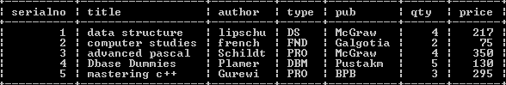

**a)Write the query to find the total qty of books.**

**b)Write the query to display the title of book by author Plamer.**

**c)Write the query to display the title,author,type,pub from computer for serialno 4.**

**d)Write the query to display the contents in descending order of quantity and ascending order of title.**

* **Solution**

*a)SELECT SUM(QTY) FROM COMPUTER;*

*b)SELECT TITLE FROM COMPUTER WHERE AUTHOR=”PLAMER”;*

*c)SELECT TITLE, AUTHOR, TYPE, PUB FROM COMPUTER WHERE SERIALNO=4;*

*d)SELECT * FROM COMPUTER ORDER BY TITLE,QTY DESC;*

Html

1) To create a free mail India form.

**Source Code**

**<HTML>**

**<HEAD><TITLE> USING FORMS </TITLE></HEAD>**

**<BODY>**

**<CENTER>**

**<FONT face="Courier New" size=5 color=red>FREE MAIL**

**INDIA.COM</FONT>**

**<br>**

**<FONT size=3>**

**<I>Get a FREE MAIL INDIA! ID and connect to people</I>**

**</FONT>**

**<COMMENT>Beginning of form tag</COMMENT>**

**<FORM NAME="FORM1" ACTION = "validate.html" METHOD = "GET">**

**<B> Personal Details </B></CENTER>**

**Enter your name:**

**<INPUT TYPE="TEXT" SIZE=30 NAME="t1"><br>**

**Gender. . . . . . .:**

**<INPUT TYPE="RADIO" NAME="r1"> MALE**

**<INPUT TYPE="RADIO" NAME="r1"> FEMALE <br>**

**Country . . . . . .:**

**<INPUT TYPE="TEXT" SIZE=30 NAME="t2"><br><br>**

**<B><CENTER>Select an ID and password:</CENTER></B>**

**Desired Email ID . :**

**<INPUT TYPE="TEXT" SIZE=30 NAME="t3"><BR>**

**Password . . . . . . .:**

**<INPUT TYPE="PASSWORD" SIZE=20 NAME="t4">**

**<FONT size=2><I> minimum 5 characters</I></FONT><br>**

**Re-type password :**

**<INPUT TYPE="PASSWORD" SIZE=18 NAME="t5"><br><br>**

**<CENTER><INPUT TYPE="SUBMIT" value="Create MyAccount"**

**name="s1"></CENTER>**

**</FORM></BODY></HTML>**

Result

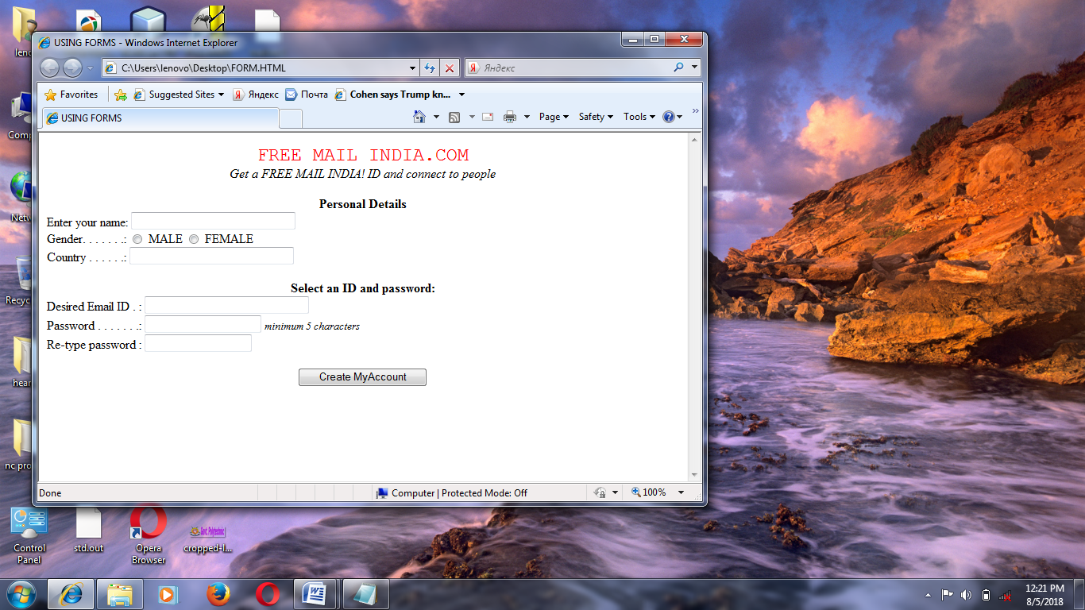

2) To create a webpage of hospital industry.

Source code

**<html>**

**<head>**

**<title>**

**Tourism Industry**

**</title>**

**</head>**

**<body bgcolor="white">**

**<h1 align=centre> Hospital Industry </h1>**

**<hr>**

**<imgsrc="file:///C:/Users/sai/Desktop/13.jpg" align="right" height="400" width="500">**

**<font color=red>**

**<p>**

**One of the industries which is on the path of rapid growthis the hospitality industry**

**<br>**

**The hotels today aims to provide the highest standard of accomodation,facilities and services at competitive prices.**

**<BR>**

**</p>**

**</font>**

**<FONT color = blue>**

**<h4> Hotels are broadly classified as : </h4>**

**<table border="20">**

**<tr>**

**<th><B> HOTELS</b></td>**

**<th><b> RESORTS</B></td>**

**</tr>**

**<tr>**

**<td> business hotels</td>**

**<td>liesure hotels </td>**

**</tr>**

**<tr>**

**<td> budget hotels </td>**

**<td> heritage hotels </td>**

**<h1><font color=gold> Departments in Hotels </font></h1>**

**<font color="green">**

**<ahrefsrc="C:\Users\user9\Desktop\front.html" Front Ofice />**

**</font>**

**<font color="blue">**

**<ul type="circle"><li> Reservations**

**<li> Receptions**

**<li> Guest Relations**

**</ul>**

**</font>**

**<font color="green">**

**<ahrefsrc="C:\Users\user9\Desktop\food.html> 2.Food and Beverages />**

**</font>**

**<font color="blue">**

**<ul type ="square">**

**<li> Room Service**

**<li> Coffee Shop**

**<li> Restaurant**

**</ul>**

**</font>**

**<hr color="black">**

**<div align="centre">**

**For all further enquiries: Contact us**

**</div></body></html>**

Result

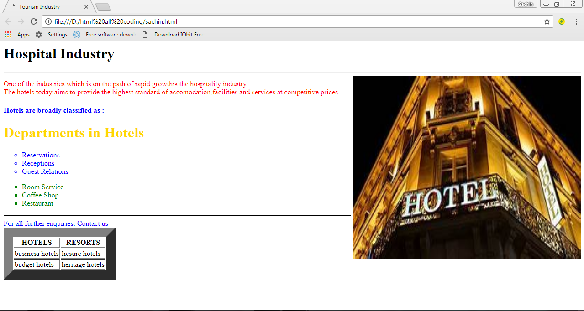

3) To create a webpage of a Computer Virus.

**Source Code**

**<HTML>**

**<HEAD>**

**<TITLE> Computer Viruses</TITLE>**

**</HEAD><BODY BGCOLOR= #00ffff Topmargin=40 leftmargin=40>**

**<BASEFONT SIZE=3 FACE="Arial">**

**<IMG src="C:\Users\admin\Desktop\VANSHIKA\photo1.jpg" width="78" height="46" align="left">**

**<H1>What is Computer Virus.??</H1>**

**<p align=left> A <b>virus</b> is basically an <i>executable file</i> that isdesigned such that it is able to infect documents, has ability to survive by <u>replicating</u> itself.<br>**

**Usually to avoid detection, a virus disguises itself as a legitimate program that a user would not normally suspect to be virus. </p>**

**<H2>Whar Virus can do? </H2>**

**<p><font size=5 color= #ff0000 >Viruses </font>are designed to corrupt or delete data on the hard disk, i.e. on the FAT (File Allocation Table).</p>**

**<H2> Types of Virus </H2>**

**<hr size=6 width=100% noshade>**

**<Font color= Maroon>**

**<p> Boot Sector Viruses </p>**

**<p> File or Program Viruses</p>**

**<a href="http://www.google.com/" ><font color="0000ff" size=4> Get more on Google.com</font></a>**

**</BODY>**

**</HTML>**

Result

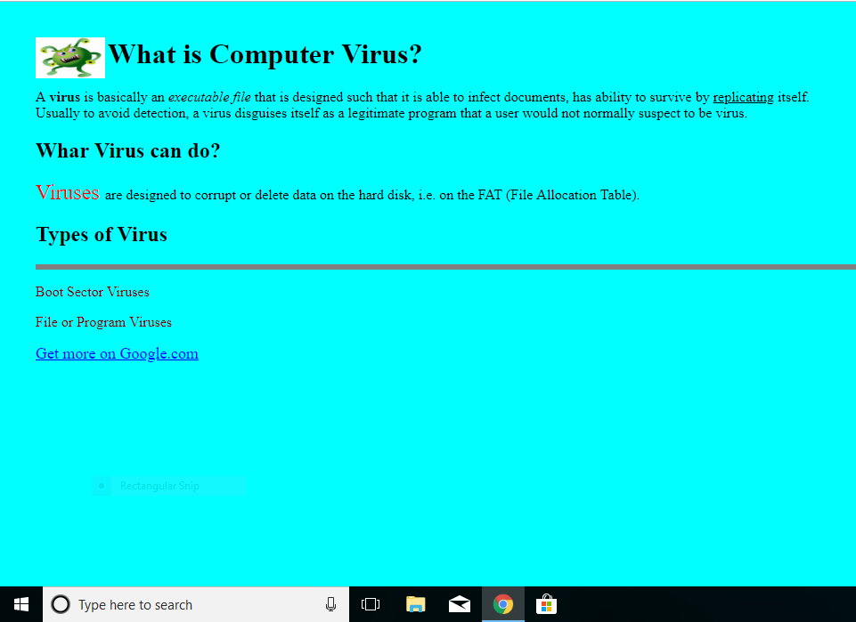

4) To create a webpage of VatikaRestaurant.

**Source Code**

**<html>**

**<head>**

**<title>VATIKA</title></head>**

**<body bgcolor="lavender" link="purple" vlink="green">**

**<h1 align=center><font color:"maroon">VATIKA RESTAURANT</font></h1>**

**<hr size=3 color=black><br>**

**<basefont face="Arial">**

**<p>Welcome to <b><font color:red>VATIKA RESTAURANT.</font></b> Your taste buds are in for a treat of their lives.This is where all the good food is.You'll love the ambience and the food is out of this world.**

**<br>**

**<p> We offer the following :</p></br>**

**<ol><li><a href="india.html">Indian</a>**

**<ul type=disc>**

**<li>MUGHLAI**

**<li>PUNJABI**

**<li>SOUTH INDIAN**

**</ul>**

**<li><a href="inter.html">International</a>**

**<ul type=square>**

**<li>CONTINENTAL**

**<li>CHINESE**

**<li>THAI**

**</ul><br></ol><br>**

**<table align=center border=2>**

**<tr><thcolspan=2>Timings</th>**

**<tr><td>Breakfast</td><td>8.00 to 11.00 am</td></tr>**

**<tr><td>lunch</td><td>12.00 to 3.00 pm</td></tr>**

**<tr><td>Dinner</td><td>7.00 to 11.00 pm</td></tr>**

**</table>**

**<hr size=3 color=black>**

**<br>**

**<p align=center style="font-size:3px">**

**For enquiries and Reservations call 1258543456</p>**

**</body>**

**</html>**

Result

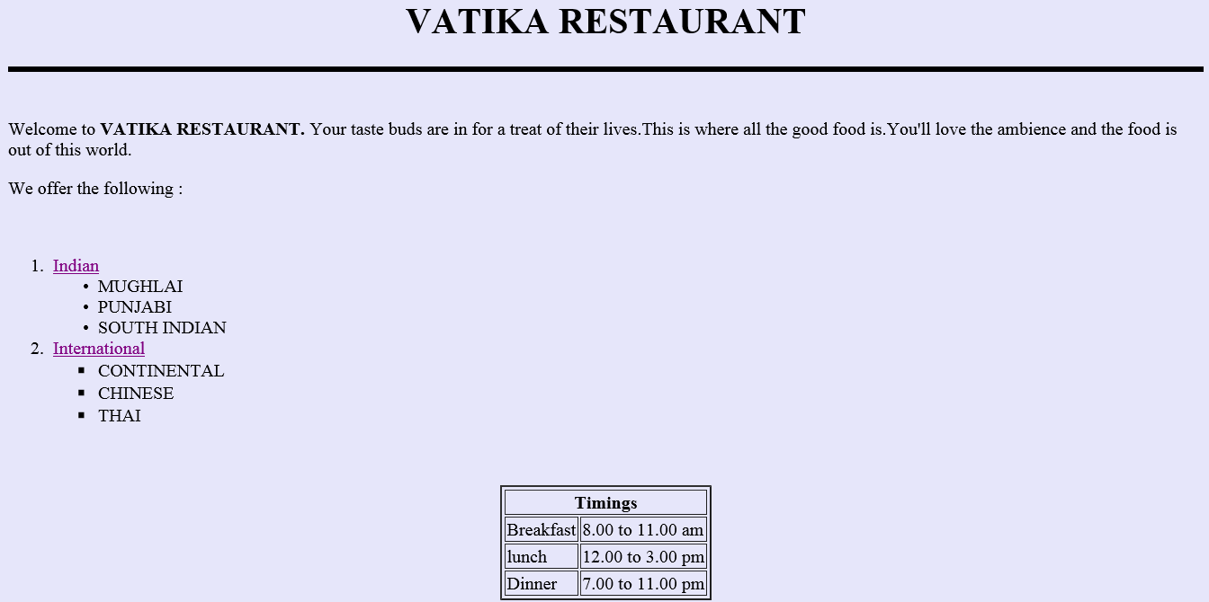

5)To create a webpage of animation industry.

**Source Code**

**<html>**

**<head><title>Animation basics</title></head>**

**<BODY bgcolor=olive>**

**<font face ="arial" color = "red">**

**<h3 align = "center">Animation Industry</h3></font>**

**<hr size = 5 color = "red" width = 50%>**

**<hr size =5 olor = "red"></font>**

**<font face ="arial">**

**Inblatin'anima' means soul. Animation is all about giving soul to a character.**

**<br>It is about moving somethinghwhihcanot move itself.**

**<imgsrc = "" align ="right"><p><p><p>**

**some of popular animation techniques are:<p>**

**<ul type = "square">**

**<li>2D Cell animation<a/></ul>**

**<dl><dd>**

**Also known as traditional animation, 2D animation involves the creation of a high volume of separate drawing thast defines a sequence.</dd></ul>**

**<ul type = "square">**

**<li>3D CGI animation<a/></ul>**

**<dl><dd>**

**This technique makes extensive use of animation software programmes, 3D object are constructed using curve or 2D geometric figures.</dd></ul>**

**<ul type = "square">**

**<li>3D motion capture animation<a/></ul>**

**<dl><dd>**

**This process of creating 3D characters is similar to the 3D CGI animation technique: however, the techniques differ with respect to the time when the animation effects are introduced.</dd></ul><p><p>**

**<table border = 5 bordercolor = "red" align = "center">**

**<tr>**

**<th>Cource type</th>**

**<th>Cource duration</th>**

**</tr>**

**<tr>**

**<th>Carrer courses</th>**

**<th>2 year</th>**

**</tr>**

**<tr>**

**<th>professional courses</th>**

**<th>1 year</th>**

**</tr>**

**<tr>**

**<th>short term cources</th>**

**<th>3-6 month</th>**

**</tr></table></body></html>**

Result

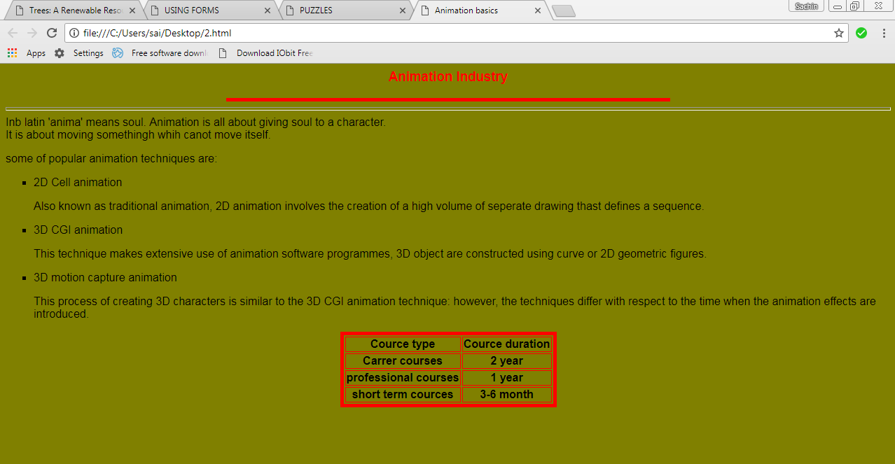

Bibliography

* [***www.google.com***](http://www.google.com)
* [***www.ncert.nic.com***](http://www.ncert.nic.com)
* [***www.sumitaarora.com***](http://www.sumitaarora.com)
* ***XII CBSE NCERT book***

***Teacher’s evaluation report***

***Project evaluation***

*School name-****St.John’s School***

*Student Name-****Kartik Gupta***

*Roll No-*

*Class-****XII***

***Teacher’s assessment***

* *Content,accuracy and originality*
* *Presentation*
* *Process of project compilation*
* *Overall remarks*

**Teacher signature**-____________________

**Date**-___________________