Currency Converter System
VITyarthi – Build Your Own Project
Student-level project documentation. I have kept the explanation simple and matched it to the actual three-module code.

1. Introduction
This project is a simple menu-based Currency Converter System. I selected this problem because currency conversion is a small real-world task that can be made easier with a Python program. I kept the project simple enough for me to understand and explain during evaluation.

2. Problem Statement
Doing repeated currency calculations manually can be inconvenient. The proposed system accepts an amount, a source currency and a target currency, then calculates the converted value. It also keeps a local history of previous conversions.

3. Objectives
The objectives are to solve a real-world problem using Python, divide the program into three meaningful modules, use file handling, demonstrate CRUD operations, validate common inputs, maintain conversion history and prepare proper documentation.

4. Target Users
The target users are students, beginners learning Python, travellers checking approximate currency values and users who want a simple local currency calculator.

5. Scope
The system supports conversion, currency viewing, adding, updating and deleting currencies, history viewing/searching/clearing and a simple report. It does not use live exchange rates, online payments or a graphical interface.

6. Functional Requirements
FR1: currency conversion. FR2: view currencies. FR3: add currency. FR4: update a rate. FR5: delete a currency. FR6: store history. FR7: search and clear history. FR8: view and save a report.

7. Non-Functional Requirements
Usability through a simple menu; reliability through local file storage; maintainability through three clearly separated modules; performance suitable for a small local dataset; portability through the Python standard library; and scalability for future features.

8. Technology Used
Python 3 and its standard library are used. The project uses functions, conditions, loops, dictionaries, modules, text-file handling and basic validation. No external package is required to run the application.

9. Currency Data
The initial sample currencies are INR, USD, EUR, GBP, JPY and AUD. Rates represent the INR value of one unit of each currency. These are fixed academic sample rates and are not live market rates.

10. System Architecture
The project has three main modules. converter.py handles calculation, currency_manager.py handles currency data and CRUD, and history_manager.py handles history and reports. main.py controls the menu and connects these modules.

11. Module Description
converter.py contains the conversion formula. currency_manager.py loads and saves rates and performs Create, Read, Update and Delete operations. history_manager.py stores conversion records, supports searching and clearing, and creates the simple report. main.py acts as the controller.

12. Conversion Logic
The system first changes the source amount into INR and then changes INR into the target currency. Formula: Amount in INR = Amount × Source Rate. Converted Amount = Amount in INR ÷ Target Rate. This allows many currency pairs without writing a separate formula for each pair.

13. Data Storage
The program uses currencies.txt for rates, history.txt for conversion history and conversion_report.txt for the generated report. Text files were selected because they are simple and suitable for this course-level project.

14. CRUD Operations
Create is adding a currency. Read is viewing currencies and history. Update changes an existing currency rate. Delete removes a currency while protecting INR because it is the base currency.

15. Error Handling
The program checks invalid menu choices, invalid numeric input, zero or negative amounts, unknown currency codes, duplicate currency codes and invalid three-letter codes. The validation is kept simple so the code remains understandable.

16. Testing
Testing covers normal conversions, reverse conversions, invalid inputs, CRUD operations, history search/clear and report saving. The detailed test cases are included in docs/testing.md.

17. Design Documentation
The project includes a process-flow diagram, architecture diagram, use-case diagram, component diagram and sequence diagram. These diagrams describe the actual three-module structure rather than adding unnecessary components.

18. GitHub Organization
The repository contains the source code, README, project statement, data files, diagrams, testing document and report. This structure makes the project easier to understand and upload to GitHub.

19. Limitations
The exchange rates are fixed sample values, there is no live API, the application is command-line based and text files are used instead of a database. These choices were made to keep the project simple and explainable.

20. Future Enhancements
Future versions could use a live exchange-rate API, a graphical interface, a database, user accounts, automated unit tests and more detailed charts.

21. Conclusion
The Currency Converter System shows how a small real-world problem can be solved with a structured Python program. The three-module design keeps the project organized while still being simple enough for a student to understand, demonstrate and explain.

22. Project Structure
main.py connects three main modules: converter.py, currency_manager.py and history_manager.py. The data folder contains the text files used by the program.

23. Design Diagrams

Process Flow
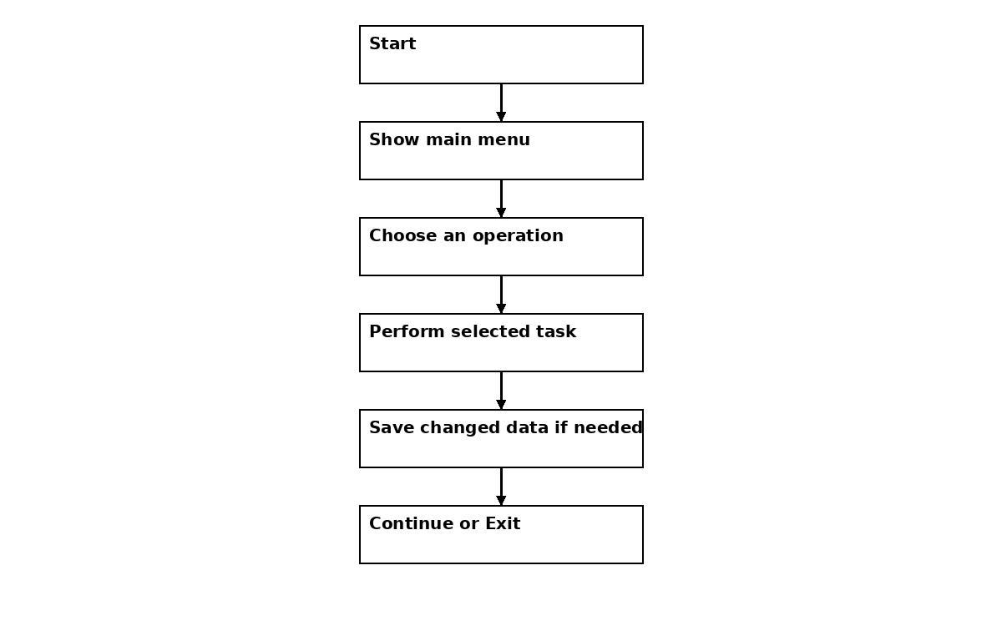

Architecture
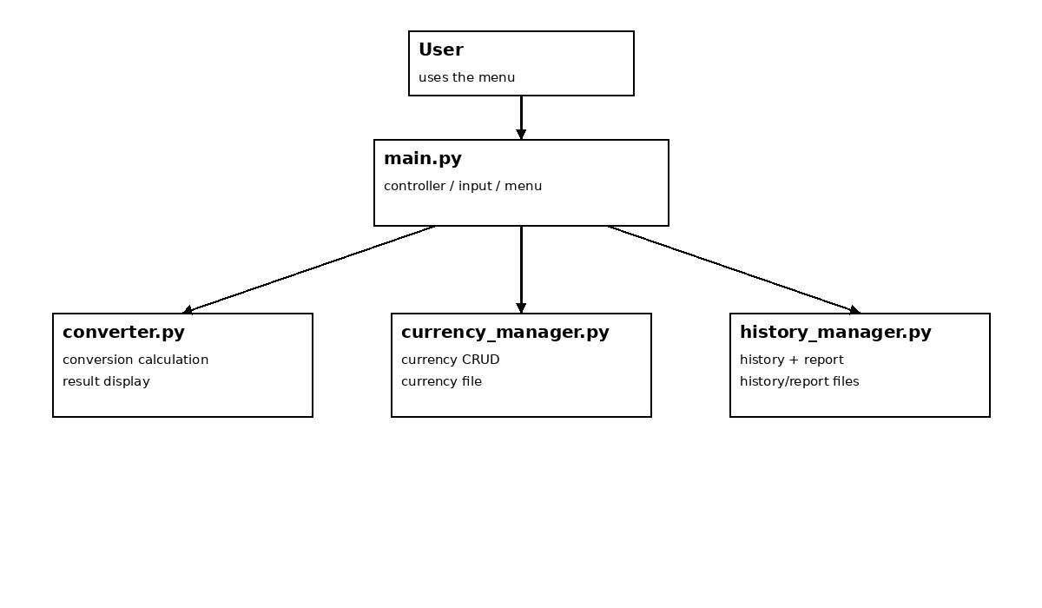

Use Case
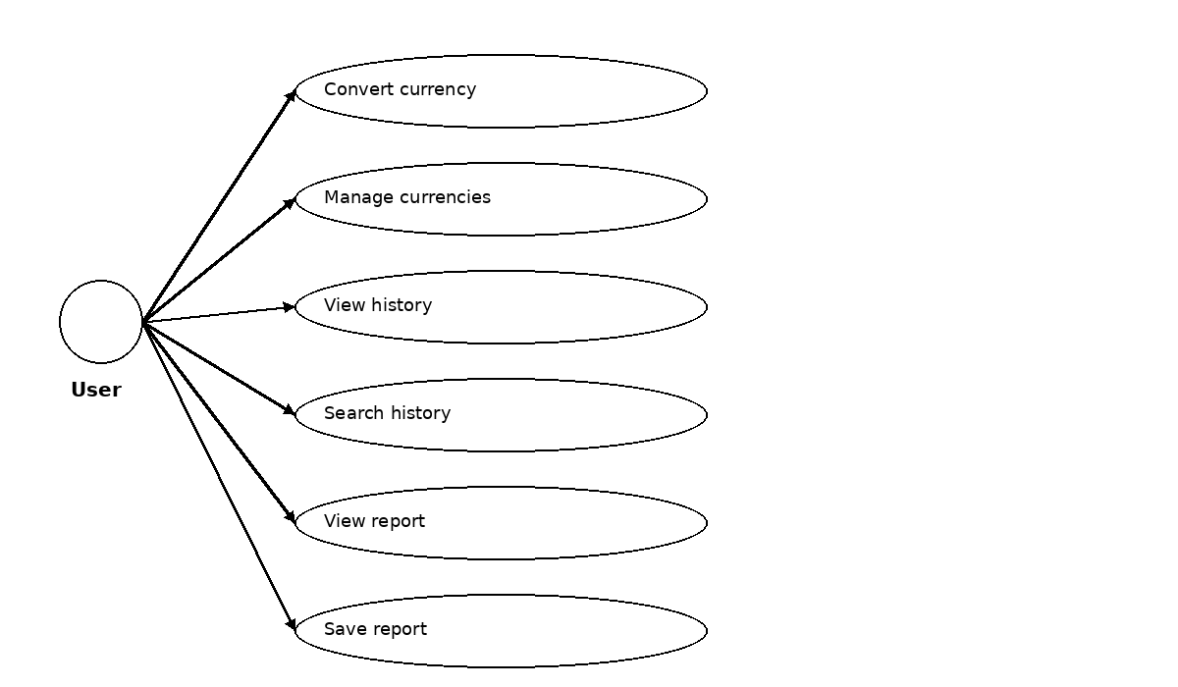

Component Diagram
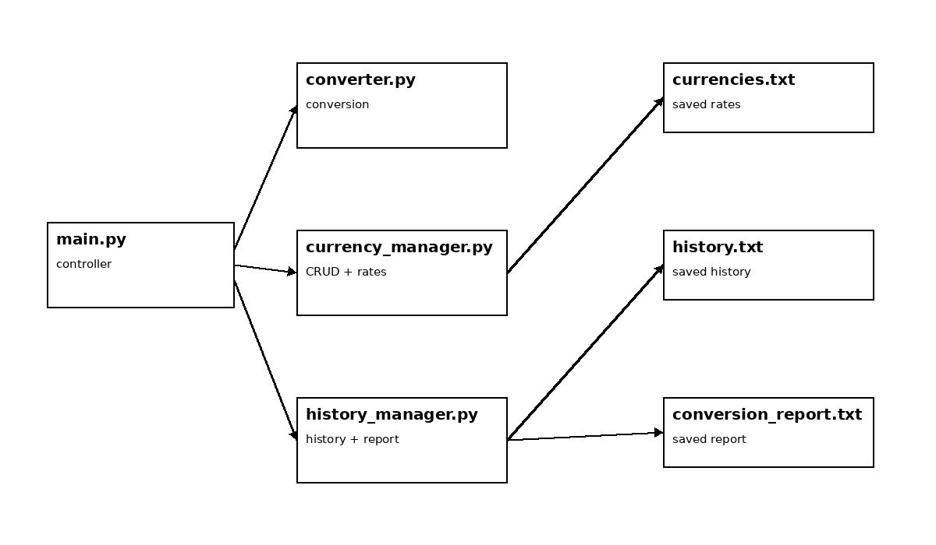

Sequence Diagram
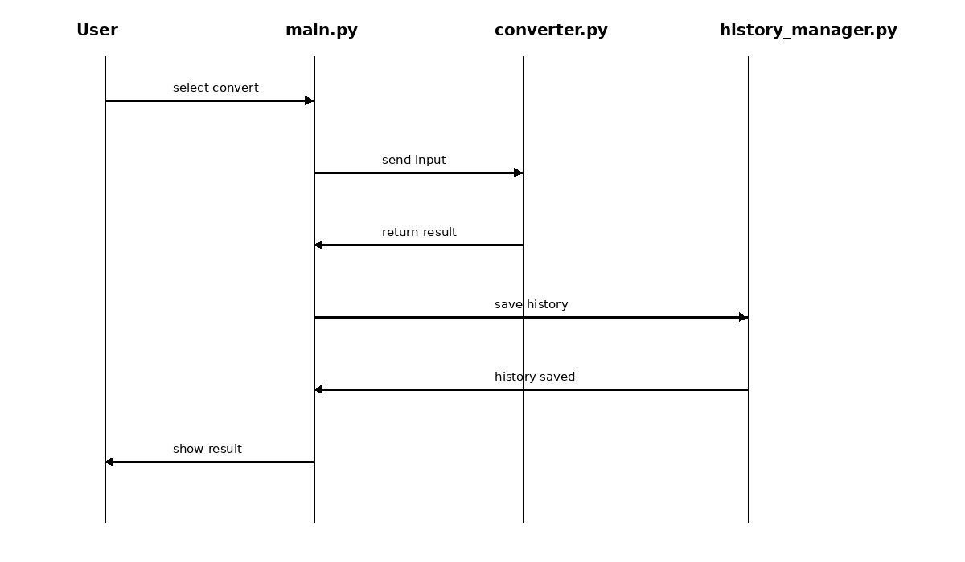

24. Test Case Summary
ID | Test | Expected result
T01 | 100 USD to INR | 8300 INR
T02 | 1000 INR to JPY | Approx. 1785.71 JPY
T03 | Zero amount | Rejected
T04 | Text as amount | Valid-number message
T05 | Invalid menu choice | Invalid-choice message
T06 | Add currency | Currency saved
T07 | Duplicate currency | Rejected
T08 | Update rate | New rate saved
T09 | Delete INR | Rejected
T10 | View history | History displayed
T11 | Search history | Matching record displayed
T12 | Save report | Report file updated

25. Viva Explanation
If I am asked to explain the project, I can start with the problem, show the three modules, demonstrate one conversion, explain the CRUD operations, show the text-file storage and history, and finish with testing and future improvements.

