**Karthik Pradeep Hegadi**

**2KE20CS032**

**Assignment 3**

1)Open browser and navigate

<https://filezillaproject.org/download.php?platform=win64>

2)Download filezilla client and install the application

3)Install and open the application

4)NavigatetoFile->sitemanager->Newsite

5)Provide all the details in the fields (port22) and then click on connect

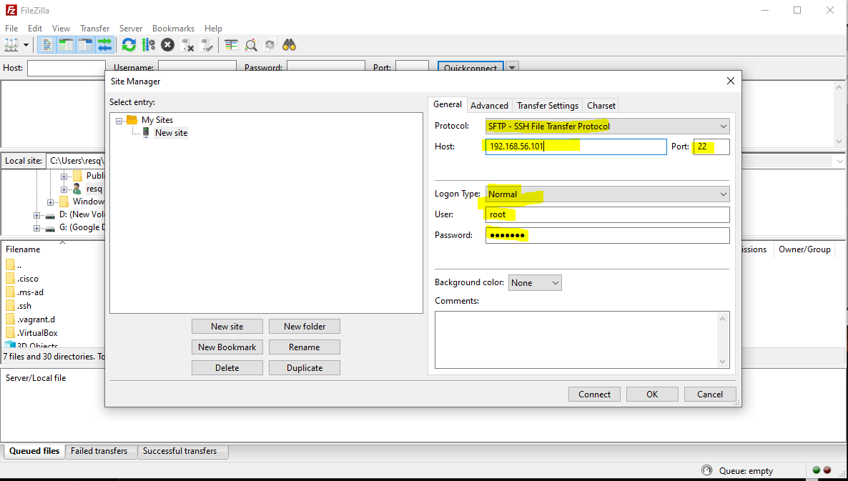

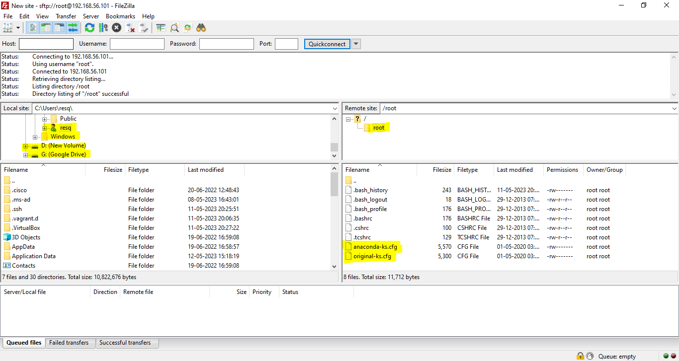

6)Successful connection will have the window opened listing all the files & folders

7) Transfering the test file from windows machine to linux centos machine 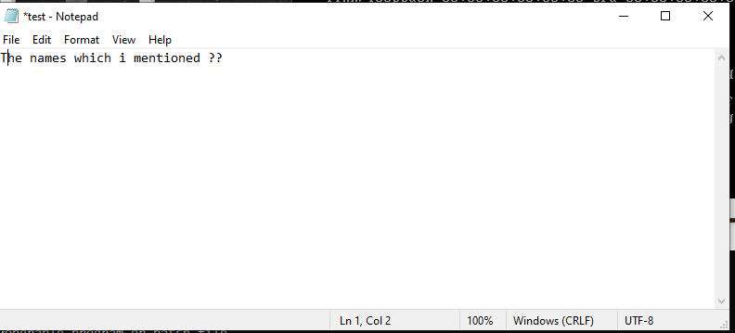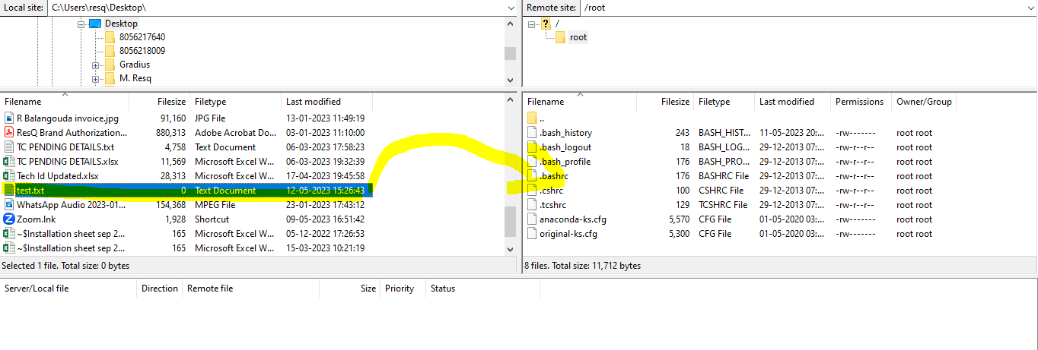

8) After the transfer of file from linux machine.

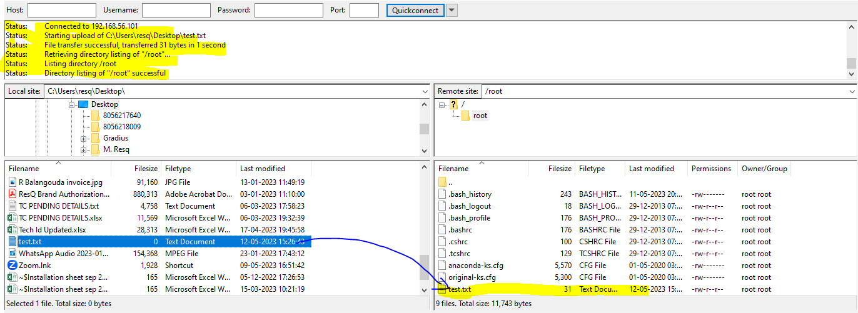

9) listing the files using **ls** command



10) opening the test text file in linux machine using vi editor

