**Karthik Pradeep Hegadi**

**2KE20CS032**

**Assignment 1**

1)Log in to your centos machine with root user id and password.

3)Openthessh_configfile“sudovi/etc/ssh/sshd_config” and change the line saccording to below lines remove

“#”Port22remove

“#”Permitrootloginremove“

#”PasswordAuthenticationyesremove

“#”PubkeyAuthenticationyes

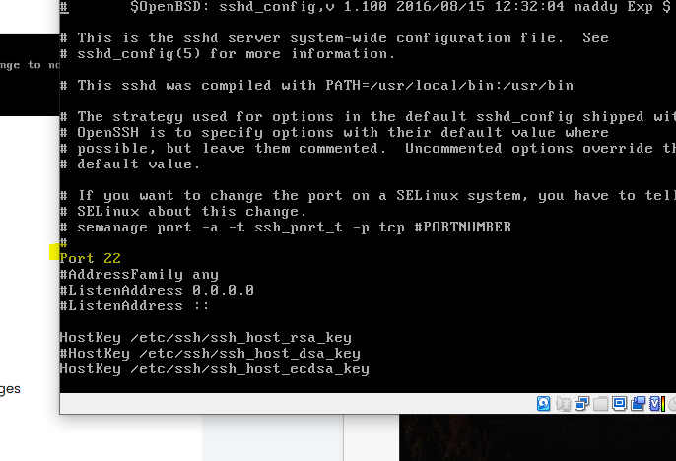

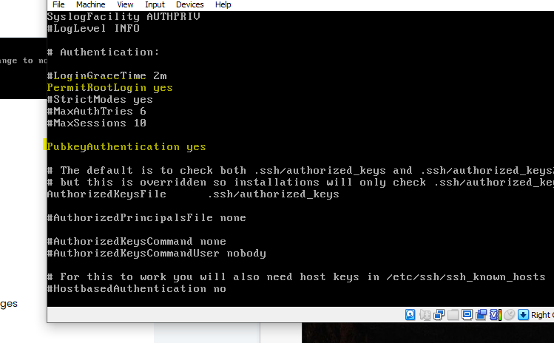

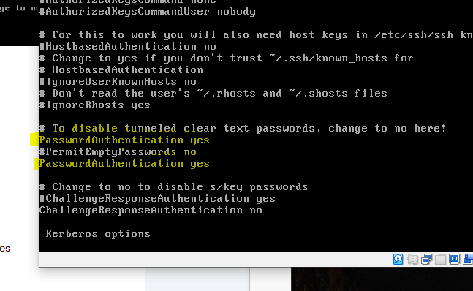

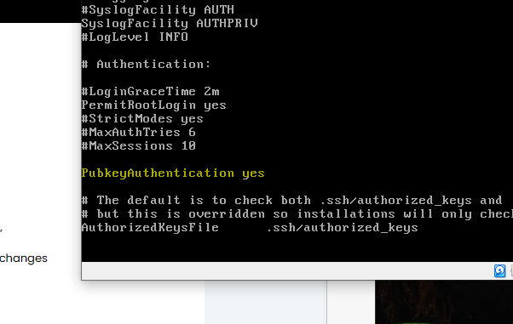

2)Run the command to install ssh in your server“sudoyum–yinstallopenssh-serveropenssh clients”

4)Restart the ssh server“sudo systemctl restart sshd”

5)Now open your virtualbox and apply the following changes

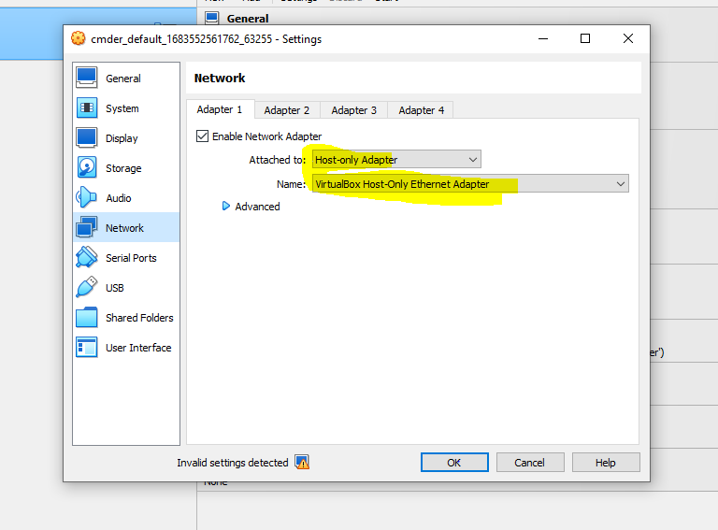

6)Open your centos server and type“ifconfig”and verify the ip addressis generated

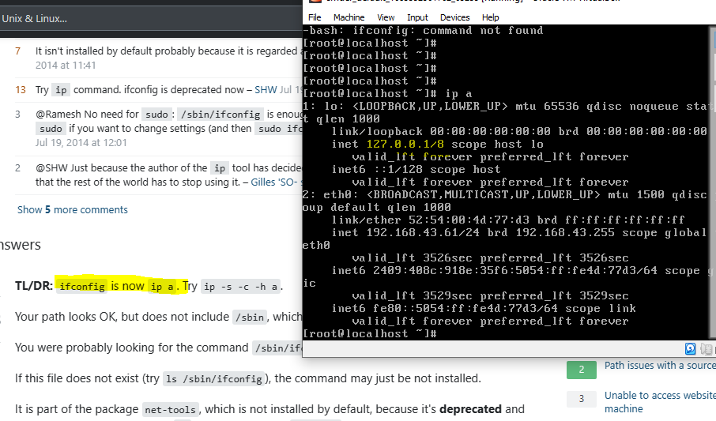

7)Open your windows command prompt and runs u sername@yourip and verify you are able to open centos using ssh.

