O R V E R A
engineered for a circular future
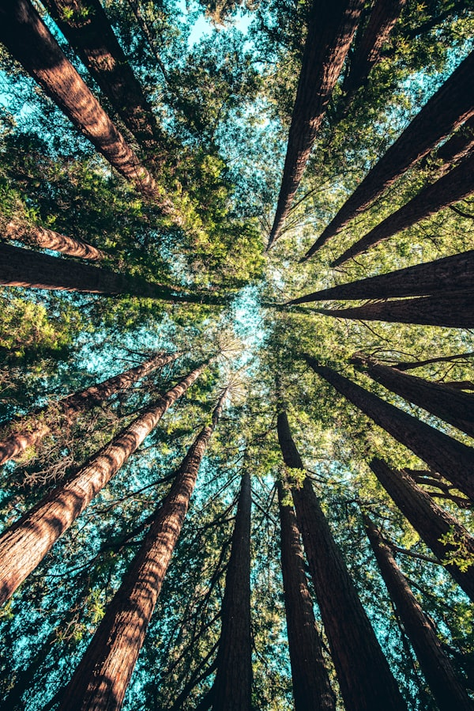
Website Copy Specifications
June 2026 • Version 2.6 • Design Redesign Edition

Brand Copy & Design Specifications
This document presents the complete editorial copywriting, navigation content, and interface values for the redesigned ORVERA website. The copy focuses on minimalism, luxury aesthetics, and professional storytelling, avoiding SaaS tech-heavy startup buzzwords.

Directory Index
1. Home Page Copy (Headlines, Taglines & CTAs)
2. About Us Copy (Story, Mission, Vision & Timeline)
3. Product Catalog (Cutlery, Bottles, Packaging Specs & Details)
4. Why Orvera & Ecological Validation Badges
5. Customer FAQ (10 Core Q&As)
6. Contact Form & Backend Integration Specifications

1. Home Page Copy
Hero Text (Primary Headline):
Redefining Packaging. Preserving Nature.
Hero Tagline Badge:
A Circular Future
Hero Intro Copy:
ORVERA engineers premium, bio-based alternatives to single-use plastics. By combining minimalist aesthetics with advanced plant-fiber technology, we offer a luxury experience that returns to the earth without leaving a trace.
Call to Actions (CTAs):
- Primary button: 'Explore Products' (smooth scrolls to Products section)
- Secondary button: 'Our Story' (smooth scrolls to About section)

2. About Us Copy

2.1 Brand Story (The Genesis)
Founded with a vision to eliminate single-use plastic waste, ORVERA bridges the gap between high design and environmental responsibility. We believe that packaging should not be a compromise, but a reflection of quality and care.
Our team engineers luxury everyday essentials from agricultural crop residues, turning what would be burned or discarded into highly functional, beautifully crafted products. By honoring organic materials, we deliver utility that respects the land.

2.2 Mission & Vision
Mission Statement:
To replace non-biodegradable polymers with circular, plant-based materials, establishing a new global standard for luxury eco-packaging that leaves zero waste behind.
Vision Statement:
A world where product design, modern luxury, and ecological balance exist in absolute harmony—nurturing both business needs and the ecosystems we depend upon.

2.3 Brand Milestone Journey
2024: Conception & Research
Research into agricultural waste composites (sugarcane bagasse and wheat straw) to replace commercial polymers.
2025: Material Breakthrough
Formulation of our compression molding methods and development of a starch-based water barrier coating.
2026: Sourcing Partnerships
Established direct crop residue supply networks with farming cooperatives in North India.
2026: Commercial Pilot
Initiated tableware and bio-bottle test integrations with 15 boutique organic cafes and resorts.

3. Product Specifications

3.1 Eco Cutlery
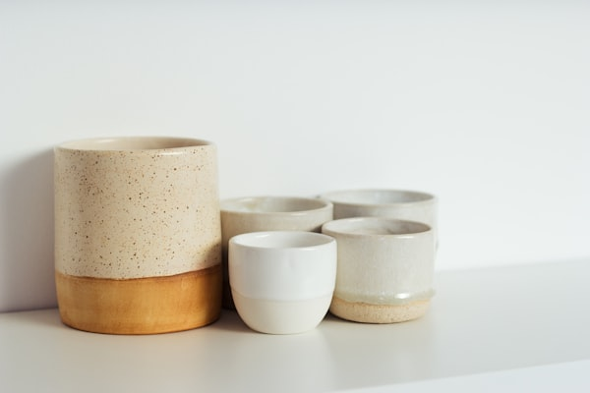
Crafted from 100% natural, fast-growing organic bamboo. Beautifully styled, splinter-free, and structurally rigid, this premium cutlery set decomposes naturally in home compost, making it the perfect choice for high-end hospitality, boutique events, and everyday luxury.
Material | 100% Moso Bamboo Pulp & Organic Fiber
Structural Durability | Strong, heat-resistant, reusable up to 5 times
Heat Tolerance | Up to 110°C (230°F) - Microwave & Freezer safe
Decomposition | Home compostable (45-60 days)

3.2 Eco Bottles
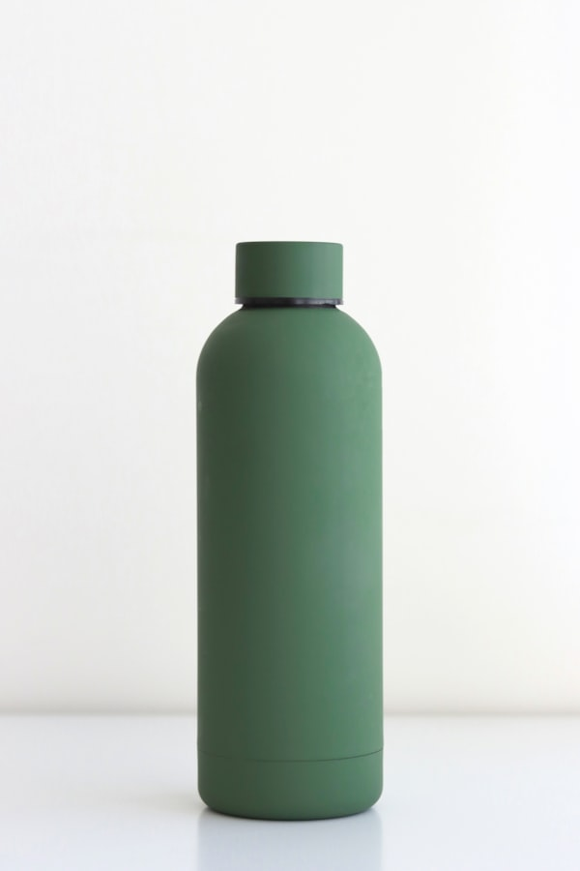
Bio-based paper water bottles made from agricultural crop residues (sugar cane bagasse and wheat straw), coated with an ultra-thin compostable water barrier. Built to be lightweight, impact-resistant, and entirely plastic-free. Fully degrades without microplastics.
Material | Sugarcane Bagasse & Wheat Straw Residues
Waterproof Layer | Plant starch, Lipids & PCL composite
Capacity Profile | 330 ml, 500 ml, 750 ml capacities
Shelf Life | 8 to 12 months filled shelf life
Decomposition | Compostable in soil within 60-90 days

3.3 Eco Packaging
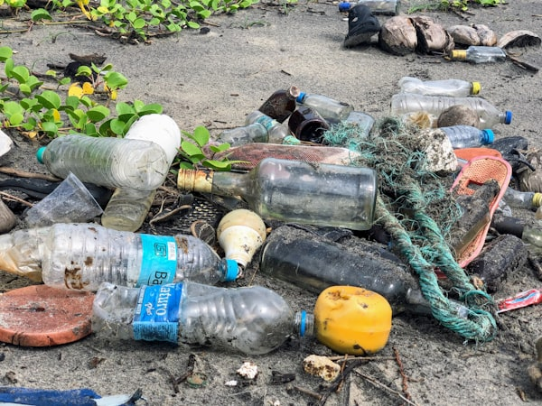
Bespoke paper wrappers, boxes, and protective sheets made from recycled organic pulp. Designed specifically for luxury brands, our custom eco-packaging provides unmatched protection while showcasing a premium textured aesthetic that delights customers.
Material | Recycled Plant Pulp & Corn Starch binding
Properties | High shock absorption and insulation profiles
Custom Options | Custom sizes, structural formats, and soy ink print
Decomposition | Compostable in home soil within 60-120 days

4. Why Orvera & Verification Badges

4.1 Five Pillars of Excellence
01. Zero Microplastics
Unlike conventional polymers, ORVERA products utilize plant-derived lipids and starches. They leave behind absolutely no synthetic chemical residues or microplastics in the ecosystem.
02. Agriloop Innovation
We source raw agricultural waste (like wheat straw and sugarcane bagasse) directly from local farmers, supporting rural economies while preventing agricultural burning.
03. Circular by Design
Every product is engineered with a circular lifecycle. They seamlessly biodegrade in home or industrial composting settings within 45 to 120 days, enriching the soil.
04. Minimalist Luxury
We prioritize elegant proportions, warm sand-tones, and natural textures. Sustainability does not mean sacrificing the premium experience of a luxury brand.
05. Carbon Reduction
By using renewable energy sources and agricultural residues, our production processes reduce carbon dioxide emissions by up to 90% compared to PET plastics.

4.2 Ecological Certifications
BPI Compostable — Certified fully biodegradable under ASTM D6400 guidelines.
FSC Certified — Raw pulp sourced only from responsibly managed forest networks.
USDA Biobased — Verified 100% renewable bio-based chemical composition.
FDA Approved — Certified food-grade contact surfaces with zero leaching risks.

5. Frequently Asked Questions
Q1: What is Orvera's core material?
ORVERA products are built from organic plant fibers, including bamboo pulp, sugarcane bagasse, and wheat straw, bound with natural starches. They are 100% bio-based.
Q2: Are Orvera products certified compostable?
Yes. Our materials comply with international composting standards (including ASTM D6400 and EN 13432), ensuring they biodegrade fully without toxic remains.
Q3: Can the Eco Bottles hold hot liquids?
Our current line is optimized for cold and ambient liquids up to 50°C (122°F). We are actively testing high-temperature coatings for coffee and tea applications.
Q4: How long does decomposition take?
In standard home composting conditions, products break down within 45 to 120 days depending on soil moisture and temperature. In industrial facilities, it takes less than 30 days.
Q5: Do the Eco Cutlery pieces splinter?
No. Our bamboo cutlery undergoes advanced compression and fine-sanding techniques, providing a completely smooth, splinter-free finish and a highly robust feel.
Q6: Is the Eco Packaging waterproof?
Our packaging materials are treated with a plant-based, water-repellent wax layer. This provides excellent humidity resistance and splash protection, keeping items dry.
Q7: Can the bottles be reused?
ORVERA bottles are designed primarily as single-use alternatives to plastic bottles. However, they are sturdy enough to be refilled and reused multiple times for dry contents or water before disposal.
Q8: Are Orvera products microwave safe?
Yes. Our Eco Cutlery and fiber-based packaging plates/bowls are microwave-safe for reheating up to 2 minutes, and they are also freezer-safe.
Q9: Where are Orvera products manufactured?
We manufacture locally in India, sourcing all raw materials directly from regional agricultural fields to keep our carbon footprint minimal and support local farming communities.
Q10: How can businesses order in bulk?
Businesses can reach out through our Contact form below. Our corporate sales team handles custom branding, bulk discounts, and scheduled supply agreements.

6. Contact & Inquiry Channels
Form Field Mapping:
- Full Name (Placeholder: 'Your Name')
- Email Address (Placeholder: 'you@company.com')
- Interested In (Dropdown: Cutlery, Bottles, Packaging, General)
- Message (Placeholder: 'Tell us about your requirements...')
Form Submission Responses:
Success Overlay: 'Inquiry Sent. Thank you! Your submission was successful and we will contact you shortly.'
Error Overlay: 'Submission Failed. An error occurred. Please try again or email us directly.'
Servlet API Response (JSON Output):
{"status": "success", "message": "Thank you, [Name]! Your inquiry has been received. Our team will get back to you shortly."}

