Manta Ray Foraging:

Parkinsons Dataset

['mean.imp', 'mle.imp', 'hdeck.imp', 'KNN.imp', 'EM.imp']

[0.64235683 0.51822039 0.64432725 0.64432725 0.64235683]

1)normal manta ray

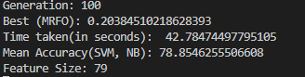

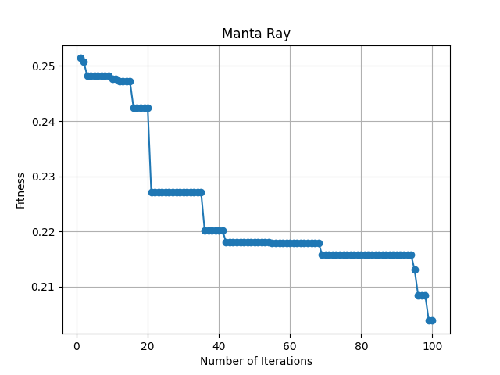

Hybrid Manta Ray

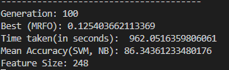

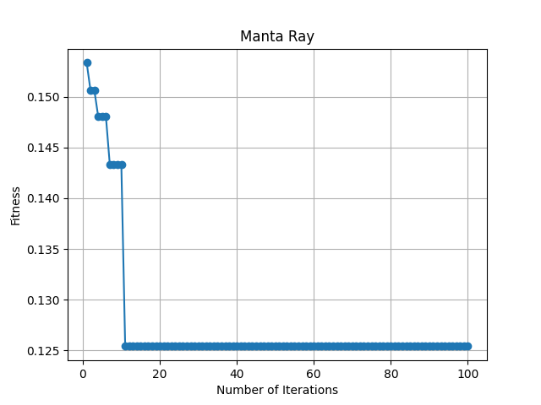

Ozone

['mean.imp', 'mle.imp', 'hdeck.imp', 'KNN.imp', 'EM.imp', 'bayesianridge', 'DTrees']

[0.85646949 0.74236985 0.85358089 0.85550663 0.8506923 0.85743236

0.85358089]

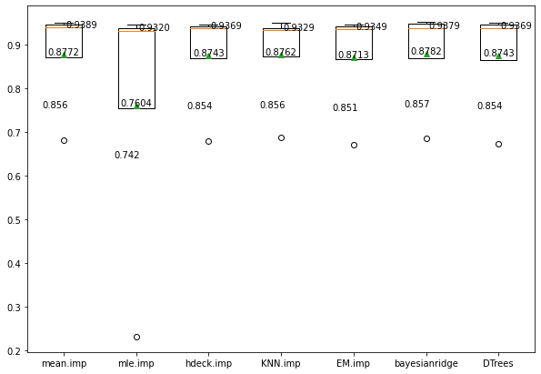

Normal:

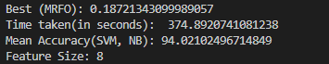

Hybrid:

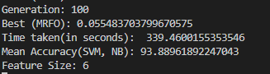

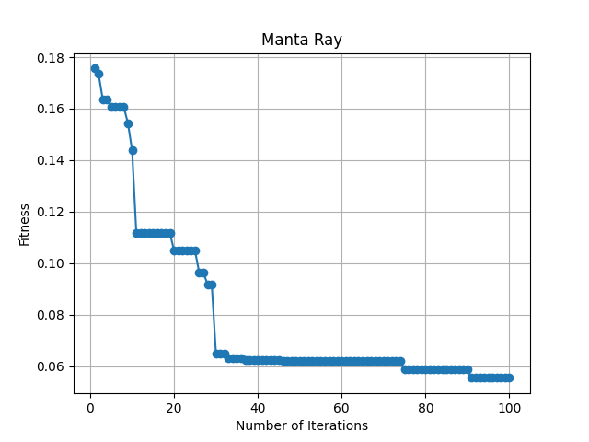

Breast D:

Normal:

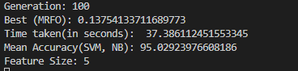MPDIWOA

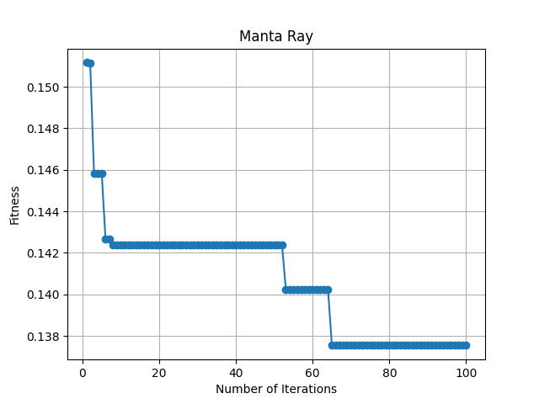

Hybrid

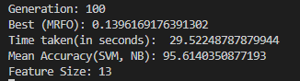

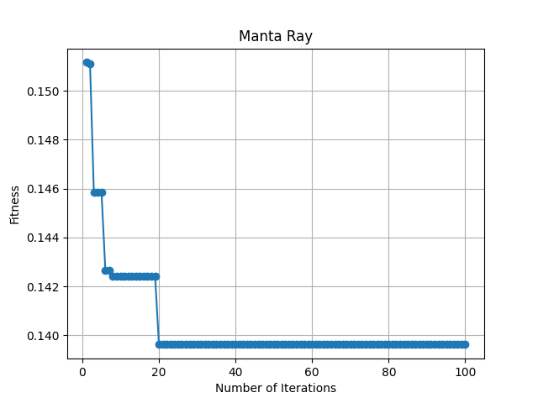

BresatP:

Normal:

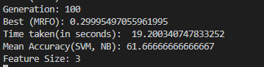



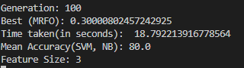

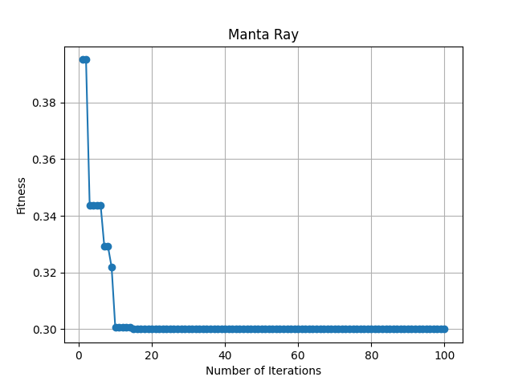

Ionosphere

Normal

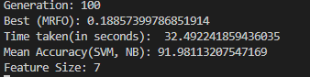

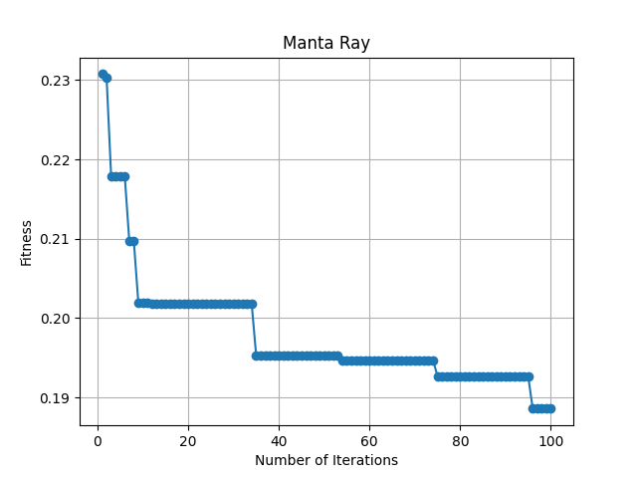

hybrid

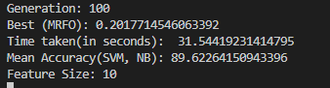

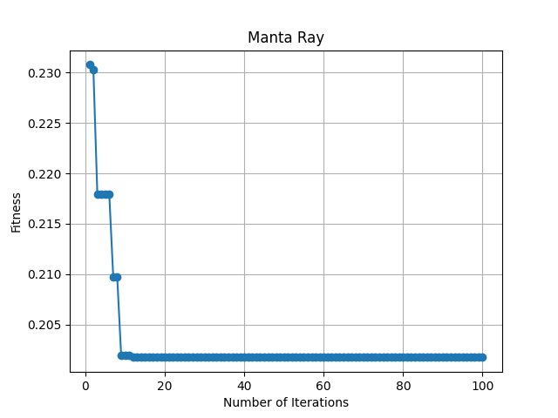

Hill-Valley

Normal

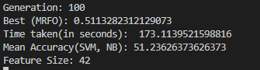

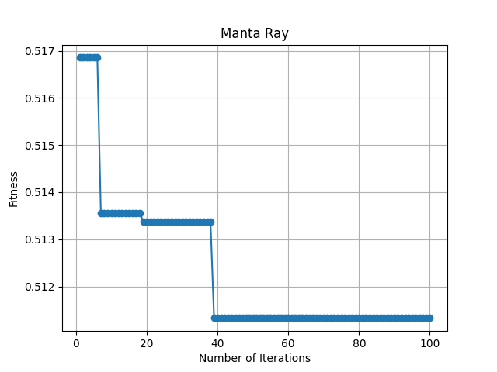

hybrid

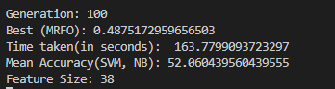

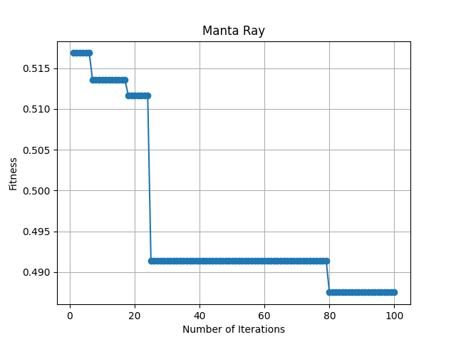

Sonar

Normal

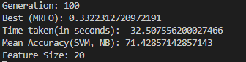

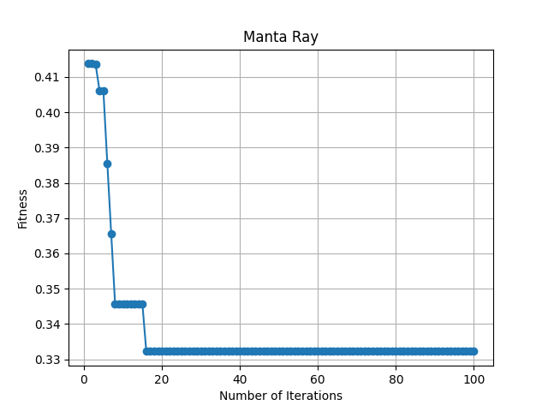

hybrid

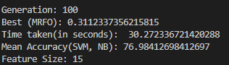

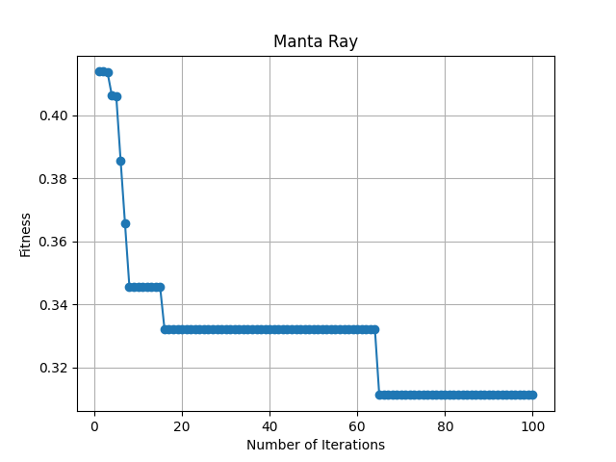

Arrythmia

Column ‘J’ was dropped due to having more than 50% missing values

Rest was imputed by hdeck method

Normal MantaRay

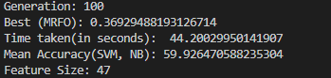

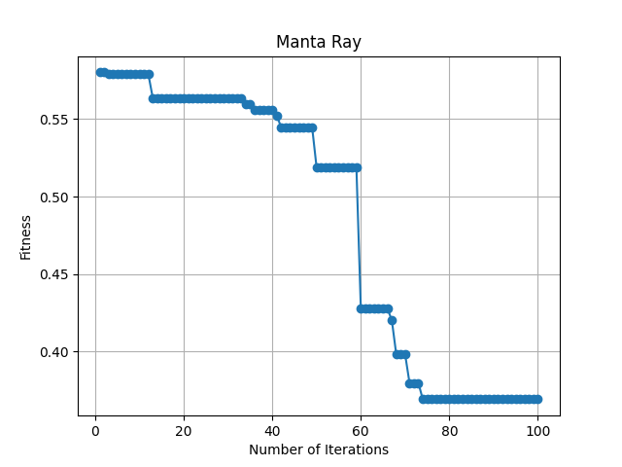

Hybrid

