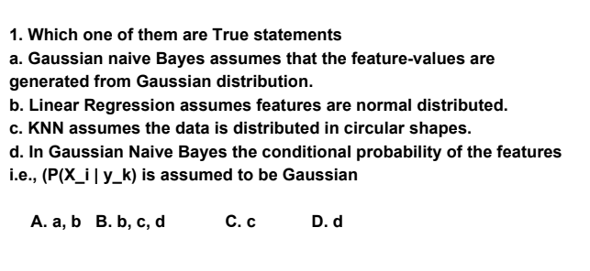

Please write down your explanation.

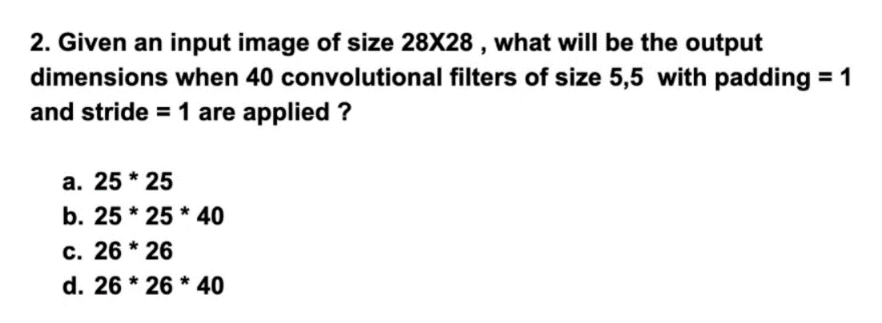

Please give below your calculations

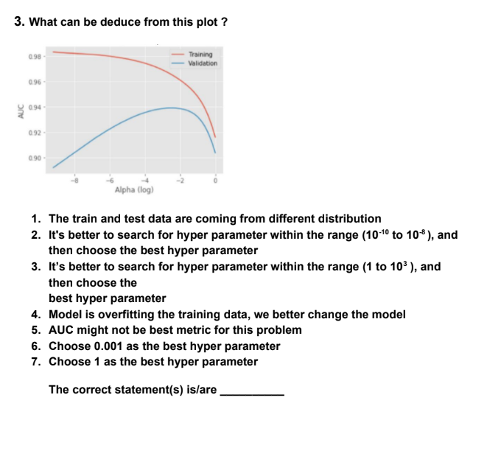

Please give below your explanation as to why the above questions are correct or wrong.

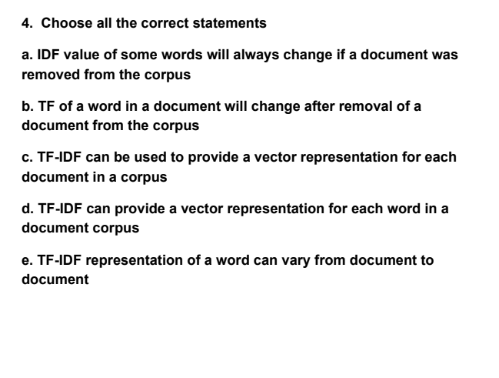

Please give below the reasons.

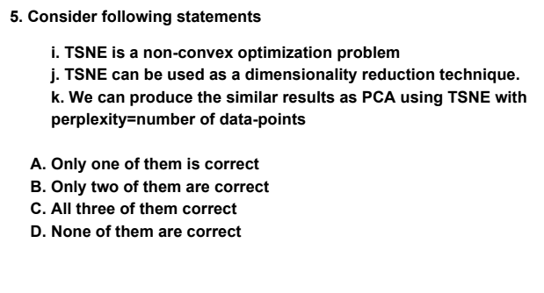

Please give below the reasons.

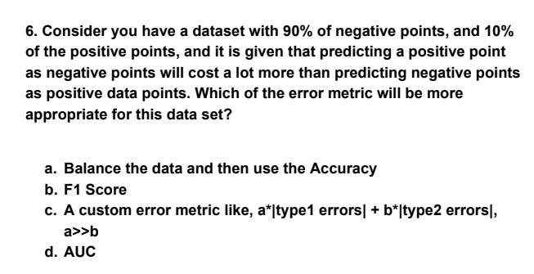

Please give below the reasons.

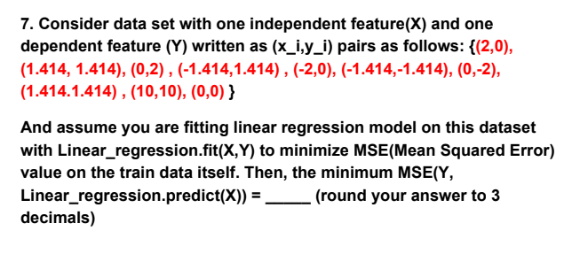

{(2,0),

(1.414, 1.414), (0,2) , (-1.414,1.414) , (-2,0), (-1.414,-1.414), (0,-2),

(1.414.1.414) , (10,10), (0,0) }

Please give below the reasons.

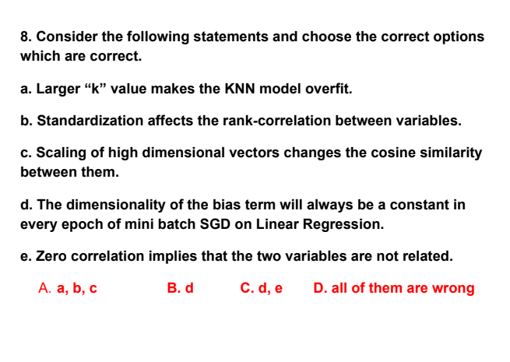

The correlation here is PCC(Pearson Correlation)

Please give below the reasons.

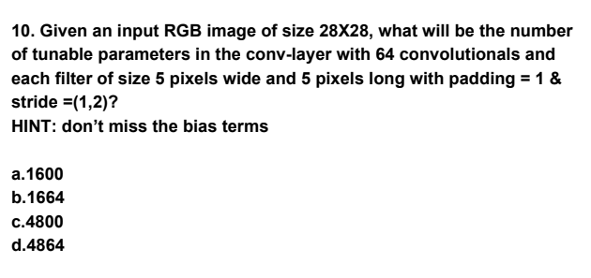

Please give below the reasons.

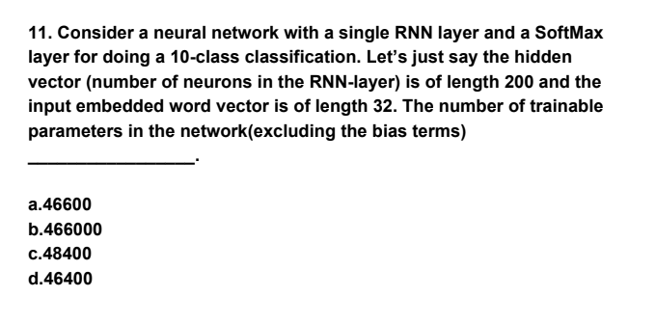

Please give below the reasons.

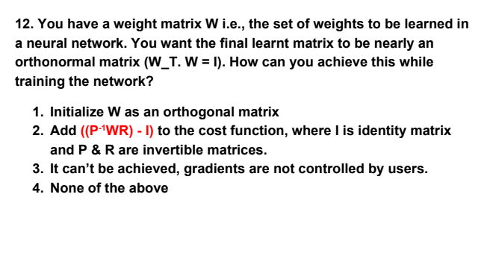

Please give below the reasons.

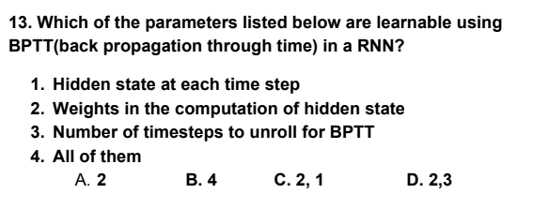

Please give below the reasons.

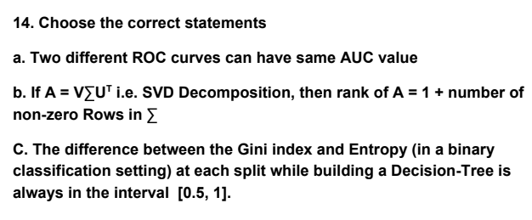

Please give below the reasons.