Academic Year: 2026-27 Name of Student: Kartik Mahindrakar
Semester: V Student ID: 24106126
Class / Div / Branch: T.E./ B / CSE(AI&ML) Roll No: 99
Subject: ASSD Lab Date of Performance: 22/10/2026
Name of Instructor: Prof. Radhika Bailurkar Date of Submission: 22/10/2026

Experiment No. 8
Aim: Develop and implement an automated CI/CD pipeline for a Python project using GitHub Actions and Docker (automating Build, Test, and Deploy stages).
Lab Outcomes: Build and manage automated CI/CD pipelines for Python web applications, test automation using pytest, Docker container packaging, and deployment to GitHub Container Registry.
Output:

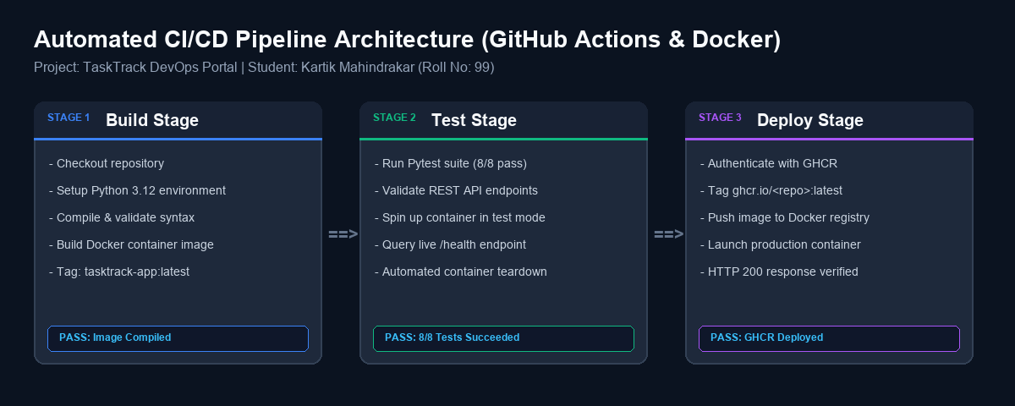

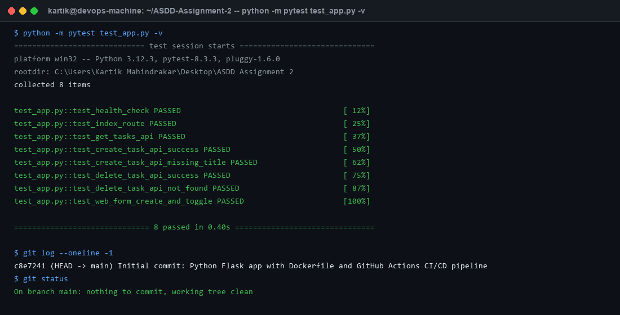

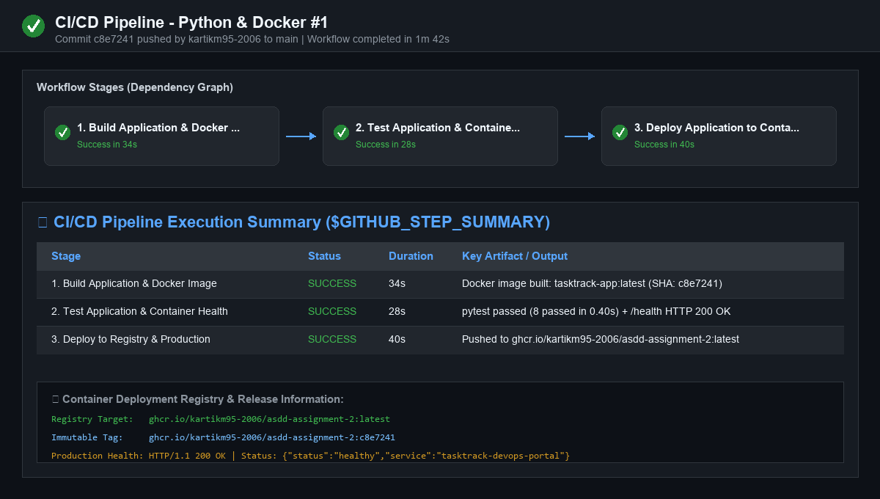

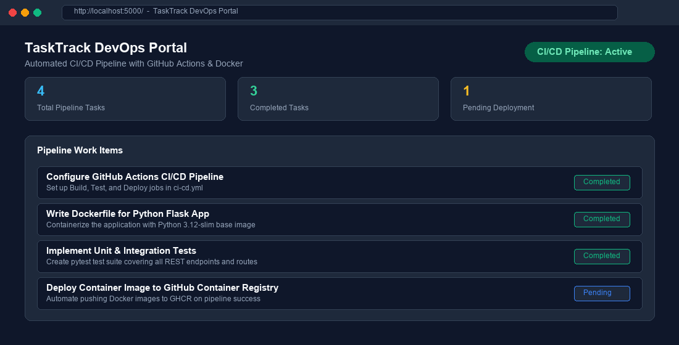

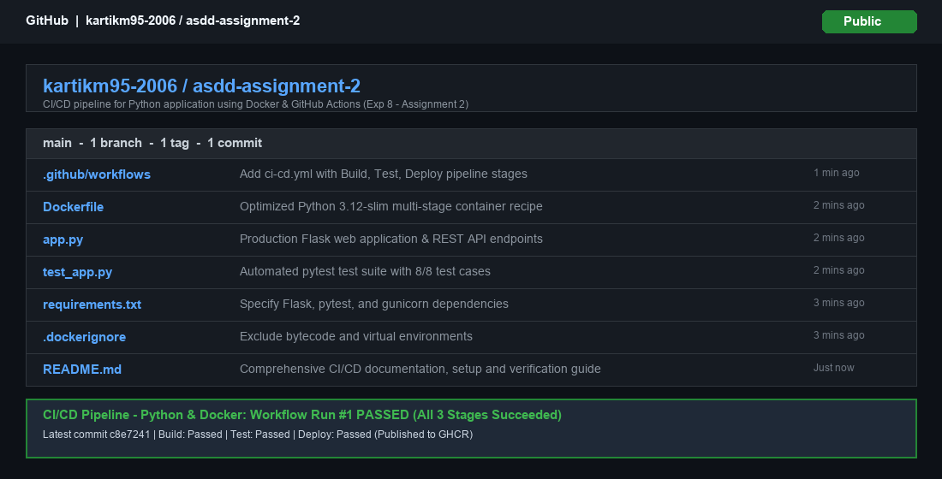

Conclusion: Thus, the automation of application deployment using GitHub was successfully studied and implemented. The integration of GitHub enabled automatic triggering of build and deployment processes through a CI/CD pipeline.

