WEEK 5 TASK

Data Visualization and Communication
Visual Storytelling with the Gapminder Dataset
Prepared by Kartik Koli | BCA | Data Analytics / Machine Learning Portfolio

1,704  Country-year observations | 142  Countries represented | 12  Time points | 5  Continent groups

Project objective
This portfolio transforms a compact country-year dataset into a coherent visual narrative. The story focuses on how population growth, economic output, and life expectancy changed from 1952 to 2007, and how those dimensions relate to one another.

Central story
Across the period, life expectancy increased across every continent, while GDP per capita also rose but remained unevenly distributed. Population growth was especially pronounced in Asia. In the 2007 cross-section, countries with higher GDP per capita generally also had higher life expectancy, but the relationship is not evidence of causation.
Dataset: Plotly Express Gapminder data (derived from Gapminder). See Sources page for attribution and links.

Executive Summary
48.94 -> 68.92 years  World population-weighted life expectancy | +19.98 years  Change, 1952 to 2007 | r = 0.81  2007 log-GDP vs life expectancy correlation | 6.25 billion  2007 total population

Key message. The visuals build from broad trends to detailed relationships. First, the audience sees a widespread rise in life expectancy. Next, economic growth is shown on a logarithmic scale so large cross-continent gaps remain visible. Population is then added as context. The central bubble scatter connects wealth, health, and population in one view, while the final two figures expose country-level improvement and within-continent variation.

Storyboard
Order | Visualization | Question | Narrative role
1 | Life expectancy trend | Did health outcomes improve? | Establishes the broad historical change.
2 | GDP per capita trend | Did economic output rise similarly? | Adds the economic dimension and inequality in levels.
3 | Population trend | Where did population growth concentrate? | Provides scale and demographic context.
4 | Wealth vs life expectancy | How were wealth and health related in 2007? | Connects the variables in one analytical view.
5 | Life expectancy gain | Which countries changed the most? | Moves from continents to country-level stories.
6 | GDP distribution | How different are countries within each continent? | Shows why continent averages can hide variation.

Why these visual techniques?
- Line charts reveal direction and pace of change across repeated time points.
- A logarithmic GDP axis compresses very large values without deleting the underlying differences.
- The bubble scatter adds a third quantitative variable - population - while color separates continents.
- The horizontal bar chart makes the largest country-level life expectancy gains easy to compare.
- The boxplot reveals the spread of GDP per capita inside each continent rather than only showing a single summary number.

1. Life Expectancy: A Broad Improvement
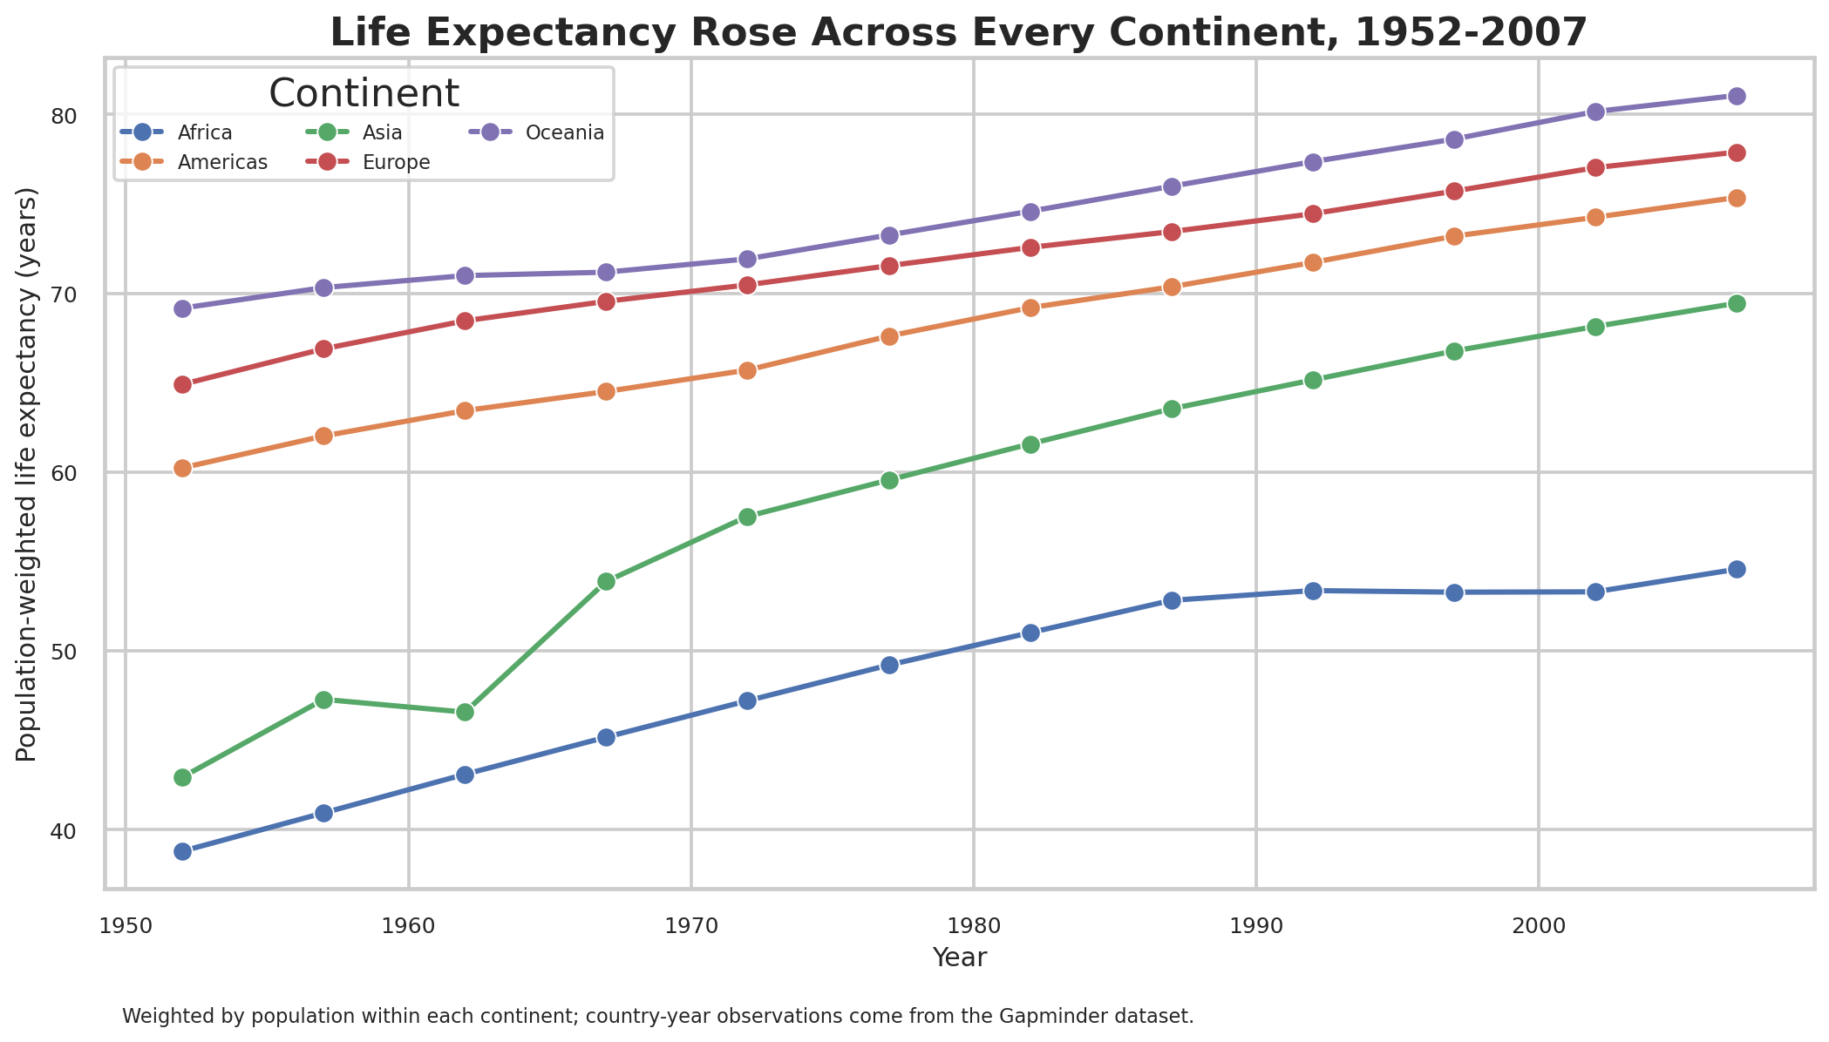
Figure 1. Population-weighted life expectancy by continent, 1952-2007.
What the chart shows. Every continent moves upward over the full period. The population-weighted world value increases from 48.94 years in 1952 to 68.92 years in 2007, a gain of about 20 years.
Why this visualization fits. A multi-series line chart is appropriate because the dataset contains repeated observations at regular five-year intervals. Weighting life expectancy by population makes the continent-level line more representative of the people living there than a simple unweighted average would be.
Narrative insight. The lines do not converge completely. In 2007, the weighted values range from about 54.6 years in Africa to 81.1 years in Oceania, showing that improvement was widespread but outcomes remained uneven.
Interpretation is descriptive and does not attribute the changes to a single cause.

2. GDP per Capita: Growth with Persistent Gaps
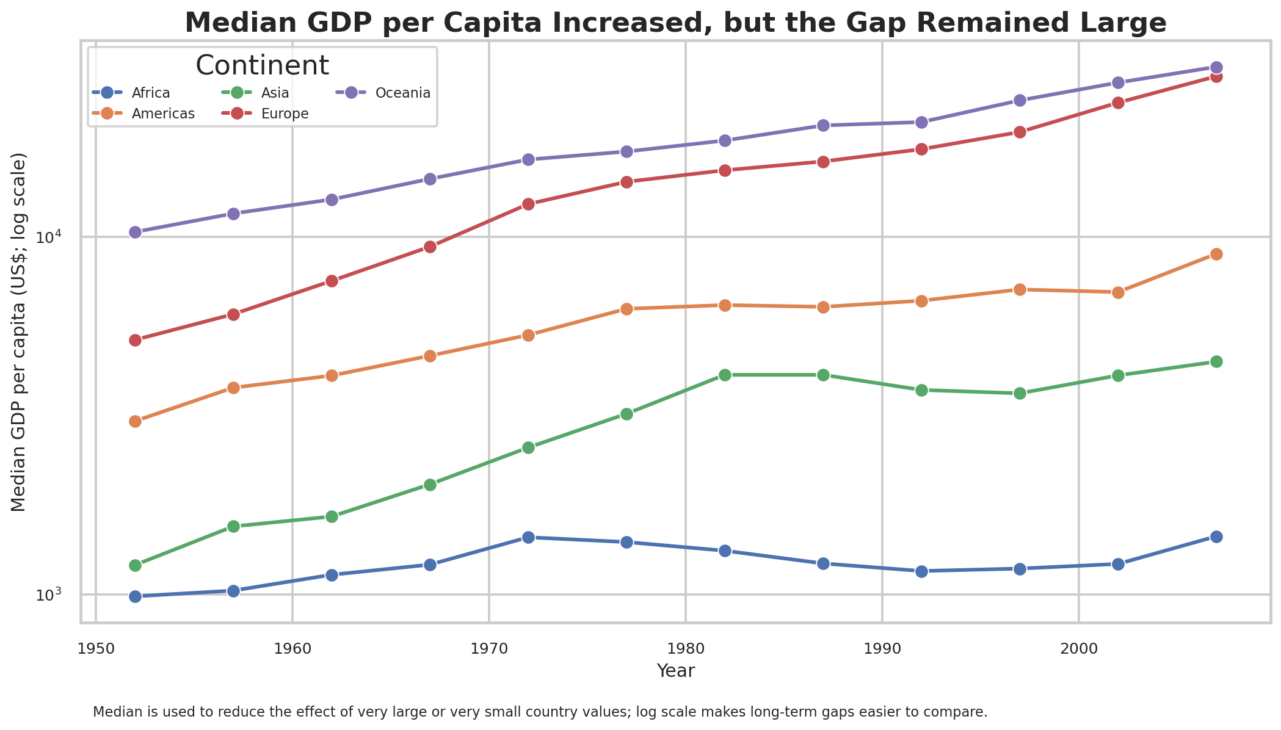
Figure 2. Median GDP per capita by continent; logarithmic y-axis.
What the chart shows. Median GDP per capita increased over the period for all five continents, but the vertical distance between regions remained substantial. In 2007, the median is about $1,452 in Africa, $4,471 in Asia, $8,948 in the Americas, $28,054 in Europe, and $29,810 in Oceania.
Why this visualization fits. GDP per capita spans a large numeric range. The logarithmic axis lets both lower- and higher-income continents remain visible on the same chart. Median values reduce the influence of extreme country values within a continent.
Narrative insight. Economic growth was broad, but it did not eliminate cross-continent differences. This is important context for the later wealth-versus-health scatterplot.

3. Population: The Scale Behind the Story
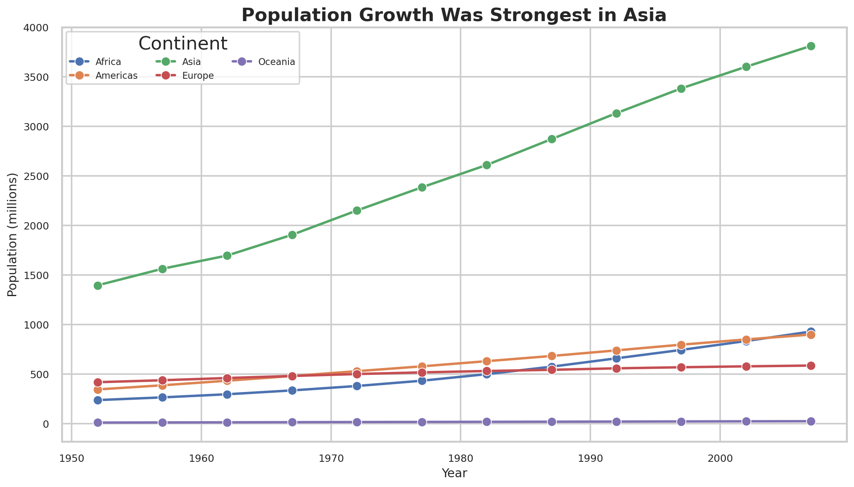
Figure 3. Population by continent, 1952-2007, in millions.
What the chart shows. Asia contains by far the largest population in the dataset and grows from roughly 1.40 billion in 1952 to 3.81 billion in 2007. Other continents also grow, but remain much smaller in total population.
Why this visualization fits. A line chart is again useful for showing growth trajectories. Displaying population in millions makes the scale interpretable while preserving the differences between continents.
Narrative insight. Population scale matters when interpreting other indicators. A change in a highly populated region can affect the global picture much more than the same change in a small population.

4. Wealth, Health, and Population in 2007
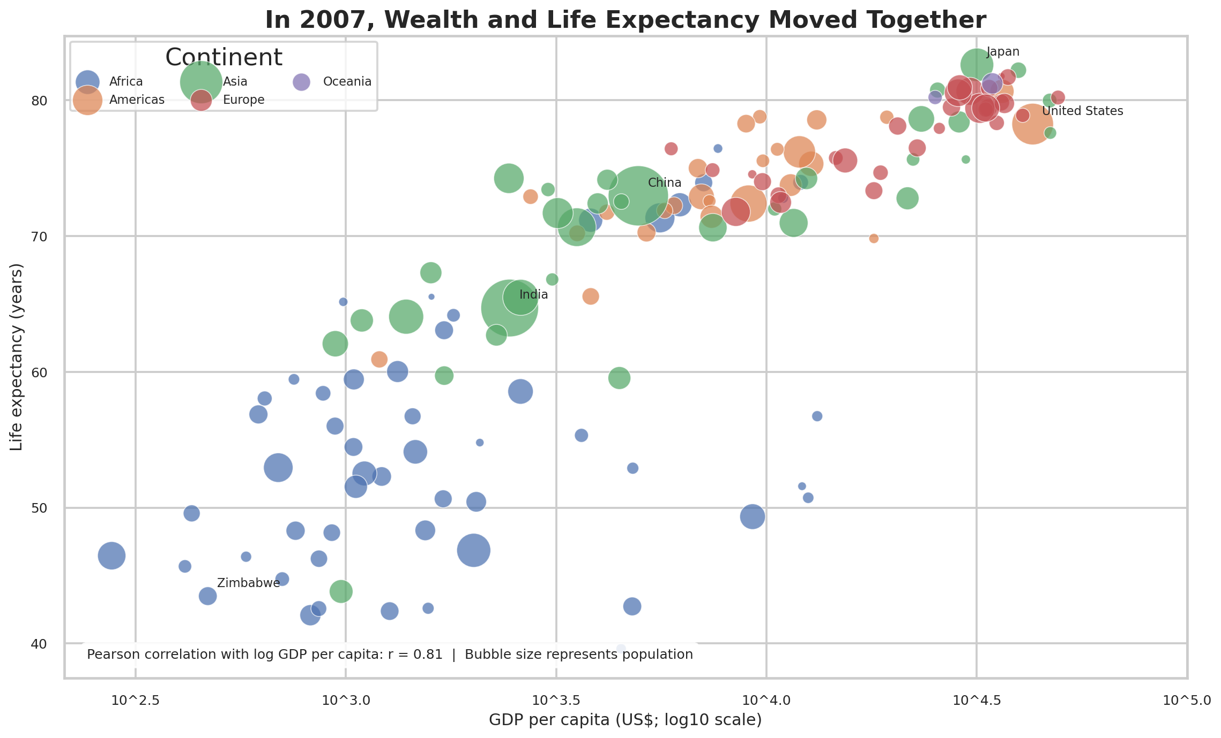
Figure 4. GDP per capita vs life expectancy in 2007; bubble size represents population.
What the chart shows. The 2007 cross-section has a strong positive relationship between life expectancy and the natural log of GDP per capita (Pearson r = 0.81). Most high-income countries cluster toward the upper-right, while lower-income observations tend to occupy lower life expectancy ranges.
Why this visualization fits. A scatterplot is appropriate for examining the association between two numeric variables. Bubble size adds population as a third dimension, and the log x-axis avoids squeezing lower-income countries into a narrow region.
Narrative insight. The association is strong, but the chart should not be read as proof that higher GDP causes longer life expectancy. Health outcomes reflect many interacting factors, and the dataset alone does not establish causal direction.
Interactive companion. The project folder contains an animated Plotly HTML version, allowing the audience to move through the years and inspect individual countries.

5. Country-Level Change: Large Life Expectancy Gains
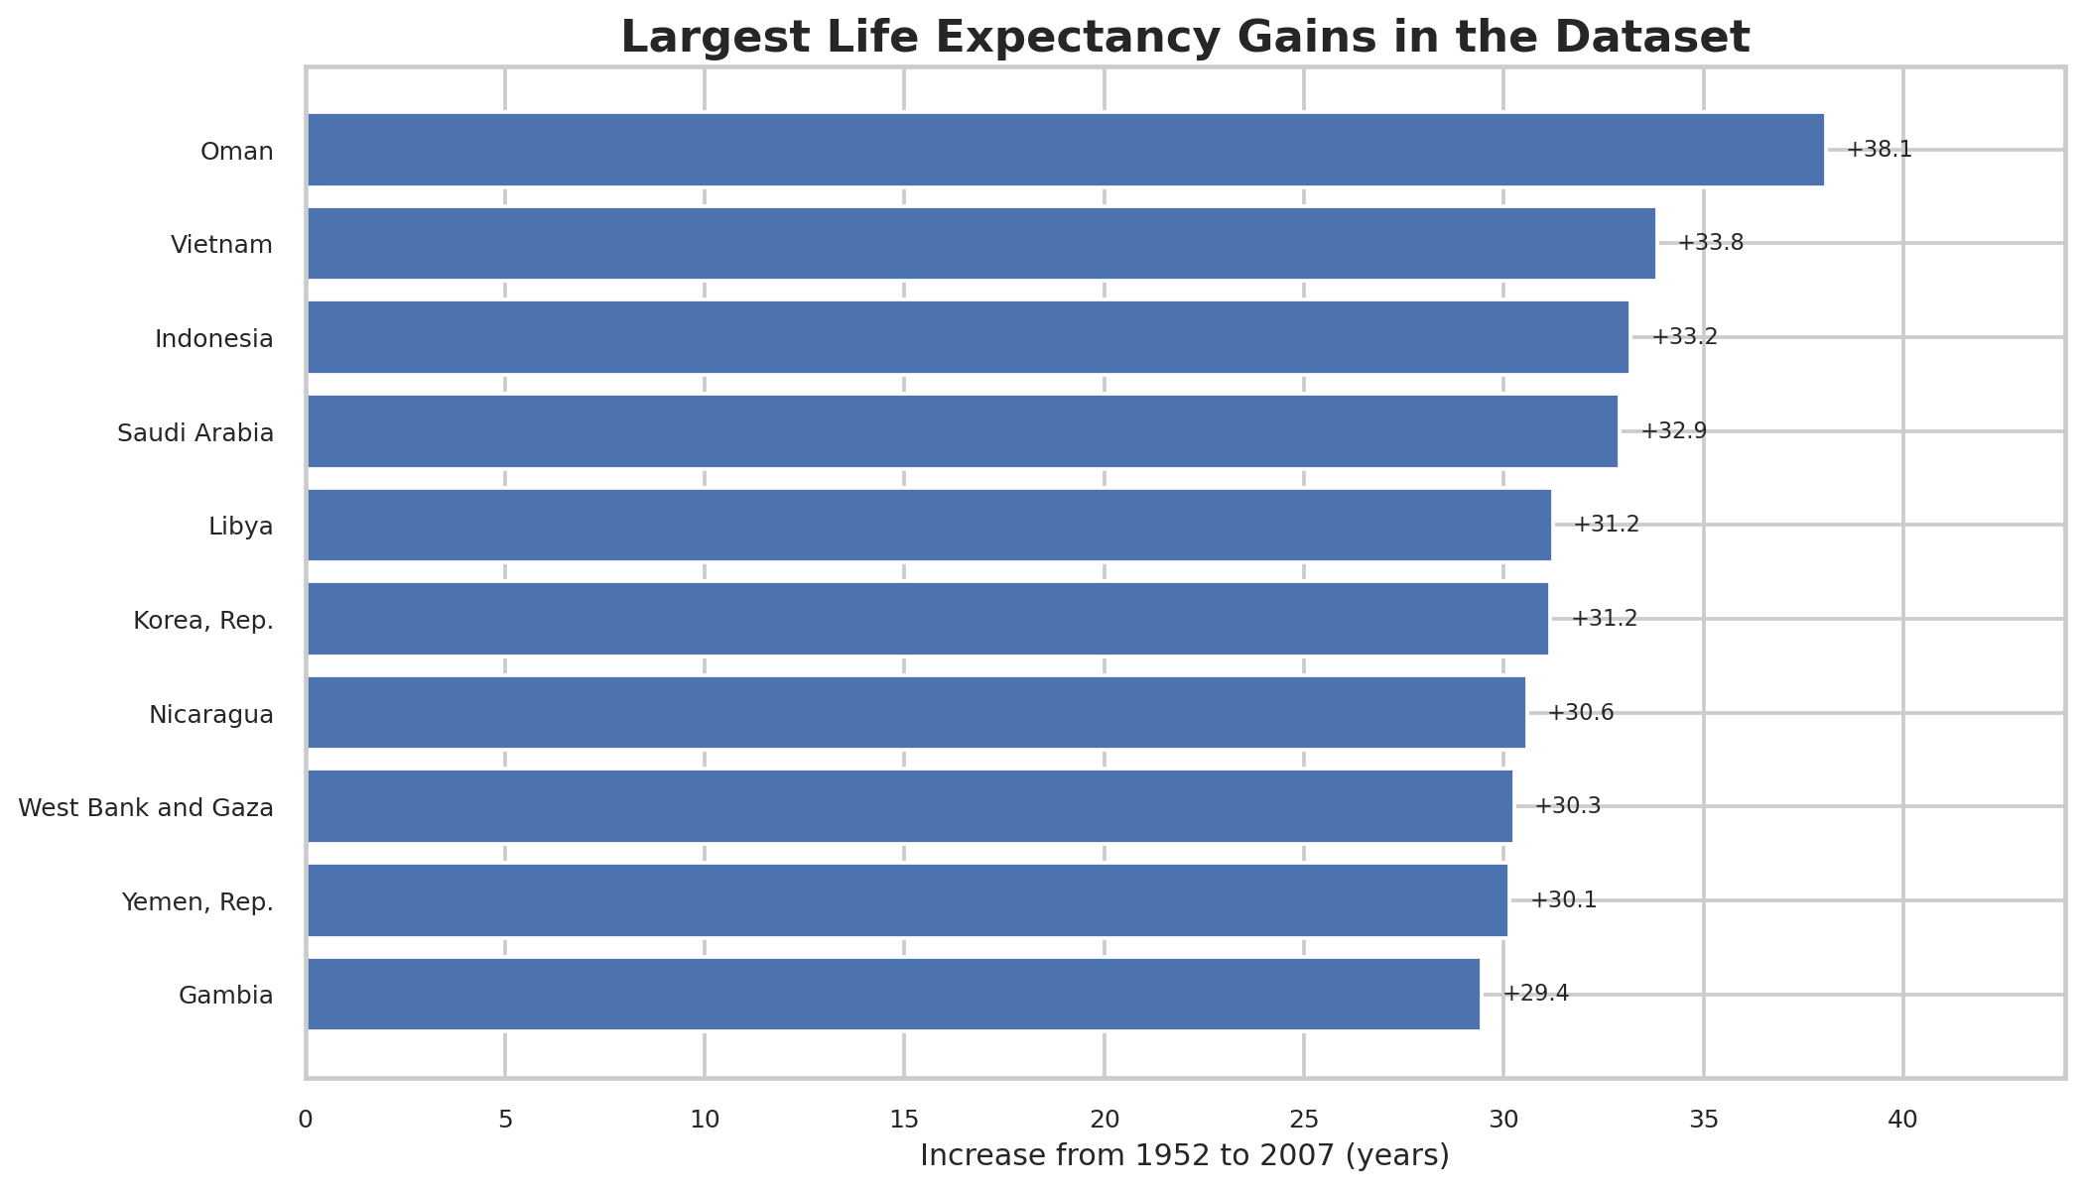
Figure 5. Ten largest life expectancy gains from 1952 to 2007.
What the chart shows. The largest gain in the dataset is for Oman, at about +38.1 years, followed by Vietnam (+33.8), Indonesia (+33.2), Saudi Arabia (+32.9), Libya (+31.2), and Korea, Rep. (+31.2).
Why this visualization fits. A sorted horizontal bar chart is effective for comparing a small set of ranked magnitudes. The data labels make the size of each gain immediately readable without requiring the audience to estimate from the axis.
Narrative insight. The earlier continent-level line chart shows the broad direction; this chart demonstrates that the magnitude of change varied substantially from country to country.
6. Within-Continent Variation: Distribution Matters
Figure 6 complements the earlier median GDP trend by showing the distribution of country values within each continent.
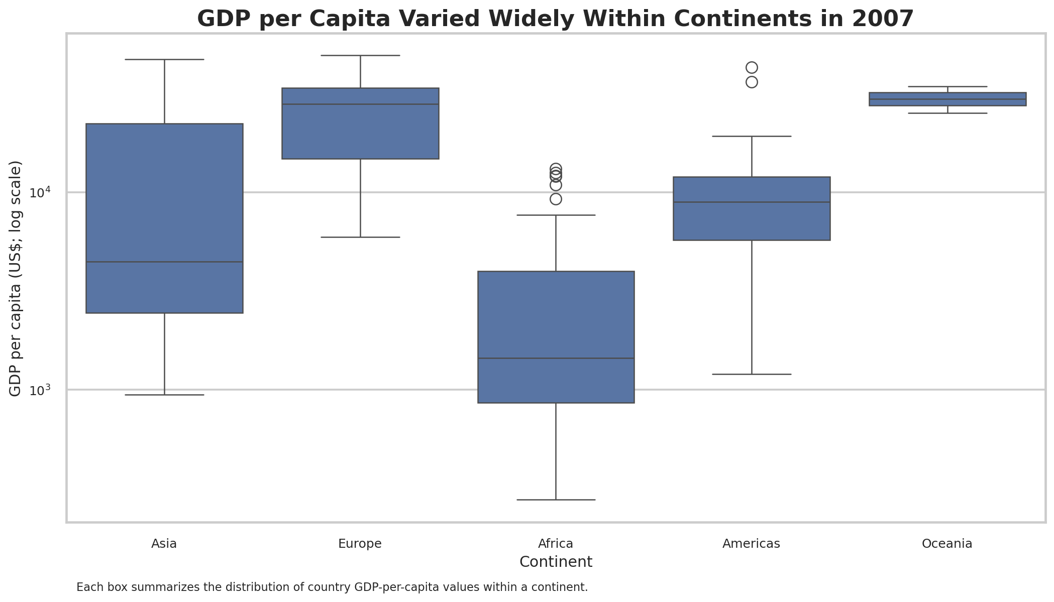
Figure 6. Distribution of country GDP per capita within each continent in 2007.
Narrative insight. The boxes and outliers show that a continent can contain countries with very different GDP-per-capita levels. This is why a single continent average or median should be treated as a summary, not as a description of every country in that region.

Technical Implementation
- Python libraries: Pandas, NumPy, Matplotlib, Seaborn, and Plotly.
- Dataset handling: loaded Plotly Express Gapminder data, sorted by country and year, and exported a clean CSV for reproducibility.
- Aggregation: population-weighted life expectancy, median GDP per capita, and summed population by continent-year.
- Static export: six PNG figures, sized for report/portfolio use.
- Interactive export: Plotly animated scatterplot saved as a standalone HTML file.

Quality and communication checks
- Every visual has a descriptive title and explicit axis labels.
- Units are shown directly in the axes or chart notes.
- The GDP chart uses a log scale and states that choice in the subtitle/note.
- The bubble scatter explains the meaning of bubble size and reports the correlation value.
- Country annotations are limited to a few reference points to avoid excessive clutter.

Limitations
- The project is descriptive; it does not identify causal effects between economic and health indicators.
- GDP per capita is summarized by median for continent trend comparisons, while the 2007 scatter uses country-level GDP per capita.
- Historical values are limited to the years represented in the Gapminder extract used by Plotly (1952-2007).
- The dataset is intentionally compact for teaching and visualization; it should not be treated as a complete modern development database.

Conclusion
The visual story is strongest when the figures are read together. Life expectancy improved broadly, GDP per capita rose but remained unequal, and population growth - especially in Asia - changed the scale of the global picture. The 2007 scatterplot then shows a strong association between wealth and life expectancy, while the country-level gain chart and boxplot remind the audience that regional summaries can hide important variation.

Sources and Attribution
- Plotly Express data documentation: https://plotly.com/python-api-reference/generated/plotly.express.data.html
- Gapminder data portal and attribution guidance: https://www.gapminder.org/data/
- Plotly animation example using Gapminder: https://plotly.com/python/animations/
Attribution note: Gapminder states that its data can be reused freely with appropriate attribution to the original source where applicable and to Gapminder.

Submission Package
- This PDF narrative report.
- Six high-resolution PNG visualizations in the figures/ folder.
- A standalone interactive HTML visualization.
- Reproducible Python source code and exported CSV summaries.

