WEEK 4 MACHINE LEARNING PROJECT
Machine Learning Model Development and Evaluation
Breast Cancer Wisconsin (Diagnostic) Classification
Prepared as a Week 4 academic submission
Dataset | 569 samples, 30 numeric features
Task | Binary classification: malignant vs benign
Split | 80% training / 20% testing, stratified
Validation | 5-fold StratifiedKFold on training set
Tuning | GridSearchCV over C and penalty
Final model | Tuned Logistic Regression pipeline

1. Introduction
The objective of this project is to develop and evaluate a supervised machine learning classifier using a publicly available dataset. The workflow is designed to reflect a real-world model-development process: data inspection, preprocessing, stratified splitting, baseline model comparison, cross-validation, hyperparameter tuning, holdout testing, interpretation, and discussion of limitations.

2. Dataset Description
The Breast Cancer Wisconsin (Diagnostic) dataset contains 569 observations, 30 real-valued predictive features, and a binary target. The features are numerical measurements derived from digitized images of breast-mass samples. The target is encoded as 0 = malignant and 1 = benign in the scikit-learn representation used for this project.
Public source: UCI Machine Learning Repository - https://archive.ics.uci.edu/dataset/17/breast+cancer+wisconsin+diagnostic
Data quality check | Result
Total samples | 569
Predictive features | 30
Missing values | 0
Duplicate rows | 0
Malignant samples | 212
Benign samples | 357
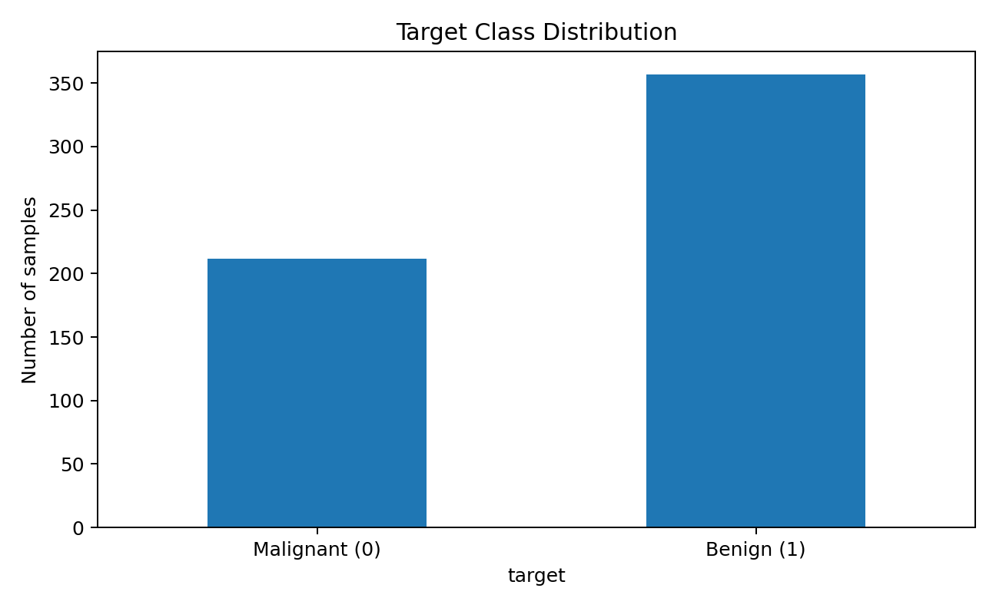
Figure 1. Target class distribution in the complete dataset.

3. Data Preprocessing
The target was separated from the 30 predictive features. A stratified 80/20 train-test split was performed with random_state=42. Stratification preserves approximately the same class proportions in both subsets. The test set was held back until final evaluation. For Logistic Regression and SVM, StandardScaler was placed inside a Pipeline so scaling parameters are learned separately within each training fold during cross-validation; this reduces data leakage risk.

4. Model Selection and Justification
Four algorithms were compared on the training data using identical 5-fold StratifiedKFold validation: Logistic Regression, Decision Tree, SVM, and Random Forest. F1-score was selected as the primary selection metric because it balances precision and recall. Accuracy, precision, recall, and ROC-AUC were retained as supporting measures.
Model | Mean CV F1 | Mean CV ROC-AUC
Logistic Regression | 0.9825 +/- 0.0078 | 0.9959 +/- 0.0050
SVM | 0.9756 +/- 0.0113 | 0.9956 +/- 0.0048
Random Forest | 0.9699 +/- 0.0146 | 0.9896 +/- 0.0083
Decision Tree | 0.9319 +/- 0.0144 | 0.9179 +/- 0.0201
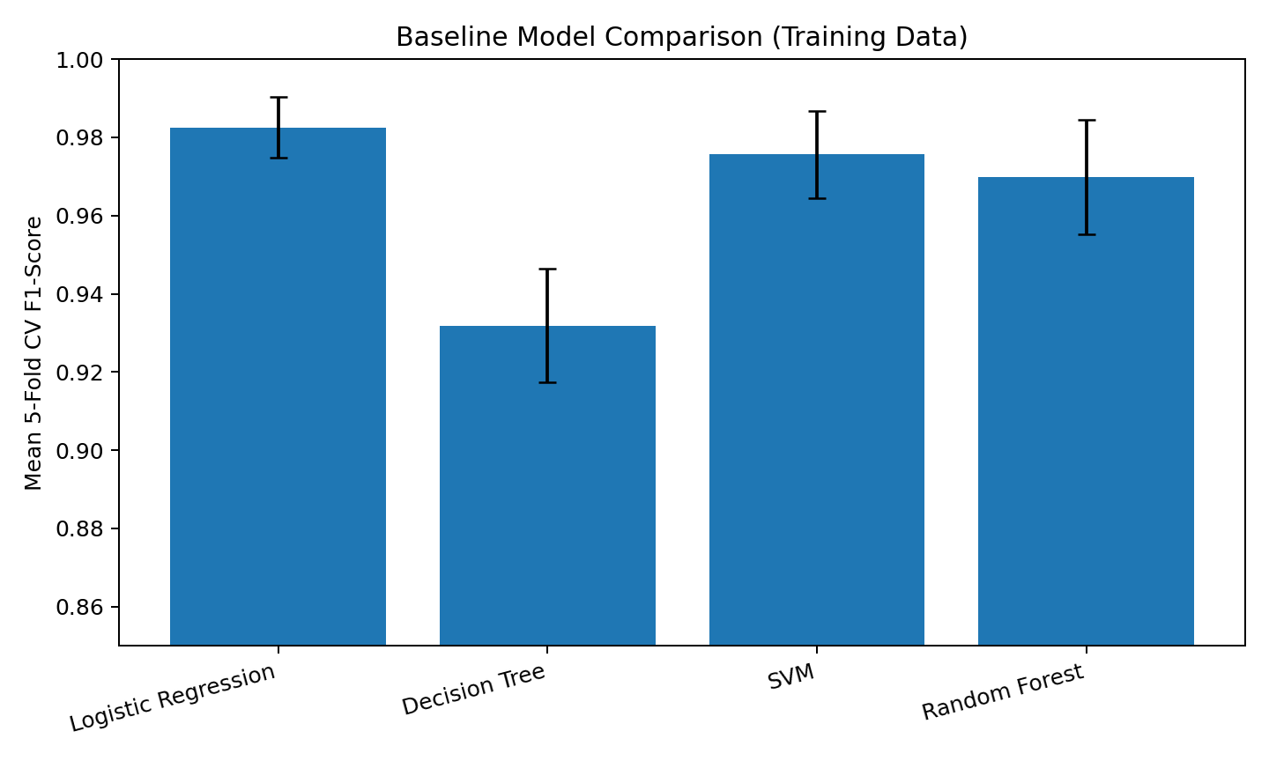
Figure 2. Baseline model comparison using mean F1-score across five stratified folds.

5. Cross-Validation and Hyperparameter Tuning
The best baseline by mean cross-validated F1-score was Logistic Regression. A GridSearchCV search was then carried out over C values [0.01, 0.1, 1, 10, 100] and L1/L2 regularization, using the liblinear solver. Five-fold stratified cross-validation was retained throughout. Because the grid search was fitted only to the training data, the test set remained independent for final evaluation.
Best parameters found: {'model__C': 0.1, 'model__penalty': 'l2', 'model__solver': 'liblinear'}
Best mean cross-validated F1-score: 0.9861
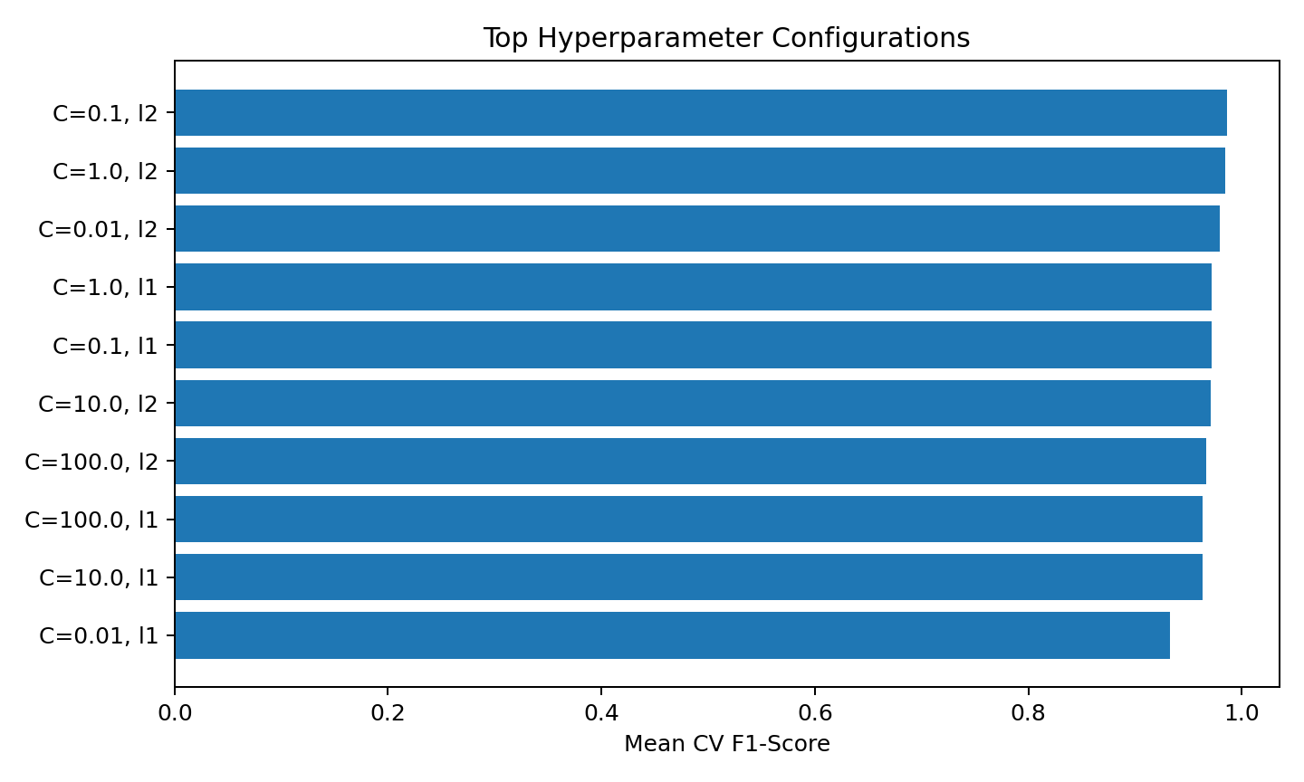
Figure 3. Top hyperparameter configurations ranked by mean CV F1-score.

6. Final Test Evaluation
After selecting the best hyperparameters, the final pipeline was evaluated on the untouched 20% holdout test set. The following metrics were calculated: accuracy, precision, recall, F1-score, and ROC-AUC.
Metric | Test-set result
Accuracy | 0.9825
Precision | 0.9861
Recall | 0.9861
F1-Score | 0.9861
ROC-AUC | 0.9960
The tuned Logistic Regression achieved a holdout accuracy of 98.25%, precision of 98.61%, recall of 98.61%, F1-score of 98.61%, and ROC-AUC of 0.9960. These values describe performance on this benchmark dataset and should not be generalized to other populations without external validation.
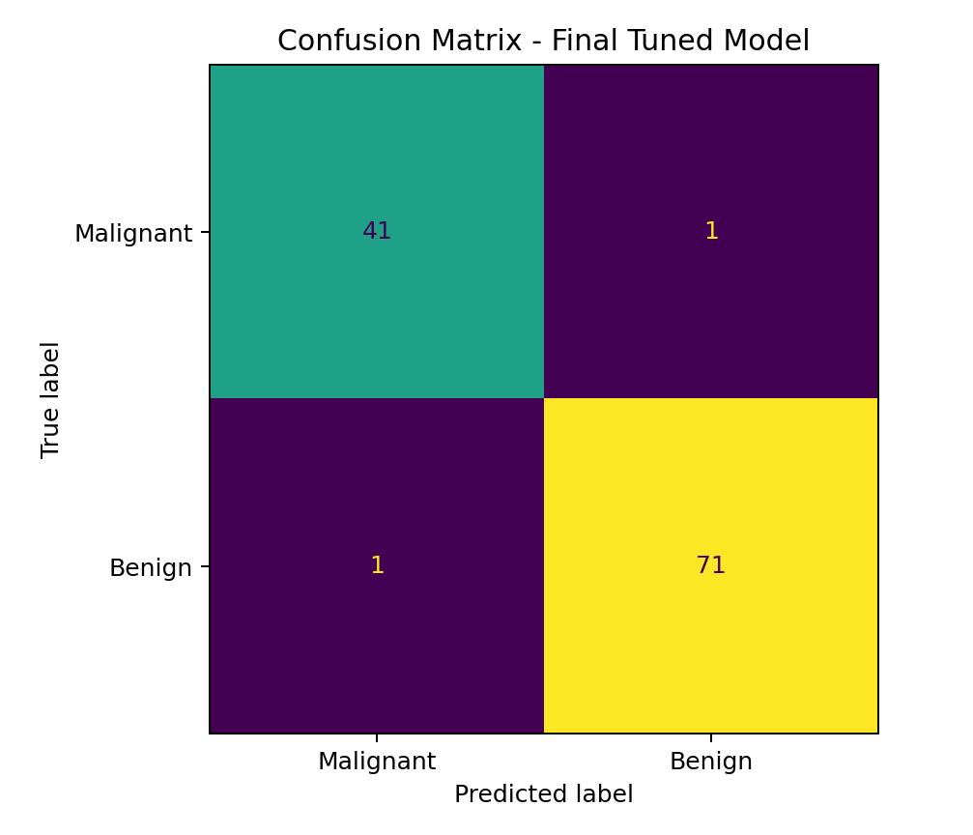
Figure 4. Confusion matrix on the holdout test set.
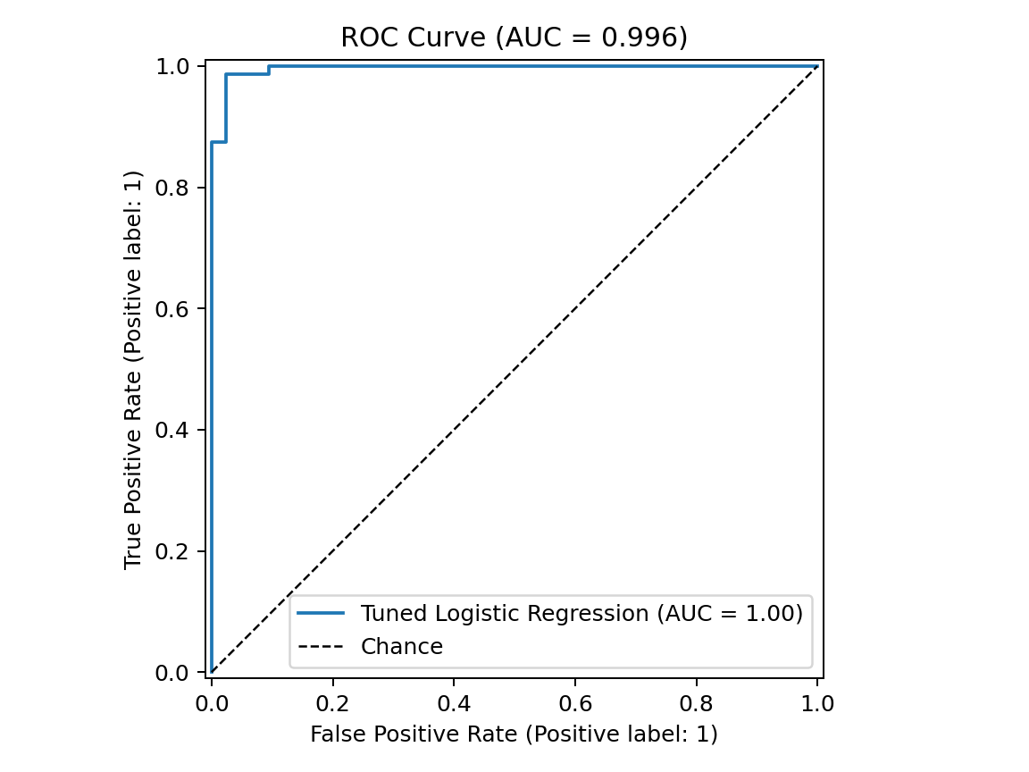
Figure 5. ROC curve for the final tuned classifier.
Confusion-matrix counts: true negatives = 41, false positives = 1, false negatives = 1, true positives = 71. Precision measures the proportion of predicted benign cases that were actually benign, while recall measures the proportion of actual benign cases correctly identified under the project label encoding.

7. Predictive Interpretation
The model combines 30 standardized numeric measurements. Coefficients provide an interpretable linear contribution for each feature after standardization. Large absolute coefficients indicate features that the fitted model used more strongly in separating the two classes. These coefficients represent model associations on this dataset and are not causal or clinical findings.
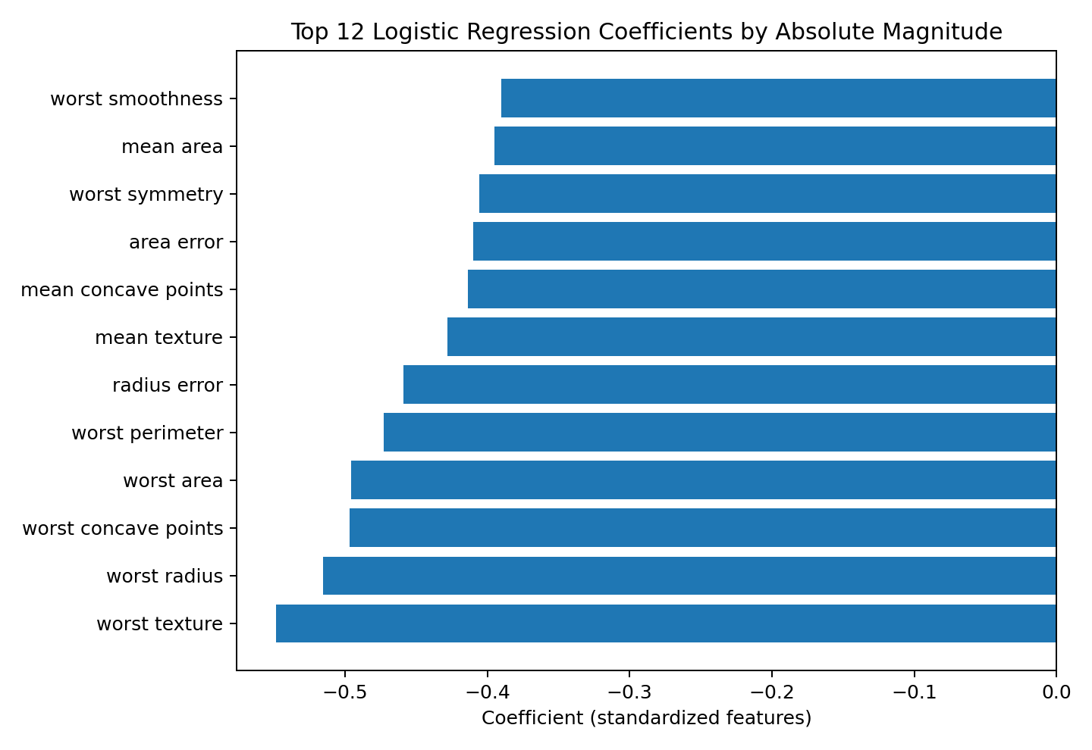
Figure 6. Twelve features with the largest absolute Logistic Regression coefficients.
Feature | Coefficient | Absolute magnitude
worst texture | -0.5486 | 0.5486
worst radius | -0.5156 | 0.5156
worst concave points | -0.4968 | 0.4968
worst area | -0.4957 | 0.4957
worst perimeter | -0.4728 | 0.4728
radius error | -0.4590 | 0.4590
mean texture | -0.4280 | 0.4280
mean concave points | -0.4138 | 0.4138

8. Strengths and Weaknesses
Strengths: the workflow uses stratified cross-validation, a clearly separated holdout test set, pipeline-based preprocessing, explicit hyperparameter search, multiple evaluation metrics, and coefficient-based interpretation. These choices improve reproducibility and reduce the risk of optimistic evaluation.
Weaknesses: Logistic Regression models a linear decision function and may miss complex nonlinear interactions. The benchmark is relatively small and may not represent all populations, acquisition protocols, or real-world workflows. A single holdout split gives one generalization estimate; external validation and nested cross-validation would provide stronger evidence for deployment. The dataset is educational/benchmark data and the resulting model must not be treated as a clinical diagnostic tool.

9. Reproducibility and Implementation Notes
- Random seed fixed at 42 for repeatable splitting and model initialization.
- Stratified 80/20 train-test split preserves class proportions.
- Five-fold StratifiedKFold is used for model comparison and hyperparameter tuning.
- Scaling is embedded in a Pipeline and is therefore learned only from the relevant training data within each fold.
- The test set is used only after model selection and tuning.
- The project includes notebook code, saved metrics, predictions, coefficients, figures and requirements for reproduction.

10. Evaluation Criteria Coverage
Rubric requirement | Where it is demonstrated
Appropriate algorithm selection and justification | Section 4: four classifiers are compared and the selection criterion is stated.
Cross-validation and hyperparameter tuning | Section 5: 5-fold StratifiedKFold + GridSearchCV over regularization settings.
Detailed evaluation metrics | Section 6: accuracy, precision, recall, F1-score, ROC-AUC and confusion matrix.
Quality of analysis and documentation | Sections 1-9: dataset, preprocessing, leakage control, interpretation, strengths, weaknesses and reproducibility.
Reproducible scientific workflow | Section 9 + notebook + requirements.txt + saved result files.

11. Conclusion
The Week 4 task was completed as a full machine-learning development cycle. A public classification dataset was inspected and preprocessed, four algorithms were compared with stratified cross-validation, the leading model was tuned with GridSearchCV, and the final estimator was evaluated on a previously unseen holdout test set using multiple classification metrics. The resulting analysis demonstrates both predictive performance and awareness of generalization, interpretability, and limitations.

References
1. UCI Machine Learning Repository, Breast Cancer Wisconsin (Diagnostic) Dataset. https://archive.ics.uci.edu/dataset/17/breast+cancer+wisconsin+diagnostic
2. scikit-learn documentation: LogisticRegression, GridSearchCV, StratifiedKFold, Pipeline, classification metrics.

