|  |  |
| --- | --- |
| Activity | Data Type |
| Number of beatings from Wife | Discrete |
| Results of rolling a dice | Discrete |
| Weight of a person | Continuous |
| Weight of Gold | Continuous |
| Distance between two places | Continuous |
| Length of a leaf | Continuous |
| Dog's weight | Continuous |
| Blue Color | Discrete |
| Number of kids | Discrete. |
| Number of tickets in Indian railways | Discrete |
| Number of times married | Discrete |
| Gender (Male or Female) | Discrete |

Q1) Identify the Data type for the Following:

Q2) Identify the Data types, which were among the following

Nominal, Ordinal, Interval, Ratio.

|  |  |
| --- | --- |
| Data | Data Type |
| Gender | Nominal |
| High School Class Ranking | Ordinal |
| Celsius Temperature | Interval |
| Weight | Ratio |
| Hair Color | Nominal |
| Socioeconomic Status | Ordinal |
| Fahrenheit Temperature | Interval |
| Height | Ratio |
| Type of living accommodation | Nominal |
| Level of Agreement | Ordinal |
| IQ(Intelligence Scale) | Ratio |
| Sales Figures | Ratio |
| Blood Group | Nominal |
| Time Of Day | Nominal |
| Time on a Clock with Hands | Interval |
| Number of Children | Ratio |
| Religious Preference | Nominal |
| Barometer Pressure | Interval |
| SAT Scores | Ratio |
| Years of Education | Ordinal |

Q3) Three Coins are tossed, find the probability that two heads and one tail are obtained?

Ans- 3/8

Explain= S={TTT,HHH,THT,HTH,HHT,TTH,THH,HTT}

n(S)=8

Let A Two heads and one tail

A={HHT,THH,HTH}

n(A)=3

P(A)=n(A)/n(S)=3/8

Probability is 3/8

Q4) Two Dice are rolled, find the probability that sum is

1. Equal to 1
2. Less than or equal to 4
3. Sum is divisible by 2 and 3

Ans- S={(1,1),(1,2),(1,3),(1,4),(1,5),(1,6)

(2,1),(2,2),(2,3),(2,4),(2,5),(2,6)

(3,1),(3,2), (3,3), (3,4),(3,5), (3,6)

(4,1),(4,2),(4,3),(4,4),(4,5),(4,6)

(5,1),(5,2),(5,3),(5,4),(5,5),(5,6)

(6,1),(6,2),(6,3),(6,4),(6,5),(6,6)}

a={}

a=0 #zero no outcome will be equal to one

b={(1,1),(1,2),(1,3),(2,1),(2,2),(3,1)}

b=6/36=6

c={(1,5), (2,4), (3,3), (4,2), (5,1), (6,6)}

c=6/36=6

Q5) A bag contains 2 red, 3 green and 2 blue balls. Two balls are drawn at random. What is the probability that none of the balls drawn is blue?

Ans-

P(5/7 , 4/6)

P(20 / 42)

P(10 / 21)

P=10/21

Q6) Calculate the Expected number of candies for a randomly selected child

Below are the probabilities of count of candies for children (ignoring the nature of the child-Generalized view)

|  |  |  |
| --- | --- | --- |
| CHILD | Candies count | Probability |
| A | 1 | 0.015 |
| B | 4 | 0.20 |
| C | 3 | 0.65 |
| D | 5 | 0.005 |
| E | 6 | 0.01 |
| F | 2 | 0.120 |

Child A – probability of having 1 candy = 0.015.

Child B – probability of having 4 candies = 0.20

Ans=Expected number of candies for a randomly selected child

=1*0.015+4*0.20+3*0.65+5*0.005+6*0.01+2*0.120

=0.015+0.8+1.95+0.025+0.06+0.24

=3.09

Expected Number is 3.09

Q7) Calculate Mean, Median, Mode, Variance, Standard Deviation, Range & comment about the values / draw inferences, for the given dataset

* For Points,Score,Weigh>

Find Mean, Median, Mode, Variance, Standard Deviation, and Range and also Comment about the values/ Draw some inferences.

**Use Q7.csv file** 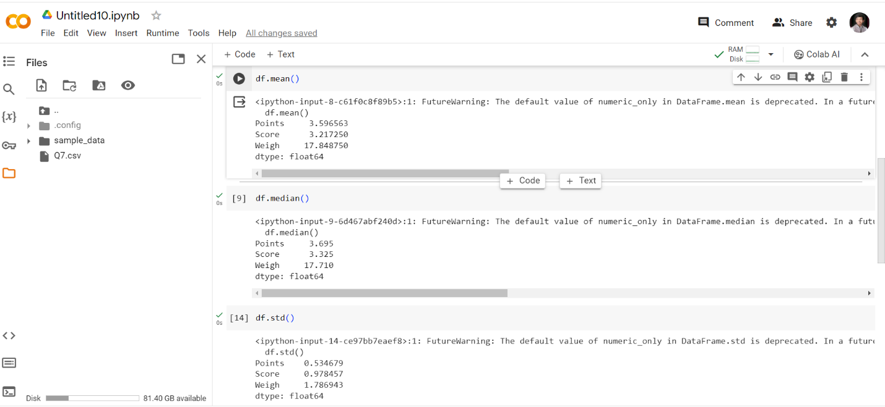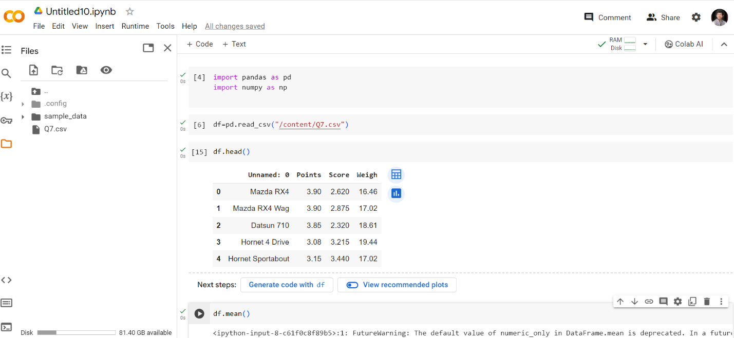

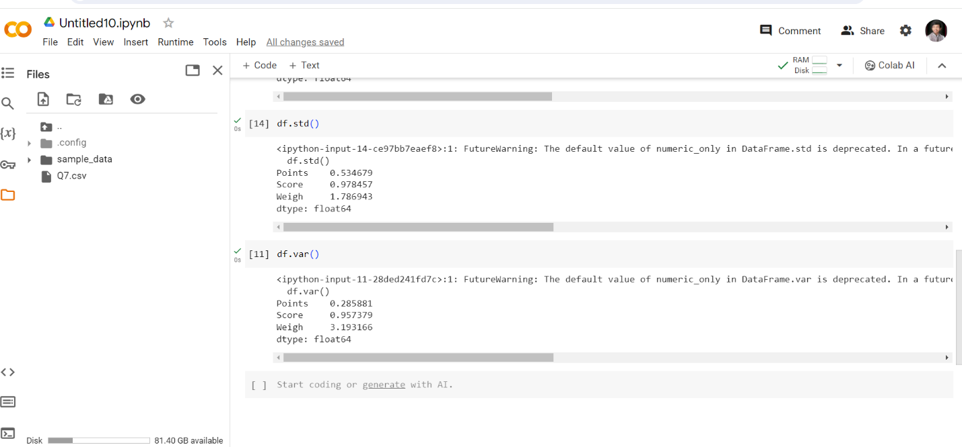

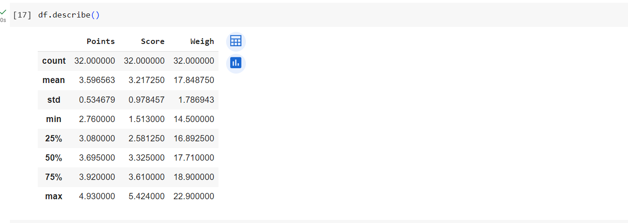Q8) Calculate Expected Value for the problem below

1. The weights (X) of patients at a clinic (in pounds), are

108, 110, 123, 134, 135, 145, 167, 187, 199

Assume one of the patients is chosen at random. What is the Expected Value of the Weight of that patient?

Ans- Expected Value = ∑ ( probability  * Value )

∑ P(x).E(x)

There are 9 patients

Probability is 1/9

E(x) 108,110,123,134,135,145,167,187,199

P(x) 1/9,1/9,1/9,1/9,1/9,1/9,1/9,1/9,1/9

Expected Value  =  (1/9)(108) + (1/9)110  + (1/9)123 + (1/9)134 + (1/9)135 + (1/9)145 + (1/9(167) + (1/9)187 + (1/9)199

= (1/9) ( 108 + 110 + 123 + 134 + 135 + 145 + 167 + 187 + 199)

= (1/9)  (  1308)

Expected Value= 145.33

**Q9) Calculate Skewness, Kurtosis & draw inferences on the following data**

**Cars speed and distance**

**Use Q9_a.csv**

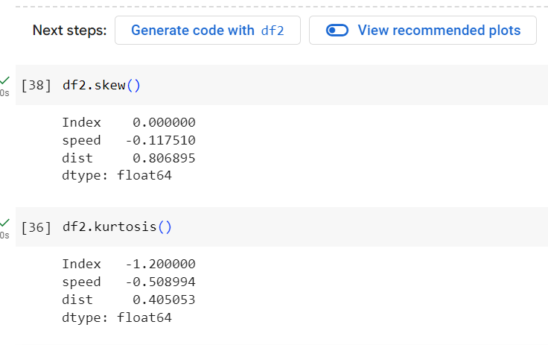

**SP and Weight(WT)**

**Use Q9_b.csv**

**Q10) Draw inferences about the following boxplot & histogram**



Ans- The Histograms Peak Has Right Skew Ans Tail Is On Right . Mean > Median . We Have Outliers On The Higher Side



Ans- The Boxplot Has Outliers On The Maximum Side.

**Q11)** Suppose we want to estimate the average weight of an adult male in Mexico. We draw a random sample of 2,000 men from a population of 3,000,000 men and weigh them. We find that the average person in our sample weighs 200 pounds, and the standard deviation of the sample is 30 pounds. Calculate 94%,98%,96% confidence interval?

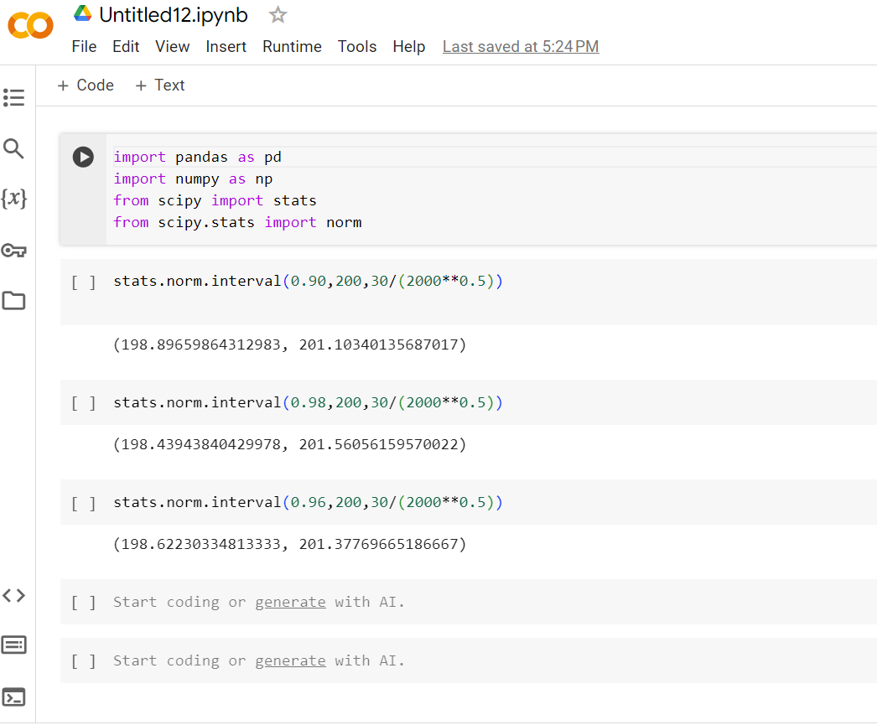

**Q12)** Below are the scores obtained by a student in tests

**34,36,36,38,38,39,39,40,40,41,41,41,41,42,42,45,49,56**

1. Find mean, median, variance, standard deviation.
2. What can we say about the student marks?

(a)Ans-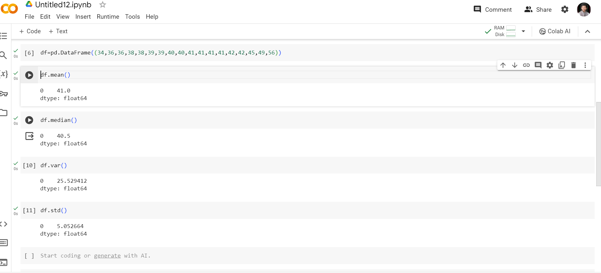

(b)Ans- We Don’t Have Outliers And The Data Is Slightly skewed towards Right Because Mean Is Greater Than Median.

Q13) What is the nature of skewness when mean, median of data are equal?

Ans-

In a distribution with zero skew, the [mean](https://www.scribbr.com/statistics/mean/) and [median](https://www.scribbr.com/statistics/median/) are equal.

Zero skew : mean = median

For example, the mean chick weight is 261.3 g, and the median is 258 g. The mean and median are almost equal. They are not perfectly equal because the sample distribution has a very small skew.

Q14) What is the nature of skewness when mean > median ?

The mean, mode and median can be used to figure out if you have a positively or negatively skewed distribution.

If the mean is greater than the median, the distribution is positively skewed.

Q15) What is the nature of skewness when median > mean?

Ans- The mean, mode and median can be used to figure out if you have a positively or negatively skewed distribution.

If the mean is greater than the median, the distribution is Negatively skewed.

Q16) What does positive kurtosis value indicates for a data ?

Ans- **Kurtosis** is a measure of whether the distribution is too peaked . A positive value for the kurtosis indicates a distribution more peaked than normal.

Q17) What does negative kurtosis value indicates for a data?

Ans- A distribution with a negative kurtosis value indicates that the distribution has lighter tails than the normal distribution.

Q18) Answer the below questions using the below boxplot visualization.



What can we say about the distribution of the data?

Ans- The Above Box Plot Is Not Normally Distributed The Median Is Towards The Higher Value.

What is nature of skewness of the data?

Ans-: The data is a skewed towards left. The whisker range of minimum value is greater than maximum

What will be the IQR of the data (approximately)?

Ans- The Inter Quantile Range = Q3 Upper quartile – Q1 Lower Quartile

= 18 – 10

=8

Q19) Comment on the below Boxplot visualizations?



Draw an Inference from the distribution of data for Boxplot 1 with respect Boxplot 2.

Ans-1) Both the box plot shares the same median that is approximately in a range between 275 to 250 and they are normally distributed with zero to no skewness neither at the minimum or maximum whisker range.

1. There Is No Outliers

Q 20) Calculate probability from the given dataset for the below cases

Data _set: Cars.csv

Calculate the probability of MPG of Cars for the below cases.

MPG <- Cars$MPG

* 1. P(MPG>38)
  2. P(MPG<40)
  3. P (20<MPG<50)

Ans-

A ) P(MPG>38)



b) P(MPG<40)

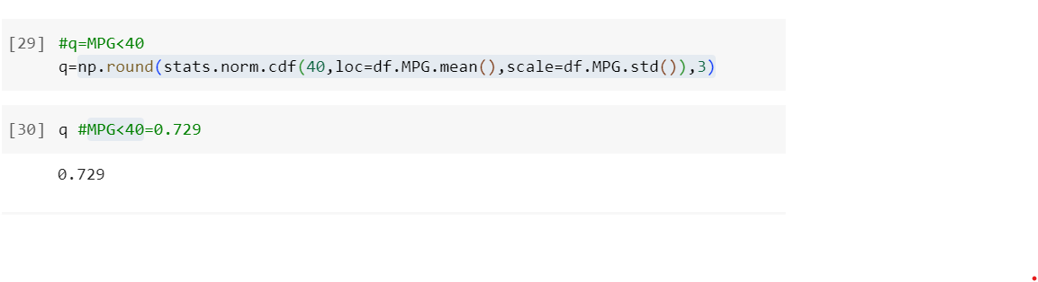

c) P (20<MPG<50)

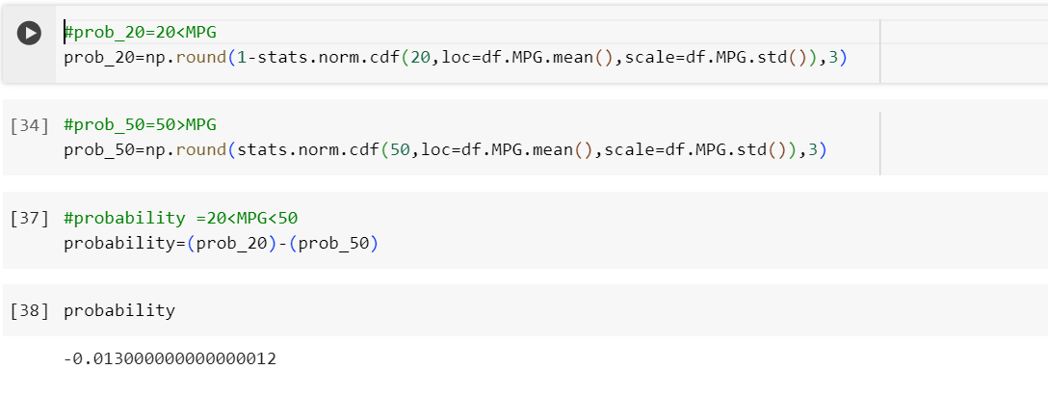

Q 21) Check whether the data follows normal distribution

1. Check whether the MPG of Cars follows Normal Distribution

Dataset: Cars.csv

Ans-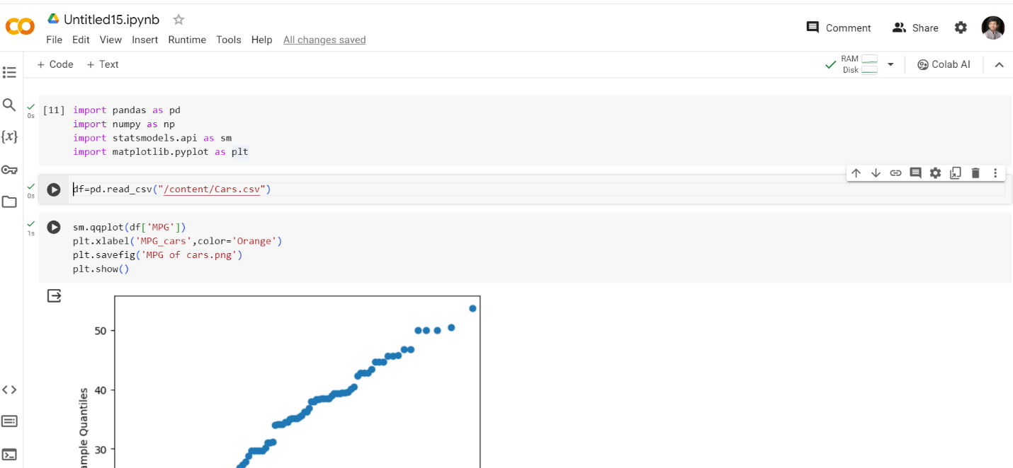

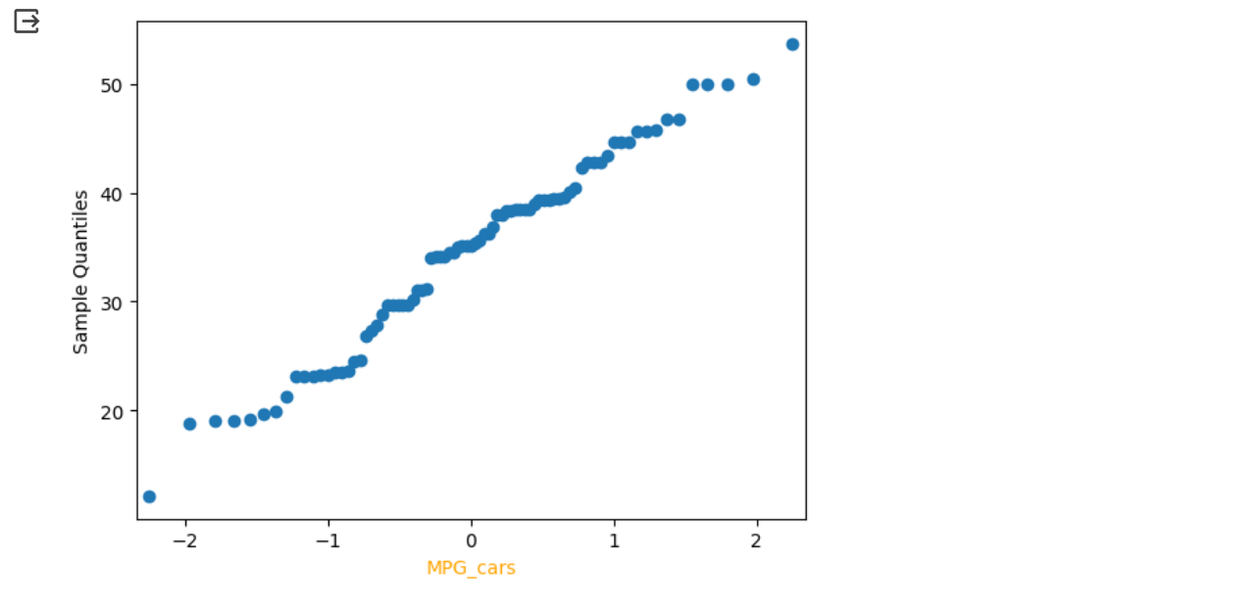

1. Check Whether the Adipose Tissue (AT) and Waist Circumference(Waist) from wc-at data set follows Normal Distribution

Dataset: wc-at.csv

Ans-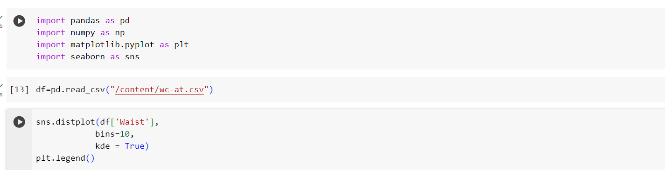

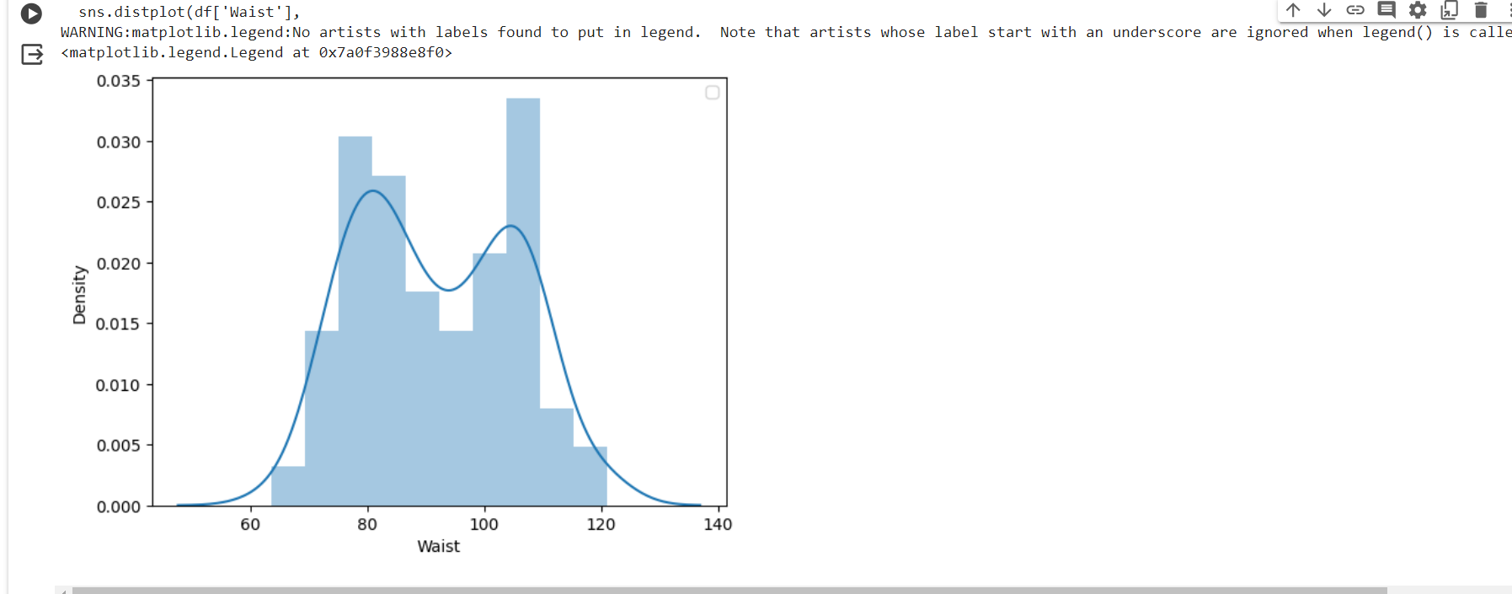

Q 22) Calculate the Z scores of 90% confidence interval,94% confidence interval, 60% confidence interval

Q 23) Calculate the t scores of 95% confidence interval, 96% confidence interval, 99% confidence interval for sample size of 25

Q 24**)** A Government company claims that an average light bulb lasts 270 days. A researcher randomly selects 18 bulbs for testing. The sampled bulbs last an average of 260 days, with a standard deviation of 90 days. If the CEO's claim were true, what is the probability that 18 randomly selected bulbs would have an average life of no more than 260 days

Hint:

rcode 🡪 pt(tscore,df)

df 🡪 degrees of freedom

Ans- x= 260

Pop mean=270

Std derivation=90

Sample size=18

**Calculate the t-score**

We'll use the formula for the t-score: 𝑡=𝑥ˉ−𝜇𝑠𝑛*t*=*n*​*s*​*x*ˉ−*μ*​ where:

𝑥=is the sample mean (260 days)

𝜇*=* is the population mean (270 days)

𝑠*=*is the standard deviation of the sample (90 days)

𝑛*=* is the sample size (18 bulbs)

Since we're dealing with a single sample, the degrees of freedom is 𝑛−1*n*−1, where 𝑛*n* is the sample size.

t score = (x – pop mean)/(std derivation)/(square root of sample size)

= (260-270/(90/sqrt(18))

=-0.471

P =2*stats.t.cdf(t_score,n-1)

P=0.643345

