**Topics: Descriptive Statistics and Probability**

1. Look at the data given below. Plot the data, find the outliers and find out $μ, σ, σ^{2}$

|  |  |
| --- | --- |
| **Name of company** | **Measure X** |
| Allied Signal | 24.23% |
| Bankers Trust | 25.53% |
| General Mills | 25.41% |
| ITT Industries | 24.14% |
| J.P.Morgan & Co. | 29.62% |
| Lehman Brothers | 28.25% |
| Marriott | 25.81% |
| MCI | 24.39% |
| Merrill Lynch | 40.26% |
| Microsoft | 32.95% |
| Morgan Stanley | 91.36% |
| Sun Microsystems | 25.99% |
| Travelers | 39.42% |
| US Airways | 26.71% |
| Warner-Lambert | 35.00% |

Ans=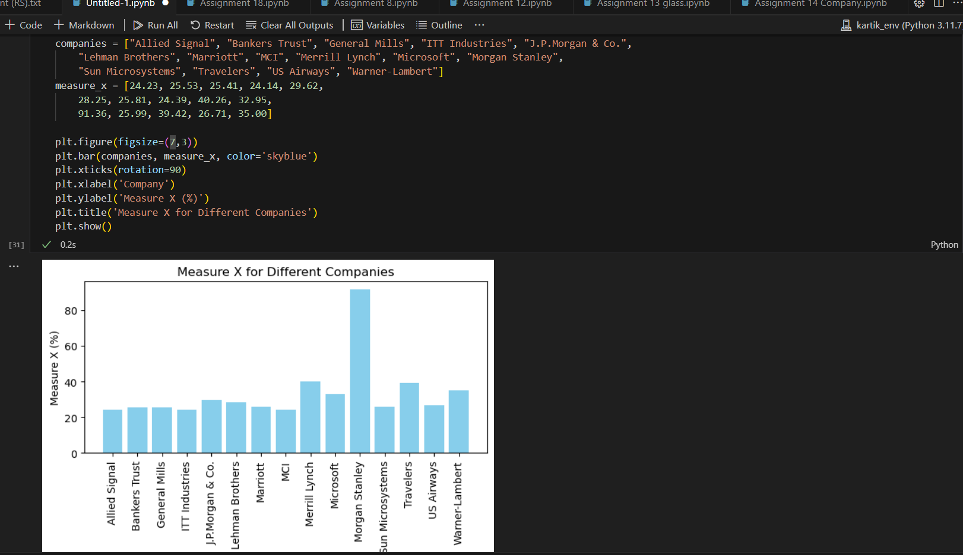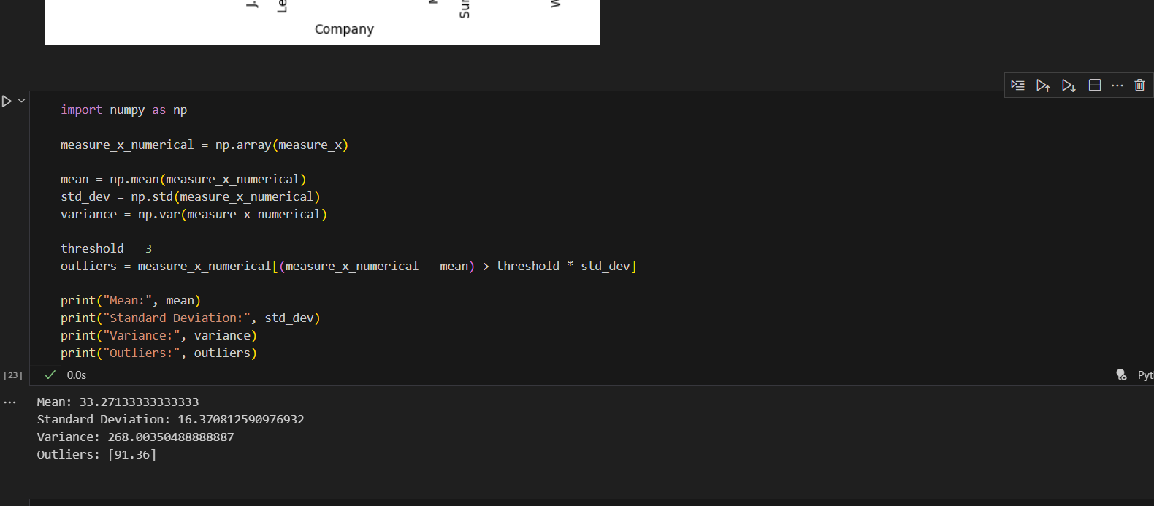



Answer the following three questions based on the box-plot above.

1. What is inter-quartile range of this dataset? (please approximate the numbers) In one line, explain what this value implies.

=0 To 25 at there are outliers on 25 point

1. What can we say about the skewness of this dataset?

=Outliers in boxplot, skewness in right side

1. If it was found that the data point with the value 25 is actually 2.5, how would the new box-plot be affected?

=Then No outliers



Answer the following three questions based on the histogram above.

1. Where would the mode of this dataset lie?

Ans-

1. Comment on the skewness of the dataset.

Ans-

1. Suppose that the above histogram and the box-plot in question 2 are plotted for the same dataset. Explain how these graphs complement each other in providing information about any dataset.

Ans-

1. AT&T was running commercials in 1990 aimed at luring back customers who had switched to one of the other long-distance phone service providers. One such commercial shows a businessman trying to reach Phoenix and mistakenly getting Fiji, where a half-naked native on a beach responds incomprehensibly in Polynesian. When asked about this advertisement, AT&T admitted that the portrayed incident did not actually take place but added that this was an enactment of something that “could happen.” Suppose that one in 200 long-distance telephone calls is misdirected. What is the probability that at least one in five attempted telephone calls reaches the wrong number? (Assume independence of attempts.)

Ans-one in 200 long-distance telephone calls is misdirected

probability of call misdirecting p = 1/200

Probability of call not Misdirecting = 1 - 1/200 = 199/200

Number of Calls = 5

P(x) = ⁿCₓpˣqⁿ⁻ˣ

n = 5

p = 1/200

q = 199/200

at least one in five attempted telephone calls reaches the wrong number

= 1 - none of the call reaches the wrong number

= 1 - P(0)

= 1 - ⁵C₀(1/200)⁰(199/200)⁵⁻⁰

= 1 - (199/200)⁵

= 0.02475

probability that at least one in five attempted telephone calls reaches the wrong number = 0.02475

1. Returns on a certain business venture, to the nearest $1,000, are known to follow the following probability distribution

|  |  |
| --- | --- |
| x | P(x) |
| -2,000 | 0.1 |
| -1,000 | 0.1 |
| 0 | 0.2 |
| 1000 | 0.2 |
| 2000 | 0.3 |
| 3000 | 0.1 |

1. What is the most likely monetary outcome of the business venture?

Ans- $ 2000 as it has maximum Probability 0.3

1. Is the venture likely to be successful? Explain

Ans-

Venture likely to be successful

if X is positive

*E*[*X*]=(−2000×0.1)+(−1000×0.1)+(0×0.2)+(1000×0.2)+(2000×0.3)+(3000×0.1)

𝐸[𝑋]=−200−100+0+200+600+300=800*E*[*X*]=−200−100+0+200+600+300=800

1. What is the long-term average earning of business ventures of this kind? Explain

Ans-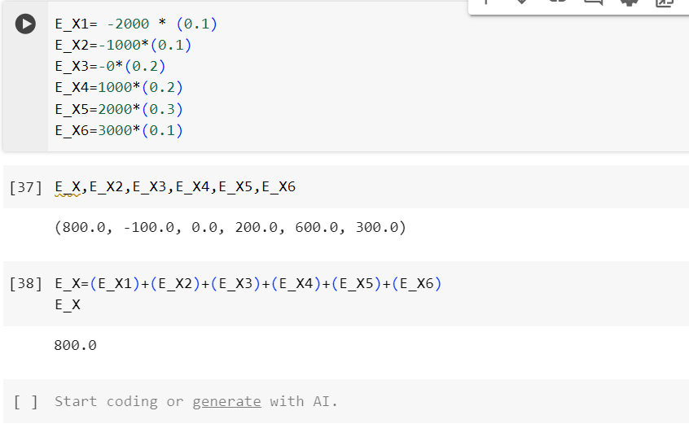

E(X)=X.P(X)

=800$

1. What is the good measure of the risk involved in a venture of this kind? Compute this measure

Ans-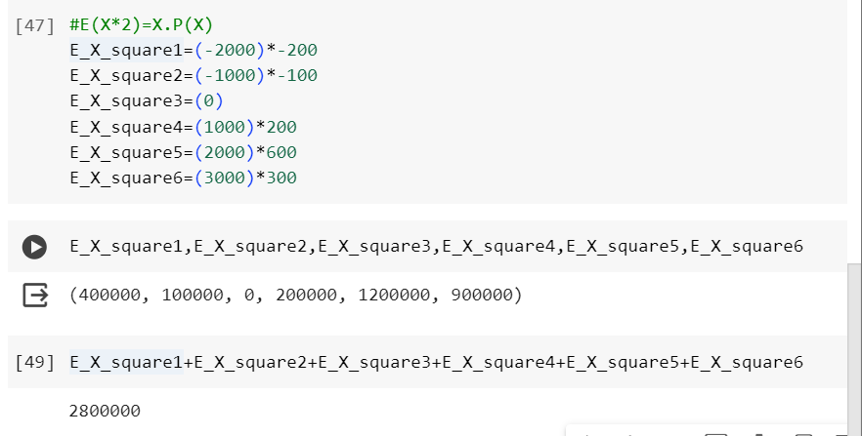

Var (X) = E(X²) - { E(X) }²

= 2800000 - 800²

= 2160000 ( Quite High)

SD = √Var ≈ $ 1470

As Variability is Quite high hence Risk is high

Coefficient of Variation (CV)= Standard Deviation​ /Mean

Lets calculate it using the previously calculated mean ($800) and standard deviation ($1494.9):

CV=1494.9800≈1.8686

CV=8001494.9​≈1.8686

The coefficient of variation is approximately 1.8686