Configuring TLS/SSL Connections for eDHR Application.

Version No. | Version Date | Changes | Owner/Author | Date of Review/Expiry
V0.1 | 05-03-2026 |  | Vijay Palle – GEHC DBA Team
V0.2 | 01-04-2026 | Added remote listener details

This Document describes technical procedure for configuring secure TLS/SSL connections using the TCPS protocol in Oracle Database 19c.
Please refer to:
KB325499: Step by Step Guide: How to Configure SSL/TLS on ORACLE RAC (with SCAN)

Prerequisites:
- port 2484 should be open for TLS/SSL connections using TCPS Protocol.
- Application team to provide the required TLS/SSL Certificates to DBA Team.

eDHR application certs and reference vendor documents are exported here.

https://gehealthcare.ent.box.com/folder/331690939172

Following eDHR databases using TLS/SSL connections.

eDHR Environment | DB name | DB servers | DC | Certificates
Dev | crp1mes | usatlldorarac01 and usatlldorarac02 | Atlanta | Certs_eDHR_FTPC11_DEV.zip
 | dev2mes | usatlldorarac01 and usatlldorarac02 | Atlanta | Certs_eDHR_FTPC11_DEV.zip
Test | tst1mes | usmkelsorarac01 and usmkelsorarac02 | Milwaukee | Certs_eDHR_FTPC11_TST.zip
 | tst2mes | usmkelsorarac01 andusmkelsorarac02 | Milwaukee | Certs_eDHR_FTPC11_TST.zip
 | Brk3mes | usmkelsorarac01 andusmkelsorarac02 | Milwaukee | Certs_eDHR_FTPC11_TST.zip
 | Brk4mes | usmkelsorarac01 andusmkelsorarac02 | Milwaukee | Certs_eDHR_FTPC11_TST.zip
Stage | stg3mes | usatllsorarac01 and usatllsorarac02 | Atlanta | SSL_FTPC11_STG_SAN.cer
 | stg4mes | usatllsorarac01 and usatllsorarac02 | Atlanta | SSL_FTPC11_STG_SAN.cer
 | stg31mes | usatllsorarac01 and usatllsorarac02 | Atlanta | SSL_FTPC11_STG_SAN.cer
 | stg41mes | usatllsorarac01 and usatllsorarac02 | Atlanta | SSL_FTPC11_STG_SAN.cer
Prod | prd3mes | usmkelporarac01 and usmkelporarac02 | Milwaukee | Certs_eDHR_FTPC11_PRD.zip
 | prd4mes | usmkelporarac01 and usmkelporarac02 | Milwaukee | Certs_eDHR_FTPC11_PRD.zip
 | prd11mes | usmkelporarac01 and usmkelporarac02 | Milwaukee | Certs_eDHR_FTPC11_PRD.zip
 | prd21mes | usmkelporarac01 and usmkelporarac02 | Milwaukee | Certs_eDHR_FTPC11_PRD.zip

- Configure TCPS protocol endpoints.

Before starting, a check of the listener resources shows support for TCP endpoints:

[grid@usmkelporarac01 bin]$ ./crsctl stat res -p |grep ENDPOINTS
ENDPOINTS=TCP:1526
ENDPOINTS=TCP:1521
ENDPOINTS=TCP:1521
ENDPOINTS=TCP:1521
ENDPOINTS=TCP:1521
ENDPOINTS=TCP:1525
[grid@usmkelporarac01 bin]$

  - Adding TCPS endpoints to the Database listener(s)

[grid@usmkelporarac01 bin]$ ./srvctl modify listener -p "TCP:1521/TCPS:2484"

- Bounce the listener.
[grid@usmkelporarac01 bin]$ ./srvctl stop listener
[grid@usmkelporarac01 bin]$ ./srvctl start listener
- Check the TCPS endpoints.

[grid@usmkelporarac01 bin]$ ./crsctl stat res -p |grep ENDPOINTS
ENDPOINTS=TCP:1526
ENDPOINTS=TCP:1521 TCPS:2484
ENDPOINTS=TCP:1521 TCPS:2484
ENDPOINTS=TCP:1521 TCPS:2484
ENDPOINTS=TCP:1521 TCPS:2484
ENDPOINTS=TCP:1525
[grid@usmkelporarac01 bin]$
Check the database listener configuration:
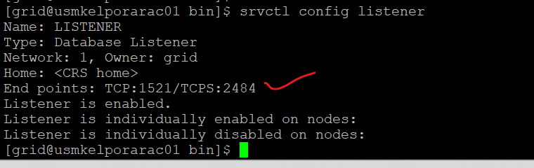

  - Adding TCPS endpoints to scan listeners.

- srvctl stop scan_listener
- srvctl stop scan
- srvctl modify listener -p "TCP:1521/TCPS:2484"
- srvctl start scan
- srvctl start scan_listener

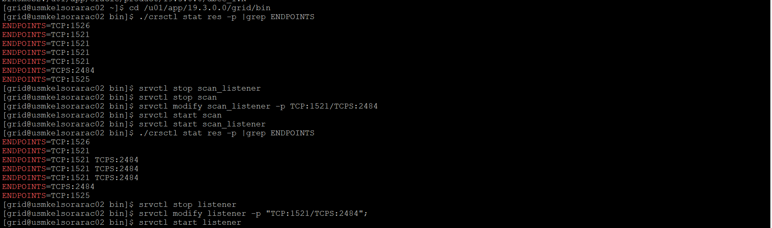

check the scan listeners configuration check using 2484 port.

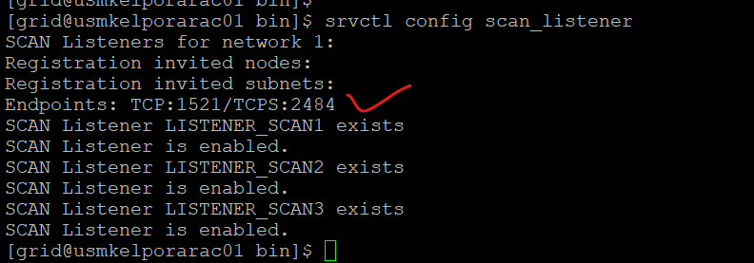

Note: performing the listeners and scan listeners bounce should be done ONLY during outage time. This might impact the other DB services running on shared cluster.

- Wallet and Certificate Management

Create a dedicated directory on each server to store the wallet files.
Recommended location would be $ORACLE_HOME/admin/SID_NAME/wallet.
In the current scenario,

Here is the location of SSL Certificate wallet for tst1mes in oramke1s DB cluster.
/u01/app/oracle/product/19.3.0.0/dbee_1/admin/tst1mes1/wallet.

Copy the Certificate files shared by application team to wallet location.

- Import the certificates to the wallet.
- Using the orapki utility, create an auto-login wallet to ensure the database can open it automatically.
- generate and add a self-signed root certificate (CA) to the wallet. For long-term stability in internal environments, the validity of this certificate to 10 years (3650 days).

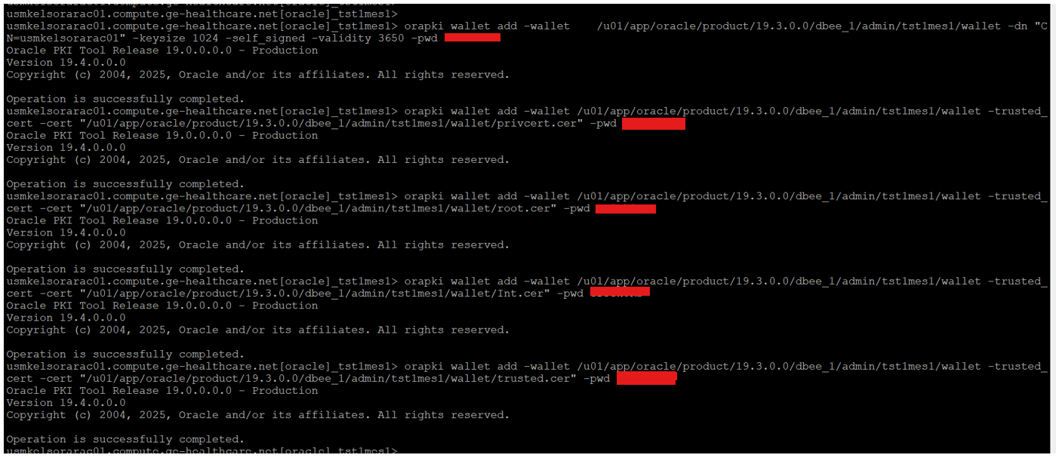

- Finally, verify the wallet’s contents using the orapki wallet display command to confirm that the requested and trusted certificates are correctly loaded.

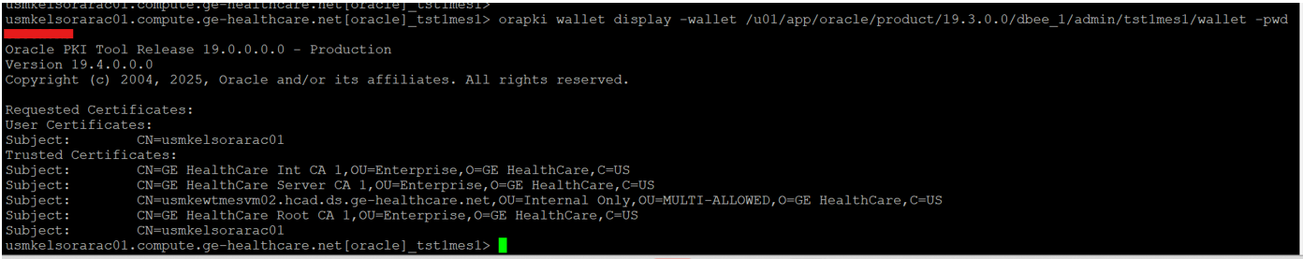

Result should display the certificate details.

- For RAC – copy the files to remaining nodes. No need to recreate on each node.

orapki wallet display -wallet /u01/app/oracle/product/19.3.0.0/dbee_1/admin/stg4mes2/wallet -pwd ********

- Network Configuration Updates.

- Create a listener with name LISTENER_SSL using 2484 port from rdbms home.

- Modify the listener.ora file and add the following entries.

SSL_CLIENT_AUTHENTICATION = FALSE

WALLET_LOCATION =
(SOURCE =
(METHOD = FILE)
(METHOD_DATA =
(DIRECTORY = /u01/app/oracle/product/19.3.0.0/dbee_1/admin/tst1mes1/wallet)
(DIRECTORY = /u01/app/oracle/product/19.3.0.0/dbee_1/admin/tst2mes1/wallet)
)
)

LISTENER_SSL =
(DESCRIPTION_LIST =
(DESCRIPTION =
(ADDRESS = (PROTOCOL = TCPS)(HOST = usmkelsorarac01.compute.ge-healthcare.net)(PORT = 2484))
)
)

SID_LIST_LISTENER_SSL =
(SID_LIST =
(SID_DESC =
(GLOBAL_DBNAME = tst1mes)
(ORACLE_HOME = /u01/app/oracle/product/19.3.0.0/dbee_1)
(SID_NAME = tst1mes1)
)
(SID_DESC =
(GLOBAL_DBNAME = tst2mes)
(ORACLE_HOME = /u01/app/oracle/product/19.3.0.0/dbee_1)
(SID_NAME = tst2mes1)
)
)

ENABLE_GLOBAL_DYNAMIC_ENDPOINT_LISTENER_SSL=ON
VALID_NODE_CHECKING_REGISTRATION_LISTENER_SSL=OFF

- Ensure wallet directory and Oracle home details are mentioned correctly.

- Add the wallet location entries in sqlnet.ora file.
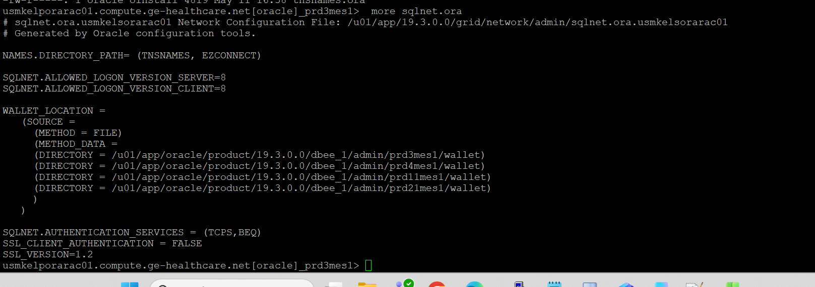

Now, perform the same steps on other nodes also if it’s for RAC.

- Create a tns for SSL connection using 2484 port and add it to local listener.

prd3mes,prd3mes_ssl =
(DESCRIPTION =
(ADDRESS = (PROTOCOL = TCPS)(HOST = oramke1p-scan.compute.ge-healthcare.net)(PORT = 2484))
(CONNECT_DATA =
(SERVER = DEDICATED)
(SERVICE_NAME = prd3mes)
)
)

Add the SSL service name at database level.

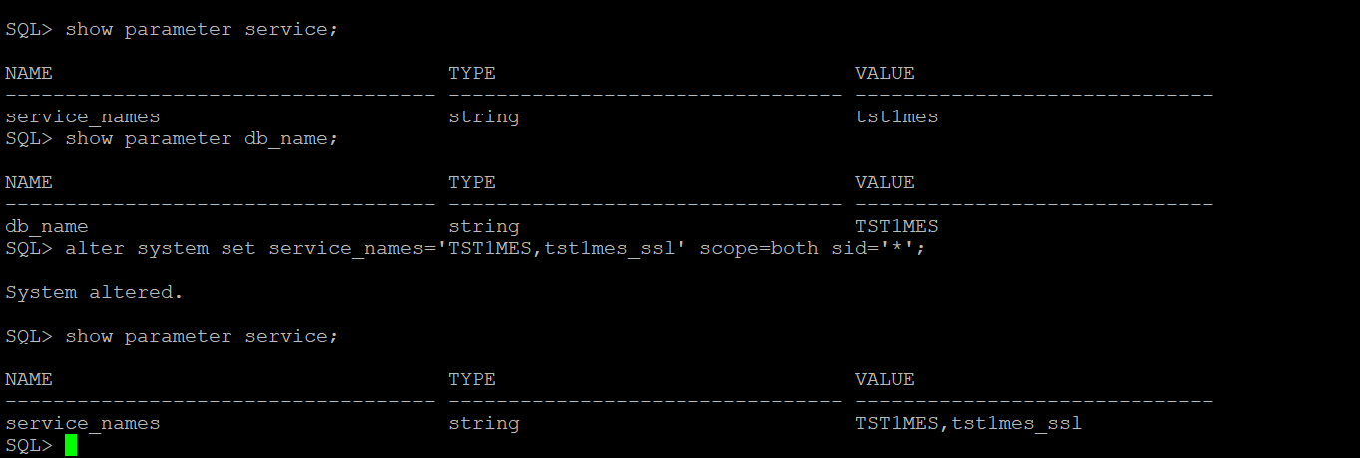

- Update the LOCAL_LISTENER and remote listener initialization parameters to include the TCPS protocol with 2484 port along with 1521 default port.

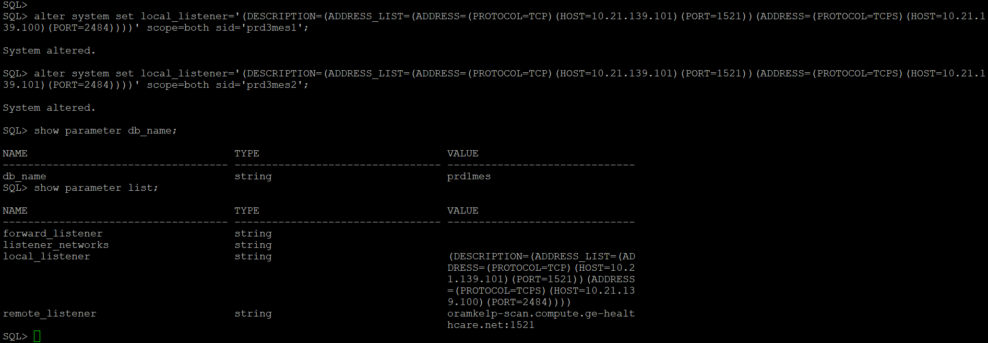

Alter system set local_listener='(DESCRIPTION=(ADDRESS_LIST=(ADDRESS=(PROTOCOL=TCP)(HOST=10.21.139.101)(PORT=1521))(ADDRESS=(PROTOCOL=TCPS)(HOST=10.21.139.100)(PORT=2484))))' scope=both sid='prd3mes1';

alter system set local_listener='(DESCRIPTION=(ADDRESS_LIST=(ADDRESS=(PROTOCOL=TCP)(HOST=10.21.139.101)(PORT=1521))(ADDRESS=(PROTOCOL=TCPS)(HOST=10.21.139.101)(PORT=2484))))' scope=both sid='prd3mes2';

- Connection Testing.

Now export the certificates from first node and share it with application team to test SSL connections.

orapki wallet export -wallet /u01/app/oracle/product/19.3.0.0/dbee_1/admin/stg4mes1/wallet -dn "CN= oramke1p" -cert /tmp/certs/prd3mes_ oramke1p-certificate.crt

- Application team will test the TLS/SSL connection using 2484 port. Here is the sample tns used by application team.

jdbc:oracle:thin:@(DESCRIPTION=(ADDRESS_LIST=(ADDRESS=(PROTOCOL=TCPS)(HOST=oraatl1s-scan.compute.ge-healthcare.net)(PORT=2484)))(CONNECT_DATA=(SERVICE_NAME=STG4MES)(SERVER=DEDICATED)))

test result:

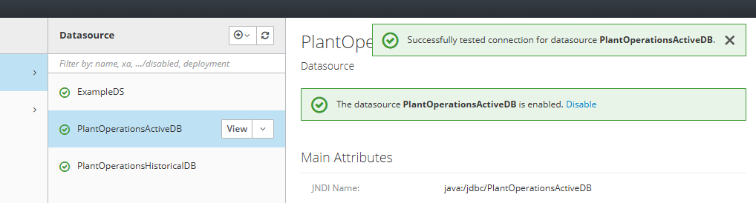

Test the connection from DBA side:

