Bug Report – Shaadi.com Registration Flow

Bug 1: Photo verification system approves third-party/friend's photo instead of validating actual profile owner

Environment: Shaadi.com Web App – My Shaadi > My Photos (https://my-shaadi.com/my-shaadi/photo)Steps to Reproduce:

1. Launch Microsoft Edge browser.

2. Navigate to https://my-shaadi.com/my-shaadi/photo.

3. Log in to a Shaadi.com account.

4. Navigate to My Shaadi > My Photos.

5. Click Browse Photo and upload a photo of a friend/another person instead of the account owner's own photo.

6. Wait for the automated photo screening process to complete (site claims ~98% activate within 2 hours).

7. Observe the uploaded photo status.
Expected Result: The photo verification system should detect that the uploaded photo does not match the profile owner (e.g., via face-match against existing verified photos, ID proof, or selfie verification) and should reject/flag the photo for manual review, since matrimonial profiles must represent the actual account holder.

Actual Result: The uploaded photo of a friend (a different individual, not the account owner) gets verified/activated successfully and is displayed as "Profile Photo" / "Album Photo" without any mismatch detection or rejection.

Impact:

Allows impersonation/fake profiles on a matrimonial platform, which is a serious trust and safety issue.

Undermines user confidence, since Shaadi.com core value proposition relies on identity authenticity.

Could enable catfishing, fraud, or misrepresentation, especially critical given the platform is used for serious relationship/marriage decisions.

Potential legal/reputational risk to the business.

Severity: Critical (High) — core trust & safety mechanism is broken; directly affects platform integrity and user safety.

Priority: P1 (High) — should be fixed urgently, as this is a security/identity-verification gap actively exploitable by any user.

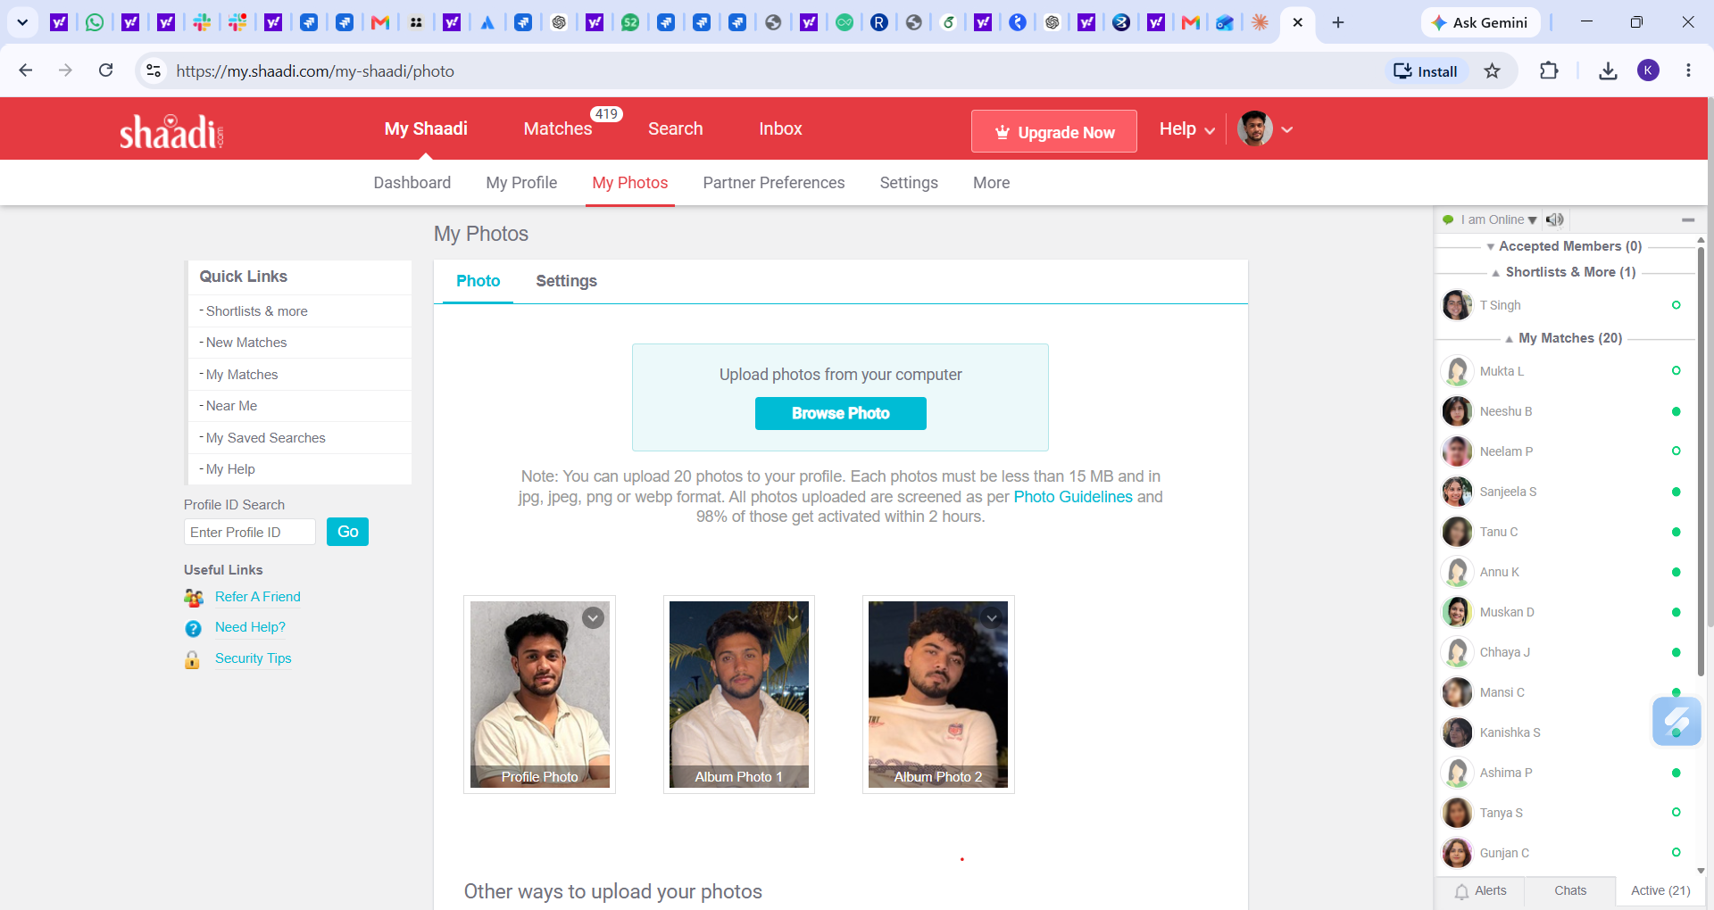

Bug 2: Continue button stays enabled even when First Name and Last Name fields are left blank
Environment: Shaadi.com Web App – Registration Flow, Name & Date of Birth step (https://www.shaadi.com)
Steps to Reproduce:
1. Launch Chrome browser.
2. Navigate to the Shaadi.com registration page.
3. Leave the First Name and Last Name fields empty.
4. Complete the rest of the required fields with valid data.
5. Click the Continue button.
Expected Result: The Continue button should stay disabled, or the system should show a validation warning that the Name fields are required, before letting the user proceed.
Actual Result: The Continue button remains clickable even with the Name fields empty, letting the user advance to the next step without filling in required information.
Impact:
- Allows incomplete or invalid profiles to be created, directly hurting data quality.
- Downstream features that rely on Name (search, matching, display) may break or show blank values.
- Undermines trust in mandatory-field validation across the rest of the registration flow.
Severity: High – required-field validation is not enforced on a core step.
Priority: P2 (High) – should be fixed promptly, as it affects every user skipping these fields.
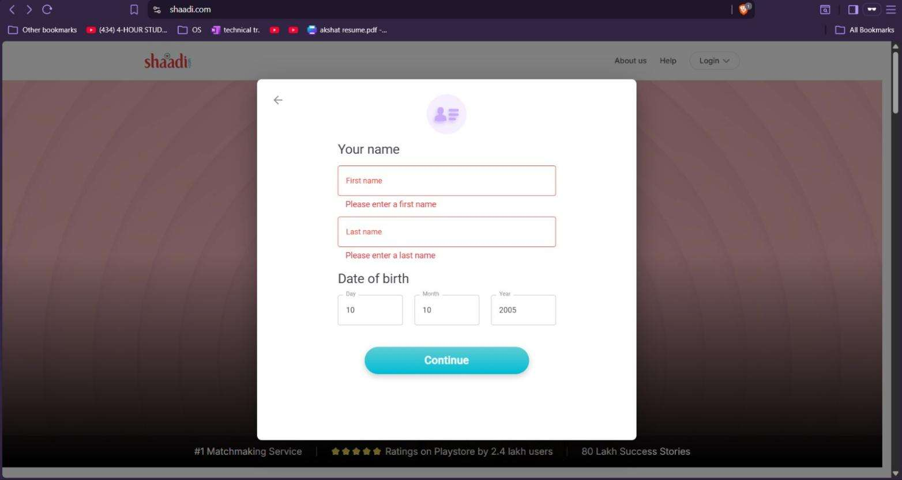

Bug 3: Month dropdown under Date of Birth displays no options
Environment: Shaadi.com Web App – Registration Flow, Date of Birth step (https://www.shaadi.com)
Steps to Reproduce:
1. Launch Chrome browser.
2. Navigate to the Shaadi.com registration page.
3. Go to the Date of Birth section.
4. Click the Month dropdown box.
Expected Result: The Month dropdown should list all 12 months (January through December) for selection.
Actual Result: The dropdown does not display anything when clicked, leaving the user unable to pick a month.
Impact:
- Blocks the entire registration process, since Date of Birth is a mandatory field that can never be completed.
- Directly causes new-user drop-off/abandonment at the registration step.
- Affects all users on the browser/environment where the dropdown fails to render.
Severity: Critical – blocks a mandatory step in the registration flow entirely.
Priority: P1 (Critical) – must be fixed urgently, as no user can complete registration while this persists.
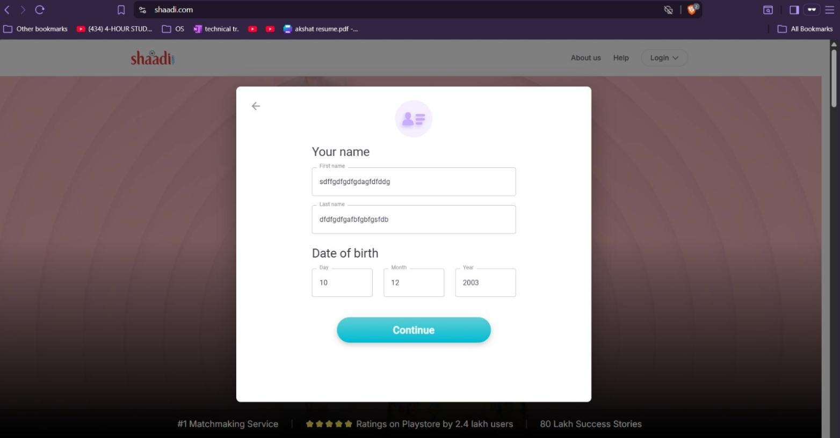

Bug 4: Email field has no visible maximum-length limit
Environment: Shaadi.com Web App – Registration Flow, Email ID & Mobile Number step (https://www.shaadi.com)
Steps to Reproduce:
1. Launch Chrome browser.
2. Navigate to the Shaadi.com registration page.
3. Go to the Email ID & Mobile Number section.
4. Enter an excessively long email address (e.g., a long string of characters followed by @gmail.com).
5. Complete the remaining fields correctly and click Submit/Continue.
Expected Result: The Email field should enforce a sensible maximum character limit and show a validation message when the entry exceeds it.
Actual Result: The unusually long email address is accepted with no validation or warning, and the user is able to proceed normally.
Impact:
- Creates unnecessary storage overhead for clearly unrealistic email values.
- May cause validation inconsistencies or failures when the email is processed on the backend or by third-party mail services.
- Could be exploited to stress-test or abuse input fields lacking boundary checks.
Severity: Medium – accepted input is unrealistic but does not block core functionality.
Priority: P3 (Medium) – should be fixed in a regular release cycle.
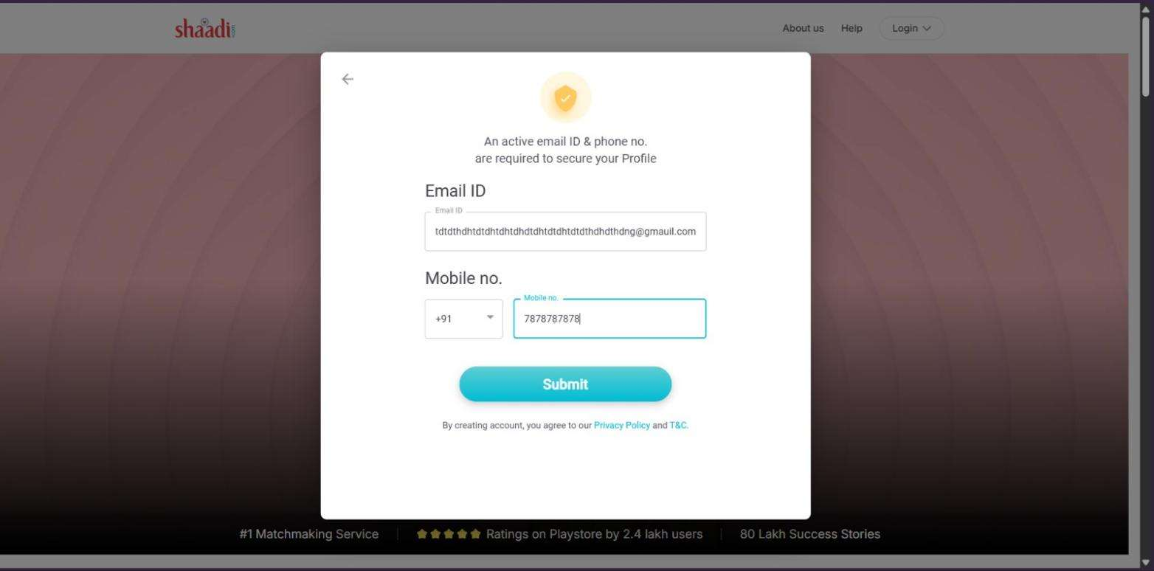

Bug 5: Email field accepts a clearly malformed email address
Environment: Shaadi.com Web App – Registration Flow, Email ID & Mobile Number step (https://www.shaadi.com)
Steps to Reproduce:
1. Launch Chrome browser.
2. Navigate to the Shaadi.com registration page.
3. In the Email field, enter an invalid value such as "testuser@ggh.com" style input where the domain is clearly not a valid mail provider.
4. Complete the remaining fields correctly.
5. Click Submit.
Expected Result: The system should verify the email follows a proper, deliverable format (e.g., name@domain.com) and display an error when it doesn't.
Actual Result: The malformed email is accepted with no error shown, and the form proceeds as though it were valid.
Impact:
- Allows unusable or junk email addresses to be registered against real accounts.
- Causes downstream problems with login, password recovery, and account notifications.
- Reduces the reliability of email-based communication for a matrimonial platform where verified contact is important.
Severity: Medium – accepted input is invalid but does not block core functionality.
Priority: P3 (Medium) – should be fixed in a regular release cycle.
