Step 4–5 Results

Language-Switching Invariance of LLM-as-a-Judge for Hindi Scripts and Hinglish — Step 4 run and results
Data: LLMBar (419 pairwise items) → 387-item human-validated core, rendered in English, Hindi (Devanagari), Romanized Hindi and code-mixed Hinglish. Six judges, two answer orders, temperature 0, Cloudflare AI Gateway (cache off).
Main findings.
- All six judges were less accurate in every Hindi-language condition than in English, and each of the 18 judge × language drops is significant after Holm correction (paired McNemar, p_{Holm} ≤ 0.02).
- Pooled accuracy: English 78.9%, Devanagari 74.1%, Hinglish 73.3%, Romanized 70.3%. Romanized Hindi is the hardest condition: an item-clustered GEE gives odds ratio 0.60 [0.54, 0.67] for a correct verdict, compared with English.
- Judges flip their verdict on 8–25% of identical item/order pairs when only the language/script changes. That is well above their own same-prompt re-run flip rate (0–11%).
- Judges are affected differently (variant × judge interaction Wald χ²=26.0, df=15, p=0.038). GPT-OSS-120B is the most robust (−3 pp); Llama-3.3-70B and Claude Haiku 4.5 lose 11–13 pp on Romanized Hindi.
- The effect remains when the 12 code-heavy items or the 34 human-fixed items are removed (Table 4).

1. Step 4 run completeness
Run | Design | Expected | Present | Valid
Main (run 0) | 387 items × 4 languages × 2 orders × 6 judges | 18,576 | 18,576 | 18,570
Repeat 1, 2 | 100 fixed items (seed 2027) × 4 × 2 × 6, twice | 9,600 | 9,600 | 9,600
The 6 unreadable judgments remained unreadable after 3 attempts each: 3 Qwen3 outputs where reasoning was cut off at the token limit, and 3 Llama-3.1-8B refusals. They are kept in the logs and counted as incorrect (a conservative choice). The run made 32,010 API calls, including retries of HTTP 429 rate-limit errors, at an estimated cost of $11.53 (token-based estimate). Every record stores the prompt hash, returned model, translation version, timestamp, token usage and raw response.

2. Method (algorithm)
Algorithm 1: Controlled language-switching meta-evaluation
Input: items D = {(x, y1, y2, g)}, languages L = {en, deva, roman, cm}, judges J, orders O = {AB, BA}
1 for each item d in D, language l in L: (x, y1, y2)_l ← validated translation T_l(d) # human-checked
2 for each judge j, item d, language l, order o:
3 prompt ← fixed LLMBar judge template filled with (x_l, first, second) per o
4 r ← j(prompt; temperature=0, no cache); parse last "Output (a|b)" → pick p ∈ {1,2}
5 if unparseable or API error: retry (≤3 attempts) else store (p, raw, usage, hashes)
6 repeat lines 2–5 for runs k = 1, 2 on a fixed 100-item subset (noise floor)
7 compute accuracy, flip rate, position consistency per (j, l); pair cells on (d, o)
8 test l vs en: exact McNemar per judge (Holm across 18 tests); item-clustered bootstrap CIs (B=2000)
9 pooled model: GEE logistic correct ~ language + judge + order, clustered by item

3. Metrics and equations
For judge $j$, language $ℓ$, item $i$, order $o$: the pick is $p_{jℓio}∈\{1,2\}$ and the gold label is $g_{i}$.
Accuracy:
Accjℓ=12|D|i∈D​o∈{AB,BA}​1[pjℓio=gi]
Language-switch flip rate (relative to English):
Flipjℓ=12|D|i,o​1[pjℓio≠pj,en,io]
Accuracy gap: $Δ_{jℓ}={Acc}_{jℓ}−{Acc}_{j,en}$. Position consistency: PCjℓ=1|D|i​1[pjℓi,AB=pjℓi,BA].
Re-run noise floor: across runs $k<k^{′}$ on the subset $D_{100}$, SelfFlipjℓ=32−1k<k′​12|D100|i,o​1[pjℓio(k)≠pjℓio(k′)], and ${Excess}_{jℓ}={Flip}_{jℓ}−{SelfFlip}_{jℓ}$.
Exact McNemar test on the paired cells, with $b$ = right in English and wrong in $ℓ$, $c$ = the reverse:
$$p=P\left(X≤min(b,c)\right)⋅2, X∼Bin(b+c,1/2)$$
GEE logistic model with exchangeable within-item correlation:
$$logitP(y_{ijℓo}=1)=β_{0}+β_{ℓ}+γ_{j}+δ_{o}, {OR}_{ℓ}=e^{β_{ℓ}}$$
Confidence intervals come from 2000 bootstrap resamples of items (the clusters), so the two orders and the paired cells of an item are resampled together.

4. Results
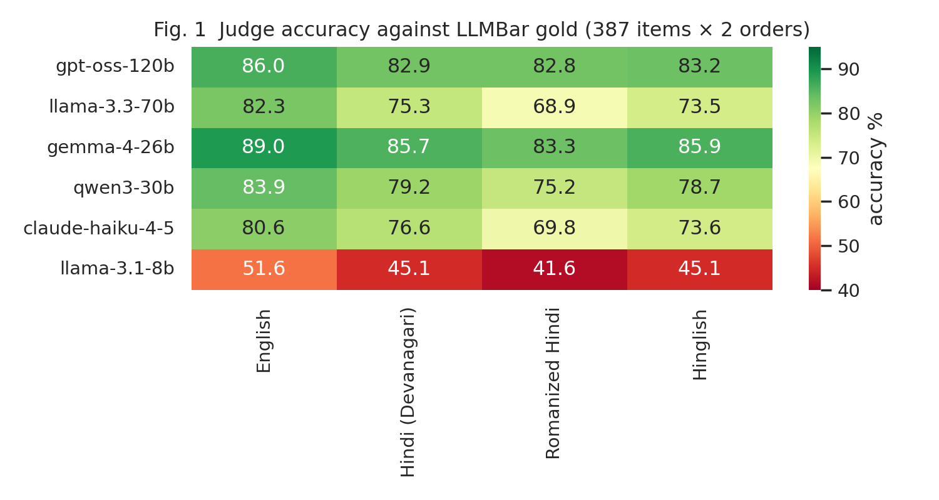
Figure 1. Accuracy (%) of each judge in each language condition.
Table 1. Per-judge results. Δacc and flip are relative to English; 95% item-clustered bootstrap CIs in brackets; p is Holm-adjusted McNemar.
Judge | Language | Acc % | Δacc pp [95% CI] | Flip % [95% CI] | Pos. consistency % | First-pos % | p (Holm)
gpt-oss-120b | English | 86.0 | — | — | 94.3 | 52.3 | —
gpt-oss-120b | Hindi (Devanagari) | 82.9 | -3.1 [-5.6, -0.5] | 8.8 [6.6, 11.2] | 91.7 | 52.3 | 0.02
gpt-oss-120b | Romanized Hindi | 82.8 | -3.2 [-5.9, -0.5] | 10.5 [7.9, 13.0] | 91.5 | 50.9 | 0.02
gpt-oss-120b | Hinglish | 83.2 | -2.8 [-5.4, -0.5] | 8.5 [6.3, 11.0] | 91.2 | 52.3 | 0.02
llama-3.3-70b | English | 82.3 | — | — | 88.9 | 52.7 | —
llama-3.3-70b | Hindi (Devanagari) | 75.3 | -7.0 [-10.2, -3.9] | 16.3 [13.6, 19.1] | 79.6 | 57.1 | 1.8e-05
llama-3.3-70b | Romanized Hindi | 68.9 | -13.4 [-16.9, -9.8] | 21.2 [17.8, 24.5] | 77.0 | 59.4 | 1.2e-15
llama-3.3-70b | Hinglish | 73.5 | -8.8 [-12.1, -5.7] | 16.3 [13.4, 19.3] | 78.0 | 58.1 | 1.5e-08
gemma-4-26b | English | 89.0 | — | — | 91.5 | 49.6 | —
gemma-4-26b | Hindi (Devanagari) | 85.7 | -3.4 [-5.6, -1.2] | 9.3 [7.2, 11.6] | 89.9 | 50.4 | 0.018
gemma-4-26b | Romanized Hindi | 83.3 | -5.7 [-8.3, -3.2] | 10.6 [8.1, 13.2] | 89.9 | 51.0 | 1.4e-05
gemma-4-26b | Hinglish | 85.9 | -3.1 [-5.2, -1.2] | 8.3 [6.1, 10.6] | 91.5 | 49.4 | 0.018
qwen3-30b | English | 83.9 | — | — | 87.6 | 56.1 | —
qwen3-30b | Hindi (Devanagari) | 79.2 | -4.7 [-7.6, -1.8] | 13.8 [11.2, 16.8] | 84.8 | 53.2 | 0.0048
qwen3-30b | Romanized Hindi | 75.2 | -8.7 [-12.0, -5.4] | 17.1 [14.2, 20.3] | 83.7 | 55.8 | 7.4e-08
qwen3-30b | Hinglish | 78.7 | -5.2 [-8.0, -2.2] | 13.2 [10.6, 16.0] | 84.7 | 56.7 | 0.00099
claude-haiku-4-5 | English | 80.6 | — | — | 87.6 | 53.4 | —
claude-haiku-4-5 | Hindi (Devanagari) | 76.6 | -4.0 [-7.0, -1.0] | 15.4 [12.5, 18.3] | 83.2 | 53.5 | 0.02
claude-haiku-4-5 | Romanized Hindi | 69.8 | -10.9 [-14.5, -7.0] | 21.2 [18.0, 24.4] | 79.8 | 53.9 | 5.7e-10
claude-haiku-4-5 | Hinglish | 73.6 | -7.0 [-10.3, -3.7] | 15.2 [12.4, 18.1] | 84.0 | 54.9 | 9e-06
llama-3.1-8b | English | 51.6 | — | — | 68.6 | 61.6 | —
llama-3.1-8b | Hindi (Devanagari) | 45.1 | -6.5 [-9.8, -3.0] | 21.8 [18.8, 24.7] | 66.1 | 64.3 | 0.0011
llama-3.1-8b | Romanized Hindi | 41.6 | -9.9 [-13.8, -6.2] | 25.3 [22.0, 28.6] | 65.9 | 63.4 | 4.9e-07
llama-3.1-8b | Hinglish | 45.1 | -6.5 [-9.7, -3.4] | 18.4 [15.8, 21.1] | 67.2 | 63.3 | 0.00033
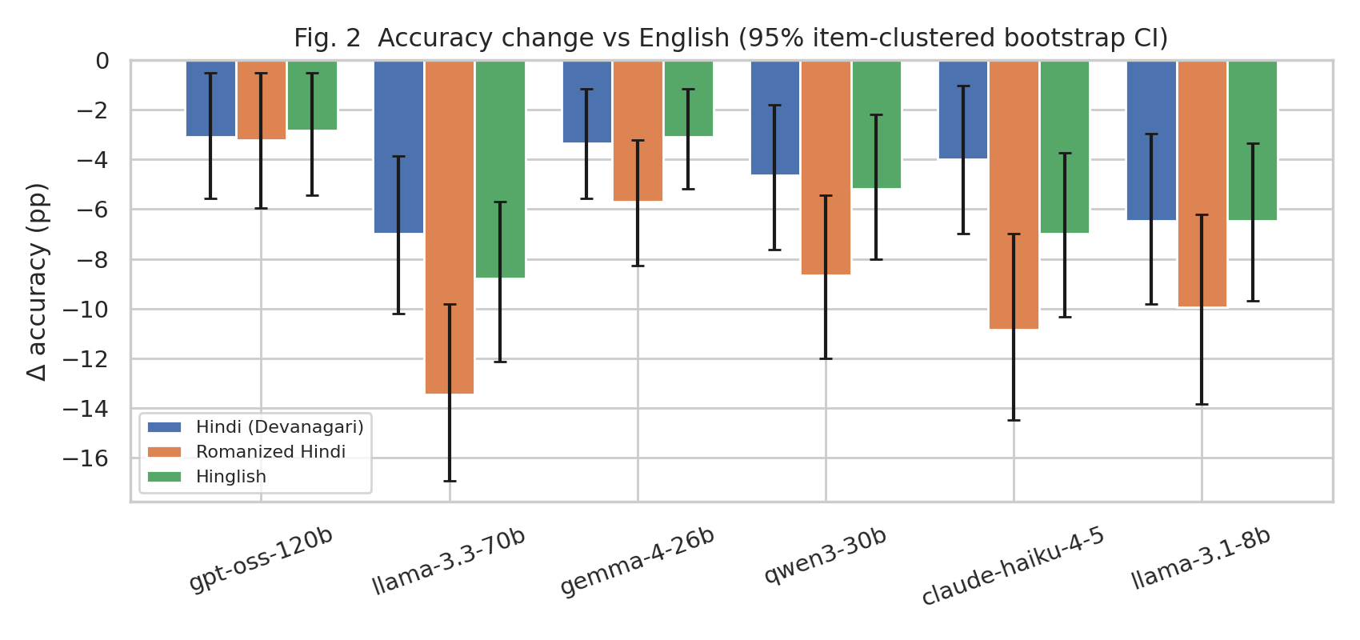
Figure 2. Accuracy change vs English with 95% CIs. All 18 bars exclude 0.
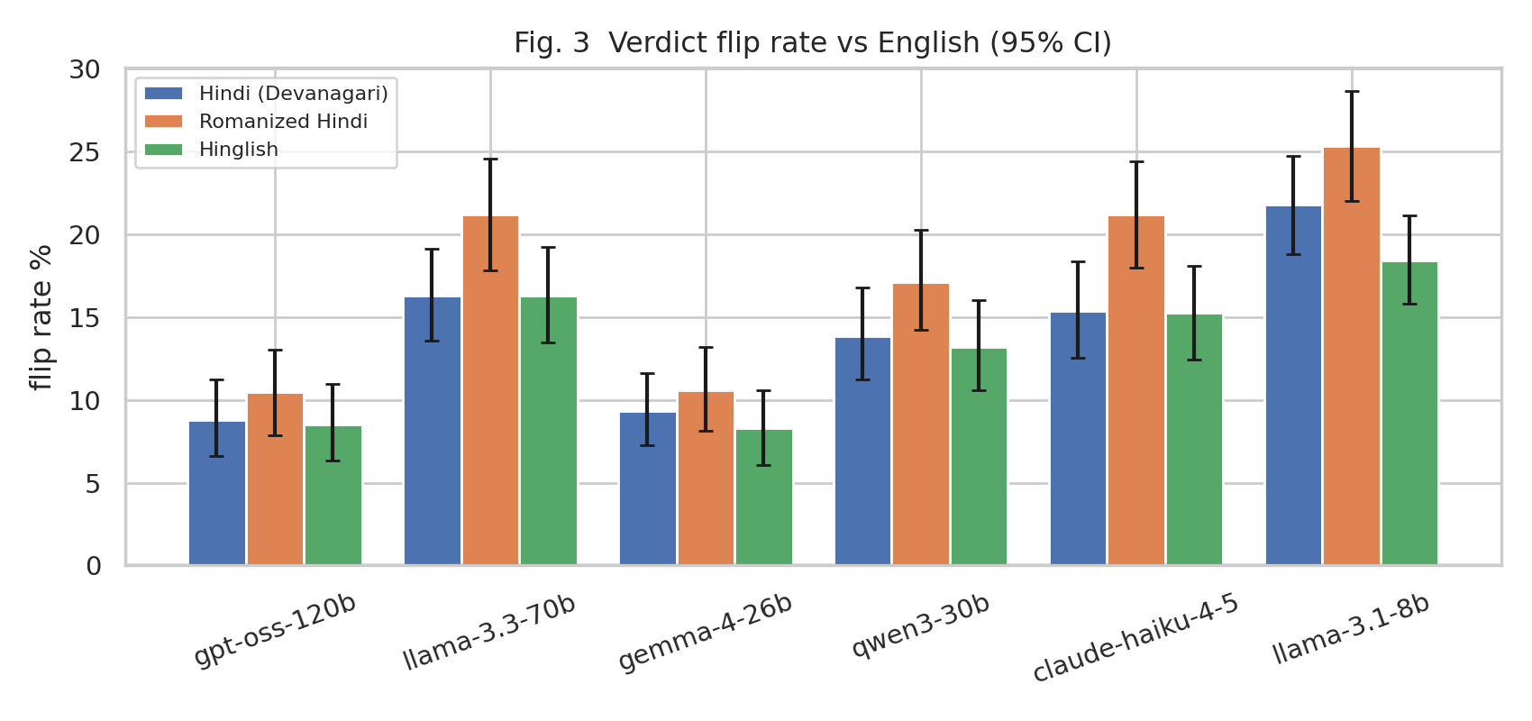
Figure 3. Fraction of identical item/order pairs whose verdict changes when only the language changes.
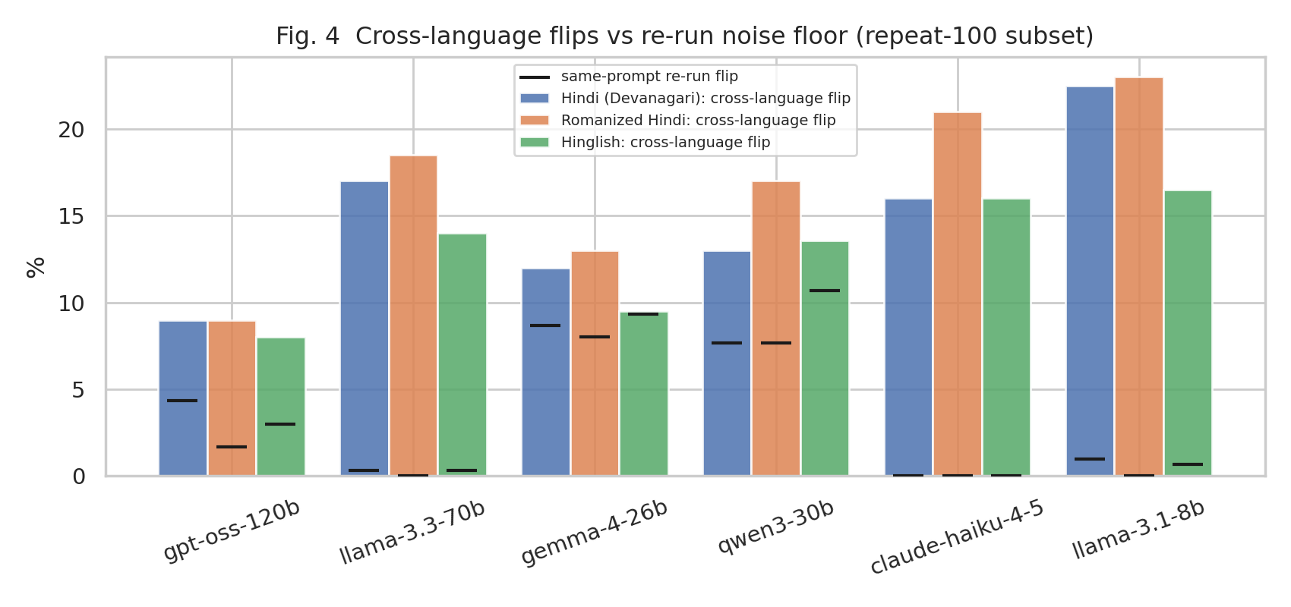
Figure 4. Cross-language flips (bars) vs the same-prompt re-run flip rate (black ticks) on the 100-item repeat subset.
Table 2. Repeat-run stability on the 100-item subset (3 runs).
Judge | Language | Self-flip % | All 3 runs identical % | Cross-language flip % (subset) | Excess pp
gpt-oss-120b | English | 1.7 | 97.5 | — | —
gpt-oss-120b | Hindi (Devanagari) | 4.3 | 93.5 | 9.0 | +4.7
gpt-oss-120b | Romanized Hindi | 1.7 | 97.5 | 9.0 | +7.3
gpt-oss-120b | Hinglish | 3.0 | 95.5 | 8.0 | +5.0
llama-3.3-70b | English | 0.0 | 100.0 | — | —
llama-3.3-70b | Hindi (Devanagari) | 0.3 | 99.5 | 17.0 | +16.7
llama-3.3-70b | Romanized Hindi | 0.0 | 100.0 | 18.5 | +18.5
llama-3.3-70b | Hinglish | 0.3 | 99.5 | 14.0 | +13.7
gemma-4-26b | English | 7.0 | 89.5 | — | —
gemma-4-26b | Hindi (Devanagari) | 8.7 | 87.0 | 12.0 | +3.3
gemma-4-26b | Romanized Hindi | 8.0 | 88.0 | 13.0 | +5.0
gemma-4-26b | Hinglish | 9.3 | 86.0 | 9.5 | +0.2
qwen3-30b | English | 7.3 | 89.0 | — | —
qwen3-30b | Hindi (Devanagari) | 7.7 | 88.5 | 13.0 | +5.3
qwen3-30b | Romanized Hindi | 7.7 | 88.5 | 17.0 | +9.3
qwen3-30b | Hinglish | 10.7 | 84.0 | 13.6 | +2.9
claude-haiku-4-5 | English | 0.7 | 99.0 | — | —
claude-haiku-4-5 | Hindi (Devanagari) | 0.0 | 100.0 | 16.0 | +16.0
claude-haiku-4-5 | Romanized Hindi | 0.0 | 100.0 | 21.0 | +21.0
claude-haiku-4-5 | Hinglish | 0.0 | 100.0 | 16.0 | +16.0
llama-3.1-8b | English | 0.3 | 99.5 | — | —
llama-3.1-8b | Hindi (Devanagari) | 1.0 | 98.5 | 22.5 | +21.5
llama-3.1-8b | Romanized Hindi | 0.0 | 100.0 | 23.0 | +23.0
llama-3.1-8b | Hinglish | 0.7 | 99.0 | 16.5 | +15.8
Llama-3.3-70B, Claude Haiku and Llama-3.1-8B are almost deterministic (self-flip ≤1%), so almost all of their cross-language flips are caused by the language change. Gemma-4 and Qwen3 have a re-run noise floor of 7–11%. For Gemma on Hinglish, the excess is about 0, so most of its Hinglish flips there are noise.
Table 3. GEE logistic model (387 item clusters, n=18,576), odds ratio of a correct verdict vs English, adjusted for judge and order.
Language | OR | 95% CI | p
Hindi (Devanagari) | 0.747 | [0.682, 0.818] | 3.0e-10
Romanized Hindi | 0.603 | [0.542, 0.671] | 1.8e-20
Hinglish | 0.714 | [0.653, 0.779] | 6.1e-14
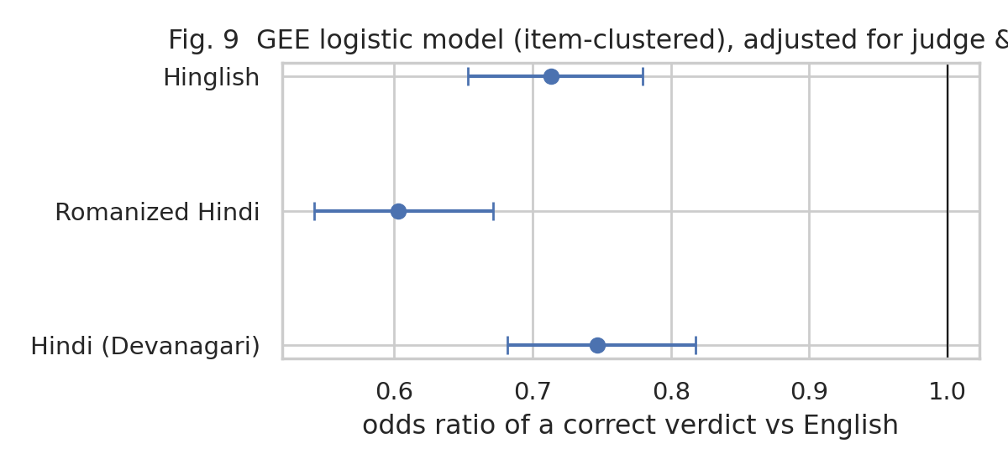
Figure 9. GEE odds ratios with 95% CIs.
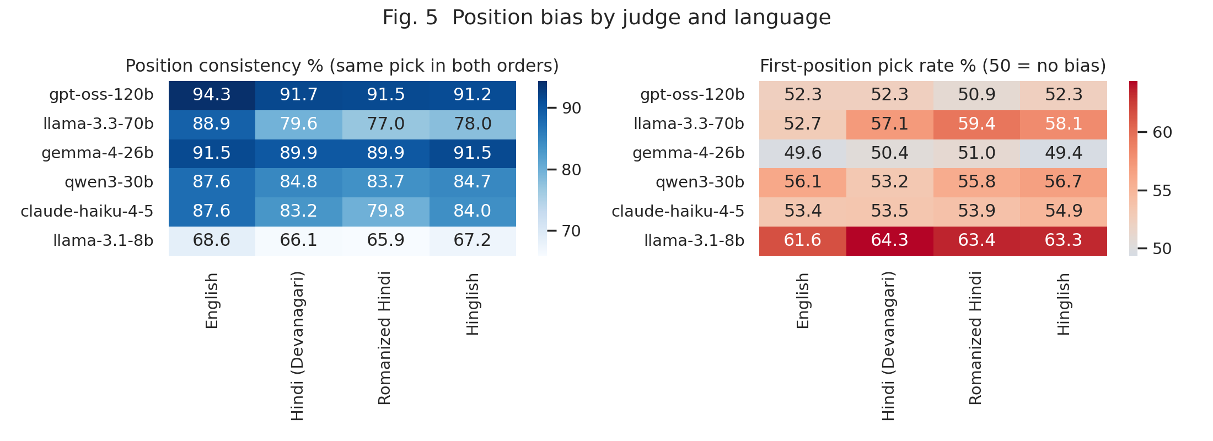
Figure 5. Position consistency and first-position preference. Switching away from English lowers consistency for most judges.
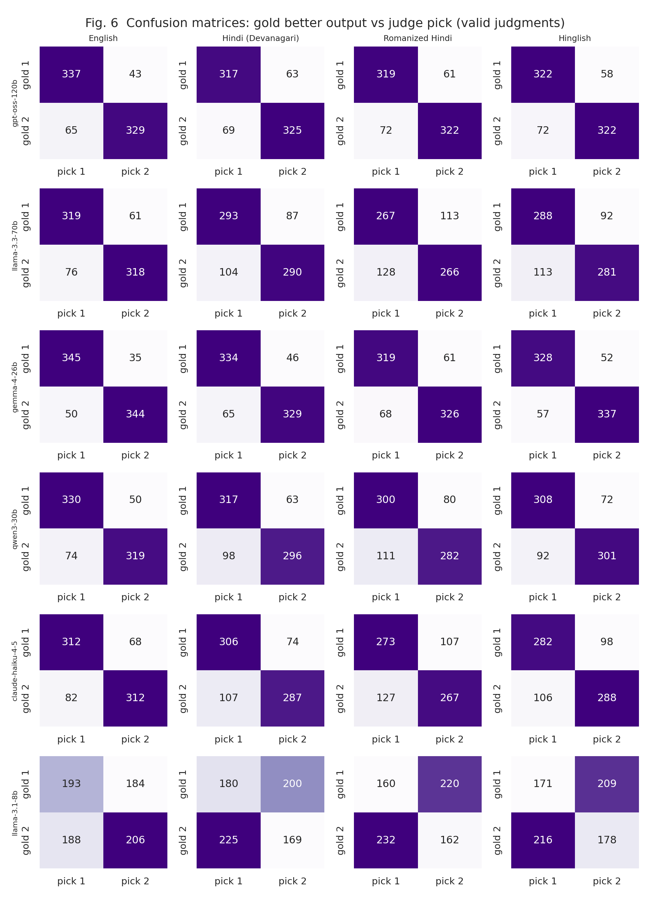
Figure 6. Confusion matrices (gold better output vs judge pick), valid judgments only. Llama-3.1-8B is near chance in English and anti-correlated with gold in Hindi conditions.
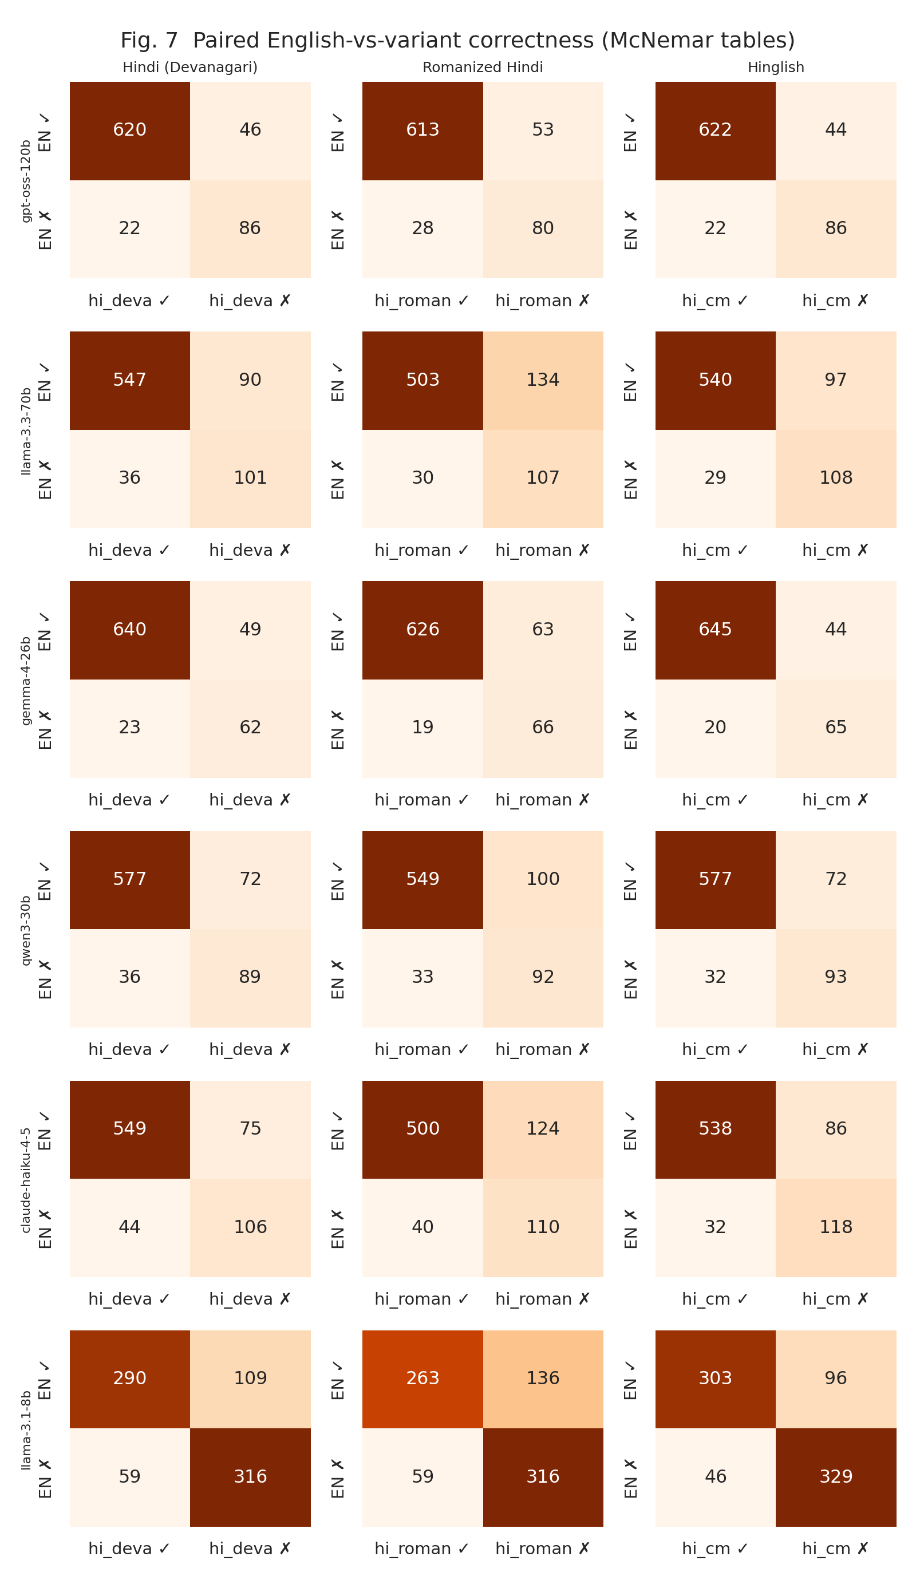
Figure 7. Paired correctness tables (English vs each language) used for the McNemar tests. The off-diagonal asymmetry (EN✓→✗ ≫ EN✗→✓) is the effect.
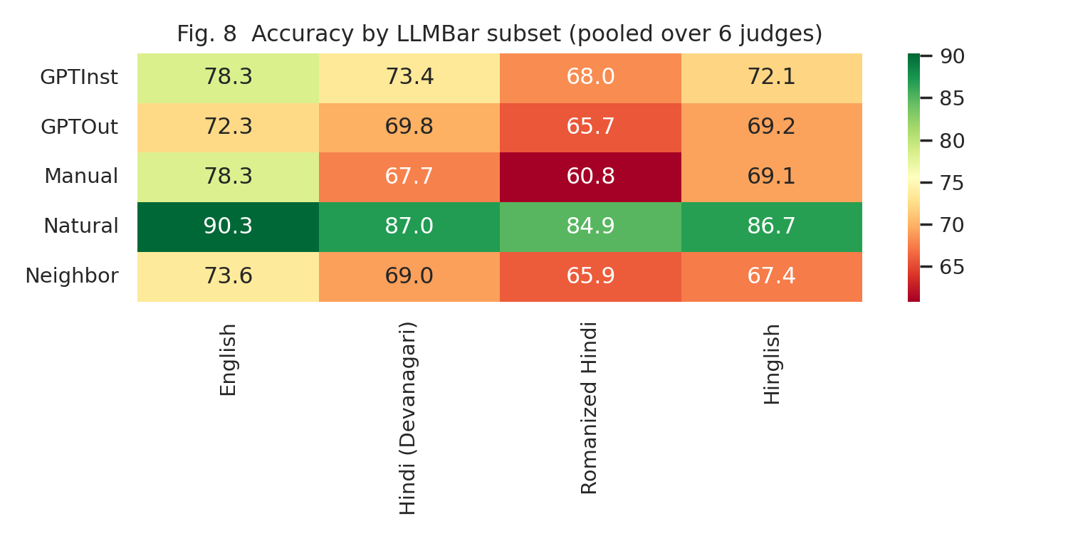
Figure 8. Accuracy by LLMBar subset, pooled over judges.

5. Robustness
Table 4. Mean Δacc (pp) across the six judges, and the number of judge × language cells significant after Holm correction.
Item set | Devanagari | Romanized | Hinglish | Significant
All 387 items | -4.8 | -8.6 | -5.6 | 18/18
Without 12 code-heavy items (375) | -4.8 | -8.9 | -5.6 | 18/18
Without 34 human-fixed items (353) | -4.4 | -8.3 | -4.8 | 18/18
The full per-judge tables for each subset are in metrics_no_codeheavy.csv and metrics_no_humanfixed.csv. Counting the 6 unreadable judgments as incorrect vs dropping them changes accuracy by at most 0.2 pp (Table 1 shows only the conservative version; both are in the CSV).

6. Limitations (to state in the paper)
- Translations were made by machine (Gemini 2.5 Pro), checked by Claude Sonnet 4.5, and human-validated by two raters on 251 cells (raw meaning agreement 91%, Gwet's AC1 0.91). A drop in accuracy may partly reflect residual translation quality rather than judge bias, although the effect holds after removing human-fixed items.
- One benchmark (LLMBar), one prompt template, and six judges accessed through Cloudflare/Anthropic APIs at a fixed date. Results are a measurement for these settings, not a universal claim.
- Claude Haiku 4.5 belongs to the same family as the verifier model (Claude Sonnet 4.5), not the translator.
- Cost is a token-based estimate; the exact billing is in the AI Gateway logs.
Code: src/judge.py, src/check_step4.py, src/step5_analysis.py, src/build_report.py. Raw data: results/step4/*.jsonl.

