



Tel: (Singapore) +65 84306322
Tel: (USA) +1 202 455 5058
Email: Chakshu@greyb.com
Singapore
1 Scotts Road, #24-05, Shaw Centre, Singapore 228208
GreyB
Validity Search
US11134316B1
21-04-2025

IF IT EXISTS, WE WILL FIND IT.
Contents
1. Understanding the Subject Patent 3
1.1 Overview 3
1.2 In depth Concept 3
1.3 Note 3
2. File History Analysis 4
2.1 Observations from file history of EP/JP/CN family member 4
2.2 Conclusion 4
3. Observations from Complaint Document 5
4. Observations from IPR Document 5
5. Observations from Standards 5
6. Analysis of known prior-art 5
7. Disclaimer 6

Understanding the Subject Patent

Overview
US11134316B1 (hereinafter referred to as ‘subject patent’/US11134316B1) …The invention pertains to an advanced video processing system that overlays multiple interactive layers onto long-form video media such as TV shows or movies. It enables real-time identification, association, and tracking of objects within video frames to create interactive elements like shopping, social media, and environment-mimicking features. These layers allow viewers to engage with products, communicate with other viewers, and explore immersive environments without disrupting the viewing experience, and are designed to be resistant to ad-blocking technologies. The system integrates these interactive layers into streaming platforms, providing a seamless, multi-faceted engagement model that enhances monetization, data collection, and viewer interaction.

In depth Concept
The core innovation addresses the challenge of integrating interactive, purchasable, and social features directly into long-form video content without interrupting the viewing experience or being susceptible to ad-blocking mechanisms. It achieves this through a computer-implemented process that analyzes video media to identify and track multiple objects—visual or audio—across frames. These objects are then associated with product, service, or content information, which can be dynamically updated based on geographic, temporal, or demographic parameters.
The processing involves automatic or manual methods for object recognition, utilizing spatial, temporal, and audio data, and generates tracking data that maps object positions over time, enabling precise overlay of interactive indicators such as icons or labels in synchronization with the media playback. This layered approach allows viewers to interact with mapped objects—view product details, make purchases, or access related content—while the video continues uninterrupted, thus creating an immersive shopping and engagement experience embedded within the media stream.
The invention also encompasses multiple interactive layers, including social media interfaces for real-time communication among viewers, environment-mimicking environments for deeper immersion, and promotional content layers. These layers are generated as part of a comprehensive video data package, which includes the original media, overlay layers, and control interfaces, and are distributed via a network to user devices. The system supports user-controlled toggling of layers, real-time interaction, and data collection on user actions for analytics and targeted advertising.
As claimed in independent claim 1, the method involves receiving video media, processing it to generate layered interactive features—identifying objects, associating interest data, tracking objects across frames, and assigning visual indicators—and distributing this enriched content to viewers, thus enabling a seamless, multi-layered interactive experience integrated directly into streaming long-form entertainment media.

Note
Search is being focused on claims 1-2{{cutoff}} (i.e. priority date) as cut-off date.

File History Analysis
We have gone through the prosecution history of the subject patent and found that the examiner had raised rejections on the basis of following documents:
Non Final Rejection 30.10.2018:
Claims 12, 19, 20 are rejected under 35 U.S.C 112(b):
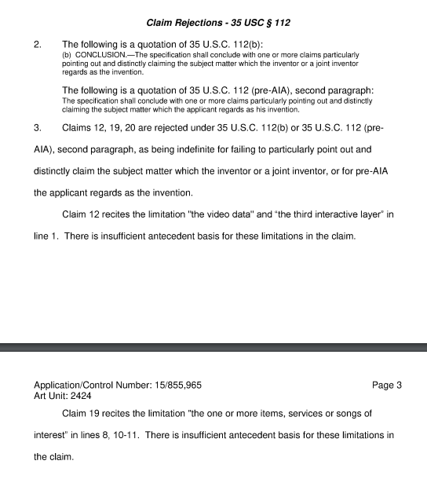
- D1: US20120167145A1 -06/2012 Incorvia; Andrew
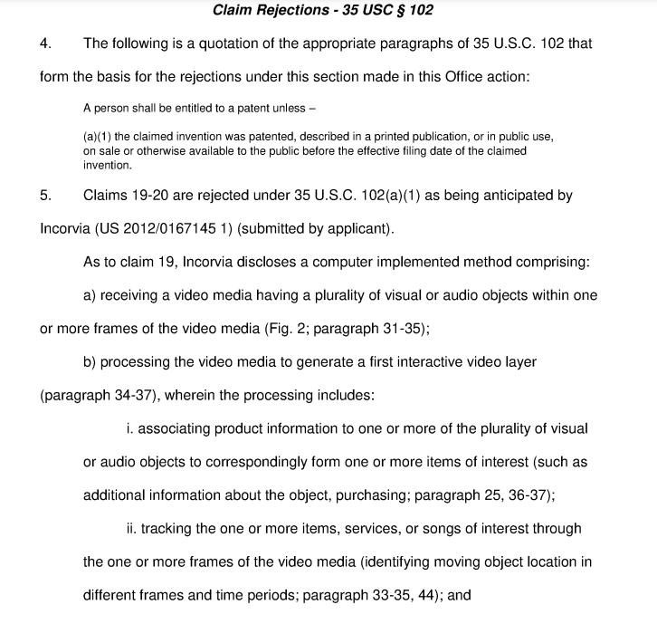
- D2: US20120159327A1 -06/2012 Law; Stacey Wing Yin
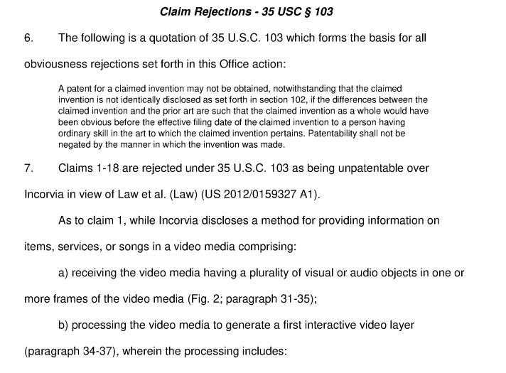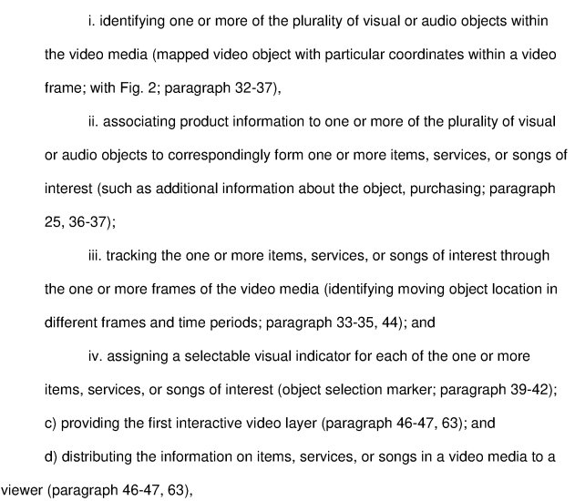

Applicant’s Amendments 29.04.2019:

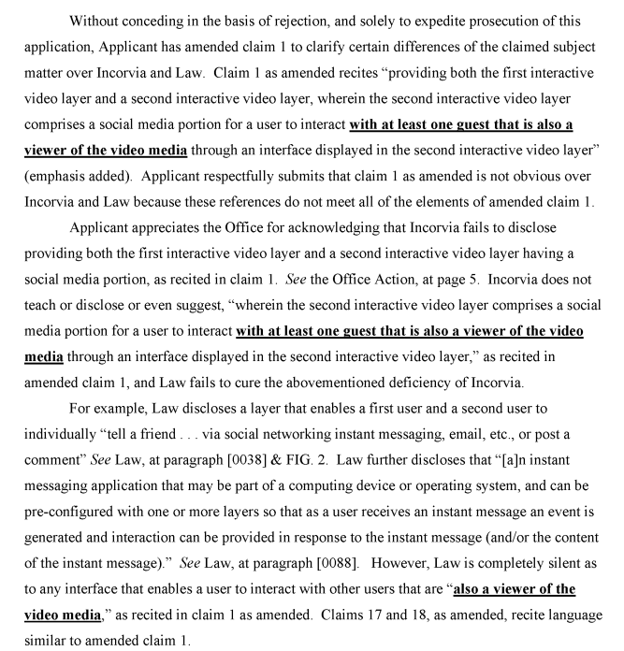
Final Rejection 29.05.2019:
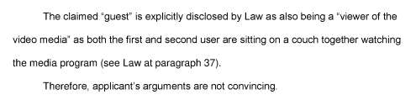
Applicant’s Amendments 26.11.2019:
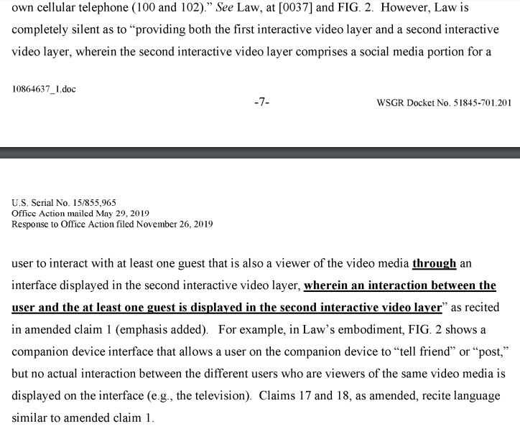

Non Final Rejection 23.03.2020:
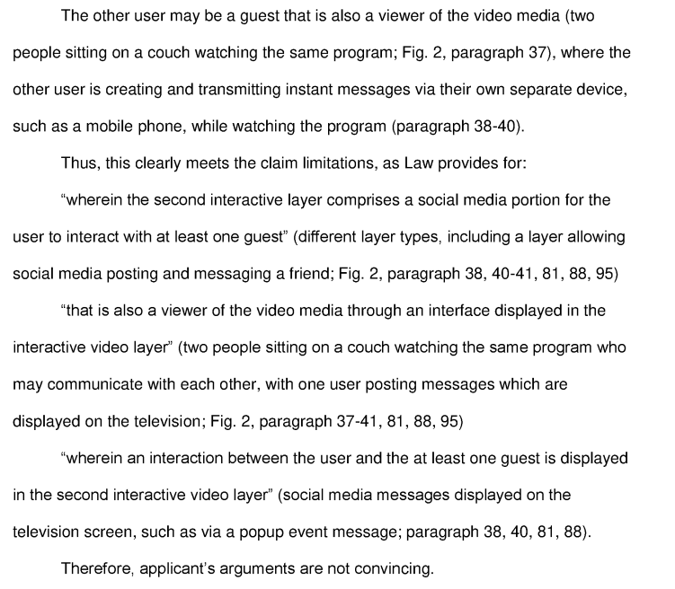
Applicant’s Arguments 22.09.2020:
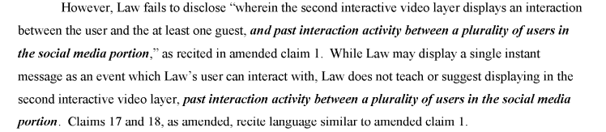

Final Rejection 14.10.2020:

Observations from file history of other US/EP/JP/CN family member
We have also checked the prosecution history of EP2675167B1 (EP counterpart of subject patent) and found that following documents were cited -

Conclusion
From the analysis of file history, we believe “” is the key feature of this invention.
Hence, search will be focused for finding prior-art disclosing the above mentioned prime aspect.

Observations from Complaint Document
Note – Add observations from complaint document if subject patent is in litigation for e.g. which products are accused, what inferences are taken, how we are going to use these in our search etc.

Observations from IPR Document
Note – If IPR was filed earlier on subject patent or its family member, we need to provide observations of discussed references and what were the gaps. If results cited in IPR of family member are useful, add those in results section.

Observations from Standards
Note – If subject patent’s technology is standard oriented, add observations from relevant standards. For example, for 3gpp, which standard and section discloses the target features. When was this idea first introduced.
You can also share observations around:
            - Participants of 3gpp meetings around the cut-off date.
            - Submissions from target company around the cut-off date.
            - Any leads from ETSI email list server.

Analysis of Already Known Prior-Art
Note – if client has shared some known prior-art, include observations on:
            - What is disclosed in which reference.
            - Overall, which features are missing in all of those.

Disclaimer
In selecting information sources and carrying out the search we use all caution possible. However, we cannot guarantee you the correctness or completeness of the data we receive. Only those documents which have already been published can be searched. In general, patent applications are published 18 months after their submission. Thus, it is possible that other relevant patent applications exist which are not available at the time of the search. Search results will always be limited by what is available at the time of your request. In order to stay within the cost limits for requests which have been broadly formulated regarding the state-of-the-art, we select those documents which, in our opinion, most optimally represent the state-of-the-art. This can have the effect that documents can be found which were not included in the first search results if a more narrowly targeted search on the same subject is done. If you change the search target we recommend that you request a new search. The Firm offers complete secrecy regarding requested and completed searches. The Search offers a technical analysis of the evaluated results, it is reiterated that an independent analysis of the compilation may be carried out to verify the results.
GreyB Services Pte Ltd (hereinafter referred to as GreyB) is not a law firm. No employee, director, agent, or officer of GreyB provides legal advice in any domestic or foreign jurisdiction. GreyB is not engaged in the practice of law in any domestic or foreign jurisdiction. Technical and Para Legal support services are provided and performed by GreyB exclusively at the request of qualified attorneys and Patent agents duly licensed to practice before the USPTO and other patent offices. GreyB does not provide legal services for non-lawyers. Services provided to non-lawyers are merely informational and/or technical and is not to be considered as legal advice.
This communication is privileged communication is protected as attorney client/attorney assistant work product.
The work product is limited by time limit set by the attorney and also by several other factors including the legibility of the data.
GreyB is not liable for any action taken by the reviewer pursuant to this report or on the basis of this report; in any case, GreyB is not liable beyond what GreyB has charged for preparing this report.
In case the reader/reviewer does not accept a part or full of the conditions and limitations mentioned in this section, the said reader/reviewer may inform GreyB immediately and ask for the refund/reimbursement before the reviewer/reader has read the report.

