







Tel: (Singapore) +65 84306322
Tel: (USA) +1 202 455 5058
Email: Chakshu@greyb.com
Singapore
1 Scotts Road, #24-05, Shaw Centre, Singapore 228208
GreyB
Validity Search
US11134316B1
30-04-2025
IF IT EXISTS, WE WILL FIND IT.
Contents
1. Understanding the Subject Patent 3
1.1 Overview 3
1.2 In depth Concept 3
1.3 Note 3
2. File History Analysis 4
2.1 Observations from file history of EP/JP/CN family member 4
2.2 Conclusion 4
3. Observations from Complaint Document 5
4. Observations from IPR Document 5
5. Observations from Standards 5
6. Analysis of known prior-art 5
7. Disclaimer 6

Understanding the Subject Patent

Overview
US11134316B1(hereinafter referred to as ‘subject patent’/US11134316B1) …The invention relates to an advanced video media processing system that overlays multiple interactive layers onto long-form entertainment content such as TV shows and movies. It enables real-time identification and tracking of objects within video frames, associating product or service information with these objects, and displaying interactive indicators that allow viewers to explore, purchase, or engage with items directly within the video. Additionally, the system incorporates social media interaction layers and immersive environment layers, providing users with options to communicate, explore deeper environments, or access related content without disrupting the viewing experience. The system is designed to be resistant to ad-blocking techniques and allows dynamic updating of product information based on time, location, or user preferences.

In depth Concept
The core innovation addresses the challenge of integrating interactive, commerce-enabled, and social features directly into long-form video content in a manner that is seamless, non-intrusive, and resistant to traditional ad-blocking methods. Unlike prior approaches that rely on external pop-ups, overlays, or invasive prompts, this system embeds multiple interactive video layers—such as shopping, social media, and immersive environments—within the video stream itself.
The process begins with the automatic or manual identification and tracking of visual or audio objects within video frames, which are then associated with relevant product, service, or content information. This association can be dynamically updated based on geographic, temporal, or demographic targeting, ensuring that the embedded interactive data remains relevant and personalized. The system employs a track file (.vtt or similar format) that records spatial and temporal data for each object, enabling real-time overlay of clickable indicators directly onto the video during playback.
When a viewer interacts with these indicators, the system displays marketing or informational panels that allow for immediate purchasing, detailed viewing, or content exploration without leaving the video stream, thus maintaining engagement and reducing drop-off. The second interactive layer introduces social media functionalities, allowing viewers to participate in private or public conversations, share content, and gather viewer feedback, all overlaid as an interactive interface synchronized with the video. The third layer offers immersive environments, such as virtual side rooms or themed settings, providing deeper engagement, promotional content, or related merchandise. The system’s architecture includes an authoring tool for content creators and advertisers to define, update, and manage interactive objects and content, which are then encoded into the video stream and delivered via a network to user devices.
This multi-layered approach enhances monetization opportunities through direct product placement, real-time purchasing, and social engagement, while also providing valuable viewer data for targeted advertising and content optimization. The independent claim 1 exemplifies this by outlining a method that encompasses object identification, association of product information, tracking across frames, and toggling of multiple interactive layers, all integrated into a cohesive delivery system that preserves the continuity of the entertainment experience.

Note
Search is being focused on claims 1-2 {{cutoff_date}} (i.e. priority date) as cut-off date.

File History Analysis
We have gone through the prosecution history of the subject patent and found that the examiner had raised rejections on the basis of following documents:
Non Final Rejection 30.10.2018:
Claims 12, 19, 20 are rejected under 35 U.S.C 112(b):
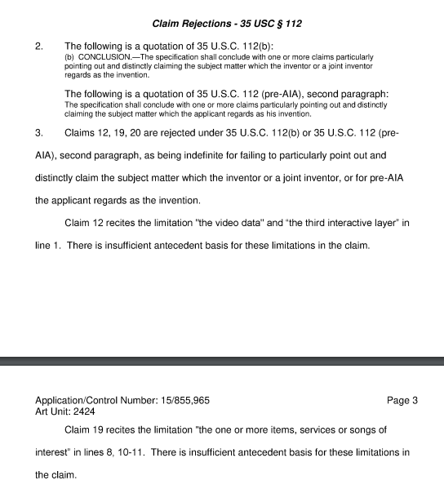
- D1: US20120167145A1 -06/2012 Incorvia; Andrew
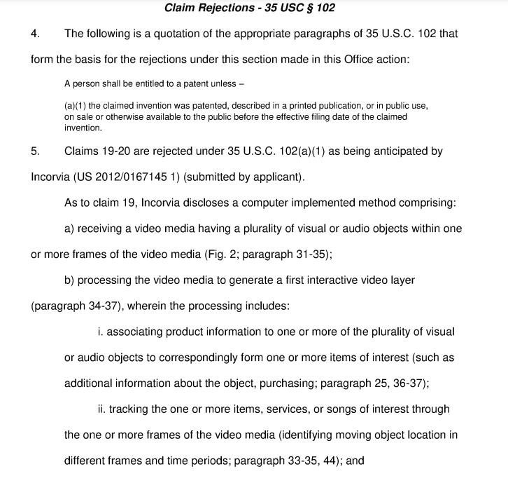
- D2: US20120159327A1 -06/2012 Law; Stacey Wing Yin
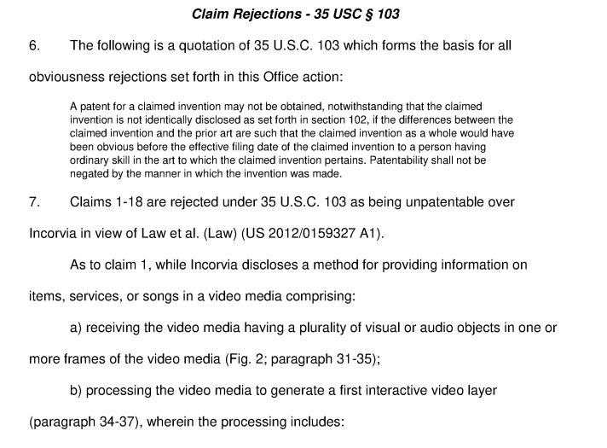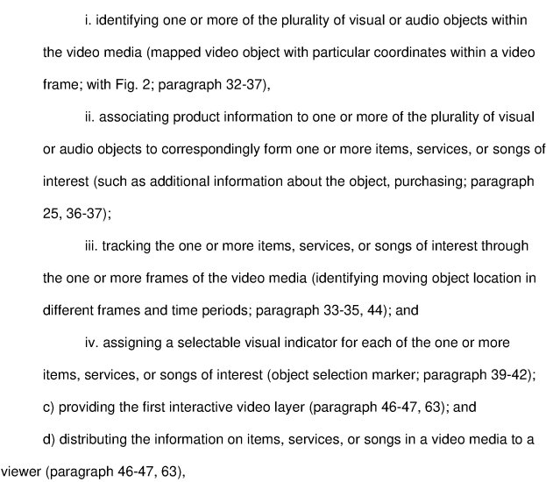

Applicant’s Amendments 29.04.2019:

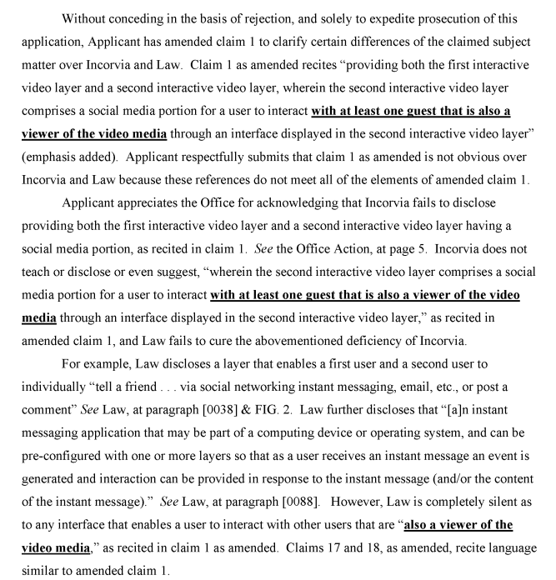
Final Rejection 29.05.2019:
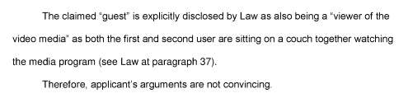
Applicant’s Amendments 26.11.2019:
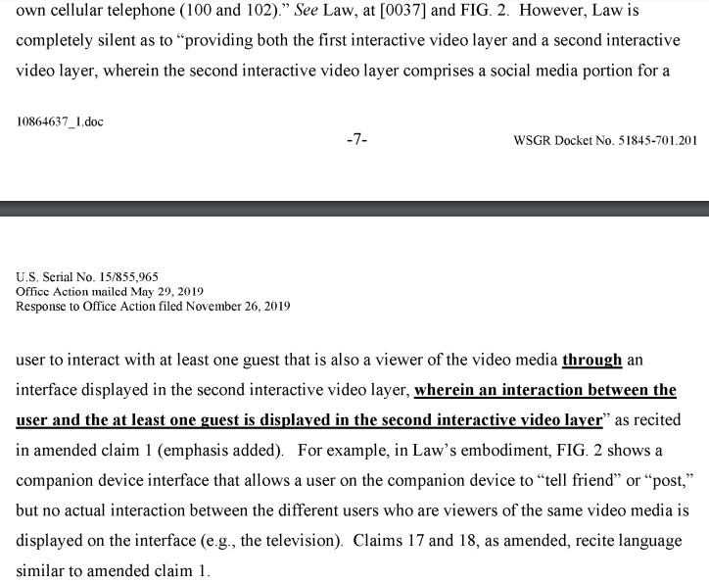

Non Final Rejection 23.03.2020:
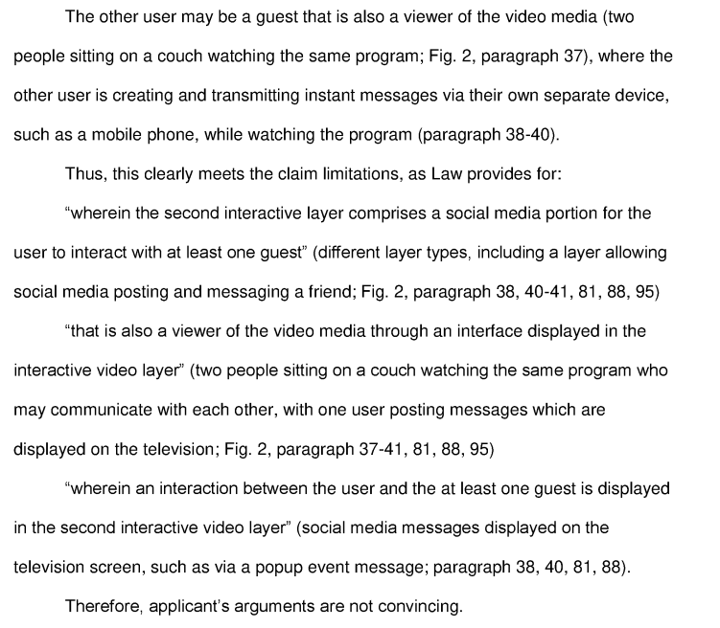
Applicant’s Arguments 22.09.2020:
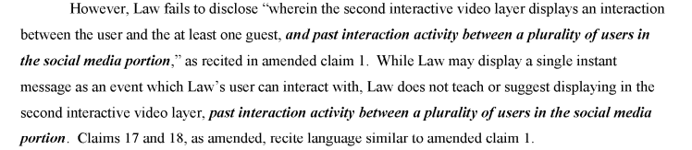

Final Rejection 14.10.2020:

Observations from file history of other US/EP/JP/CN family member
We have also checked the prosecution history of EP2675167B1 (EP counterpart of subject patent) and found that following documents were cited -

Conclusion
From the analysis of file history, we believe “” is the key feature of this invention.
Hence, search will be focused for finding prior-art disclosing the above mentioned prime aspect.

Observations from Complaint Document
Note – Add observations from complaint document if subject patent is in litigation for e.g. which products are accused, what inferences are taken, how we are going to use these in our search etc.

Observations from IPR Document
Note – If IPR was filed earlier on subject patent or its family member, we need to provide observations of discussed references and what were the gaps. If results cited in IPR of family member are useful, add those in results section.

Observations from Standards
Note – If subject patent’s technology is standard oriented, add observations from relevant standards. For example, for 3gpp, which standard and section discloses the target features. When was this idea first introduced.
You can also share observations around:
            - Participants of 3gpp meetings around the cut-off date.
            - Submissions from target company around the cut-off date.
            - Any leads from ETSI email list server.

Analysis of Already Known Prior-Art
Note – if client has shared some known prior-art, include observations on:
            - What is disclosed in which reference.
            - Overall, which features are missing in all of those.

Disclaimer
In selecting information sources and carrying out the search we use all caution possible. However, we cannot guarantee you the correctness or completeness of the data we receive. Only those documents which have already been published can be searched. In general, patent applications are published 18 months after their submission. Thus, it is possible that other relevant patent applications exist which are not available at the time of the search. Search results will always be limited by what is available at the time of your request. In order to stay within the cost limits for requests which have been broadly formulated regarding the state-of-the-art, we select those documents which, in our opinion, most optimally represent the state-of-the-art. This can have the effect that documents can be found which were not included in the first search results if a more narrowly targeted search on the same subject is done. If you change the search target we recommend that you request a new search. The Firm offers complete secrecy regarding requested and completed searches. The Search offers a technical analysis of the evaluated results, it is reiterated that an independent analysis of the compilation may be carried out to verify the results.
GreyB Services Pte Ltd (hereinafter referred to as GreyB) is not a law firm. No employee, director, agent, or officer of GreyB provides legal advice in any domestic or foreign jurisdiction. GreyB is not engaged in the practice of law in any domestic or foreign jurisdiction. Technical and Para Legal support services are provided and performed by GreyB exclusively at the request of qualified attorneys and Patent agents duly licensed to practice before the USPTO and other patent offices. GreyB does not provide legal services for non-lawyers. Services provided to non-lawyers are merely informational and/or technical and is not to be considered as legal advice.
This communication is privileged communication is protected as attorney client/attorney assistant work product.
The work product is limited by time limit set by the attorney and also by several other factors including the legibility of the data.
GreyB is not liable for any action taken by the reviewer pursuant to this report or on the basis of this report; in any case, GreyB is not liable beyond what GreyB has charged for preparing this report.
In case the reader/reviewer does not accept a part or full of the conditions and limitations mentioned in this section, the said reader/reviewer may inform GreyB immediately and ask for the refund/reimbursement before the reviewer/reader has read the report.

