Admin table:

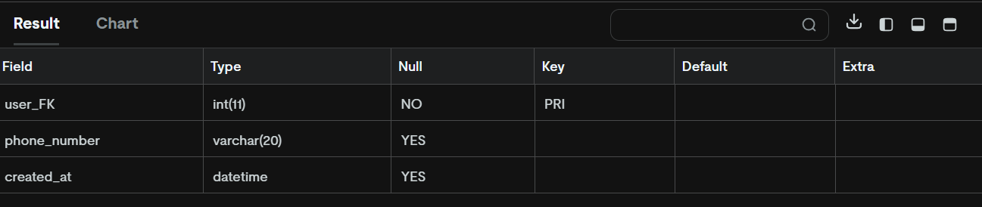

Assignments table:

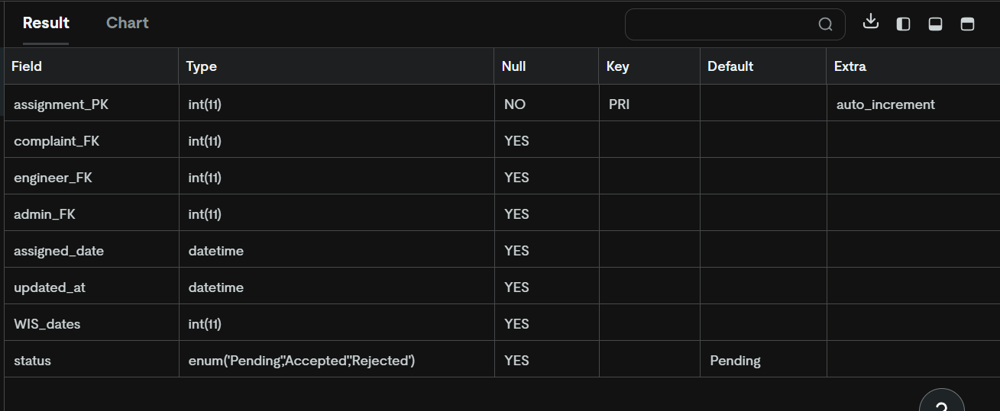

Complaint_comments table:

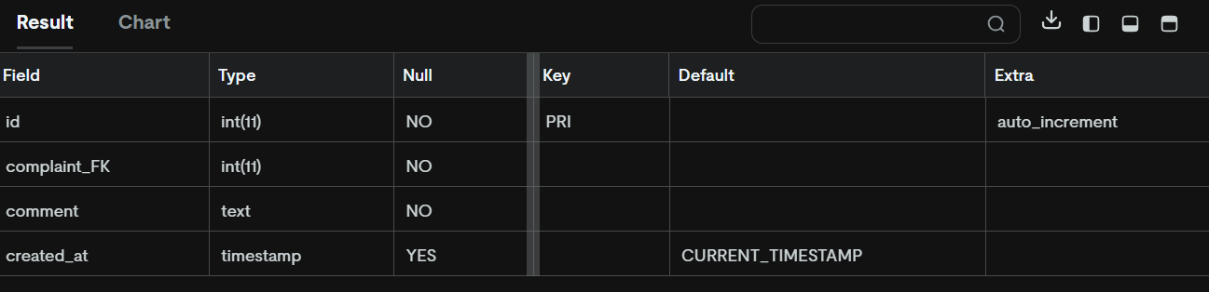

Complaint_visits table:

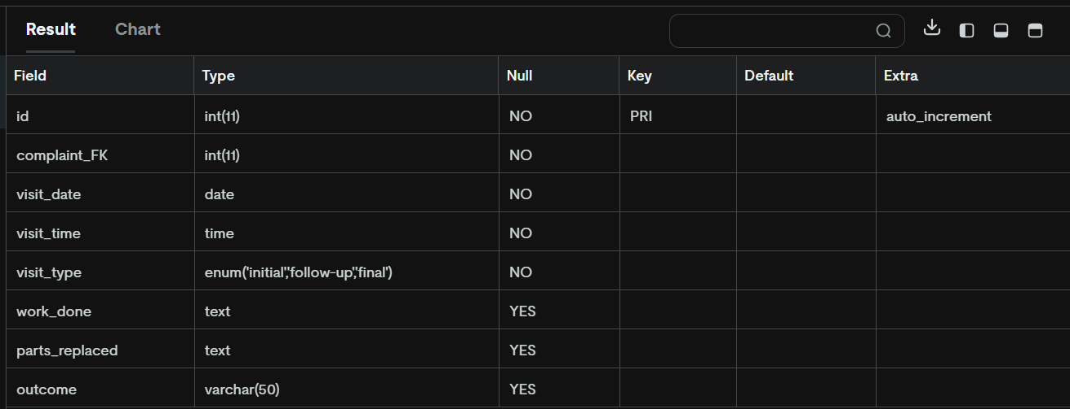

Complaints table

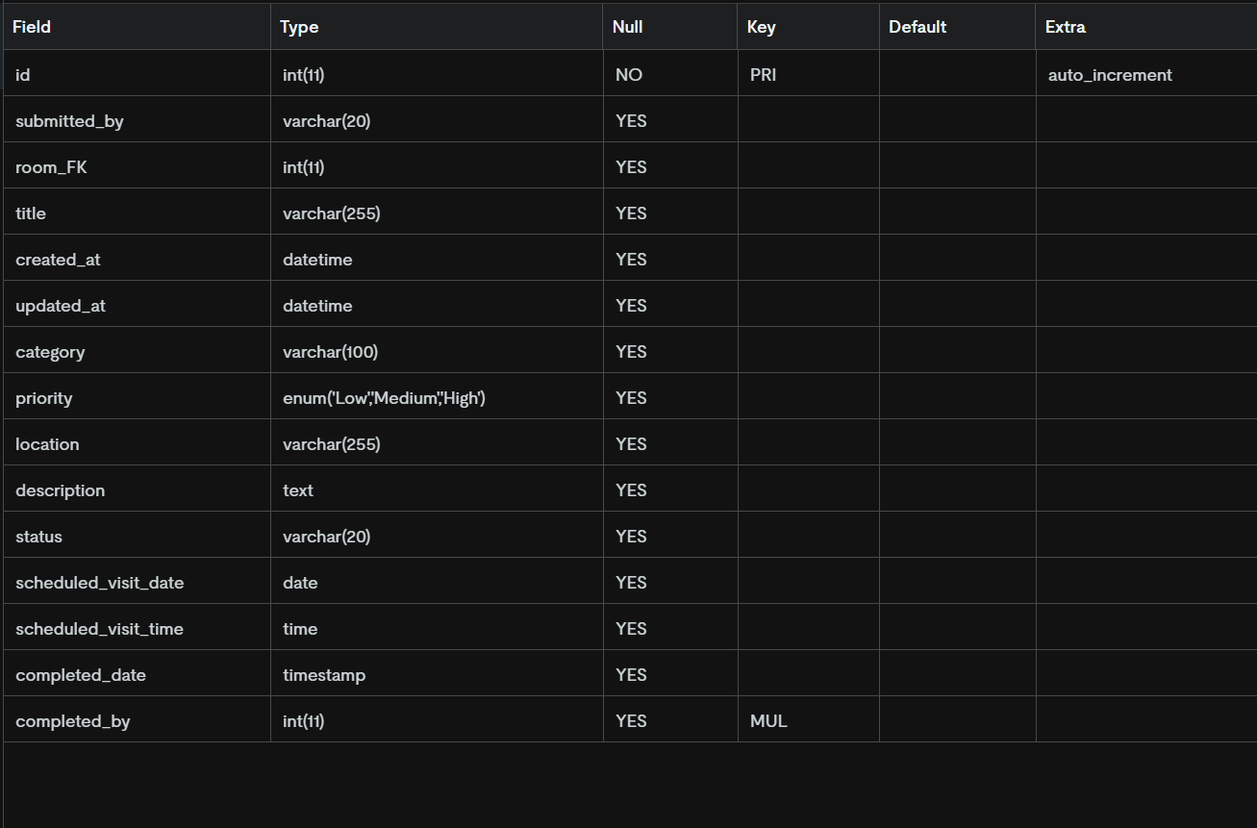

Engineers table

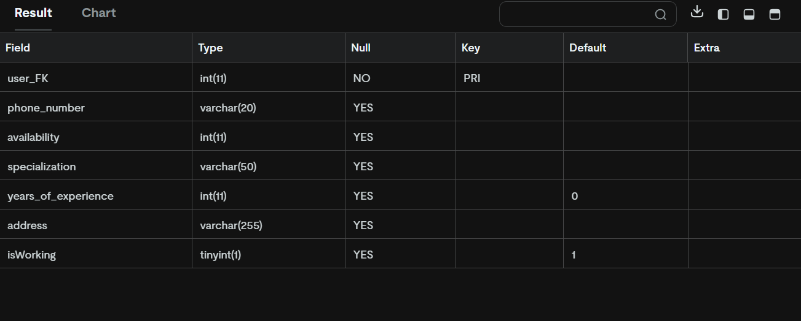

Feedback table:

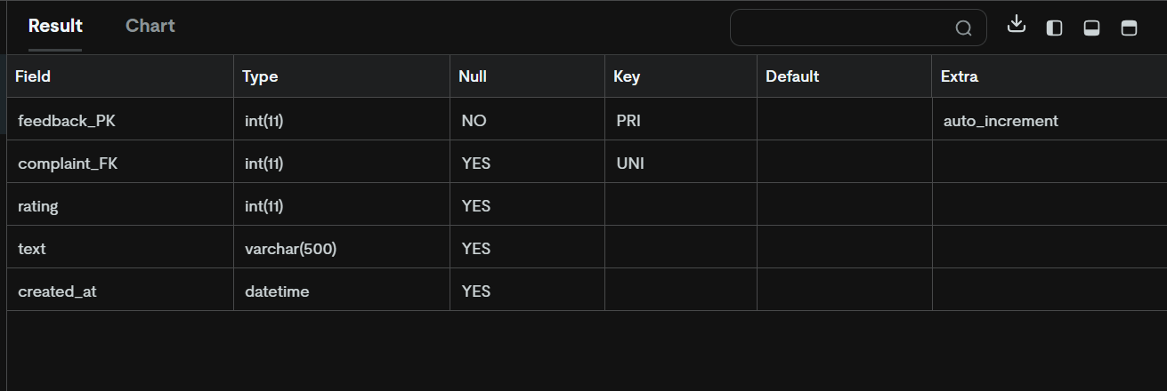

Notifications table:

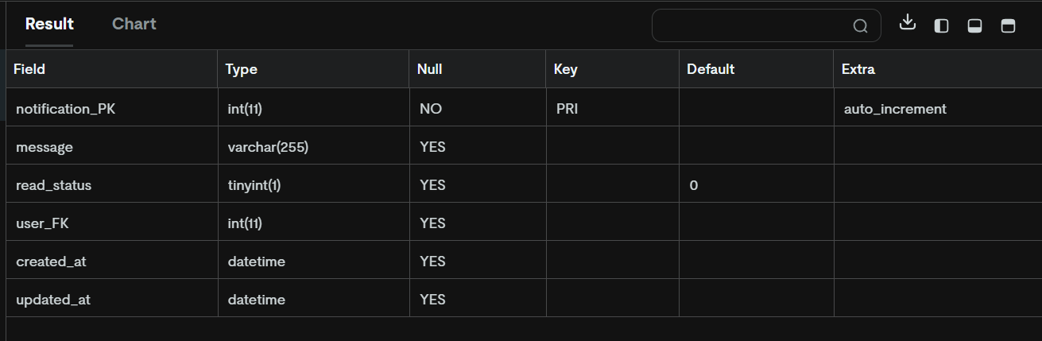

Rooms table:

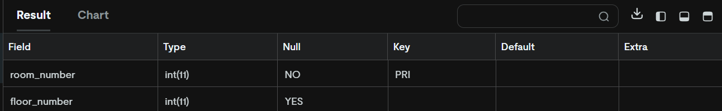

Students table:

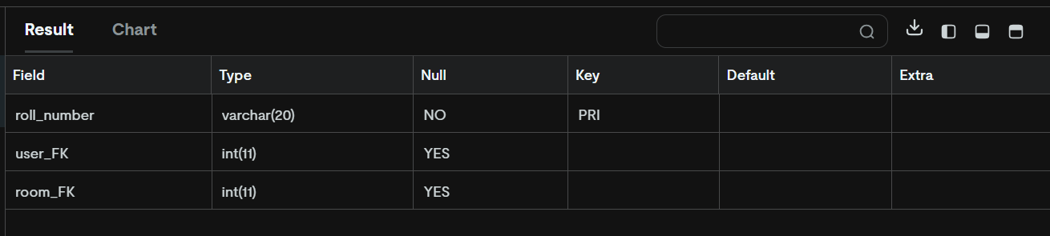

Users table:

