Employee Feedback: Please describe the following.

- Have you ever been imparted training/work assistance by your team members? Please specify – ‘who’& ‘on what’. Also, was it sufficient for that moment?
ISO Awareness & IQA (Internal Quality Auditor) training from Ms. Jyotsna, Yes it was sufficient for that moment.

- Please name persons, (within or outside your team) whom you have trained/ provided assistance. Also mention the subject / topic of training.
Puneet, Sanjay, Dinesh, Jatin & Gaurav (Operations), persons at client side (Viceroy & JD Cabs) several times.
Topic: Complete working of Viceroy, VTS, JD Cabs & TabCab MDT flow.

- Do you understand your responsibilities (or are you clueless) in the absence of your TL? Have you ever acted in place of your TL?
Yes, I worked in the absence of my TL & Understand my Responsibilities completely at that time.

- Were there any situations, when you felt that you have to carry the “burden” or “extra work” on account of some team members? Why?
No, I didn’t faced this situation because of any team members, But I managed to face Burdens sometime because of work when project was near to release Date that helps me to manage work pressure in critical conditions.

- Please mention the initiative/ steps you have taken to minimize such situations.
By completing the task assigned on Time. Managing Time according to the Tasks assigned, also by working upto the late hours.

- Have you ever been given the charge of an activity / or of your colleagues outside your team? Please describe.
- Yes, Given a charge to provide training to Puneet & Dinesh (Operations) to make them understand Viceroy & VTS applications Completely.
- Charge given to implement Microsoft Test Manager 2010, Implemented Manual part successfully.
- Provided the opportunity to work at client side & represent BSL, done successfully
- Implemented load testing Using MS visual studio 2012

- Please cite one instance when you have been involved in conducting a training session?
. Involved in conducting training to some selected employees of company regarding Device Testing in Viceroy.

- Mention the training(s) you would like to be conducted for you / your team members. Also, provide feedback on your whether your past training requirements have been met?
Yes, I would like to be trained in automation Testing Tool, Past training requirements have been Met & they are upto the expectations.

- Would you like to bring a change in your career path by changing your team? If Yes, please mention the team you would like to join, and why?
No, I would like to work with my current team in future also & will make my career grow with them, but yes I love to work with new people also.

- Have you attended any training session on Quality/ ISO?

If ‘Yes’, then mention how many times: __2_ ; If No, please mention the reason from the following:

No info or notice Personal reasons Officer did not allow Extra Work Pressure

- How often do you follow the ISO / Quality guidelines for your process?

Always Most of the times Sometimes Rarely Not applicable
Ans: Always
- Have you ever interacted with outside clients? Please mention, when and how? Do you look forward to such opportunities?
Yes, Interacted with Client most of the Times, when I was working on JD Cabs & Viceroy project also involved in minutes of meeting for requirement gathering & project related discussion . would like to do if any opportunity arise in future.

- Suggest 3 ways to increase your individual productivity and the productivity of your team.
By learning & applying Time management skills, Reducing Communication gaps & by working smartly.
- Suggest 3 ways we should work upon to make Binary into a dream organization.
By providing various benefits to Employees, so that they take more interest in there work, By understanding & completing tasks on time & more efficiently.

- What is the profile / job, you would like to hold after 1 year? 3 years? 5 years?
1 year – Software Test Engineer
3 year – Sr. Software Test Engineer
5 year – Test Lead

- Mention three skills you have learnt in the appraisal period under consideration.
Software Manual Testing Skills, Automation Tools, Communication skills
- Mention 3 skills of yours which Binary can make better use of.
Ability to work in Team, Smart Working, Hard worker
- Mention 3 attributes, which you think, your officer likes in you.
Punctuality, Work under pressure, Hard worker

Any Other:
___________________________________________________________________________________________

Date: 19/9/2013 Appraisee’s Signature: Sagar sachdev

Please rate your self on a scale of 1 to 10, against the following attributes / parameters.

FOR THE REVIEWER:

In the earlier section, please mention your views over the appraisee’s comments wherever needed, just near his own statements. In this section, please rate the appraisee on a scale of 1 to 10 for his deliverables in the following KRAs.

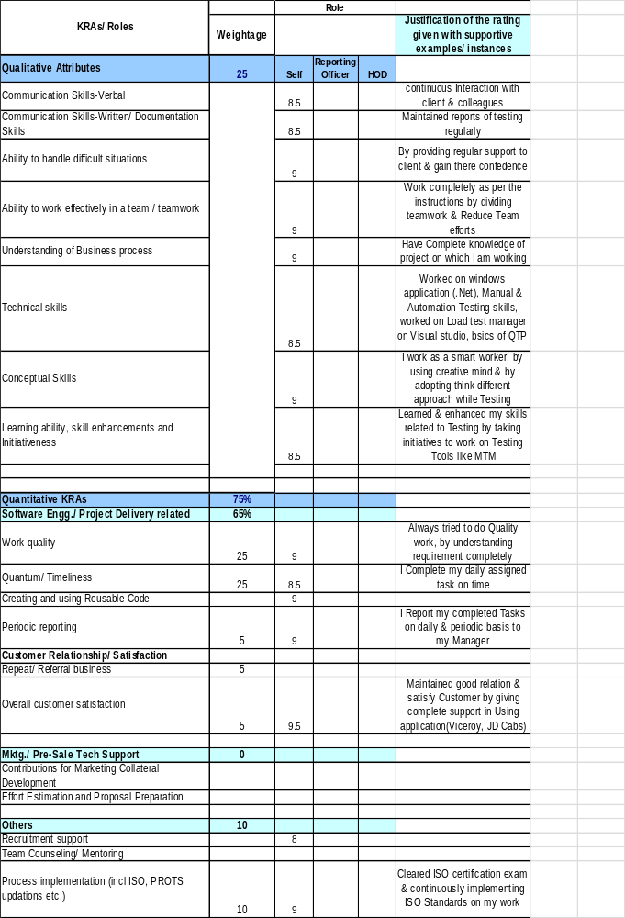

Any additional task to be included as a KRA: (can be suggested by both- the appraisee or the reviewer). Also, rate it on a scale of 1 to 10.
__________________________________________________________________________________________

__________________________________________________________________________________________

Have you been doing this? -----

Have you ever suggested a ‘quotation’ to be displayed on the reception notice board / BEST?
Ans. No
Do you keep your mobile on Silent / or low volume while in office?
Ans. Yes
Do you usually get water/tea /coffee yourself?
Ans. No
Do you usually sign the Movement Register while moving out of office premises?
Ans. Yes
Do you inform your team / colleagues while moving out of your seat for more than 10 mins?
Ans. Yes
Do you regularly inform your Officer and HR about your leaves at least one working day in advance?
Ans. Yes
Do you always punch in your movement with the Access Card?
Ans. Yes
Do you spend time in beautifying/ cleaning / arranging your work station?
Ans. Sometimes
Do you answer your calls within 2 rings, usually?
Ans. Yes

HR FEEDBACK:

Leaves: Pre informed Informed Un Informed Total

Punctuality Average Frequency of breaks per day

Cleanliness Dressing sense Etiquette Behaviour

Participation and Involvement in parties & get- together/s Sociability:

Suggestions offered through: BEST Suggestion Box Mails

Usage of BEST: Frequency of Password blocked
No. of Training sessions attended (with break up):

Overall HR Rating (On 1to 10 scale):______

RECOMMENDATIONS BY THE REPORTING OFFICER / TL:

Please write about the potential of the appraisee in terms of his ability to handle higher responsibilities and what specific inputs from organization are required. (Training etc). Also, any other additional inputs would be welcome.

__________________________________________________________________________________________

__________________________________________________________________________________________

Overall Rating (On 1 to 10 scale):_______

DATE: _______________ SIGNATURE OF RO / TL: _______________________

RECOMMENDATIONS BY HOD:

__________________________________________________________________________________________

Overall Performance Rating (On 1 to 10 scale): ____________________

Final Decision:

Revised Designation: __________ Revised CTC: Rs.________ Change in Deptt:_____________

w.e.f.: _____________ New Role:_____________

DATE: _______________ SIGNATURE OF HOD: __________________________

Note :

- For immediate supervisor of Appriasee - Please mark your comments wherever required over the statements of Appraisee.

- For Appraisee – Must go through page no. 4, “ have you been doing this ” and please put your name on each page in the space provided.

