CycloProp: Advanced UAV Propulsion Challenge
Stage 1 - Preliminary Engineering Design Report
Kalash CR-1, a single cyclorotor propulsion module. Team Kalash, VPKBIET. Team ID TM-5A7C41AF909.

Team and Submission Information
Particular | Details
Team ID | TM-5A7C41AF909
Team Name | Kalash
Institution / Organization | VPKBIET (category: UG)
Team Leader | Kartik Shirode
Team Members | Kartik Shirode (team leader), Mandar Wagh, Aditya Shilalkar. All B.Tech third year
Faculty / Industry Mentor, if any | None at Stage 1
Email Address | kartikshirode123@gmail.com
Contact Number | 9823376032
Proposed Design Name | Kalash CR-1
Date of Submission | 27 September 2026

1. Executive Summary

1.1 Proposed Cyclorotor Concept
Design name:
Kalash CR-1
Brief description of the proposed configuration:
One cycloidal rotor, 220.0 mm in diameter and 290.4 mm wide, with 3 NACA 0020 blades of 72.6 mm chord. Each blade pitches plus or minus 40 degrees about its 30 percent chord point through its own passive four-bar linkage, and all three linkages share one offset pivot 11.53 mm from the rotor axis.
Turning that offset about the rotor axis turns the thrust vector. Two 20 g servos do it through a phasing carrier outside the rotor, so nothing on the rotor is actuated. A T-Motor MN5006 KV450 drives the rotor at 2337 rpm through a 4.25 to 1 toothed belt from an 8S pack. Design thrust is 17.0 N.
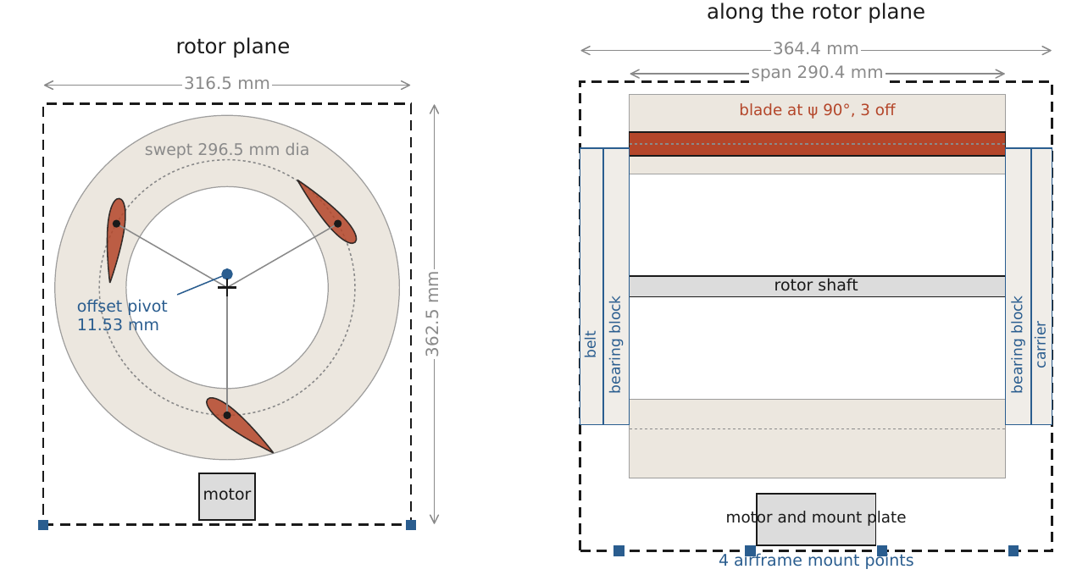
Figure 1. General arrangement. Rotor plane (left) and side view (right). Swept diameter 296.5 mm, packaged envelope 364.4 x 316.5 x 362.5 mm on 4 mount points.

1.2 Key Design Parameters
Parameter | Preliminary Value | Unit
Rotor diameter | 220.0 (296.5 swept by the pitching blades) | mm
Rotor width | 290.4 | mm
Number of blades | 3 | --
Blade chord | 72.6 | mm
Blade profile / airfoil | NACA 0020 | --
Operating RPM | 2337 | rpm
Blade pitch range | -40 to +40 | deg
Pitch amplitude | 40 | deg
Estimated thrust | 17.0 (16.15 on the low coefficient) | N
Estimated shaft power | 377.4 | W
Estimated electrical power | 518.0 at the module | W
Estimated module mass | 0.688 (0.776 conservative) | kg
Estimated thrust-to-weight ratio | 2.5191 (2.1221 worst case) | --
Estimated maximum thrust-vectoring angle | +/- 60 (120 of authority) | deg

1.3 Design Summary
Principal design features:
One rotor rather than a cluster. On a common model it gives the lowest module mass and the best thrust to weight of the three layouts we compared (section 3).
Passive cyclic pitch. A four-bar per blade sets the 40 degree amplitude from one 11.53 mm offset, and no actuator rides on the rotor.
Thrust vectoring by rotating that offset: 120 degrees of authority from 2 servos through a 1.5 step up gear pair.
Sandwich blades of PMI foam, 2 plies of 60 gsm carbon twill and a CFRP spar on the pitch axis, 31.75 g each.
Every number in this report comes out of Python scripts reading one data file, and a checking script recomputes them, so geometry, performance and mass stay consistent.
Key design innovation / distinguishing feature:
The pitch schedule and the thrust direction come from the same linkage. The offset length sets the amplitude and its direction sets the phase, so vectoring needs one small rotation of a carrier that doesn't spin with the rotor.
The linkage solution also decided the drivetrain. The solved pitch links pass within 0.019 mm of the rotor axis, so no shaft can run through that plane, and the rotor is driven from one end only.
Expected performance:
17.0 N at 2337 rpm for 518.0 W at the module. The mass budget is 687.91 g, so thrust to weight is 2.5191 at the design point. With the conservative mass and a 5 percent thrust loss for blade flexibility applied together it falls to 2.1221.
Principal technical challenges identified:
1. Thrust to weight clears 2.5 by only 0.8 percent, on a mass estimate that isn't accurate to 0.8 percent. Closing the worst case needs 117.26 g.
2. The thrust coefficient is transferred from published rotors of the same shape family, not measured on this one.
3. The motor runs at 93 percent of a derated continuous power rating.
4. The quasi steady model almost certainly under-predicts side force, which costs vectoring authority.

2. Requirements and Design Targets

2.1 Challenge Requirements
Parameter | Challenge Requirement | Team Design Target
Thrust | >= 10 N | 17.0 N design, 16.1493 N with a 5% blade flexibility loss
Thrust-to-weight ratio | > 2.5 | 2.5191 design. 2.1221 with both downsides. Stage 2 gate: conservative mass under 658.48 g
Rotor type | Cycloidal rotor with blade-pitch variation | Single cyclorotor, 3 blades, passive four-bar cyclic pitch, +/-40 deg
Thrust vectoring | Required | 120 deg of direction authority by rotating the pitch offset
Design approach | CAD and engineering analysis | Closed form analysis in Python from one data file. CAD, CFD and FEA are Stage 2 items
Final objective | Build-ready design for subsequent implementation | Geometry frozen at Stage 1. Stage 2 turns it into CAD, drawings, a verified mass and a spin test plan

2.2 Selected Design Targets and Rationale
Design Parameter | Selected Value | Basis / Engineering Rationale
Rotor diameter | 220.0 mm | Smallest radius the selected motor holds continuously. At 100 mm the motor would need 531.5 W against 520.0 W derated continuous
Rotor width | 290.4 mm | 4 chords, blade aspect ratio 4, from Kellen's UAV scale optimum shape family [1]
Number of blades | 3 | At fixed solidity fewer blades give more thrust [2], and 3 is Kellen's optimum for this Reynolds band [1]
Blade chord | 72.6 mm | Chord to radius 0.66, Kellen's optimum. Solidity 0.3151, inside the 0.30 to 0.40 band he measured
Blade profile / airfoil | NACA 0020 | Thick symmetric section. Efficient at this Reynolds number and deep enough for a real spar
Operating RPM | 2337 | The speed at which a blade area coefficient of 0.6055 gives 17.0 N. Chord Reynolds 130,296, inside Kellen's 100,000 to 300,000
Mean blade pitch | 0 deg | The horn to chord angle, -102.50 deg, is chosen so the cycle mean pitch is zero
Pitch amplitude | 40 deg | Kellen's optimum for this shape family [1]
Maximum vectoring angle | +/-60 deg | 80 deg of servo travel through a 1.5 step up gives 120 deg of carrier rotation
Target power | 518.0 W | Motor input 483.2 W against the MN5006's 520 W derated continuous rating
Target module mass | under 693 g | The mass at which 17.0 N gives exactly 2.5. Budget 687.91 g nominal, 775.74 g conservative

2.3 Design Constraints and Assumptions
List only assumptions that directly affect geometry, thrust prediction, power estimate, mass estimate, structural assessment, or manufacturability.
No. | Constraint / Assumption | Basis
1 | Blade area thrust coefficient 0.6055, held below the 0.6648 Kellen measured on this shape family | [1], [2]. Deliberately low
2 | Figure of merit 0.5215: Kellen's 0.6 scaled to our lower coefficient by (0.6055 / 0.6648)^1.5 | [1]
3 | Efficiencies: belt 0.93, motor 0.84, ESC 0.95. Rotor tare 10 percent of shaft power | Efficiencies assumed; tare from [2]
4 | Motor 180 s ratings derated to 0.80 for continuous duty | Judgement. The problem statement sets no endurance to size it against
5 | Hover at sea level, ISA air, density 1.225 kg/m3, no freestream | Standard
6 | Blade loads at 4.0 times the mean, a 1.20 overspeed case, every margin floored at 1.5 | Top of the published 3 to 4 range [8]
7 | Material allowables are published class values | No coupon tests yet
8 | Mass growth by line class: 8% catalogue, 12% machined, 15% calculated, 25% allowance | Set before the total was known

3. Concept Development and Selection
Teams may present up to three concepts. If only one concept was considered, provide the design rationale and trade-offs clearly.

3.1 Concept Options
Item | Concept 1 | Concept 2 | Concept 3
Concept name | Single rotor, 3 blades, R 110 mm | Two rotors, 3 blades each, R 80 mm | Three rotors, 3 blades each, R 65 mm
Operating principle | One rotor makes all 17.0 N at 2337 rpm | Each rotor makes 8.5 N at 3124 rpm | Each rotor makes 5.67 N at 3864 rpm
Advantages | Least hardware: one shaft, one mechanism, one belt. Chord Reynolds 130,296, inside the measured band. Lowest mass | Smaller rotors. Aerodynamic power 330.3 W, 3% lower. Differential thrust possible | Smallest rotors. Aerodynamic power 331.93 W. Most control options
Limitations | Largest single rotor and the most torque, 1.5424 Nm, so it needs a belt reduction | Hardware doubles. Reynolds 92,133, below the measured band. 400 mm largest dimension | Hardware triples. Reynolds 75,227. 490 mm largest dimension, three mechanisms to phase together
Expected performance | 647.23 g, T/W 2.6774, stacked downside 2.1281 | 796.12 g, T/W 2.1767, stacked downside 1.7286 | 994.94 g, T/W 1.7417, stacked downside 1.3823
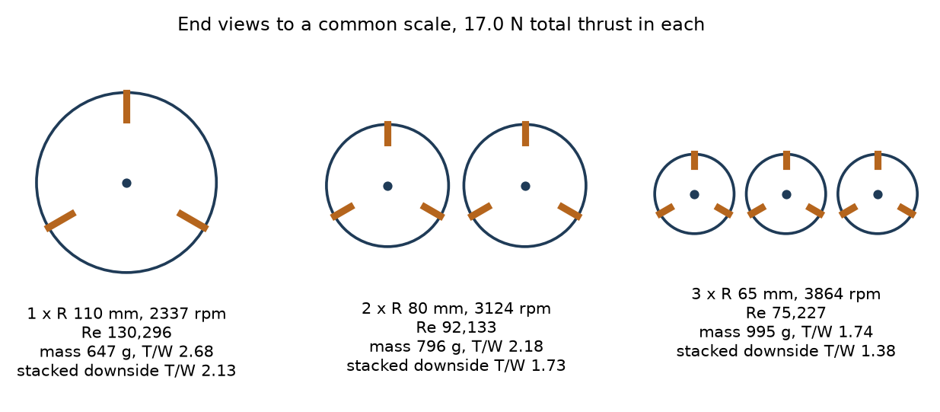
Figure 2. The three layouts, end views to one scale. Masses are the early mass envelope applied the same way to all three; the refined budget in section 8 applies to the selected concept only.

3.2 Concept Selection Matrix
Evaluation Parameter | Weight (%) | Concept 1 | Concept 2 | Concept 3
Thrust potential | 15 | 5 | 3 | 2
Power requirement | 10 | 4 | 5 | 5
Mass | 20 | 5 | 3 | 1
Pitch-control capability | 10 | 5 | 3 | 2
Thrust-vectoring capability | 10 | 4 | 4 | 4
Structural feasibility | 10 | 4 | 4 | 4
Manufacturability | 10 | 5 | 3 | 2
Mechanism complexity | 10 | 5 | 3 | 2
Cost | 5 | 5 | 3 | 2
Total | 100 | 94 | 68 | 50
Selected concept:
Concept 1, the single rotor.
Basis for selection:
It wins the criterion the challenge makes hard, module thrust to weight, by 23 percent on the stacked downside case (2.1281 against 1.7286), and it wins every other column of the 3.1 table apart from aerodynamic power, where the clusters are 2 to 3 percent better. Splitting the thrust splits the aerodynamics but not the hardware: 7 of the 13 mass envelope lines multiply by rotor count. Every disputed assumption was set in the clusters' favour, with no wake interaction, one shared motor and controller, and the same coefficient despite their lower Reynolds number.
Scores are 1 to 5 and the total is the weighted sum out of 100: 94, 68 and 50. The thrust, power and mass rows follow the numbers in 3.1. The other rows are our judgement and are marked as such here.
Key trade-offs:
A single rotor needs 1.542 Nm at 2337 rpm, more than any outrunner in this mass class gives directly, so it carries a belt reduction. It also has the largest swept diameter, 296.5 mm, which sets the envelope. We accept both for about 149 g less module mass than the twin.

4. Rotor and Blade Design

4.1 Rotor Configuration
Parameter | Description / Value
Rotor architecture | Single cyclorotor. Blades parallel to the rotation axis, pinned at both ends to CFRP spider arms on 7075-T6 hub bosses, on a CFRP shaft driven from one end
Number of blades | 3
Direction of rotation | Counter-clockwise, looking along the axis from the non-drive end
Rotor diameter | 220.0 mm to the pitch axes. 296.5 mm swept by the pitching blades
Rotor width | 290.4 mm blade span
Blade spacing | 120 deg in azimuth
Operating RPM | 2337 rpm, tip speed 26.92 m/s
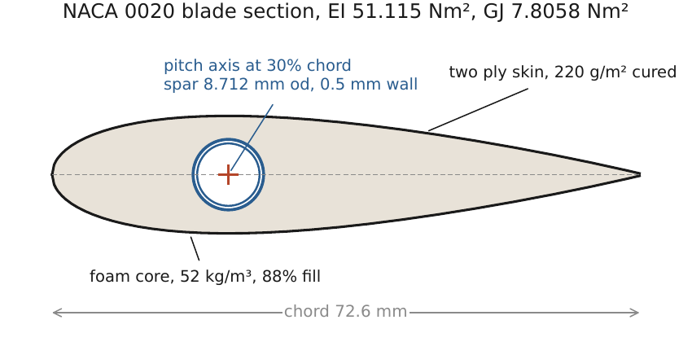
Figure 3. Blade section, NACA 0020 at 72.6 mm chord on an 8.712 mm spar at 30 percent chord, which is also the pitch axis. Overall rotor dimensions are in Figure 1.

4.2 Blade Geometry
Parameter | Value | Unit | Basis
Airfoil / blade profile | NACA 0020 | -- | Kellen's shape family [1]
Chord | 72.6 | mm | Chord to radius 0.66
Thickness | 14.52 | mm | 20% of chord
Blade length | 290.4 | mm | Aspect ratio 4
Pitch range | -40 to +40 | deg | Solved schedule reaches +40.52 and -39.35
Pitch amplitude | 40 | deg | Set by the 11.53 mm offset
Blade twist, if any | 0 built | deg | 0.014 under aerodynamic load; 2.2346 wind up at the free end from the centrifugal pitching moment
Estimated blade mass | 31.75 | g | Integrated from the section: core, skins, spar, 2 root fittings
Reason for blade-profile selection:
Thick symmetric sections hold their performance at chord Reynolds numbers near 130,000, and 20 percent thickness gives a 14.5 mm deep section: room for an 8.71 mm spar on the pitch axis inside a closed foam and skin cell. It is symmetric because the blade pitches both ways through 40 degrees. The curved flow at chord to radius 0.66 gives it virtual camber, which is already inside the coefficient we transfer, since Kellen measured it on the same shape family.
Expected operating Reynolds-number range:
130,296 at the design point, from 1.225 kg/m3, 26.92 m/s and 72.6 mm chord. Over the operating cases in 5.4 it runs from about 113,942 to 130,296, inside Kellen's measured 100,000 to 300,000.

5. Preliminary Aerodynamic Analysis

5.1 Analysis Approach
Select the method used and provide sufficient details for the committee to reproduce or verify the estimate.
☒ Analytical calculation
☒ Blade Element / Blade Element Momentum Method
☒ Published experimental correlations
☐ CFD or other numerical method
☐ Other: __________________________
Item | Details
Software / calculation tool | Python 3, standard library only: tools/linkage.py (kinematics and loads) and tools/structure.py (structure and mass), both in the zip. All inputs and results in numbers.json. Figures drawn with Matplotlib
Operating condition | Hover, 17.0 N at 2337 rpm, no freestream
Air density | 1.225 kg/m3
Atmospheric conditions | ISA sea level. Viscosity 1.838e-05 Pa s, as implied by the stored Reynolds number
Other assumptions | Uniform induced inflow, quasi steady blade forces, no wake interaction, no dynamic stall beyond an incidence cap

5.2 Aerodynamic Calculation Summary
Calculation methodology:
Thrust comes from a blade area thrust coefficient measured on this shape family, not from a blade element model, because at chord to radius 0.66 a blade element model without a curvilinear flow correction is less trustworthy than the measurement. Power comes from momentum theory and a figure of merit, checked by a second route through a published power loading. Blade loads come from a 36 point quasi steady azimuthal model run on the solved pitch schedule.
Governing equations used:
T = C_Tb x 0.5 rho u^2 x (N c b), with u = Omega R and N c b the blade area
P_ideal = T^1.5 / sqrt(2 rho A), with A = 2 R b the projected area; induced velocity v_i = sqrt(T / (2 rho A)), inflow ratio lambda = v_i / u
FM = 0.6 x (C_Tb / 0.6648)^1.5; P_aero = P_ideal / FM; P_shaft = P_aero / 0.9 (10% tare)
P_elec = P_shaft / (eff_belt x eff_motor x eff_ESC); Q = P_shaft / Omega; Re = rho u c / mu
Azimuthal load: F(psi) = 2 pi alpha x (u_t^2 + u_p^2), alpha = theta(psi) - atan(u_p / u_t), alpha capped at 28 deg
Blade loading assumptions:
Mean vertical force 5.6667 N per blade. The azimuthal model gives a peak of 14.4260 N, a peak to mean of 2.5458. A quasi steady model under-predicts the peak, so the structure is sized on 4.0, the top of the published 3 to 4 range [8]. The blade is not chordwise balanced: its centre of mass sits at 39.31% chord against a 30% pitch axis, and the pitch loads carry that.
Airfoil data / aerodynamic coefficients used:
Blade area thrust coefficient 0.6055 nominal and 0.5752 low (5% flexibility loss). It is bracketed by 0.6648 measured by Kellen on this shape family [1], 0.7211 recomputed from Benedict's quad rotor hover point [2] and 0.8114 from his twin rotor, which we treat as an upside only. The load model uses a thin airfoil lift slope of 2 pi per radian, scaled so the cycle mean equals the 17.0 N design thrust.

5.3 Preliminary Performance Estimate
Parameter | Value | Unit
Tip speed | 26.92 | m/s
Reynolds number | 130,296 | --
Swept area | 0.063888 (projected, 2R x b) | m^2
Estimated blade loading | 0.6055 (blade area thrust coefficient) | --
Estimated thrust | 17.0 | N
Estimated torque | 1.542 | N m
Estimated shaft power | 377.4 | W
Estimated electrical power | 518.0 | W
Thrust estimation methodology and calculation:
T = 0.6055 x 0.5 x 1.225 x 26.92^2 x 0.06325 = 17.0 N, where 0.06325 m2 is 3 blades of 72.6 by 290.4 mm. The low case takes 5 percent off for blade flexibility, 16.1493 N. Both clear 10 N on their own.
Power estimation methodology and calculation:
Ideal power over the projected area of 0.063888 m2 is 17.0^1.5 / sqrt(2 x 1.225 x 0.063888) = 177.2 W, with induced velocity 10.42 m/s and inflow ratio 0.3871. Over a figure of merit of 0.5215 that is 339.7 W at the blades. A 10 percent rotor tare, 37.7 W, gives 377.4 W at the shaft, 1.542 Nm at 2337 rpm. Through the belt, motor and ESC that is 508.6 W at the ESC, and the servos, controller and regulator loss take the module to 518.0 W. A second route through Benedict's measured power loading of 0.062 N/W gives 274.2 W at the blades, 19.3 percent lower. We carry the higher one.
Expected aerodynamic efficiency / figure of merit, if applicable:
Figure of merit 0.5215, Kellen's measured 0.6 scaled down to our lower coefficient so the same caution isn't spent twice. Power loading at the module is 0.0328 N/W.

5.4 Sensitivity to Operating Conditions
Provide estimates for at least three operating conditions.
Operating Condition | RPM | Pitch | Estimated Thrust | Estimated Power
Case 1: 13 N case | 2044 | +/-40 deg, mean 0 | 13.0 N | 323.1 W motor input
Case 2: 16 N case | 2267 | +/-40 deg, mean 0 | 16.0 N | 441.2 W motor input
Case 3: 17 N case (design point) | 2337 | +/-40 deg, mean 0 | 17.0 N | 483.2 W motor input
Case 4: 18 N case | 2405 | +/-40 deg, mean 0 | 18.0 N | 526.5 W motor input; over the 520 W rating
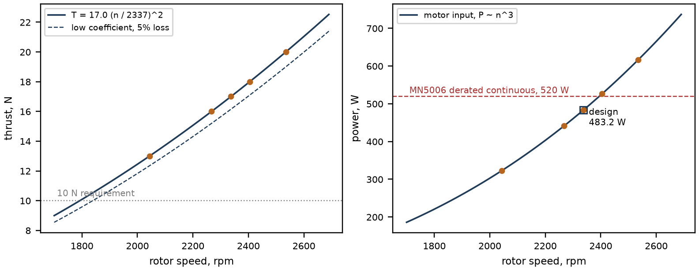
Figure 4. Thrust and motor input power against rotor speed at fixed pitch schedule. Points are the stored sensitivity rows (13, 16, 17, 18 and 20 N). Above the design point the motor runs out of continuous power, which is why the design stops at 17.0 N.

6. Blade-Pitch Kinematics and Thrust Vectoring

6.1 Pitch-Control Mechanism
Item | Description / Value
Mechanism description | Passive four-bar per blade: rotor arm L1 110.0 mm, offset link L2 11.53 mm (ground), pitch link L3 108.0 mm, horn L4 18.0 mm. All three blades share one offset pivot. Double crank by Grashof (11.53 + 110.0 < 18.0 + 108.0)
Actuation method | Rotor rotation drives the pitch. The actuators only rotate the offset direction, through a phasing carrier that doesn't spin
Actuator type | Digital metal gear servos, 20 g class, 3.9 kgf cm stall, on 60 mm sector gears driving a 40 mm carrier ring (1.5 step up), set 180 deg apart to preload the mesh
Number of actuators | 2
Expected actuator force / torque | Carrier torque 0.1287 Nm peak at 3 per rev, 0.0965 Nm per servo against half of stall, margin 1.982. Peak pitch link force 144.19 N
Pitch-control range | Amplitude fixed at +/-40 deg by L2. Phase commandable over 120 deg (+/-60)
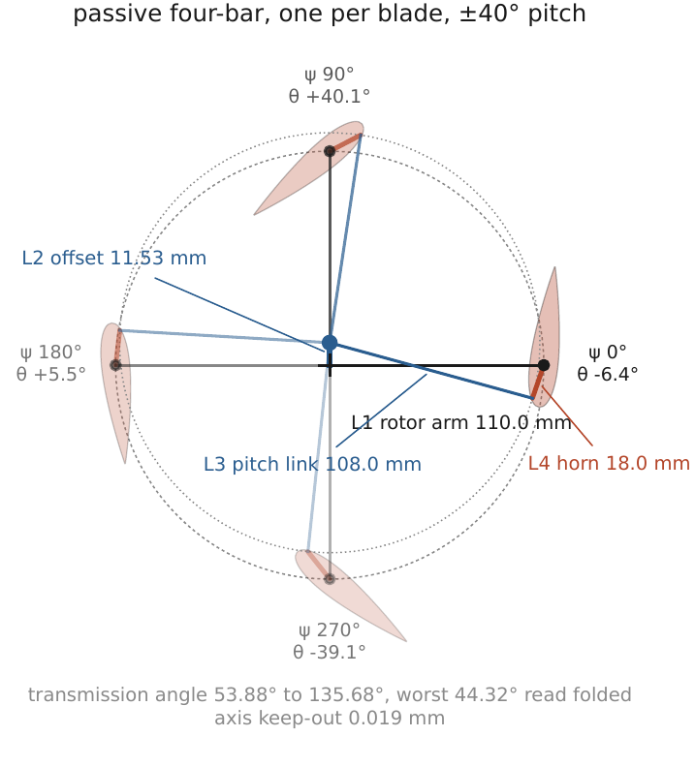
Figure 5. Four-bar pitch kinematics at four azimuths. Transmission angle 53.88 to 135.68 deg, worst 44.32 deg read folded.

6.2 Pitch-Angle Relationship
Rotor azimuth definition:
Azimuth psi is measured from the offset link direction, rotor turning counter-clockwise viewed from the non-drive end. Module vertical sits 9.08 deg further round, which trims out the cycle mean side force at zero command.
Pitch-angle relationship:
Solved from loop closure rather than prescribed: R u(psi) + a u(alpha) + l u(gamma) = e u(phi), and pitch theta = alpha - psi - theta_0.
It stays close to theta = 40 cos(psi - 90 - phi_c - 7.75) deg, with an rms deviation of 1.1406 deg. That deviation is what the load model runs on and is where part of the side force comes from.
Definition of variables:
R = 110.0 mm rotor arm; a = 18.0 mm horn; l = 108.0 mm pitch link; e = 11.53 mm offset; u(x) the unit vector at angle x; psi blade azimuth; alpha horn direction and gamma pitch link direction in the fixed frame; phi offset direction; phi_c the vector command; theta_0 = -102.50 deg, the fixed horn to chord angle.
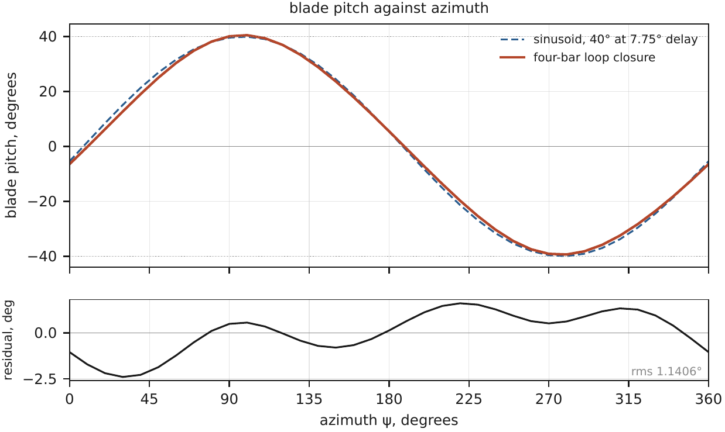
Figure 6. Blade pitch against azimuth from the solved four-bar, against the 40 deg sinusoid. Peak pitch lags the offset direction by 7.75 deg.

6.3 Kinematic Parameters
Parameter | Value | Unit
Degrees of freedom | 1 per blade, driven by rotor rotation; 1 control input, the offset direction | --
Maximum pitch angle | +40.52 | deg
Minimum pitch angle | -39.35 | deg
Pitch amplitude | 40 (79.9 peak to peak) | deg
Phase angle | 7.75 linkage lag; command range +/-60 | deg
Maximum actuator displacement | 41.9 (80 deg servo rotation at the 60 mm sector gear) | mm
Estimated actuator force / torque | 0.0965 Nm per servo (0.1287 Nm at the carrier) | N or N m

6.4 Thrust-Vectoring Assessment
Description of how cyclic blade pitch produces thrust vectoring:
Each blade's incidence follows the geometry of its four-bar, so blades on one side of the rotor run at positive pitch and blades on the other side at negative, and the cycle averaged force points roughly along the offset direction. Turning the offset pivot about the rotor axis turns the whole pitch schedule with it, and the resultant turns by the same angle.
Expected maximum vectoring angle:
+/-60 deg from the trimmed zero, 120 deg of authority. Measured side force on similar rotors runs 10 to 35 deg [3], [7], far above our model's 9.078 deg. Indexing the carrier zero at the middle of that band, we expect roughly four fifths of the authority to stay usable.
Control parameter(s):
Phase command (offset direction) sets the thrust direction. Rotor speed through the ESC sets the magnitude. Amplitude is fixed by geometry.
Expected relationship between control input and thrust direction:
One to one in the model: direction equals command and the magnitude stays 17.0 N at every command. That comes from the model's rotational symmetry and is not a measurement. The 9.078 deg tilt at zero command (7.75 deg linkage lag, about 1.33 deg aerodynamic) is a bias removed by indexing, and because the tilt moves with rpm, a magnitude change needs a small phase correction.
Case | Mean Pitch | Pitch Amplitude | Phase Angle | Estimated Thrust | Expected Thrust Direction
1 | 0 deg | 40 deg | -60 deg | 17.0 N | 60 deg left of vertical: 8.50 N up, -14.72 N lateral
2 | 0 deg | 40 deg | -30 deg | 17.0 N | 30 deg left of vertical: 14.72 N up, -8.50 N lateral
3 | 0 deg | 40 deg | +0 deg | 17.0 N | vertical: 17.00 N up, +0.00 N lateral
4 | 0 deg | 40 deg | +30 deg | 17.0 N | 30 deg right of vertical: 14.72 N up, +8.50 N lateral
5 | 0 deg | 40 deg | +60 deg | 17.0 N | 60 deg right of vertical: 8.50 N up, +14.72 N lateral
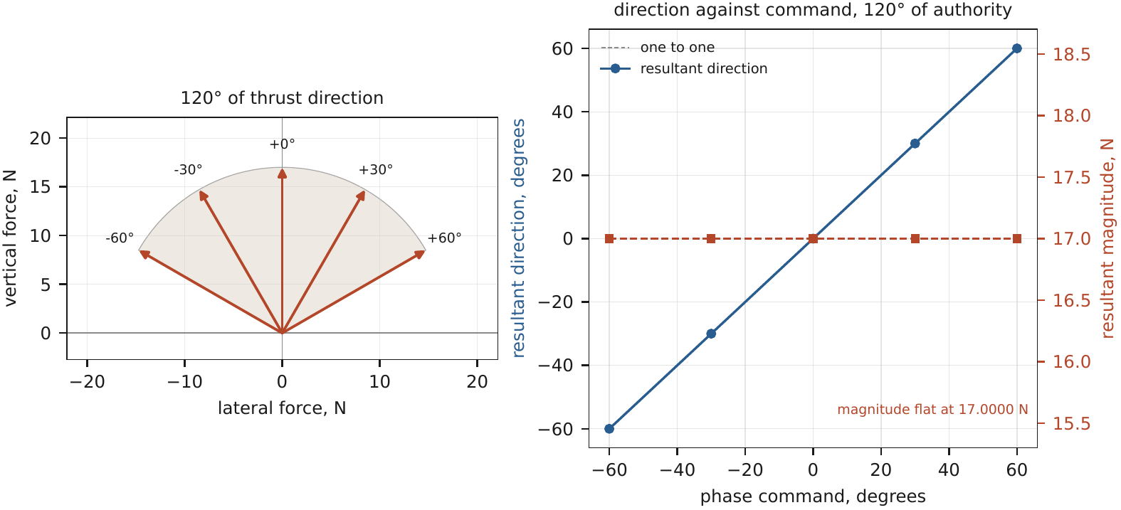
Figure 7. Thrust vector map. The flat 17.0 N magnitude is the model's symmetry, not a measured result. At zero command the resultant sits 9.078 deg off the offset direction.

7. Powertrain Selection

7.1 Motor and Actuator Selection
Item | Details
Motor manufacturer / model | T-Motor Antigravity MN5006 KV450
KV rating | 450 rpm/V
Operating voltage | 8S pack: 29.6 V nominal, 28.4427 V loaded, 33.6 V charged. The windings see 23.2293 V at the design point, inside the 4-6S catalogue window of 25.2 V
Rated / maximum current | 26.0 A for 180 s; 20.8 A continuous after the 0.80 derate; 19.2876 A at the design point
Maximum power | 650 W for 180 s; 520 W derated continuous; 483.2 W at the design point
Motor mass | 106 g with cable
Selection basis | The only one of 5 screened motors that holds power, torque (0.3902 of 0.4414 Nm), current and speed (9932 of 12799 rpm) at once, all on continuous ratings
Pitch actuator model | Digital metal gear servo, 20 g class, from a supplier listing. The exact part is fixed against a datasheet in Stage 2
Pitch actuator rating | 3.9 kgf cm (0.3825 Nm) stall at 6 V; slew 0.1733 s over the range
Pitch actuator mass | 20.0 g each, 40.0 g for 2

7.2 Powertrain Components
Component | Proposed Specification / Model | Mass | Rating | Selection Basis
Motor | T-Motor MN5006 KV450 | 106.0 g | 650 W, 26 A for 180 s | Datasheet; holds the design point continuously
ESC | 40 A 8S class brushless ESC | 19.5 g | 40 A, 8S | Above the 19.29 A design current and the 33.6 V charged pack
Pitch actuator | 2 x 20 g digital metal gear servo | 40.0 g | 0.3825 Nm stall | Margin 1.982 on the carrier ripple
Bearings | 2 x 61802 main, 12 x 693ZZ pitch, 2 x MR128ZZ carrier | 36.0 g | 693ZZ C0 216.985 N by ISO 76 | Pitch bearings duplexed, 4 per blade, for the centrifugal pull
Shaft | CFRP tube 16 x 1.5 mm, 340 mm, bonded 7075-T6 plugs | 59.2 g | 24.9563 Nm torsion | Torsion margin 16.18
Controller / electronics | Matek F411-WSE class board, plus a step down regulator 42 V in, 12 V out | 18.5 g | Board 6-30 V input | The 8S pack exceeds the board's 30 V, so the regulator is required
Other | HTD-3M belt, 16 and 68 tooth pulleys, 4.25:1, tensioner | 60.2 g | efficiency 0.93 assumed | The rotor needs 1.542 Nm; the motor gives 0.3902

7.3 Power Requirement
Parameter | Value | Unit
Estimated aerodynamic power | 339.7 | W
Estimated shaft power | 377.4 | W
Estimated electrical power | 518.0 (module); 508.6 at the ESC | W
Estimated maximum current | 19.29 (motor, design point) | A
Assumed motor efficiency | 84 | %
Assumed mechanical efficiency | 93 (belt) | %
Assumed ESC efficiency | 95 | %
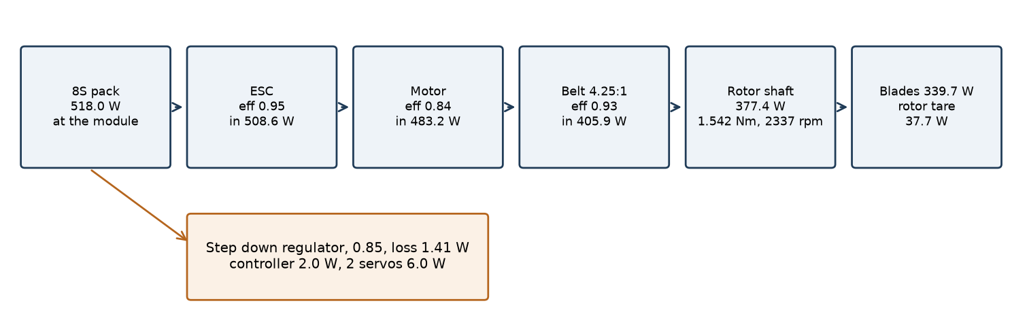
Figure 8. Power flow at the design point, from the pack to the blades.

8. Mass Budget and Thrust-to-Weight Assessment

8.1 Mass Budget
Component | Quantity | Unit Mass | Total Mass | Basis
Blades | 3 | 31.75 g | 95.24 g | PMI foam core at 52 kg/m3 and 88% fill, 2 plies of 60 gsm carbon twill, an 8.71 mm CFRP spar on the pitch axis and two 7075-T6 root fittings, integrated over the NACA 0020 section
Blade hubs | 2 hub sets | 31.32 g | 62.65 g | 6 CFRP spider arms of 14 x 1.5 mm, 2 split 7075-T6 bosses of 22 mm OD, 6 7075-T6 clevis brackets
Shaft | 1 | - | 59.21 g | Roll wrapped CFRP tube, 16 mm OD, 1.5 mm wall, 340 mm, with bonded 7075-T6 end plugs forming the 15 mm journals
Bearings | 16 | - | 36.00 g | 2 x 61802 main (8.0 g each), 12 x 693ZZ pitch (1.3 g each), 2 x MR128ZZ carrier (2.2 g each), supplier listings
Frame | 1 | - | 100.58 g | 2 machined 7075-T6 bearing blocks, 4 CFRP tubes of 8 mm OD, a 2.5 mm 7075-T6 motor plate, and a visible 15.0 g reserve for gussets, clamps and trays not yet drawn
Pitch mechanism | 1 set | - | 36.12 g | 3 CFRP pitch links with rod ends, 3 7075-T6 horns, the offset post, a 6061-T6 carrier ring with its 40 mm gear and the 60 mm sector gear
Actuator | 2 | 20.00 g | 40.00 g | 20 g class digital metal gear servos, supplier listing
Motor | 1 | 106.00 g | 106.00 g | T-Motor MN5006 KV450 datasheet, with cable
ESC | 1 | 19.50 g | 19.50 g | 40 A 8S class ESC with leads, supplier listing
Fasteners | about 40 | - | 21.50 g | M3 screws, washers and threaded inserts, plus epoxy paste at the bonded joints. Both are allowances
Mounting hardware | 4 | 1.80 g | 7.20 g | 7075-T6 lugs at the 4 airframe mount points
Transmission | 1 set | - | 60.21 g | HTD-3M 16 and 68 tooth 6061-T6 pulleys, 9 mm by 375 mm belt, idler tensioner. 4.25 to 1
Other | 3 | - | 43.70 g | 8.5 g controller board, 10.0 g step down regulator allowance, 25.2 g wiring harness allowance
Total | 34 lines | - | 687.91 g | Conservative column 775.74 g (+12.8%)
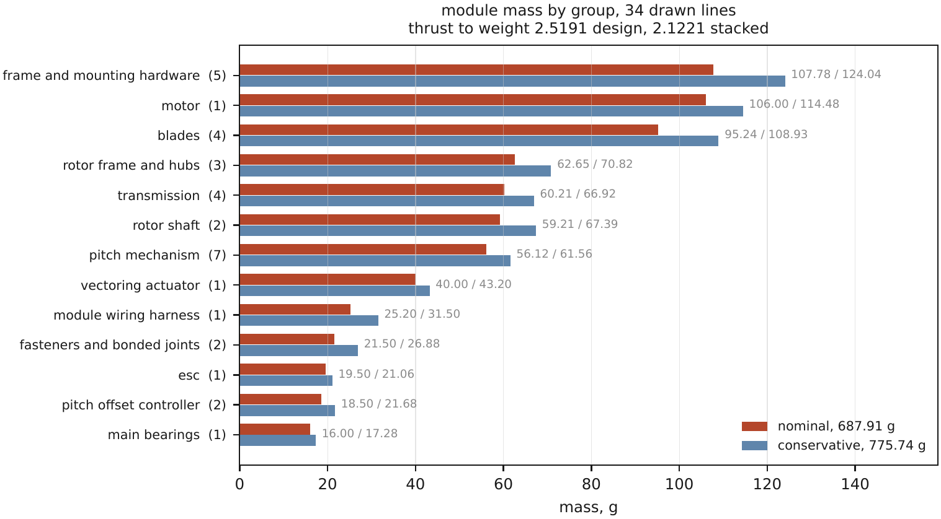
Figure 9. Module mass by group, nominal and conservative. The full 34 line budget is in the supporting files.

8.2 Thrust-to-Weight Estimate
Parameter | Value | Unit
Estimated maximum thrust | 17.0 (design) | N
Estimated module mass | 0.68791 | kg
Estimated module weight | 6.7484 | N
Estimated T/W ratio | 2.5191 | --
Estimated uncertainty / confidence | 2.12 to 2.52 across the four cases below. Medium confidence | --
Basis of thrust estimate:
Blade area coefficient 0.6055 held below Kellen's measured 0.6648 on this shape family, at 2337 rpm (section 5.3). The low case, 16.1493 N, takes 5 percent off for blade flexibility, most of which is the calculated 2.2346 deg torsional wind up.
Basis of mass estimate:
34 budget lines, each a drawn section, a catalogue part or a stated allowance, with growth by line class. It is not yet CAD mass properties or weighed parts.
Four cases are reported because they tell different stories. Design point: 17.0 N on 687.91 g gives 2.5191. Low coefficient alone: 2.3931. Conservative mass alone: 2.2339. Both together: 2.1221.
This is a preliminary pass with an open compliance risk. The design point clears 2.5 by 0.8 percent and the mass estimate isn't accurate to 0.8 percent. The conservative column would have to lose 117.26 g for the worst case to clear 2.5, so Stage 2 treats 658.48 g on that column as a gate and replaces the estimate with CAD mass properties, weighed parts and a thrust test.

9. Preliminary Structural Assessment
A detailed FEA is not required at Stage 1. The objective is to establish that the proposed structure is physically plausible and that the principal load-bearing components have been considered.

9.1 Structural Configuration
Structural arrangement:
Three sandwich blades pinned at both ends through root fittings and pitch bearings to clevis brackets on six CFRP spider arms, clamped to the CFRP shaft by two 7075-T6 split bosses. The shaft runs in two 61802 bearings in 7075-T6 blocks on four CFRP frame tubes, with the motor on a 7075-T6 plate below and four lugs to the airframe.
Critical load-bearing components:
The blade in combined centrifugal and aerodynamic bending; the root fittings and pitch bearings, which carry 209.161 N of centrifugal pull per blade; the pitch horn at 144.19 N of link force; the rotor shaft at 1.542 Nm plus a 66.502 N belt side load.
Principal load paths:
Centrifugal: blade, root fittings, pitch bearings, root brackets, spider arms, hub boss.
Thrust and reaction torque: hub boss, shaft, main bearings, bearing blocks, frame tubes, 4 mount lugs.
Pitch control: horn, pitch link, offset post, carrier bearings, frame.

9.2 Preliminary Strength Assessment
Component | Material | Critical Load | Preliminary Stress | Allowable Stress | FOS
Blade | PMI foam core, 2 ply carbon twill skin, CFRP spar | 8.4153 Nm combined bending (12.1181 at 1.20 overspeed) | 71.7 MPa, skin | 215.3 MPa, skin wrinkling | 3.00 / 2.08
Shaft | CFRP tube 16 x 1.5 mm | 1.542 Nm torque + 1.995 Nm bending | 5.56 MPa combined shear | 55 MPa shear | 9.90
Frame | CFRP tubes, 7075-T6 blocks and lugs | worst lug about 13.4 N | not computed; stiffness governs | 5.8 kN lug net section | > 100
Hub | 7075-T6 boss, 693ZZ root bearings | 209.161 N per blade (301.192 at overspeed) | load check on bearing rating | 781.148 N (4 bearings, ISO 76) | 3.73 / 2.59
Pitch linkage | 7075-T6 horn, CFRP link | 144.19 N | 121.7 MPa, horn | 400 MPa (7075-T6) | 3.29
Calculation methodology:
Closed form, in tools/structure.py. Beam bending on the blade section integrated from its own ordinates (EI 51.115 Nm2, GJ 7.8058 Nm2), with the skin wrinkling stress 0.5 x (E_skin E_core G_core)^(1/3). Thin wall torsion and combined shear on the shaft, net section bending on the horn, and the ISO 76 static rating for the bearings. FOS is allowable over demand; where two are given, the second is the 1.20 overspeed case. Stresses in the table are the demand scaled onto the governing allowable.
Principal assumptions:
Blade load factor 4.0 on the mean aerodynamic force; a 1.20 overspeed case; published class allowables with no coupon; a floor of 1.5 on every margin.
Critical loading condition:
1.20 overspeed, about 2804 rpm, with the 4.0 aerodynamic peak on top: blade combined bending 12.1181 Nm, FOS 2.08, the lowest in the module.
Preliminary conclusion:
All eight computed margins clear 1.5 and the two lowest are both overspeed cases. Centrifugal pull, 209.161 N per blade, is 9.2 times the mean aerodynamic force, so this rotor is a centrifugal machine first. Not yet analysed: the bonded root joint itself, fatigue, the shaft's critical speed and stress concentrations. Those are Stage 2 FEA and coupon work.

10. Materials, Manufacturing, and Assembly

10.1 Material Selection
Component | Proposed Material | Key Properties | Reason for Selection
Blade | PMI foam (Rohacell 51 IG class) core, 2 plies of 60 gsm carbon twill | Foam 52 kg/m3, E 70 MPa, G 19 MPa; skin E 60 GPa | Skin wrinkling over the core sets the blade allowable, so the foam is structural; light enough to keep centrifugal load down
Frame | CFRP tube, 8 mm OD; 7075-T6 blocks and lugs | CFRP E 130 GPa, 1550 kg/m3; 7075-T6 400 MPa, 2810 kg/m3 | Stiffness per gram for the tubes; machinable bores for the blocks
Shaft | Roll wrapped CFRP tube with bonded 7075-T6 plugs | Shear allowable 55 MPa, 1550 kg/m3 | Torsion margin 16.18 at 36 g; metal only at the journals
Hub | 7075-T6 split boss, CFRP spider arms | 400 MPa, 2810 kg/m3 | Clamps on the tube without crushing it; carries the root brackets
Pitch mechanism | 6061-T6 carrier ring and sector gear; 693ZZ and MR128ZZ bearings | 240 MPa, 2700 kg/m3 | Stiffness parts, easy to machine and gear cut
Linkages | CFRP tube 4 mm OD pitch links with rod ends; 7075-T6 horns | 7075-T6 400 MPa | The horn governs the link path at FOS 3.29

10.2 Manufacturing and Assembly
Component | Proposed Manufacturing Method | Key Considerations
Blade | CNC profiled foam halves with the spar channel cut; 2 plies wet laid in a machined two part mould, vacuum bagged, room temperature cure; 7075-T6 root fittings bonded and pinned | Mould quality and blade mass matched within 0.5 g across the set
Frame | CFRP tubes cut to length; bearing blocks CNC milled with both bores in one setup; bolted | Bearing bore alignment, 0.010 mm
Shaft | Plugs bonded into the tube first, then both journals ground in one setup | Journal run out under 0.02 mm; grinding after bonding keeps them concentric
Hub | Turned and milled 7075-T6 boss, reamed bore; spider arms CNC routed from 1.5 mm CFRP plate | Bore to shaft 0.015 mm; clamp without crushing the tube
Pitch mechanism | Turned 6061-T6 carrier and sector gear, gear teeth cut as job work; CNC 7075-T6 horns and post; rod ends bought | Backlash 0.05 mm; pitch checked against the solved schedule at 12 azimuths
Expected manufacturing constraints:
The PMI foam is a 4 week import with no Indian stockist, and it gates the build, so it is ordered first. The gear pair is the only job needing a cutter a local shop won't keep, and at a quantity of one it is priced by setup. Two joints, the shaft plugs and the blade root, can't be reworked once cured.
Availability of materials/components:
Motor, servos, bearings, belt, ESC and CFRP tube are stocked by Indian distributors. The bill of materials totals 68,830 INR (40,030 bought parts and material, 28,800 tooling and fabrication), at distributor list prices. Nothing has been quoted yet.
Preliminary assembly approach:
Bond the shaft plugs and grind the journals; build and weigh the 3 blades; mate the spiders to the shaft and hang the blades on their pitch bearings; fit the main bearings and blocks to the frame and drop the rotor in; fit the carrier, offset post and pitch links, setting link lengths against the schedule; then motor, pulleys and belt, tensioned last; then ESC, controller, servos and harness. Before any spin: blade masses matched, run out measured, pitch checked at 12 azimuths, a static pull on one attachment above 301 N, and a first spin in four steps with current logged.

11. CAD and System Packaging
Figure 10. System layout (same drawing as Figure 1). No CAD model exists at Stage 1; every dimension here is solved in the scripts and CAD is Stage 2 item 1.

11.1 Major Dimensions
Parameter | Dimension | Unit
Overall length | 364.4 (along the rotor axis) | mm
Overall width | 316.5 | mm
Overall height | 362.5 (includes the 46 mm motor stack) | mm
Rotor diameter | 220.0 (296.5 swept) | mm
Rotor width | 290.4 | mm
Mounting dimensions | 4 lugs on a 320 x 240 pattern | mm
Motor envelope | 46 axial stack below the rotor, on the drive end plate | mm
Actuator envelope | Non-drive end: 16 axial phasing carrier bay; 2 servo cases on the frame, not yet dimensioned | mm

11.2 System Integration
Item | Description
Motor arrangement | One outrunner under the rotor at the drive end, belt up to a 68 tooth rotor pulley
Bearing arrangement | 2 x 61802 on the shaft end plugs in 7075-T6 blocks; 12 x 693ZZ at the blade roots; 2 x MR128ZZ carrying the carrier
Pitch mechanism | All at the non-drive end: offset post from the phasing carrier, 3 pitch links to the horns
Actuator arrangement | 2 servos 180 deg apart on sector gears, outside everything that rotates
Mounting interface | 4 lugs in the plane of the rotor axis. 4 rather than 3 because the airframe sees 1.542 Nm of steady reaction torque
Potential interference | The pitch links pass 0.019 mm from the rotor axis, so nothing coaxial may sit in that plane. Blade sweep annulus 86.92 to 148.25 mm kept clear. Neighbour clearance 98.47 mm
Assembly considerations | Bonded joints first, then rotor into frame, mechanism, drive and electronics last
Maintenance/accessibility | Carrier and servos come off the non-drive end without disturbing the rotor; belt reachable at the drive end; each blade comes out once its link is unpinned
Critical dimensions/tolerances | Journal run out 0.02 mm; bearing bores 0.010 mm; pitch link free length 0.05 mm; gear backlash 0.05 mm

12. Design Risks and Open Technical Questions

12.1 Risk Assessment
Risk / Failure Mode | Cause | Consequence | Probability | Severity | Mitigation
Thrust below 17.0 N | Transferred coefficient wrong for this rotor; high inflow ratio 0.3871 | T/W under 2.5; 10 N still met at 16.15 N | Medium | High | Transient CFD, then a load cell run
Mass growth | Wet layup blades come out heavy; undrawn frame parts use up the 15 g reserve | T/W under 2.5 (margin is 0.8%) | High | High | CAD mass properties, weighed parts, 658.48 g gate
Motor overheats in continuous running | 0.80 derate has no source; motor at 93% of it | Lower thrust or a heavier motor | Medium | Medium | Dynamometer run at working current, early in Stage 2
Pitch bearing wear (false brinelling) | 80 deg oscillation, balls never recirculate (ratio 0.5533) | Pitch play, loss of schedule | Medium | Medium | Run to failure at speed on the flight grease
Side force larger than modelled | Quasi steady model; measured 10 to 35 deg on similar rotors | About a fifth of vectoring authority lost | High | Low | Index carrier zero; load cell calibration across speed
Blade root joint failure | 301.192 N through a bonded joint not yet qualified | Blade release | Low | High | Bond shear coupons, static pull above 301 N before any spin, spin behind a guard
Foam supply delay | 4 week import, no Indian source | Build slips | Medium | Medium | Order first; fallback is a thicker skin and a rerun

12.2 Open Technical Questions
List key technical questions that require further detailed analysis, simulation, or validation.
1. Does the transferred coefficient hold on this rotor at inflow ratio 0.3871? Transient CFD and a load cell run.
2. How large is the real side force, and how does it move with rpm? It sets usable vectoring authority.
3. What life do the 693ZZ pitch bearings have in 80 deg oscillation at 39 Hz?
4. How strong is the bonded blade root in shear, peel and 3 per rev fatigue?
5. Where is the shaft's first bending mode against 2337 rpm, and does the MN5006 hold its rating at the 8S duty?

13. Design Development and Engineering Decisions

13.1 Design Evolution
Version | Date | Major Change | Reason / Evidence | Outcome
V1 | 29-31 Aug 2026 | Geometry frozen: R 110 mm, 3 blades, 18 N design, 6S pack, 3.5:1 belt | Kellen's shape family and the week 2 radius sweep | 580.05 g, T/W 3.1633 design, 2.2525 stacked
V2 | 1 Sep 2026 | Figure of merit corrected 0.6 to 0.5215; design 17 N; pack 8S; belt 4.25:1; 20 g servos; four-bar 18 x 108 mm; pitch bearings doubled; six mass lines redrawn | FM must scale with the lowered coefficient; at 6S the motor capped at 392 W against 406 W needed | 677.91 g, T/W 2.5563 design, 2.1569 stacked
V3 | 4 Sep 2026 | 10 g step down regulator added for the pitch controller | The controller is rated 6 to 30 V and a charged 8S pack reaches 33.6 V | 687.91 g, T/W 2.5191 design, 2.1221 stacked

13.2 Significant Design Decisions
Item | Decision 1
Design question | Design thrust and pack voltage after the power correction
Options considered | Keep 18 N on a bigger motor; drop thrust on the same motor; raise the pack voltage
Selected option | 17 N on the MN5006, 8S pack, 4.25:1 belt
Basis for selection | Output power a motor can give is capped at the speed rule x loaded pack voltage x continuous current, and KV cancels, so gearing can't move it. 8S lifts the cap; 17 N is where every drive line keeps 7% or better
Supporting calculation / evidence | At 8S the cap is 532.4 W against 405.9 W wanted. Motor at 483.2 of 520 W, 19.29 of 20.8 A, 0.3902 of 0.4414 Nm, 9932 of 12799 rpm
Item | Decision 2
Design question | Should the blade be chordwise balanced?
Options considered | Balance with nose ballast at the pitch axis; leave it unbalanced
Selected option | Leave it unbalanced
Basis for selection | Balancing lifts the pitch link margin from 3.29 to 6.20 but costs mass on a case that already misses
Supporting calculation / evidence | Balancing takes the stacked T/W from 2.1221 to 2.0292; the unbalanced link path still clears at 3.29

13.3 Current Design Limitations
1. Thrust and the side force rest on a transferred coefficient and a quasi steady model. Nothing has been measured on this rotor.
2. Mass is a line by line estimate, not CAD mass properties or weighed parts, and the pass at the design point is 0.8 percent.
3. No CAD, FEA or CFD exists yet. Structure is closed form and the root joint, fatigue and rotor dynamics are not analysed.
4. The efficiency chain and the motor derate are assumed, and the motor figure is the sensitive one.
5. The team is three programmers. Fabrication and testing experience has to come from new members, a mentor or the workshop.

14. References and Sources
All externally sourced numerical values, component specifications, material properties, aerodynamic data, and design correlations should be traceable to their respective sources.
No. | Reference / Source | Link / DOI / Datasheet | Application in Design
1 | Kellen, A. J. Performance Measurements on a UAV-Scale Cycloidal Rotor in Hover. MS thesis, Texas A&M University, 2019 | https://hdl.handle.net/1969.1/184958 | Shape family; coefficient 0.6648; FM 0.6; solidity and Reynolds bands; horn length
2 | Benedict, M. Fundamental Understanding of the Cycloidal-Rotor Concept for Micro Air Vehicle Applications. PhD dissertation, University of Maryland, 2010 | https://hdl.handle.net/1903/11257 | Coefficients 0.7211 and 0.8114; power loading 0.062 N/W; 10% tare; blade count
3 | Sirohi, J., Parsons, E. and Chopra, I. Hover performance of a cycloidal rotor for a micro air vehicle. J. American Helicopter Society, 2007 | journal article | Side force angle, about 10 deg
4 | Xisto, C., Leger, J., Pascoa, J. et al. Parametric analysis of a large-scale cycloidal rotor in hovering conditions. J. Aerospace Engineering, 2016 | journal article | Parametric context for blade number and pitch
5 | Runco, C. and Benedict, M. Design, development, and flight testing of a 70-gram micro quad-cyclocopter. Int. J. Micro Air Vehicles 15, 2023 | open access | Module T/W benchmark; centrifugal to aerodynamic load ratio
6 | Shrestha, E., Benedict, M. et al. Understanding upward scalability of cycloidal rotors for large-scale UAS applications. JAHS 67(4), 2022 | journal article (summary read) | Reynolds invariance; blade mass scaling
7 | Adams, Z., Benedict, M., Hrishikeshavan, V. and Chopra, I. Design, development, and flight test of a small-scale cyclogyro UAV utilizing a novel cam-based passive blade pitching mechanism. Int. J. Micro Air Vehicles 5(2), 2013 | journal article (summary read) | Side force 15 to 35 deg
8 | Alsabri, A. A. M. et al. Independent effects of blade number and solidity on cyclorotor hover performance. Aerospace 13(9), 765, 2026 | https://doi.org/10.3390/aerospace13090765 (summary read) | Peak to mean blade load 3 to 4
9 | T-Motor Antigravity MN5006 KV450 datasheet | manufacturer datasheet (PDF) | 650 W / 26 A for 180 s, 106 g, 60 mOhm, 4-6S
10 | ISO 76, Rolling bearings: static load ratings | standard | 693ZZ static rating, 216.985 N

15. Digital / AI Tools and Design Integrity

15.1 Digital / AI Tools Used
Tool | Purpose | Nature / Extent of Use
Claude (Anthropic), used through Claude Code | Writing and checking the Python calculation scripts, drafting report text, reading and summarising sources, internal design reviews | Extensive. Most of the calculation code and text was produced with it under the team's direction. Every number is recomputed by the scripts from one data file, and the team takes responsibility for all of it
OpenAI Codex | Independent audits of the report against the problem statement | Several review rounds. Each finding was checked, then fixed or answered in the design record
Python 3, Matplotlib | All calculations (standard library) and figures | Open source
Pandoc, XeLaTeX, Microsoft Word | Document preparation | Formatting only

15.2 Design Integrity Declaration
We confirm that the engineering design, calculations, CAD development, analysis methodology, interpretation of results, and technical decisions presented in this report have been reviewed and verified by the team.
The team accepts responsibility for the technical accuracy, validity, and integrity of the submitted work.
The team understands that the evaluation committee may request supporting calculation files, CAD models, design-history records, or other technical evidence and may require team members to explain, reproduce, modify, or defend the technical work presented in this report.
Team Leader: | Kartik Shirode
Signature:
Date: | 27 September 2026

16. Final Stage 1 Design Summary
Parameter | Final Stage 1 Value | Unit
Rotor diameter | 220.0 | mm
Rotor width | 290.4 | mm
Number of blades | 3 | --
Blade chord | 72.6 | mm
Operating RPM | 2337 | rpm
Maximum blade pitch | 40.52 | deg
Pitch amplitude | 40 | deg
Maximum vectoring angle | +/-60 | deg
Estimated thrust | 17.0 | N
Estimated torque | 1.542 | N m
Estimated shaft power | 377.4 | W
Estimated electrical power | 518.0 | W
Estimated module mass | 0.688 | kg
Estimated T/W ratio | 2.5191 | --
Primary blade material | PMI foam core, carbon twill skin, CFRP spar | --
Primary frame material | CFRP tube and 7075-T6 | --
Motor | T-Motor MN5006 KV450 | --
Pitch actuator | 2 x 20 g digital metal gear servo | --
Why is the proposed design expected to meet the 10 N thrust requirement?
Design thrust is 17.0 N on a coefficient held below the value measured on this shape family, at a Reynolds number inside the measured band. Even with 5 percent off for blade flexibility it is 16.15 N, 61 percent above the requirement. The motor holds the design point on continuous ratings.
Why is the proposed design expected to achieve T/W > 2.5?
At the design point it does, at 2.5191, but only by 0.8 percent, so we don't claim it with confidence. The three downside cases fall to 2.39, 2.23 and 2.12. We publish the 117.26 g that would close the worst case, and Stage 2 replaces the estimate with measured mass and thrust before anything else. The routes to more margin are a measured coefficient and a lower KV motor on more cells.
What are the three most important assumptions underlying the current design?
1. The blade area coefficient 0.6055 transfers to this rotor.
2. The mass budget holds: 34 lines with growth by class, nothing yet weighed.
3. The efficiency chain (0.93, 0.84, 0.95) and the 0.80 motor derate.
What are the most important technical questions still to be resolved?
1. Measured thrust and side force on this rotor.
2. Measured module mass, starting from CAD mass properties.
3. Strength and life of the bonded blade root and the oscillating pitch bearings.
Overall assessment of Stage 1 design readiness:
Preliminary design closed on paper. Geometry, kinematics, loads, mass, power and cost are consistent with each other and recomputed from one file. It is not build ready: thrust to weight is an open compliance risk, and CAD, CFD, FEA and testing are the first Stage 2 work.

Appendix A - Supporting Calculations
Attach detailed hand calculations, spreadsheet outputs, MATLAB/Python calculations, or other supporting engineering calculations.
Supporting files in the zip, folder 03_Calculations: stage-1/design/numbers.json holds every input and result; tools/linkage.py solves the four-bar, the pitch schedule, the aerodynamic loads and the vector map; tools/structure.py builds the blade section, the margins and the mass budget. Both are plain Python 3 with no third party packages. Running python tools/linkage.py --write and then python tools/structure.py --write regenerates numbers.json byte for byte. The 32 page detailed design note in folder 02_Detailed_Design_Note carries every calculation in prose.
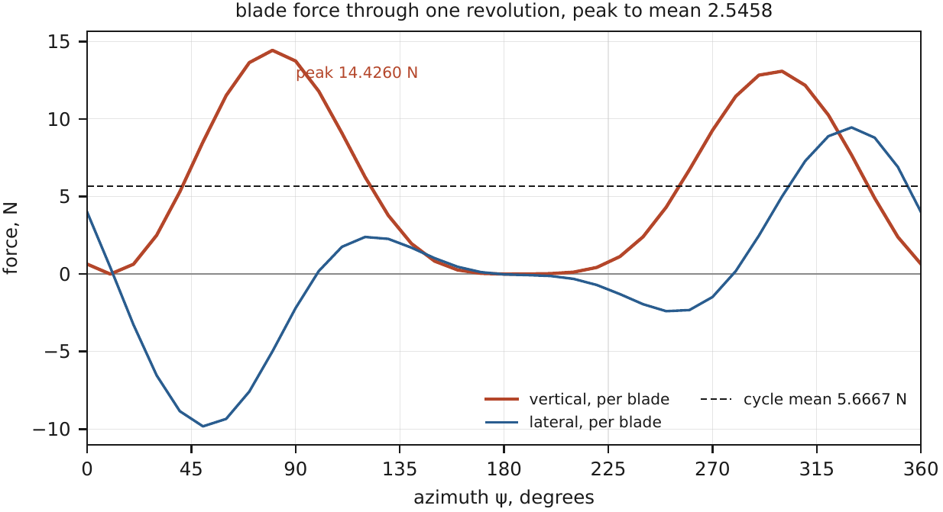
Figure A1. Blade force against azimuth on the solved pitch schedule. Peak 14.4260 N against a mean of 5.6667 N.

Appendix B - Preliminary CAD
Attach additional CAD views, drawings, dimensions, and component layouts.
No CAD model exists at Stage 1. The dimensioned layout is Figure 1, the blade section Figure 3 and the linkage Figure 5, all drawn from the same numbers file. The packaging and interface definition is in 04_Design_Record/09-packaging-and-integration.md.

Appendix C - Design Development Evidence
Attach preliminary sketches, earlier design versions, calculation iterations, design-review records, photographs, or other evidence of design development.
Folder 04_Design_Record holds the design document for each item and the evidence ledger that grades every borrowed number by how it was obtained. The design documents cite numbered, dated decisions (for example D67 for the V2 change in section 13.1). The full decision log is available on request.

Appendix D - Additional Technical References
Attach additional papers, datasheets, technical reports, standards, and other sources.
Not read and not used as evidence, listed for Stage 2: Ramsey, R. A., Development and Flight Testing of a 25-Kilogram Quad-Cyclocopter, MS thesis, Texas A&M, 2022; Heimerl, Halder, Benedict et al., Experimental and Computational Investigation of a UAV-Scale Cycloidal Rotor in Forward Flight, VFS 77th Annual Forum, which measured instantaneous blade forces.

Stage 1 Evaluation Summary
Evaluation Criterion | Weight | Score
Engineering requirements and design targets | 5
Concept development and selection | 8
Rotor and blade design | 10
Preliminary aerodynamic analysis | 15
Blade-pitch kinematics and thrust vectoring | 15
Powertrain and power requirement | 8
Mass budget and T/W assessment | 12
Preliminary structural assessment | 5
Materials, manufacturing, and assembly | 5
CAD and system packaging | 5
Risk assessment and open technical questions | 4
Design development and engineering decisions | 8
Technical clarity and completeness | 5
Total | 100

Stage 1 Evaluation Philosophy
Stage 1 focuses on engineering reasoning, preliminary calculations, feasibility, and technical credibility. Detailed CFD, detailed FEA, optimization, prototype development, and experimental validation are not expected at this stage.
The quality of a submission will be assessed primarily on:
· Soundness of engineering assumptions.
· Correctness and transparency of preliminary calculations.
· Physical plausibility of predicted performance.
· Understanding of blade-pitch kinematics and thrust vectoring.
· Credibility of the mass and power estimates.
· Consistency between geometry, operating conditions, and predicted performance.
· Quality of engineering judgement and design trade-offs.
· Evidence that the team understands the proposed design and its limitations.
A technically simple design supported by transparent and defensible engineering calculations is preferred over a complex design supported by insufficient justification.

