AWS VPC Design & Implementation Documentation
1. Objective
The objective of this task is to design and implement a custom Amazon VPC with six subnets, segregated using public and private route tables, and enable internet access through an Internet Gateway (IGW).
This architecture separates workloads based on functionality such as Admin, Edge, Web, App, Platform, and Shared.

2. Architecture Overview
VPC Components
- VPC: Custom VPC
- Subnets: 6 (each with a unique CIDR)
- Route Tables:
  - Public Route Table
  - Private Route Table
- Internet Gateway (IGW): Attached to VPC

3. Network Design
3.1 VPC Configuration
Component | Value
VPC Name | Custom VPC
CIDR Block | (example: 10.0.0.0/16)
Region | (mention region)
📸 Screenshot: VPC creation page showing VPC name and CIDR
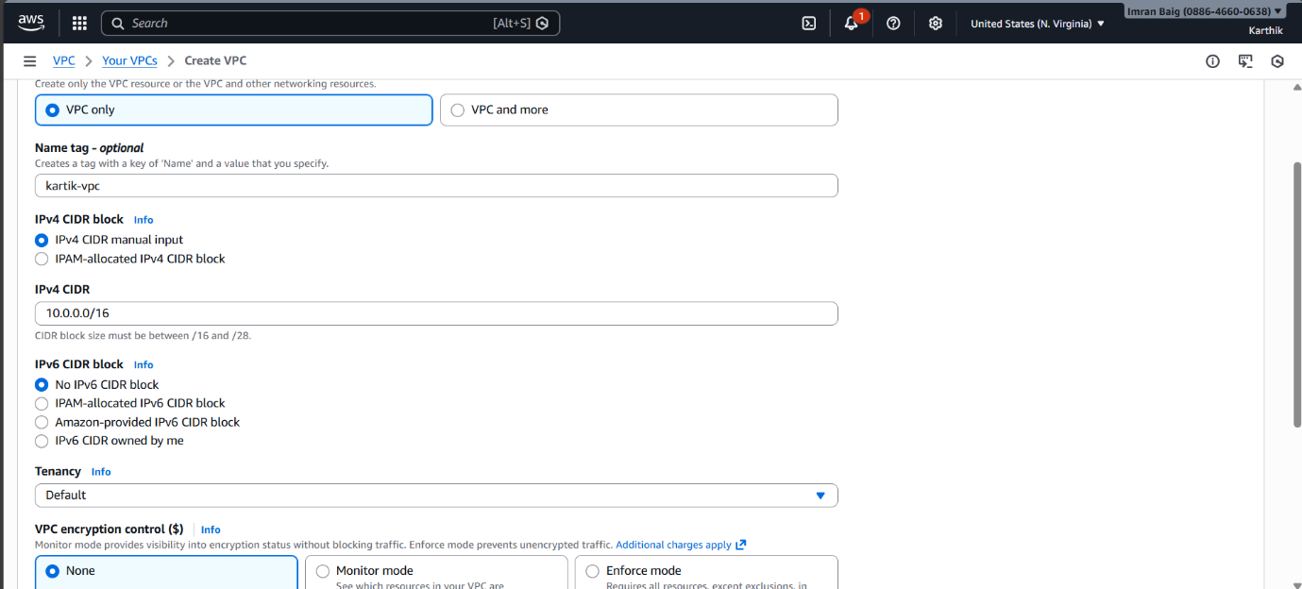
4. Subnet Design
Each subnet has a unique CIDR block and a specific purpose.
Subnet Name | Type | CIDR Block | Route Table
Admin | Public | (10.0.62.0/24) | Public RT
Edge | Public | (10.0.60.0/23) | Public RT
Web | Private | (10.0.56.0/22) | Private RT
App | Private | (10.0.48.0/21) | Private RT
Platform | Private | (10.0.32.0/20) | Private RT
Shared | Private | (10.0.0.0/19) | Private RT
📸 Screenshot: Subnets list showing all six subnets and CIDRs
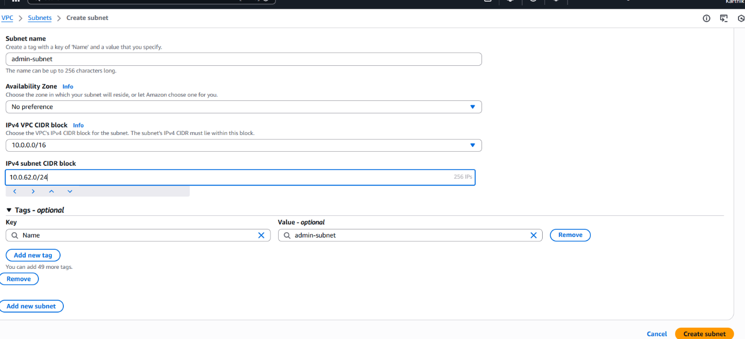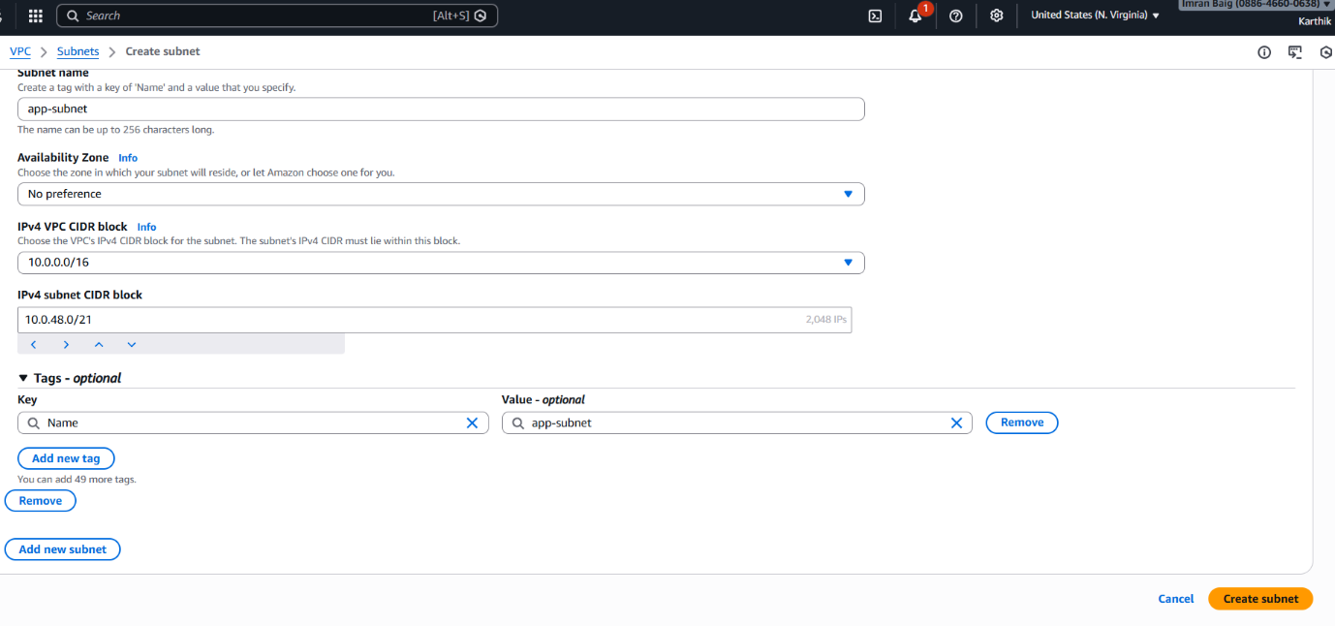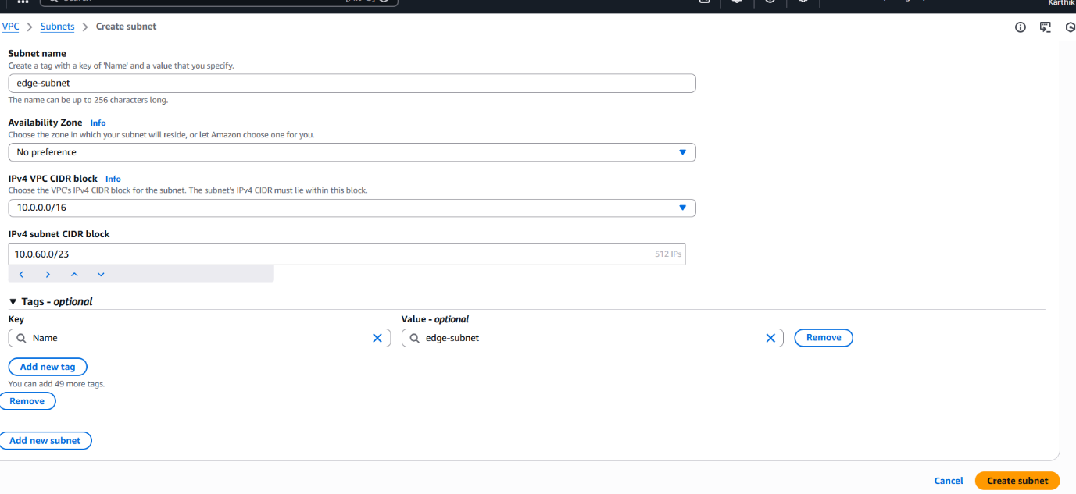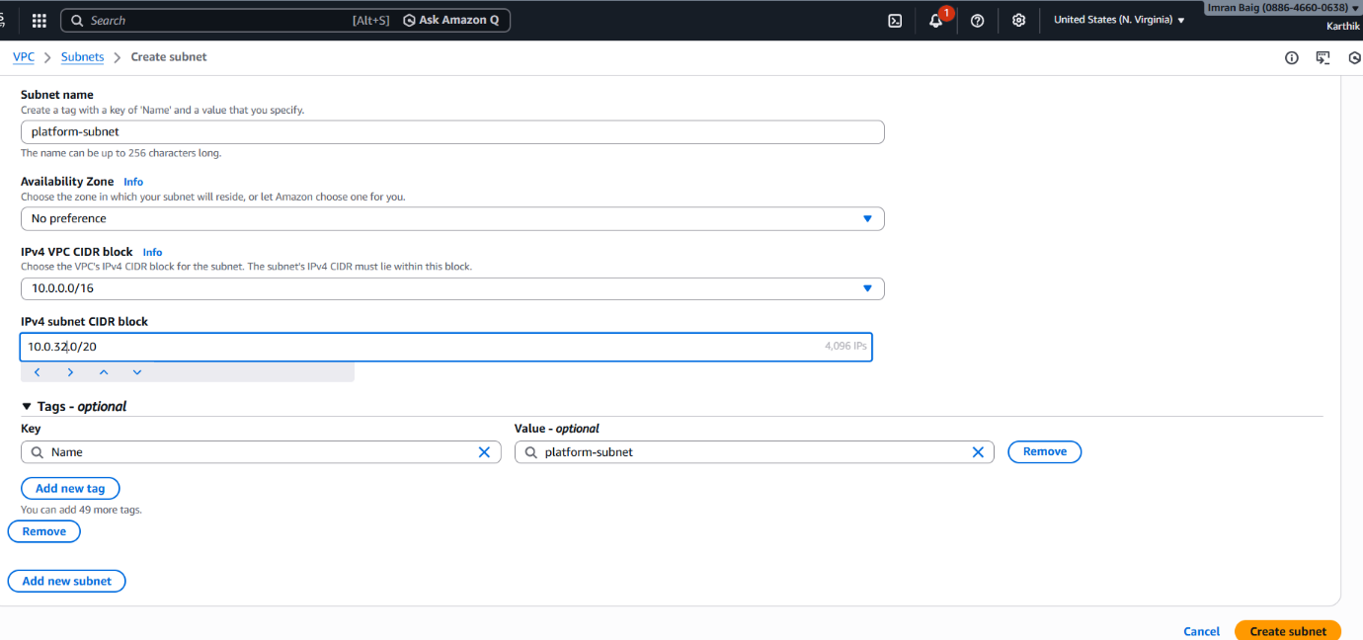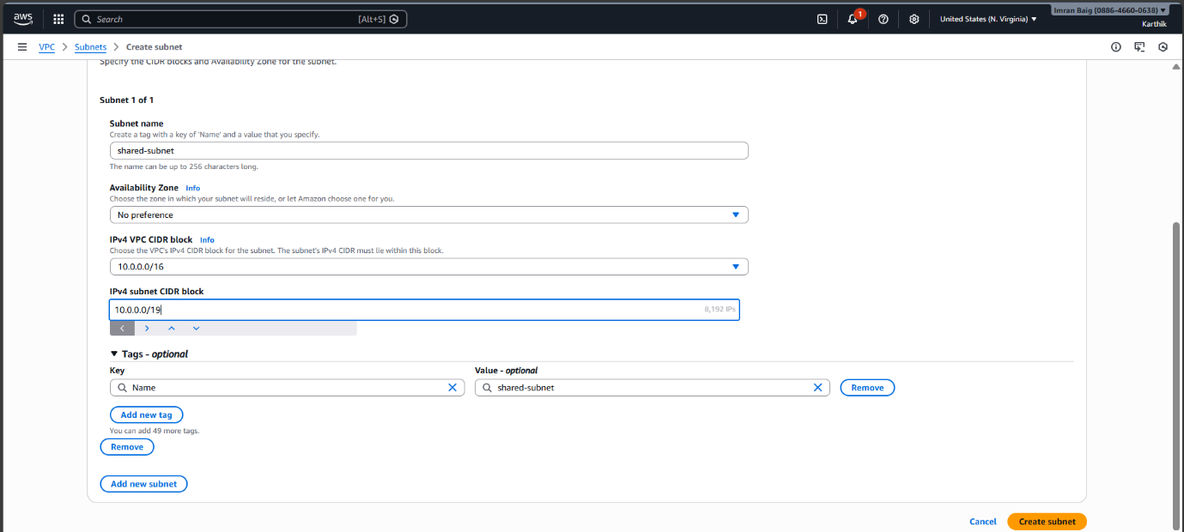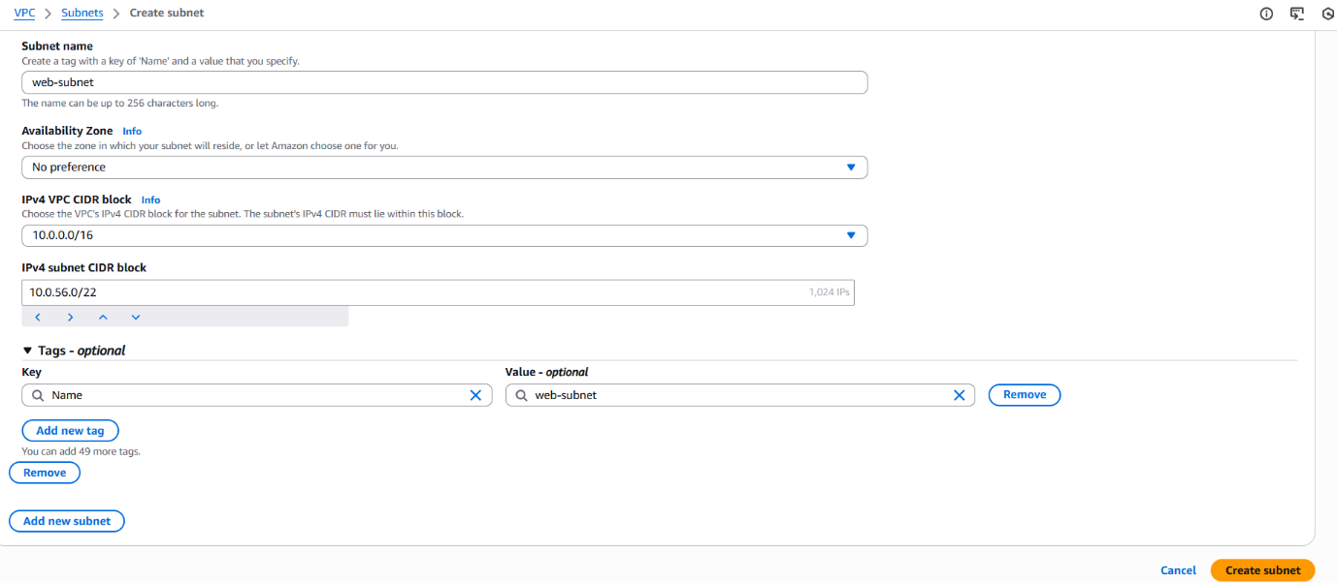

5. Internet Gateway Configuration
5.1 IGW Creation
- Created a new Internet Gateway
- Assigned a meaningful name
📸 Screenshot: Internet Gateway creation
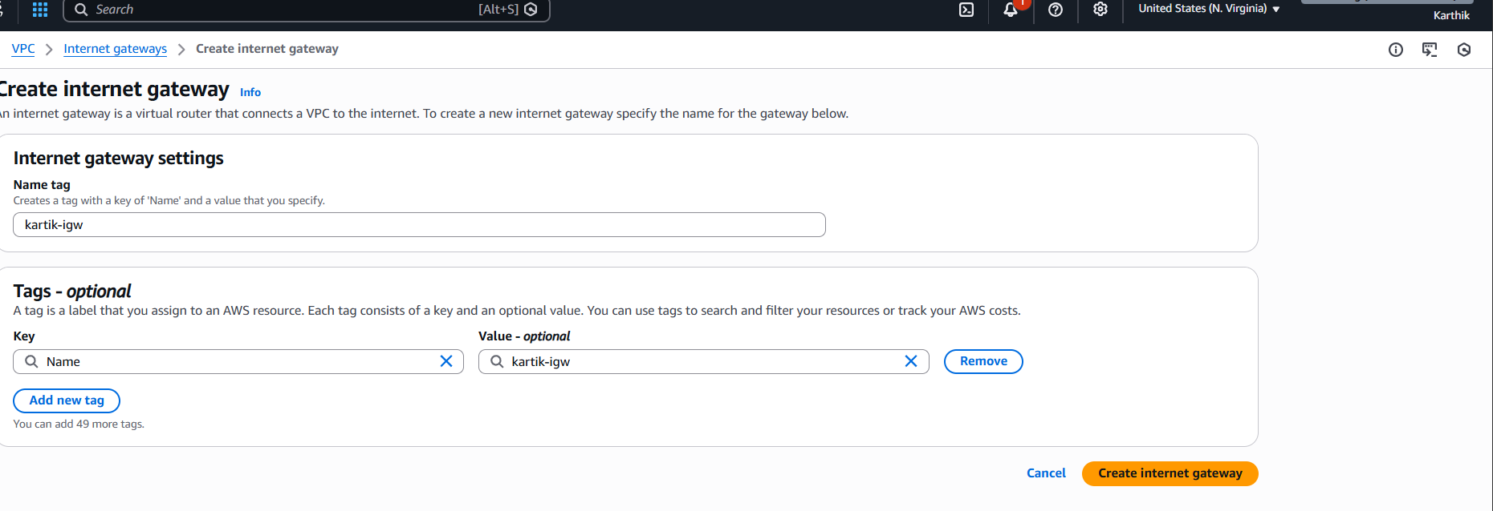
5.2 IGW Attachment
- Attached IGW to the custom VPC
📸 Screenshot: IGW attached to VPC
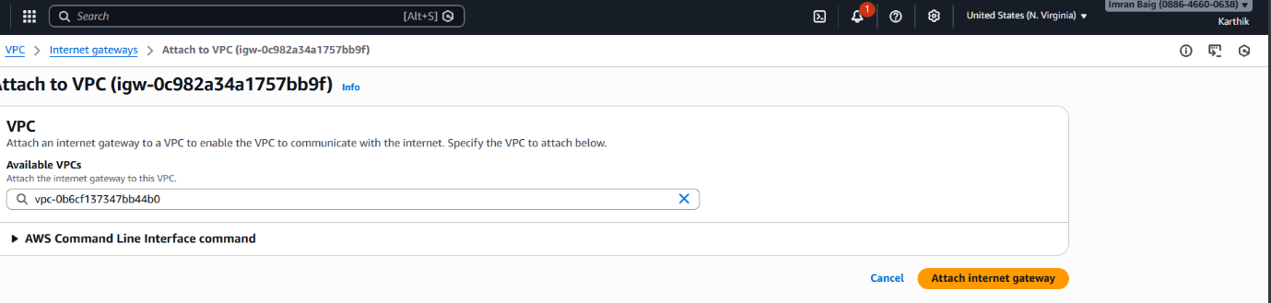

6. Route Table Configuration
6.1 Public Route Table
Purpose: Allow internet access for public subnets (Admin & Edge)
Routes Configured:
Destination | Target
VPC CIDR | local
0.0.0.0/0 | Internet Gateway
📸 Screenshot: Public route table routes
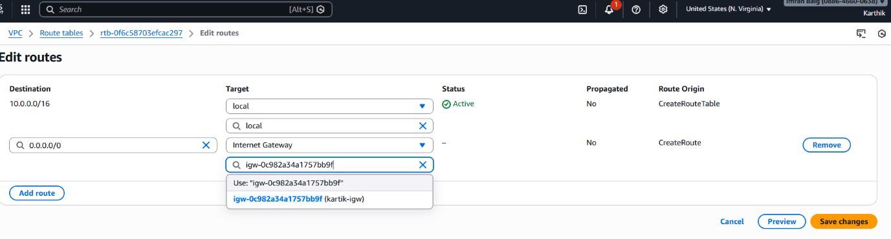

6.2 Private Route Table
Purpose: Internal communication only for private subnets
Routes Configured:
Destination | Target
VPC CIDR | local
📸 Screenshot: Private route table routes
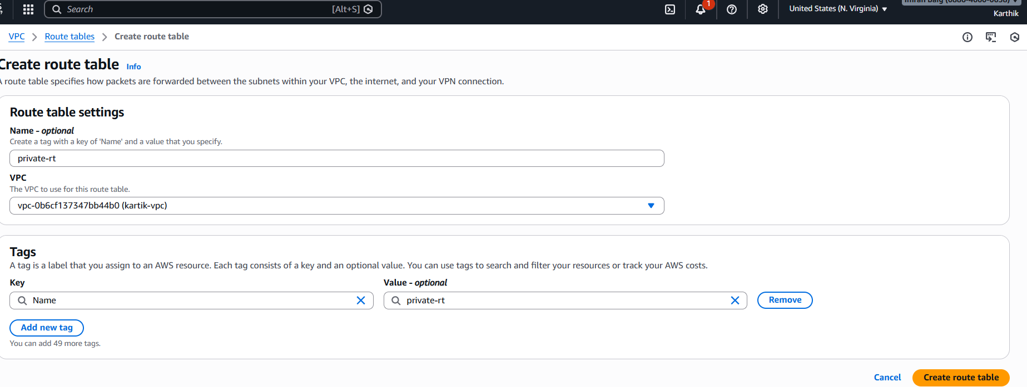

7. Subnet to Route Table Association
7.1 Public Route Table Associations
Associated subnets:
- Admin
- Edge
📸 Screenshot: Public RT subnet associations
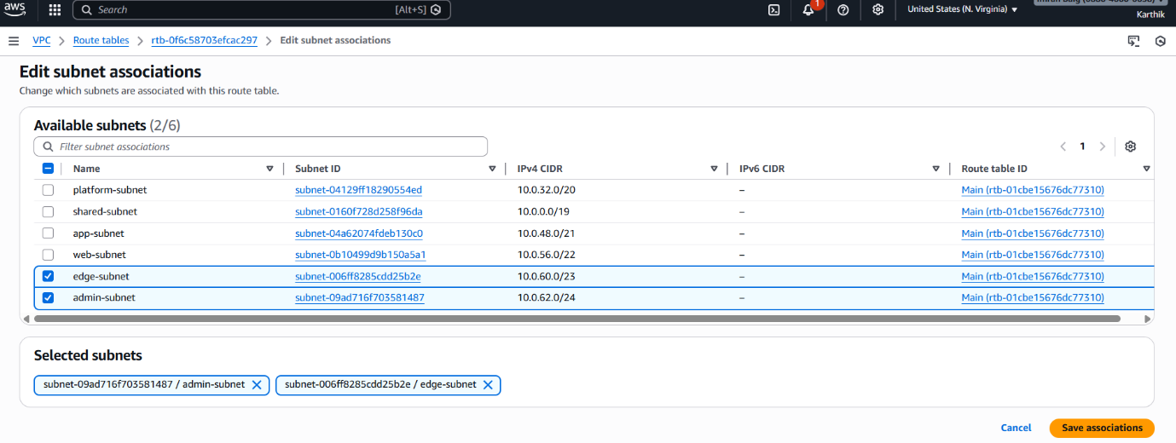

7.2 Private Route Table Associations
Associated subnets:
- Web
- App
- Platform
- Shared
📸 Screenshot: Private RT subnet associations
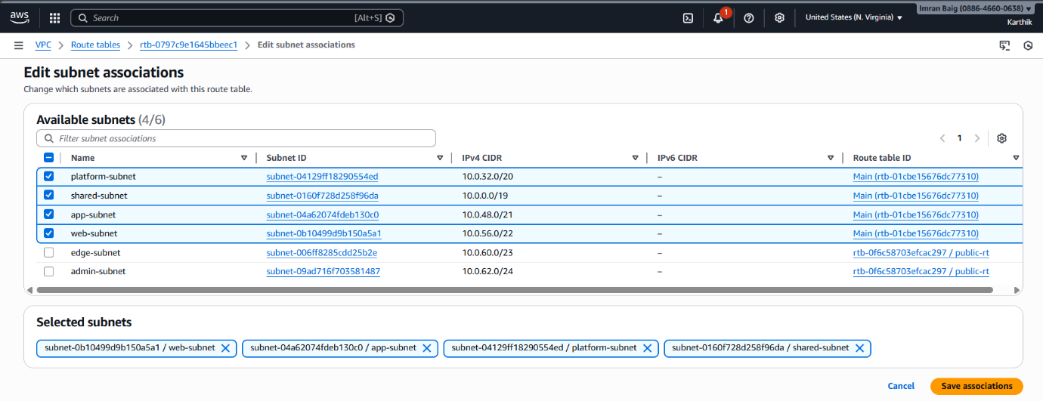

8. Final Architecture Summary
- Public subnets can access the internet using IGW
- Private subnets are isolated and secured
- Traffic segregation achieved using route tables
- Logical separation of workloads improves security and scalability
📸 Screenshot: Final VPC resource map
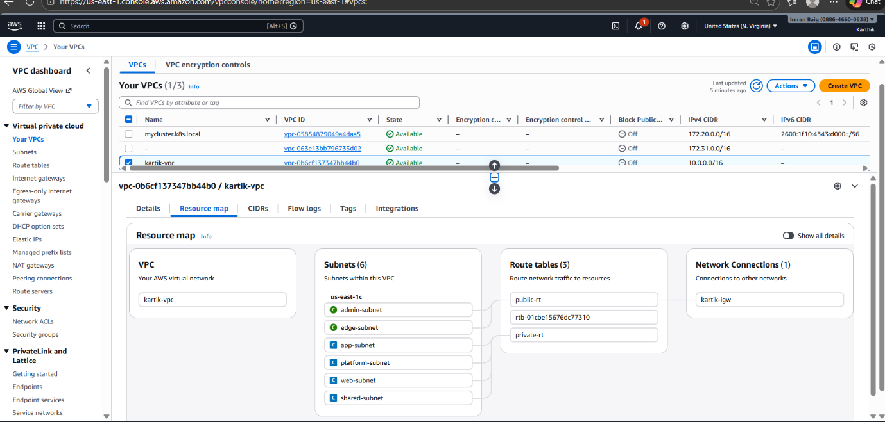

9. Conclusion
This VPC design follows best practices by:
- Separating public and private resources
- Using multiple subnets with unique CIDRs
- Implementing controlled routing via route tables
- Ensuring secure and scalable network architecture

10. Appendix (Optional)
- AWS Console region details
- Naming conventions used
- Future enhancements (NAT Gateway, Security Groups, NACLs)

