**SRM INSTITUTE OF SCIENCE AND TECHNOLOGY**

**SCHOOL OF COMPUTING**

**DEPARTMENT OF SOFTWARE ENGINEERING**

**SUBJECT CODE NAME :18CSE373T / PROGRAMMING IN JAVASCRIPT**

Assignment 2

1. Write a JavaScript program To view the current day and time in the prescribed sequence,

*Sample Output :*

 Today is : Tuesday.  
Current time is : 10 PM : 30 : 38

ANS : - **HTML CODE**

<!DOCTYPE html>

<html>

<head>

<meta charset="utf-8">

<title>JavaScript current day and time</title>

</head>

<body></body>

<script type="text/javascript" src="assig1.js"></script>

</html>

**JavaScript CODE**

var today = new Date();

var day = today.getDay();

var daylist = ["Sunday","Monday","Tuesday","Wednesday ","Thursday","Friday","Saturday"];

document.write(console.log("Today is : " + daylist[day] + "."));

var hour = today.getHours();

var minute = today.getMinutes();

var second = today.getSeconds();

var prepand = (hour >= 12)? " PM ":" AM ";

hour = (hour >= 12)? hour - 12: hour;

if (hour===0 && prepand===' PM ')

{

if (minute===0 && second===0)

{

hour=12;

prepand=' Noon';

}

else

{

hour=12;

prepand=' PM';

}

}

if (hour===0 && prepand===' AM ')

{

if (minute===0 && second===0)

{

hour=12;

prepand=' Midnight';

}

else

{

hour=12;

prepand=' AM';

}

}

document.write(console.log("Current Time : "+hour + prepand + " : " + minute + " : " + second));

**CONSOLE OUTPUT**

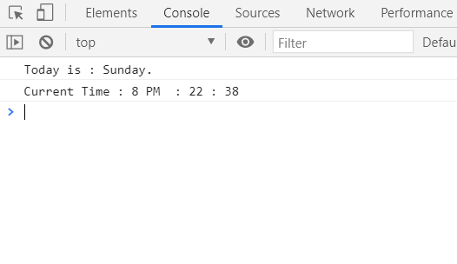

1. Write a programme to measure the multiplication and division of two numbers in JavaScript (input from user).

*Sample form* :  
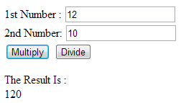

**HTML CODE**

<!DOCTYPE html>

<html>

<head>

<meta charset=utf-8 />

<title>JavaScript program to calculate multiplication and division of two numbers </title>

<style type="text/css">

body {margin: 30px;}

</style>

</head>

<body>

<form>

1st Number : <input type="text" id="firstNumber" /><br>

2nd Number : <input type="text" id="secondNumber" /><br>

<input type="button" onClick="multiplyBy()" Value="Multiply" />

<input type="button" onClick="divideBy()" Value="Divide" />

</form>

<p>The Result is : <br>

<span id = "result"></span>

</p>

</body>

<script type="text/javascript" src="ques2.js"></script>

</html>

**JavaScript CODE**

function multiplyBy(){

num1=document.getElementById("firstNumber").value;

num2=document.getElementById("secondNumber").value;

document.getElementById("result").innerHTML=num1*num2;

}

function divideBy(){

num1=document.getElementById("firstNumber").value;

num2=document.getElementById("secondNumber").value;

document.getElementById("result").innerHTML=num2/num1;

}

**OUTPUT SCREEN**

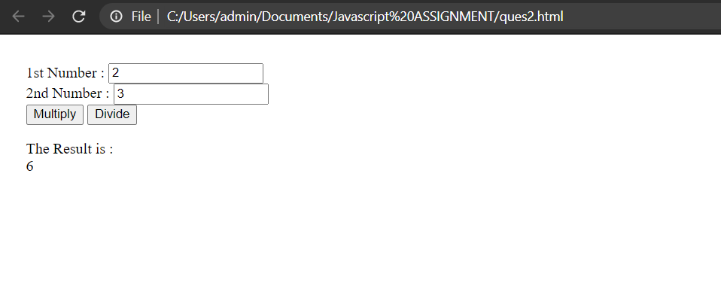

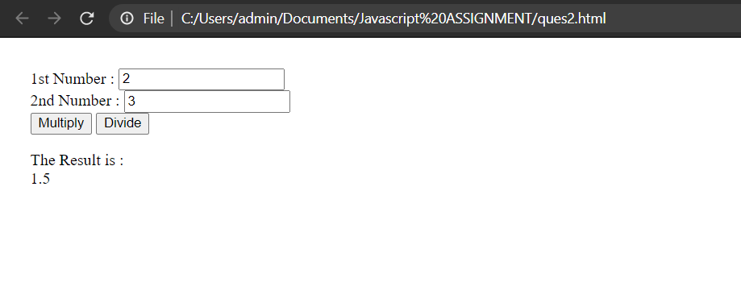

1. Write a programme in JavaScript to delete all characters that occur multiple times from a given string.

Sample output

abcdabc

d

**HTML CODE**

<!DOCTYPE html>

<html>

<head>

<meta charset="utf-8">

<meta name="viewport" content="width=device-width">

<title>Remove all characters from a given string that appear more than once</title>

</head>

<body>

<form>

ENTER STRING : <input type="text" id="kar"> <br>

<input type="button" onclick="remove_duplicate_cchars()" value="OUTPUT">

</form>

<p>The Result is : <br>

<span id = "result"></span>

</p>

</body>

<script type="text/javascript" src="ques3.js"></script>

</html>

**JavaScript CODE**

var b=[];

function remove_duplicate_cchars() {

var v=document.getElementById('kar').value;

var a=[];

for(var i=0;i<v.length;i++)

{

a[i]=v[i];

}

for(var i=0;i<v.length;i++){

var c=0;

for(var j=0;j<v.length;j++){

if(a[i]==a[j]){

c=c+1;

}

}

if(c==1){

b.push(a[i]);

}

}

document.writeln("Output : " + b.join(''));

}

**INPUT SCREEN**

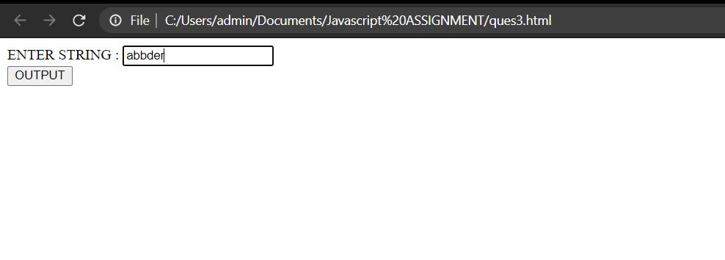

**OUPUT SCREEN**

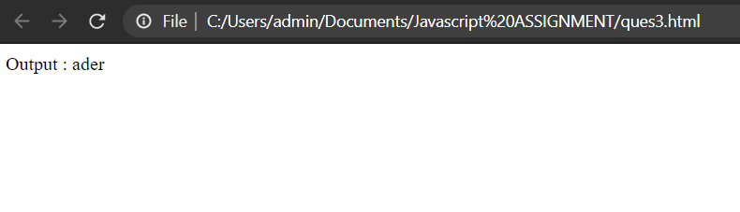

1. Write a JavaScript program to compute the total and multiplication of an array

Sample Output:

123456

Sum 21

Product 720

**HTML CODE**

<!DOCTYPE html>

<html>

<head>

<title></title>

</head>

<body>

<input type="text" id="pb"><br>

<input type="button" name="" onclick="sum()" value="output">

</body>

<script type="text/javascript" src="ques4.js"></script>

</html>

**JavaScript CODE**

function sum(){

var x=document.getElementById('pb').value;

a=[];

for(var i=0;i<x.length;i++)

{

a[i]=parseInt(x[i]);

}

var s;

var m=1;

for(var i=0;i<a.length;i++)

{

s=a.reduce(function(a,b){return a+b;},0);

m=m*a[i];

}

document.writeln("Output <br>")

document.writeln("Sum " + s + "<br>");

document.writeln("Product " + m);

}

**INPUT SCREEN**

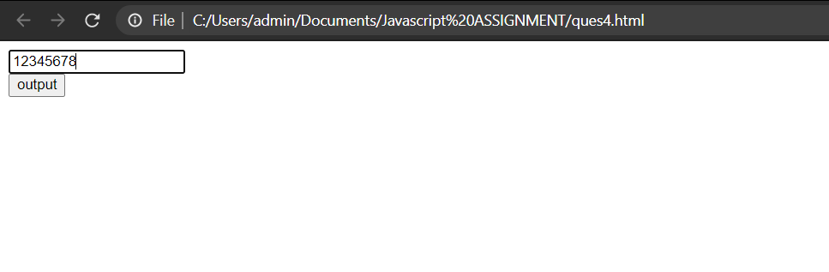

**OUPUT SCREEN**

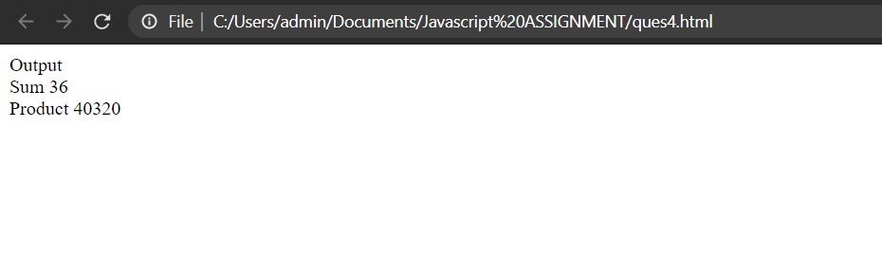

Write a programme in JavaScript that produces a portion of a string using objects.  
*Sample Data:*dog  
*Expected Output:* ["d", "do", "dog", "o", "og", "g"]

**HTML CODE**

<!DOCTYPE html>

<html>

<head>

<title>ques5</title>

</head>

<body>

<input type="text" name="" id="kar"><br>

<input type="button" name="" onclick="serg()" value="Output">

</body>

<script type="text/javascript" src="ques5.js"></script>

</html>

**JavaScript CODE**

function serg() {

a=[];

var f=document.getElementById('kar').value;

document.writeln(f[0]);

for(var i=0;i<f.length;i++){

for(var j=1;j<=f.length-i;j++){

a=f.substr(i,j);

document.writeln(a);

}

}

}

**INPUT SCREEN**

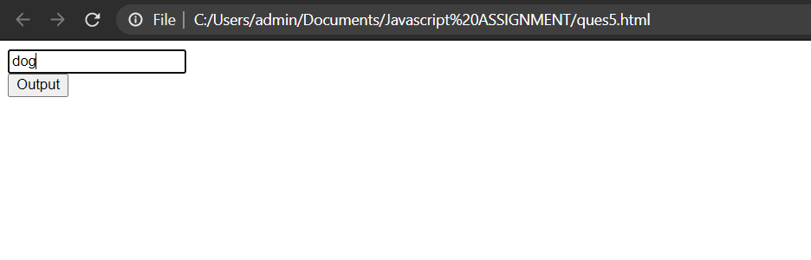

**OUPUT SCREEN**

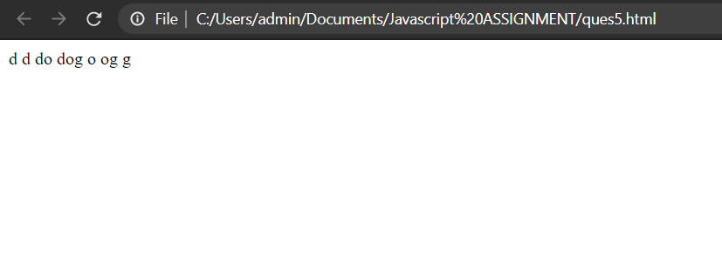

Submitted By :- GROUP 8

Group Members : - Kartik Srivastava(RA1811033010031)

Himanshu Bathla(RA1811033010032)

Varun Singh ( RA1811033010034)