Smart Classroom Interaction System

## Project Description

Smart classroom interaction system will be a system which will provide ways to enhance the way in which the students and faculty interact during and after a presentation based lecture. It will utilize the students' smartphone and the faculty's system (which is being used to deliver the presentation) to automate certain tasks, such as distribution of presentation document, annotations, references, notifications, assignments, etc.

### Features

Following will be the important features to be implemented:

1. **Automatic distribution/synchronisation of presentation documents, annotations and references to the students present during the lecture**
2. **Overview of the previous slides to the student on his smartphone who enters the lecture late**
3. **A very brief overview of the previous lecture on the mobile of the students, at the beginning of the lecture**
4. **Creation of a discussion thread on a forum about a topic being discussed in the class (with least inputs from the users about creating this forum)**
5. Automatic transition of the presentation depending upon the words being spoken by the speaker (faculty)
6. Popups of references (such as a website like wikipedia) if the faculty talks about the topic external to the presentation text
7. Automatic addition of notifications, both to students and the faculty, about an assignment or task being talked about in the class

## Critical Issues

### Authentication

Below are the various stages requiring authentication:

1. Authentication of student mobile device (client) by the host machine and vice versa.
2. Faculty authentication on the host system (server)
3. Authentication of users on the discussion forum

### Privacy and protection of data

Handling of privacy is important here both on the host machine as well as on the mobile device

1. From the student's device (mobile host), no private data from the device will be sent over the network to the server.
2. The student will receive data from the server automatically, however, the app will allow configurations that will prevent automatic synchronization.
3. On the server (system being used for the presentation), the data being fetched from the internet (e.g. for getting references for the current slide) will be displayed only as a small popup during the presentation. This also can be avoided by configuring the server-side application
4. The data from the server, which will be distributed will come from the currently running presentation. The other documents (like related documents, images, etc) will come from a predefined directory and/or set of documents. No other directories will be used as the source by the distributing machine/server.
5. Automatic transition of the presentation will not take place just by one instance of a keyword. The application will analyze a few sentences, or certain short duration of time, spoken by the presenter, before taking the decision.The algorithm to be used, and these decisions are the areas that will need to be addressed in the design phase.
6. The data downloaded on users mobile will be saved on a user-defined location, and can be disposed/moved at a later stage by the user.

### Data transfer

The data transfer will take place from the host system to the students' mobile devices.

* Data transfer will be done by the server application. At the present, we do not feel the need to use FTP for data transfer. The server application can itself split the file into chunks and send to the client, and also send the other data such as annotations and notifications.
* To handle large number of mobile devices (e.g. a class of 300+ students), we will be using broadcast over wifi for common data such as annotations.
* For data to be sent to specific users, we need to work on an algorithm/mechanism to reduce the waiting time for other hosts.
* One possible solution would be a hybrid network, that turns into P2P as soon as there is atleast one user who has completely downloaded the data. Wifi direct can be used to facilitate this.

### Failure handling

Following are the types of failures which may occur, and need to be handled:

1. Mobile device getting disconnected (e.g. wifi turned off) while the synchronization is going on with the host machine
2. Host machine unexpectedly turned off (e.g. power breakdown)
3. Mobile device unexpectedly turned off (e.g. battery discharge)

### Degree of transparency

Following are the various functionalities which will be performed without any kind of user intervention, thus giving an idea about the degree of transparency in the system:

1. When the user enters the classroom/presentation room, the application will automatically discover user's device's presence, and the synchronization will start. This assumes the user has the client app installed, the wifi on the device is turned on and the device gets connected to the classroom's wifi automatically.
2. The presenter/faculty does not have to explicitly issue command (voice or otherwise) for performing transition of the slides while delivering the presentation. The system recognizes when the transition is required.
3. Any assignment or task being discussed in the class is automatically added to the calendar of the clients (student mobile devices)

## Phases:

Following are the phases in which we will work on the project. We would be following iterative development model.

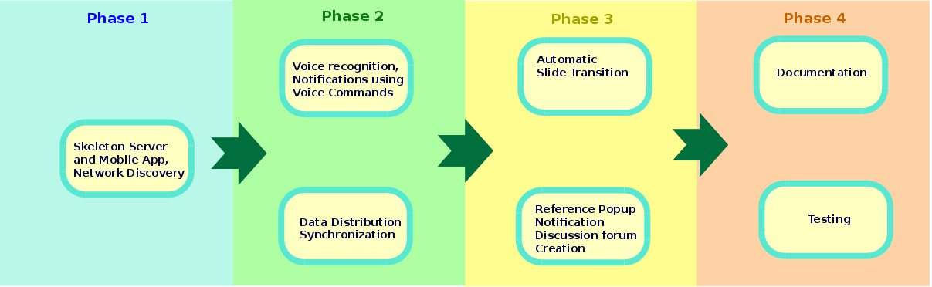

## Division of roles

|  |  |  |
| --- | --- | --- |
| Name | ID | Role |
| Kartik Somani | 2013H103110P | Skeleton Mobile app, Voice recognition and voice commands, Automatic Slide Transition |
| Hrishikesh Chaudhary | 2013H103109P | Network Discovery, Data Distribution, Reference Popup |
| Gaurav Sharma | 2013H103103P | Network Discovery, Synchronization, Discussion forum creation |
| Abhishek Suman | 2013H103096P | Skeleton Serverside application,Voice recognition and voice commands, Automatic Slide Transition |