**BERT**

*“We’re making a significant improvement to how we understand queries, representing the biggest leap forward in the past five years, and one of the biggest leaps forward in the history of Search” -* **Pandu Nayak, Google Fellow and Vice President of Search, on advancements on search using BERT at Google.**

BERT stands for **B**idirectional **E**ncoder **R**epresentations from **T**ransformers. It is designed to pre-train deep bidirectional representations from unlabeled text by jointly conditioning on both left and right context. As a result, the pre-trained BERT model can be fine-tuned with just one additional output layer to create state-of-the-art models for a wide range of NLP tasks.

First, it’s easy to get that BERT stands for **B**idirectional **E**ncoder **R**epresentations from **T**ransformers. Each word here has a meaning. For now, the key takeaway from this line is – **BERT is based on the Transformer architecture.**

Second, BERT is pre-trained on a large corpus of unlabelled text including the entire Wikipedia(that’s 2,500 million words!) and Book Corpus (800 million words).

Third, BERT is a **“deeply bidirectional”** model. Bidirectional means that BERT learns information from both the left and the right side of a token’s context during the training phase.

The bidirectionality of a model is important for truly understanding the meaning of a language. Let’s see an example to illustrate this. There are two sentences in this example and both of them involve the word “bank”:

[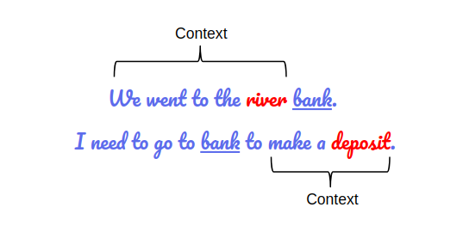](https://cdn.analyticsvidhya.com/wp-content/uploads/2019/09/sent_context.png)

*BERT captures both the left and right context*

If we try to predict the nature of the word “bank” by only taking either the left or the right context, then we will be making an error in at least one of the two given examples.

One way to deal with this is to consider both the left and the right context before making a prediction. That’s exactly what BERT does!

**For understanding BERT we will have to understand Transformer.**

**Transformer** that has been the latest development to handle the sequential data by implementing the below mechanism

* **Non sequential**: Sentences are processed as a whole rather than word by word. As We can see that the architecture of the Transformer is such a way that we can send the inputs simultaneously so It does not suffer from the problem we face in LSTM called long term dependency. **Transformers**do not relies on past hidden states to capture dependencies with previous words, they process a sentence as a whole, reason why there is no risk to loose (or 'forget') past information.
* **Attention Mechanism**: this is the newly introduced 'unit' used to compute similarity scores between words in a sentence. You will get deeper understanding for a beautiful written blog [http://jalammar.github.io/illustrated-transformer/](https://inblog.in/A-gentle-Introduction-to-LSTM-1DydP2G9fP)
* **Positional embeddings**: Position and order of words are the essential parts of any language. They define the grammar and thus the actual semantics of a sentence. Transformer model itself doesn’t have any sense of position/order for each word. Consequently, there’s still the need for a way to incorporate the order of the words into our model.so the positional encoding is way to add the piece of information about the position of the each words

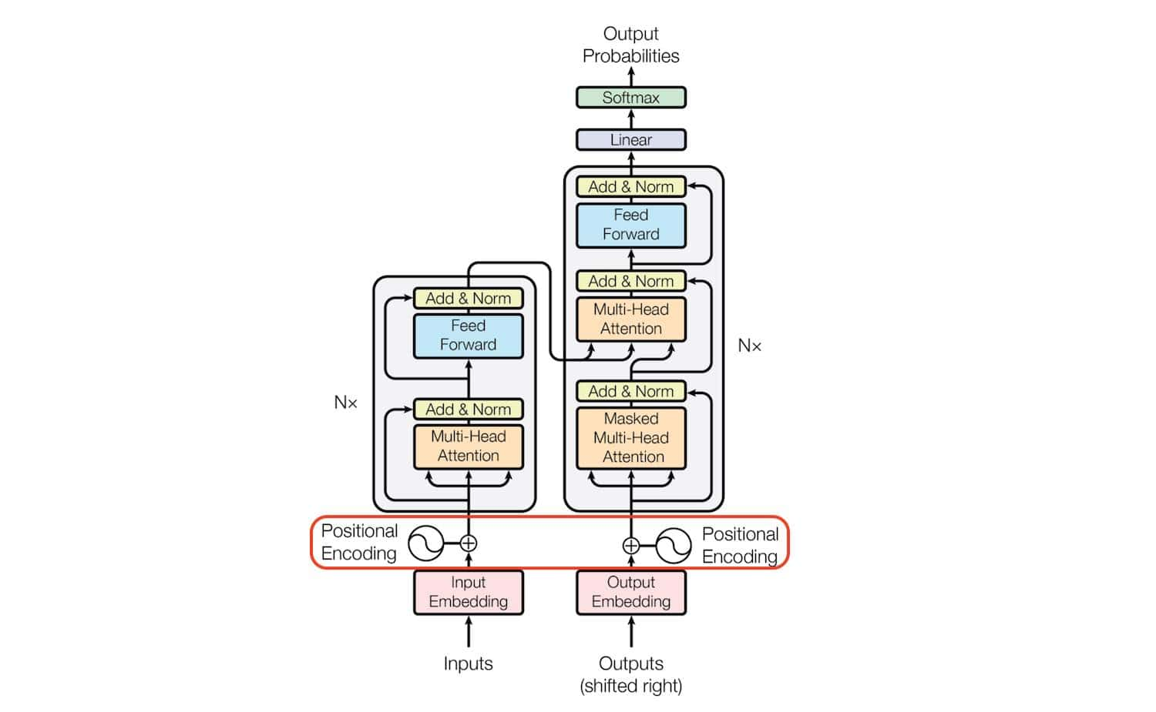

The transformer architecture consists of the stack of six **Encoders** and **Decoders.**

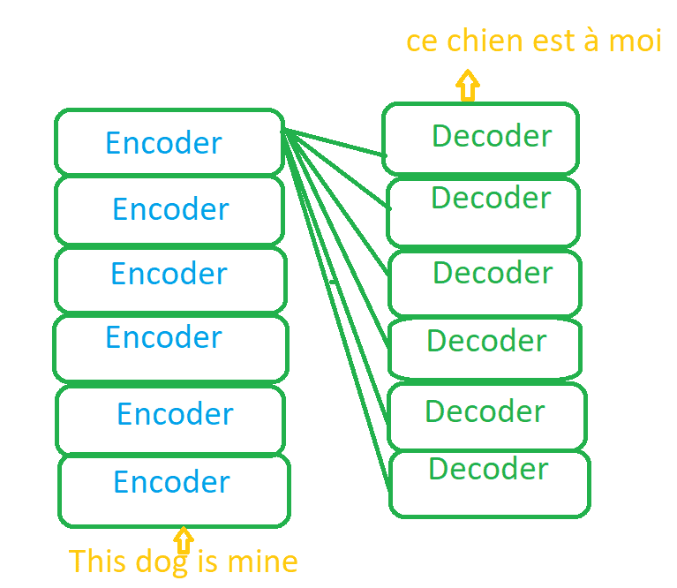

Each encoder consists of Self Attention layer and Feed forward network. The purpose of Encoder is to understand the What is English? and What is context?

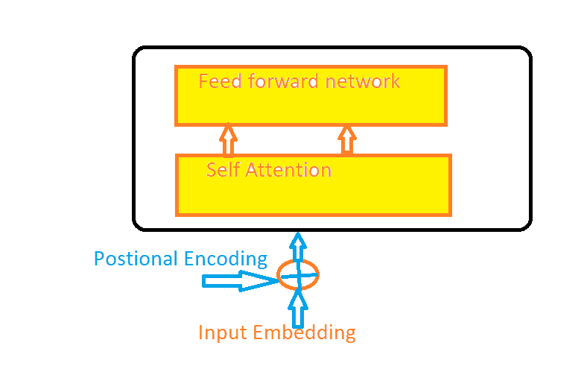

The Purpose of the decoder is Map One langauge with other language. Like How English are mapped in French.

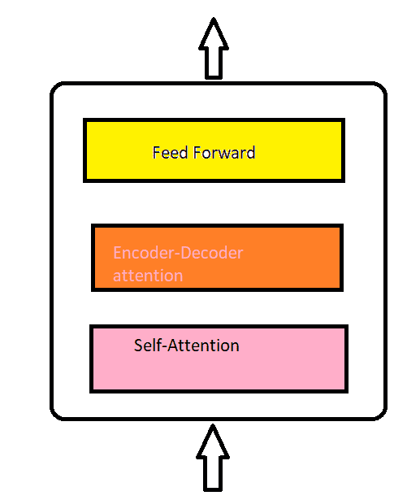

**BERT ARCHITECTURE**

The BERT architecture builds on top of Transformer. We currently have two variants available:

* BERT Base: 12 layers (transformer blocks), 12 attention heads, and 110 million parameters
* BERT Large: 24 layers (transformer blocks), 16 attention heads and, 340 million parameters

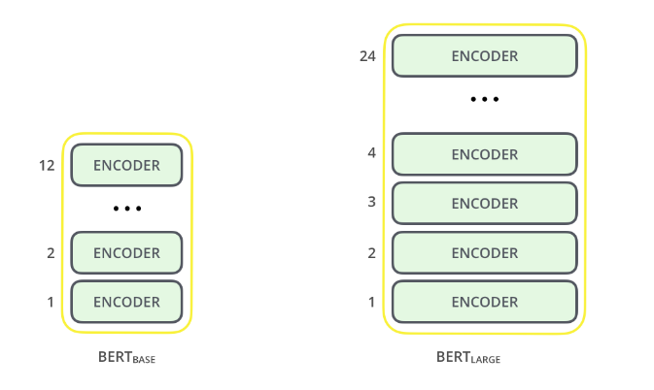

**BERT**use bidirectional transformer (both left-to-right and right-to-left direction) rather than dictional transformer (left-to-right direction).

**Why BERT if we have Transformer?**

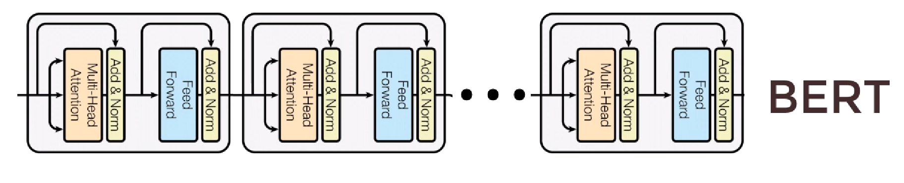

* **T**he Transformer has a language translation lock which means it can only do Machine Translation problems.
* However, BERT can solve multiple types of problems ! Which include :
  + Machine Translation
  + Question Answering
  + Sentiment Analysis
  + Text Summarization
  + Word embedding

**BERT Training**

The training of BERT is done in two phases :

1. Pretrain BERT to understand language – Model understands what is language and context
2. Fine tune BERT to learn specific task – Model knows the language but now learns to solve a problem.

**High level explanation of the two phases :**

1. **Pretraining phase – Understanding of language**

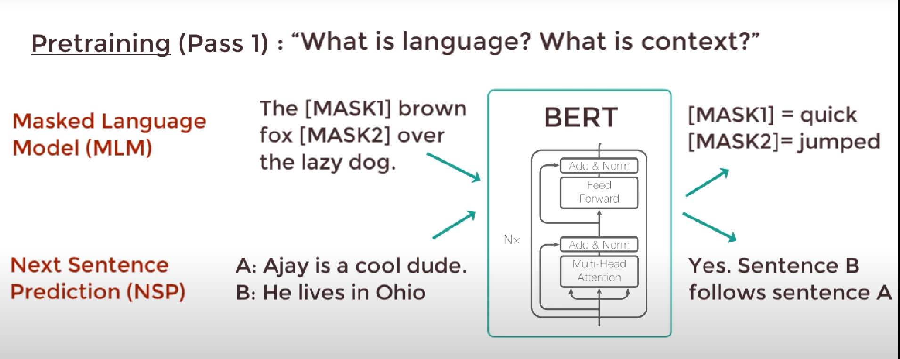

* To understand the language BERT trains on two unsupervised tasks simultaneously:
  + Masked Language Model (MLM) - BERT takes in a sentence with random words filled with “masks”. The goal is to output this masks correctly.
  + Next Sentence Prediction (NSP) - BERT takes in two sentences and it determines if the second sentence actually follows the first. This is a binary classification task. This helps BERT understand context between different sentences themselves.
* Using MLM and NSP BERT gets good understanding of language !

1. **Fine Tuning – Using language for a specific task**

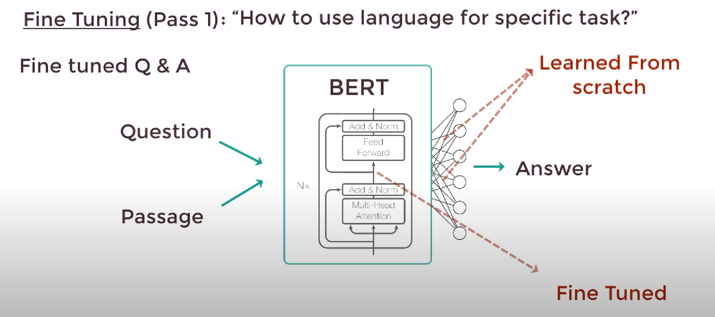

* Lets say we have a question answering task from a given passage.
* We just need to replace the fully connected output layer with a fresh new set of output layers that can output the answer to the question we want. Then we can perform supervised training using a question answering dataset.
* The model won’t take long to train as only the output parameters that are learned from scratch. The rest of the model parameters are fine tuned.
* We can do this with any NLP problem! Not just Q/A task.

**Low level explanation of the two phases :**

1. **Pre-training phase – Understanding of language**

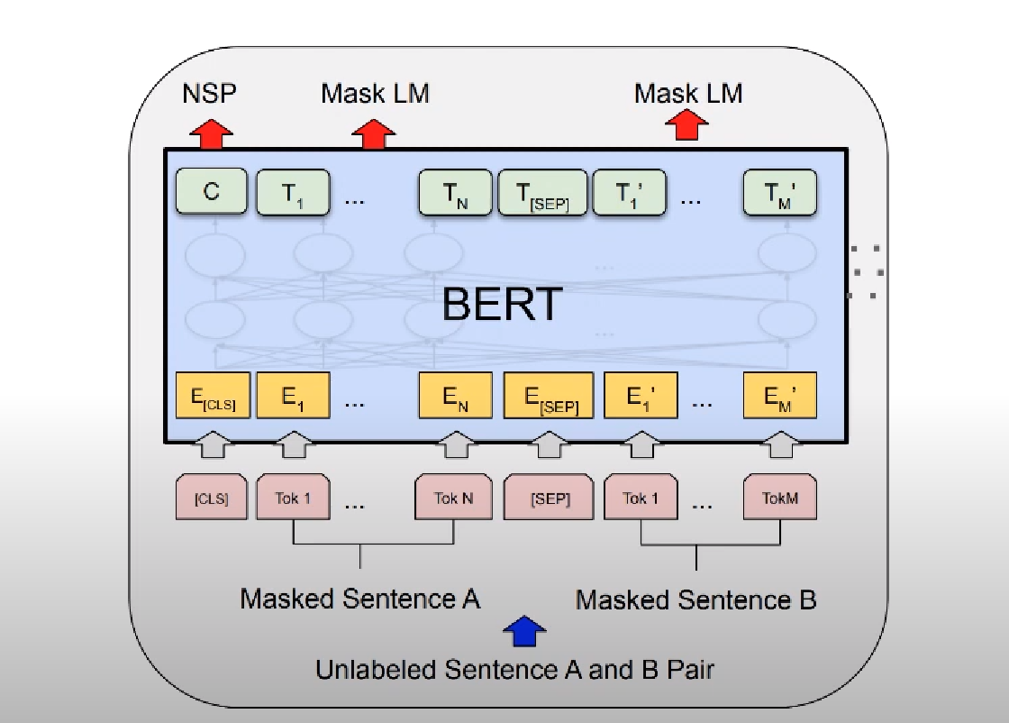

* Masked Language Modelling and Next Sentence Prediction is trained simultaneously.
* C outputs either 1 or 0 depending on if sentence B follows sentence A or not.
* T1.....TN are word vectors that correspond to the output.
* The masked sentence is converted to embeddings using pretrained embeddings. Lets see how the embeddings is done :
* **Inputs to the BERT**

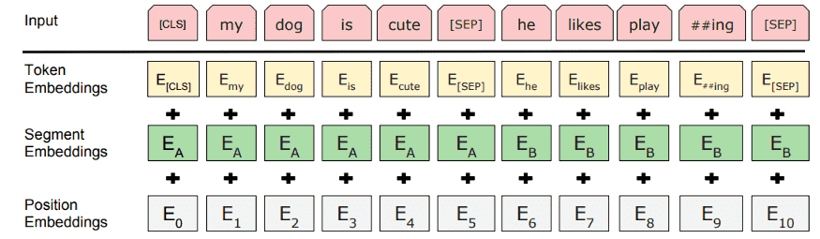

BERT use three embeddings to compute the input representations.

* + **Token Embedding:** Generally it is called Word embedding. The main paper uses “WordPieces” embeddings that have a vocabulary of 30K words. The vectors also encodes the sematic meaning of among the words.
  + **Segment embeddings:**Sentence number that has been encoded into a vector.
  + **Position Embedding:** Position of the words within that sentence.

Adding these three embeddings together we get an embedding vector that we use as input to BERT.

Segment + Position embeddings are required for temporal ordering since all these vectors are fed in simultaneously into BERT. Language models need these ordering preserved.

1. **Fine Tuning – Using language for a specific task**

* **Training the BERT**

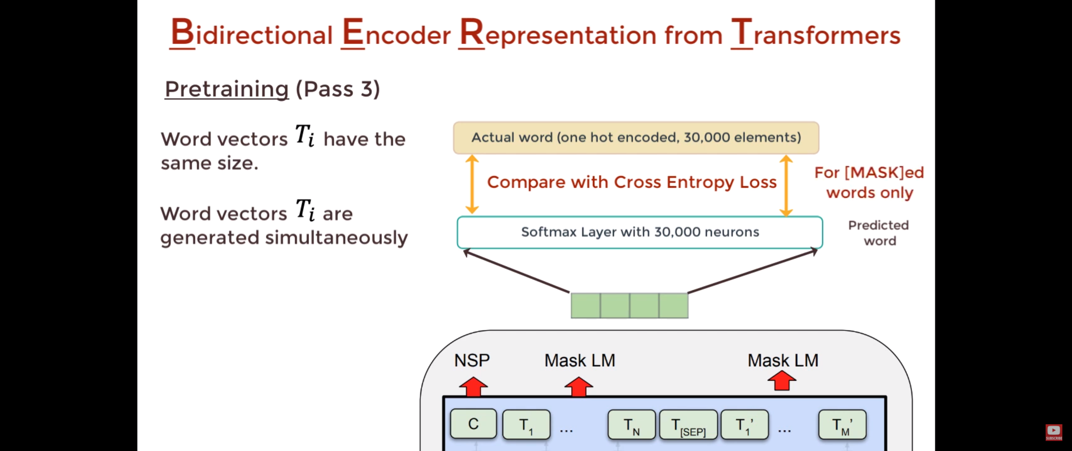

* + Take each output word vector and pass it to fully connected layered output with neurons = tokens of the vocabulary. In that output layer we would apply Softmax activation which will convert word vector to a distribution.
  + We compare the actual distribution with the output distribution and train the network using cross entropy loss.
  + Note that the loss only considers the predictions of the masked words and it ignores all the other words that are output by the network. Therefore, more focus is given in predicting the masked values.
* Our model performance will also depend on how big our BERT is. If we are using BERT large we will get way better performance as it has way more parameters than default BERT :

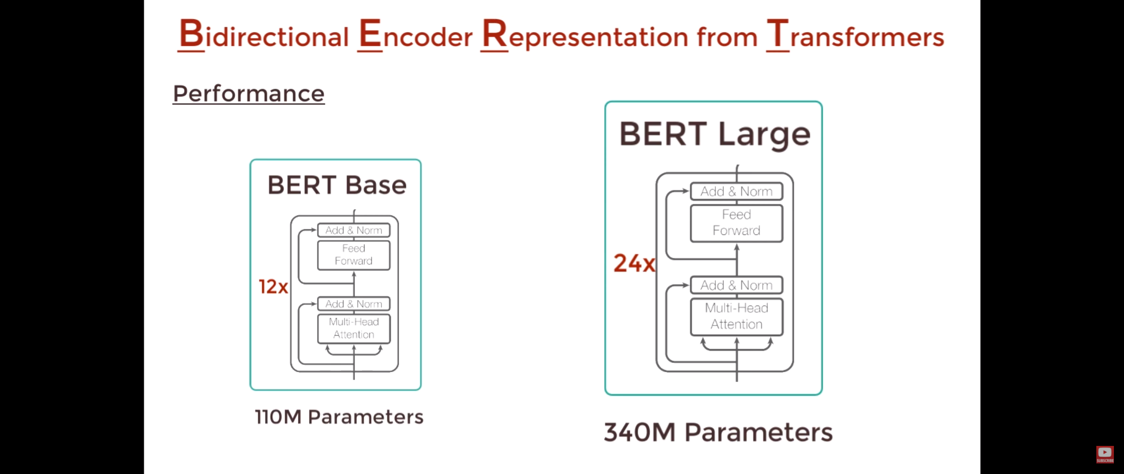

**List of all the pretrained models HuggingFace library provides us :**

|  |  |
| --- | --- |
| bert-base-uncased | 12-layer, 768-hidden, 12-heads, 110M parameters.  Trained on lower-cased English text. |
| bert-large-uncased | 24-layer, 1024-hidden, 16-heads, 336M parameters.  Trained on lower-cased English text. |
| bert-base-cased | 12-layer, 768-hidden, 12-heads, 109M parameters.  Trained on cased English text. |
| bert-large-cased | 24-layer, 1024-hidden, 16-heads, 335M parameters.  Trained on cased English text. |
| bert-base-multilingual-uncased | (Original, not recommended) 12-layer, 768-hidden, 12-heads, 168M parameters.  Trained on lower-cased text in the top 102 languages with the largest Wikipedias  (see [details](https://github.com/google-research/bert/blob/master/multilingual.md)). |
| bert-base-multilingual-cased | (New, **recommended**) 12-layer, 768-hidden, 12-heads, 179M parameters.  Trained on cased text in the top 104 languages with the largest Wikipedias  (see [details](https://github.com/google-research/bert/blob/master/multilingual.md)). |
| bert-base-chinese | 12-layer, 768-hidden, 12-heads, 103M parameters.  Trained on cased Chinese Simplified and Traditional text. |
| bert-base-german-cased | 12-layer, 768-hidden, 12-heads, 110M parameters.  Trained on cased German text by Deepset.ai  (see [details on deepset.ai website](https://deepset.ai/german-bert)). |
| bert-large-uncased-whole-word-masking | 24-layer, 1024-hidden, 16-heads, 336M parameters.  Trained on lower-cased English text using Whole-Word-Masking  (see [details](https://github.com/google-research/bert/#bert)). |
| bert-large-cased-whole-word-masking | 24-layer, 1024-hidden, 16-heads, 335M parameters.  Trained on cased English text using Whole-Word-Masking  (see [details](https://github.com/google-research/bert/#bert)). |
| bert-large-uncased-whole-word-masking-finetuned-squad | 24-layer, 1024-hidden, 16-heads, 336M parameters.  The bert-large-uncased-whole-word-masking model fine-tuned on SQuAD  (see details of fine-tuning in the [example section](https://github.com/huggingface/transformers/tree/master/examples)). |
| bert-large-cased-whole-word-masking-finetuned-squad | 24-layer, 1024-hidden, 16-heads, 335M parameters  The bert-large-cased-whole-word-masking model fine-tuned on SQuAD  (see [details of fine-tuning in the example section](https://huggingface.co/transformers/examples.html)) |
| bert-base-cased-finetuned-mrpc | 12-layer, 768-hidden, 12-heads, 110M parameters.  The bert-base-cased model fine-tuned on MRPC  (see [details of fine-tuning in the example section](https://huggingface.co/transformers/examples.html)) |
| bert-base-german-dbmdz-cased | 12-layer, 768-hidden, 12-heads, 110M parameters.  Trained on cased German text by DBMDZ  (see [details on dbmdz repository](https://github.com/dbmdz/german-bert)). |
| bert-base-german-dbmdz-uncased | 12-layer, 768-hidden, 12-heads, 110M parameters.  Trained on uncased German text by DBMDZ  (see [details on dbmdz repository](https://github.com/dbmdz/german-bert)). |
| cl-tohoku/bert-base-japanese | 12-layer, 768-hidden, 12-heads, 111M parameters.  Trained on Japanese text. Text is tokenized with MeCab and WordPiece and this requires some extra dependencies,  [fugashi](https://github.com/polm/fugashi) which is a wrapper around [MeCab](https://taku910.github.io/mecab/).  Use pip install transformers["ja"] (or pip install -e .["ja"] if you install from source) to install them.  (see [details on cl-tohoku repository](https://github.com/cl-tohoku/bert-japanese)). |
| cl-tohoku/bert-base-japanese-whole-word-masking | 12-layer, 768-hidden, 12-heads, 111M parameters.  Trained on Japanese text. Text is tokenized with MeCab and WordPiece and this requires some extra dependencies,  [fugashi](https://github.com/polm/fugashi) which is a wrapper around [MeCab](https://taku910.github.io/mecab/).  Use pip install transformers["ja"] (or pip install -e .["ja"] if you install from source) to install them.  (see [details on cl-tohoku repository](https://github.com/cl-tohoku/bert-japanese)). |
| cl-tohoku/bert-base-japanese-char | 12-layer, 768-hidden, 12-heads, 90M parameters.  Trained on Japanese text. Text is tokenized into characters.  (see [details on cl-tohoku repository](https://github.com/cl-tohoku/bert-japanese)). |
| cl-tohoku/bert-base-japanese-char-whole-word-masking | 12-layer, 768-hidden, 12-heads, 90M parameters.  Trained on Japanese text using Whole-Word-Masking. Text is tokenized into characters.  (see [details on cl-tohoku repository](https://github.com/cl-tohoku/bert-japanese)). |
| TurkuNLP/bert-base-finnish-cased-v1 | 12-layer, 768-hidden, 12-heads, 125M parameters.  Trained on cased Finnish text.  (see [details on turkunlp.org](http://turkunlp.org/FinBERT/)). |
| TurkuNLP/bert-base-finnish-uncased-v1 | 12-layer, 768-hidden, 12-heads, 110M parameters.  Trained on uncased Finnish text.  (see [details on turkunlp.org](http://turkunlp.org/FinBERT/)). |
| wietsedv/bert-base-dutch-cased | 12-layer, 768-hidden, 12-heads, 110M parameters.  Trained on cased Dutch text.  (see [details on wietsedv repository](https://github.com/wietsedv/bertje/)). |

* There are thousands more community made model too which can be used !
* Here are examples of pretrained models in action on HuggingFace’s official website : <https://huggingface.co/transformers/task_sum3mary.html>

**How Google used BERT to improve their search ! :**

* Reference article : <https://blog.google/products/search/search-language-understanding-bert>
* At Google applying BERT models to both ranking and featured snippets in Search, they are able to do a much better job helping to find useful information.
* They realized particularly for longer, more conversational queries, or searches where prepositions like “for” and “to” matter a lot to the meaning, search were able to understand the context of the words in query entered.
* Here’s a search for “2019 brazil traveler to usa need a visa.” The word “to” and its relationship to the other words in the query are particularly important to understanding the meaning. It’s about a Brazilian traveling to the U.S., and not the other way around.



* Here is another example where BERT has helped Google grasp the subtle nuances of language that computers don’t quite understand the way humans do.

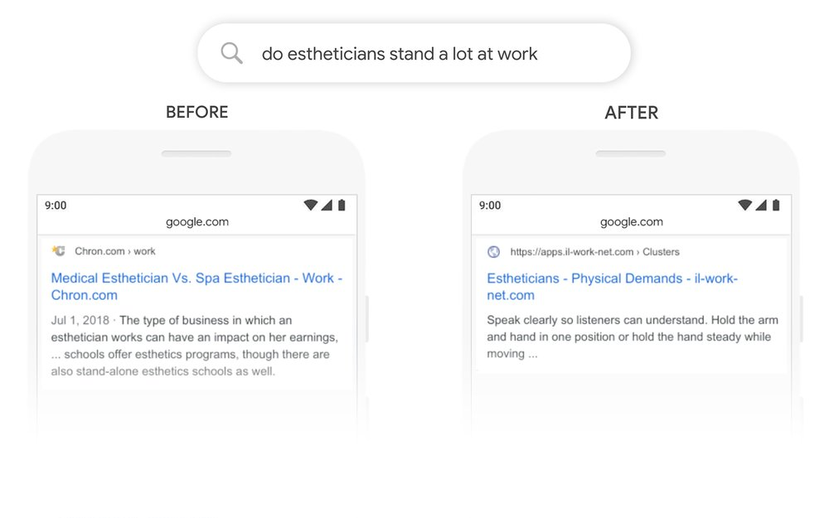

# **Conclusion**

BERT is undoubtedly a breakthrough in the use of Machine Learning for Natural Language Processing. The fact that it’s approachable and allows fast fine-tuning will likely allow a wide range of practical applications. A lot of the AI companies have already started to implement BERT in their NLP tasks.