Session 2025-2026

Vision: Dream of where you want. | Mission: Means to achieve Vision

Program Educational Objectives of the program (PEO): (broad statements that describe the professional and career accomplishments)
PEO1 | Preparation | P: Preparation | Pep-CL abbreviation  pronounce as Pep-si-lL easy to recall
PEO2 | Core Competence | E: Environment (Learning Environment)
PEO3 | Breadth | P: Professionalism
PEO4 | Professionalism | C: Core Competence
PEO5 | Learning Environment | L: Breadth (Learning in diverse areas)

Program Outcomes (PO): (statements that describe what a student should be able to do and know by the end of a program)
Keywords of POs:
Engineering knowledge, Problem analysis, Design/development of solutions, Conduct Investigations of Complex Problems, Engineering Tool Usage, The Engineer and The World, Ethics, Individual and Collaborative Team work, Communication, Project Management and Finance, Life-Long Learning

PSO Keywords: Cutting edge technologies, Research

“I am an engineer, and I know how to apply engineering knowledge to investigate, analyse and design solutions to complex problems using tools for entire world following all ethics in a collaborative way with proper management skills throughout my life.” to contribute to the development of cutting-edge technologies and Research.

Integrity: I will adhere to the Laboratory Code of Conduct and ethics in its entirety.

Name and Signature of Student and Date
(Signature and Date in Handwritten)

Sr. No. | COs | POs |  |  |  |  |  |  |  |  |  |  |  | PSOs
 |  | Course Outcomes | 1 | 2 | 3 | 4 | 5 | 6 | 7 | 8 | 9 | 10 | 11 | PSO 1 | PSO2
1 | CO1 | Demonstrate the ability to execute Linux process management, memory management, and shell commands to manage system resources efficiently. | 3 | 3 | 3 | - |  | - | - | - | - | - | 3 | 3
2 | CO2 | Develop programs utilizing system calls, thread programming, and page replacement algorithms to simulate and analyze operating system functionalities. | 3 | 3 | 3 | - | - | - | - | - | - | - | 3 | 3
3 | CO3 | Design and implement process scheduling, memory allocation, and deadlock detection algorithms to address real-world operating system challenges. | 3 | 3 | 3 | - |  | - | - | - | - | - | 3 | 3
 |  | Avg |  | 3 | 3 | - |  | - | - | - | - | - | 3 | 3

Session | 2025-26 (EVEN) |  | Course Name | Operating Systems Lab
Semester | 4 |  | Course Code | 23CT1402
Roll No | 54 |  | Name of Student | Karan Kumar
Practical Number |  | 4
Course Outcome |  | - Understand Computer System Configuration and Simulate system resources efficiently using Linux Commands (CO1)  - Analyse operating system functionalities utilizing system calls, thread programming and process scheduling algorithms (CO2)  - Apply Synchronization primitives to implement a Deadlock-free solution(CO3)  - Simulate Disk scheduling, Memory allocation, File allocation, page replacement algorithms (CO4)
Aim |  | Aim: Implement Process and thread (Life cycle of process):  1. Process creation and Termination  2. Thread creation and Termination.
Problem Definition |  | Write a C program to Implement process and thread lifecycle
Theory  (100 words) |  | In an operating system, a process is a program in execution and it goes through several stages known as the process life cycle such as new, ready, running, waiting, and terminated. Processes can create other processes using system calls like fork(). The newly created process is called a child process, while the original process is called the parent process. Process termination occurs when a process finishes its execution using exit() or when the parent process waits for the child using wait().  A thread is the smallest unit of CPU execution within a process. Multiple threads can exist inside a single process and share the same memory space. Threads are created using the POSIX thread library (pthread) with functions like pthread_create() and terminated using pthread_exit() or when the thread function finishes execution.
Procedure and Execution  (100 Words) |  | - Open a Linux terminal or development environment.  - Create a C program file using a text editor such as nano, vi, or gedit.  - Write the program for process creation using the fork() system call.  - Use wait() to synchronize the parent and child processes.  - Compile the program using the gcc compiler.  - Execute the program and observe the creation and termination of processes.  - Next, write a program for thread creation using the pthread library.  - Use pthread_create() to create a thread and pthread_join() to wait for the thread to finish.  - Compile the thread program using gcc with the -pthread flag.  - Run the program and observe the thread execution and termination.
Code 1:
#include <stdio.h>
#include <unistd.h>
#include <sys/types.h>
#include <sys/wait.h>

int main() {

pid_t pid;

pid = fork(); // Create a new process

if (pid < 0) {
printf("Process creation failed\n");
}

else if (pid == 0) {
// Child Process
printf("Child Process Executing\n");
printf("Child PID: %d\n", getpid());
printf("Parent PID: %d\n", getppid());

printf("Child Process Terminating\n");
}

else {
// Parent Process
wait(NULL); // Wait for child to finish

printf("Parent Process Executing\n");
printf("Parent PID: %d\n", getpid());

printf("Parent Process Terminating\n");
}

return 0;
}
Code 2:
#include <stdio.h>
#include <pthread.h>

void* threadFunction(void* arg) {

printf("Thread is running\n");

printf("Thread ID: %lu\n", pthread_self());

printf("Thread terminating\n");

pthread_exit(NULL);
}

int main() {

pthread_t thread;

printf("Creating thread...\n");

pthread_create(&thread, NULL, threadFunction, NULL);

pthread_join(thread, NULL);

printf("Thread finished execution\n");

return 0;
}
Output:
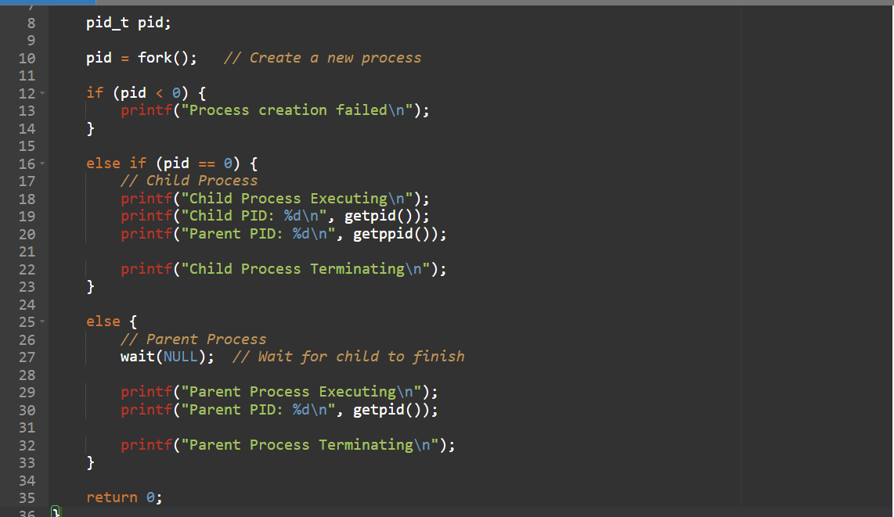
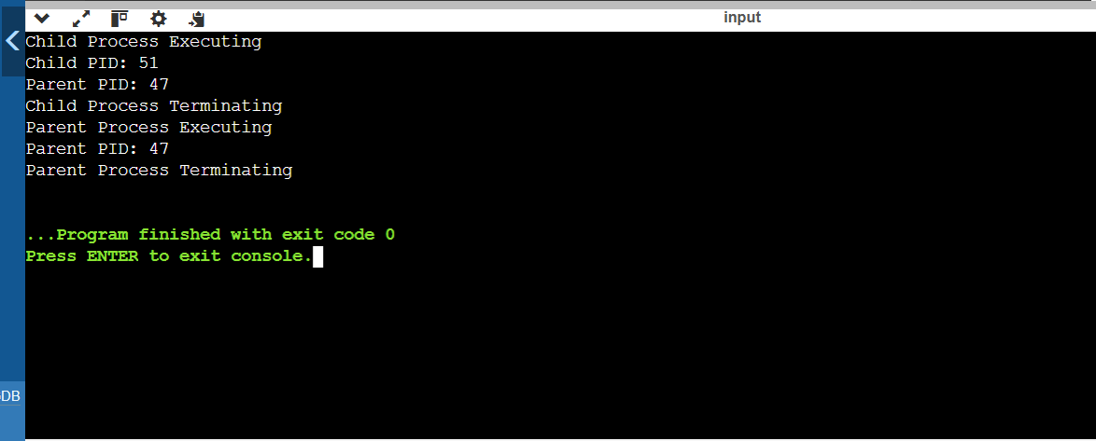
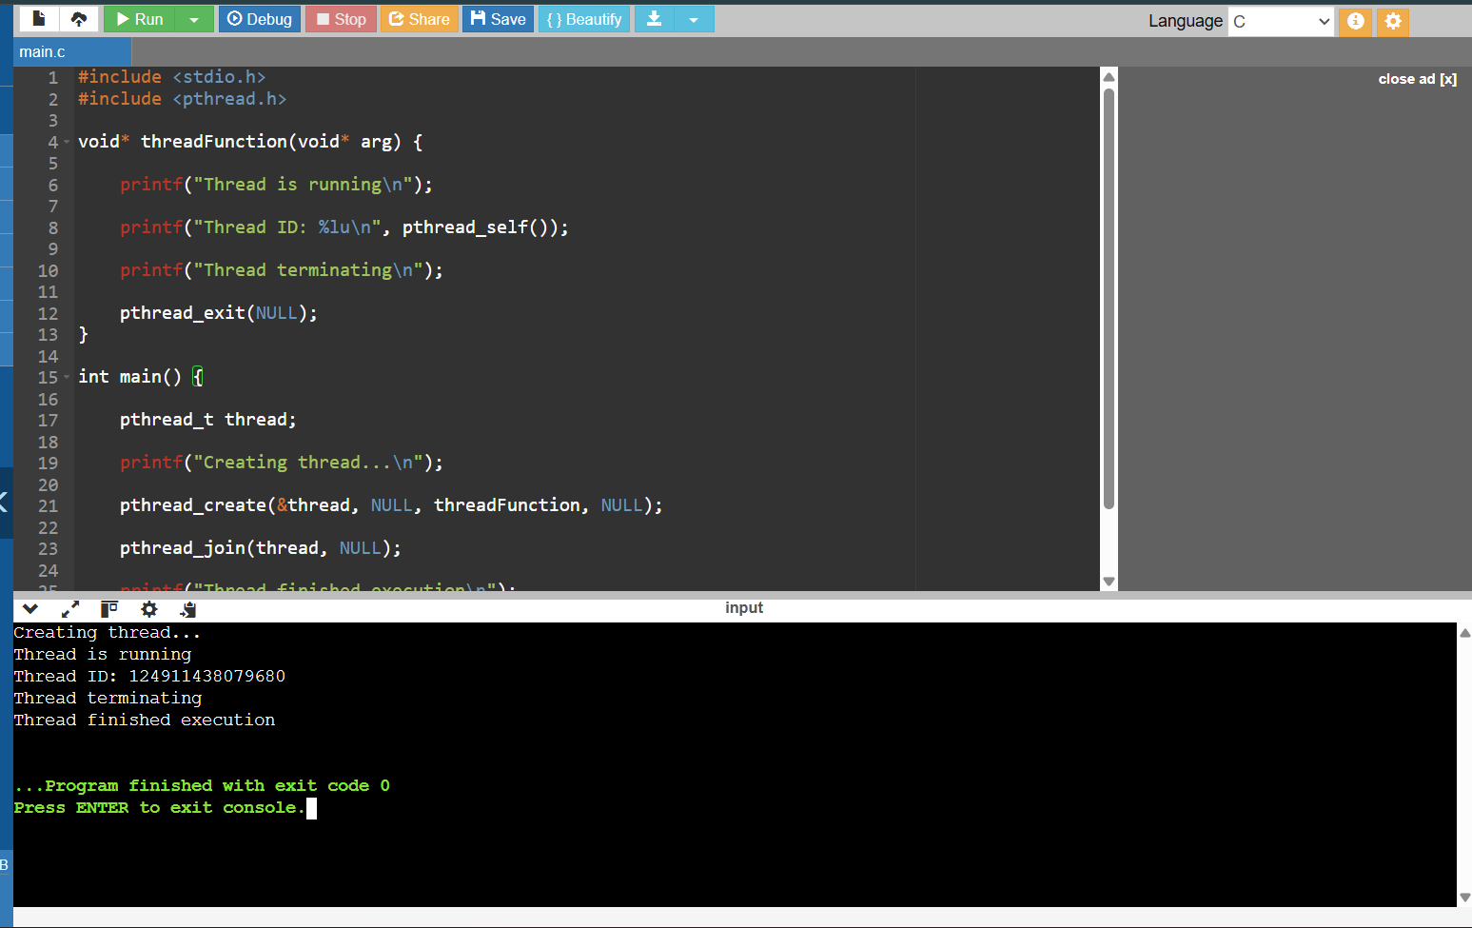

Output Analysis |  | When the program is executed, the operating system first creates the parent process. Using the fork() system call, the parent process creates a child process. After the child process is created, both the parent and child processes run independently. The child process prints its process ID using getpid() and the parent process ID using getppid(). After completing its execution, the child process terminates and the parent process waits for the child using the wait() system call before continuing its execution.  In the thread program, the main program creates a new thread using pthread_create(). The created thread starts executing the specified thread function and prints its thread ID using pthread_self(). Once the thread completes its task, it terminates using pthread_exit(). The main thread waits for the created thread to finish using pthread_join() before the program ends.  Thus, the output confirms the successful creation, execution, and termination of both processes and threads, demonstrating their life cycle in the operating system.
Link of student Github profile where lab assignment has been uploaded |  | https://github.com/karanKumar/OS_Practicals
Conclusion |  | Thus, the experiment was successfully performed to demonstrate the life cycle of processes and threads. The program illustrated how a parent process creates a child process using the fork() system call and how the process terminates after execution. Similarly, thread creation and termination were implemented using the POSIX thread library functions such as pthread_create() and pthread_exit(). This experiment helps in understanding how operating systems manage multiple processes and threads efficiently for concurrent execution.
Plagiarism Report (Similarity index < 12%) |  | 10%
Date |  | 04/02/2026

Requirement (Hardware/Software) :

Theory: Brief Explanation of each of the following parameter of Configuration of Computer System Hardware and Operating System w.r.t,

- Processor model :-

- RAM size :-

- Processor frequency :

- Cache memory size :

- SSD and HDD capacities :

- Operating system (32-bit or 64-bit) :

- Hyper-threading support: Indicate if the processor supports hyper-threading and provide a brief explanation. :-

Configuration of Your system (Desktop, Laptop and Mobile):

OUTPUT (SCREEN SHOT) :

Conclusion:

