Session 2025-2026

Vision: Dream of where you want. | Mission: Means to achieve Vision

Program Educational Objectives of the program (PEO): (broad statements that describe the professional and career accomplishments)
PEO1 | Preparation | P: Preparation | Pep-CL abbreviation  pronounce as Pep-si-lL easy to recall
PEO2 | Core Competence | E: Environment (Learning Environment)
PEO3 | Breadth | P: Professionalism
PEO4 | Professionalism | C: Core Competence
PEO5 | Learning Environment | L: Breadth (Learning in diverse areas)

Program Outcomes (PO): (statements that describe what a student should be able to do and know by the end of a program)
Keywords of POs:
Engineering knowledge, Problem analysis, Design/development of solutions, Conduct Investigations of Complex Problems, Engineering Tool Usage, The Engineer and The World, Ethics, Individual and Collaborative Team work, Communication, Project Management and Finance, Life-Long Learning

PSO Keywords: Cutting edge technologies, Research

“I am an engineer, and I know how to apply engineering knowledge to investigate, analyse and design solutions to complex problems using tools for entire world following all ethics in a collaborative way with proper management skills throughout my life.” to contribute to the development of cutting-edge technologies and Research.

Integrity: I will adhere to the Laboratory Code of Conduct and ethics in its entirety.

Name and Signature of Student and Date
(Signature and Date in Handwritten)

Sr. No. | COs | POs |  |  |  |  |  |  |  |  |  |  |  | PSOs
 |  | Course Outcomes | 1 | 2 | 3 | 4 | 5 | 6 | 7 | 8 | 9 | 10 | 11 | PSO 1 | PSO2
1 | CO1 | Demonstrate the ability to execute Linux process management, memory management, and shell commands to manage system resources efficiently. | 3 | 3 | 3 | - |  | - | - | - | - | - | 3 | 3
2 | CO2 | Develop programs utilizing system calls, thread programming, and page replacement algorithms to simulate and analyze operating system functionalities. | 3 | 3 | 3 | - | - | - | - | - | - | - | 3 | 3
3 | CO3 | Design and implement process scheduling, memory allocation, and deadlock detection algorithms to address real-world operating system challenges. | 3 | 3 | 3 | - |  | - | - | - | - | - | 3 | 3
 |  | Avg |  | 3 | 3 | - |  | - | - | - | - | - | 3 | 3

Session | 2025-26 (EVEN) |  | Course Name | Operating Systems Lab
Semester | 4 |  | Course Code | 23CT1402
Roll No | 55 |  | Name of Student | Kartik Tale
Practical Number
Course Outcome |  | - Understand Computer System Configuration and Simulate system resources efficiently using Linux Commands (CO1)  - Analyse operating system functionalities utilizing system calls, thread programming and process scheduling algorithms (CO2)  - Apply Synchronization primitives to implement a Deadlock-free solution(CO3)  - Simulate Disk scheduling, Memory allocation, File allocation, page replacement algorithms (CO4)
Aim |  | To implement a simulator program for Non-Preemptive CPU Scheduling Algorithms (FCFS and SJF) using Arrival Time and Burst Time with the help of structures in C.
Problem Definition |  | Write a C program to implement FCFS and SJF non-preemptive CPU scheduling algorithms.
Theory  (100 words) |  | CPU scheduling is a mechanism used by the operating system to decide which process should get CPU time. In non-preemptive scheduling, once a process starts executing, it runs until it finishes execution.  First Come First Serve (FCFS) schedules processes according to their arrival time. The process that arrives first is executed first. It is simple but may cause large waiting times.  Shortest Job First (SJF) selects the process with the smallest burst time among the available processes. It minimizes average waiting time but requires knowledge of burst times.  In scheduling algorithms, Arrival Time (AT) indicates when a process enters the ready queue and Burst Time (BT) indicates how long the CPU needs to execute the process.
Procedure and Execution  (100 Words) |  | - Start the system and open a C programming environment.  - Create a C file using a text editor.  - Define a structure to store process details such as process ID, arrival time, burst time, waiting time, and turnaround time.  - Accept the number of processes from the user.  - Input Arrival Time (AT) and Burst Time (BT) for each process.  - Implement FCFS scheduling by sorting processes according to arrival time.  - Implement SJF scheduling by selecting the process with the smallest burst time among available processes.  - Calculate Waiting Time (WT) and Turnaround Time (TAT).  - Compile the program using gcc.  - Execute the program and observe the results.
 |  | Code :
Output:
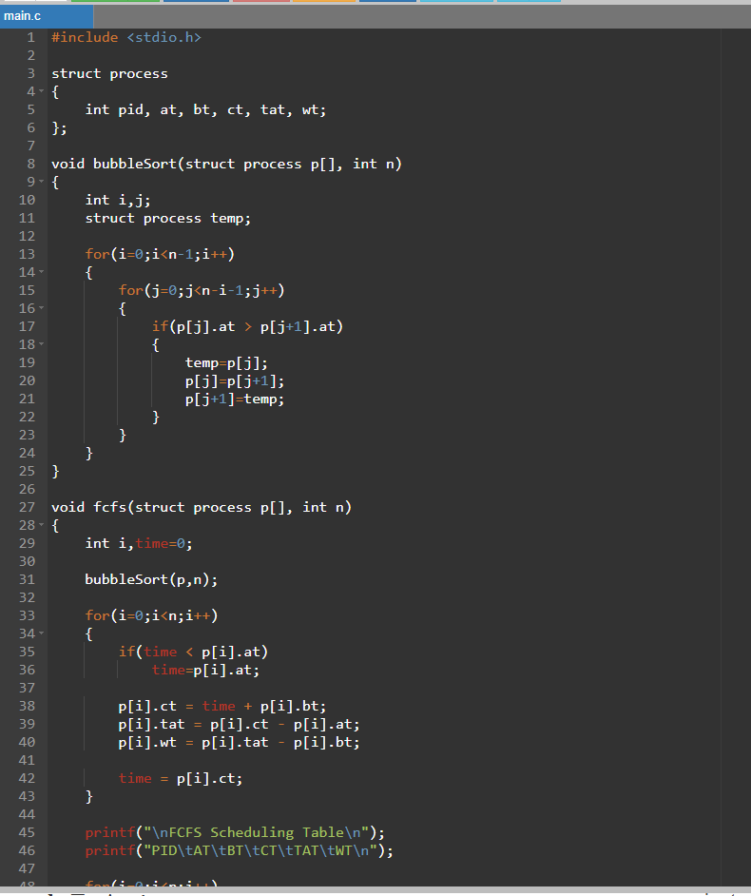
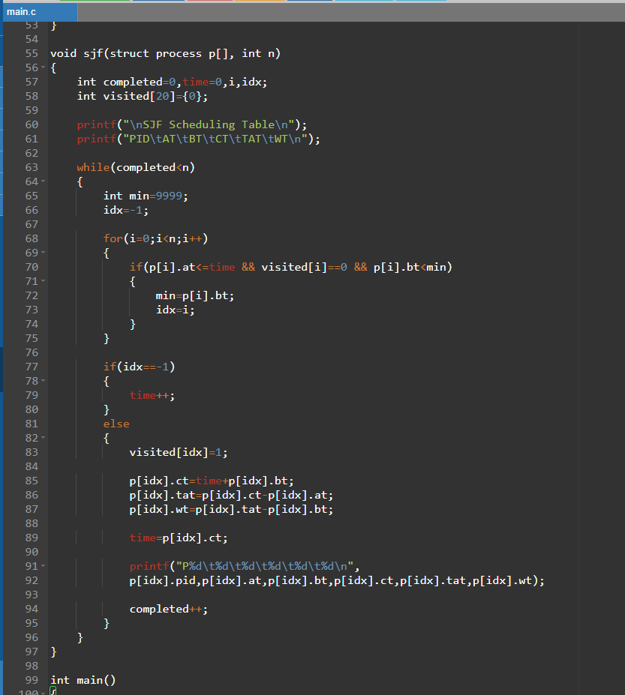
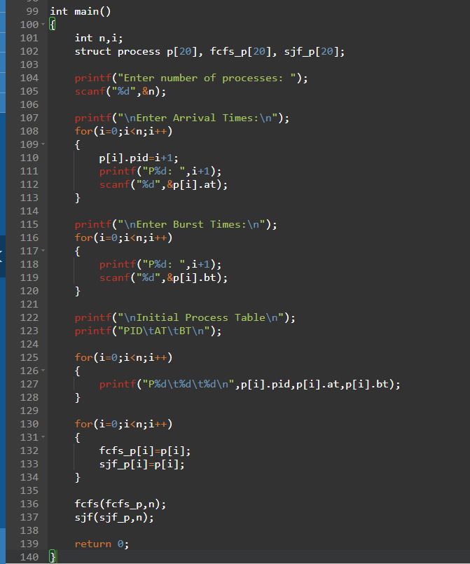
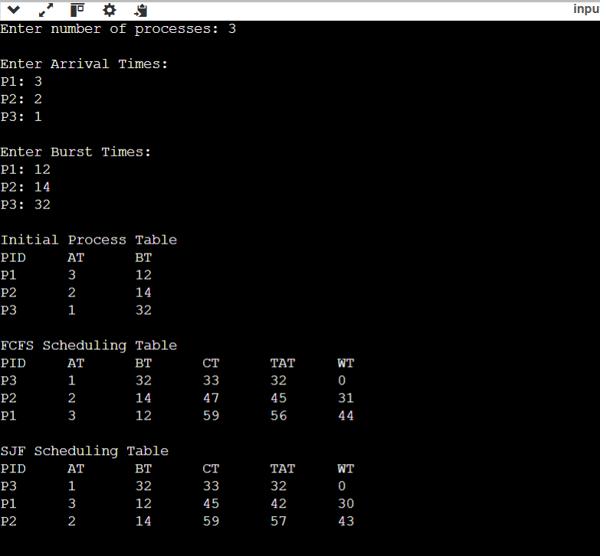
Output Analysis |  | When the program runs, the user enters the Arrival Time and Burst Time for each process.  In FCFS scheduling, processes are executed in the order of arrival. The CPU executes the first arriving process and then continues with the next processes sequentially.  In SJF scheduling, the scheduler selects the process with the shortest burst time among the processes that have already arrived. This helps reduce the average waiting time compared to FCFS.  The program calculates Waiting Time (WT) and Turnaround Time (TAT) for each process and displays the average values.
Link of student Github profile where lab assignment has been uploaded |  | https://github.com/kartiktale12/OS_Practicals
Conclusion |  | Thus, the simulator program for Non-Preemptive CPU Scheduling Algorithms (FCFS and SJF) was successfully implemented using structures in C. The program accepts arrival time and burst time as input and calculates the waiting time and turnaround time for each process. From the results, it can be observed that SJF scheduling generally provides better performance than FCFS in terms of average waiting time, making it more efficient in many cases.
Plagiarism Report (Similarity index < 12%) |  | 10%
Date |  | 04/02/2026

Requirement (Hardware/Software) :

Theory: Brief Explanation of each of the following parameter of Configuration of Computer System Hardware and Operating System w.r.t,

- Processor model :-

- RAM size :-

- Processor frequency :

- Cache memory size :

- SSD and HDD capacities :

- Operating system (32-bit or 64-bit) :

- Hyper-threading support: Indicate if the processor supports hyper-threading and provide a brief explanation. :-

Configuration of Your system (Desktop, Laptop and Mobile):

OUTPUT (SCREEN SHOT) :

Conclusion:

