Session 2025-2026

Vision: Dream of where you want. | Mission: Means to achieve Vision

Program Educational Objectives of the program (PEO): (broad statements that describe the professional and career accomplishments)
PEO1 | Preparation | P: Preparation | Pep-CL abbreviation  pronounce as Pep-si-lL easy to recall
PEO2 | Core Competence | E: Environment (Learning Environment)
PEO3 | Breadth | P: Professionalism
PEO4 | Professionalism | C: Core Competence
PEO5 | Learning Environment | L: Breadth (Learning in diverse areas)

Program Outcomes (PO): (statements that describe what a student should be able to do and know by the end of a program)
Keywords of POs:
Engineering knowledge, Problem analysis, Design/development of solutions, Conduct Investigations of Complex Problems, Engineering Tool Usage, The Engineer and The World, Ethics, Individual and Collaborative Team work, Communication, Project Management and Finance, Life-Long Learning

PSO Keywords: Cutting edge technologies, Research

“I am an engineer, and I know how to apply engineering knowledge to investigate, analyse and design solutions to complex problems using tools for entire world following all ethics in a collaborative way with proper management skills throughout my life.” to contribute to the development of cutting-edge technologies and Research.

Integrity: I will adhere to the Laboratory Code of Conduct and ethics in its entirety.

Name and Signature of Student and Date
(Signature and Date in Handwritten)

Sr. No. | COs | POs |  |  |  |  |  |  |  |  |  |  |  | PSOs
 |  | Course Outcomes | 1 | 2 | 3 | 4 | 5 | 6 | 7 | 8 | 9 | 10 | 11 | PSO 1 | PSO2
1 | CO1 | Demonstrate the ability to execute Linux process management, memory management, and shell commands to manage system resources efficiently. | 3 | 3 | 3 | - |  | - | - | - | - | - | 3 | 3
2 | CO2 | Develop programs utilizing system calls, thread programming, and page replacement algorithms to simulate and analyze operating system functionalities. | 3 | 3 | 3 | - | - | - | - | - | - | - | 3 | 3
3 | CO3 | Design and implement process scheduling, memory allocation, and deadlock detection algorithms to address real-world operating system challenges. | 3 | 3 | 3 | - |  | - | - | - | - | - | 3 | 3
 |  | Avg |  | 3 | 3 | - |  | - | - | - | - | - | 3 | 3

Session | 2025-26 (EVEN) |  | Course Name | Operating Systems Lab
Semester | 4 |  | Course Code | 23CT1402
Roll No | 55 |  | Name of Student | Kartik Tale
Practical Number
Course Outcome |  | - Understand Computer System Configuration and Simulate system resources efficiently using Linux Commands (CO1)  - Analyse operating system functionalities utilizing system calls, thread programming and process scheduling algorithms (CO2)  - Apply Synchronization primitives to implement a Deadlock-free solution(CO3)  - Simulate Disk scheduling, Memory allocation, File allocation, page replacement algorithms (CO4)
Aim |  | To write a simulator program for Pre-emptive CPU Scheduling Algorithms such as Shortest Job First (SJF / SRTF), Priority Scheduling, and Round Robin and calculate Completion Time (CT), Turnaround Time (TAT), and Waiting Time (WT) for each process.
Problem Definition |  | Write a C program to implement the Priority and Round Robin CPU scheduling Algorithm.
Theory  (100 words) |  | CPU scheduling is the process by which the operating system selects a process from the ready queue for execution by the CPU. In pre-emptive scheduling, the CPU can be taken away from a running process if another process with higher priority or shorter remaining time arrives.  Shortest Job First (Pre-emptive), also known as Shortest Remaining Time First (SRTF), always selects the process with the smallest remaining burst time.  Priority Scheduling assigns a priority value to each process, and the CPU is allocated to the process with the highest priority.  Round Robin Scheduling assigns a fixed time slice called time quantum to each process. After the time quantum expires, the process is pre-empted and moved to the end of the ready queue.  These algorithms help improve CPU utilization and system responsiveness.
Procedure and Execution  (100 Words) |  | - Start the system and open a C programming environment or Linux terminal.  - Create a C program file using a text editor.  - Define a structure to store process information such as process ID, arrival time, burst time, priority, completion time, waiting time, and turnaround time.  - Accept the number of processes and input Arrival Time (AT), Burst Time (BT), and Priority.  - Implement the Pre-emptive SJF (Shortest Remaining Time First) algorithm.  - Implement the Pre-emptive Priority Scheduling algorithm.  - Implement the Round Robin Scheduling algorithm using a specified time quantum.  - Calculate Completion Time (CT), Turnaround Time (TAT), and Waiting Time (WT).  - Compile the program using the gcc compiler.  - Execute the program and observe the scheduling results.
Code:
#include <stdio.h>

struct process
{
int pid, at, bt, rt, pr;
int ct, tat, wt;
};

void printTable(struct process p[], int n)
{
int i;
printf("PID\tAT\tBT\tCT\tTAT\tWT\n");

for(i=0;i<n;i++)
{
printf("P%d\t%d\t%d\t%d\t%d\t%d\n",
p[i].pid,p[i].at,p[i].bt,p[i].ct,p[i].tat,p[i].wt);
}
}

void sjf_preemptive(struct process p[], int n)
{
int time=0,completed=0,i,min,idx;

while(completed<n)
{
min=9999;
idx=-1;

for(i=0;i<n;i++)
{
if(p[i].at<=time && p[i].rt>0 && p[i].rt<min)
{
min=p[i].rt;
idx=i;
}
}

if(idx!=-1)
{
p[idx].rt--;
time++;

if(p[idx].rt==0)
{
completed++;
p[idx].ct=time;
p[idx].tat=p[idx].ct-p[idx].at;
p[idx].wt=p[idx].tat-p[idx].bt;
}
}
else
time++;
}

printf("\nPreemptive SJF Scheduling\n");
printTable(p,n);
}

void priority_preemptive(struct process p[], int n)
{
int time=0,completed=0,i,idx,min;

while(completed<n)
{
idx=-1;
min=9999;

for(i=0;i<n;i++)
{
if(p[i].at<=time && p[i].rt>0 && p[i].pr<min)
{
min=p[i].pr;
idx=i;
}
}

if(idx!=-1)
{
p[idx].rt--;
time++;

if(p[idx].rt==0)
{
completed++;
p[idx].ct=time;
p[idx].tat=p[idx].ct-p[idx].at;
p[idx].wt=p[idx].tat-p[idx].bt;
}
}
else
time++;
}

printf("\nPreemptive Priority Scheduling\n");
printTable(p,n);
}

void roundRobin(struct process p[], int n, int tq)
{
int time=0,completed=0,i;
int queue[100],front=0,rear=0;
int visited[20]={0};

queue[rear++]=0;
visited[0]=1;

while(front<rear)
{
i=queue[front++];

if(p[i].rt>tq)
{
time+=tq;
p[i].rt-=tq;
}
else
{
time+=p[i].rt;
p[i].rt=0;
completed++;

p[i].ct=time;
p[i].tat=p[i].ct-p[i].at;
p[i].wt=p[i].tat-p[i].bt;
}

int j;
for(j=0;j<n;j++)
{
if(p[j].at<=time && visited[j]==0)
{
queue[rear++]=j;
visited[j]=1;
}
}

if(p[i].rt>0)
queue[rear++]=i;
}

printf("\nRound Robin Scheduling\n");
printTable(p,n);
}

int main()
{
int n,i,tq;

struct process p[20], temp[20];

printf("Enter number of processes: ");
scanf("%d",&n);

for(i=0;i<n;i++)
{
p[i].pid=i+1;

printf("Enter AT for P%d: ",i+1);
scanf("%d",&p[i].at);

printf("Enter BT for P%d: ",i+1);
scanf("%d",&p[i].bt);

printf("Enter Priority for P%d: ",i+1);
scanf("%d",&p[i].pr);

p[i].rt=p[i].bt;
}

printf("Enter Time Quantum for Round Robin: ");
scanf("%d",&tq);

for(i=0;i<n;i++) temp[i]=p[i];
sjf_preemptive(temp,n);

for(i=0;i<n;i++) {temp[i]=p[i]; temp[i].rt=temp[i].bt;}
priority_preemptive(temp,n);

for(i=0;i<n;i++) {temp[i]=p[i]; temp[i].rt=temp[i].bt;}
roundRobin(temp,n,tq);

return 0;
}
Output:
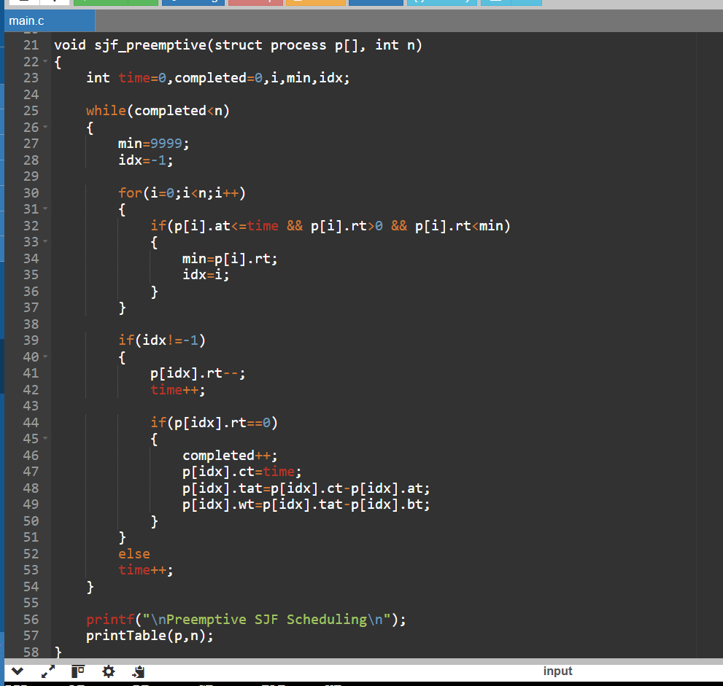
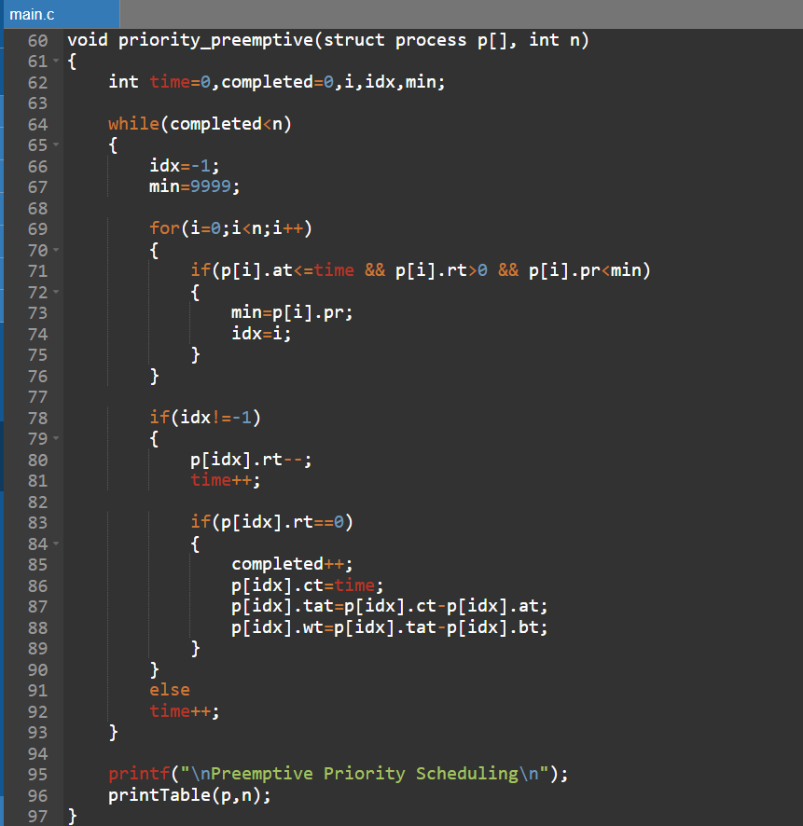
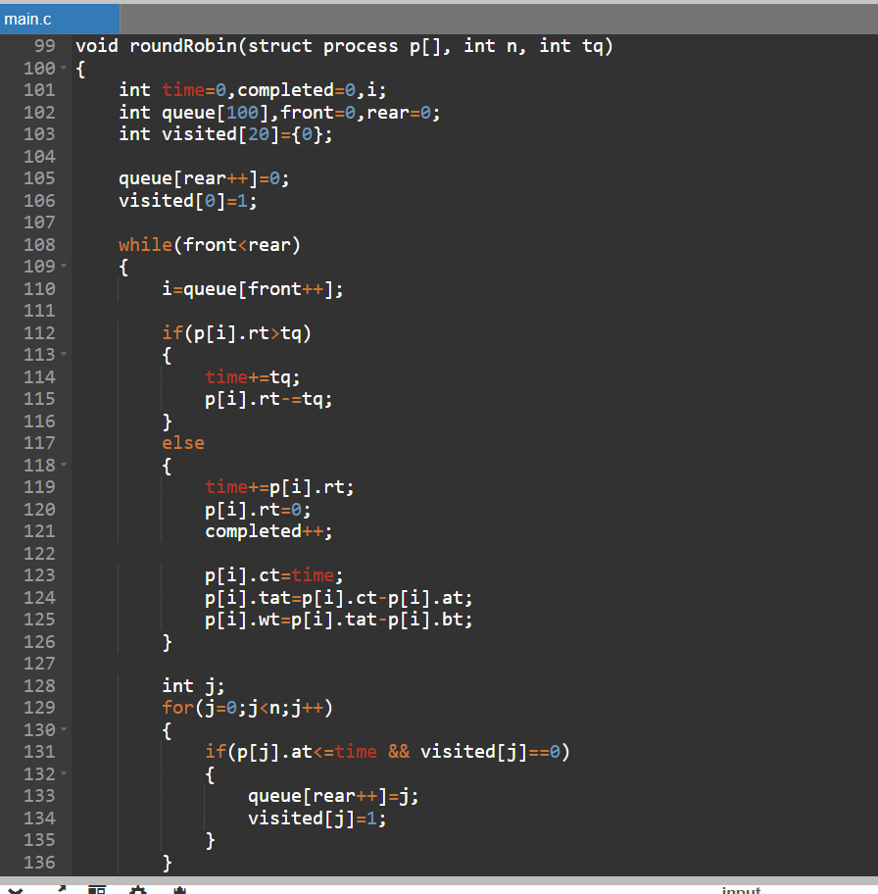
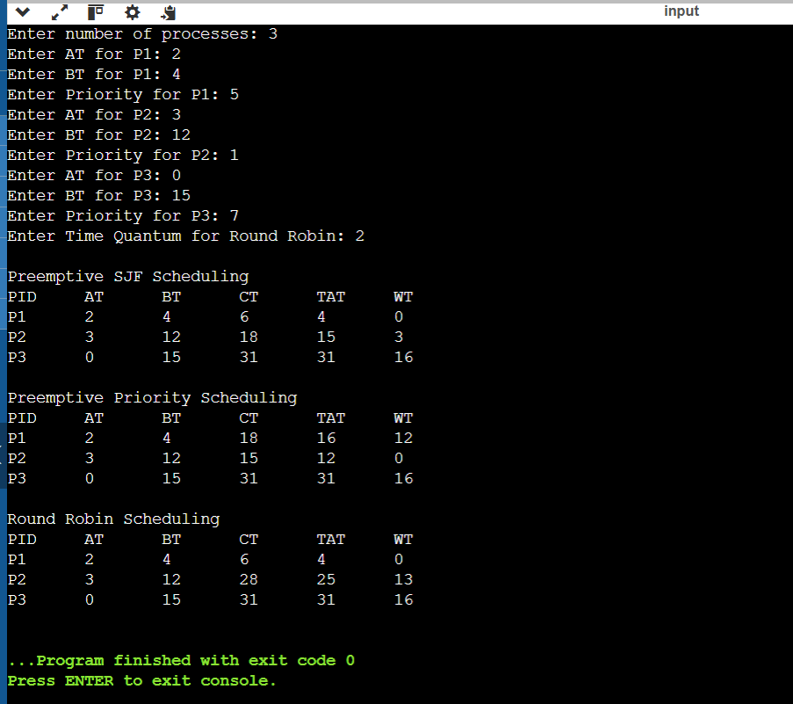

Output Analysis |  | When the program is executed, the user enters the arrival time, burst time, and priority of each process along with the time quantum for Round Robin scheduling.  In Pre-emptive SJF, the CPU always selects the process with the smallest remaining burst time. If a new process arrives with a smaller burst time than the currently running process, the CPU switches to the new process.  In Pre-emptive Priority Scheduling, the CPU executes the process with the highest priority (lowest priority number). If a higher priority process arrives, the current process is pre-empted.  In Round Robin Scheduling, each process gets a fixed time slice called time quantum. If the process does not finish within the quantum, it is moved to the end of the queue.  The program calculates Completion Time (CT), Turnaround Time (TAT), and Waiting Time (WT) for each process and displays them in a table.
Link of student Github profile where lab assignment has been uploaded |  | https://github.com/kartiktale12/OS_Practicals
Conclusion |  | Thus, the simulator program for Pre-emptive CPU Scheduling Algorithms (SJF, Priority, and Round Robin) was successfully implemented. The program demonstrates how processes are scheduled dynamically by the CPU using different scheduling strategies. By calculating completion time, turnaround time, and waiting time, the experiment helps in understanding the performance and behavior of different CPU scheduling algorithms in an operating system.
Plagiarism Report (Similarity index < 12%) |  | 10%
Date |  | 04/02/2026

Requirement (Hardware/Software) :

Theory: Brief Explanation of each of the following parameter of Configuration of Computer System Hardware and Operating System w.r.t,

- Processor model :-

- RAM size :-

- Processor frequency :

- Cache memory size :

- SSD and HDD capacities :

- Operating system (32-bit or 64-bit) :

- Hyper-threading support: Indicate if the processor supports hyper-threading and provide a brief explanation. :-

Configuration of Your system (Desktop, Laptop and Mobile):

OUTPUT (SCREEN SHOT) :

Conclusion:

