Session 2025-2026

Vision: Dream of where you want. | Mission: Means to achieve Vision

Program Educational Objectives of the program (PEO): (broad statements that describe the professional and career accomplishments)
PEO1 | Preparation | P: Preparation | Pep-CL abbreviation  pronounce as Pep-si-lL easy to recall
PEO2 | Core Competence | E: Environment (Learning Environment)
PEO3 | Breadth | P: Professionalism
PEO4 | Professionalism | C: Core Competence
PEO5 | Learning Environment | L: Breadth (Learning in diverse areas)

Program Outcomes (PO): (statements that describe what a student should be able to do and know by the end of a program)
Keywords of POs:
Engineering knowledge, Problem analysis, Design/development of solutions, Conduct Investigations of Complex Problems, Engineering Tool Usage, The Engineer and The World, Ethics, Individual and Collaborative Team work, Communication, Project Management and Finance, Life-Long Learning

PSO Keywords: Cutting edge technologies, Research

“I am an engineer, and I know how to apply engineering knowledge to investigate, analyse and design solutions to complex problems using tools for entire world following all ethics in a collaborative way with proper management skills throughout my life.” to contribute to the development of cutting-edge technologies and Research.

Integrity: I will adhere to the Laboratory Code of Conduct and ethics in its entirety.

Name and Signature of Student and Date
(Signature and Date in Handwritten)

Sr. No. | COs | POs |  |  |  |  |  |  |  |  |  |  |  | PSOs
 |  | Course Outcomes | 1 | 2 | 3 | 4 | 5 | 6 | 7 | 8 | 9 | 10 | 11 | PSO 1 | PSO2
1 | CO1 | Demonstrate the ability to execute Linux process management, memory management, and shell commands to manage system resources efficiently. | 3 | 3 | 3 | - |  | - | - | - | - | - | 3 | 3
2 | CO2 | Develop programs utilizing system calls, thread programming, and page replacement algorithms to simulate and analyze operating system functionalities. | 3 | 3 | 3 | - | - | - | - | - | - | - | 3 | 3
3 | CO3 | Design and implement process scheduling, memory allocation, and deadlock detection algorithms to address real-world operating system challenges. | 3 | 3 | 3 | - |  | - | - | - | - | - | 3 | 3
 |  | Avg |  | 3 | 3 | - |  | - | - | - | - | - | 3 | 3

Session | 2025-26 (EVEN) |  | Course Name | Operating Systems Lab
Semester | 4 |  | Course Code | 23CT1402
Roll No | 55 |  | Name of Student | Kartik Tale
Practical Number |  | 7
Course Outcome |  | - Understand Computer System Configuration and Simulate system resources efficiently using Linux Commands (CO1)  - Analyse operating system functionalities utilizing system calls, thread programming and process scheduling algorithms (CO2)  - Apply Synchronization primitives to implement a Deadlock-free solution(CO3)  - Simulate Disk scheduling, Memory allocation, File allocation, page replacement algorithms (CO4)
Aim |  | To simulate the Banker’s Deadlock Detection Algorithm.
Problem Definition |  | Design a program that implements the Banker’s Algorithm and prints the safe sequence of  processes if the system is in a safe state.
Theory  (100 words) |  | The Banker’s Algorithm is a deadlock avoidance algorithm used in operating systems. It ensures that a system never enters an unsafe state by checking resource allocation before execution.  A system is said to be in a safe state if there exists at least one sequence of processes such that all processes can complete execution without deadlock.  🔹 Key Data Structures  - Available → Available resources  - Max → Maximum demand of each process  - Allocation → Currently allocated resources  - Need → Remaining resources required  🔹 Formula  Need[i][j] = Max[i][j] – Allocation[i][j]
Procedure and Execution  (100 Words) |  | 1. Enter number of processes and resources  2. Input Allocation matrix  3. Input Maximum matrix  4. Input Available resources  5. Calculate Need matrix  6. Initialize Finish[i] = false  7. Find a process where Need ≤ Available  8. If found:  - Allocate resources  - Add Allocation to Available  - Mark process as finished  9. Repeat until all processes finish or no process is found  10. If all Finish = true → Safe State  Otherwise → Deadlock
Code:
#include <stdio.h>

int main() {
int n, m, i, j, k;
int allocation[10][10], max[10][10], need[10][10];
int available[10];
int finish[10] = {0}, safeSeq[10], count = 0;

printf("Enter number of processes: ");
scanf("%d", &n);

printf("Enter number of resources: ");
scanf("%d", &m);

printf("\nEnter Allocation Matrix:\n");
for(i = 0; i < n; i++)
for(j = 0; j < m; j++)
scanf("%d", &allocation[i][j]);

printf("\nEnter Maximum Matrix:\n");
for(i = 0; i < n; i++)
for(j = 0; j < m; j++)
scanf("%d", &max[i][j]);

printf("\nEnter Available Resources:\n");
for(i = 0; i < m; i++)
scanf("%d", &available[i]);

// Calculate Need Matrix
for(i = 0; i < n; i++)
for(j = 0; j < m; j++)
need[i][j] = max[i][j] - allocation[i][j];

// Banker's Algorithm
for(k = 0; k < n; k++) {
for(i = 0; i < n; i++) {
if(finish[i] == 0) {
int flag = 0;

for(j = 0; j < m; j++) {
if(need[i][j] > available[j]) {
flag = 1;
break;
}
}

if(flag == 0) {
safeSeq[count++] = i;

for(j = 0; j < m; j++)
available[j] += allocation[i][j];

finish[i] = 1;
}
}
}
}

int deadlock = 0;
for(i = 0; i < n; i++)
if(finish[i] == 0)
deadlock = 1;

if(deadlock == 1) {
printf("\nDeadlock detected\n");
} else {
printf("\nSystem is in safe state\n");
printf("Safe sequence: ");
for(i = 0; i < n; i++)
printf("P%d ", safeSeq[i]);
}

return 0;
}
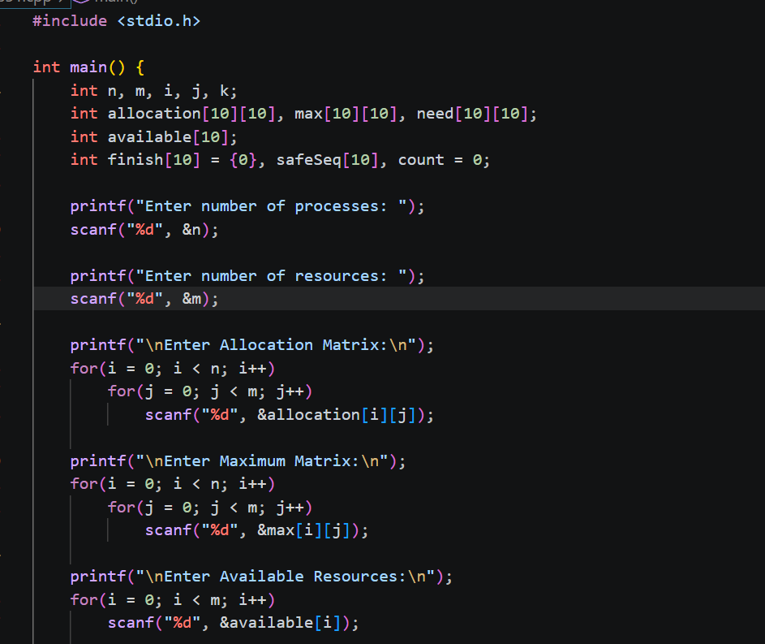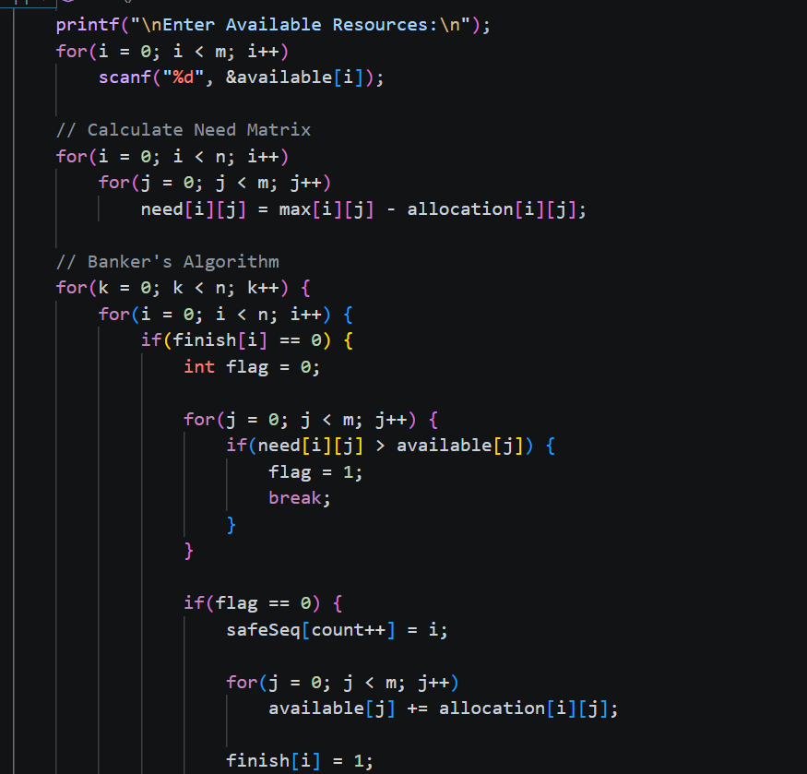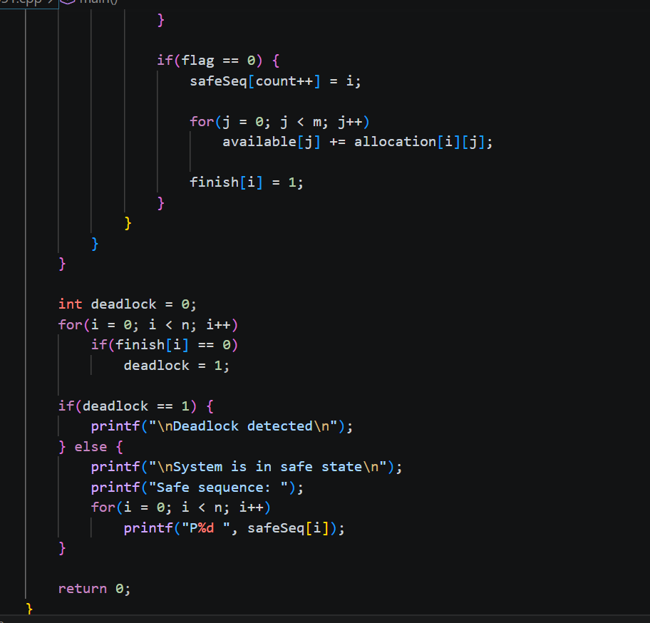

Output:
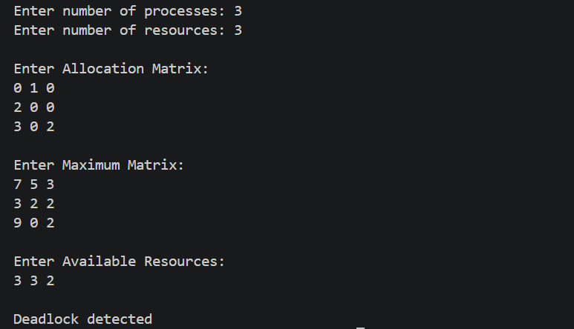

Output Analysis |  | - The algorithm checks each process sequentially  - It ensures that available resources can satisfy process needs  - If satisfied, the process executes and releases resources  - These resources are reused for other processes  - Since all processes completed successfully, the system is in a safe state  - The safe sequence shows the correct execution order
Link of student Github profile where lab assignment has been uploaded |  | https://github.com/kartiktale12/OS_Practicals
Conclusion |  | The Banker’s Algorithm successfully avoids deadlock by checking system safety before resource allocation. The program verifies whether the system is safe and provides a safe sequence. If no sequence exists, it detects deadlock, ensuring reliable resource management in operating systems.
Plagiarism Report (Similarity index < 12%) |  | 11%
Date |  | 01/04/2026

Requirement (Hardware/Software) :

Theory: Brief Explanation of each of the following parameter of Configuration of Computer System Hardware and Operating System w.r.t,

- Processor model :-

- RAM size :-

- Processor frequency :

- Cache memory size :

- SSD and HDD capacities :

- Operating system (32-bit or 64-bit) :

- Hyper-threading support: Indicate if the processor supports hyper-threading and provide a brief explanation. :-

Configuration of Your system (Desktop, Laptop and Mobile):

OUTPUT (SCREEN SHOT) :

Conclusion:

