Session 2025-2026

Vision: Dream of where you want. | Mission: Means to achieve Vision

Program Educational Objectives of the program (PEO): (broad statements that describe the professional and career accomplishments)
PEO1 | Preparation | P: Preparation | Pep-CL abbreviation  pronounce as Pep-si-lL easy to recall
PEO2 | Core Competence | E: Environment (Learning Environment)
PEO3 | Breadth | P: Professionalism
PEO4 | Professionalism | C: Core Competence
PEO5 | Learning Environment | L: Breadth (Learning in diverse areas)

Program Outcomes (PO): (statements that describe what a student should be able to do and know by the end of a program)
Keywords of POs:
Engineering knowledge, Problem analysis, Design/development of solutions, Conduct Investigations of Complex Problems, Engineering Tool Usage, The Engineer and The World, Ethics, Individual and Collaborative Team work, Communication, Project Management and Finance, Life-Long Learning

PSO Keywords: Cutting edge technologies, Research

“I am an engineer, and I know how to apply engineering knowledge to investigate, analyse and design solutions to complex problems using tools for entire world following all ethics in a collaborative way with proper management skills throughout my life.” to contribute to the development of cutting-edge technologies and Research.

Integrity: I will adhere to the Laboratory Code of Conduct and ethics in its entirety.

Name and Signature of Student and Date
(Signature and Date in Handwritten)

Sr. No. | COs | POs |  |  |  |  |  |  |  |  |  |  |  | PSOs
 |  | Course Outcomes | 1 | 2 | 3 | 4 | 5 | 6 | 7 | 8 | 9 | 10 | 11 | PSO 1 | PSO2
1 | CO1 | Demonstrate the ability to execute Linux process management, memory management, and shell commands to manage system resources efficiently. | 3 | 3 | 3 | - |  | - | - | - | - | - | 3 | 3
2 | CO2 | Develop programs utilizing system calls, thread programming, and page replacement algorithms to simulate and analyze operating system functionalities. | 3 | 3 | 3 | - | - | - | - | - | - | - | 3 | 3
3 | CO3 | Design and implement process scheduling, memory allocation, and deadlock detection algorithms to address real-world operating system challenges. | 3 | 3 | 3 | - |  | - | - | - | - | - | 3 | 3
 |  | Avg |  | 3 | 3 | - |  | - | - | - | - | - | 3 | 3

Session | 2025-26 (EVEN) |  | Course Name | Operating Systems Lab
Semester | 4 |  | Course Code | 23CT1402
Roll No | 55 |  | Name of Student | Kartik Tale
Practical Number |  | 8
Course Outcome |  | - Understand Computer System Configuration and Simulate system resources efficiently using Linux Commands (CO1)  - Analyse operating system functionalities utilizing system calls, thread programming and process scheduling algorithms (CO2)  - Apply Synchronization primitives to implement a Deadlock-free solution(CO3)  - Simulate Disk scheduling, Memory allocation, File allocation, page replacement algorithms (CO4)
Aim |  | Simulate the Page Replacement Algorithms (Any Two)  A. First in First Out(FIFO)  B. Least Recently Used (LRU)  C. Optimal
Problem Definition |  | 1. Write a C program to simulate FIFO, LRU, and Optimal Page  Replacement algorithms for the page reference string:  7 0 1 2 0 3 0 4 2 3 0 3 2  with 3 frames.  Calculate total page faults for each algorithm and compare.
Theory  (100 words) |  | In operating systems, paging is used for memory management. When a page fault occurs and no free frame is available, a page replacement algorithm is used to replace an existing page.  🔹 FIFO (First In First Out)  - Oldest page is replaced first  - Implemented using queue  - Simple but may not be efficient  🔹 LRU (Least Recently Used)  - Replaces the page that was not used for the longest time  - Uses past usage to predict future  🔹 Optimal Algorithm (Concept)  - Replaces the page that will not be used for the longest time in future  - Best performance but not practical
Procedure and Execution  (100 Words) |  | - Enter number of pages  - Enter page reference string  - Enter number of frames  - Initialize frames with -1  - Check if page is already present  - If not present → page fault occurs  - Replace page using algorithm logic (FIFO / LRU)  - Display frames after each step  - Count total page faults
Code:
#include <stdio.h>

#define MAX 50

// FIFO Algorithm
void FIFO(int pages[], int n, int f) {
int frames[10], i, j, k = 0, faults = 0, found;

for(i = 0; i < f; i++) frames[i] = -1;

for(i = 0; i < n; i++) {
found = 0;
for(j = 0; j < f; j++) {
if(frames[j] == pages[i]) {
found = 1;
break;
}
}

if(!found) {
frames[k] = pages[i];
k = (k + 1) % f;
faults++;
}
}

printf("FIFO Page Faults = %d\n", faults);
}

// LRU Algorithm
int findLRU(int time[], int f) {
int i, min = time[0], pos = 0;
for(i = 1; i < f; i++) {
if(time[i] < min) {
min = time[i];
pos = i;
}
}
return pos;
}

void LRU(int pages[], int n, int f) {
int frames[10], time[10];
int i, j, faults = 0, counter = 0, found, pos;

for(i = 0; i < f; i++) {
frames[i] = -1;
time[i] = 0;
}

for(i = 0; i < n; i++) {
found = 0;
counter++;

for(j = 0; j < f; j++) {
if(frames[j] == pages[i]) {
found = 1;
time[j] = counter;
break;
}
}

if(!found) {
pos = findLRU(time, f);
frames[pos] = pages[i];
time[pos] = counter;
faults++;
}
}

printf("LRU Page Faults = %d\n", faults);
}

// Optimal Algorithm
void Optimal(int pages[], int n, int f) {
int frames[10], i, j, k, faults = 0, found, farthest, pos;

for(i = 0; i < f; i++) frames[i] = -1;

for(i = 0; i < n; i++) {
found = 0;

for(j = 0; j < f; j++) {
if(frames[j] == pages[i]) {
found = 1;
break;
}
}

if(!found) {
faults++;

for(j = 0; j < f; j++) {
if(frames[j] == -1) {
frames[j] = pages[i];
break;
}
}

if(j == f) {
farthest = -1;
pos = -1;

for(j = 0; j < f; j++) {
int next = -1;

for(k = i + 1; k < n; k++) {
if(frames[j] == pages[k]) {
next = k;
break;
}
}

if(next == -1) {
pos = j;
break;
}

if(next > farthest) {
farthest = next;
pos = j;
}
}

frames[pos] = pages[i];
}
}
}

printf("Optimal Page Faults = %d\n", faults);
}

// Main Function
int main() {
int pages[] = {7,0,1,2,0,3,0,4,2,3,0,3,2};
int n = 13;
int frames = 3;

FIFO(pages, n, frames);
LRU(pages, n, frames);
Optimal(pages, n, frames);

return 0;
}
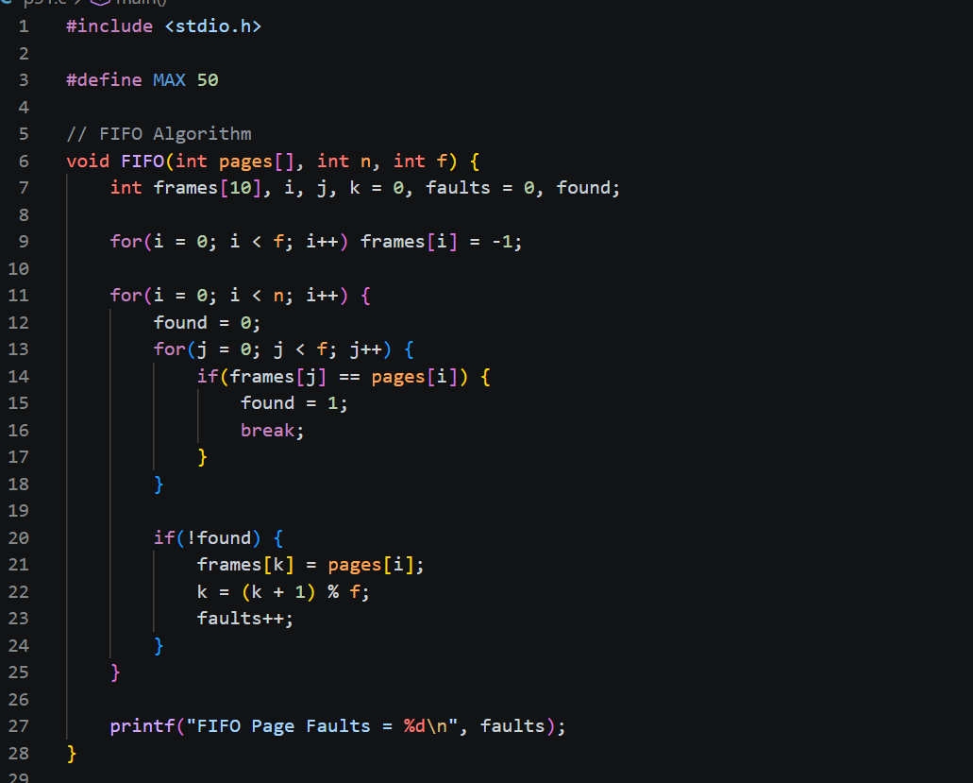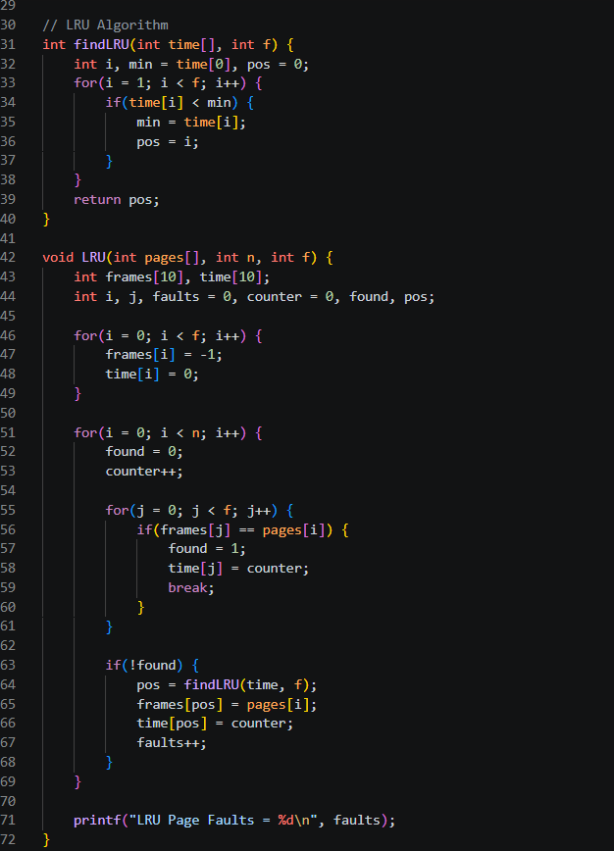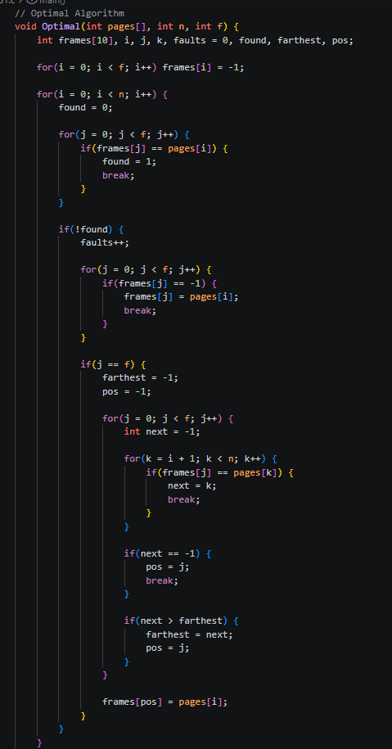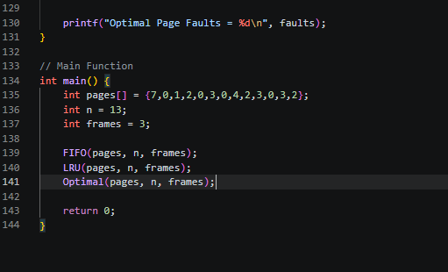

Output:
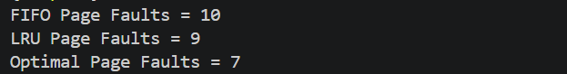

Output Analysis |  | For the given page reference string 7 0 1 2 0 3 0 4 2 3 0 3 2 with 3 frames, different page replacement algorithms produce different numbers of page faults based on their working strategy. The FIFO algorithm replaces the oldest page without considering its future use, resulting in 10 page faults, making it the least efficient. The LRU algorithm replaces the least recently used page, which improves performance and reduces page faults to 9, as it keeps frequently used pages in memory. The Optimal algorithm replaces the page that will not be used for the longest time in the future, giving the minimum page faults of 7, thus being the most efficient. Therefore, the comparison shows that Optimal performs best, followed by LRU, and FIFO performs worst, highlighting the importance of intelligent page replacement strategies in memory management.
Link of student Github profile where lab assignment has been uploaded |  | https://github.com/kartiktale12/OS_Practicals
Conclusion |  | The simulation of FIFO and LRU algorithms demonstrates how page replacement works in operating systems. LRU performs better than FIFO in most cases as it uses past usage patterns. These algorithms help in efficient memory management and reducing page faults.
Plagiarism Report (Similarity index < 12%) |  | 9%
Date |  | 25/03/2026

Requirement (Hardware/Software) :

Theory: Brief Explanation of each of the following parameter of Configuration of Computer System Hardware and Operating System w.r.t,

- Processor model :-

- RAM size :-

- Processor frequency :

- Cache memory size :

- SSD and HDD capacities :

- Operating system (32-bit or 64-bit) :

- Hyper-threading support: Indicate if the processor supports hyper-threading and provide a brief explanation. :-

Configuration of Your system (Desktop, Laptop and Mobile):

OUTPUT (SCREEN SHOT) :

Conclusion:

