Session 2025-2026

Vision: Dream of where you want. | Mission: Means to achieve Vision

Program Educational Objectives of the program (PEO): (broad statements that describe the professional and career accomplishments)
PEO1 | Preparation | P: Preparation | Pep-CL abbreviation  pronounce as Pep-si-lL easy to recall
PEO2 | Core Competence | E: Environment (Learning Environment)
PEO3 | Breadth | P: Professionalism
PEO4 | Professionalism | C: Core Competence
PEO5 | Learning Environment | L: Breadth (Learning in diverse areas)

Program Outcomes (PO): (statements that describe what a student should be able to do and know by the end of a program)
Keywords of POs:
Engineering knowledge, Problem analysis, Design/development of solutions, Conduct Investigations of Complex Problems, Engineering Tool Usage, The Engineer and The World, Ethics, Individual and Collaborative Team work, Communication, Project Management and Finance, Life-Long Learning

PSO Keywords: Cutting edge technologies, Research

“I am an engineer, and I know how to apply engineering knowledge to investigate, analyse and design solutions to complex problems using tools for entire world following all ethics in a collaborative way with proper management skills throughout my life.” to contribute to the development of cutting-edge technologies and Research.

Integrity: I will adhere to the Laboratory Code of Conduct and ethics in its entirety.

Name and Signature of Student and Date
(Signature and Date in Handwritten)

Sr. No. | COs | POs |  |  |  |  |  |  |  |  |  |  |  | PSOs
 |  | Course Outcomes | 1 | 2 | 3 | 4 | 5 | 6 | 7 | 8 | 9 | 10 | 11 | PSO 1 | PSO2
1 | CO1 | Demonstrate the ability to execute Linux process management, memory management, and shell commands to manage system resources efficiently. | 3 | 3 | 3 | - |  | - | - | - | - | - | 3 | 3
2 | CO2 | Develop programs utilizing system calls, thread programming, and page replacement algorithms to simulate and analyze operating system functionalities. | 3 | 3 | 3 | - | - | - | - | - | - | - | 3 | 3
3 | CO3 | Design and implement process scheduling, memory allocation, and deadlock detection algorithms to address real-world operating system challenges. | 3 | 3 | 3 | - |  | - | - | - | - | - | 3 | 3
 |  | Avg |  | 3 | 3 | - |  | - | - | - | - | - | 3 | 3

Session | 2025-26 (EVEN) |  | Course Name | Operating Systems Lab
Semester | 4 |  | Course Code | 23CT1402
Roll No | 55 |  | Name of Student | Kartik Tale
Practical Number |  | 9
Course Outcome |  | - Understand Computer System Configuration and Simulate system resources efficiently using Linux Commands (CO1)  - Analyse operating system functionalities utilizing system calls, thread programming and process scheduling algorithms (CO2)  - Apply Synchronization primitives to implement a Deadlock-free solution(CO3)  - Simulate Disk scheduling, Memory allocation, File allocation, page replacement algorithms (CO4)
Aim |  | Implement a program to simulate disk scheduling algorithms.  A. FCFS/SCAN  B. SSTF/LOOK
Problem Definition |  | Write a C program to simulate the disk scheduling algorithms FCFS (First Come First Serve) and SSTF (Shortest Seek Time First). The program should accept a sequence of disk requests and the initial head position as input. It must service the requests using both algorithms, display the seek sequence (order of execution) for each, and calculate the total head movement. Finally, the program should compare the performance of both algorithms based on the total head movement.
Theory  (100 words) |  | Disk scheduling algorithms are used in operating systems to decide the order in which disk I/O requests are serviced. Since multiple processes may request disk access at the same time, efficient scheduling is required to reduce seek time, improve performance, and increase system throughput. The movement of the disk arm from one track to another is called seek time, and minimizing this movement is the main goal of disk scheduling.  The First Come First Serve (FCFS) algorithm is the simplest disk scheduling method. It processes requests in the order they arrive in the queue. Although it is easy to implement and ensures fairness, it may result in large head movements, leading to poor performance and increased seek time.  The Shortest Seek Time First (SSTF) algorithm improves upon FCFS by selecting the request that is closest to the current head position. This reduces the total head movement and improves efficiency. However, SSTF may cause starvation, as some requests that are far away from the current head position may be delayed indefinitely.  Thus, disk scheduling algorithms play a crucial role in optimizing disk performance, and SSTF generally provides better results than FCFS in terms of reducing seek time and improving overall efficiency.
Procedure and Execution  (100 Words) |  | - Start the program  - Input the number of disk requests  - Enter the disk request sequence  - Input the initial head position  🔹 For FCFS Algorithm  - Initialize total head movement = 0  - Move the disk head in the order of given requests  - Calculate movement using:  |current position – next request|  - Add movement to total head movement  - Display the seek sequence  - Display total head movement  🔹 For SSTF Algorithm  - Mark all requests as unvisited  - From current head position, find the nearest request  - Move head to that request  - Calculate and add seek time  - Mark that request as visited  - Repeat until all requests are serviced  - Display the seek sequence  - Display total head movement  - Compare results of both algorithms  - Stop the program
Code:
#include <stdio.h>
#include <stdlib.h>

// -------- FCFS Function --------
void FCFS(int req[], int n, int head) {
int total = 0;

printf("\n--- FCFS Disk Scheduling ---\n");
printf("Seek Sequence: %d", head);

for(int i = 0; i < n; i++) {
total += abs(head - req[i]);
head = req[i];
printf(" -> %d", head);
}

printf("\nTotal Head Movement (FCFS) = %d\n", total);
}

// -------- SSTF Function --------
void SSTF(int req[], int n, int head) {
int total = 0;
int visited[n];

for(int i = 0; i < n; i++)
visited[i] = 0;

printf("\n--- SSTF Disk Scheduling ---\n");
printf("Seek Sequence: %d", head);

for(int i = 0; i < n; i++) {
int minDist = 99999, index = -1;

for(int j = 0; j < n; j++) {
if(!visited[j]) {
int dist = abs(head - req[j]);
if(dist < minDist) {
minDist = dist;
index = j;
}
}
}

visited[index] = 1;
total += minDist;
head = req[index];

printf(" -> %d", head);
}

printf("\nTotal Head Movement (SSTF) = %d\n", total);
}

// -------- Main Function --------
int main() {
int n, head;

printf("Enter number of disk requests: ");
scanf("%d", &n);

int req[n];

printf("Enter disk request sequence:\n");
for(int i = 0; i < n; i++) {
scanf("%d", &req[i]);
}

printf("Enter initial head position: ");
scanf("%d", &head);

// Call both algorithms
FCFS(req, n, head);
SSTF(req, n, head);

return 0;
}
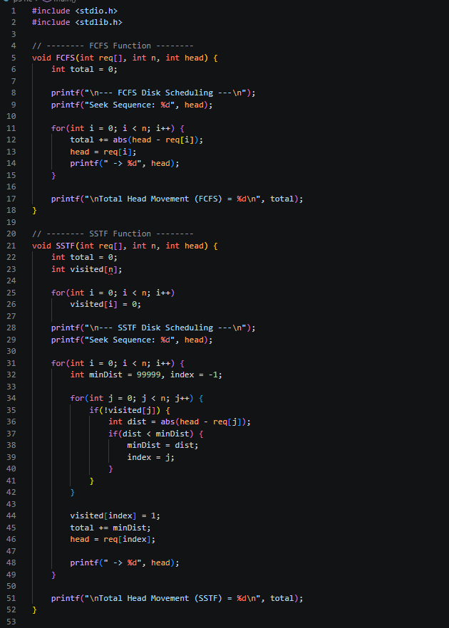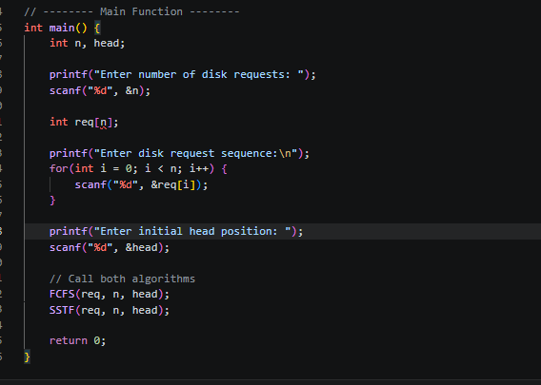

Output:
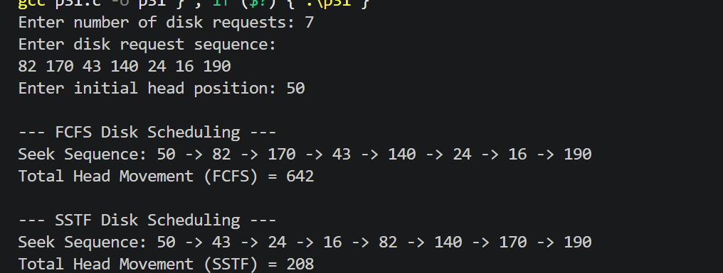
Output Analysis |  | For the given disk request sequence 82, 170, 43, 140, 24, 16, 190 with an initial head position of 50, the FCFS algorithm services requests in the order they arrive, resulting in a total head movement of 642. This large movement occurs because FCFS does not consider the distance between consecutive requests, leading to inefficient disk arm movement. In contrast, the SSTF algorithm selects the request closest to the current head position at each step, significantly reducing unnecessary movement and resulting in a total head movement of 208. Thus, SSTF performs much better than FCFS in terms of minimizing seek time and improving efficiency. However, SSTF may cause starvation for requests that are far from the current head position. Overall, SSTF is more efficient than FCFS for disk scheduling.
Link of student Github profile where lab assignment has been uploaded |  | https://github.com/kartiktale12/OS_Practicals
Conclusion |  | The simulation of FCFS and SSTF disk scheduling algorithms shows that the choice of algorithm significantly affects disk performance. FCFS is simple and fair but results in higher head movement and increased seek time. SSTF improves efficiency by selecting the nearest request, thereby reducing total head movement and improving system performance. However, SSTF may lead to starvation of some requests. Therefore, while FCFS is easy to implement, SSTF is generally preferred for better performance in disk scheduling.
Plagiarism Report (Similarity index < 12%) |  | 10%
Date |  | 01/04/2026

Requirement (Hardware/Software) :

Theory: Brief Explanation of each of the following parameter of Configuration of Computer System Hardware and Operating System w.r.t,

- Processor model :-

- RAM size :-

- Processor frequency :

- Cache memory size :

- SSD and HDD capacities :

- Operating system (32-bit or 64-bit) :

- Hyper-threading support: Indicate if the processor supports hyper-threading and provide a brief explanation. :-

Configuration of Your system (Desktop, Laptop and Mobile):

OUTPUT (SCREEN SHOT) :

Conclusion:

