Session 2025-2026

Vision: Dream of where you want. | Mission: Means to achieve Vision

Program Educational Objectives of the program (PEO): (broad statements that describe the professional and career accomplishments)
PEO1 | Preparation | P: Preparation | Pep-CL abbreviation  pronounce as Pep-si-lL easy to recall
PEO2 | Core Competence | E: Environment (Learning Environment)
PEO3 | Breadth | P: Professionalism
PEO4 | Professionalism | C: Core Competence
PEO5 | Learning Environment | L: Breadth (Learning in diverse areas)

Program Outcomes (PO): (statements that describe what a student should be able to do and know by the end of a program)
Keywords of POs:
Engineering knowledge, Problem analysis, Design/development of solutions, Conduct Investigations of Complex Problems, Engineering Tool Usage, The Engineer and The World, Ethics, Individual and Collaborative Team work, Communication, Project Management and Finance, Life-Long Learning

PSO Keywords: Cutting edge technologies, Research

“I am an engineer, and I know how to apply engineering knowledge to investigate, analyse and design solutions to complex problems using tools for entire world following all ethics in a collaborative way with proper management skills throughout my life.” to contribute to the development of cutting-edge technologies and Research.

Integrity: I will adhere to the Laboratory Code of Conduct and ethics in its entirety.

Name and Signature of Student and Date
(Signature and Date in Handwritten)

Sr. No. | COs | POs |  |  |  |  |  |  |  |  |  |  |  | PSOs
 |  | Course Outcomes | 1 | 2 | 3 | 4 | 5 | 6 | 7 | 8 | 9 | 10 | 11 | PSO 1 | PSO2
1 | CO1 | Demonstrate the ability to execute Linux process management, memory management, and shell commands to manage system resources efficiently. | 3 | 3 | 3 | - |  | - | - | - | - | - | 3 | 3
2 | CO2 | Develop programs utilizing system calls, thread programming, and page replacement algorithms to simulate and analyze operating system functionalities. | 3 | 3 | 3 | - | - | - | - | - | - | - | 3 | 3
3 | CO3 | Design and implement process scheduling, memory allocation, and deadlock detection algorithms to address real-world operating system challenges. | 3 | 3 | 3 | - |  | - | - | - | - | - | 3 | 3
 |  | Avg |  | 3 | 3 | - |  | - | - | - | - | - | 3 | 3

Session | 2025-26 (EVEN) |  | Course Name | Operating Systems Lab
Semester | 4 |  | Course Code | 23CT1402
Roll No | 55 |  | Name of Student | Kartik Tale
Practical Number |  | 2
Course Outcome |  | - Understand Computer System Configuration and Simulate system resources efficiently using Linux Commands (CO1)  - Analyse operating system functionalities utilizing system calls, thread programming and process scheduling algorithms (CO2)  - Apply Synchronization primitives to implement a Deadlock-free solution(CO3)  - Simulate Disk scheduling, Memory allocation, File allocation, page replacement algorithms (CO4)
Aim |  | Execute Linux process management system calls.
Problem Definition |  | 1. Write a C program where the parent creates two child processes and waits for them in  a specific order using waitpid().
Theory  (100 words) |  | In Linux, process management system calls are used to create, execute, and control processes. The fork() system call is used to create a new process called a child process, which is an exact copy of the parent process. Each process has a unique process ID (PID). The waitpid() system call allows the parent process to wait for a specific child process to terminate, providing better control compared to wait(). Using waitpid(), a parent can decide the order in which it waits for child processes. These system calls are essential for multitasking and synchronization in operating systems.
Procedure and Execution  (100 Words) |  | Steps for Implementation:  1. Open a Linux terminal.  2.Create a C source file using a text editor (e.g., vi, nano, or gedit).  3. Write a C program that:  - Uses fork() twice to create two child processes.  - Stores the PIDs of both child processes.  - Uses waitpid() to wait for the child processes in a specific order.  4. Compile the program using gcc.  5. Execute the compiled program.  6. Observe the process creation and termination order.
Code:
#include <stdio.h>
#include <sys/types.h>
#include <sys/wait.h>
#include <unistd.h>

int main() {
pid_t pid1, pid2;
int status;

pid1 = fork();

if (pid1 == 0) {
// First child process
printf("First Child: PID = %d\n", getpid());
sleep(2);
printf("First Child exiting\n");
}
else {
pid2 = fork();

if (pid2 == 0) {
// Second child process
printf("Second Child: PID = %d\n", getpid());
sleep(1);
printf("Second Child exiting\n");
}
else {
// Parent process
printf("Parent: PID = %d\n", getpid());

// Wait for second child first
waitpid(pid2, &status, 0);
printf("Parent waited for Second Child\n");

// Wait for first child next
waitpid(pid1, &status, 0);
printf("Parent waited for First Child\n");
}
}
return 0;
}
Output:
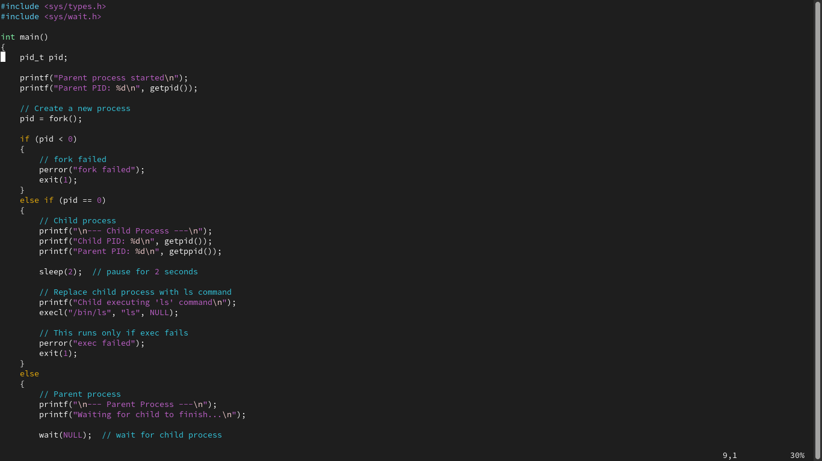

Output Analysis |  | - The parent process creates two child processes using fork().  - Each child prints its PID and sleeps for a different duration.  - Even though the first child sleeps longer, the parent explicitly waits for the second child first using waitpid(pid2, ...).  - This demonstrates that waitpid() allows the parent to control the order of child process termination.  - The output confirms successful process synchronization.
Link of student Github profile where lab assignment has been uploaded |  | https://github.com/kartiktale12/OS_Practicals
Conclusion |  | The program successfully demonstrates Linux process management using fork() and waitpid(). Two child processes are created, and the parent process waits for them in a specific order. This experiment shows how waitpid() provides precise control over process synchronization, which is essential for managing concurrent processes in an operating system.
Plagiarism Report (Similarity index < 12%) |  | 8%
Date |  | 28/01/2026

Practical No. 1
Aim: Explore Configuration details of Computer System Hardware and Operating System of your personal computer/Laptop with respect to -
a) Processor model
b) RAM size
c) Processor frequency
d) Cache memory size
e) SSD and HDD capacities
f) Operating system (32-bit or 64-bit)
g) Hyper-threading support: Indicate if the processor supports hyper-threading and provide a brief explanation.
Requirement (Hardware/Software) :

Theory: Brief Explanation of each of the following parameter of Configuration of Computer System Hardware and Operating System w.r.t,

- Processor model :-

- RAM size :-

- Processor frequency :

- Cache memory size :

- SSD and HDD capacities :

- Operating system (32-bit or 64-bit) :

- Hyper-threading support: Indicate if the processor supports hyper-threading and provide a brief explanation. :-

Configuration of Your system (Desktop, Laptop and Mobile):

OUTPUT (SCREEN SHOT) :

Conclusion:

