Session 2025-2026

Vision: Dream of where you want. | Mission: Means to achieve Vision

Program Educational Objectives of the program (PEO): (broad statements that describe the professional and career accomplishments)
PEO1 | Preparation | P: Preparation | Pep-CL abbreviation  pronounce as Pep-si-lL easy to recall
PEO2 | Core Competence | E: Environment (Learning Environment)
PEO3 | Breadth | P: Professionalism
PEO4 | Professionalism | C: Core Competence
PEO5 | Learning Environment | L: Breadth (Learning in diverse areas)

Program Outcomes (PO): (statements that describe what a student should be able to do and know by the end of a program)
Keywords of POs:
Engineering knowledge, Problem analysis, Design/development of solutions, Conduct Investigations of Complex Problems, Engineering Tool Usage, The Engineer and The World, Ethics, Individual and Collaborative Team work, Communication, Project Management and Finance, Life-Long Learning

PSO Keywords: Cutting edge technologies, Research

“I am an engineer, and I know how to apply engineering knowledge to investigate, analyse and design solutions to complex problems using tools for entire world following all ethics in a collaborative way with proper management skills throughout my life.” to contribute to the development of cutting-edge technologies and Research.

Integrity: I will adhere to the Laboratory Code of Conduct and ethics in its entirety.

Name and Signature of Student and Date
(Signature and Date in Handwritten)

Sr. No. | COs | POs |  |  |  |  |  |  |  |  |  |  |  | PSOs
 |  | Course Outcomes | 1 | 2 | 3 | 4 | 5 | 6 | 7 | 8 | 9 | 10 | 11 | PSO 1 | PSO2
1 | CO1 | Demonstrate the ability to execute Linux process management, memory management, and shell commands to manage system resources efficiently. | 3 | 3 | 3 | - |  | - | - | - | - | - | 3 | 3
2 | CO2 | Develop programs utilizing system calls, thread programming, and page replacement algorithms to simulate and analyze operating system functionalities. | 3 | 3 | 3 | - | - | - | - | - | - | - | 3 | 3
3 | CO3 | Design and implement process scheduling, memory allocation, and deadlock detection algorithms to address real-world operating system challenges. | 3 | 3 | 3 | - |  | - | - | - | - | - | 3 | 3
 |  | Avg |  | 3 | 3 | - |  | - | - | - | - | - | 3 | 3

Session | 2025-26 (EVEN) |  | Course Name | Operating Systems Lab
Semester | 4 |  | Course Code | 23CT1402
Roll No | 55 |  | Name of Student | Kartik Tale
Practical Number |  | 3
Course Outcome |  | - Understand Computer System Configuration and Simulate system resources efficiently using Linux Commands (CO1)  - Analyse operating system functionalities utilizing system calls, thread programming and process scheduling algorithms (CO2)  - Apply Synchronization primitives to implement a Deadlock-free solution(CO3)  - Simulate Disk scheduling, Memory allocation, File allocation, page replacement algorithms (CO4)
Aim |  | Execute Linux memory management system calls and  Device management system calls.
Problem Definition |  | Write a C program to demonstrate the use of the munmap() system call.
Theory  (100 words) |  | Memory management system calls in Linux are used to allocate, map, and release memory dynamically. The mmap() system call maps a file or device into the process’s virtual address space, allowing efficient file and memory access. Once the mapped memory is no longer required, the munmap() system call is used to unmap the memory region, releasing it back to the operating system. Proper use of munmap() prevents memory leaks and ensures efficient memory utilization. These system calls are commonly used in shared memory, file handling, and device access operations in Linux-based systems.
Procedure and Execution  (100 Words) |  | - Open a Linux terminal.  - Create a C file using a text editor.  - Write a program that:  - Opens a file using open().  - Maps the file into memory using mmap().  - Accesses the mapped memory.  - Unmaps the memory using munmap().  - Compile the program using gcc.  - Run the executable.  - Observe the successful unmapping of memory.
Code:
#include <stdio.h>
#include <stdlib.h>
#include <fcntl.h>
#include <sys/mman.h>
#include <unistd.h>
#include <string.h>

int main() {
int fd;
char *map;
const char *message = "Hello Linux Memory Management\n";
size_t length = strlen(message);

// Open or create a file
fd = open("testfile.txt", O_RDWR | O_CREAT, 0666);

// Set file size
ftruncate(fd, length);

// Map file into memory
map = (char *)mmap(NULL, length, PROT_READ | PROT_WRITE, MAP_SHARED, fd, 0);

// Write to mapped memory
memcpy(map, message, length);

printf("Data written using mmap\n");

// Unmap memory
munmap(map, length);
printf("Memory unmapped successfully\n");

close(fd);
return 0;
}

Output:
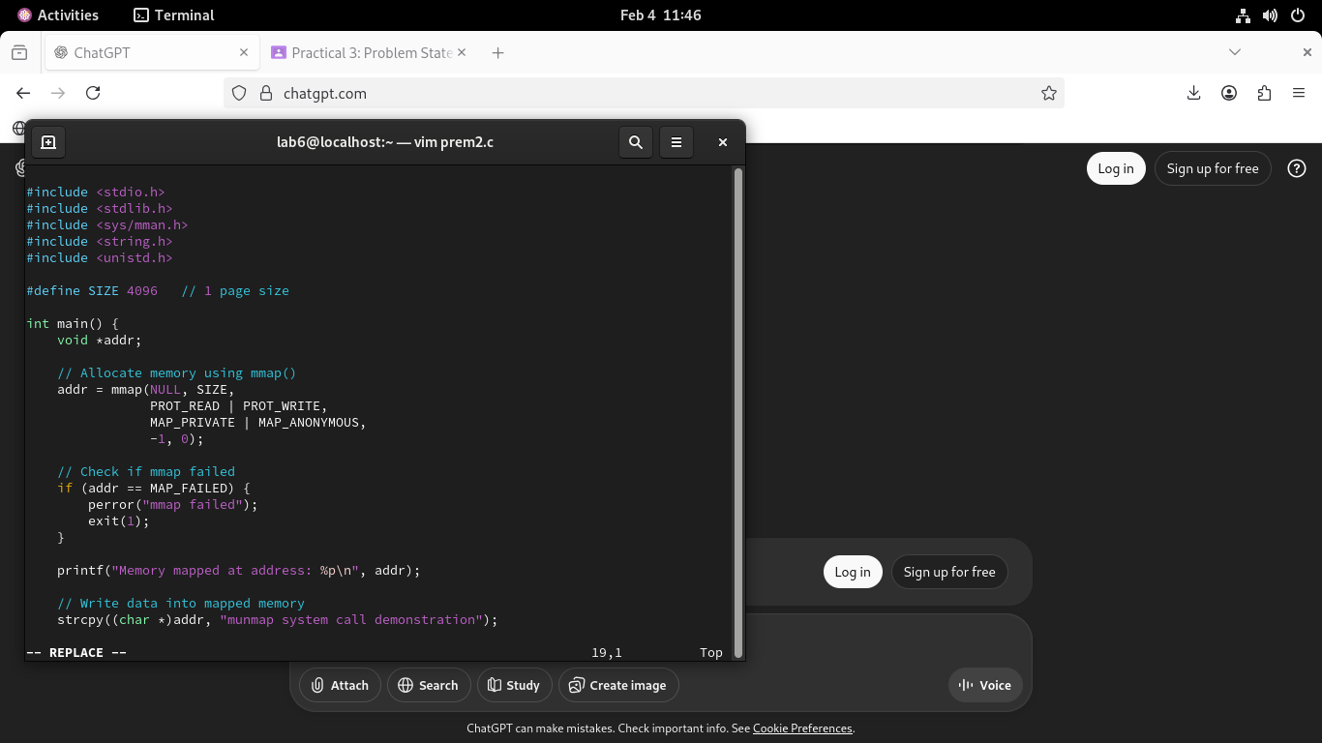

Output Analysis |  | - The file is opened and mapped into the process address space using mmap().  - Data is written directly into memory instead of using traditional file I/O.  - The munmap() system call successfully releases the mapped memory region.  - The message confirms that memory is properly unmapped and returned to the OS.  - The file testfile.txt contains the written data, verifying correct memory mapping.
Link of student Github profile where lab assignment has been uploaded |  | https://github.com/kartiktale12/OS_Practicals
Conclusion |  | The program demonstrates the effective use of Linux memory management system calls. Memory is allocated using mmap() and safely released using munmap(). This experiment highlights the importance of proper memory cleanup to avoid memory leaks and ensure efficient resource utilization in operating systems.
Plagiarism Report (Similarity index < 12%) |  | 10%
Date |  | 04/02/2026

Requirement (Hardware/Software) :

Theory: Brief Explanation of each of the following parameter of Configuration of Computer System Hardware and Operating System w.r.t,

- Processor model :-

- RAM size :-

- Processor frequency :

- Cache memory size :

- SSD and HDD capacities :

- Operating system (32-bit or 64-bit) :

- Hyper-threading support: Indicate if the processor supports hyper-threading and provide a brief explanation. :-

Configuration of Your system (Desktop, Laptop and Mobile):

OUTPUT (SCREEN SHOT) :

Conclusion:

