Session | 2024-25 (ODD) |  | Course Name | Web Technology Lab
Semester | 3 |  | Course Code | 23CT1301
Roll No | A-52  A-53  A-55 |  | Name of Students | Karan Kumar  Kartik Tale  Krutant Tale
Practical Number |  | 10 – Mini Project
Course Outcome |  | - Understand various internet technologies.  - Design the web pages using HTML and CSS.  - Implement the XML technology to store the data.  - Develop the interactive web pages using JavaScript.
Aim |  | Aim: Develop a Full Stack Recipe Management Web Application
Problem Definition |  | To design and develop a Recipe Management Web App demonstrating complete CRUD (Create, Read, Update, Delete) operations with frontend-backend integration using web technologies.
Theory  (100 words) |  | The Recipe Management Web App allows users to create, view, update, and delete recipes. It is developed using HTML for structure, CSS for styling, and JavaScript for interactivity. The backend is implemented using Node.js and Express.js, and the data is stored in a JSON file acting as a local database. The application demonstrates dynamic DOM manipulation, data validation, and API connectivity between frontend and backend. It provides a user-friendly interface for managing recipes efficiently.
Procedure and Execution  (100 Words) |  | Step for Implementation:  1. Create a project folder named RECIPEAPP.  2. Inside it, make backend and frontend folders.  3. In frontend, create:  - index.html – structure of the web app  - style.css – for UI styling  - script.js – handles interactivity and API calls  4. In backend, create:  - server.js – Node.js + Express server  - recipes.json – acts as a database  5. Install dependencies using npm init and npm install express cors multer.  6. Create CRUD API routes in server.js.  7. Connect frontend with backend using fetch() in script.js.  8. Validate user input before saving.  9. Run the server (node server.js) and open index.html in browser.
Code:
Recipe App :

frontend :

index.html :

<!DOCTYPE html>
<html lang="en">

<head>
<meta charset="UTF-8">
<meta name="viewport" content="width=device-width, initial-scale=1.0">
<link rel="stylesheet" href="style.css" />
<title>Recipe App</title>
</head>
<body>

<header>
<nav>
<h1>Recipe App</h1>
<form id="searchForm">
<input type="text" placeholder="Search for recipes....." class="searchBox" />
<button type="submit" class="searchBtn">Search</button>
</form>
</nav>
</header>

<main>
<section>
<div class="recipe-container">
<h2>Search your favourite recipes....</h2>
</div>

<div class="recipe-detail">
<button type="button" class="recipe-close-btn">×</button>
<div class="recipe-detail-content"></div>
</div>
</section>

<!-- Add Recipe Section -->
<section class="add-recipe-section">
<h2>Add / Manage Your Recipes</h2>
<form id="addRecipeForm">
<input type="text" id="recipeName" placeholder="Recipe Name" required><br>
<input type="file" id="recipeImageFile" accept="image/*" required><br>
<textarea id="recipeIngredients" placeholder="Ingredients" required></textarea><br>
<textarea id="recipeInstructions" placeholder="Instructions" required></textarea><br>
<button type="submit">Add Recipe</button>
</form>
</section>
</main>

<script src="script.js"></script>

</body>
</html>
style.css :

* {
margin: 0;
padding: 0;
box-sizing: border-box;
font-family: Verdana, Geneva, Tahoma, sans-serif;
}

body {
background-color: #2b1d0f;
color: #fff;
}

/* Navbar */
header nav {
background-color: #212121;
padding: 20px;
display: flex;
justify-content: space-between;
align-items: center;
z-index: 1;
}

header nav h1 {
font-size: 26px;
font-weight: 700;
letter-spacing: 1px;
text-transform: uppercase;
}

header nav form {
display: flex;
justify-content: center;
}

form input[type="text"] {
flex-grow: 1;
margin-right: 10px;
}

form input[type="text"], button[type="submit"] {
border: none;
font-size: 18px;
padding: 10px;
border-radius: 4px;
}

button[type="submit"] {
background-color: #f44336;
color: #fff;
cursor: pointer;
transition: background-color 0.2s ease-in-out;
}

form button[type="submit"]:hover,
.recipe button:hover,
.recipe-close-btn:hover {
background-color: #ff5c5c;
}

/* Recipe Grid */
.recipe-container {
text-align: center;
margin-top: 20px;
display: grid;
grid-template-columns: repeat(auto-fit, minmax(300px, 1fr));
grid-gap: 40px;
width: 80%;
margin: 10px auto;
padding: 20px;
place-items: center;
}

.recipe {
background-color: #fff;
display: flex;
flex-direction: column;
color: #000;
border-radius: 6px;
box-shadow: 0 5px 10px rgba(78, 73, 73, 0.1),
-5px -5px 10px rgba(34, 34, 34, 0.5);
cursor: pointer;
max-width: 350px;
transition: transform 0.3s ease-in-out;
}

.recipe:hover {
transform: scale(1.02);
}

.recipe img {
height: 250px;
width: 100%;
object-fit: cover;
}

.recipe h3 {
font-size: 22px;
margin-block: 5px;
}

.recipe p {
font-size: 16px;
color: #4a4a4a;
margin: 5px 0;
}

.recipe button {
font-size: 16px;
font-weight: 600;
padding: 8px;
border-radius: 5px;
border: none;
cursor: pointer;
margin: 8px auto;
background-color: #f44336;
color: #fff;
}

/* Recipe Detail Popup */
.recipe-detail {
display: none;
position: fixed;
top: 50%;
left: 50%;
transform: translate(-50%, -50%);
background-color: #694c2f;
border-radius: 12px;
width: 50%;
height: 70%;
font-size: 18px;
overflow-y: scroll;
padding: 20px;
z-index: 10;
}

.recipe-detail-content {
padding: 20px;
}

.recipeName {
text-align: center;
text-transform: uppercase;
text-decoration: underline;
margin-bottom: 10px;
}

.recipe-close-btn {
border: none;
font-size: 20px;
padding: 8px;
border-radius: 4px;
background-color: #f44336;
color: #fff;
position: absolute;
top: 10px;
right: 10px;
width: 30px;
height: 30px;
display: flex;
justify-content: center;
align-items: center;
}

/* Add Recipe Section */
.add-recipe-section {
background: #3a2a18;
padding: 20px;
margin: 20px auto;
border-radius: 10px;
width: 80%;
text-align: center;
}

.add-recipe-section h2 {
margin-bottom: 15px;
}

#addRecipeForm input,
#addRecipeForm textarea,
#addRecipeForm button {
width: 80%;
margin-bottom: 10px;
padding: 10px;
font-size: 16px;
border-radius: 6px;
border: none;
}

#addRecipeForm button {
background-color: #f44336;
color: #fff;
cursor: pointer;
}

#addRecipeForm button:hover {
background-color: #ff5c5c;
}

@media screen and (max-width:600px) {
header nav {
flex-direction: column;
}
header nav form {
width: 80%;
margin-top: 20px;
}
.recipe-detail {
width: 90%;
height: 80%;
}
}
script.js :

const BASE_URL = window.location.origin.includes('5000') ? window.location.origin : 'https://recipe-app-3e8c.onrender.com';

// === DOM Elements ===
const searchBox = document.querySelector('.searchBox');
const searchBtn = document.querySelector('.searchBtn');
const recipeContainer = document.querySelector('.recipe-container');
const recipeDetailContent = document.querySelector('.recipe-detail-content');
const recipeCloseBtn = document.querySelector('.recipe-close-btn');

// === Fetch from API ===
const fetchRecipes = async (query) => {
recipeContainer.innerHTML = "<h2>Fetching Recipes....</h2>";
try {
// Proxy via your backend
const res = await fetch(`${BASE_URL}/api/recipes?search=${encodeURIComponent(query)}`);
const response = await res.json();

recipeContainer.innerHTML = "";
if (!response.meals) {
recipeContainer.innerHTML = "<h2>No recipes found!</h2>";
return;
}

response.meals.forEach(meal => {
const recipeDiv = document.createElement('div');
recipeDiv.classList.add('recipe');
recipeDiv.innerHTML = `
<img src="${meal.strMealThumb}" alt="${meal.strMeal}">
<h3>${meal.strMeal}</h3>
<p><b>${meal.strArea}</b> Dish</p>
<p>Category: <b>${meal.strCategory}</b></p>
`;

const button = document.createElement('button');
button.textContent = "View Recipe";
recipeDiv.appendChild(button);
button.addEventListener('click', () => openRecipePopup(meal));

recipeContainer.appendChild(recipeDiv);
});
} catch (error) {
console.error(error);
recipeContainer.innerHTML = "<h2>Error fetching recipes...</h2>";
}
};

const fetchIngredients = (meal) => {
let ingredientsList = "";
for (let i = 1; i <= 20; i++) {
const ingredient = meal[`strIngredient${i}`];
const measure = meal[`strMeasure${i}`];
if (ingredient) ingredientsList += `<li>${measure} ${ingredient}</li>`;
else break;
}
return ingredientsList;
};

const openRecipePopup = (meal) => {
recipeDetailContent.innerHTML = `
<h2 class="recipeName">${meal.strMeal}</h2>
<h3>Ingredients:</h3>
<ul>${fetchIngredients(meal)}</ul>
<div class="recipeInstructions">
<h3>Instructions:</h3>
<p>${meal.strInstructions}</p>
</div>
`;
recipeDetailContent.parentElement.style.display = "block";
};

recipeCloseBtn.addEventListener('click', () => {
recipeDetailContent.parentElement.style.display = "none";
});

searchBtn.addEventListener('click', (e) => {
e.preventDefault();
const searchInput = searchBox.value.trim();
if (!searchInput) {
recipeContainer.innerHTML = "<h2>Type something to search.</h2>";
return;
}
fetchRecipes(searchInput);
});

// === Custom CRUD ===
async function displayCustomRecipes() {
document.querySelectorAll('.custom-recipe').forEach(r => r.remove());
try {
const res = await fetch(`${BASE_URL}/api/custom`);
if (!res.ok) throw new Error('Failed to load custom recipes');
const recipes = await res.json();

recipes.forEach(meal => {
const recipeDiv = document.createElement('div');
recipeDiv.classList.add('recipe', 'custom-recipe');
recipeDiv.innerHTML = `
<img src="${meal.imgUrl ? BASE_URL + meal.imgUrl : '/fallback-image.png'}" alt="${meal.name}">
<h3>${meal.name}</h3>
<p><b>Ingredients:</b> ${meal.ingredients}</p>
<button class="viewBtn">View</button>
<button class="editBtn">Edit</button>
<button class="deleteBtn">Delete</button>
`;

// View button
recipeDiv.querySelector('.viewBtn').addEventListener('click', () => {
recipeDetailContent.innerHTML = `
<h2 class="recipeName">${meal.name}</h2>
<h3>Ingredients:</h3>
<p>${meal.ingredients}</p>
<div class="recipeInstructions">
<h3>Instructions:</h3>
<p>${meal.instructions}</p>
</div>
`;
recipeDetailContent.parentElement.style.display = "block";
});

// Edit button
recipeDiv.querySelector('.editBtn').addEventListener('click', () => {
document.getElementById('recipeName').value = meal.name;
document.getElementById('recipeIngredients').value = meal.ingredients;
document.getElementById('recipeInstructions').value = meal.instructions;
addRecipeForm.dataset.editId = meal.id;
window.scrollTo({ top: document.body.scrollHeight, behavior: 'smooth' });
});

// Delete button
recipeDiv.querySelector('.deleteBtn').addEventListener('click', async () => {
if (!confirm('Delete this recipe?')) return;
try {
const del = await fetch(`${BASE_URL}/api/custom/${meal.id}`, { method: 'DELETE' });
if (!del.ok) throw new Error('Delete failed');
displayCustomRecipes();
} catch (err) {
console.error(err);
alert('Error deleting recipe');
}
});

recipeContainer.appendChild(recipeDiv);
});
} catch (err) {
console.error(err);
recipeContainer.innerHTML = '<h2>Error loading custom recipes</h2>';
}
}
addRecipeForm.addEventListener('submit', async (e) => {
e.preventDefault();

const name = document.getElementById('recipeName').value.trim();
const ingredients = document.getElementById('recipeIngredients').value.trim();
const instructions = document.getElementById('recipeInstructions').value.trim();
const file = document.getElementById('recipeImageFile').files[0];

if (!name || !ingredients || !instructions) {
alert("Please fill all text fields!");
return;
}

const formData = new FormData();
formData.append('name', name);
formData.append('ingredients', ingredients);
formData.append('instructions', instructions);
if (file) formData.append('image', file);

const editId = addRecipeForm.dataset.editId;
try {
let res;
if (editId) {
// Update
res = await fetch(`${BASE_URL}/api/custom/${editId}`, { method: 'PUT', body: formData });
delete addRecipeForm.dataset.editId;
} else {
// Add
res = await fetch(`${BASE_URL}/api/custom`, { method: 'POST', body: formData });
}

if (!res.ok) throw new Error('Save failed');

await displayCustomRecipes();
addRecipeForm.reset();
alert(editId ? 'Recipe updated!' : 'Recipe added!');
} catch (err) {
console.error(err);
alert('Error saving recipe');
}
});
document.addEventListener('DOMContentLoaded', () => {
displayCustomRecipes();
});

backend :

server.js :

// server.js
require('dotenv').config();
const express = require('express');
const cors = require('cors');
const multer = require('multer');
const fs = require('fs');
const path = require('path');
const fetch = require('node-fetch'); // use node-fetch@2 for CommonJS

const app = express();
const PORT = process.env.PORT || 5000;
const DATA_FILE = path.join(__dirname, 'recipes.json');

// === Helper functions for JSON storage ===
function readRecipes() {
if (!fs.existsSync(DATA_FILE)) return [];
const data = fs.readFileSync(DATA_FILE, 'utf8');
try {
return JSON.parse(data);
} catch {
return [];
}
}
function saveRecipes(recipes) {
fs.writeFileSync(DATA_FILE, JSON.stringify(recipes, null, 2));
}

// === Middleware ===
app.use(cors());
app.use(express.json());
app.use('/uploads', express.static(path.join(__dirname, 'uploads')));

// === Multer setup for image uploads ===
const storage = multer.diskStorage({
destination: (req, file, cb) => {
const dir = path.join(__dirname, 'uploads');
if (!fs.existsSync(dir)) fs.mkdirSync(dir);
cb(null, dir);
},
filename: (req, file, cb) => {
const ext = path.extname(file.originalname);
cb(null, Date.now() + '-' + Math.round(Math.random() * 1e9) + ext);
}
});
const upload = multer({
storage,
limits: { fileSize: 5 * 1024 * 1024 }, // 5MB
fileFilter: (req, file, cb) => {
if (!file.mimetype.startsWith('image/')) return cb(new Error('Only images allowed'));
cb(null, true);
}
});

// === API Routes ===

// Proxy search (TheMealDB)
app.get('/api/recipes', async (req, res) => {
const q = req.query.search || '';
try {
const r = await fetch(`https://www.themealdb.com/api/json/v1/1/search.php?s=${encodeURIComponent(q)}`);
const data = await r.json();
res.json(data);
} catch (err) {
console.error(err);
res.status(500).json({ error: 'Failed to fetch recipes' });
}
});

// Get all custom recipes
app.get('/api/custom', (req, res) => {
const recipes = readRecipes();
res.json(recipes);
});

// Get one recipe
app.get('/api/custom/:id', (req, res) => {
const recipes = readRecipes();
const recipe = recipes.find(r => r.id === req.params.id);
if (!recipe) return res.status(404).json({ error: 'Not found' });
res.json(recipe);
});

// Add a new recipe
app.post('/api/custom', upload.single('image'), (req, res) => {
const { name, ingredients, instructions } = req.body;
if (!name || !ingredients || !instructions) {
if (req.file) fs.unlinkSync(req.file.path);
return res.status(400).json({ error: 'Missing fields' });
}

const newRecipe = {
id: Date.now().toString(),
name,
ingredients,
instructions,
imgUrl: req.file ? `/uploads/${req.file.filename}` : '',
createdAt: new Date().toISOString(),
};

const recipes = readRecipes();
recipes.push(newRecipe);
saveRecipes(recipes);
res.status(201).json(newRecipe);
});

// Update recipe
app.put('/api/custom/:id', upload.single('image'), (req, res) => {
const recipes = readRecipes();
const idx = recipes.findIndex(r => r.id === req.params.id);
if (idx === -1) {
if (req.file) fs.unlinkSync(req.file.path);
return res.status(404).json({ error: 'Recipe not found' });
}

const recipe = recipes[idx];

// If new image uploaded, remove old one
if (req.file && recipe.imgUrl) {
const oldPath = path.join(__dirname, recipe.imgUrl);
if (fs.existsSync(oldPath)) fs.unlinkSync(oldPath);
recipe.imgUrl = `/uploads/${req.file.filename}`;
}

recipe.name = req.body.name || recipe.name;
recipe.ingredients = req.body.ingredients || recipe.ingredients;
recipe.instructions = req.body.instructions || recipe.instructions;
recipe.updatedAt = new Date().toISOString();

recipes[idx] = recipe;
saveRecipes(recipes);
res.json(recipe);
});

// Delete recipe
app.delete('/api/custom/:id', (req, res) => {
const recipes = readRecipes();
const recipe = recipes.find(r => r.id === req.params.id);
if (!recipe) return res.status(404).json({ error: 'Recipe not found' });

// Remove image
if (recipe.imgUrl) {
const imgPath = path.join(__dirname, recipe.imgUrl);
if (fs.existsSync(imgPath)) fs.unlinkSync(imgPath);
}

const updated = recipes.filter(r => r.id !== req.params.id);
saveRecipes(updated);
res.json({ message: 'Deleted' });
});

// Health check
app.get('/api/health', (_, res) => res.json({ ok: true }));

// === Start server ===
app.listen(PORT, () => console.log(`✅ Server running on http://localhost:${PORT}`));

Check github for more code
Output:
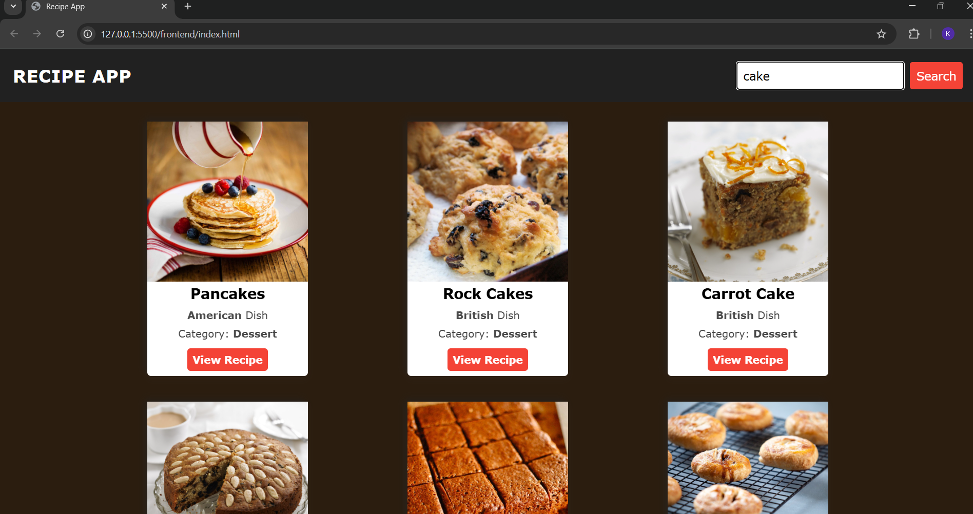
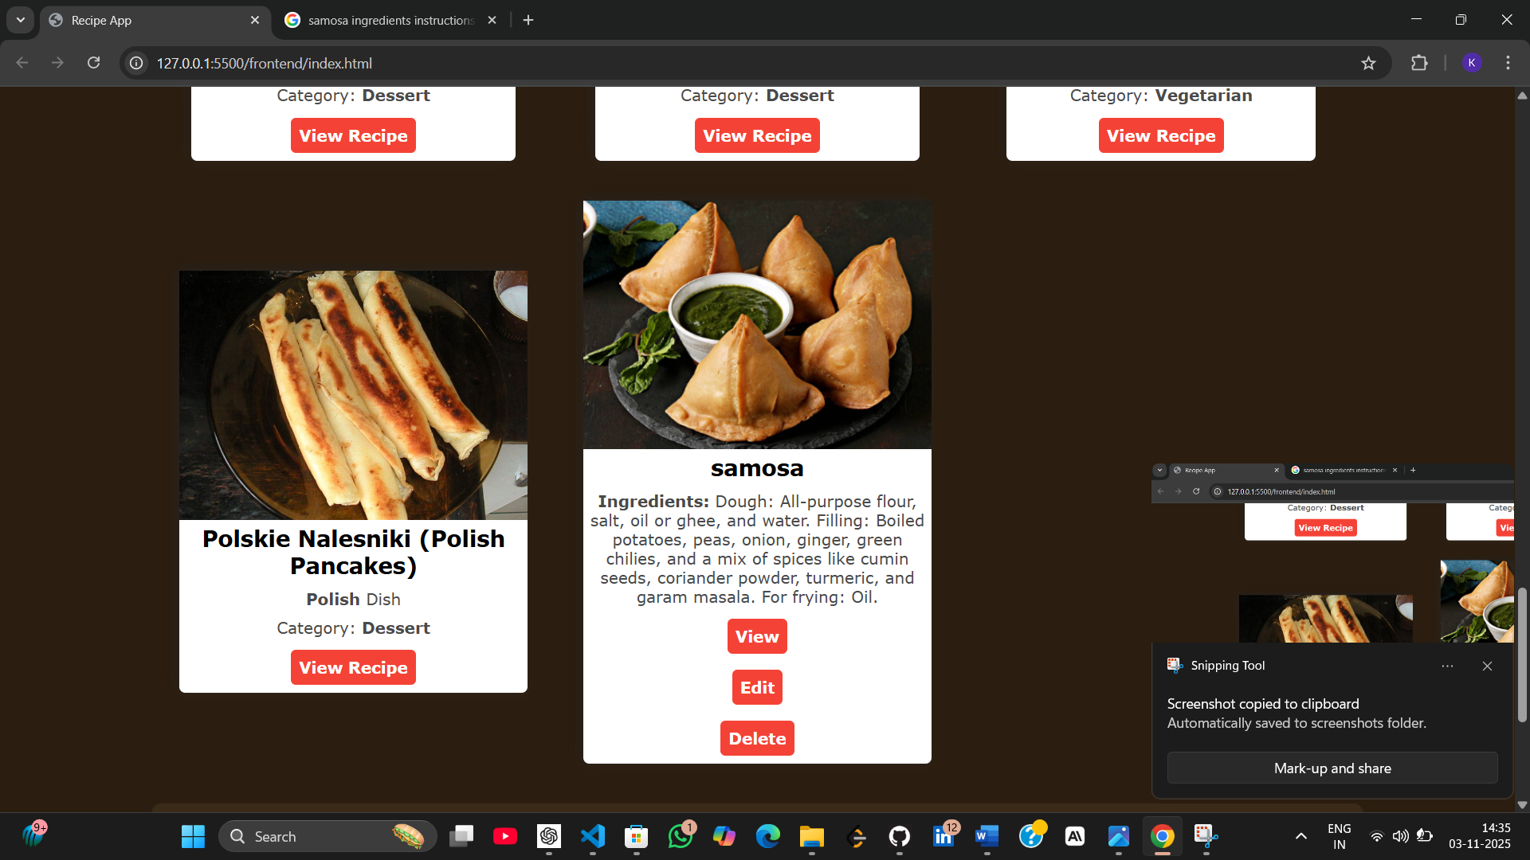
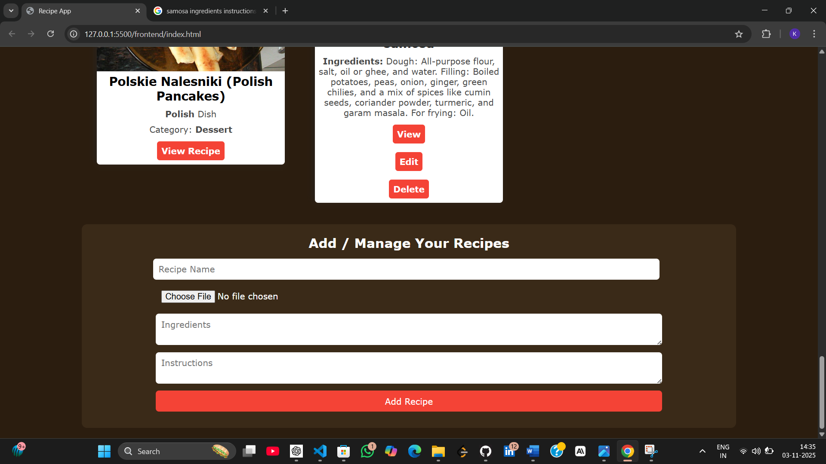
Output Analysis |  | The Recipe App is a fully functional, responsive web application built using HTML, CSS, and JavaScript. When the user opens the app, they are greeted with a clean interface that includes a search bar and navigation area where they can search for their favorite recipes. The app connects to the MealDB API to fetch and display a variety of dishes based on the user’s query. Each recipe is displayed in a grid layout, showing the meal’s image, name, category, and area. The design uses smooth transitions, hover effects, and a visually appealing color scheme, making it both attractive and easy to use.  When a user searches for a recipe, the app shows a loading animation before displaying the results. Each recipe card contains a “View Recipe” button that, when clicked, opens a detailed popup modal. This popup displays the recipe name, list of ingredients with measurements, and step-by-step cooking instructions. It also provides options to print the recipe directly or save it to favorites. Saved recipes are stored using the browser’s localStorage, ensuring that they remain available even after the page is refreshed.  The app also includes advanced features like a random recipe generator, allowing users to explore new dishes with one click, and a category filter, which helps narrow down searches based on meal types such as vegetarian, seafood, or dessert. If the MealDB API fails or if the user is offline, the app automatically loads recipes from a local indianRecipes.json file containing popular Indian dishes such as Paneer Butter Masala, Dal Tadka, and Biryani. This ensures the app remains functional even without an internet connection.  Additionally, the project includes a unit test system (test.html and unit-tests.js) that verifies key functionalities like recipe fetching, localStorage operations, and fallback data loading. These tests run directly in the browser and confirm that the app’s logic works as intended. Two small server scripts (server.bat and server.sh) are also provided to easily launch the app on a local server, solving potential CORS issues with local JSON data.  Overall, the Recipe App provides a seamless user experience with modern features like responsive design, persistent favorites, random meal suggestions, and print options. It is well-documented through a professional README file that includes setup, deployment, and troubleshooting instructions. The final version is suitable for presentation as a Mini Project (MSPA-4), demonstrating key web development concepts like API integration, asynchronous programming, local data handling, and front-end interactivity.
Link of student Github profile where lab assignment has been uploaded |  | https://github.com/kartiktale12/Recipe_App  https://github.com/karankumarr1408/Recipe_App  https://github.com/Krutanttale /Recipe_App
Conclusion |  | In short, the Recipe App is a responsive and interactive web project built with HTML, CSS, and JavaScript. It allows users to search, view, and save recipes using the MealDB API and also works offline with local Indian recipes. The app includes features like category filters, random recipe generation, a favorites system, print options, and loading animations. With clean UI, localStorage integration, and built-in unit tests, it fulfills all MSPA-4 mini project requirements and demonstrates practical web development skills effectively.
Plag Report (Similarity index < 12%) |  | 9%
Date |  | 3/11/2025

