logocover

**Fashion MNIST Kubeflow Pipeline with GPU Runbook**

Date Prepared: Feb 2021

Document Information

|  |  |  |  |
| --- | --- | --- | --- |
| Project Name | **HPE** | | |
| Project Owner |  | Document Version No | 0.1 |
| Quality Review Method |  |  |  |
| Prepared By | vivek-singh.bhadauriya@hpe.com | Preparation Date | 30-Apr-2021 |
| Reviewed By | Jai Kakkar | Review Date |  |

**Table of Contents**

1 Summary 4

2 Prepare the DataSEt 6

3 Deploy Kubeflow Notebook 8

4 Execute the Notebook 10

# Summary

This runbook will demonstrate set up Kubeflow Notebook on HPECP 5.3 and build a Kubeflow Pipeline which will trained model using GPU.

**Use Case**

Fashion-MNIST is a dataset of Zalando's article images consisting of a training set of 60,000 examples and a test set of 10,000 examples. Each example is a 28x28 grayscale image, associated with a label from 10 classes.

The images show individual articles of clothing at low resolution (28 by 28 pixels), as seen here:

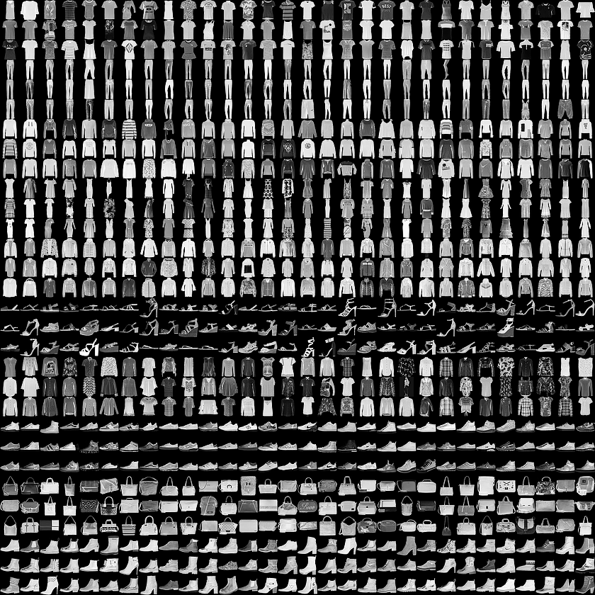

**Steps**

* Create PVC.
* Upload required file to PVC.
* Submit the pipeline using Kubeflow Notebook.

Source Code: <https://github.hpe.com/hpe/field-resources/tree/master/HPECP-5.3/Kubeflow/Fashion-MNIST-Keras-GPU-Pipeline>

# Prepare the DataSEt

In this step we are going to create PVC for the use case.

Log in to Kubernetes Master Host and create a file name **fashion-mnist-pvc.yaml**.

apiVersion: v1

kind: PersistentVolumeClaim

metadata:

name: fashion-mnist-pvc

spec:

accessModes:

- ReadWriteMany

resources:

requests:

storage: 2Gi

Command to apply the **fashion-mnist-pvc.yaml**.

kubectl create -f fashion-mnist-pvc.yaml -n kubeflow

Download required files from below links:

* <https://raw.githubusercontent.com/zalandoresearch/fashion-mnist/master/data/fashion/t10k-images-idx3-ubyte.gz>
* <https://raw.githubusercontent.com/zalandoresearch/fashion-mnist/master/data/fashion/t10k-labels-idx1-ubyte.gz>
* <https://raw.githubusercontent.com/zalandoresearch/fashion-mnist/master/data/fashion/train-images-idx3-ubyte.gz>
* <https://raw.githubusercontent.com/zalandoresearch/fashion-mnist/master/data/fashion/train-labels-idx1-ubyte.gz>

After downloading the above files, we need to deploy a pod with attaching the PVC created to copy files to volume mount.

Create a **pod.yaml** file.

apiVersion: v1

kind: Pod

metadata:

name: dataaccess

spec:

containers:

- name: alpine

image: alpine:latest

command: ['sleep', 'infinity']

volumeMounts:

- name: mypvc

mountPath: /data

volumes:

- name: mypvc

persistentVolumeClaim:

claimName: fashion-mnist-pvc

Command to apply the **pod.yaml**.

kubectl create -f pod.yaml -n kubeflow

Once the pod with name **dataaccess** come to ready state execute the below command:

kubectl cp t10k-images-idx3-ubyte.gz dataaccess:/data -n kubeflow

kubectl cp t10k-labels-idx1-ubyte.gz dataaccess:/data -n kubeflow

kubectl cp train-images-idx3-ubyte.gz dataaccess:/data -n kubeflow

kubectl cp train-labels-idx1-ubyte.gz dataaccess:/data -n kubeflow

After copying the file will delete the pod.

kubectl delete -f pod.yaml -n kubeflow

# Deploy Kubeflow Notebook

Go to Tenant and click on Kubeflow Dashboard.

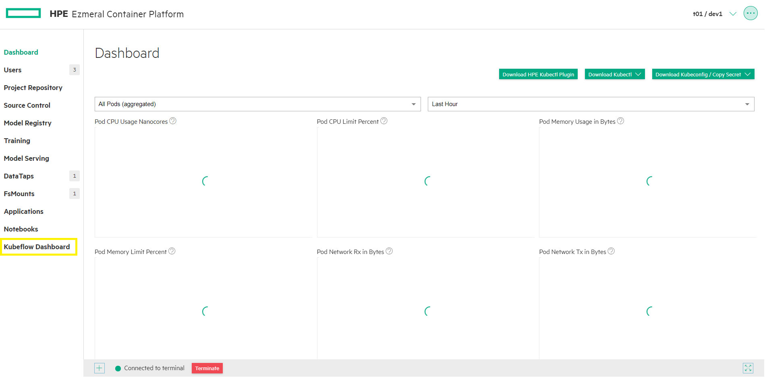

Login to Kubeflow UI with AD user.

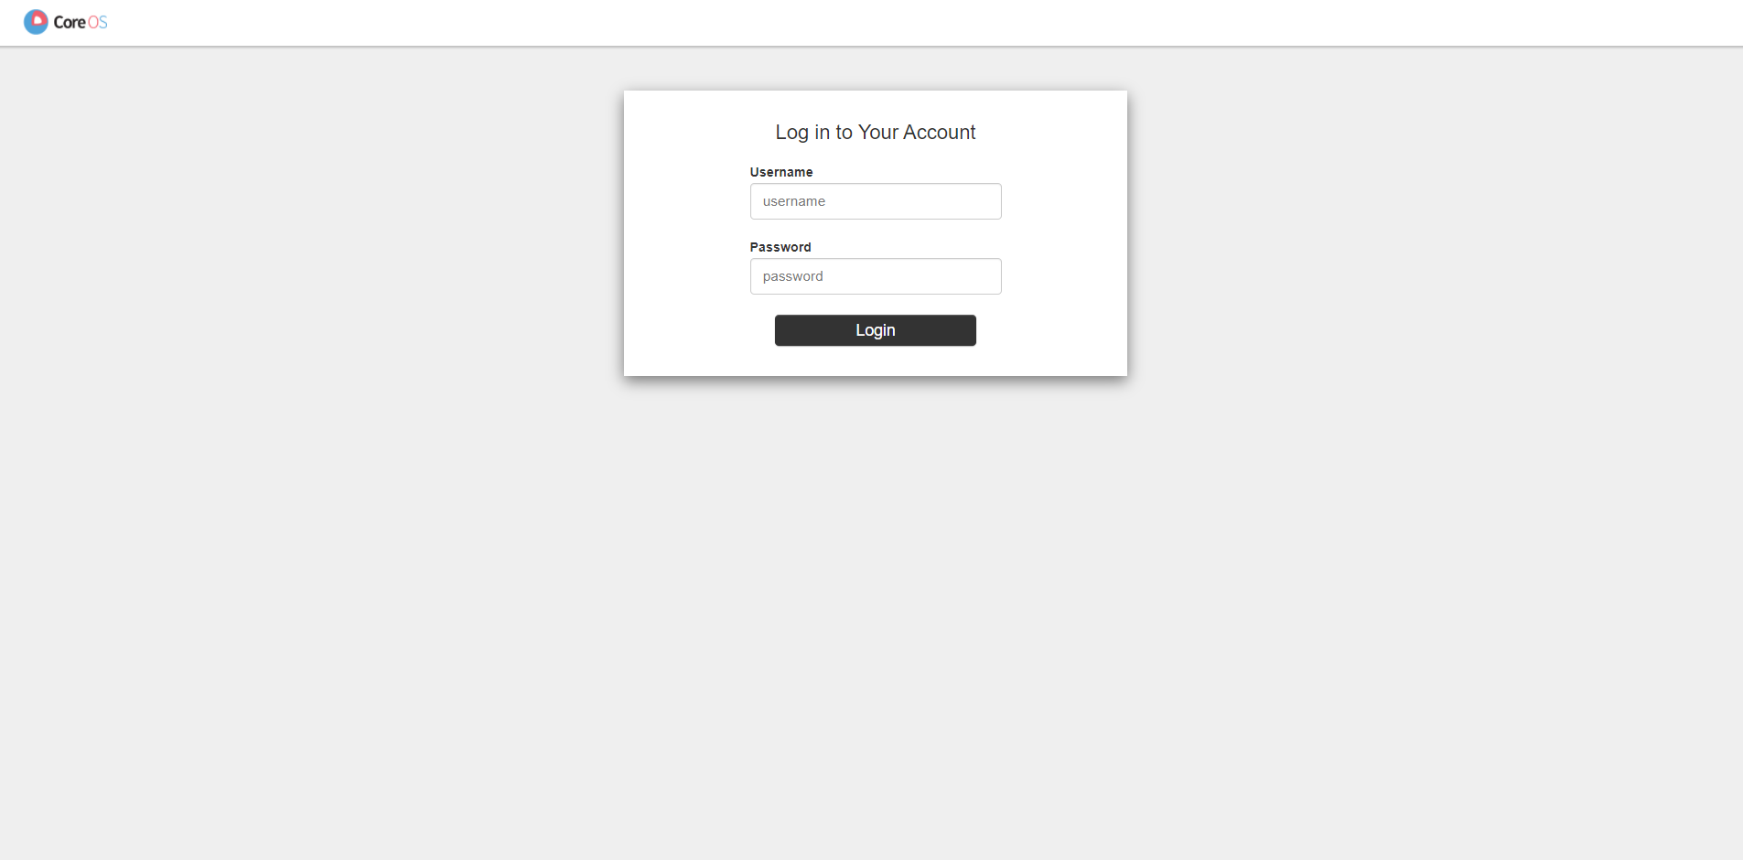

After Login on Kubeflow UI, click on Notebook Server.

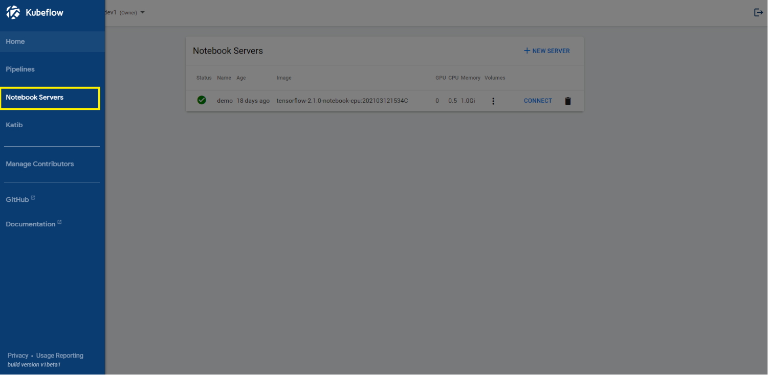

If there is no Notebook Server, you can create new one. Click on Connect, that will redirect to Notebook Server and the upload the **Fashion-MNIST-GPU-KF-Pipeline.ipynb** notebook**.**

# Execute the Notebook

After Uploading the notebook, will execute the notebook cell to submit the pipeline.

The main importing to place our pipeline step container to spin up on GPU host is the below function.

<https://kubeflow-pipelines.readthedocs.io/en/latest/source/kfp.dsl.html?highlight=GPU#kfp.dsl.UserContainer.set_gpu_limit>

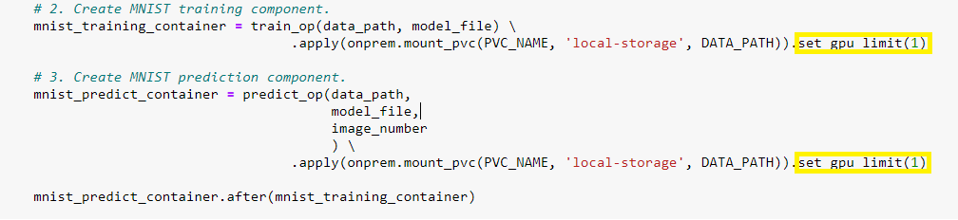

Once the pipeline is submitted.



Click on **Run details**.

It will redirect you to the Kubeflow UI and display the Pipeline execution.

**Training:**

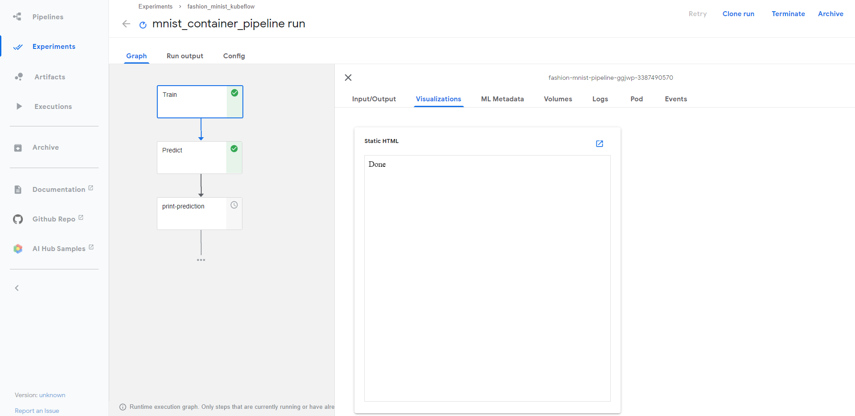

**Prediction:**

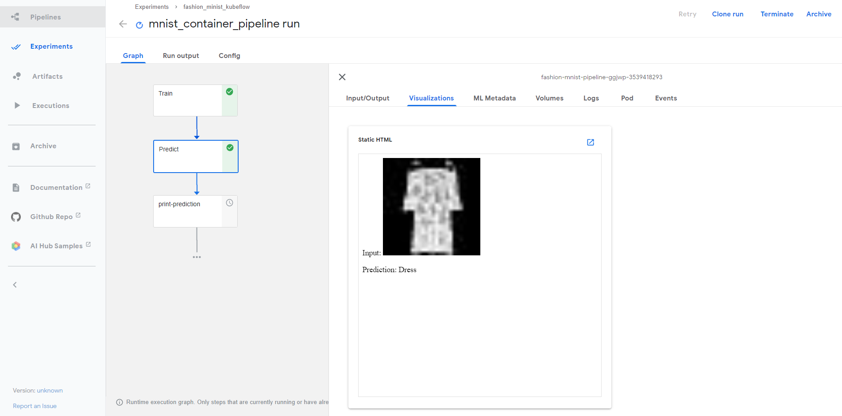

**Prediction Result:**

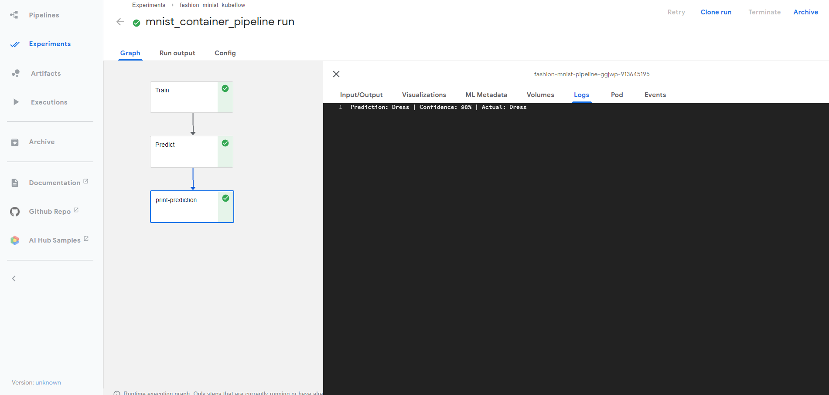

**Model Metrics:**

