Name: Kartik Vedi Student ID: 300374518  
CSIS 4260 Section: 001 Seminar: 1 Data Mining Techniques for Structured Data

# Topic: **Key Techniques for Data Mining and In-depth Exploration of One Algorithm**

# **Executive Summary**

The seminar explores the topic of data mining, which is the process of gleaning useful patterns and insights from organised data. References to reputable articles, particularly those from IBM, Data Science Central, and Digital Ocean, provide a solid foundation for the examination of important data mining approaches. Throughout the presentation, Random Forest—a powerful ensemble learning technique used for both classification and regression tasks—will be highlighted.

The main topic of our lecture, Random Forest, functions by building an ensemble of decision trees in the training stage. This group method produces a stable and adaptable algorithm that can handle a variety of features in big datasets. The algorithm's strength is its ability to provide randomness to the creation of individual trees, so mitigating worries about overfitting. The practical implementation of the method is demonstrated by an example scenario involving the prediction of medical risk categories.

The lecture emphasises that Random Forest is suitable for situations with big datasets, a variety of characteristics, and the risk of overfitting with single decision trees. Because of its adaptability, it can be used in a variety of industries, including as marketing, banking, and healthcare.

Although it has several advantages, real-time applications and interpretability are recognised as possible drawbacks. This helps practitioners make well-informed decisions depending on the particular needs of their data mining projects.

# **Main Idea**

Random Forest is a flexible and strong ensemble learning method that is frequently used to address problems with regression and classification. Its main method of working is to build a group, or a "forest," of decision trees in the training stage. Compared to single decision trees, an ensemble technique offers better accuracy, robustness, and durability.

Overview of the Algorithm:

Ensemble Construction: As part of the ensemble construction process, Random Forest starts by building a number of decision trees, each of which is trained using a different subset of the training set and features at random. The individual trees are given diversity by this randomization, which reduces the possibility of overfitting to particular patterns in the data.

Bootstrap Aggregating (Bagging): A procedure known as bootstrapping is utilised to create the random subsets that are used in each tree's training. In order to ensure that each subset may contain duplicate instances, sampling with replacement from the original dataset is used in this process. By lowering the model's variance, bagging strengthens the model.

Feature Randomness: Random Forest restricts the traits that each tree is able to take into account upon splitting, adding even more variability. This encourages a more balanced model by preventing some aspects from controlling the decision-making process.

For instance:

Consider the following scenario: given a patient dataset, we wish to determine if the patients have a low, medium, or high chance of contracting a specific medical disease. Numerous characteristics, including age, BMI, cholesterol, and exercise habits, are included in the dataset.

The Random Forest training phase commences with the creation of several decision trees, each trained on a distinct selection of data and a random population of patients. While some trees may place greater emphasis on cholesterol levels and exercise routines, others may be more concerned about age and BMI.

Voting Mechanism: Using its own viewpoint, each tree "votes" for a new patient's risk category during prediction. The majority vote of all trees determines the final prediction.

Result: The Random Forest model will identify a patient as being at medium risk if the majority of trees support this prediction.

Benefits

Robustness: The ensemble approach improves generalisation to fresh data and lowers the chance of overfitting.

Versatility: Applicable to both classification and regression tasks.

Importance of Features: Offers information on how significant various features are for generating forecasts.

Problems:

Computational Intensity: It can take a lot of resources to train several decision trees. Interpretability: Interpreting individual decision trees is difficult due to their ensemble character.

In conclusion, Random Forest is a strong and broadly used algorithm that strikes a compromise between generalization and accuracy. It is a useful tool in many industries, including healthcare, finance, and other fields, due to its capacity to manage a variety of datasets and reduce overfitting.

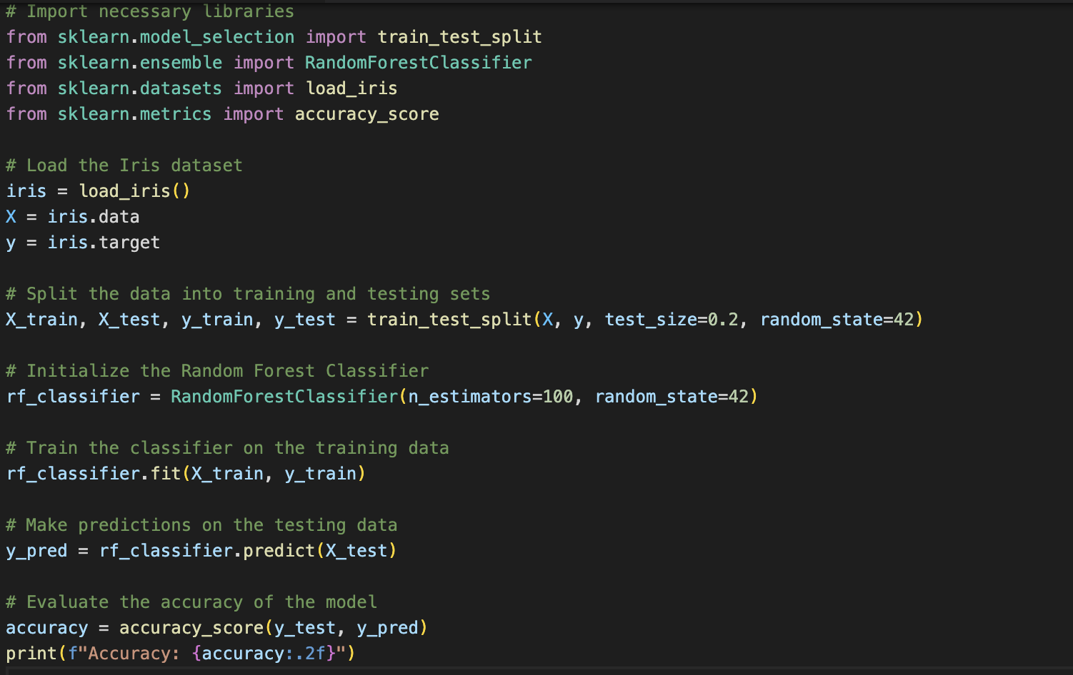

# **When to use it**

When dealing with huge datasets, a variety of characteristics, and the potential for overfitting when using individual decision trees, Random Forest is incredibly helpful. Because of its adaptability, it is a favoured option in many fields where structured data with several attributes is common.

Large Datasets:

Random Forest is well-suited for handling huge datasets due to its ensemble methodology. It effectively handles the complexity of large datasets by building several decision trees on various subsets of the data, preventing the model from becoming unduly specialised and improving its generalisation to new, unseen examples.

Diverse Features:

Random Forest performs well when datasets show a broad range of attributes with different levels of significance. The algorithm's capacity to construct trees using any feature subsets guarantees the capture of intricate relationships within the data, hence reducing the possibility of attribute-specific bias.

Possibility of Overfitting:

When overfitting with single decision trees is a concern, Random Forest is very helpful. The ensemble nature, which is attained by combining several trees, helps to reduce the eccentricities of individual trees, producing a more resilient model that is less susceptible to noise and outliers.

Relevance Throughout Domains:

Applications for Random Forest can be found in many different fields, including marketing, finance, and healthcare. It can handle complex financial data with many variables and be used in finance for fraud detection and credit rating. The algorithm is excellent at forecasting illness risk in the healthcare industry based on a variety of patient variables. Similar to this, in marketing, where datasets frequently include several attributes, it works well for customer segmentation and consumer behaviour prediction.

In conclusion, Random Forest is a great option for handling huge, varied datasets from a range of fields. Its resistance to overfitting and dexterity in navigating complex data structures make it an effective and adaptable tool for handling challenging predictive modelling problems.

# **Where not to use it**

Despite its adaptability, Random Forest might not be the best option in all circumstances, especially if interpretability or real-time processing are crucial.

Applications in Real Time:

The ensemble of decision trees that Random Forest creates is mostly responsible for its computational intensity, which is one of its limitations. The time required to train and implement a Random Forest model could be a barrier in real-time applications where prompt decision-making is essential. For situations needing quick answers, other algorithms that provide faster predictions—like more straightforward decision trees or linear models—might be more appropriate.

Interpretability:

Although Random Forest's ensemble approach improves prediction accuracy, it also adds complexity to the model. Because so many trees contribute to the final forecast, it might be difficult to understand how a Random Forest model makes its decisions. Simpler models with more understandable explanations may be favoured in circumstances where interpretability is essential, such as in legal or regulatory contexts.

Resource Constraints:

While Random Forest excels at managing massive datasets, it can also be a hindrance in situations where resources are scarce. Limited processing power or memory systems may face difficulties when training and maintaining an ensemble of decision trees due to the computational demands. Other algorithms that need less resources might be more appropriate in these situations.

Expenses for Tiny Datasets:

The overhead of creating an ensemble of decision trees may outweigh the advantages for datasets that are relatively small. Without the extra complexity of Random Forest, simpler models or algorithms designed for smaller datasets might perform comparably in similar situations.

In conclusion, Random Forest performs well in many scenarios, but it is less appropriate for real-time applications, circumstances where it is necessary to provide clear explanations for the model, and environments with limited resources due to its computational intensity, interpretability issues, and potential overhead. Selecting the appropriate algorithm is contingent upon the particular demands and limitations of the given problem.

# **References**

1. IBM DeveloperWorks - https://www.ibm.com/developerworks/library/ba-data-mining-techniques/
2. Data Science Central - https://www.datasciencecentral.com/profiles/blogs/the-7-most-important-data-mining-techniques
3. DigitalOcean - https://www.digitalocean.com/community/tutorials/a-comparison-of-nosql-database-management-systems-and-models