Name: Kartik Vedi Student ID: 300374518  
CSIS 4260 Section:001 Seminar: 2

# Topic: Beautiful Soup: A Powerful Tool for Web Scraping and Data Extraction

# Executive Summary

A robust Python module called Beautiful Soup is an essential resource for web scraping and data extraction from HTML pages. This session explores the complex world of Beautiful Soup, revealing its features and throwing light on both its many uses and constraints. The library offers an intuitive user interface that makes it easier to navigate websites and decipher HTML structures.

We will delve into the nuances of Beautiful Soup and highlight its benefits over hand scraping throughout the presentation. Through an exploration of real-world scenarios, attendees will get a practical comprehension of how Beautiful Soup may substantially improve the effectiveness and precision of web data extraction. Users may easily gather, examine, and work with data from the web with Beautiful Soup's assistance, from tag selection to navigation and data manipulation.

We'll talk about a few important topics, including Beautiful Soup's tool compatibility. Attendees will learn about the smooth integration of Beautiful Soup with other Python modules, including requests for content fetching from websites. We'll also go over situations where writing bespoke code could be required to address certain difficulties with web scraping. The goal of this session is to provide attendees a thorough understanding of Beautiful Soup so they may use it to their advantage when extracting data from websites.

# Main Idea

Beautiful Soup works like a delicious soup, breaking down HTML's complexity into easily ingested components. It offers numerous functions, such as:

Tag Selection: You can identify and extract information from certain items by using selectors such as CSS, IDs, classes, or tag names. Imagine picking out your favourite components by skimming the soup!

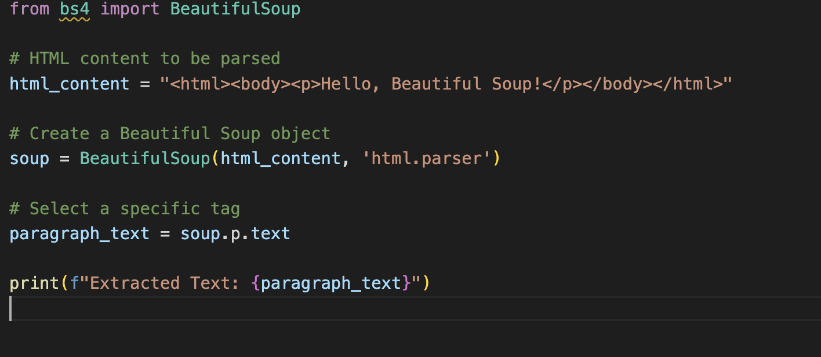

Navigation: Navigating the HTML tree structure is like to a chef navigating a kitchen; just move between tags to find the information you require.

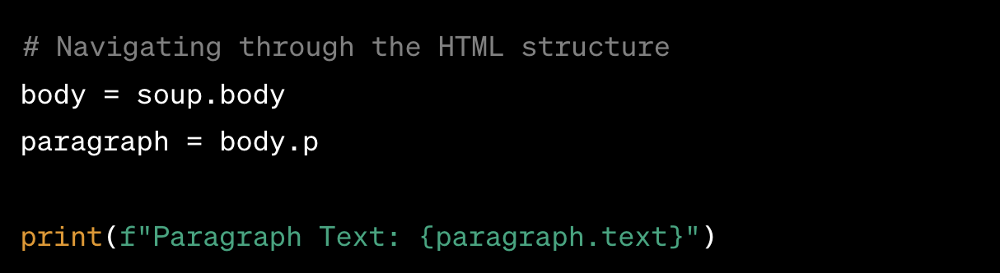

Data extraction: It is the process of taking important information out of HTML elements, such as text, links, and attributes. Consider it as gathering the tasty pieces from the soup.

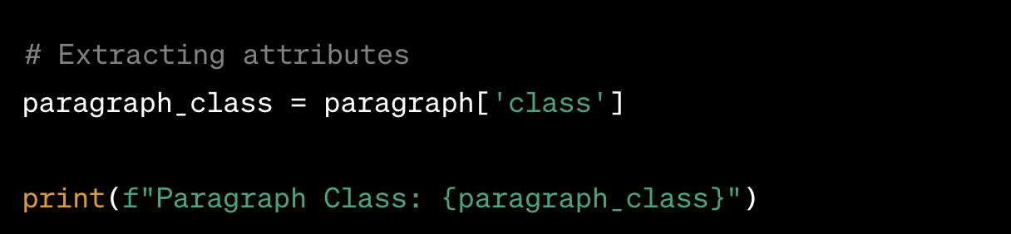

Manipulation: Make changes to the extracted data, tidy it up, and prepare it for additional processing or analysis. It's similar to assembling the components of a tasty meal.

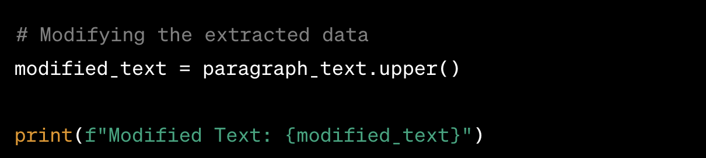

Beautiful Soup offers several advantages over manual scraping:

Efficiency: When compared to manual parsing, it saves a great deal of time and work.

Accuracy: When compared to manual data extraction, it minimises errors and inconsistencies.

Scalability: It has the ability to effectively and efficiently manage massive volumes of data.

Flexibility: It offers a large number of features and is compatible with different kinds of data.

As an illustration:

1.Scraping product information from e-commerce websites.

2.Extracting news articles and headlines.

3.Collecting social media data for analysis.

4. Downloading images and other multimedia content.

**When to Use Beautiful Soup**

Beautiful Soup emerges as the ideal solution in various scenarios where web data extraction is paramount. Its versatility and effectiveness become particularly evident in the following situations:

1. **Unstructured Data Formats like HTML:** Beautiful Soup shines when dealing with unstructured data formats, primarily HTML. It excels at parsing and navigating through HTML documents, providing a systematic approach to extracting valuable information. Whether it's scraping text, links, or attributes, Beautiful Soup simplifies the process, making it a go-to tool for handling HTML data.
2. **Repetitive Tasks Involving Data Extraction from Multiple Web Pages:** In cases where data extraction tasks are repetitive and involve multiple web pages, Beautiful Soup offers a streamlined solution. Its ability to automate the extraction process saves time and effort compared to manual approaches. By creating scripts that utilize Beautiful Soup, users can efficiently scale their web scraping operations across numerous pages, ensuring consistent and accurate results.
3. **Situations Where Manual Scraping is Impractical or Time-Consuming:** Beautiful Soup becomes indispensable when manual scraping becomes impractical or time-consuming. In scenarios where a large volume of data needs to be collected swiftly, manual extraction becomes a bottleneck. Beautiful Soup's automation capabilities, combined with its efficient parsing algorithms, make it a practical choice for expediting the data extraction process.
4. **Analyzing Web Content for Research or Business Intelligence Purposes:** For research or business intelligence endeavors that involve analyzing web content, Beautiful Soup stands out. It facilitates the extraction of relevant information from websites, enabling researchers and analysts to gather data for insights, trends, and informed decision-making. Beautiful Soup's flexibility and ease of use make it a valuable asset in the exploration and extraction of web-based knowledge.

In essence, Beautiful Soup proves to be an invaluable tool in situations where web data extraction demands precision, efficiency, and adaptability. Its applicability extends across diverse domains, providing a robust solution for users dealing with varying characteristics of web data.

**Where Not to Use Beautiful Soup**

Despite its effectiveness, Beautiful Soup may not be the optimal choice in certain situations. Here are scenarios where its usage might be less suitable:

1. **Dynamic Websites:** Beautiful Soup is not the preferred tool for scraping dynamic websites that heavily rely on JavaScript to render content. As it primarily parses static HTML content, dynamic web pages that load data dynamically may not be fully accessible. In such cases, using tools like Selenium, which can interact with JavaScript-driven elements, becomes necessary for comprehensive data extraction.
2. **Complex Data Structures:** Highly intricate HTML structures or deeply nested data may pose challenges for Beautiful Soup. While the library excels in handling typical HTML layouts, extremely complex structures might require custom parsing techniques. In such instances, developers might need to resort to more specialized approaches tailored to the specific intricacies of the data format.
3. **Ethical Considerations:** Beautiful Soup, like any web scraping tool, must be used ethically and in compliance with website terms of service. Respect for ethical considerations is paramount. Web scraping without permission, especially in violation of a site's robots.txt file, could lead to legal issues. Users should be cautious, ensuring that their scraping activities adhere to ethical guidelines and respect the policies set forth by the websites being scraped.

Understanding these limitations helps users make informed decisions about when to opt for Beautiful Soup and when alternative solutions may be more suitable. While it excels in various scenarios, acknowledging its boundaries ensures responsible and effective use in web scraping endeavors.

**References**

* Beautiful Soup Documentation: <https://www.crummy.com/software/BeautifulSoup/bs4/doc/>
* Tutorial: Web Scraping with Beautiful Soup: <https://realpython.com/courses/web-scraping-beautiful-soup/>
* Case Study: Extracting Product Data from Amazon: <https://medium.com/analytics-vidhya/web-scraping-a-to-z-using-scrapy-6ece8b303793>