Name: Kartik Vedi Student ID:400474518  
CSIS 4260 Section:01 Seminar: 3

# Topic: Text Mining

# Executive Summary

Text mining is a flexible and dynamic field that weaves through many different domains in the everchanging field of data science, including social media evaluation, machine translation, chatbots, deep learning for text analysis, text generation, and information extraction/sentiment analysis. This lecture is a thorough investigation into the various facets of text mining with the goal of revealing the subtleties of the instruments, uses, and algorithms that characterise its usefulness.

During the lecture, participants will learn about the various tools used in text mining and their distinct features and uses. The selected routes demonstrate how flexible the technology is to many types of data analytics requirements, from the semantic analysis capabilities of SwissText to the sentiment analysis capabilities of tools such as TextBlob. The story also touches on the uses of text mining, highlighting the ways in which it is revolutionising industries like customer service with chatbots, delivering sophisticated insights via semantic analysis, and assessing public opinion through sentiment analysis.

Crucially, the seminar delves into the heart of text mining by elucidating its algorithms. It unveils the inner workings of Natural Language Processing (NLP), a cornerstone for tools like IBM Watson and Microsoft Azure Bot Service in the domain of chatbots. Through this exploration, the seminar aims to humanize the intricate world of text mining, offering insights into the tools' practical implications, the expansive applications across industries, and the fundamental algorithms shaping the technology's trajectory. Ultimately, it serves as a guiding beacon for understanding the transformative potential of text mining within the broader landscape of data science.

**Tools Used: Chatbots in Text Mining**

A key component of the text mining industry, chatbots use a variety of technologies to build conversational agents that can comprehend and reply to user inquiries. Microsoft Azure Bot Service and IBM Watson Assistant are two of the most well-known technologies in this field.

IBM Watson Assistant: This powerful tool for creating chatbots with sophisticated natural language processing (NLP) features is IBM Watson Assistant. It gives programmers the ability to create chatbots that can understand the intent of users, enabling dynamic and context-aware conversations. Because IBM Watson Assistant is compatible with several channels, it can be seamlessly integrated with chat apps, websites, and mobile apps. It continuously improves its grasp of linguistic subtleties by utilising machine learning, which makes it skilled at processing a variety of human inputs.

As an illustration, consider an IBM Watson Assistant-built chatbot for online shopping. "Can you help me find a pair of running shoes?" asks a user. By utilising natural language processing (NLP) techniques, the chatbot deciphers the user's intent and initiates a conversation to ascertain certain preferences, including colour, size, and brand. This demonstrates how the tool can comprehend and respond to intricate user requests.

The Microsoft Azure Bot Service is an additional crucial element for the development of chatbots. It provides a thorough foundation for creating intelligent bots that function well with a variety of apps, such as Skype and Microsoft Teams. With the help of Azure Bot Service's user-friendly interface, developers can create chatbots with little to no code. It facilitates the quick development process by supporting the integration of conversational elements and pre-built templates.

Consider an e-commerce website with a customer support chatbot installed via Microsoft Azure Bot Service. A user asks how an order is progressing. With the use of Azure's natural language processing (NLP) capabilities, the chatbot gathers pertinent data from the database and gives the user real-time updates on their order, demonstrating how the tool can be used to improve customer care.

NLP Algorithms: The application of Natural Language Processing (NLP) algorithms is essential to chatbot functionality. These algorithms facilitate efficient communication by enabling machines to comprehend, interpret, and produce writing that resembles that of a person. NLP is essential to chatbots because it helps them understand user input and provide sophisticated responses.

For instance, when a user types in a question such as "What are the latest promotions?" an NLP algorithm analyses the text, finds important terms, and deduces the question's purpose. The chatbot can then produce an appropriate answer that highlights current sales or exclusive deals.

Essentially, NLP algorithms are used by chatbot development platforms like Microsoft Azure Bot Service and IBM Watson Assistant to generate intelligent, context-aware bots that can improve user experiences in a variety of industries.

Chatbot Applications for Text Mining

Text mining-driven chatbots have shown to be extremely useful in a wide range of businesses due to their capacity to adapt to different kinds, domains, and characteristics of data.

1. Customer service: Chatbots are useful for offering round-the-clock assistance in the field of customer service. Chatbots use text mining algorithms to comprehend client inquiries, analyse them, and provide timely and correct responses. This app guarantees quick response to inquiries, increasing client satisfaction by providing round-the-clock support.
2. **E-commerce:** E-commerce platforms harness chatbots to revolutionize the shopping experience. Through text mining, these chatbots analyze user preferences, past purchases, and browsing behavior to provide personalized recommendations. By guiding users through product selections and answering inquiries in real-time, chatbots contribute to a more engaging and user-friendly shopping journey.
3. **Healthcare:** In the healthcare domain, chatbots driven by text mining play a crucial role in appointment scheduling, medication reminders, and health information dissemination. Text mining algorithms help in understanding patient queries, extracting relevant information, and delivering accurate responses. Chatbots in healthcare streamline administrative processes, improve medication adherence, and disseminate health-related information efficiently.These applications highlight the versatility of chatbots in handling different types of data, ranging from customer inquiries and preferences to healthcare-related information. The adaptability of text mining techniques enables chatbots to navigate various domains, making them indispensable tools for enhancing user experiences, improving operational efficiency, and providing valuable support across diverse industries.

Natural Language Processing (NLP) in Chatbots: An Algorithm Explanation

Natural Language Processing (NLP) is a powerful algorithm that is at the heart of chatbot creation. It allows the bot to read user input and respond to it in a way that is human-like. Sentiment analysis, a popular use of NLP in chatbots, involves the algorithm identifying the emotional tenor of user inquiries. Let's examine a useful coding example that makes use of the TextBlob package and Python.

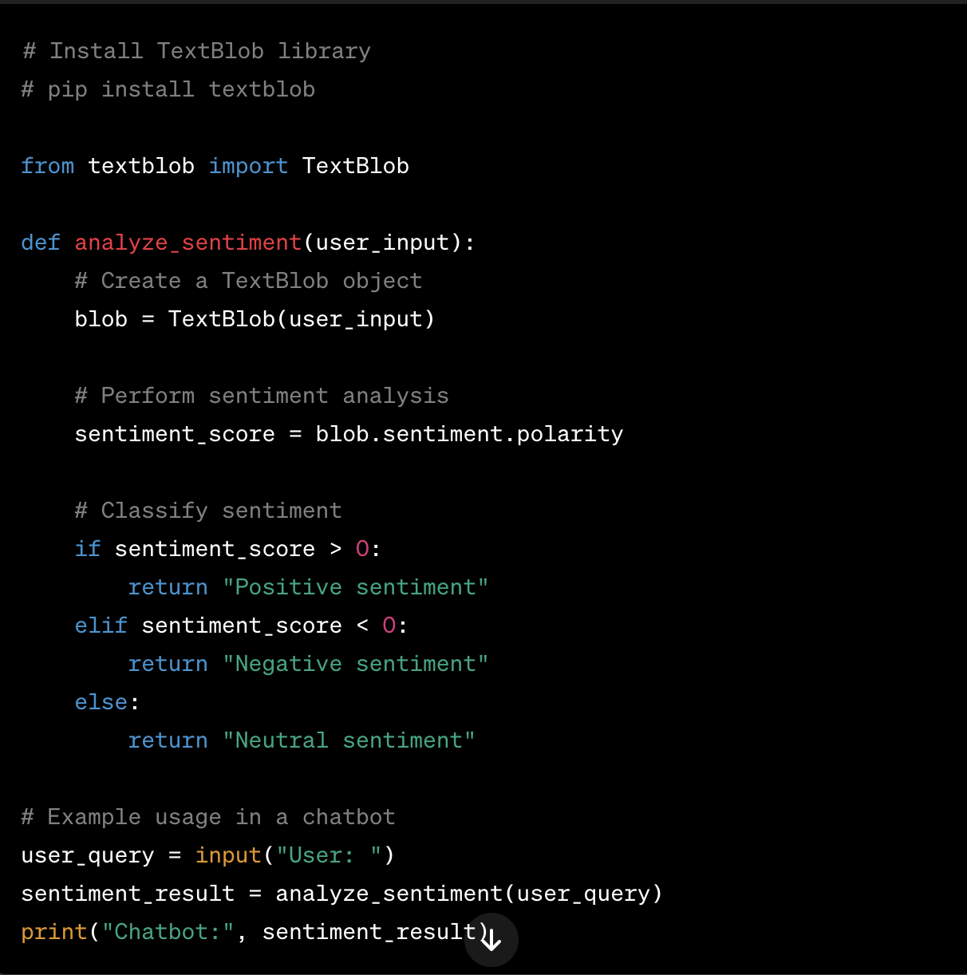

The TextBlob package makes sentiment analysis easier in this scenario. After analysing the user's input for sentiment polarity, the TextBlob class returns a number score. Based on the score, the chatbot then categorises the sentiment as neutral, negative, or positive.

This bit of code demonstrates how an NLP-based sentiment analysis method can be used in a chatbot. With libraries like spaCy or NLTK, similar techniques can be expanded to other NLP domains like entity recognition and intent understanding.

By incorporating these coding strategies, chatbots improve their overall efficacy and contribute to a more engaging user experience by learning to recognise and respond to the emotional nuanced questions that users pose.

# References

[https://www.predictiveanalyticstoday.com/top-free-software-for-text-analysis-text-mining-text-analytics/](https://www.predictiveanalyticstoday.com/top-free-software-for-text-analysis-text-mining-text-analytics/" \t "_blank)

<https://www.swisstext.org/#presentations>

<http://arxiv-sanity.com/>

<https://www.researchgate.net/>  <https://datascience.codata.org/> <https://www.engpaper.com/> <http://www.academia.edu/Documents/in/Data_Science>