ECO - BALANCE
Synopsis Report
Submitted by
EVA TOMAR
240935106093
In partial fulfillment for the award of the degree
Of
(BACHELOR OF COMPUTER APPLICATION)
UNDER THE GUIDANCE OF
Ms. Rashmi Vaishnav
At


INSTITUTE OF MANAGEMENT STUDIES GHAZIABAD
(UNIVERSITY COURSES CAMPUS)
NH-24, Adhyatmik Nagar, Ghaziabad (U.P)
(2024 – 2027)
Points to be Focused on in the Project Synopsis

BCA PROJECT SYNOPSIS
EcoBalance
A Data-Driven Sustainable Living and Resource Management Application
“Measure your impact. Save your resources. Give back to the environment.”
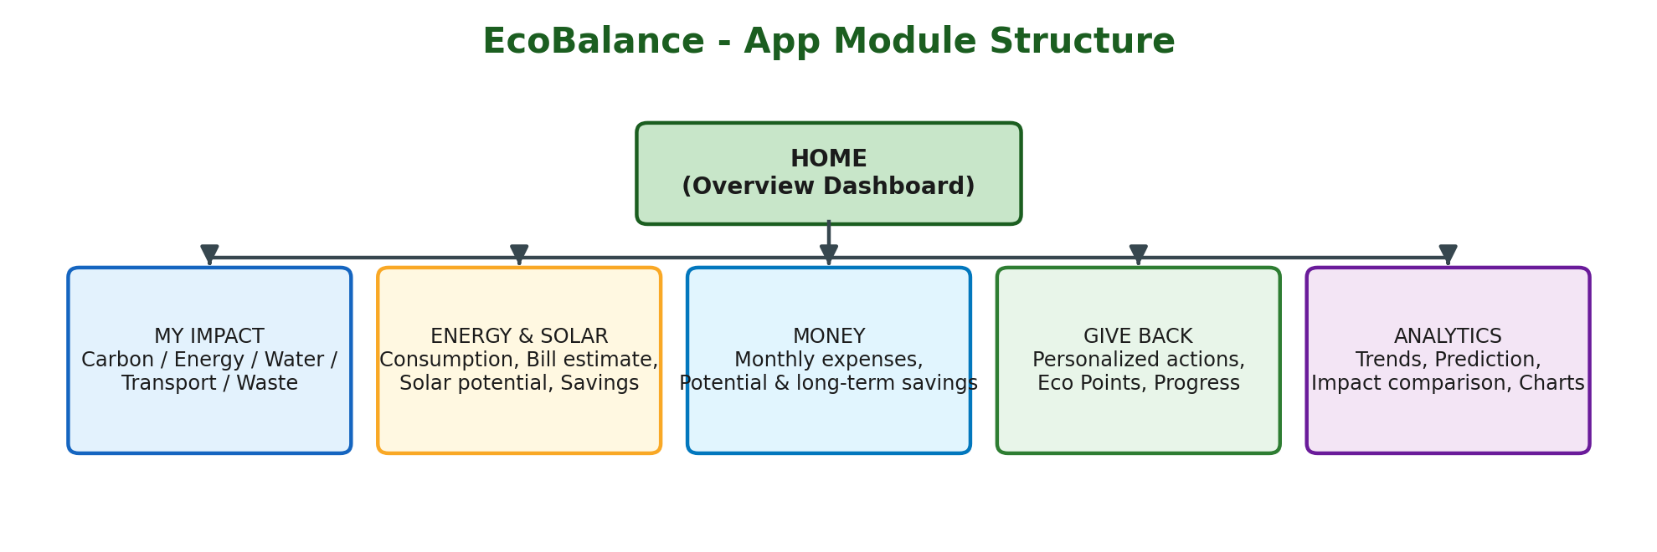

About the App
EcoBalance is an integrated web/mobile application designed to help individuals and households understand, manage, and reduce their environmental footprint while saving money in the process. Rather than treating sustainability as an abstract idea, EcoBalance converts everyday lifestyle inputs — electricity usage, water consumption, transportation habits, food and waste patterns, and paper usage — into clear, measurable insights.
The application is built around five core modules — My Impact, Energy & Solar, Money, Give Back, and Analytics — all accessible from a single home dashboard. Users log their monthly resource usage, and the system uses Python-based data processing and machine learning to calculate an overall Environmental Impact Score, estimate electricity bills and potential solar savings, track monthly expenses, and forecast next month's electricity consumption.
What makes EcoBalance distinct is its ‘Give Back to Nature’ engine: instead of generic sustainability advice, the app analyzes each user's specific usage pattern and recommends personalized actions — such as tree-care activities, e-waste recycling, or low-emission commuting — rewarding progress through an Eco Points system. In this way, the app connects three dimensions that are usually handled separately: environmental awareness, financial savings, and data-driven personalization, making it a genuine Data Science project rather than a simple utility calculator.
Fig. 1 — EcoBalance App Module Structure

1. Problem Statement
Individuals and households today have little visibility into their day-to-day environmental impact — electricity usage, water consumption, transportation habits, and waste generation are rarely tracked or analyzed together. As a result, people are unaware of how their lifestyle choices contribute to carbon emissions, nor do they know the financial cost of inefficient resource use. There is no easy-to-use, integrated system that helps individuals measure their environmental footprint, understand the associated costs, and receive personalized guidance on how to reduce both simultaneously.

2. Rationale for Selection of Topic
With rising environmental concerns, energy costs, and growing interest in sustainable living, there is a real need for tools that make sustainability measurable and actionable rather than abstract. Most existing apps focus on only one dimension — either carbon tracking or bill estimation or solar calculation — in isolation. This project is relevant because it combines environmental impact assessment, financial analysis, and data-driven personalization into a single application, giving users a practical reason (cost savings) alongside the ethical one (environmental responsibility) to adopt sustainable habits. It also allows the application of core BCA Data Science concepts — data collection, analysis, prediction, and recommendation — to a real-world, socially relevant problem.

3. Objectives of the Project
- To design a system that records and analyzes a user’s electricity, water, transportation, and waste-related data.
- To calculate an estimated environmental impact / carbon footprint score based on user-entered data.
- To estimate potential solar energy generation, electricity bill reduction, and payback period for a user’s household.
- To analyze and display monthly resource expenditure and identify areas of potential financial savings.
- To build a predictive model (using historical consumption data) that forecasts a user’s next-month electricity consumption.
- To generate personalized, data-driven sustainability recommendations (“Give Back to Nature” actions) based on each user’s usage pattern.
- To implement a gamified Eco Points / progress system to encourage continued sustainable behavior.

4. Scope of the Project
- The application covers five key resource domains: electricity, water, transportation, food/waste, and paper usage.
- Target users include students, households, and individuals interested in tracking and reducing their environmental and financial footprint.
- The current scope is limited to user-entered/estimated data (not live IoT sensor integration).
- All financial and environmental estimates (solar savings, carbon footprint, etc.) are approximations based on standard emission/cost factors and are clearly labeled as such.
Future Extensions:
- Integration with smart meters / IoT devices for real-time data.
- Location-based solar and weather API integration.
- Mobile app version built with Flutter.
- Social/community leaderboards and integration with local recycling or tree-plantation drives.

5. Methodology Adopted
The project follows a modular development approach combined with a standard Data Science pipeline. The overall development workflow proceeds as: User Input → Data Storage (Database) → Data Processing (Python) → Environmental/Financial Calculations → ML-based Prediction & Recommendation → Dashboard Visualization.
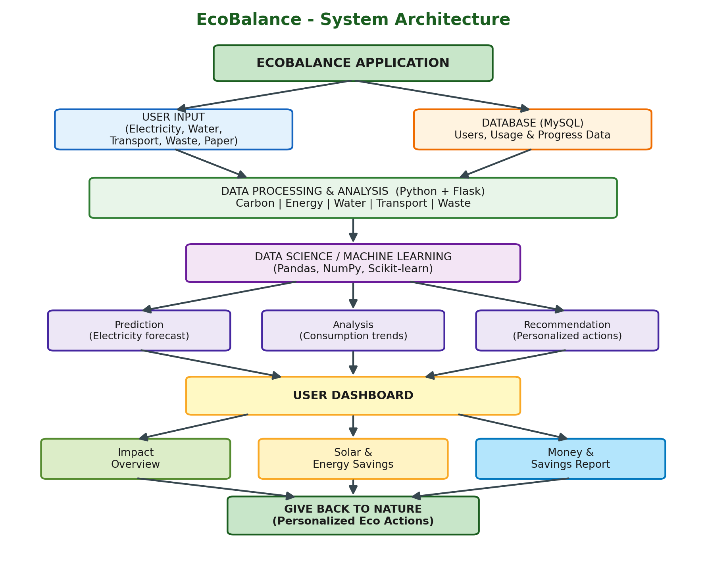
Fig. 2 — EcoBalance System Architecture
The Data Science component of the project follows the pipeline shown below:
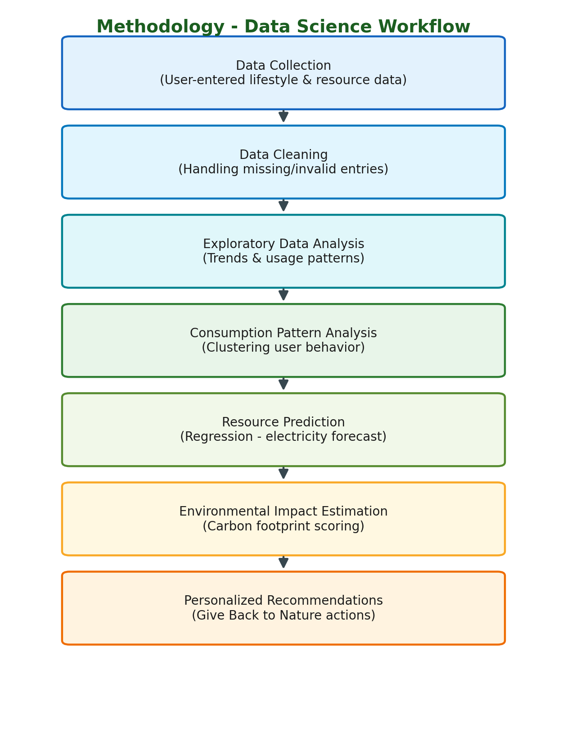
Fig. 3 — Data Science Workflow / Methodology
Key Techniques Used:
- Regression modeling (starting with Linear Regression, extendable to Random Forest / Decision Tree) for electricity consumption prediction.
- Clustering (e.g., K-Means) to group users by sustainability behavior patterns and tailor recommendations accordingly.
- Rule-based scoring system for the Eco Impact Score and recommendation engine.
- Agile/incremental development, starting with core calculator modules before layering ML-based prediction and recommendations.

6. Hardware and Software Requirements

Hardware Requirements
Processor | Intel i5 (or equivalent) and above
RAM | 8 GB minimum
Storage | 256 GB SSD (recommended)
Connectivity | Internet connection for API / dataset access

Software Requirements
Frontend | HTML, CSS, JavaScript (or Flutter for mobile app)
Backend | Python with Flask (REST API)
Data Science / ML | Python — Pandas, NumPy, Scikit-learn, Matplotlib / Plotly
Database | MySQL
IDE / Tools | VS Code, Jupyter Notebook, MySQL Workbench / XAMPP
Version Control | Git and GitHub

7. Testing Technologies / Approaches
- Unit Testing: Verifying individual functions (e.g., carbon footprint calculation, bill estimation formulas) return expected results.
- Integration Testing: Ensuring smooth data flow between frontend, Flask API, database, and ML modules.
- System Testing: End-to-end testing of the complete user flow — from data entry to dashboard output.
- Database Testing: Validating correct storage, retrieval, and updating of user records across tables.
- Model Validation / Testing: Measuring prediction accuracy of the electricity consumption model using metrics such as MAE/RMSE on test data.
- Usability Testing: Confirming that the dashboard and recommendations are clear and understandable to a non-technical user.
- Calculation Validation: Cross-checking system-generated estimates (solar savings, carbon impact) against manually computed sample cases.

8. Expected Contribution of the Project
EcoBalance is expected to provide users with a single, integrated platform that connects environmental awareness with tangible financial insight — a combination not commonly found in existing standalone carbon-tracking or solar-calculator tools. By using data-driven prediction and personalized recommendations rather than generic sustainability tips, the project demonstrates a practical application of Data Science techniques to real-world resource management. The system is expected to help users make informed, cost-conscious, and environmentally responsible decisions, while also serving as a scalable foundation for future enhancements such as IoT integration and real-time analytics.

