Linux Assignment Submission
Name: Kartik Zadokar
Date: 23-07-2026
GitHub Repository Link: https://github.com/kartikzadokar55-bot/tutedude-devops-course

1. Creating and Renaming Files/Directories
Commands:
mkdir test_dir
cd test_dir
touch example.txt
mv example.txt renamed_example.txt
pwd
ls -l
Explanation:
Created a directory named test_dir, created an empty file example.txt, and renamed it to renamed_example.txt using the mv command.
Screenshot:
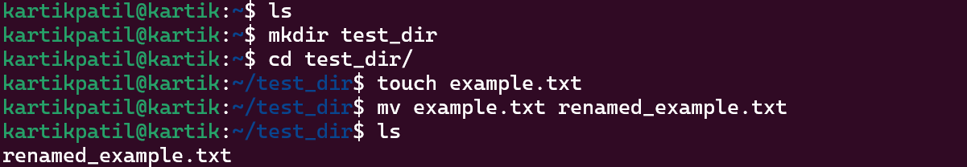

2. Viewing File Contents
Commands:
cat /etc/passwd
head -5 /etc/passwd
tail -5 /etc/passwd
Explanation:
Displayed the complete contents of /etc/passwd using cat, the first five lines using head, and the last five lines using tail.
Screenshot:
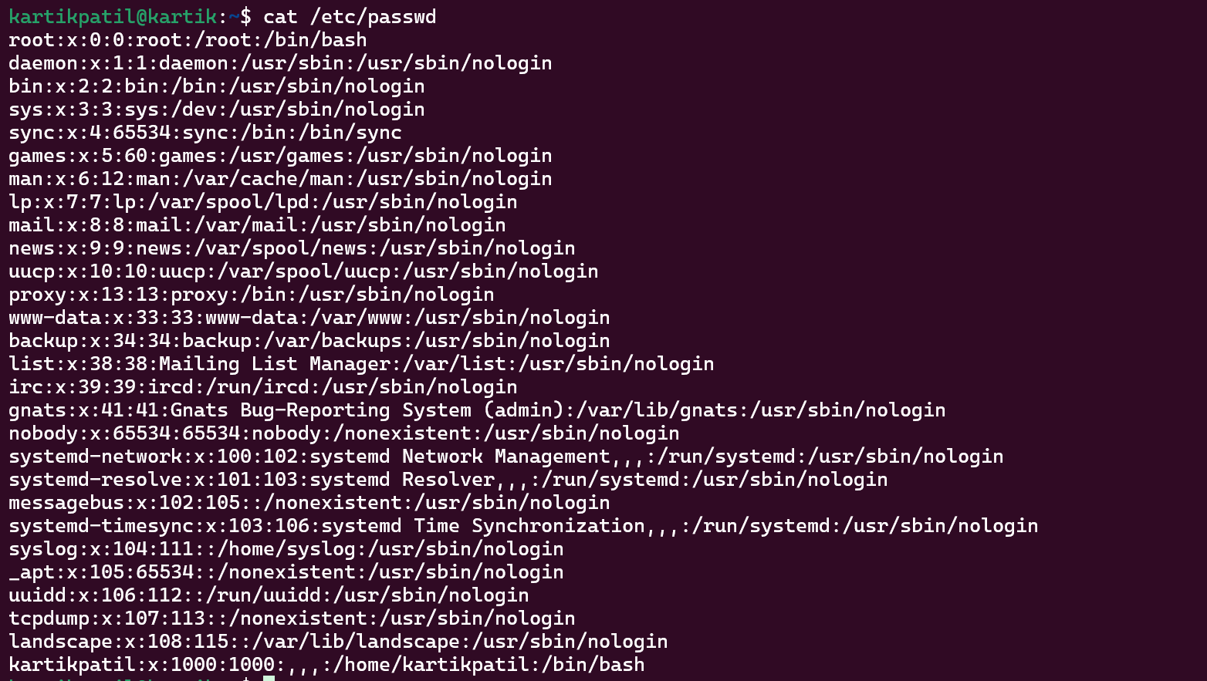
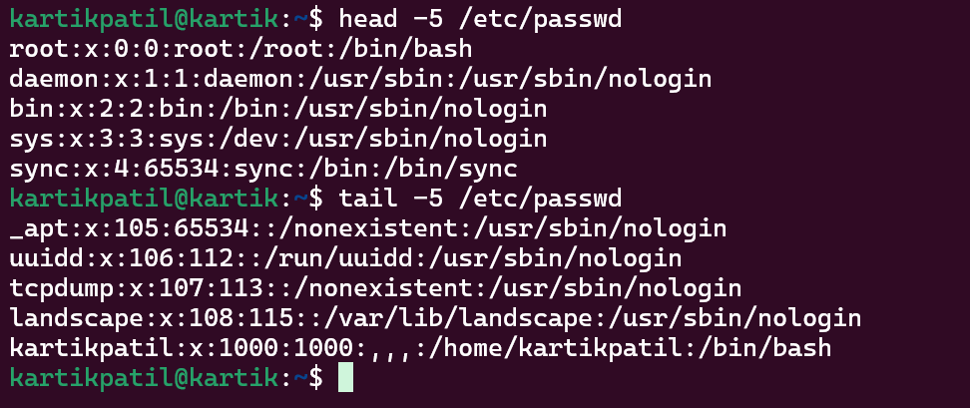

3. Searching for Patterns
Commands:
grep root /etc/passwd
Explanation:
Used grep to search for all lines containing the word 'root' in /etc/passwd.
Screenshot:

4. Zipping and Unzipping
Commands:
cd ..
zip -r test_dir.zip test_dir
mkdir unzipped_dir
unzip test_dir.zip -d unzipped_dir
Explanation:
Compressed the test_dir directory into a ZIP archive and extracted it into the unzipped_dir directory.
Screenshot:
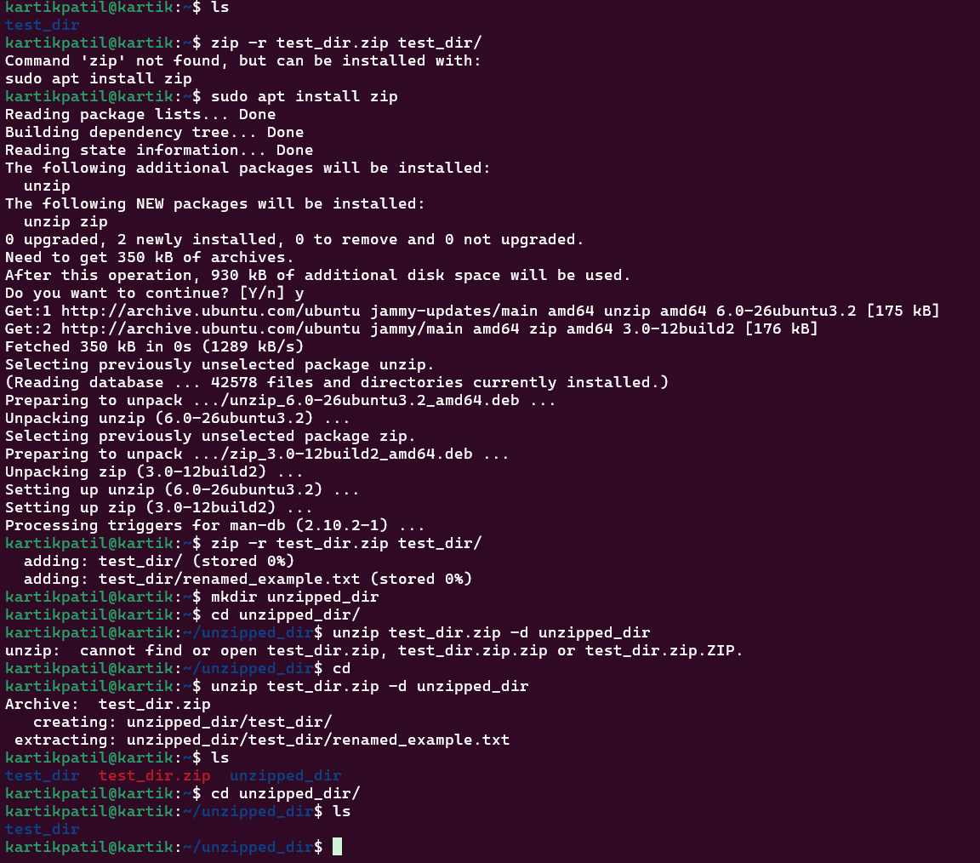

5. Downloading Files
Commands:
wget https://www.w3.org/TR/PNG/iso_8859-1.txt
Explanation:
Downloaded a sample text file from the internet using wget.
Screenshot:
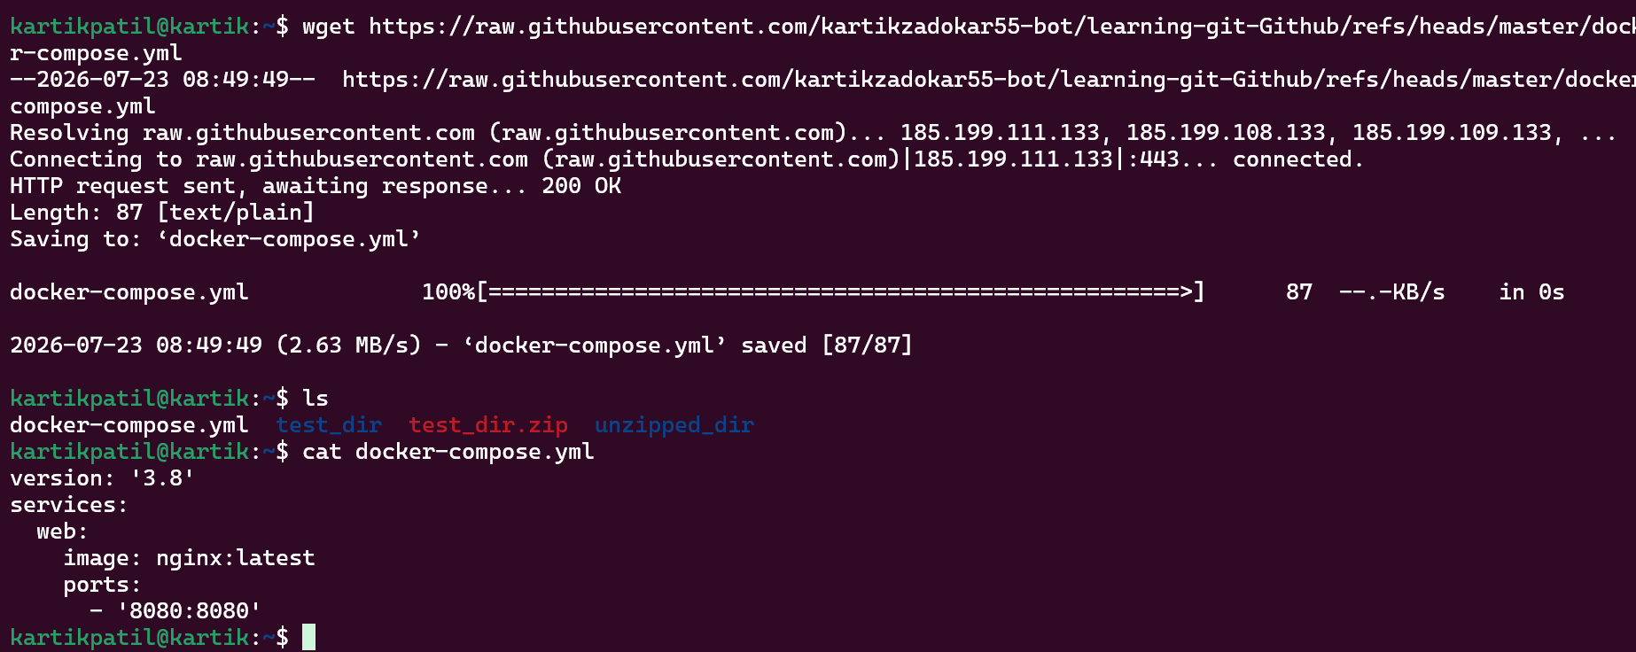

6. Changing Permissions
Commands:
touch secure.txt
chmod 444 secure.txt
ls -l secure.txt
Explanation:
Created a file named secure.txt and changed its permissions to read-only for everyone using chmod 444.
Screenshot:
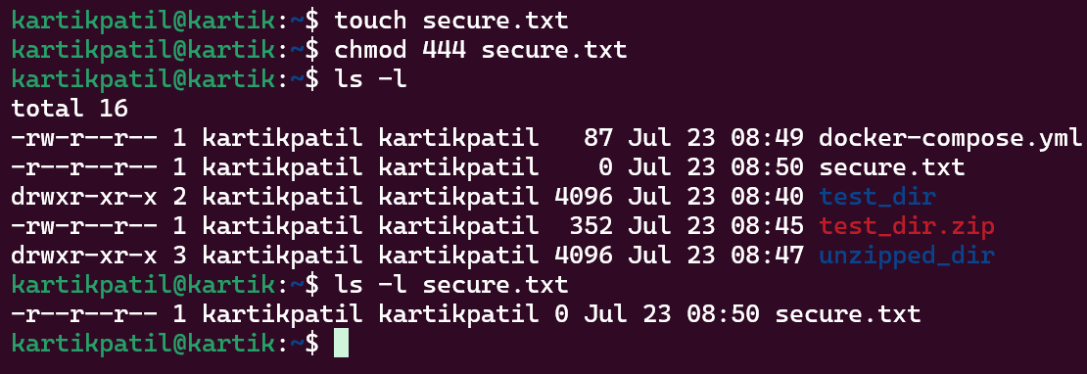

7. Working with Environment Variables
Commands:
export MY_VAR="Hello, Linux!"
echo $MY_VAR
Explanation:
Created an environment variable named MY_VAR and verified its value using echo.
Screenshot:
