1. Creating and Renaming Files/Directories
Create a directory named test_dir using mkdir.
Command : mkdir test_dir
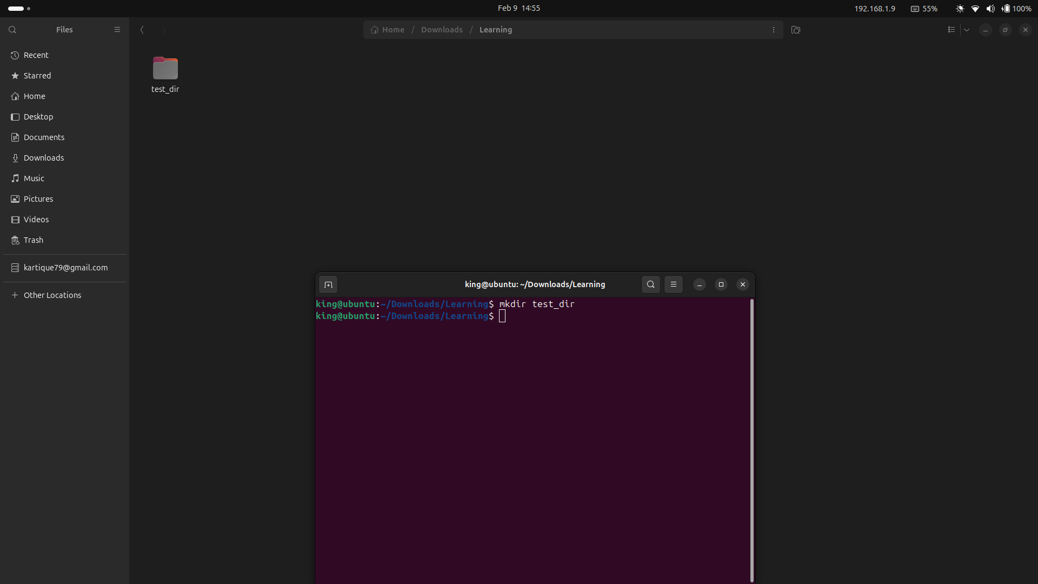
Inside test_dir, create an empty file called example.txt.
Commands : cd test_dir, touch example.text
can also create with touch test_dir/example.text
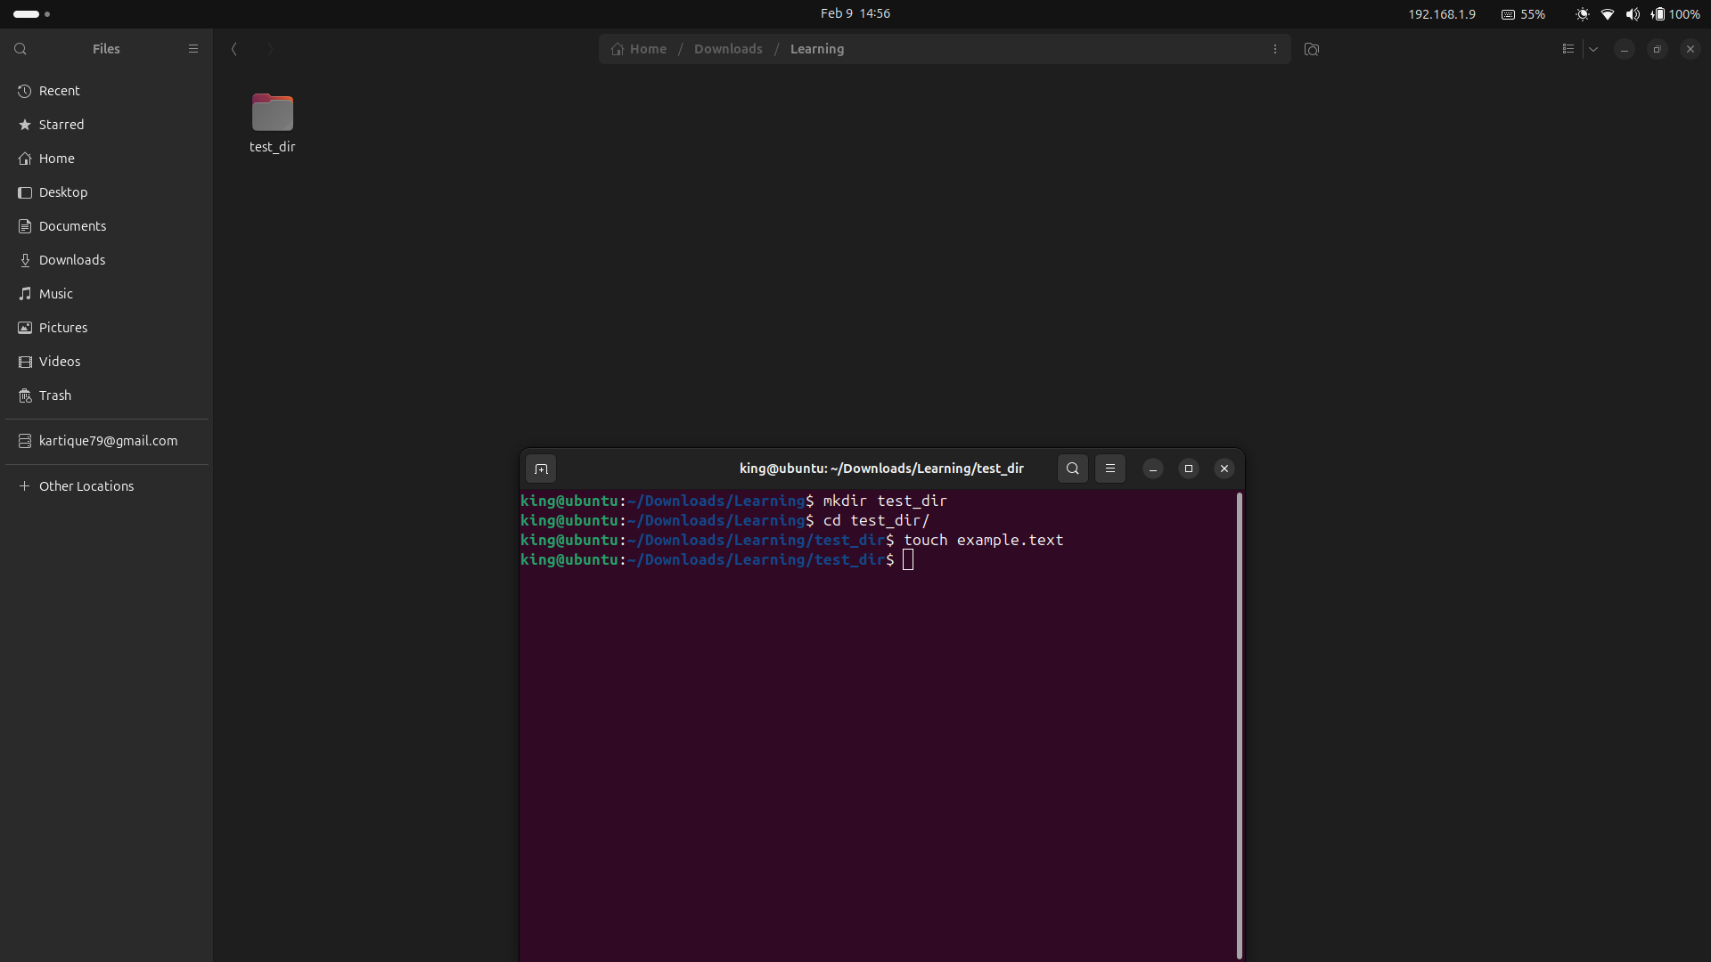
Rename example.txt to renamed_example.txt using mv
command : mv example.txt renamed_example.txt

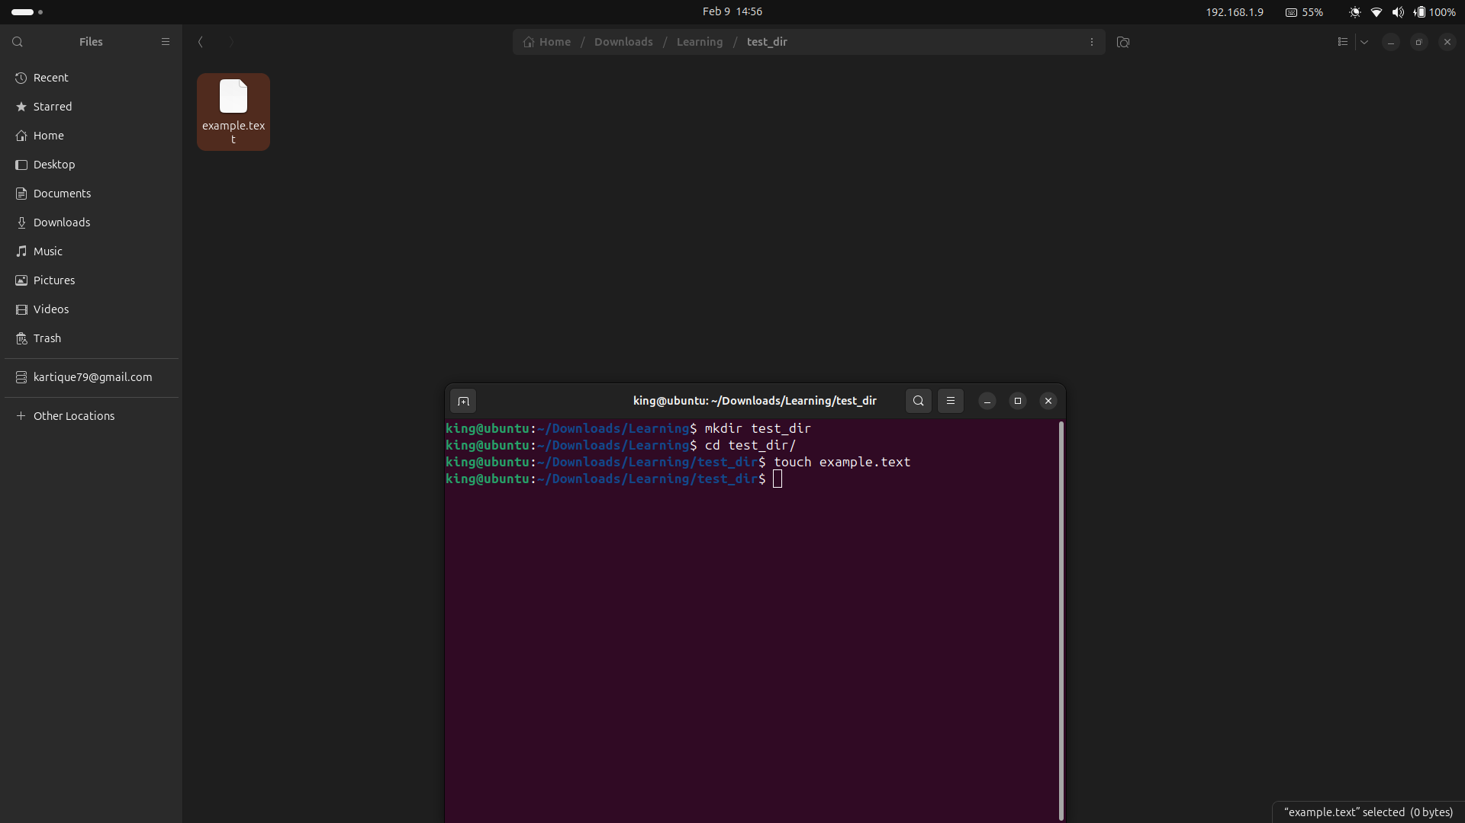
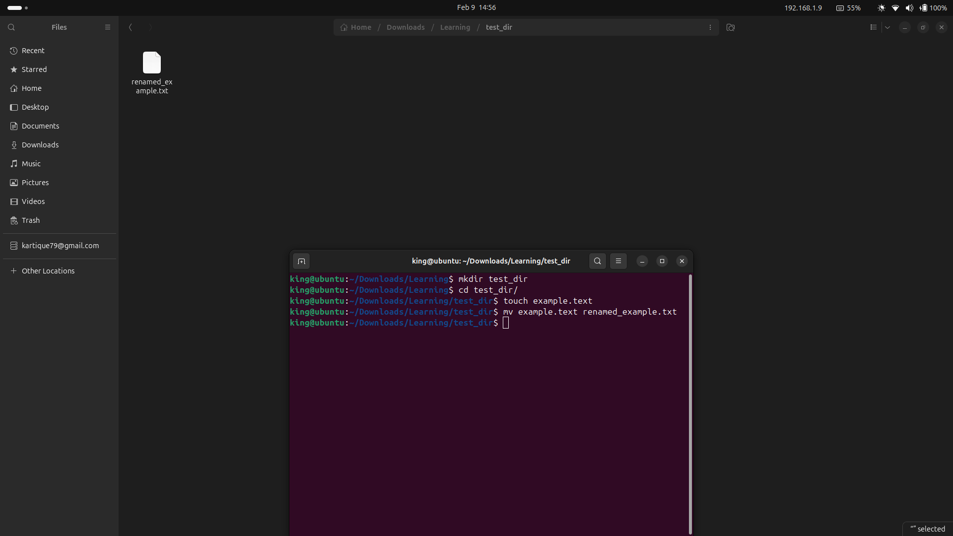

2. Viewing File Contents
Use cat to display the contents of /etc/passwd.
Cat /etc/passwd
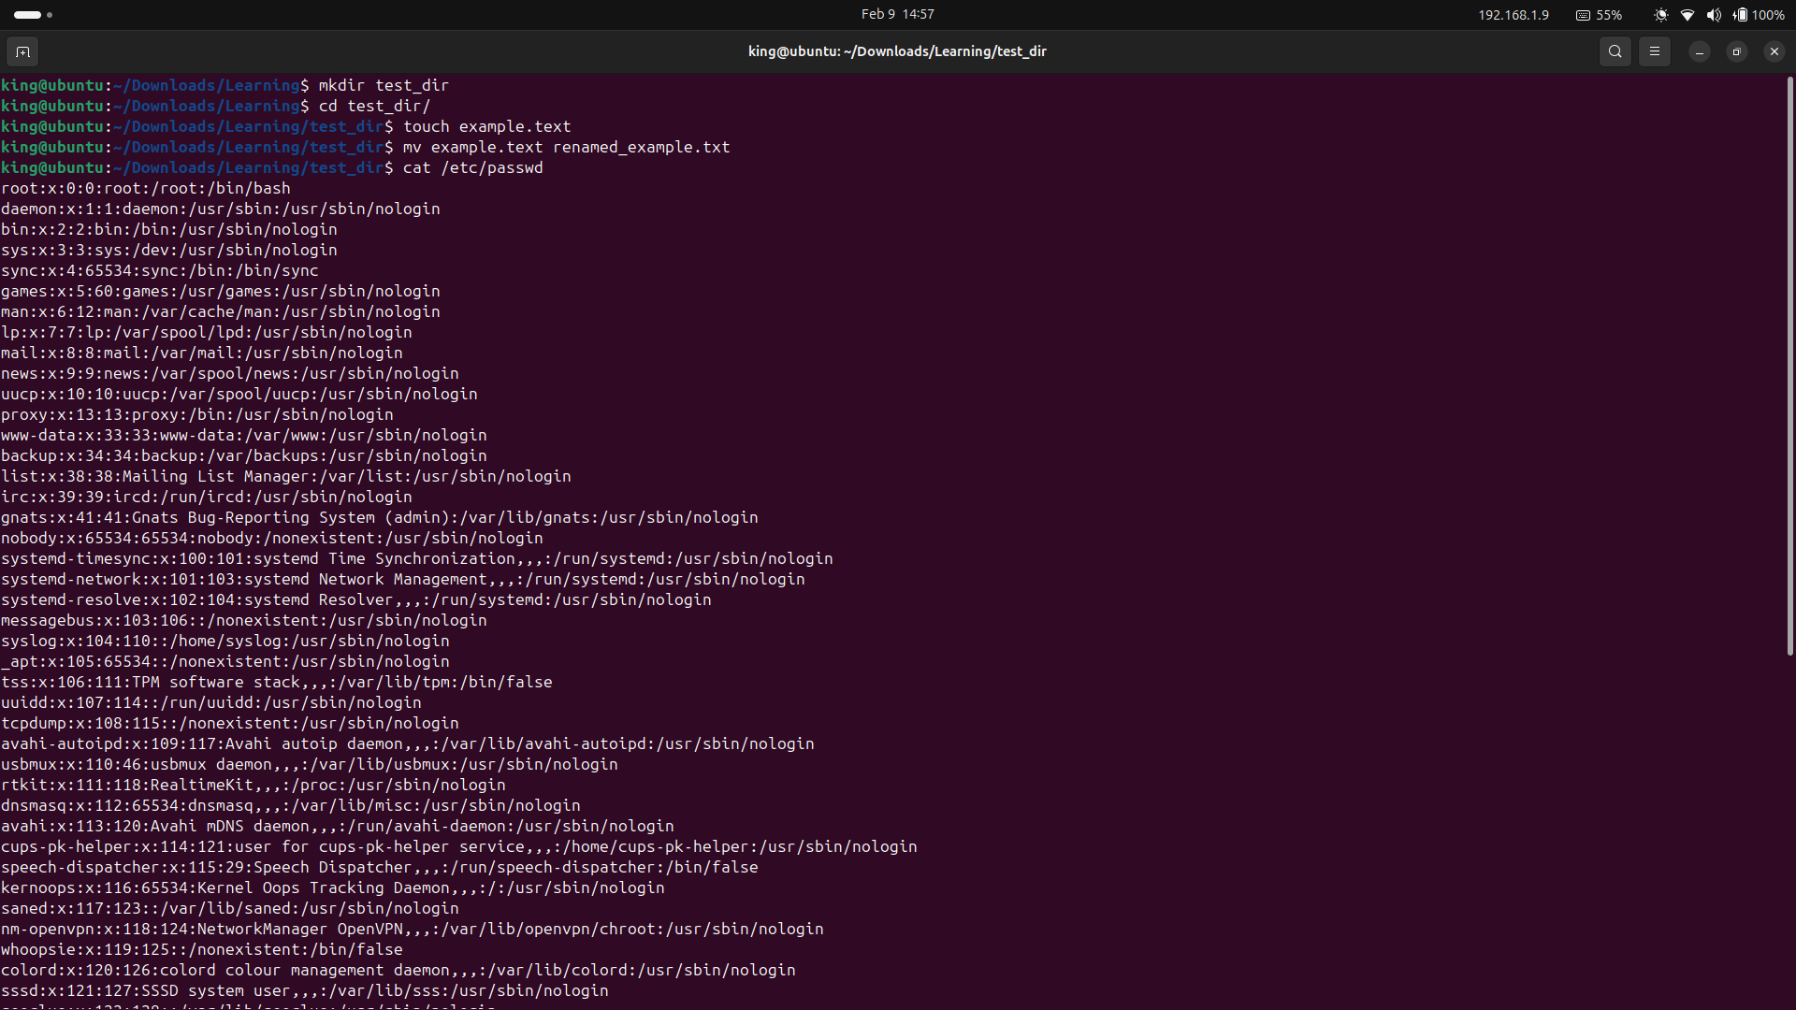
Display only the first 5 lines of /etc/passwd using head.
Command: head -n 5 /etc/passwd
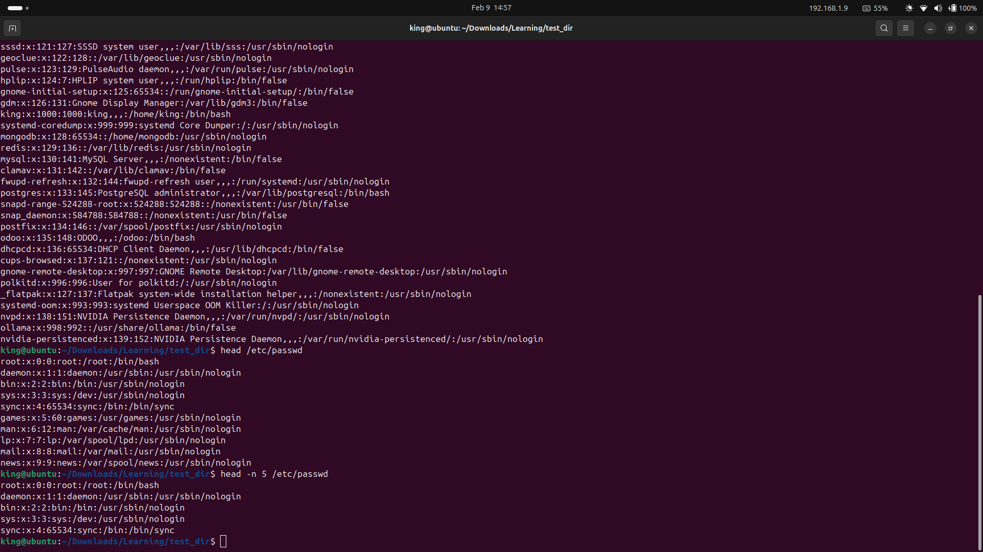
Display only the last 5 lines of /etc/passwd using tail.
Command: tail -n 5 /etc/passwd
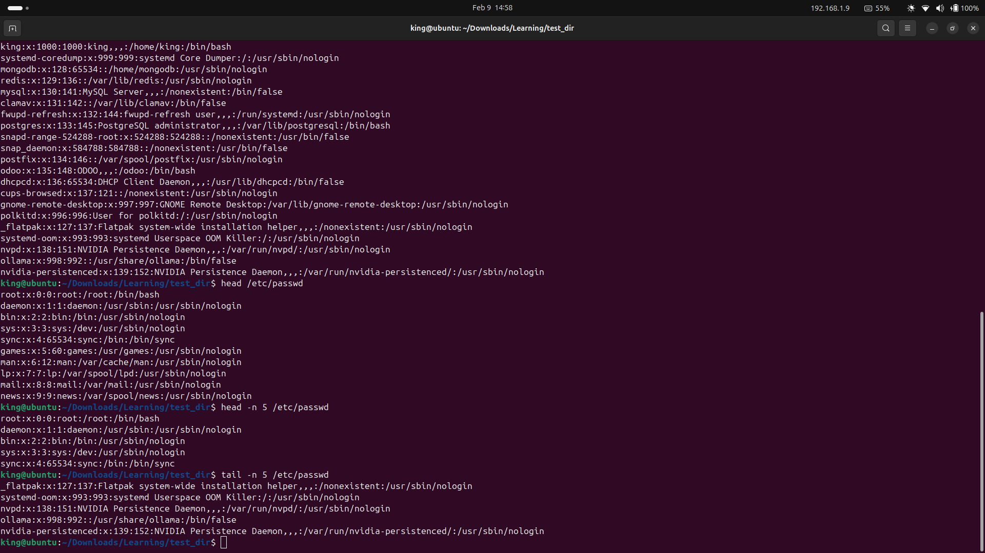
3.Searching for Patterns
Use grep to find all lines containing the word "root" in /etc/passwd.
Command: cat /etc/passwd | grep “root”

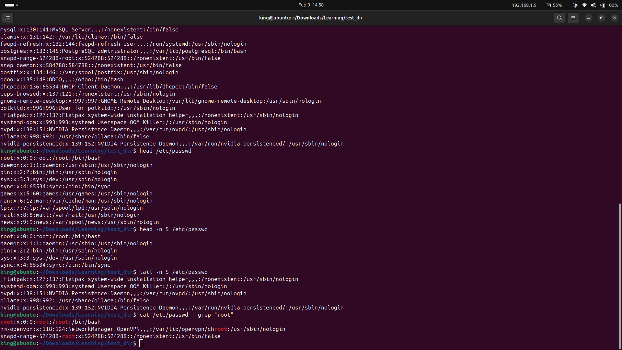
4. Zipping and Unzipping
Compress the test_dir directory into a file named test_dir.zip using zip.
Command: zip -r test_dir.zip test_dir
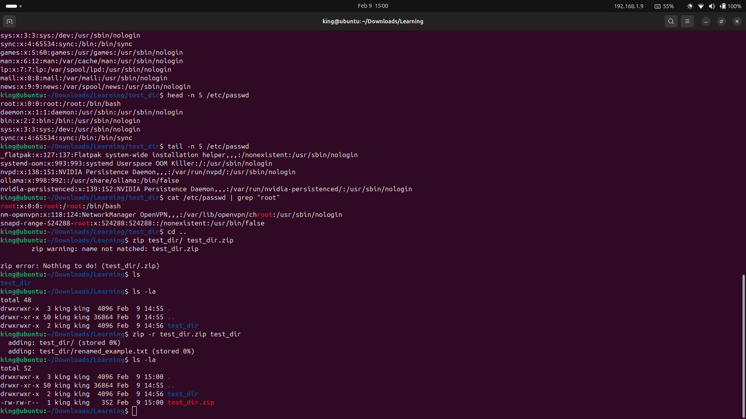
Unzip test_dir.zip into a new directory named unzipped_dir.
Command: unzip test_dir.zip
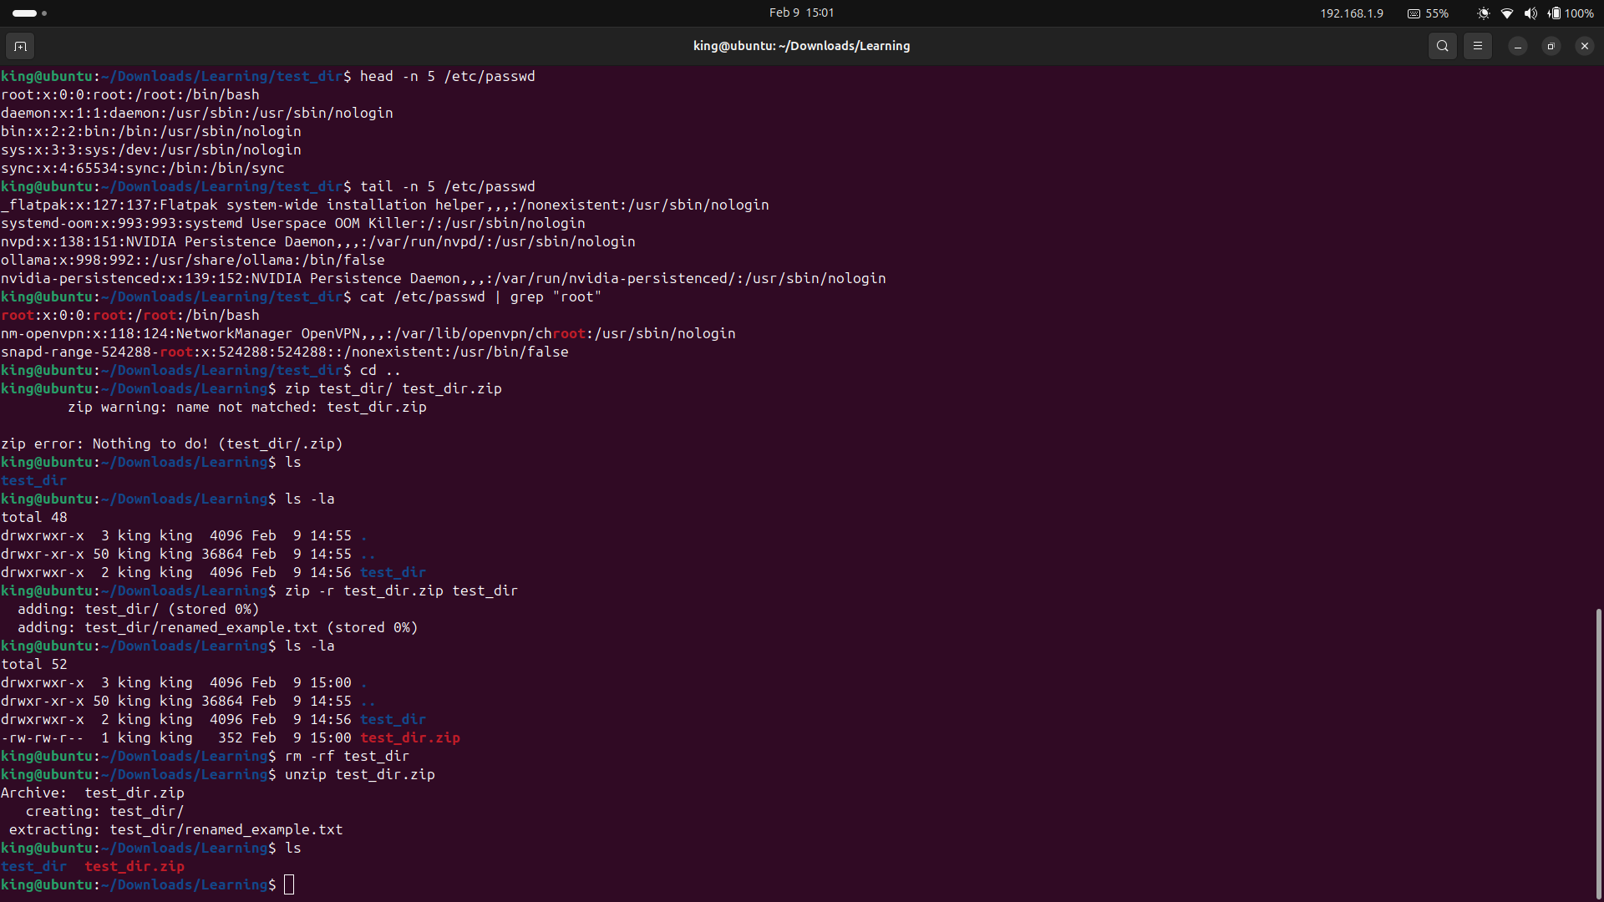

5. Downloading Files
Use wget to download a file from a URL (e.g., https://example.com/sample.txt).
Command: wget https://filesamples.com/samples/video/3gp/sample_1280x720_surfing_with_audio.3gp
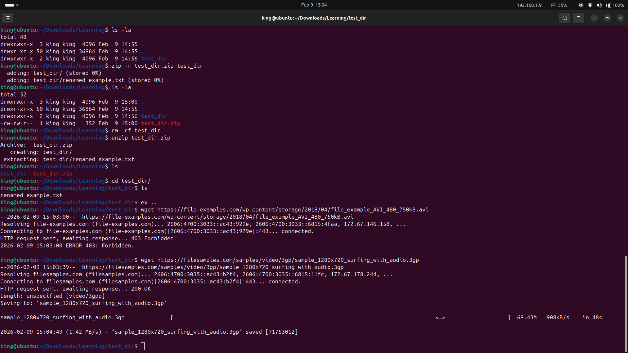
6. Changing Permissions
Create a file named secure.txt and change its permissions to read-only for everyone using chmod.
Command: touch secure.txt, chmod 444 secure.txt
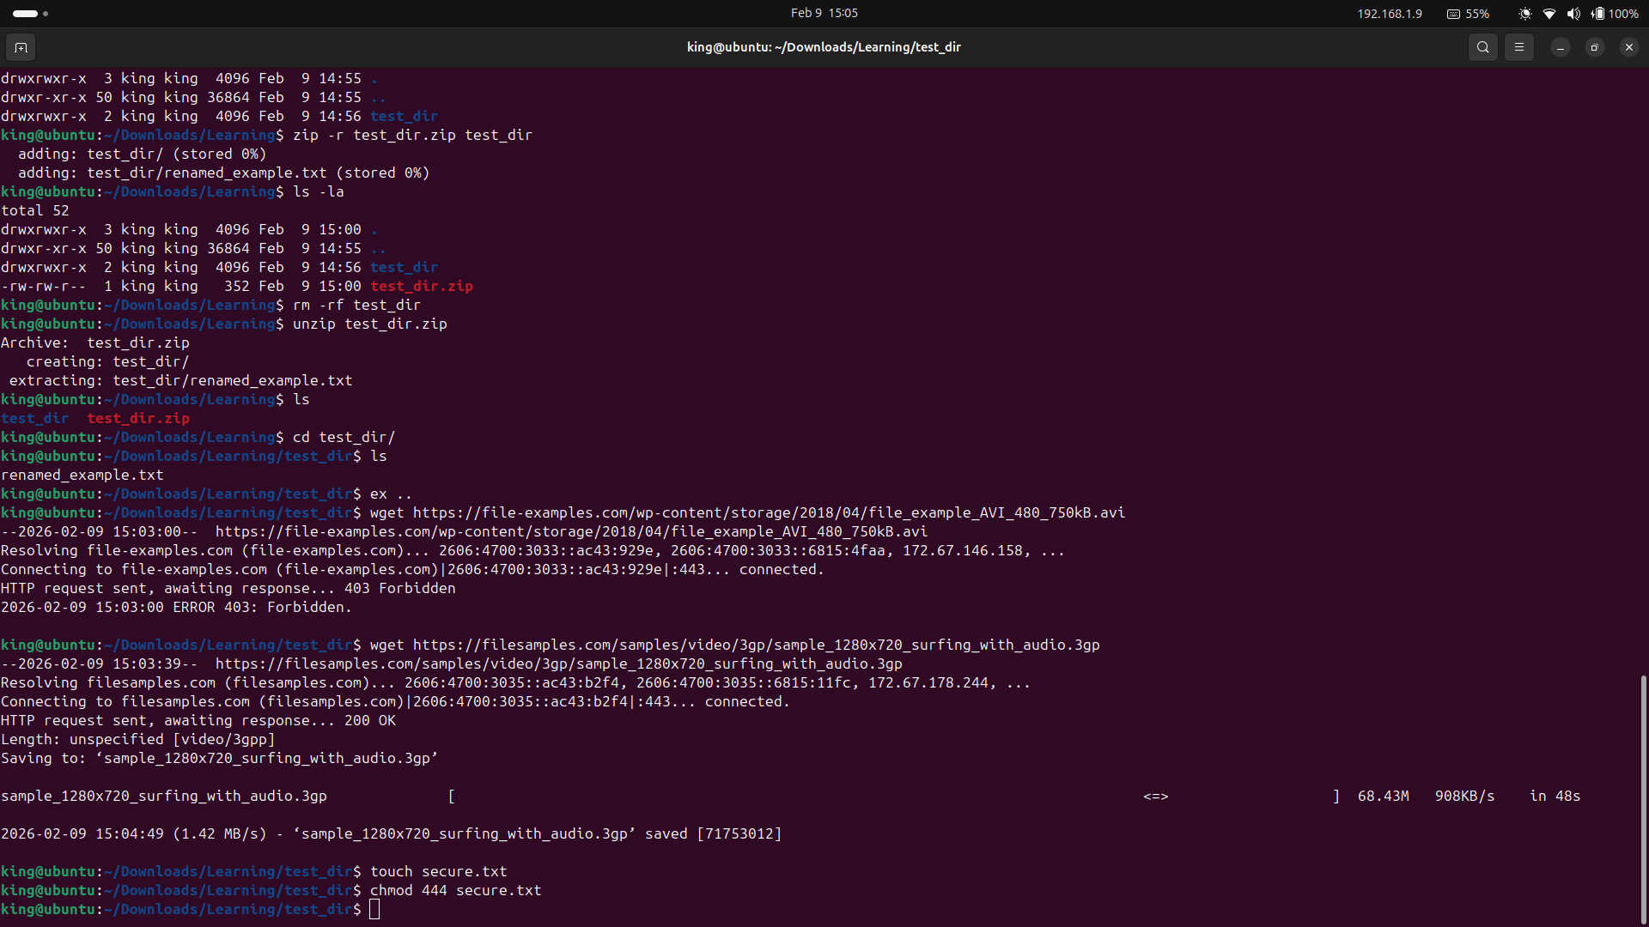
7. Working with Environment Variables
Use export to set a new environment variable called MY_VAR with the value "Hello, Linux!".

Command: export MY_VAR=”Hello, Linux!”
for printing
echo $MY_VAR

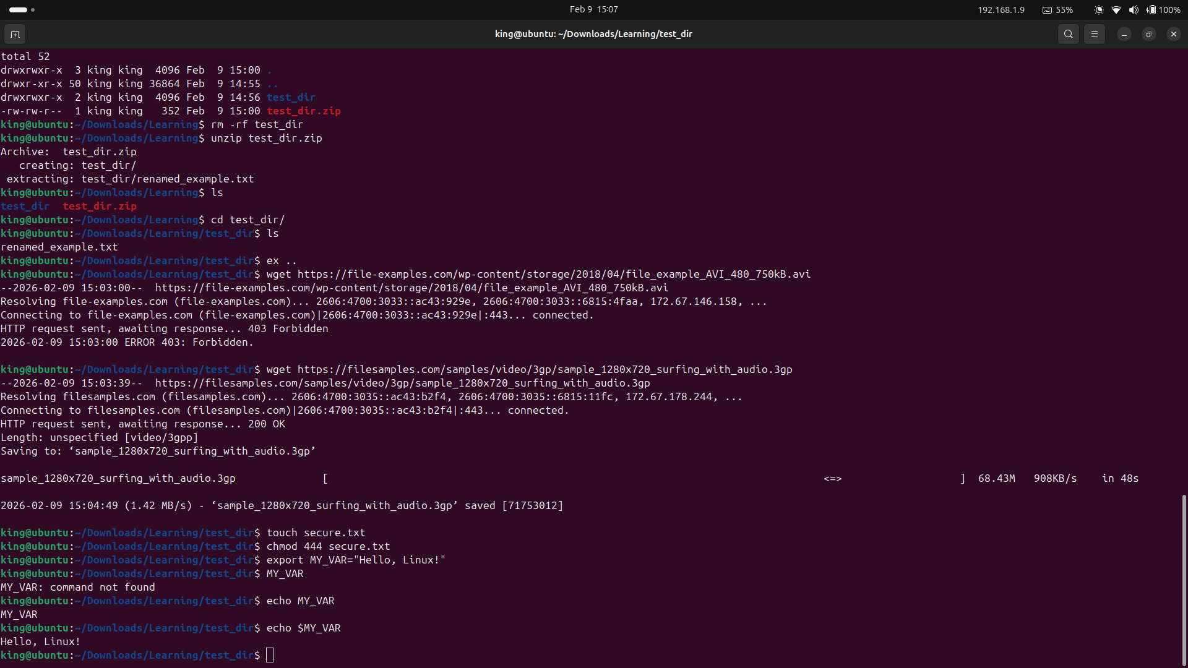
Submission Guidelines -: Attach Screenshots or command along with explanation and submit in doc(google doc or microsoft doc) format also attach github repo link

