На 3

viewer {

login, name, email, url,

repositories(first: 10) {

nodes {

name

description

createdAt

url

}

}

}

На 4

mutation CreateRepository {

createRepository(input: {visibility: PRIVATE, name: "hw-5"}) {

repository {

name, id

}

}

}

mutation CreateIssue {

createIssue(input: {repositoryId: "MDEwOlJlcG9zaXRvcnkzNjQwNDQ1MzU=", title: "NewIssue", body: "great job"}) {

issue {

number

body

id

}

}

}

mutation UpdateIssue {

updateIssue(input: {id: "MDU6SXNzdWU4NzQ4NjE2Njk=", title: "Update issue", body: "ussue is updated"}) {

issue {

number

body

id

}

}

}

mutation CloseIssue {

closeIssue(input: {issueId: "MDU6SXNzdWU4NzQ4NjE2Njk="}) {

clientMutationId

}

}

На 5

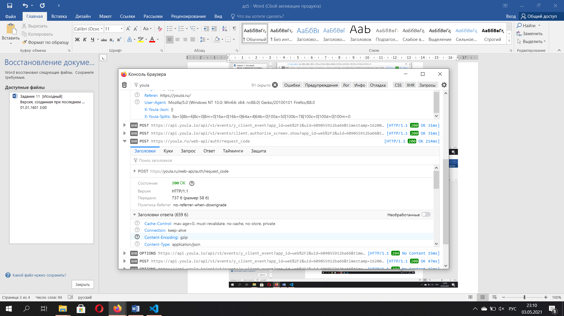

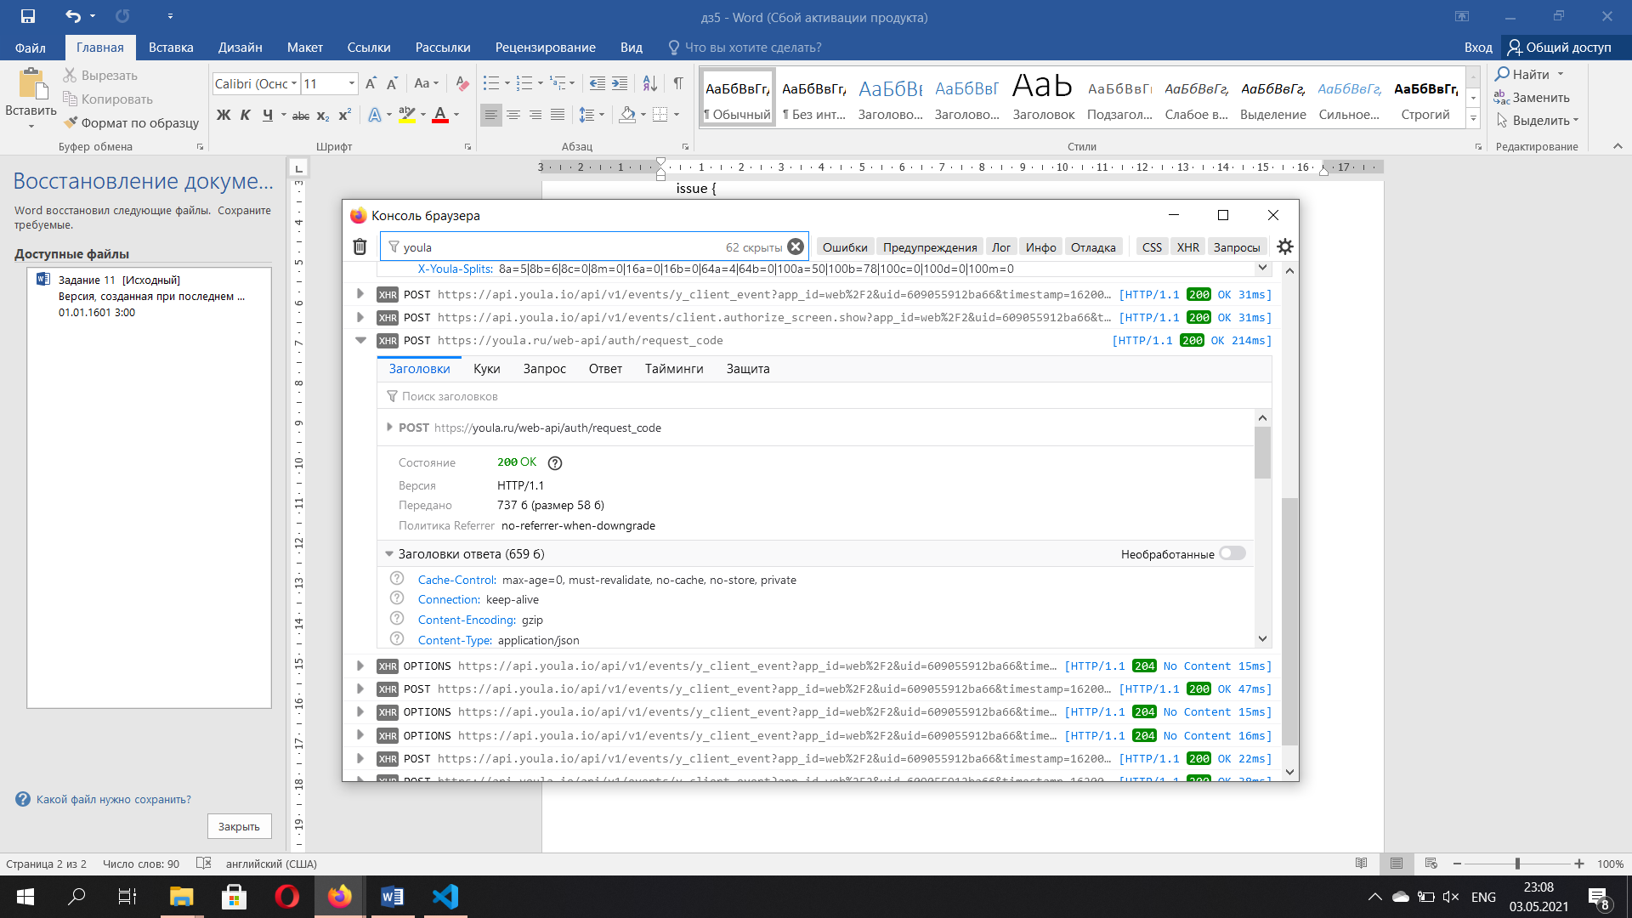

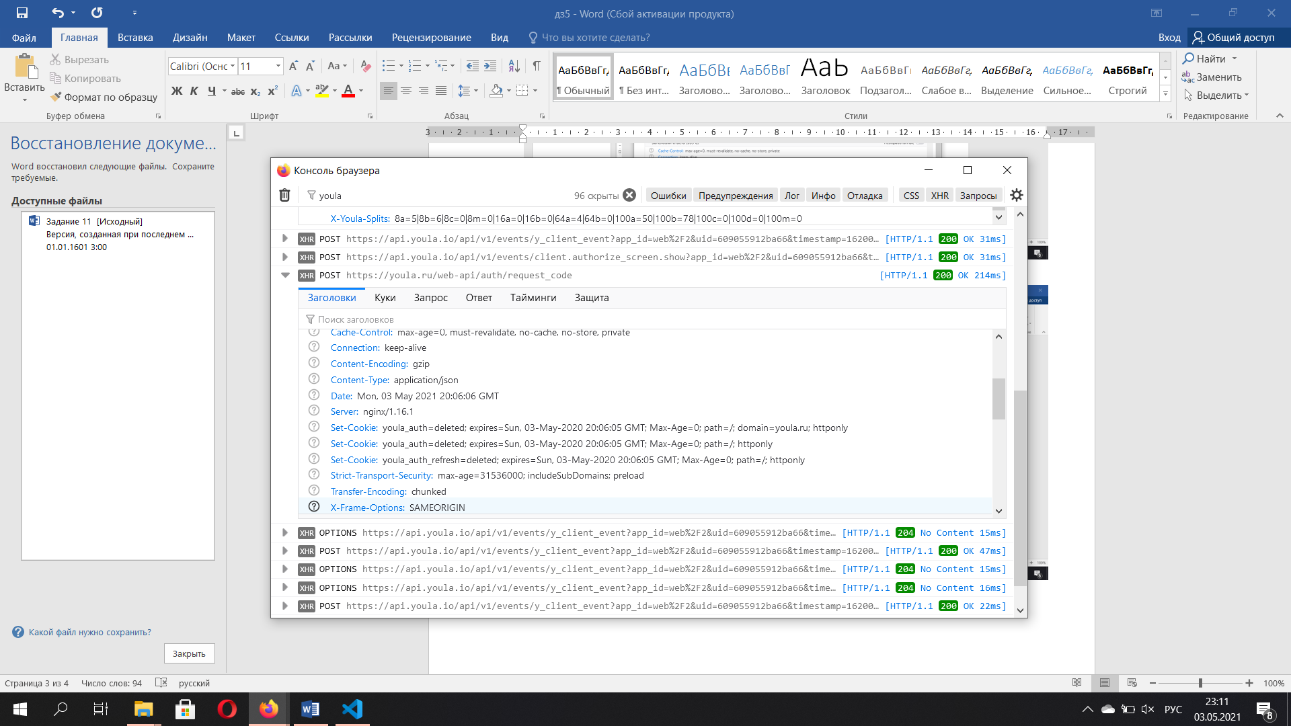

|  |  |
| --- | --- |
| Content-Type | application/json |

