
GSH QGIS Cloud Desktop

Software Requirements Specification
Multi-tenant user management • Per-hour compute • Persistent storage billing
Field | Value
Project | GSH QGIS Cloud Desktop
Platform | geospatialhosting.com (GSH)
Document type | Software Requirements Specification (SRS)
Version | 0.3 — Branded draft with UML diagrams and wireframes
Author | Tim Sutton, Kartoza
Status | Draft
Date | May 2026

Table of Contents

1. Introduction

1.1 Purpose
This document specifies the requirements for a new product offering on the Geospatial Hosting (GSH) platform: QGIS Cloud Desktop. The offering delivers a full QGIS desktop experience to end users via an in-browser VNC session, backed by a per-user containerised desktop environment. It also introduces two cross-cutting capabilities that GSH does not yet support: (a) organization-scoped end-user management, allowing GSH customers to manage their own users; and (b) per-hour metered billing for compute combined with monthly billing for allocated persistent storage.

1.2 Scope
This specification covers:
- Organization and end-user management on top of existing GSH customer accounts.
- Passwordless authentication for organization users (passkeys).
- Role-based access to the QGIS Cloud Desktop offering and machine-tier assignment.
- Provisioning, lifecycle and teardown of per-user QGIS desktop containers.
- Persistent per-user home directory storage with bind-mount semantics across sessions.
- Optional auto-provisioning of a PG service file linking the user's QGIS desktop to an organization-owned PostgreSQL instance on GSH.
- Per-hour (or part-hour) compute billing and pro-rated monthly storage billing, with defensible audit logging.
- Itemized billing reports for organization owners.
Out of scope for this specification:
- Changes to existing GSH monthly SaaS offerings (GeoServer, GeoNode, Postgres, G3W, etc.) other than the integration touch-points described.
- The internal architecture of the QGIS-in-VNC container (kasmVNC + QGIS), beyond what is needed to drive provisioning and persistence.
- Marketing site, sales pipeline, and external accounting/ERP integration (assumed handled by the existing GSH billing pipeline).

1.3 Definitions and Acronyms
Term | Definition
GSH | Geospatial Hosting — the Kartoza-operated SaaS platform at geospatialhosting.com.
Customer | An existing GSH account holder. May own one or more Organizations.
Organization | A tenant under a Customer. Owns subscriptions, users, storage allocations, and Postgres instances.
Organization Owner | A Customer-level user who administers an Organization (manages users, roles, storage, tiers, and Postgres linkage).
End User (Org User) | A user account created inside an Organization by the Organization Owner. Authenticates with a passkey.
QGIS Cloud Desktop | The new per-hour product offering: a containerised QGIS desktop accessed in-browser via VNC.
Machine Tier | A named compute spec (vCPU, RAM, ephemeral disk) with an associated per-hour price.
Session | A single bounded period during which an End User has a running QGIS desktop instance.
Persistent Home | The per-user persistent storage volume bind-mounted into each Session as the user's home directory.
kasmVNC | The browser-delivered VNC server embedded in the QGIS container (prototype already exists).
PG Service File | Standard PostgreSQL connection alias file (pg_service.conf) used by QGIS and libpq clients.

1.4 References
- Existing GSH customer and subscription model (current production system).
- Prototype QGIS-in-kasmVNC container (already built by Tim).
- PostgreSQL pg_service.conf specification.
- WebAuthn / FIDO2 passkey specification.

2. Product Overview

2.1 Product Perspective
GSH today provides managed monthly SaaS subscriptions for geospatial server-side tools. QGIS Cloud Desktop is a fundamentally different offering: it targets individual end users inside customer organizations, it bills compute by the hour, and it requires GSH to manage end-user identity rather than just customer-level identity. The platform therefore needs new abstractions — Organization and End User — and a new billing mechanism — per-hour metered compute and per-month pro-rated storage — before the QGIS offering itself can be sold.

2.2 Product Functions (high level)
- Allow a Customer to create and manage one or more Organizations.
- Allow an Organization Owner to create End Users and assign them passkey credentials.
- Allow an Organization Owner to grant the QGIS Cloud Desktop role to End Users, choose a Machine Tier per user, and allocate a quantity of Persistent Home storage per user.
- Allow an End User to log in with their passkey, spin up a QGIS Cloud Desktop session (one at a time), use it through the browser, and shut it down.
- Destroy the compute container on session end, while retaining the Persistent Home volume for the next session.
- Optionally inject a pre-populated PG service file into the user's home directory linking them to an organization-owned Postgres instance.
- Meter and log every minute of compute use; bill in whole hours (any started hour is billed in full).
- Meter Persistent Home allocations daily and bill them monthly, pro-rated to the day for any mid-month changes.
- Present an itemized bill to the Organization Owner showing compute and storage usage per End User.

2.3 User Classes and Characteristics (Personas)

2.3.1 Customer (existing concept)
An existing GSH account holder. Owns the billing relationship with Kartoza. Owns one or more Organizations. In most cases the Customer and the primary Organization Owner are the same human, but the data model must allow them to differ.

2.3.2 Organization Owner (new)
Administers an Organization. Creates End Users, assigns roles, sets machine tiers per user, allocates and reassigns storage, links users to Postgres instances, and consumes itemized billing reports. Typically a technical lead or GIS manager at the Customer's company.

2.3.3 End User / Organization User (new)
A GIS practitioner working for the Customer. Logs in with a passkey, launches a QGIS Cloud Desktop session at their pre-assigned machine tier, works in QGIS, and shuts the session down when finished. Does not see billing or other users in their Organization. May only run one session at a time.

2.3.4 GSH Platform Operator (Kartoza staff)
Existing role. Operates the platform, can view all tenants for support, can intervene in stuck sessions, and reconciles disputed bills against the audit log.

3. Functional Requirements
Each requirement carries an ID of the form FR-NNN. Requirements marked (MUST) are mandatory for the first production release; (SHOULD) are strongly desired; (MAY) are optional and may be deferred.

3.1 Organizations
ID | Requirement
FR-001 | (MUST) A Customer can create one or more Organizations. Each Organization has a unique slug, display name, and Customer owner reference.
FR-002 | (MUST) A Customer can rename an Organization and change its display name without affecting its identifier.
FR-003 | (MUST) A Customer can archive (soft-delete) an Organization. Archived Organizations cannot create new resources; existing resources are torn down per policy in §3.7.
FR-004 | (MUST) Each Organization has exactly one billing relationship — it rolls up into the parent Customer's GSH invoice.
FR-005 | (SHOULD) A Customer can transfer an Organization to another Customer (with audit trail).

3.2 End Users within an Organization
ID | Requirement
FR-010 | (MUST) An Organization Owner can create End Users. Each End User belongs to exactly one Organization.
FR-011 | (MUST) End Users authenticate using passkeys (WebAuthn). No passwords are stored or required.
FR-012 | (MUST) An Organization Owner can issue an enrolment link (single-use, time-limited) for a new End User to register a passkey on their device.
FR-013 | (MUST) An Organization Owner can register additional passkeys for an existing End User and revoke any individual passkey.
FR-014 | (MUST) An Organization Owner can disable or delete an End User. Disabling immediately invalidates active sessions (§3.5).
FR-015 | (SHOULD) End Users can self-register additional passkeys on new devices, gated by re-authentication on an existing passkey.
FR-016 | (MUST) End User identifiers are unique within the Organization. The same email may exist across different Organizations as distinct End Users.

3.3 Roles
ID | Requirement
FR-020 | (MUST) Roles are defined per offering (initially only QGIS Cloud Desktop). Roles are granted by the Organization Owner to End Users.
FR-021 | (MUST) An End User without the qgis-desktop role cannot launch a QGIS Cloud Desktop session and is not billable for compute.
FR-022 | (MUST) The role model must extend to future offerings (e.g. as identities in the existing Keycloak environment) without schema changes for new offerings beyond seed data.
FR-023 | (SHOULD) Roles support per-role attributes (e.g. machine tier for qgis-desktop, see §3.4).

3.4 Machine Tiers and Storage Allocation (qgis-desktop role)
ID | Requirement
FR-030 | (MUST) The platform maintains a catalogue of Machine Tiers. Each tier has: code, display name, vCPU count, RAM (GiB), ephemeral disk (GiB), per-hour price (currency-aware), and an active/retired flag.
FR-031 | (MUST) When granting qgis-desktop to an End User, the Organization Owner selects exactly one active Machine Tier for that user.
FR-032 | (MUST) The Organization Owner can change the Machine Tier on a user at any time. The change takes effect on the user's next session start (it does not migrate a running session).
FR-033 | (MUST) The Organization Owner allocates a Persistent Home size (GiB) to each qgis-desktop user. Default starting allocation must be configurable per Organization (e.g. 100 GiB).
FR-034 | (MUST) The Organization Owner can grow a user's Persistent Home at any time. Shrinking is not supported in v1 (FR-034a).
FR-034a | (NOTE) Shrinking allocations is explicitly out of scope for v1 because it is unsafe in the presence of existing data.
FR-035 | (MUST) The Organization Owner can reassign a user's Persistent Home to themselves (i.e. mount the volume into their own next session) for forensic / handover purposes. All such reassignments are written to the audit log with actor, target, and reason.
FR-036 | (MUST) The Organization Owner can destroy a user's Persistent Home. Destruction requires explicit confirmation, is logged, and stops further storage billing from the day of destruction (pro-rated).

3.5 QGIS Cloud Desktop Session Lifecycle
ID | Requirement
FR-040 | (MUST) An authenticated End User with the qgis-desktop role can request a session. The platform provisions a container at the user's assigned Machine Tier with the user's Persistent Home bind-mounted at /home/<user>.
FR-041 | (MUST) An End User can have at most one active session at any time. Requests while a session is active either return the existing session or are rejected with a clear error.
FR-042 | (MUST) A session is exposed to the End User via the existing in-browser kasmVNC client. No client-side software install must be required beyond a modern browser.
FR-043 | (MUST) An End User can explicitly end their session. The container is destroyed; the Persistent Home is detached cleanly (no force-unmount).
FR-044 | (MUST) Sessions are automatically ended on configurable idle timeout (default: 30 minutes of no VNC input) and on hard maximum session length (default: 12 hours). Both values are platform-configurable.
FR-045 | (MUST) When an Organization Owner disables a user or revokes the qgis-desktop role, any active session for that user is terminated within 60 seconds.
FR-046 | (MUST) Container destruction must be idempotent and survive process / node failure: on platform restart, orphaned containers are reaped and their sessions closed in the audit log.
FR-047 | (SHOULD) The platform exposes a real-time status to the End User: provisioning, running, ending, ended, error — with last-known duration and accrued cost estimate.

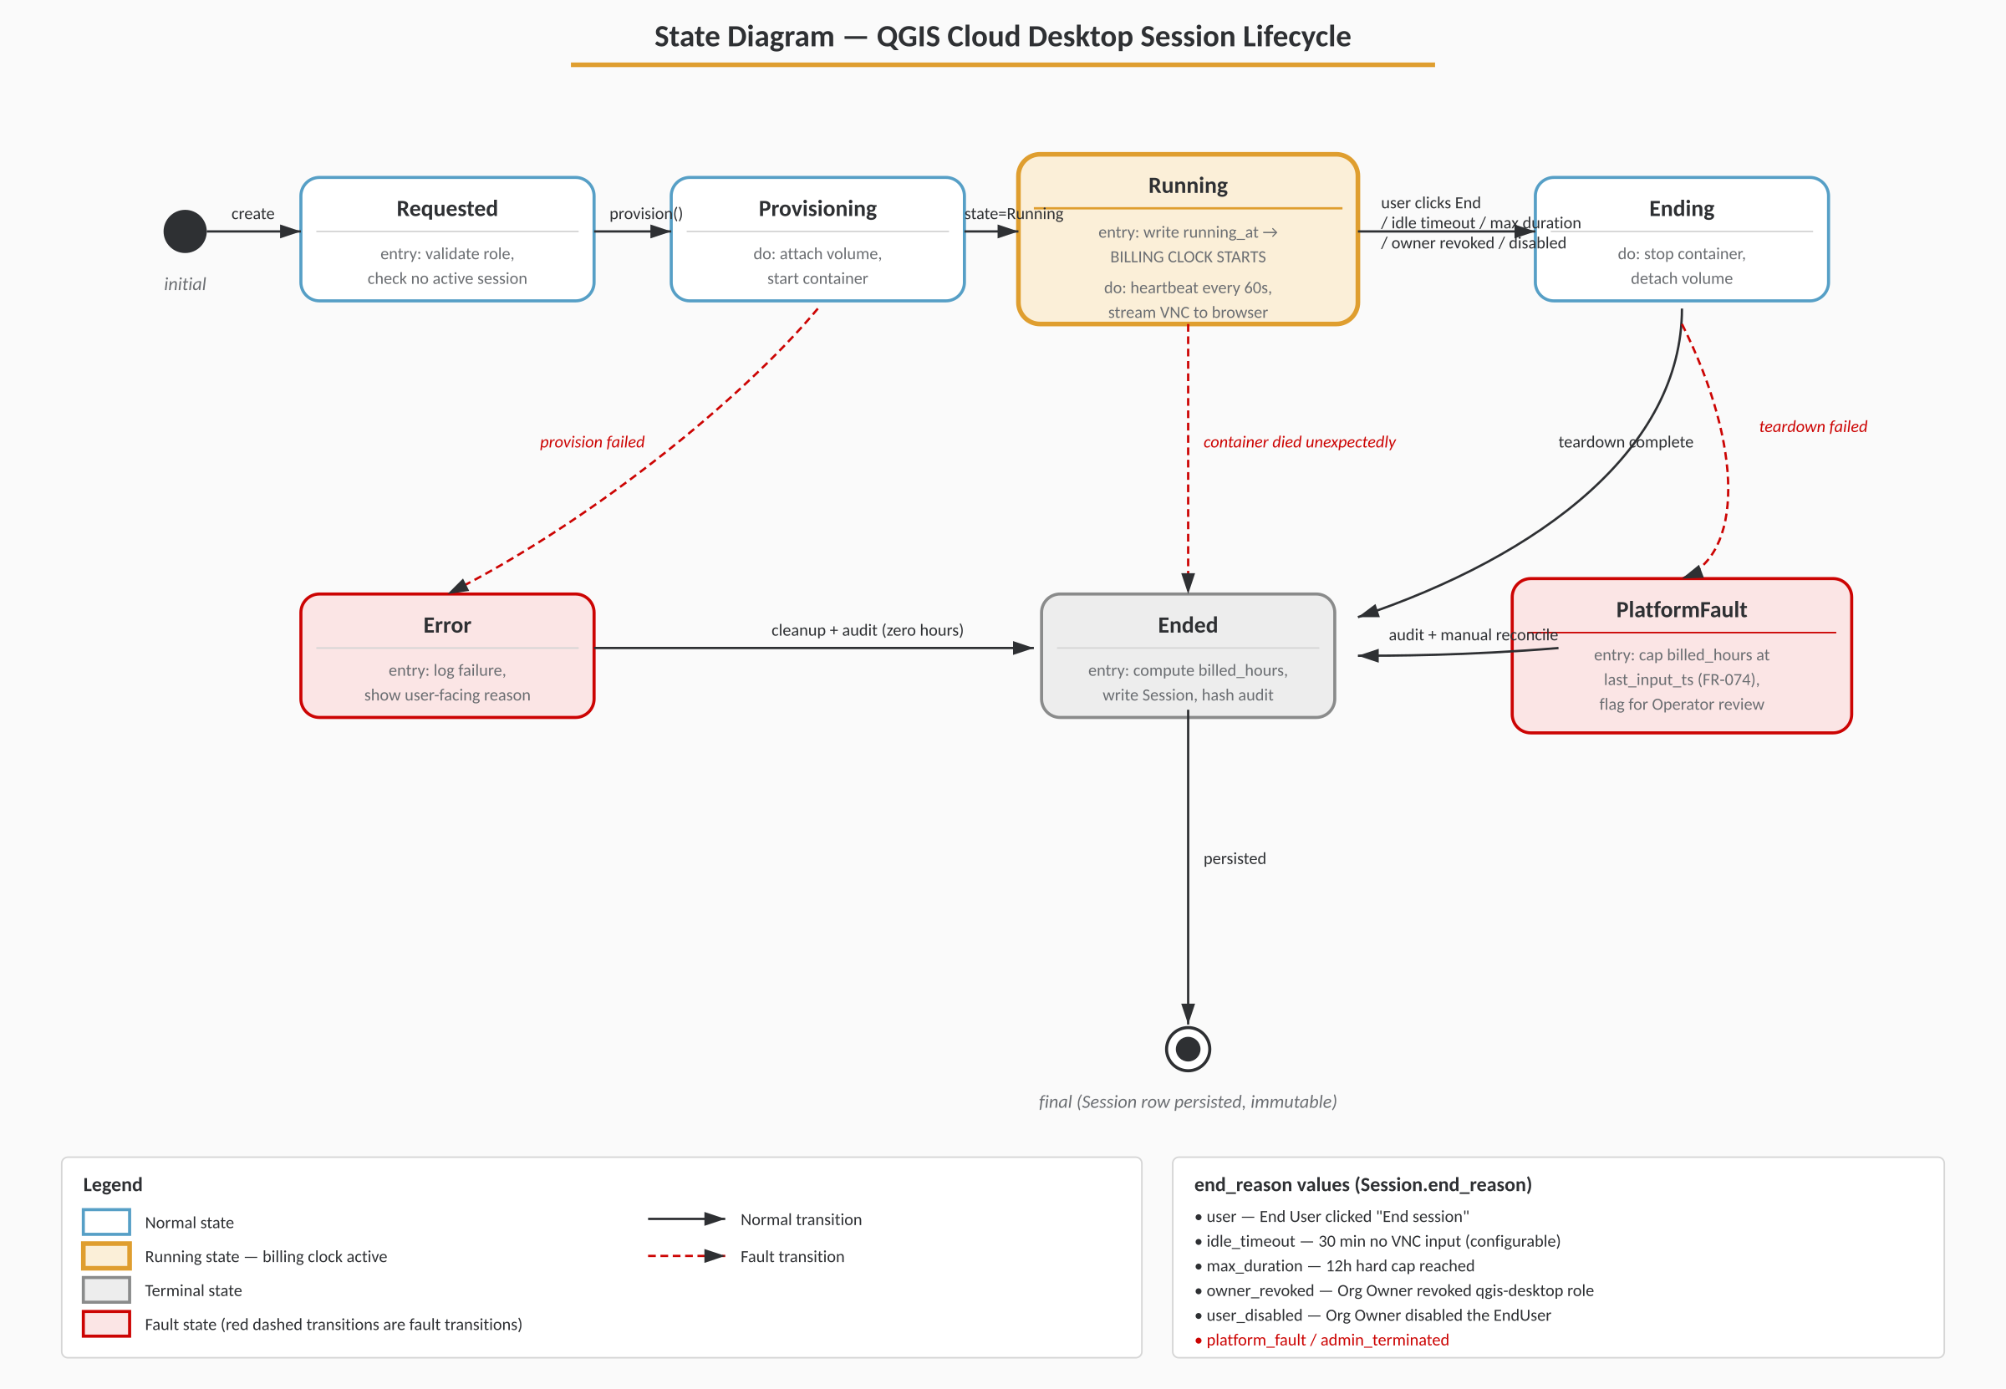
Figure 3 — Session Lifecycle State Diagram — Normal states in blue, the billable Running state in yellow, fault states and transitions in red. The billing clock starts only when the session reaches Running.

3.6 PostgreSQL Linkage (PG Service File)
ID | Requirement
FR-050 | (MUST) If the Organization owns one or more Postgres instances on GSH, the Organization Owner can, on a user's qgis-desktop profile, tick "Provision PG service for <instance>". One tick per Postgres instance the user should reach.
FR-051 | (MUST) When ticked, the Organization Owner is presented with a short form to define the credentials for that user's database account: service alias, database name, username, password (or generated), SSL mode. Fields are pre-filled with sensible defaults from the instance metadata.
FR-052 | (MUST) On the next session start (and on every subsequent session start while the link is active), the platform writes / refreshes ~/.pg_service.conf inside the Persistent Home with an entry per linked instance. The file is owned by the End User, mode 0600.
FR-053 | (MUST) Unticking a Postgres linkage removes the entry from ~/.pg_service.conf on the next session start and (separately) does not by itself drop the database account — that is a manual action against the Postgres offering.
FR-054 | (SHOULD) The platform offers (but does not require) one-click creation of the actual Postgres role/account on the linked instance, using existing GSH Postgres management APIs.

3.7 Archival, Deletion and Data Retention
ID | Requirement
FR-060 | (MUST) Deleting an End User offers the Organization Owner three choices for the Persistent Home: keep (reassign to owner), destroy now, or destroy after N days. Storage billing continues until destruction.
FR-061 | (MUST) Archiving an Organization terminates all sessions, freezes role grants, and presents the Customer with the same retention choices for every Persistent Home in the Organization.
FR-062 | (MUST) All destructions are logged with actor, target volume, size at destruction, and timestamp.

4. Billing and Metering

4.1 Compute Billing
ID | Requirement
FR-070 | (MUST) Compute is billed per hour or part thereof at the price of the Machine Tier in effect at session start. A session of 10 minutes and a session of 59 minutes are both billed as 1 hour.
FR-071 | (MUST) An hour is measured from session start (container reaches Running state) to session end (container destroyed). Provisioning time before Running and tear-down time after the user disconnects are not billed.
FR-072 | (MUST) Sessions that cross hour boundaries accrue an additional whole-hour charge at the start of each new wall-clock-since-start hour. (Example: 65 minutes = 2 hours.)
FR-073 | (MUST) The Machine Tier price is locked at session start. Mid-session price changes in the catalogue do not affect a running session.
FR-074 | (MUST) If a session ends because of platform fault (e.g. node failure outside the user's control), the billed duration is capped at the last confirmed user activity timestamp, and the event is flagged for Operator review.

4.2 Storage Billing
ID | Requirement
FR-080 | (MUST) Persistent Home storage is billed monthly per GiB-allocated, at a price configurable per Organization (default: platform-wide tariff).
FR-081 | (MUST) Allocation changes (grow, reassign, destroy) are billed pro-rata to the calendar day on which they take effect.
FR-082 | (MUST) The unit of measurement is the allocated size, not actual used bytes. A user with 100 GiB allocated and 5 GiB used is billed for 100 GiB.
FR-083 | (MUST) The monthly storage invoice line is itemized per End User and shows: user, GiB-days at each tier, and resulting amount.

4.3 Audit Logging (defensibility)
Why this matters
Billing audit logging is a first-class requirement. Every billable event must be recorded such that, if a Customer disputes an invoice three months later, the Operator can produce a complete, tamper-evident trail of compute time and storage allocations and reconcile it to the cent.

ID | Requirement
FR-090 | (MUST) Every session writes a structured audit record with: session_id, organization_id, end_user_id, machine_tier_code, tier_price_snapshot, container_id, provision_started_at, running_at, ended_at, end_reason, billed_hours, and final amount.
FR-091 | (MUST) During a running session, a heartbeat record is written at least once per minute capturing: timestamp, container state, last VNC input timestamp, CPU and memory in-use samples. These records support reconstruction in the event of failure.
FR-092 | (MUST) Every allocation change (create, grow, reassign, destroy) writes an audit record with: actor (Customer + Organization Owner identity + IP + user-agent), target end_user_id, old_gib, new_gib, effective_from (date), and reason (free-text from UI).
FR-093 | (MUST) Audit records are append-only. The store must reject in-place mutation. Corrections are made by writing a compensating record that references the original.
FR-094 | (MUST) Audit records are retained for at least 7 years (configurable). Storage is independent of the operational database so that operational deletion does not affect audit history.
FR-095 | (SHOULD) Each daily audit batch is hash-chained to the previous batch (Merkle-style) so any tampering is detectable.
FR-096 | (MUST) An Operator can run a reconciliation report for any billing period that recomputes the invoice from the audit log and flags any drift against what was actually billed.

4.4 Itemized Billing Presentation
ID | Requirement
FR-100 | (MUST) The Organization Owner can view, for any month (current or past), an itemized statement showing per End User: total compute hours per Machine Tier, storage GiB-days, and resulting amounts.
FR-101 | (MUST) Each line is expandable to the underlying sessions / allocation changes that produced it, with their audit IDs.
FR-102 | (MUST) Statements are exportable to CSV and PDF.
FR-103 | (SHOULD) The Organization Owner can set a soft monthly budget per End User and receive notifications at 80% / 100% of budget. Exceeding budget does not by itself block sessions in v1.

5. Data Model
The following is the logical data model. Field types are indicative; the implementing developer should adapt to the existing GSH ORM conventions (e.g. Django models / Postgres) while preserving the relationships and constraints described. The diagram below summarises all entities and their relationships at a glance; the per-entity field listings follow.
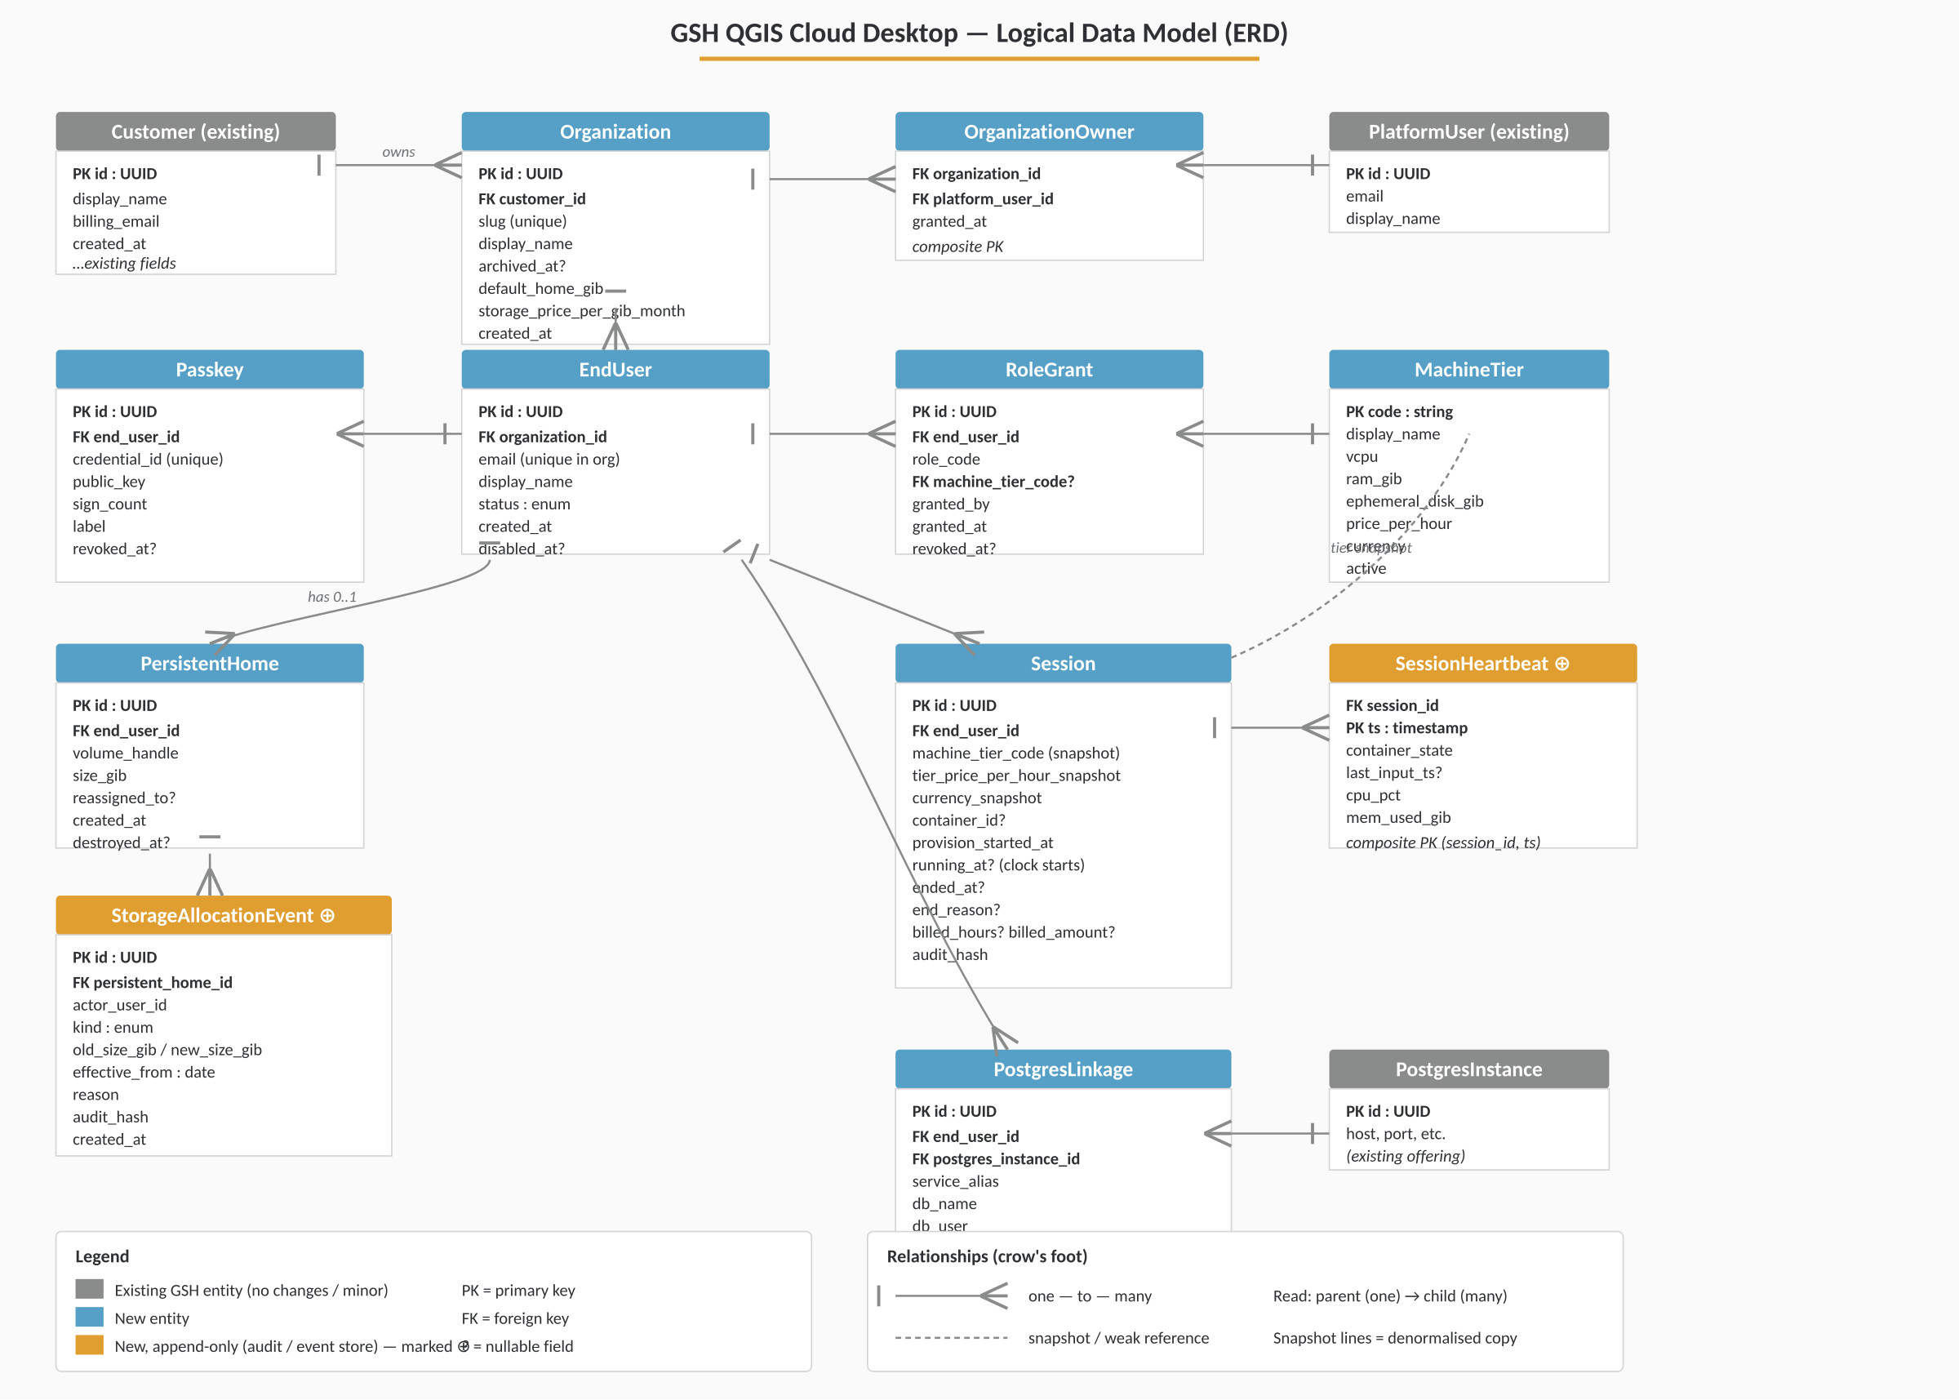
Figure 1 — Logical Data Model (ERD) — Entities and relationships using crow's-foot notation. Grey = existing, blue = new, yellow = new append-only audit / event stores.

5.1 Core entities

Customer (existing)
Customer {
id : UUID (PK)
display_name : string
billing_email : string
created_at : timestamp
...existing fields...
}

Organization (new)
Organization {
id : UUID (PK)
customer_id : UUID (FK -> Customer)
slug : string (unique)
display_name : string
archived_at : timestamp? // null = active
default_home_gib : int // default Persistent Home size for new users
storage_price_per_gib_month : decimal // optional override of platform tariff
created_at : timestamp
}

OrganizationOwner (new)
OrganizationOwner {
organization_id : UUID (FK -> Organization)
platform_user_id : UUID (FK -> existing GSH platform user)
granted_at : timestamp
// composite PK on (organization_id, platform_user_id)
}

EndUser (new)
EndUser {
id : UUID (PK)
organization_id : UUID (FK -> Organization)
email : string // unique within organization
display_name : string
status : enum { invited, active, disabled, deleted }
created_at : timestamp
disabled_at : timestamp?
}

Passkey (new)
Passkey {
id : UUID (PK)
end_user_id : UUID (FK -> EndUser)
credential_id : bytes (unique) // WebAuthn credential ID
public_key : bytes // COSE-encoded
sign_count : int
label : string // e.g. "Tim's MacBook"
created_at : timestamp
revoked_at : timestamp?
}

MachineTier (new)
MachineTier {
code : string (PK) // e.g. "qgis-small"
display_name : string
vcpu : int
ram_gib : int
ephemeral_disk_gib: int
price_per_hour : decimal
currency : string
active : bool
created_at : timestamp
}

RoleGrant (new)
RoleGrant {
id : UUID (PK)
end_user_id : UUID (FK -> EndUser)
role_code : string // e.g. "qgis-desktop"
machine_tier_code : string? // required when role_code = "qgis-desktop"
granted_by : UUID // platform_user_id of Organization Owner
granted_at : timestamp
revoked_at : timestamp?
}

PersistentHome (new)
PersistentHome {
id : UUID (PK)
end_user_id : UUID (FK -> EndUser, unique while not destroyed)
volume_handle : string // backend volume identifier
size_gib : int // current allocation
reassigned_to : UUID? // FK -> EndUser (Organization Owner's EndUser, if reassigned)
created_at : timestamp
destroyed_at : timestamp?
}

StorageAllocationEvent (new, append-only)
StorageAllocationEvent {
id : UUID (PK)
persistent_home_id: UUID (FK)
actor_user_id : UUID // platform_user_id of who made the change
kind : enum { create, grow, reassign, destroy }
old_size_gib : int?
new_size_gib : int?
effective_from : date // for pro-rata billing
reason : text?
audit_hash : bytes // chained hash for tamper-evidence
created_at : timestamp
}

Session (new)
Session {
id : UUID (PK)
end_user_id : UUID (FK -> EndUser)
machine_tier_code : string // snapshot at start
tier_price_per_hour_snapshot : decimal
currency_snapshot : string
container_id : string? // backend orchestrator handle
provision_started_at : timestamp
running_at : timestamp? // billing clock starts here
ended_at : timestamp?
end_reason : enum { user, idle_timeout, max_duration, owner_revoked,
user_disabled, platform_fault, admin_terminated }?
billed_hours : int? // computed on close, integer (any part-hour rounds up)
billed_amount : decimal?
audit_hash : bytes
}

SessionHeartbeat (new, append-only)
SessionHeartbeat {
session_id : UUID (FK -> Session)
ts : timestamp
container_state : string
last_input_ts : timestamp?
cpu_pct : float
mem_used_gib : float
// composite PK (session_id, ts)
}

PostgresLinkage (new)
PostgresLinkage {
id : UUID (PK)
end_user_id : UUID (FK -> EndUser)
postgres_instance_id : UUID // FK -> existing GSH Postgres offering
service_alias : string // pg_service.conf section name
db_name : string
db_user : string
db_password_secret_ref : string // reference into secrets store; never persisted in plaintext
ssl_mode : string
active : bool
created_at : timestamp
updated_at : timestamp
}

5.2 Relationships (text ERD)
Customer (1) --< (N) Organization
Organization (1) --< (N) OrganizationOwner >-- (1) PlatformUser
Organization (1) --< (N) EndUser
EndUser (1) --< (N) Passkey
EndUser (1) --< (N) RoleGrant >-- (0..1) MachineTier
EndUser (1) --< (0..1) PersistentHome
PersistentHome (1) --< (N) StorageAllocationEvent
EndUser (1) --< (N) Session >-- (1) MachineTier (snapshot)
Session (1) --< (N) SessionHeartbeat
EndUser (1) --< (N) PostgresLinkage >-- (1) PostgresInstance (existing)

6. Use Cases and User Stories
The diagram below summarises the use cases by actor; detailed flows for each use case follow in §6.1–§6.7. Use cases prefixed UC-OP are operational and are exercised by Kartoza staff rather than tenant users.
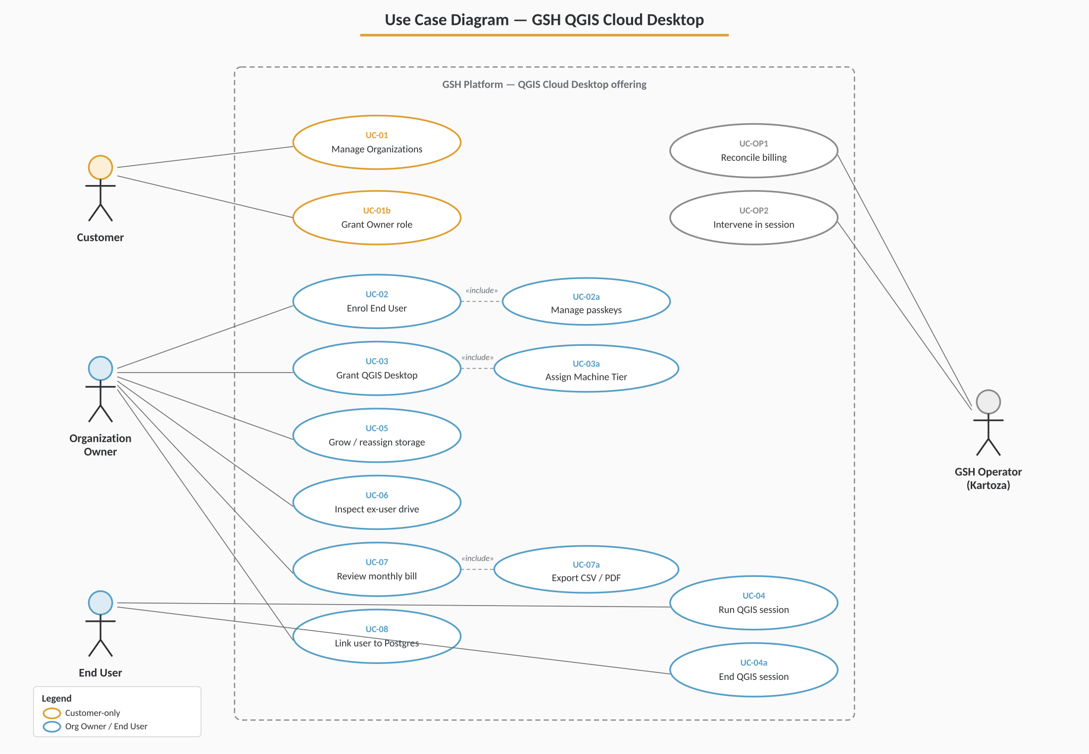
Figure 2 — Use Case Diagram — Actors and the use cases each invokes. The dashed boundary marks the GSH platform; «include» relationships pull in shared sub-flows.

6.1 UC-01 — Customer creates an Organization and invites an Organization Owner
Actor: Customer
Preconditions: Customer has an active GSH account.
Main flow:
- Customer opens "Organizations" in their GSH dashboard.
- Customer creates a new Organization (display name, slug).
- Customer adds themselves as Organization Owner (default) or invites another platform user.
- System creates the Organization in active state with default_home_gib = platform default.
Postconditions: A new Organization exists and at least one Organization Owner is granted.

6.2 UC-02 — Organization Owner enrols an End User
Actor: Organization Owner
Preconditions: An active Organization exists.
Main flow:
- Owner opens the Organization's Users page.
- Owner clicks "Invite user", enters email and display name.
- System creates an EndUser in status=invited and generates a single-use enrolment link valid for 7 days.
- Owner sends the link to the user out-of-band (or the system emails it directly).
- User opens the link, registers a passkey via WebAuthn ceremony.
- System stores the Passkey, sets EndUser.status = active.
Alternative flows:
- Owner registers an additional passkey for an existing user (e.g. lost device): same ceremony, attached to existing EndUser.
- Owner revokes a specific passkey, leaving any others active.

6.3 UC-03 — Organization Owner grants QGIS Cloud Desktop to a user
Actor: Organization Owner
Main flow:
- Owner opens an EndUser's profile.
- Owner toggles on "QGIS Cloud Desktop".
- System prompts for Machine Tier and Persistent Home size (pre-filled with Organization defaults).
- Owner confirms. System creates a RoleGrant and a PersistentHome (size=requested).
- System writes a StorageAllocationEvent of kind=create with effective_from=today.

6.4 UC-04 — End User runs a QGIS session
Actor: End User
Main flow:
- User opens the GSH login page and authenticates with their passkey.
- User lands on their dashboard showing their entitlements (currently: QGIS Cloud Desktop, tier X).
- User clicks "Launch desktop".
- System checks: no existing active session; role active; persistent home present.
- System provisions a container of the user's MachineTier and bind-mounts the PersistentHome at /home/<user>.
- System opens the in-browser kasmVNC client when the container reports Running.
- System records Session.running_at and starts the billing clock.
- User works in QGIS. PG service file is present in $HOME if a PostgresLinkage is active.
- User chooses "End session". System tears down the container, records ended_at and end_reason=user, computes billed_hours = ceil((ended_at - running_at) / 1 hour), persists Session row.
Alternative flows:
- Idle timeout: 30 minutes since last VNC input → session ends with end_reason=idle_timeout.
- Max duration: 12 hours since running_at → end_reason=max_duration.
- Platform fault: container dies unexpectedly → billed_hours capped at last_input_ts; flagged for Operator.

6.5 UC-05 — Organization Owner grows a user's storage
Actor: Organization Owner
Main flow:
- Owner edits the user's profile and changes Persistent Home size from 100 → 250 GiB.
- System validates the new size > current size.
- System issues the backend volume expand operation.
- On success, writes StorageAllocationEvent(kind=grow, old=100, new=250, effective_from=today).
- Subsequent monthly storage billing is pro-rated from effective_from.

6.6 UC-06 — Organization Owner inspects an ex-employee's drive
Actor: Organization Owner
Main flow:
- Owner disables the EndUser. Any active session is terminated within 60s.
- Owner clicks "Reassign storage to me" on the user's profile and enters a reason.
- System updates the PersistentHome.reassigned_to to the Owner's own EndUser identity (creating one if the Owner is also acting as an End User).
- On the Owner's next session, the reassigned volume is mounted at /home/<owner-user>/<original-user-name>.
- Owner reviews the data, then chooses to destroy the volume or release the reassignment.
All steps are written to the audit log with actor, target and reason.

6.7 UC-07 — Organization Owner reviews the monthly bill
Actor: Organization Owner
Main flow:
- Owner opens "Billing" in the Organization dashboard.
- Owner selects a month.
- System presents an itemized statement: per user, compute hours by tier and storage GiB-days, with totals.
- Owner expands a line to see contributing sessions or allocation changes with audit IDs.
- Owner exports the statement as CSV or PDF if needed.

7. System Architecture
The system is organised into four layers: untrusted browser, application services, the per-session sandbox (the ephemeral QGIS container with its bind-mounted Persistent Home), and the underlying infrastructure and data stores. New services introduced by this offering are highlighted; existing GSH components are shown in grey.
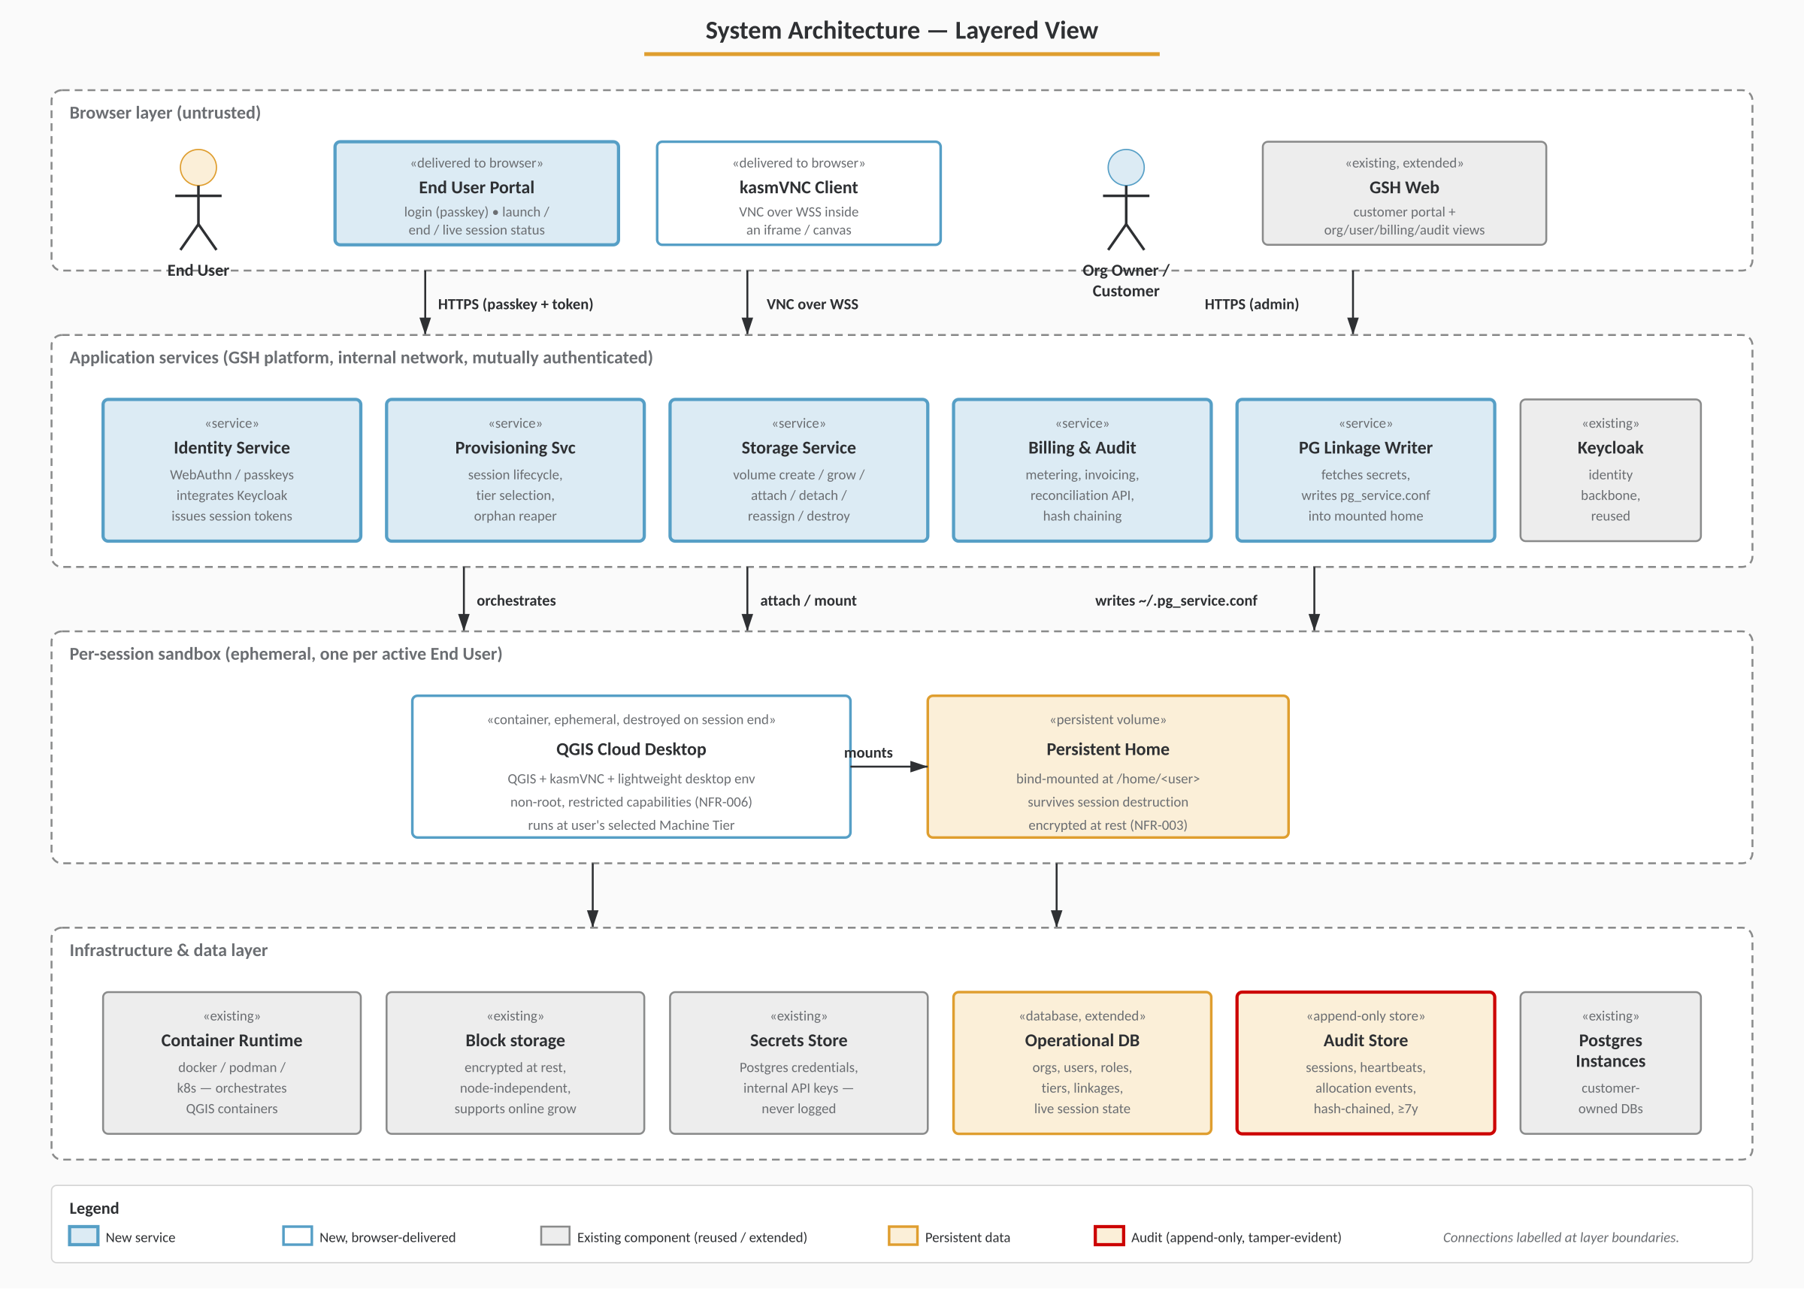
Figure 4 — System Architecture (Layered View) — Components grouped by layer with labelled inter-layer connections. The Audit Store is highlighted because no service may mutate or delete its records.

7.1 Components
- GSH Web — existing customer portal, extended with Organization, End User, role and billing views.
- End User Portal — new, minimal UI for End Users to log in with a passkey and manage their session.
- Identity Service — passkey (WebAuthn) registration / authentication. Integrates with existing Keycloak environment.
- Provisioning Service — orchestrates QGIS container lifecycle (start, mount, stop, reap) against the container backend.
- QGIS Cloud Desktop Container — existing prototype: QGIS + kasmVNC. Bind-mount target at /home/<user>.
- Storage Service — manages PersistentHome volumes, grow/destroy/reassign operations against the backing storage.
- Billing & Audit Service — collects session and storage events, performs metering, produces invoices, exposes audit/reconciliation APIs.
- Operational Database — existing GSH primary store, extended with the entities in §5.
- Audit Store — append-only store with chained hashes, separate from the operational DB (FR-094).

7.2 Trust boundaries
- End Users authenticate only into the End User Portal and their own session. They have no access to Organization Owner functionality or to other users' data.
- Organization Owners authenticate as platform users and can only see resources scoped to Organizations they own.
- The container itself has no credentials for any GSH back-end services. Anything secret (e.g. Postgres credentials in pg_service.conf) is provisioned at session start into the user's home directory, owned by the user, mode 0600.

7.3 Session-start sequence
The session-start flow takes a user from passkey authentication to a billable, running QGIS desktop. The billing clock starts only when the container reaches the Running state and the session record is written to the Audit Store (step 13).
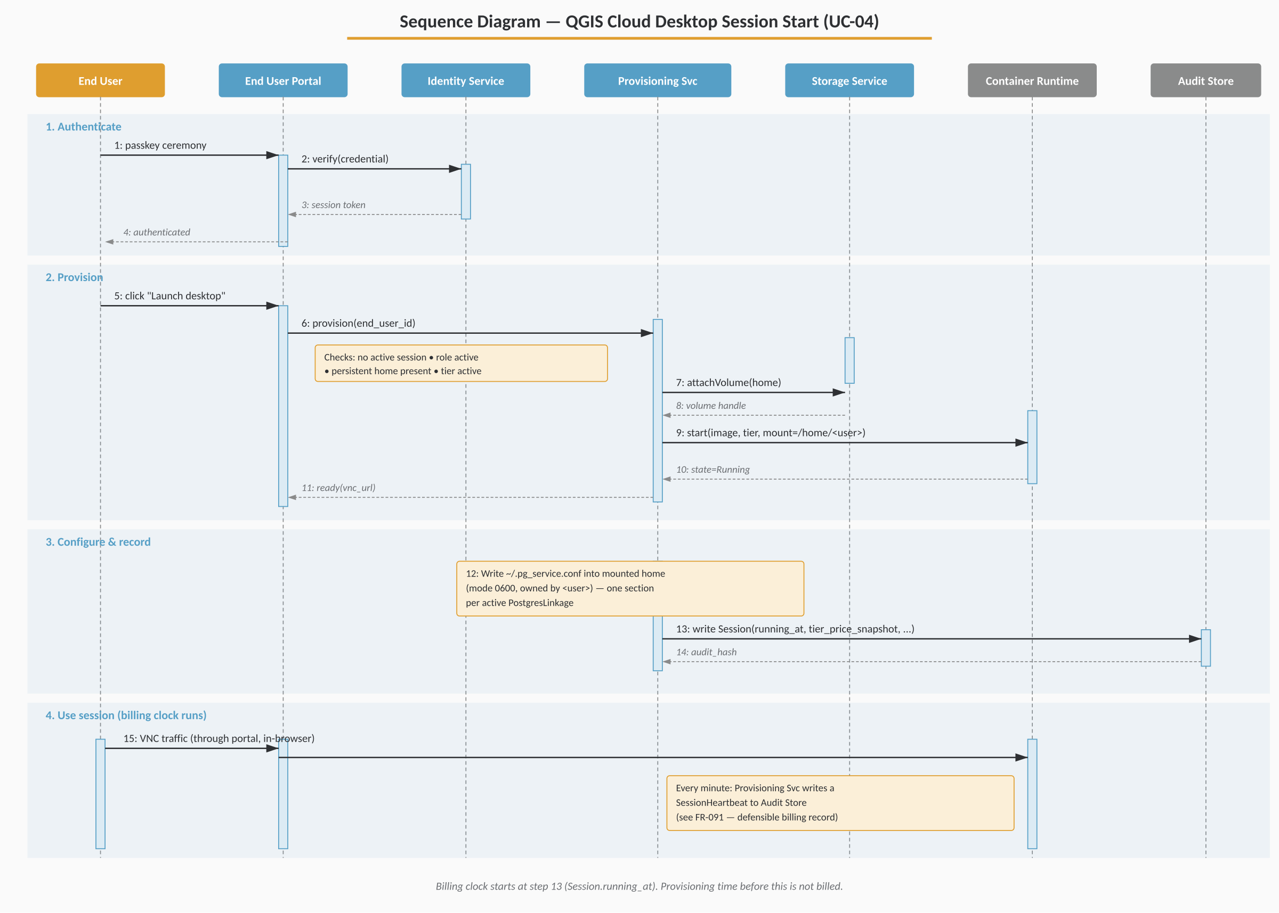
Figure 5 — Session Start Sequence (UC-04) — Phases: authenticate, provision, configure & record, use session. Yellow phase bands indicate billable activity.

7.4 Session-end sequence
Session end is triggered by one of several reasons (user, idle timeout, max duration, owner revoked, user disabled, or platform fault). The teardown sequence is identical; only the recorded end_reason and — for platform faults — the cap on billed_hours differ.
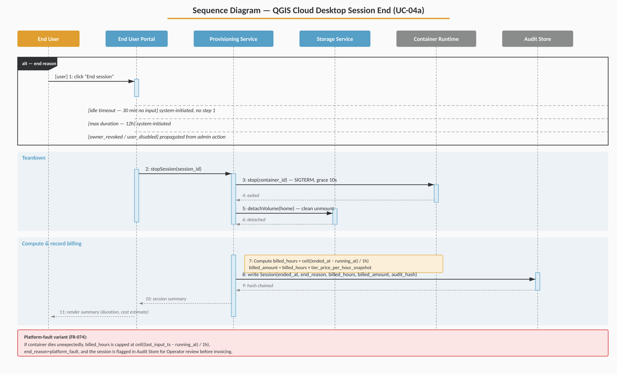
Figure 6 — Session End Sequence (UC-04a) — alt-frame at the top enumerates the trigger paths into the common teardown. The red callout shows the platform-fault variant (FR-074).

8. Non-Functional Requirements

8.1 Security
ID | Requirement
NFR-001 | End User authentication is passkey-only. No password fallback.
NFR-002 | All session traffic between browser and container traverses TLS to the platform edge; VNC over WebSocket is wrapped in TLS.
NFR-003 | Persistent Home volumes are encrypted at rest.
NFR-004 | Secrets (database passwords, etc.) are held in a secrets store; only the per-session writer pulls them to write the pg_service.conf into the mounted home; they are never logged.
NFR-005 | Cross-organization data isolation must be enforced at the data layer (row-level security or strictly-scoped queries), not only at the UI.
NFR-006 | Container escape mitigations: non-root user inside the container; restricted capabilities; per-session ephemeral host namespace.

8.2 Performance and Capacity
ID | Requirement
NFR-010 | Time from user clicking "Launch" to running session ≤ 60 seconds at p95 for the smallest tier on a warm cluster.
NFR-011 | Concurrent sessions: design target of 200 concurrent sessions across the platform in v1, scalable horizontally.
NFR-012 | Audit ingestion path must sustain at least 10× peak session rate without backpressure on the user-facing path.

8.3 Reliability
ID | Requirement
NFR-020 | Loss of a compute node must not lose Persistent Home data. Volumes are independent of compute nodes.
NFR-021 | Loss of a compute node mid-session is reported within 30 seconds and the session is closed in the audit log with end_reason=platform_fault.
NFR-022 | Audit Store is replicated; loss of a single node does not lose audit data.

8.4 Observability
ID | Requirement
NFR-030 | All services emit structured logs with session_id, organization_id, end_user_id (where applicable).
NFR-031 | Metrics: active sessions, provisioning latency, session duration distribution, storage GiB allocated, failed sessions by end_reason.
NFR-032 | An Operator dashboard exposes the above per Organization.

8.5 Compliance and Retention
ID | Requirement
NFR-040 | Audit records retained ≥ 7 years.
NFR-041 | Personal data (End User email, display name) deletable on request, but billing-relevant identifiers must remain in the audit log (pseudonymised if necessary).

9. UI Surfaces
This section enumerates the new screens and provides lo-fi wireframes for the most important ones. The wireframes communicate information architecture and interaction intent — visual design (typography scale, exact spacing, iconography) should follow existing GSH conventions and the Kartoza brand. Where a wireframe and a requirement disagree, the requirement wins.

9.1 Customer / Organization Owner screens
- Organizations list — create / archive / open. See Figure 7.
- Organization → Overview — summary of users, sessions today, storage allocated, current month-to-date cost.
- Organization → Users — list of End Users, status, role, tier, storage, last session, MTD cost. See Figure 8.
- End User → Profile — identity, passkeys (add / revoke), roles, QGIS tier, storage allocation, Postgres linkages. See Figure 9.
- Organization → Postgres linkages — for each Postgres instance owned by the Organization, which users are linked and with what credentials.
- Organization → Billing — monthly statements with drill-down, export to CSV/PDF, per-user budgets. See Figure 10.
- Organization → Audit — searchable view of role grants, storage allocation events, session summaries.
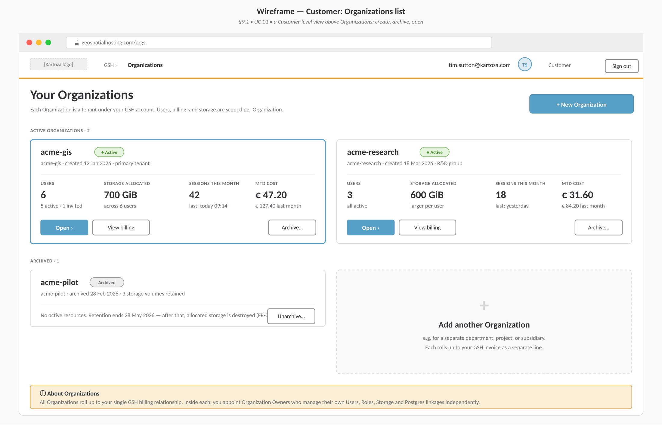
Figure 7 — Customer: Organizations list — The top-level Customer view. Each Organization is an independent tenant with its own users, billing and storage.
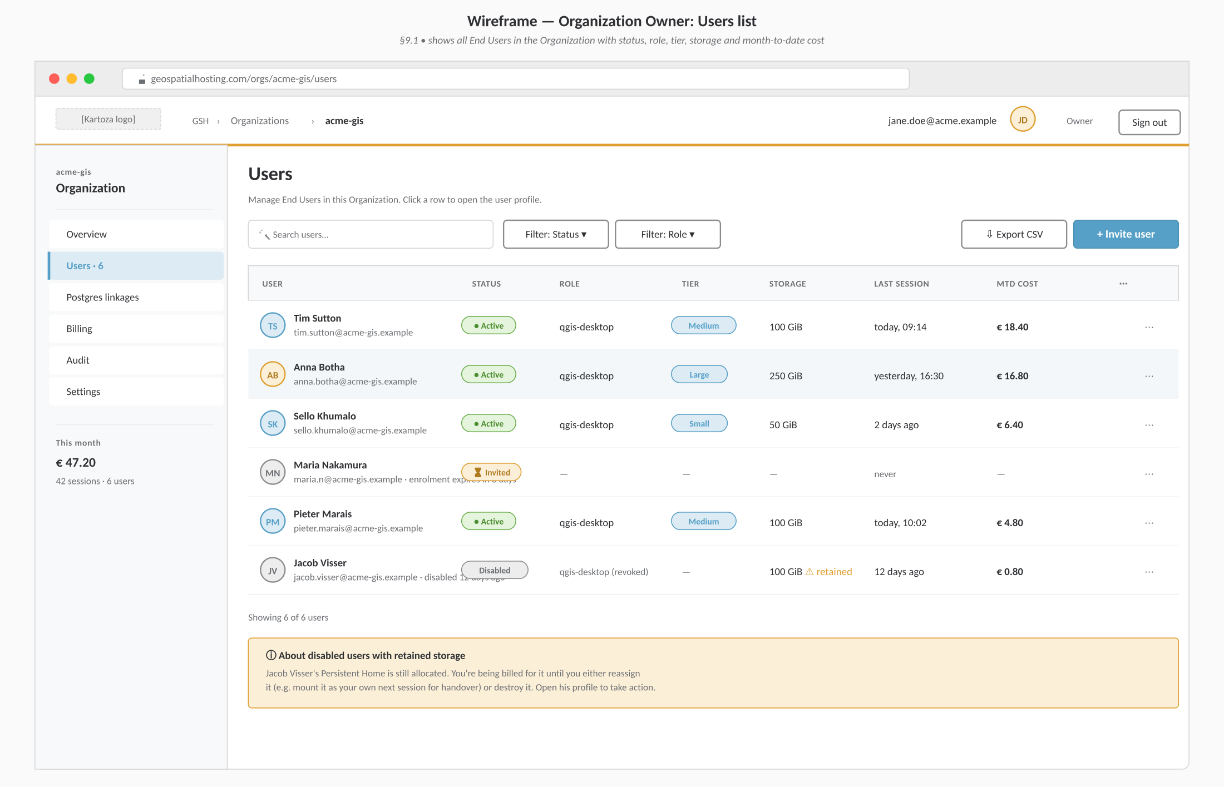
Figure 8 — Organization Owner: Users list — Per-Organization roster with at-a-glance status, machine tier, storage and month-to-date cost columns. The disabled-with-retained-storage callout is shown.
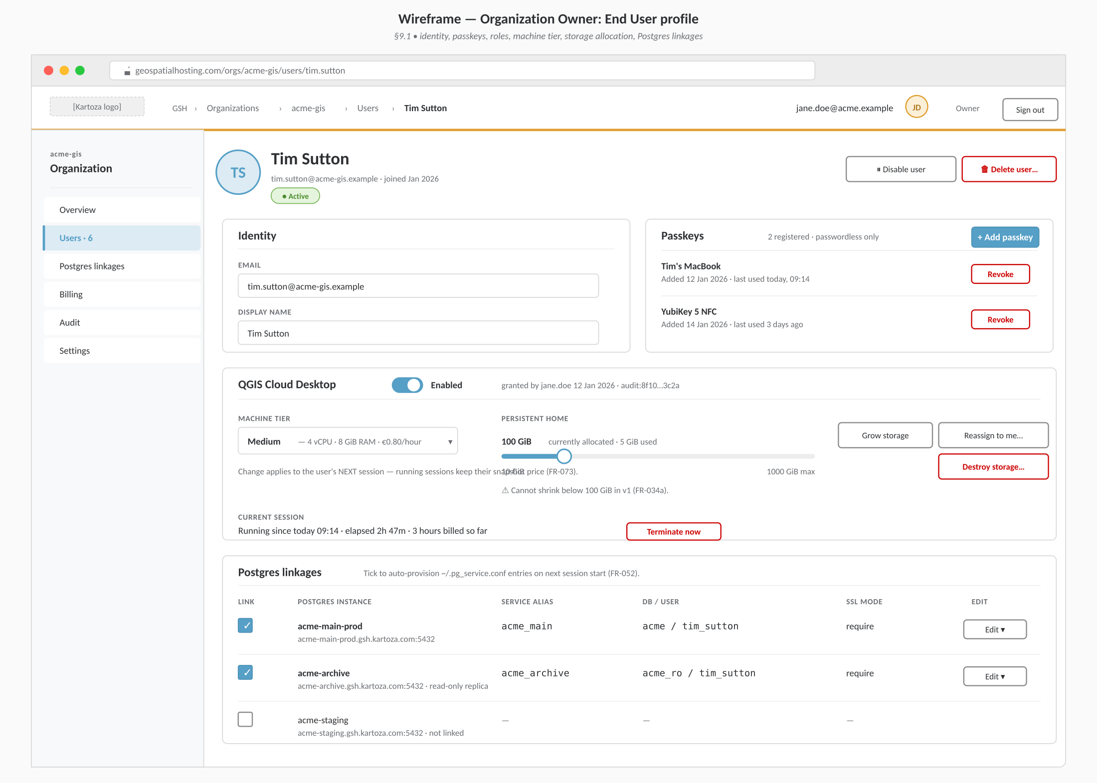
Figure 9 — Organization Owner: End User profile — Identity, passkeys, QGIS Cloud Desktop entitlement (tier + storage), Postgres linkages. Destructive actions are styled in alert red and confirmation-gated.
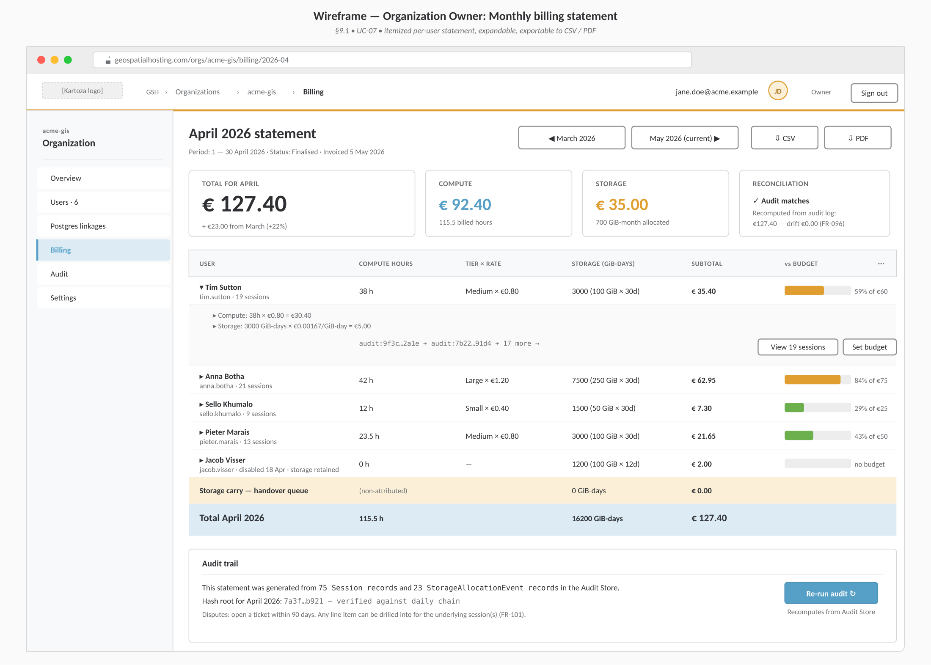
Figure 10 — Organization Owner: Monthly billing statement — Itemized per-user statement. Reconciliation card top-right shows the recomputed total from the Audit Store — proving the bill matches the audit trail (FR-096).

9.2 End User screens
- Login — passkey-only.
- Dashboard — "Launch QGIS desktop" button, session state, recent sessions (informational, no cost shown to End User by default). See Figure 11.
- Live session — embedded kasmVNC viewer with an "End session" control and a status strip showing elapsed time, billed hours, and timeouts. See Figure 12.
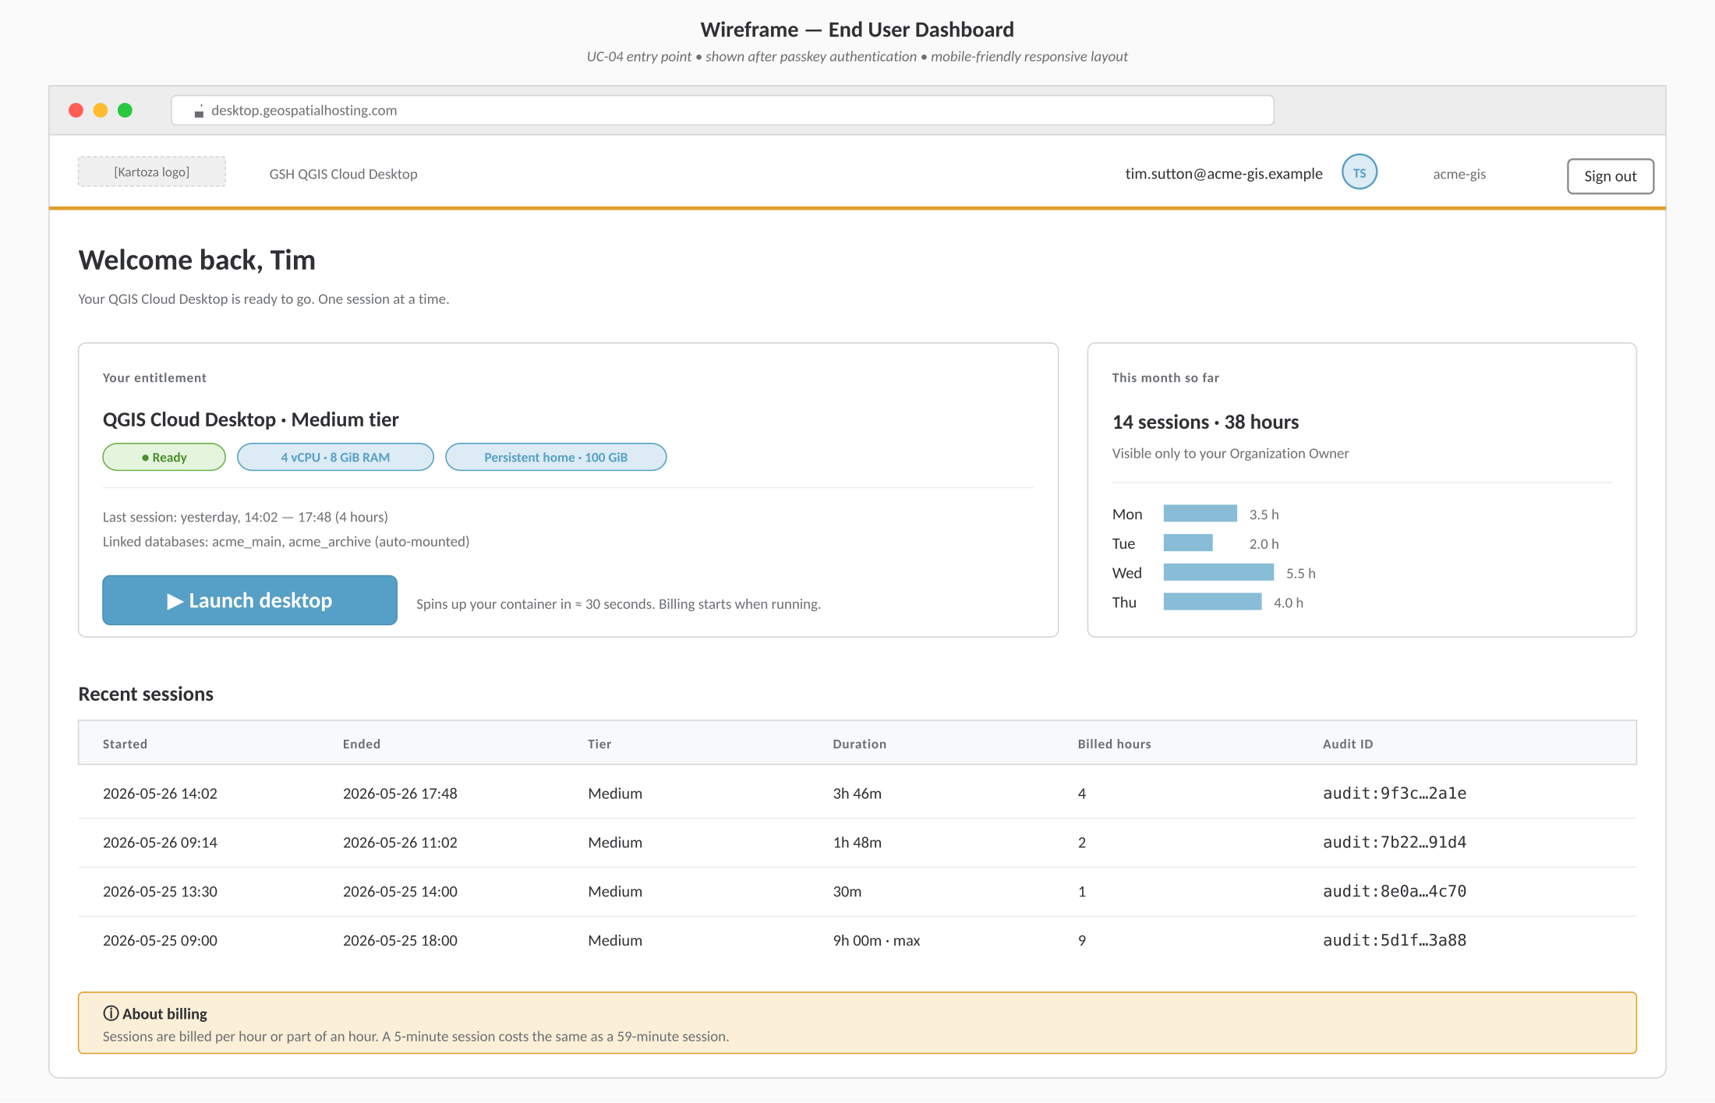
Figure 11 — End User: Dashboard — The launch surface. Entitlement card on the left, monthly summary on the right, recent sessions table below. Each row links to its audit ID.
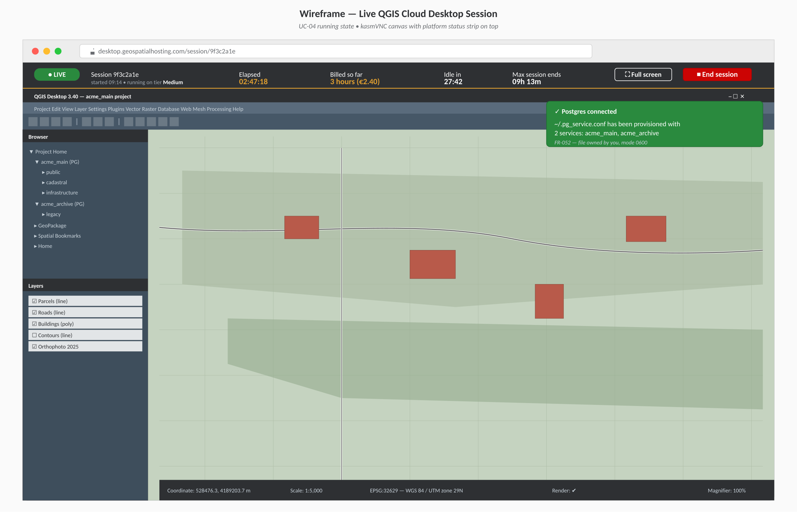
Figure 12 — End User: Live QGIS Cloud Desktop session — Dark platform status strip across the top of the kasmVNC canvas: LIVE pill, elapsed, billed so far, idle countdown, max session countdown, End session. Postgres-connected toast indicates ~/.pg_service.conf was written successfully.

10. Phasing and Acceptance

10.1 Suggested phasing
- Phase 1 — Organizations + End Users + Passkeys + Roles (no compute yet).
- Phase 2 — Machine Tier catalogue + PersistentHome allocation + audit/billing scaffolding (no live sessions).
- Phase 3 — QGIS Cloud Desktop session lifecycle (single user, single tier, end-to-end).
- Phase 4 — Per-hour metering, reconciliation reports, itemized billing UI.
- Phase 5 — Postgres linkage and pg_service.conf injection.
- Phase 6 — Reassignment, destructive operations, budgets, hardening.

10.2 Acceptance criteria (cross-cutting)
- All requirements marked (MUST) in §3 and §4 are implemented and covered by automated tests.
- A reconciliation report can be produced for any past day and matches what was actually billed to the cent.
- A simulated 100-session soak test produces zero billing drift, zero orphaned containers, and zero orphaned volumes.
- A disabled user cannot start a session; an active session for a disabled user is terminated within 60 seconds.
- A user whose Persistent Home has been reassigned cannot mount it on their next session start.
- A pg_service.conf entry appears in the user's home directory within 5 seconds of session start when a linkage is active, with correct ownership and mode 0600.

10.3 Open questions for review
Items to confirm before final sign-off
• Default idle timeout (currently proposed: 30 minutes) and maximum session length (currently proposed: 12 hours).
• Currency model — single currency per Customer or per Organization?
• Whether to require a credit check / payment-method-on-file at the Organization level before any End User can launch a session.
• Whether End Users may see their own past sessions and accumulated time (informational), or whether all visibility sits with the Organization Owner.
• Pricing tariff for storage: flat per-GiB-month or tiered by size.
• Network access from the QGIS container: open egress, allow-list, or via per-organization egress proxy?


Kartoza
Open Source Geospatial Solutions

