**TOPIC: GGIS development: user cases**

**DATE:** 10 May 2020

**FROM:** Arnaud Sterckx - IGRAC

*This document explores different user cases for the GGIS…*

# Unregistered user

The unregistered user is the occasional visitor of the GGIS. He is looking for groundwater data and information on a specific topic or region. He is for instance a policy/decision-makers, farmer, consultant, driller, water manager, researcher, employee for a NGO, etc. After consulting the GGIS, he will figure out that:

1. The GGIS doesn’t provide the information he was looking for
2. He found the information he was looking for
3. He needs more, in which case he decides to contact IGRAC or to register (Section 2)

Exploring the data would be a stepwise process:

1. The user is first invited to look at one of the main regional/thematic/project-specific viewers (cfr. Current GGIS). These main viewers are currently accessible from the website of IGRAC (<https://www.un-igrac.org/global-groundwater-information-system-ggis>). A main GGIS page exists where the viewers are available (<https://apps.geodan.nl/igrac/ggis-viewer/>, Figure 1) but we no longer use it because we can’t update the content ourselves. As all data (see below) and features for admins and registered users are managed in GeoNode, superposing a dedicated GGIS page to the default GeoNode main page might not be appropriate. We could continue using the IGRAC website for highlighting the main viewers. 🡪 Or would it be possible to customize the main page of GeoNode, in order to highlight the viewers? Developing a dedicated GGIS page might be needed though for handling the GWML2 database.

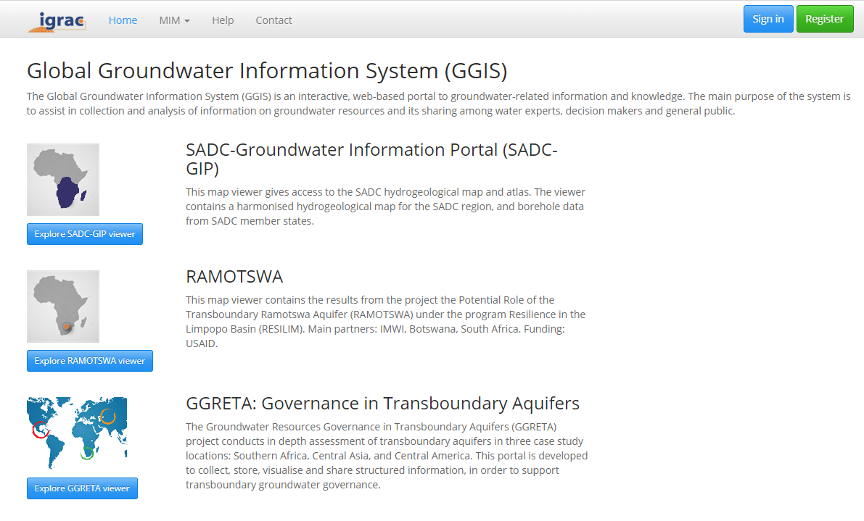

Figure 1 – Main page of the GGIS (not in use because IGRAC can’t update the content directly). Users are accessing the viewers from our website instead.

1. The user is also invited to find out more data in the data inventory, where he can use several filters provided by GeoNode.
2. In GeoNode, the user can also find out more map viewers, which have been created by IGRAC or registered users, for various purposes. These map viewers are less prominent than those highlighted in the first place (either because they are less relevant or because IGRAC hasn’t controlled the quality, or because it is meant to be a private viewer). In practice there is no formal difference between a category 1 and a category 2 viewer, but their contents and roles are different. IGRAC should be able to decide which viewers can move from category 2 to 1 (and vice-versa).
3. Finally, the user can explore documents in the document inventory.

Most unregistered users of the GGIS have assumingly little knowledge in ICT and GIS, for which we would like to keep the GGIS menu as simple as possible. For them, GeoNode menu items like “remote services” or those under “about” are not relevant. 🡪 can we create a simplified menu?

# Registered user

There are two reasons for registering in the GGIS:

* Contributing to the GGIS, such as uploading data (in the GWML2 database and in GeoNode) or creating/editing maps;
* Accessing content that is not public.

Examples:

1. As part of the Ramotswa transboundary aquifer assessment project, IGRAC supports organizations from the riparian states (Botswana and South Africa) to share groundwater-related data and information in the GGIS. Each partner registers in the GGIS, where he can upload map layers, groundwater monitoring data and documents. If data are sensitive, he can restrict the sharing to the group of partners. Some partners don’t upload data but make use of the data shared by the others. The public data generated by this project would be gathered in a map viewer highlighted in the website of IGRAC or in GGIS main page, or eventually in the websites of the partners. Secondary viewers with private data would also available in GeoNode. The main viewer would give access to the documents of this particular project.
2. The MAR Portal is the GGIS viewer dedicated to Managed Aquifer Recharge. We would like to engage the MAR community to share data and information in the GGIS. Partners could register and upload map layers, monitoring data, reports and photos on existing MAR sites around the world.
3. The GGMN is a program led by IGRAC to collect groundwater monitoring data from all countries. Each national organisation in charge of groundwater monitoring should be able to register and to upload groundwater monitoring data in the system. They should decide if the data are public or not. They could create a map viewer containing their monitoring data and other relevant maps in their country. All groundwater monitoring data would be contained in one main viewer highlighted in the main GGIS page or in IGRAC website.
4. IGRAC collaborates with several organisations around the world. We would like to provide these organisations with an account in the GGIS, so they can also share data.

Remark: Not all these potential users are necessarily skilled in GIS and ICT, but we can assist them in using the platform properly. What might simplify their experience is to use default filters in GeoNode to highlight the content they are most likely interested in. For instance, a “MAR Portal” user clicking on “Documents” would see only MAR related documents. Those default filters could be un-checked. It is relatively important for us that our users experience the GGIS as a tailor-made tool that fits their purpose. Our partners feel that the MAR Portal, the GGMN, or the Ramotswa Information System have been developed for them[1], and it is important that it remains so. I would like to avoid that users feel lost when navigating through the GGIS among loads of content (data, maps, user groups) that they don’t find relevant.

Remark: we have to give more thinking on the integration of the GWML2 database in that framework.

1. The previous GGIS version was partitioned in project workspaces.