
Section: Analysis
Module : Vector Digitizing


Digitising in Context
“Data collection methods have become more sophisticated and readily available with GPS and mobile phones. Digitizing is a method for converting historical data into digital formats and creating new data sets.”
In this module we will learn the basis of creating new datasets and adding new features to an existing datasets using digitising. We will learn how to produce datasets that are topologically correct.

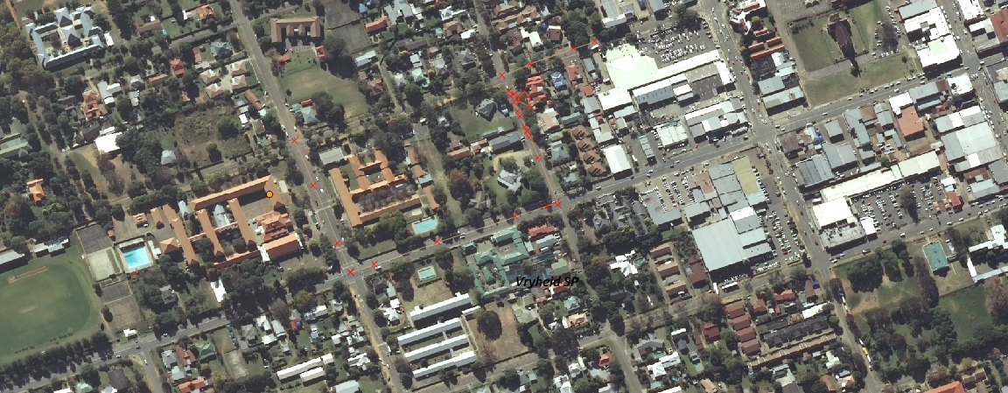
You try:
Problem:
You are a city official and need to undertake a study to find new roads,park and traffic lights in your town. Create a roads,traffic lights and parks asset register. Ensure that all digitised object adhere to topology rules.

Goal: To learn the basis of digitization for point,roads and polygons. Capture at least two adjacent polygons and two road intersections.
Data: Create a new vector layer (polygon,line) to digitize into.
* Load the administrative layer of your town and the raster layer for your town
* Zoom to a reasonable scale before starting digitizing

Name | Value
Vector Layer | Multi line, Multi Polygon
Digitising | Advanced digitising toolbar
Topology | Snapping Options, Trace

More about digitising
Digitizing point features is putting a point representing x and y coordinate. Digitizing lines involves creating a line feature that consists of a node (start and end) and a series of vertices which indicate a change of direction along that line. Straight features require fewer vertices, curved/complex features require more vertices. Digitizing a polygon involves creating three or more line segments which are joined. The start node of the line is also the end node of the line.

When digitizing a layer snapping should be activated so that the new features created adhere to the topology rules. There are a variety of tools that can be activated to leverage digitizing functionality and these tools usage vary based on the type of feature being created. Functionality can also differ based on the type of geometry a feature has etc. Multi polygon,Multi line string and Multi point


Check your knowledge:
- What is the main use of snapping when digitizing:
- To make roads layer look nice
- To ensure spatial relationship between datasets is maintained properly
- It is not necessary
- Which of the following can be a problem in manual digitizing :
- Hand eye coordination
- Availability of suitable hardware and software
- Boredom
- Can digitizing be used to create data from historical maps:
- True
- False
Answers: 1b, 2a, 3t


Further reading:
https://docs.qgis.org/2.14/en/docs/gentle_gis_introduction/topology.html
http://wiki.openstreetmap.org/wiki/Relation:multipolygon
http://wiki.openstreetmap.org/wiki/Relation:multilinestring

